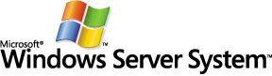
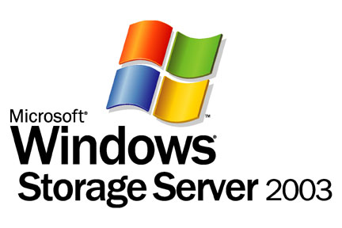
Windows Storage Server 2003 in a Hybrid Network of UNIX and Windows Systems

Microsoft Corporation
Published: January 2004

Abstract
Sharing data between UNIX® and Windows® systems can be cumbersome and costly in terms of end-user productivity, data reliability, and licensing fees. The Microsoft® Windows® Storage Server 2003 operating system offers new solutions to IT departments overrun by the complexity of integrating cross-platform data. This paper describes the file-sharing features of the operating system and the technology that enables UNIX client systems to access files stored on a Windows platform. It also explores several cost-saving strategies for managing the integrated data.

Contents
Introduction 1
Appraising UNIX and Windows Interoperation 1
Bridging the Data Gap 2
Completing the Solution 3
Components of Windows Storage Server 2003 Devices 5
NAS Hardware 6
Windows File Systems 6
Windows Storage Server 2003 6
Services for NFS 8
Partner Software 9
A Closer Look at Services for NFS 10
Sharing Files with Server for NFS 10
UNIX and Windows File Names 13
NFS File Locking 14
NFS Parameters 14
Storage Consolidation 16
Application and Storage Independence 16
Enhanced Storage Use 17
NAS-SAN Integration 17
Business Continuity Planning 19
Data Replication 19
NFS Shadow Copies 20
Backup and Restore Alternatives 21
Comprehensive Storage Management 23
Summary 24
Related Links 25

Introduction
Data-processing practices are ever changing. As innovation makes its way into corporate network infrastructures, older technology is often displaced. UNIX servers that surpass mainframes in the transaction-processing arena are examples of this type of transition. Other innovations, such as those introduced by the Microsoft® Windows Server System™, coexist in networks of heterogeneous computers running various operating systems.
Far from having a single-platform infrastructure, the average corporate network has five operational server platforms, each performing a different task within the organization. It is common to find the UNIX operating system in the mix, often hosting backend, mission-critical applications.
Similarly, the Microsoft® Windows® operating system, with its attractive price-performance ratio, is well represented. Once thought to be only a middle-tier computing environment, Windows servers increasingly host backend database and enterprise-management applications. Consequently, both UNIX and Windows systems have become indispensable fixtures in corporate network infrastructures.

Appraising UNIX and Windows Interoperation
UNIX and Windows applications, databases, and business processes represent large capital expenditures for corporations. Each platform comes with its own tools, user environment, features, and protocols. For example, UNIX and Linux systems use the Network File System (NFS) protocol to export directories to NFS clients on the network; Windows systems share folders using the Common Internet File System (CIFS) or Server Message Block (SMB) protocols. Account management, directory structures, and file-naming conventions also work differently on UNIX from the way they do on Windows systems.
Given these differences, UNIX and Windows computers tend to remain isolated from each other as separate domains. Figure 1 shows the typical state of interoperation in a mixed computing environment; little or no cross-platform file sharing occurs, even though the network infrastructure is identical. At best, users copy or move files manually by using generic tools like the File Transfer Protocol (FTP).
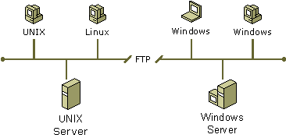
Figure 1: UNIX and Windows Networks Separated by Incompatible File-sharing Protocols
The true cost of disconnected UNIX and Windows networks extends beyond the price of redundant servers. Data moved or copied from one operating system to the other is often done haphazardly, resulting in corrupt or poorly synchronized data. Dissimilar authentication mechanisms can produce inconsistent, even unauthorized, access to network resources. Users and administrators struggle unproductively with multiple file-access protocols and tools.
Administering separate domains involves acquiring and maintaining the requisite skills associated with each operating system. UNIX and Windows use different user directories to store user accounts, group accounts, and other network objects. Managing account and network resources (such as users or devices) across multiple platforms causes duplication of effort, cripples productivity, and complicates network administration.

Bridging the Data Gap
Integrating UNIX, Linux, and Windows resources into a secure, highly productive network, and reducing the associated administrative overhead, remains a challenge for many information technology (IT) departments. Minimally, an integrated solution must:
- Eliminate redundant account and network resources.
- Provide seamless access to files across both operating systems.
- Consolidate authentication resources to eliminate duplication.

Since its introduction in 1999, Microsoft® Windows® Services for UNIX (SFU) has exceeded these minimal requirements. SFU provides interoperability components that leverage existing UNIX network resources and expertise within an organization. It also provides manageability components that simplify network administration and account management.
Besides supplying the protocols to share files between UNIX and Windows computers, this add-on software provides a "single sign-on" capability by synchronizing passwords and mapping authentication credentials between operating systems. It includes Interix, a high-performance UNIX environment that offers two command shells (C and Korn), more than 350 commands and utilities (such as the vi editor and Perl), and a complete set of development tools and libraries for porting UNIX applications to the Interix subsystem.

Completing the Solution
Although SFU is key to interoperation, it is but one aspect of a successful data processing strategy. IT departments still face an increasing demand for reliable, available data that is easily managed. In addition to better platform integration, a solution must be
- Scalable, ensuring that storage capacity keeps pace with data growth.
- Fault tolerant, ensuring that mission-critical data is well protected from the risk of hardware failure, security threats, and disaster.
- Manageable, enabling administrators who use software tools to manage many resources as one.
While there are many storage solutions available, few offer the cross-platform storage capabilities just described. Microsoft Windows Storage Server 2003 is a network attached storage (NAS) operating system that enables original equipment manufacturers (OEMs) to assemble optimized, file-serving appliances that can do it all.
NAS devices running Windows Storage Server 2003 combine the following characteristics into solutions that target networks where UNIX and Windows computers dominate:
- Simple to use; OEMs configure these devices for fast deployment (typically within 15 minutes).
- Network ready; administrators can connect a Windows Storage Server 2003 device to a local area network (LAN) without interfering with existing infrastructure.
- Configured for UNIX interoperation; Windows Storage Server devices include a subset of SFU functionality, which provides NFS file sharing and supports SFU interoperability.

Designed to separate storage resources from application servers, which simplifies storage management, Windows Storage Server devices unite UNIX and Windows network resources into a single domain, as Figure 2 shows.
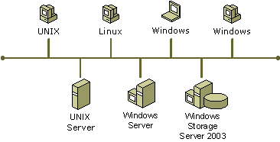
Figure 2: UNIX and Windows Client Computers Sharing Files Located on a Single Window Storage Server
Windows Storage Server devices communicate with Windows client systems using the SMB or CIFS protocols (SMB is an improved version of CIFS). UNIX client systems use native NFS to access files on these dedicated Windows file servers. Both SMB and NFS benefit from the performance enhancements introduced by the Windows Storage Server 2003 operating system.
Deploying a Windows Storage Server device into a hybrid network of UNIX and Windows computers eases the effort of managing cross-platform data and introduces options to those who must plan for future growth. This paper explores the components of the device, provides a detailed look at the mechanism for sharing data over NFS, and discusses several strategies for improving data availability while reducing costs.

Components of Windows Storage Server 2003 Devices
A Windows Storage Server device is a dedicated, single-function file or print server that provides storage space in a heterogeneous environment. OEMs select, configure, and test the various hardware and software components of a storage-server solution.
Figure 3 shows the three distinct components of a Windows Storage Server device that pertain to NFS file sharing: NAS hardware, Windows Storage Server 2003 operating system (including Windows files systems and Services for NFS), and partner software. Figure 3 also lists the various storage-related technologies associated with each component.
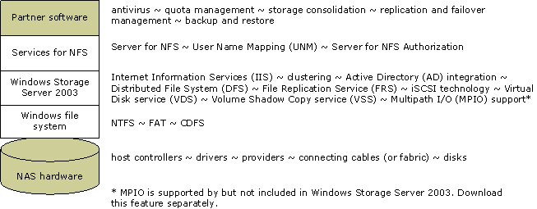
Figure 3: Constituent Components of a Window Storage Server Device
The sections that follow describe these components in more detail, starting with NAS hardware and working upwards.

NAS Hardware
Partner OEM relationships are at the core of Windows Storage Server solutions. Well-known manufacturers including Dell, EMC, Fujitsu-Siemens Computers, Hewlett Packard, Inline, Iomega, Maxxan Systems, and NEC, among others, offer an extensive range of NAS-based products.
Windows Storage Server devices typically lack a monitor, keyboard, and mouse. Instead, a web-based user interface provides remote administration from anywhere on the network. The capacity of these dedicated file servers ranges from 160 gigabytes to more than 80 terabytes.
Host controllers, drivers, RAID providers, cables, and disks vary in response to the requirements specified by the consumer. By configuring, testing, and supporting NAS hardware components, OEM partners sharpen network file I/O processing and storage effectiveness.

Windows File Systems
File Allocation Table (FAT) and the CDFS file systems support similar levels of functionality. Neither of these file systems provides any type of access control. Users must expose FAT-formatted data as read-only resources to maintain a degree of access protection.
The NTFS file system assigns permissions to multiple users or groups independently. For example, an administrator can grant read-and-write access to user "bob" and grant read-only access to user "deb." The same file can also have permissions that apply to one or more groups.
The Windows security subsystem delivers a more robust means of access protection for the NTFS file system than is available to UNIX file systems. Under UNIX, a file has a single owner and a single group with permissions (read, write, and/or execute) granted to each. UNIX also grants separate permissions to others—users external to the group that owns the file.

Windows Storage Server 2003
The integrated services of Windows Storage Server 2003 have been enhanced to include features that assist IT departments in controlling storage-related costs and increasing file sharing among users whether they use UNIX or Windows.

File-Sharing Protocols
- Storage Message Block (SMB) and Common Internet File System (CIFS)
- Network File System (NFS)
- AppleTalk
- Hypertext Transfer Protocol (HTTP)
- Web Document Authoring and Versioning (WebDAV)

Note
NAS devices not based on Windows Storage Server 2003 typically support only the CIFS and NFS protocols.

Network Protocols
- User Datagram Protocol (UDP)
- Transport Control Protocol/Internet Protocol (TCP/IP)
- AppleTalk
- Internet Packet Exchange (IPX)

Transport Support
- Fiber Channel
- Ethernet
- Multipath Input/Output (MPIO)
- Internet Small Computer System Interface (iSCSI)

Software Support
- Internet Information Services (IIS), Version 6.0
- Distributed File System (DFS)
- File Replication service (FRS)

Management
- Microsoft Admin UI
- Remote Desktop for Administration
- Virtual Disk service (VDS)
- Simple Network Mail Protocol (SNMP)
- Telnet
- Quota Management

Security and Authentication
- All supported Windows security packages—Microsoft® Windows Server™ 2003 Active Directory® directory service, Kerberos, Windows NT Domains, NTLM, Secure Sockets Layer (SSL), Internet Protocol Security (IPSec), and Apple User Account Management (AUM)

Reliability and Availability
- Volume Shadow Copy service (VSS)
- Clustering (support for up to eight nodes)
- Software RAID 0, 1, 5
- System Monitoring
For a description of each feature, see the Windows Storage Server 2003 home page (http://go.microsoft.com/fwlink/?LinkId=19650).

Services for NFS
Services for NFS integrates with the operating system to give NFS clients access to resources on Windows Storage Server devices without having to explicitly sign on to the Windows domain. Unlike SFU (3.0 and higher), Services for NFS supplies only those components that support file serving.
All components of Services for NFS—Server for NFS, Server for NFS Authentication, and User Name Mapping—come preinstalled on Windows Storage Server devices, and support both NFS 2.0 and NFS 3.0 client software. UNIX clients require neither additional software nor Client Access Licenses (CALs) to access Windows Storage Server 2003 shares.
Services for NFS uses the Open Network Computing remote procedure call (ONC RPC) protocol to implement the NFS protocol. It also uses the external data representation (XDR) protocol to ensure portable data transmission between NFS clients and the NFS server.

Partner Software
Microsoft and the NAS OEM community continue to collaborate closely with storage industry leaders to enable a wide range of solutions supporting Windows Storage Server 2003. Antivirus, backup, consolidation, replication, and disk quota software are often preinstalled on Windows Storage Server devices.
OEMs select utility software based on the demands of the market, the relationship an OEM has with the independent software vendor (ISV) providing the utility, and the appropriateness of the software to file-sharing activities. For example, antivirus software is considered universally valuable in protecting data on a file server; application-management software is better suited to application servers. For a list summary of partner solutions, see Windows Storage Partners (http://go.microsoft.com/fwlink/?LinkId=22738).

A Closer Look at Services for NFS
File serving is the practice of repetitively opening, closing, reading, and writing files. In a heterogeneous network, a file server must support the file-sharing protocols of all the clients it serves. These protocols enable clients running dissimilar operating systems to make requests and receive responses from remote devices, such as Windows Storage Server devices.
As noted earlier, these devices perform file processing for a diverse set of network clients. This section focuses on the NFS protocol used by a UNIX client to access the files shared by a Windows Storage Server device.

Sharing Files with Server for NFS
With Server for NFS, a device running the Windows Storage Server 2003 operating system can host NFS shares. Users on computers running NFS client software can access directories (called shares) on a Windows Storage Server device by mounting those directories to their computers. To a user on a UNIX client computer, the mounted files look like local files.
Note
SFU includes components that make exported UNIX directories available to Windows clients. These components—Client for NFS and Gateway for NFS—are never installed on Windows Storage Server devices.

File-Access Components
Server for NFS works in conjunction with User Name Mapping and Server for NFS Authentication to validate file processing for networked UNIX clients. The collaboration provides a consistent, intuitive mapping of file permissions that UNIX clients can work with, and users can understand.
User Name Mapping and Server for NFS Authentication perform the following roles in the file-access process:
- User Name Mapping unifies UNIX and Windows namespaces, and provides UNIX users with single sign-on access to Windows resources, including Windows Storage Server devices. Specifically, User Name Mapping extracts UNIX user identifications (UIDs) and group identifications (GIDs) from NFS requests, and maps them to Windows user names.
- Server for NFS Authentication provides an interface between Server for NFS and the Windows security authority. This authentication component receives requests for Windows user credentials from Server for NFS, retrieves the credentials from the Windows security authority, and returns them to Server for NFS.

File-Access Security
Server for NFS security combines Windows security and the security protocols that protect Windows Storage Server shares, and controls access to shared directories by specific client computers. Both Windows security and NFS security control access to files by individual users, based on the user logon account. For added security, Server for NFS forces the user to be reauthenticated when the client connection is inactive for a predefined period.

File Sharing Step-by-Step
Server for NFS, User Name Mapping, and Server for NFS Authentication interact to serve up files on request. Figure 4 simulates a UNIX client request, showing each segment of the process. By default, Services for NFS configurations map and authenticate users locally, as is the case in this example.
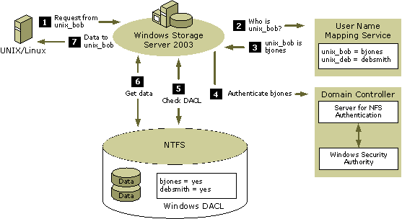
Figure 4: UNIX Client Requesting Data Stored on a Windows Storage Server Device
Steps for User Name Mapping and Authentication:
- Request from unix_bob. During the initial request for file access, Server for NFS determines whether or not the client computer has the privilege to access the file server. If not, Server for NFS returns an error message.
- Who is unix_bob? Server for NFS checks whether or not the user on whose behalf the request is made has a Windows account; then, it passes the UID and GIDs obtained from the NFS client to the User Name Mapping component.
Note
If the request is anonymous and Server for NFS is configured to allow anonymous access, Server for NFS supplies the anonymous UID and GID instead.
- unix_bob is bjones. If the UID corresponds to a Windows account in the User Name Mapping database, and if any of the GIDs match a Windows group, User Name Mapping returns the user name of the account and the group names to Server for NFS.
- Authenticate bjones. Server for NFS logs on the user by passing the user name to the Server for NFS Authentication component, which uses the Windows Security Authority to obtain security credentials. Server for NFS Authentication returns the user's security credentials to Server for NFS.
For details about domain-user authentication, see Network-Wide Authentication.
- Check DACL. Once Server for NFS has obtained these credentials, it uses them to request file access on behalf of the user. When the server receives a request from Server for NFS for access to a file, the server checks the discretionary access control list (DACL) in the file security descriptor to determine whether the specified user and the groups to which the user belongs are permitted the requested access. If access is denied, the server returns an error to Server for NFS, which, in turn, sends an error message to the NFS client.
- Get data. The server allows Server for NFS to read or write the contents of the file on behalf of the NFS client.
- Data to unix_bob. Server for NFS returns the requested data to the UNIX client computer in a format that is consistent with user expectations.

Simple and Advanced Mapping
User Name Mapping supports both simple and advanced mapping. When a user has identical user names in the UNIX and Windows domains, simple mapping associates the accounts on behalf of the user, relieving administrators of the need to map the names explicitly. Administrators can use advanced mapping to explicitly map UNIX and Windows users who have different user names in the two domains. Figure 4 shows an advanced mapping configuration.
User Name Mapping running on a Windows Storage Server device provides the name-matching capabilities necessary for NFS file serving. However, administrators can configure User Name Mapping to run on one or more dedicated servers to improve performance and provide failover capability should one of the servers become unavailable.
Administrators can also configure User Name Mapping to retrieve Windows user names from Windows domain controllers, and to get UNIX UIDs and GIDs from Network Information Server (NIS) or Personal Computer Network File System (PCNFS) systems. Support for NIS allows administrators to take advantage of User Name Mapping with minimal disruption to the rest of the NIS infrastructure. Neither NIS nor PCNFS components—both included with SFU—can run on a Windows Storage Server device.

Network-Wide Authentication
For domain-based authentication, Server for NFS Authentication must be installed on all Windows domain controllers if those controllers are running at Windows 2000 domain functional level. Any domain controller can receive an authentication request, but it can respond properly only if Server for NFS Authentication is installed locally.
Alternatively, when the domain is at the Windows Server 2003 domain functional level and Server for NFS runs exclusively on Windows Server 2003 or Windows Storage Server 2003 computers, Server for NFS can take advantage of a feature called protocol transition to process authentication requests. Protocol transition eliminates the requirement of running Server for NFS Authentication on each domain controller.

UNIX and Windows File Names
Many of the conventions used for naming files and directories on UNIX systems differ from those used by Windows. Depending on the operating system, file names can be case sensitive, contain special characters, or be hidden from users. This section identifies these differences and describes how administrators can configure Server for NFS to deal appropriately with them.

Case sensitivity
UNIX is case sensitive when handling directory and file names. In contrast, Windows computers preserve the case but are not case sensitive.
By default, Server for NFS is case sensitive when matching directory- and file-access requests to directories and files in its shared directories; it preserves the case of the names of directories and files when creating files on behalf of NFS clients computers. Administrators can configure Server for NFS to ignore case sensitivity when returning directory and file names.

Special characters
Every file system reserves characters for use in path and command syntax. For example, a file stored on NTFS cannot contain a colon (:) character because that character separates the drive letter from the rest of the path in a fully qualified path name. UNIX file systems do not use letters to identify drives, so colon characters are valid in UNIX file names.
Administrators can specify how characters in directory and file names will be converted when files are shared between Server for NFS and client computers. To accomplish this, the administrator creates a file that defines how these characters are to be mapped and then specifies where Server for NFS can find the file containing the character map.

Hidden files
Files can be hidden on both UNIX and Windows computers. In the case of Windows computers, files are hidden by setting a special attribute for the file. UNIX file systems simply do not list files whose names begin with a period (.) character. By default, Server for NFS does not create files with names beginning with a period as hidden files in the Windows file system.

NFS File Locking
Server for NFS implements mandatory locks even for those locking requests that are received through NFS. This practice ensures that locks acquired through NFS are visible through the SMB protocol and to applications accessing the files locally. The operating system enforces mandatory locks.

NFS Parameters
The appeal of a Windows Storage Server device stems from its configuration status: NFS file sharing simply works. Nevertheless, hands-on administrators can adjust the factory settings to enhance usability or performance as needed. Server for NFS has a number of parameters that administrators can use to hone file-sharing effectiveness. Administrators can use either the command line or the Windows Services for UNIX Administration Microsoft Management Console (MMC) to configure performance settings for Server for NFS.
The sections that follow list the server options that can be configured.

Server Settings
- Enable TCP support: This setting enables TCP in addition to UDP connections. TCP is designed for high reliability, but at a greater performance cost.
- Enable NFSv3 support: This setting turns on full support for NFS v3 protocol, if the client supports the protocol level.
- Directory cache size: A cache of directory information can be searched, instead of directories on the physical disk. The maximum (and default) size is 128 kilobytes (KB).

Authentication Settings
- Renew authentication: If used, the default value is set to 600 seconds. Renewing authentication enhances security, but at a greater performance cost.
- Do not renew authentication: If used, Server for NFS assumes that the client remains authenticated after the first authentication.

File-Name Handling Settings
- Translate file names: This setting specifies a character-translation file that allows UNIX file name characters to be translated to valid Windows file names.
- Create files starting with '.' as hidden files: This setting configures Windows to set the hidden attribute on UNIX file names that start with a period (.).

Case Sensitivity Settings
- Case sensitive lookups: Case sensitive lookups: This setting specifies that all files be treated as fully case-sensitive. When the Case sensitive lookups setting is unchecked, administrators can force the case in which the file names are returned by using the underlying file system. Administrators can optionally set case to all lowercase letters, all uppercase letters, or to preserve the existing case.

Nfsonly Mode
- nfsonly.exe: Administrators execute the Nfsonly function on individual shares to enhance caching and improve file-sharing performance. Candidate NFS-only shares must not be accessible by any means other than NFS; otherwise, data corruption can occur.

Storage Consolidation
Although the unit cost of storage has decreased, the amount of data a corporation must keep on hand, and the expense of managing that data, have increased exponentially. Compliance with the upcoming Sarbanes-Oxley Act, for example, only compounds the storage quandary. This legislation requires corporations to store a plethora of information, retrieve the data on request, and track the coming and going of every item.
The pressures of heightened productivity, content-rich files, and immense database applications coupled with years of IT evolution—including mergers and acquisitions—have left companies with complex, heterogeneous infrastructures that are widely distributed. To deal effectively with these problems, smart companies are turning to storage consolidation to increase efficiency, to make better use of server capacity and manpower, and to reduce the cost of storage.

Application and Storage Independence
Application servers and file servers perform best when tuned for their specific needs. General-purpose servers that host both applications and data are less efficient and, therefore, produce lackluster performance for both uses. Figure 5 shows the immediate reduction in network complexity when applications and file servers operate independently, and a single Window Storage Server device replaces many underutilized file servers.
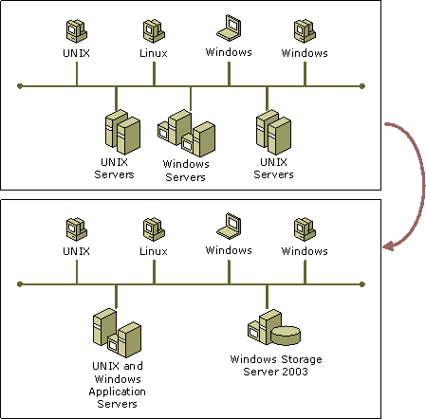
Figure 5: Sample Network Before and After Storage Consolidation
Separating applications from data is a well-understood concept in UNIX circles; tools for managing UNIX servers are abundant, reliable, proprietary, and expensive. Less often considered is the notion that an IT department should consolidate the contents of multiple UNIX and Windows file servers onto a single, more powerful NAS server.
Once consolidated, UNIX files benefit from the many enhancements available to Windows Storage Server devices, including simplified storage management. There are fewer backup devices to contend with and even fewer platform-specific backup procedures to learn.
Additionally:
- Virtual Disk service (VDS) makes it easier to manage disks and volumes.
- Volume Shadow Copy service (VSS) improves backup and recovery tasks.
- Distributed File System (DFS) provides intelligent failover support that enhances data availability while reducing costs.
- File Replication service (FRS) protects data, improves data availability, and synchronizes data across geographically dispersed networks.
- Server clustering, RAID technology, and redundant hardware ensure fault tolerance.

Enhanced Storage Use
It might be possible for an administrator to reduce data by removing duplicate files or permanently archiving unused data prior to the consolidation endeavor. Some administrators of a heterogeneous environment do not have enough training on each operating system to recognize opportunities to consolidate such data on a routine basis. Thus, unwanted data and inappropriate files tend to accumulate over time.
Using partner consolidation software, administrators can analyze and clean data before migrating that data to a Window Storage Server device. Wizards identify old files, duplicate files, orphan files, and files that violate policy; assist administrators in determining which data to migrate and when to migrate it; and perform the actual migration.

NAS-SAN Integration
As described earlier, Windows Storage Server devices provide an established way to consolidate data and storage resources. A Storage Area Network (SAN) is another a type of storage network that is relevant to consolidation. Whereas clients share files with NAS, servers share block-level storage with SANs.
NAS is quick and inexpensive to implement, because it uses existing networking infrastructure. SANs are built on dedicated, high-performance fiber channel networks specifically designed for block I/O applications like SQL and Exchange. Support in Windows for iSCSI technology, which transfers storage commands over industry-standard TCP/IP, provides inexpensive, simple storage networking that can support both NAS and SAN hardware.
As Figure 6 shows, a Windows Storage Server device attached to a LAN can act as a gateway to the nearly unlimited capacity of storage arrays attached to a SAN. The NAS device supplies the file-serving capabilities and the SAN provides the physical storage.
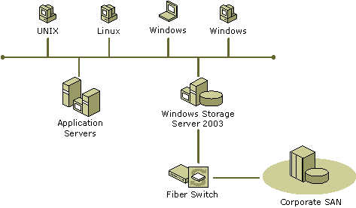
Figure 6: Windows Storage Server Device as a Gateway to SAN Storage

Business Continuity Planning
Mission-critical data must be persistently available to network users, replicated to enhance performance or to recover from a disaster, and backed up routinely. Planning for the unknown is something that every organization, large or small, must undertake. Because it is a requirement of the times, information managers must determine the proper course to follow.
A mixed network of operating systems and proprietary hardware complicates this planning process, unless an IT department proactively reduces the quantity of differing systems. File-server consolidation is the first step in the reduction process, because it immediately cuts down the number of computers. Data replication, copying real-time data to one or more target servers, is the next critical step in the effort.

Data Replication
Several types of data replication technology are available: whole-file, application-driven, hardware, and software replication. Whole-file replication is often too bandwidth-intensive to be practical for dedicated file servers. Application replication copies only application-specific data. Neither of these replication options boosts file-serving efficiency.
While the mission-critical data of an organization is often protected by hardware fault tolerant solutions (RAID 1 or RAID 5), the cost of this solution is high. Many IT budgets cannot accommodate the redundant hardware subsystems necessary for mirrored or striped with parity copies. As a result, a significant portion of the data of an organization might lack this type of replication protection.
Critical data is not what it once was; business and technical professionals use data in ways that early continuity planners could not have anticipated. More data needs to be at the fingertips of more people, without the overhead costs of hardware replication. Software replication of data on Windows Storage Server devices can provide replication efficiency and failover protection at a very attractive price. Figure 7 shows a simple one-to-one replication profile where data at one location is replicated to a second location. Once configured, software replication continuously replicates the data.
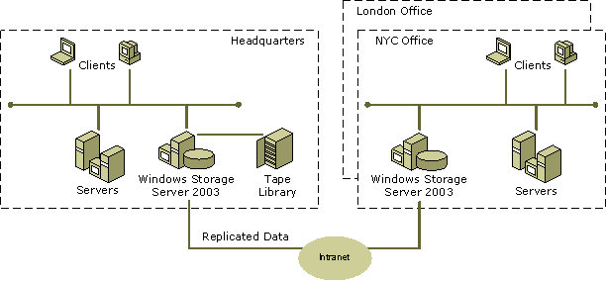
Figure 7: Geographically Distributed Replicas of Data
Distributing replicated data geographically serves two purposes: the data is accessed locally at each site (headquarters and branch sites) for enhanced performance, and the data has a high degree of availability. If one site goes down, the other site can provide failover capacity. Replication can occur within the same facility; however, a facility-wide outage incapacitates all copies of the data.
ISV-supplied replication software typically operates at the byte level, not at the block or file level. When an I/O operation changes 10 bytes of data, only those few bytes are queued for replication.

NFS Shadow Copies
Even experienced UNIX users occasionally enter rm *.* at the UNIX prompt only to realize too late that they have removed the wrong segment of the directory structure. Data replication cannot mitigate the damage, as replication software also honors user requests to delete all the files and subdirectories of the current directory.
Mishaps of this kind frustrate users and administrators alike, and create costs for corporations because of lost productivity. Windows Storage Server 2003 Volume Shadow Copy service (VSS) technology provides an alternative to the tedious task of restoring files from tape. With VSS, an administrator can capture snapshots or shadow copies of data on Windows Storage Server devices at intervals defined by corporate policy. UNIX users can access the previous versions of files stored on shares by means of the NFS client; no additional software is required.
Server for NFS exposes each of the shadow copies of a share as a subdirectory of the share. The name of each shadow-copy subdirectory reflects the creation time of the shadow copy, using the format .@GMT-YYYY.MM.DD-HH:MM:SS. Thus, a directory named .@GMT-2003.08.18-16:41:36 contains shadow copies made at 16:41:36 on August 18, 2003, Greenwich Mean Time (GMT). Note that each shadow-copy subdirectory name begins with the dot character, rendering it hidden. A user entering the ls command at the UNIX prompt lists only non-hidden files and subdirectories; however, by entering the ls –l command, the user lists all files and subdirectories, including all shadow-copy subdirectories.
Server for NFS periodically polls the system for the arrival or removal of shadow copies and then updates the root directory view accordingly. Users can access only those shadow copies to which they have read access at the time the shadow copy is taken. To prevent users from modifying shadow copies, all shadow-copy subdirectories are read-only, regardless of user ownership or access rights, or permissions set on the original files.

Backup and Restore Alternatives
Data replication and shadow copies minimize data loss and maximize data availability. However, neither is a replacement for regular data backups.
Tape backups endure because they are inexpensive and easy to use. They are also slow. Disk-to-disk backups can speed up the process considerably, without adding substantially to the cost. While not a replacement for tape backups, disk-to-disk backups represent an intermediate phase between disk and tape. For example, instead of backing up production data directly to tape, administrators can create a tape backup from a shadow copy, a mirrored copy, or a replica of production data without interrupting production. Disk-to-disk backups are quickly made and quickly restored, being random-access based instead of serial-access based like tapes.
Furthermore, disk-to-disk backups, when combined with software replication, yield an effective remote-office backup strategy, even when adequate technical staffing is lacking. A centralized tape library attached to a Windows Storage Server device at headquarters (see Figure 8) eliminates the need to have individual backup devices scattered throughout the enterprise. By automating the process, administrators can ensure that data from all remote sites is backed up consistently and is error-free.
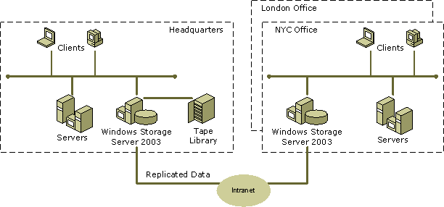
Figure 8: Centralized Backup Strategy for Remote-Office Administration
Because Windows Storage Server devices support NAS-SAN integration, tape backups can take place over a SAN as well as a LAN. In a NAS-SAN configuration, each Windows Storage Server device attached to the SAN has access to the SAN-based tape device.

Comprehensive Storage Management
Although managing a heterogeneous network of computers is a complex venture, consolidating file servers, replicating data, and creating shadow copies can ease the job significantly. Windows Storage Server devices arrive configured and are ready for immediate deployment. These devices are typically fault tolerant and can be set to automatically switch to a second disk with replicated data should the first disk fail. Optional clustering—two or more files servers that act and are managed as one—provides additional protection without incurring additional administrative overhead.
Using consolidation to reduce or eliminate UNIX file servers from the network infrastructure simply cuts down on the number of devices to troubleshoot, patch, and back up. More to the point, having fewer UNIX servers to maintain gives UNIX administrators more time to focus on network and application support, making better use of their skills.
VDS is the service supporting the Disk Management user interface (UI) and two scriptable command-line interfaces (CLI) for disk management: Diskpart and Diskraid. Administrators can use these interfaces to manage multi-vendor storage more effectively without undergoing training on each storage device.
For UNIX administrators, Windows Storage Server 2003 provides command-line access to the Services for NFS components. Windows administrators can choose from a number of different interfaces to meet their management needs, including both local and web-based UIs. Table 2 summarizes these administration interfaces and utilities.
Table 2: Graphical and Command-Line Interfaces in Windows Storage Server 2003

Administrative Interface | Description
Web User Interface (UI) | Enables administrators to remotely manage Windows user accounts, create shares, and control backups and similar tasks from any location on the network or Internet.
Microsoft Management Console (MMC) | Enables Services for UNIX Administration snap-in capabilities.  Enables Disk Management snap-in capabilities.
Command-line utilities | Enables administrators to configure Services for NFS (nfsadmin), to mount shares on NFS clients (nfshare), to enhance the performance of individual shares (nfsonly), and to configure advanced user mapping (mapadmin).
Remote Desktop | Enables remote control of other Windows computers for administration.

Summary
Windows Storage Server devices allow an organization to store more data at a lower cost. They cost less to purchase, maintain, and add, as the need for storage space grows. Techniques, such as storage consolidation and data replication, keep storage utilization levels high and data available to users anywhere in the enterprise.
Consolidated, replicated data shared from a Windows Storage Server device is equally available to UNIX and Windows users and applications. Services for NFS, like the other components of a Windows Storage Server device, optimizes file serving by excluding all non-relevant functions, resulting in excellent performance. In conjunction with SFU running on an application server, Windows Storage Server devices provide the specialized file-serving arm of a complete interoperation solution where users have password synchronization, familiar shell commands, and a superior environment in which to migrate scripts and applications from UNIX to Windows.

Related Links
See the following resources for further information:
- Windows Storage Server 2003 home page (http://go.microsoft.com/fwlink/?LinkId=19650)
- Microsoft Windows Server 2003 vs. Linux Competitive File Server Performance Comparison (4/03) (http://go.microsoft.com/fwlink/?LinkId=22502)

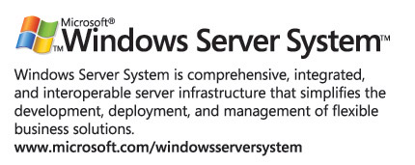

The information contained in this document represents the current view of Microsoft Corporation on the issues discussed as of the date of publication. Because Microsoft must respond to changing market conditions, it should not be interpreted to be a commitment on the part of Microsoft, and Microsoft cannot guarantee the accuracy of any information presented after the date of publication.
This white paper is for informational purposes only. MICROSOFT MAKES NO WARRANTIES, EXPRESS OR IMPLIED, IN THIS DOCUMENT.
Complying with all applicable copyright laws is the responsibility of the user. Without limiting the rights under copyright, no part of this document may be reproduced, stored in, or introduced into a retrieval system, or transmitted in any form or by any means (electronic, mechanical, photocopying, recording, or otherwise), or for any purpose, without the express written permission of Microsoft Corporation.
Microsoft may have patents, patent applications, trademarks, copyrights, or other intellectual property rights covering subject matter in this document. Except as expressly provided in any written license agreement from Microsoft, the furnishing of this document does not give you any license to these patents, trademarks, copyrights, or other intellectual property.
© 2004 Microsoft Corporation. All rights reserved.
Microsoft, Microsoft Active Directory, Microsoft Windows, Microsoft Windows Server System, and Microsoft Windows Storage Server, are either registered trademarks or trademarks of Microsoft Corporation in the United States and/or other countries.
The names of actual companies and products mentioned herein may be the trademarks of their respective owners.

Dan Kusnetzky, IDC. “Windows vs. Unix pits execs against techs.”
Microsoft Windows Services for UNIX is a standalone product that provides complete interoperation between UNIX and Windows systems. Neither SFU 3.0 nor SFU 3.5 can be installed on Windows Storage Server devices.
Redundant array of independent disks (RAID).
This feature requires Windows Storage Server 2003, Enterprise Edition.
Hardware RAID is available in many OEM products and is the recommended implementation.
This description pertains to NTFS files and folders only. Services for NFS does not export CDFS or FAT file systems.
Protocol transition in Window Storage Server 2003 requires a QFE to the Windows Storage Server device.

