
Top New Features
Microsoft® SQL Server® 2008 R2 expands on the value delivered in SQL Server® 2008 with new technologies and capabilities specifically designed to make actionable intelligence accessible to all employees in the enterprise— leading to better, faster, more relevant decisions. You can empower your users to gain deeper insight into any aspect of their business and to share their findings effortlessly and securely. You can also significantly improve IT and developer efficiencies.
Learn more at http://www.microsoft.com/sqlserver/2008/en/us/R2-SSBI.aspx.
Take a look at how key innovations in SQL Server 2008 R2 enable you to empower your users, facilitate sharing and collaboration, and increase IT and developer efficiencies:
PowerPivot for Excel 2010. Delivers unmatched computational power directly within Microsoft Excel. Users can quickly transform huge quantities of data into meaningful information using familiar Excel software, and share their workbooks using SharePoint.
Report Builder 3.0. Accelerates report creation, collaboration, and consistency by enabling users to create and share reusable report elements in a Shared Component Library. Shared components make it quick and easy to assemble comprehensive business reports in a professional-looking format.
Master Data Services. Provides the foundation to create, edit, and update master data including members and hierarchies, and to drive direct stewardship to ensure data quality by enforcing business rules, integrity, and security.

Empower Your Users
Give your users the power to gain deeper insight into any business aspect by supplying the best authoring and publishing tools, enabling them to import data from any location, and providing the ability to deliver rich visualizations.
Intuitive Authoring and Publishing
Work with the most effective tools from Microsoft to drive excellence in managed, self-service BI.
Process massive amounts of data in seconds. Capitalize on column-based compression and the in-memory BI engine available with PowerPivot for Excel 2010, and take advantage of Data Analysis Expressions (DAX) to perform powerful manipulations, aggregate over billions of rows, and define calculated columns and measures.
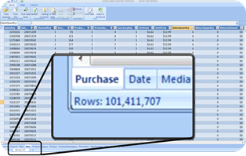
Enjoy interactive slicing and dicing in Excel. Use familiar PivotTable® views, charts, and slicers for interactive analysis. Sort, filter, and scroll through millions of rows with the same performance as a few thousand rows.
Share data models and analysis via SharePoint. Work seamlessly via Web browser without having to download all the data to each workstation, and automatically refresh shared applications to ensure most recent data.
Use workbooks as data sources for reports. Access shared workbook applications like a cube by taking advantage of a new version of Analysis Services for SharePoint 2010.
Import Data from any Location
Unlock your data from any location and integrate reports that expose data feeds for analysis.
Combine data from multiple sources. Create meaningful information from a multitude of sources, including relational databases, multidimensional sources, cloud services, data feeds, Excel files, text files, and data from the Web.
Integrate reports into analysis. Use business reports that expose ATOM feeds as data sources for analysis. Report-based ATOM feeds provide an easy way to make complex enterprise systems accessible to users.
Deliver Rich Visualizations
Make the most of reusable components and rich visualization capabilities to deliver meaningful, effective reporting solutions.
Use “Grab and Go” reporting. Reuse common report elements published in the Shared Component Library and synchronize updates with these components to make building up-to-date reports quick and easy.
Enjoy rich visualization of geospatial data. “Mash up” business information with geographic representations for location-based data visualization, including mapping, routing, and custom shapes.
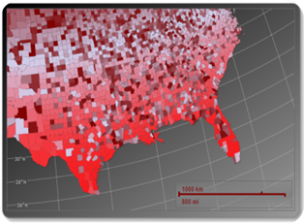
Share and Collaborate
Facilitate seamless and secure sharing and collaboration, capitalize on existing capabilities, and take advantage of new possibilities offered by SQL Server 2008 R2:
Collaborate Seamlessly and Securely
Make it safe and easy for your users to work together and boost the productivity of your entire team:
Work seamlessly via Web browser. Access shared applications directly in the browser without having to download all the data to every workstation. Enjoy SharePoint’s attractive user interface and the same performance and features as the Excel client.
Capitalize on standard SharePoint features. Benefit from all the features that make SharePoint so effective, such as role-based security, workflows, and versioning.
Maximize business insight. Collaborate with users creating ad-hoc analyses, reuse available applications as data sources and published reports as data feeds, and take advantage of SharePoint permissions and workflows to coordinate how users share their own solutions.
Refresh Data Models Automatically
Ensure your organization’s business decisions are always based on up-to-date information:
Make decisions based on most recent data. Schedule data refreshes for workbooks in SharePoint to ensure the data remains current automatically, even over the Internet.
Monitor data refresh activities. Use the PowerPivot IT Operations Dashboard to monitor shared applications and ensure they are always available and up-to-date.
Increase IT Efficiency
Boost the efficiency of your IT department by driving direct stewardship to ensure data quality, centralizing BI and data management, and encapsulating enterprise data sources.
Manage your Master Data
Deliver a single version of the truth for all organizational and self-service BI applications.
Deliver faster, more accurate results across the enterprise. Ensure reporting consistency across systems by using Master Data Services, and establish a Master Data Hub to define, deploy and manage master data centrally.
Drive direct stewardship to ensure data quality. Enforce business rules and manage supporting domains in a central stewardship portal to create, edit, and update master data, including members and hierarchies.
Centralize BI and Data Management
Integrate the management of BI and data to ensure high availability, scalability, and reliability for mission-critical applications.
Discover mission-critical self-service BI applications. Leverage the PowerPivot IT Operations Dashboard to monitor and manage shared applications. Track usage patterns over time, drill down to reveal hidden details, discover solutions that have become mission-critical, and provision appropriate server resources to ensure high availability and performance.
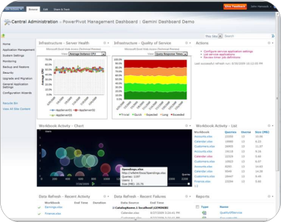
Ensure data quality, integrity, and security. Eliminate financial losses caused by dirty data by relying on the proven technologies in the Microsoft BI Solution Stack.
Encapsulate Enterprise Data Sources
Make sure your users have secure access to the mission-critical information they need.
Give users virtually unlimited data access. Encapsulate mission-critical enterprise data sources for ad-hoc analysis by using Report Builder 3.0 and ATOM feeds.
Consolidate heterogeneous data sources for analysis. Integrate a range of varied data sources in reports that serve as data feeds for analysis to speed up common or complex analysis tasks and increase consistency.

