Configuring Windows HotStart
May 13, 2006
Abstract
Windows HotStart™ on the Microsoft® Windows Vista™ operating system provides built-in support for a fast system startup experience that boots or resumes directly into media or other applications. This paper describes how to enable and configure Windows Hotstart, troubleshoot Windows HotStart implementations, and use Windows HotStart for Microsoft media applications.
This information applies for the Windows Vista operating system.
The current version of this paper is maintained on the Web at:
http://www.microsoft.com/whdc/system/platform/firmware/hotstart.mspx
References and resources discussed here are listed at the end of this paper.
Contents
Introduction 3
Configuring and Troubleshooting Windows HotStart 3
Verify that ACPI Has Enumerated HotStartButtons Correctly 3
Configure the Windows Hotstart Button Agent and Application Launch 4
Configuring the Target Application 4
Example Configuration 5
Configuring Windows HotStart through Group Policy 6
Verify that the Windows HotStart Button Agent Is Receiving the Button-Press Event 7
Launching Applications 7
Launching Windows Media Center Edition 7
Launching Windows Media Player 8
Blocking User Input during Application Launch 9
Resources 10

Disclaimer

This is a preliminary document and may be changed substantially prior to final commercial release of the software described herein.

The information contained in this document represents the current view of Microsoft Corporation on the issues discussed as of the date of publication. Because Microsoft must respond to changing market conditions, it should not be interpreted to be a commitment on the part of Microsoft, and Microsoft cannot guarantee the accuracy of any information presented after the date of publication.

This White Paper is for informational purposes only. MICROSOFT MAKES NO WARRANTIES, EXPRESS, IMPLIED OR STATUTORY, AS TO THE INFORMATION IN THIS DOCUMENT.

Complying with all applicable copyright laws is the responsibility of the user. Without limiting the rights under copyright, no part of this document may be reproduced, stored in or introduced into a retrieval system, or transmitted in any form or by any means (electronic, mechanical, photocopying, recording, or otherwise), or for any purpose, without the express written permission of Microsoft Corporation.

Microsoft may have patents, patent applications, trademarks, copyrights, or other intellectual property rights covering subject matter in this document. Except as expressly provided in any written license agreement from Microsoft, the furnishing of this document does not give you any license to these patents, trademarks, copyrights, or other intellectual property.

Unless otherwise noted, the example companies, organizations, products, domain names, e-mail addresses, logos, people, places and events depicted herein are fictitious, and no association with any real company, organization, product, domain name, email address, logo, person, place or event is intended or should be inferred.

© 2006 Microsoft Corporation. All rights reserved.

Microsoft, Win32, Windows, Windows HotStart, Windows Media, and Windows Vista are either registered trademarks or trademarks of Microsoft Corporation in the United States and/or other countries.

The names of actual companies and products mentioned herein may be the trademarks of their respective owners.

Introduction
The Microsoft® Windows Vista™ operating system provides built-in support for launching applications directly from system startup. Windows HotStart™ takes advantage of existing support in Windows Vista for OnNow power management initiatives and technologies, including the platform sleep states and wake capabilities that are defined by the ACPI specification and supported by the Microsoft Windows® Driver Model (WDM), the underlying operating system, and platform hardware.
Manufacturers can take advantage of Windows HotStart to add consumer-friendly application-access buttons through chassis front panels or infrared (IR) remote controls to their system designs. A common example of such a control is a media playback button that starts or wakes the computer and immediately (as soon as the system is running) presents the user with a media player or dedicated media shell.
This paper describes how to enable and configure Windows Hotstart and use it to launch media applications. For detailed information about implementing platform support for Windows HotStart, see Direct Application Launch from System Startup on Windows Vista in "Resources" at the end of this paper.

Configuring and Troubleshooting Windows HotStart
Configuring Windows HotStart involves the following steps:
1. Verify that ACPI has enumerated all of the application-launch buttons and stored the contents in the registry correctly.
2. Set individual registry keys or use group policy to configure the Windows HotStart button agent and application launch.
3. Verify that the Windows HotStart button agent is receiving the application-launch button-press event.

Verify that ACPI Has Enumerated HotStartButtons Correctly
To verify that ACPI has correctly stored the buffer contents in the registry, check to see if the following registry entries exist on the system. (The IDs do not necessarily have to start with zero.)
HKLM\SYSTEM\CurrentControlSet\Enum\ACPI\PNP0C32\<ButtonID>
HKLM\SYSTEM\CurrentControlSet\Enum\ACPI\PNP0C32\<ButtonID>\Control
HKLM\SYSTEM\CurrentControlSet\Enum\ACPI\PNP0C32\<ButtonID>\Device Parameters
HKLM\SYSTEM\CurrentControlSet\Enum\ACPI\PNP0C32\<ButtonID>\LogConf
HKLM\SYSTEM\CurrentControlSet\Enum\ACPI\PNP0C32\<ButtonID>\Properties

Verify that the UserHIDBlock value is set properly:
HKEY_LOCAL_MACHINE\SYSTEM\CurrentControlSet\Enum\ACPI\PNP0C32\<ButtonID>\Device Parameters

Name: UserHIDBlock
Type: REG_BINARY
Data: <UsageID>

For example, the UserHIDBlock value could be:
ButtonID: 0
UsageID: 04

Or, as an alternative, the UserHIDBlock value could be:
ButtonID: 2
UsageID: 21 01 00 00

Configure the Windows Hotstart Button Agent and Application Launch
Windows Vista provides a user-mode button agent that subscribes to application-launch notifications from the Windows kernel power manager and launches the application that is associated with a specific button usage ID in the Windows registry. This behavior is implemented as a task named HotStart that is launched by Windows Task Manager when the user logs on.
The HotStart task can be viewed and configured in the Scheduled Tasks viewer management console in the Performance and Maintenance Control Panel application.

Configuring the Target Application
The manufacturer can configure the application that is associated with a specific UsageID by using the following registry key:
HKLM\System\CurrentControlSet\Control\MobilePC\HotStartButtons\<UsageID>

<UsageID> corresponds to the value that is specified in the system’s ACPI namespace. The GHID method returns this value for each application-launch button instance. Note that this registry key is not present in the registry by default; it must be added by the manufacturer when the system is configured to support direct application launch.
As described in Direct Application Launch from System Startup on Windows Vista, the usage ID is encoded in little-endian order. The proper <UsageID> key should be created in little-endian byte order, with leading zeros truncated.

Examples
If UserHIDBlock of button 2 is '21 01 00 00', the key name in little-endian would be '00000121' before truncation and '121' after truncation.
If UserHIDBlock of button 0 is '04', the name in little-endian would be '04' before truncation and '4' after truncation.

Syntax
To create the target application path, create a string value named ApplicationPath under the appropriate <UsageID> key. The value for this key should contain the full path to the application to be launched, enclosed in quotation marks. Any additional command line parameters should be delimited by white space after the application-launch path.
For example, to launch foo.exe with /bar and /xyz as parameters, specify the following:
"C:\Windows\System32\foo.exe" /bar /xyz

The maximum length of ApplicationPath string is 260 characters. This includes all executable launch paths and parameters.
Note
In the Windows Vista Community Technology Preview (CTP) build 5308 and earlier, instead of creating a value called ApplicationPath, the (Default) value is used as the launch application path. For example, to launch calc.exe, you would set the (Default) value to "C:\Windows\System32\calc.exe".

Windows Vista does not populate the application-launch button by default, and so makes no associations between usage ID values and target applications. The manufacturer can choose any value for usage ID and map it to any target application.

Example Configuration
The following example demonstrates how to configure a system that implements a direct application-launch button to start an application. In this example:
- The BIOS returns the value 0x04 for the usage ID when the GHID method is evaluated.
- Windows Media Player is the application that is launched when the application-launch button is pressed.

To configure the HotStart task to launch Microsoft Windows Media® Player, follow these steps:
1. Start the Registry Editor and select the following key:
HKLM\System\CurrentControlSet\Control
2. Add the following key:
MobilePC
3. Under the MobilePC key, add the following key:
HotStartButtons
4. Under the HotStartButtons key, add a key whose name matches the UsageID returned by the BIOS GHID method for the button that you are configuring. In this example, the BIOS returns 0x04 for the UsageID, so the key under the HotStartButtons key would be:
4
5. Edit the default value for this key and set this value to the full path of the application to launch:
"C:\program files\windows media player\wmplayer.exe"

Figure 1 shows an example of the new key in the Registry Editor window.
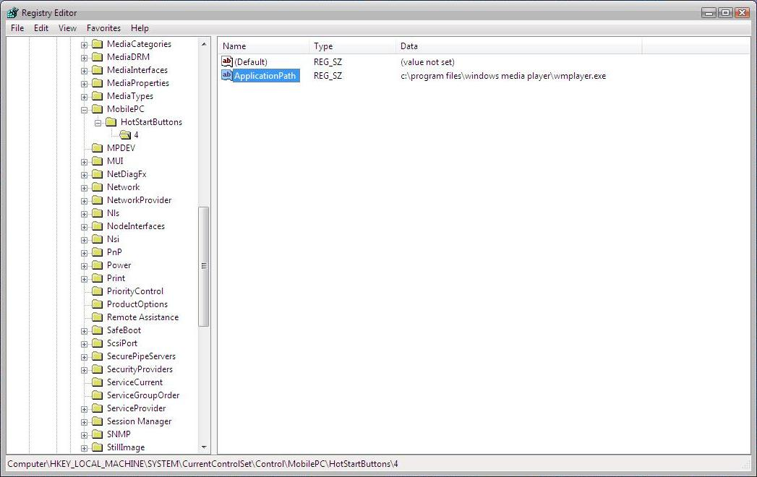
Figure 2. Example Configuration for Direct Application Launch

Configuring Windows HotStart through Group Policy
The HotStart task can be enabled through Group Policy by setting the following registry keys:
<HKCU/HKLM>\Software\Microsoft\Windows\CurrentVersion\Policies\System
"NoHotStart"=dword:0

In addition to the Windows HotStart-specific group policy above, the general AutoPlay group policy also applies to Windows HotStart. To prevent the HotStart task from running, set the AutoPlay group policy to 0xFF. The HotStart task runs with any other value besides 0xFF.
<HKCU/HKLM>\Software\Microsoft\Windows\CurrentVersion\Policies\Explorer
"NoDriveTypeAutoRun"=dword:0xFF

Note
For Windows Vista Beta 2 and earlier builds, NoDriveTypeAutoRun must be explicitly set to zero for HotStart to run. For subsequent builds, HotStart runs unless NoDriveTypeAutoRun is explicitly set to 0xFF.

The Group Policy Object Editor, gpedit.msc, can be used to verify that the following group policies have been set properly (either disabled or not configured):
Local Computer Policy/Computer Configuration/Administrative Templates/System/Windows HotStart Group Policy/Turn off Windows HotStart

Local Computer Policy/Computer Configuration/Administrative Templates/System/Turn off Autoplay

Verify that the Windows HotStart Button Agent Is Receiving the Button-Press Event
To verify that the Windows HotStart button agent is properly receiving the button-press event from the kernel power manager, check the HotStart Timestamp value after pressing the button.
The Timestamp value is stored under the LastTimeStamp value at:
HKLM\Software\Microsoft\Windows\CurrentVersion\HotStart

Launching Applications
Windows HotStart is a general-purpose Windows Vista platform feature that can launch any application; the target application is not required to be a Microsoft application. Windows Vista does not populate the application-launch button by default, and so the manufacturer can choose to map the hardware buttons to any target application.
An application is launched by Windows HotStart through a command line; thus, it supports all command line parameters that are typically used by the target application. The command line parameters can simply be added to the end of the target application path string value in the ApplicationPath registry key.
The rest of this section describes command-line parameters that can be used to further customize the application experience that is triggered by Windows HotStart when it is used to launch Windows Media Center Edition (MCE) or Windows Media Player (WMP).

Launching Windows Media Center Edition
To launch MCE, use the following command line:
<Path where MCE is located>\ehshell.exe

For example:
c:\windows\ehome\ehshell.exe

The following command options can be used with the MCE command line to launch MCE:
Command | Behavior
ehshell.exe /directmedia:general | Launches MCE in full screen.
ehshell.exe /directmedia:music | Launches MCE in full screen and sends the MyMusic command.
ehshell.exe /directmedia:video | Launches MCE in full screen and sends the MyVideos command.
ehshell.exe /directmedia:tv | Launches MCE in full screen and sends the MyRecordedTv command.
ehshell.exe /directmedia:pictures | Launches MCE in full screen and sends the MyPictures command.
ehshell.exe /directmedia:discplayback | Launches MCE in full screen and begins playback of the disc by reusing AutoRun code.

For each of these commands except discplayback, DirectMediaToCC is called with the direct media value (such as music, video, TV, or eTV). After the page has been loaded, the command code that was returned by the command is issued.
When discplayback is selected, a flag is set that forces a call to the AutoScan code after the first page has been loaded. If a playable disc is found, it is automatically played.

Launching Windows Media Player
To launch WMP, use the following command line:
<Path where WMP is located>\wmplayer.exe

For example:
c:\program files\Windows Media Player\wmplayer.exe

The following table lists command options for launching WMP:
Command option | Behavior
Path\filename  For example:  wmplayer c:\filename.wma | Starts WMP and plays the designated file.
Path\filename /fullscreen  For example:  wmplayer c:\filename.wmv /fullscreen | Plays the specified file in full-screen mode. The path and file name of the content to play must be specified.
/Device:{DVD|AudioCD}  For example:  wmplayer /device:audio CD | Plays a DVD or audio CD.
path\filename ?WMPSkin=skin name  For example:  wmplayer "c:\filename.wma"?wmpskin= headspace | Opens WMP and applies the specified skin.
/Service:keyname | Opens WMP and shows the online store that is specified by keyname  (WMP 10 only).
/Task NowPlaying | Opens WMP in the Now Playing feature.
/Task MediaGuide | Opens WMP in the Media Guide feature.  WMP 10: Opens the player in the current active online store.
/Task CDAudio | Opens WMP in the Copy from CD feature.  WMP 10: Opens the player in the Rip feature.
/Task CDWrite | Opens WMP in the Burn feature  (WMP 10 only).
/Task MediaLibrary | Opens WMP in the Media Library feature.  WMP 10: Opens the player in the Library feature.
/Task RadioTuner | Opens WMP in the Radio Tuner feature.  WMP 10: Opens the player in the current active online store.
/Task PortableDevice | Opens WMP in the Copy to CD or Device feature.  WMP 10: Opens the player in the Sync feature.
/Task Services /Service servicename | Opens WMP in the Premium Services feature and shows the service that the servicename parameter specifies. This value is the unique name for the service. If the specified service has not been previously viewed, the servicename parameter is ignored.  WMP 10: Opens the player in the specified online store.
/Task ServiceTaskX | Opens WMP in the online store service task pane specified by X. For example, /Task ServiceTask1 opens the player in the first online store service task pane.
/Task SkinViewer | Opens WMP in the Skin Chooser feature.
/Playlist playlist | Opens WMP and plays the specified playlist.

Blocking User Input during Application Launch
System implementers may want to implement an input lock to prevent a user from accidentally disrupting or exiting from an application after Windows HotStart has launched the application. Implementing such a lock is not required; the following section is provided merely for informative purposes.
The following scenario shows how an input lock can be useful:
1. A parent launches a media application to play a DVD by pressing a Windows HotStart button on a mobile PC. The parent has previously enabled and configured the input lock functionality on the mobile PC.
2. The parent gives the mobile PC to a young child in the backseat of a car.
3. The child can press keys on the keyboard without accidentally exiting the media application or reconfiguring the PC.

The Microsoft Win32® function SetWindowsHookEx can be used to block user input while Windows HotStart is launching an application. The SetWindowsHookEx function installs an application-defined hook procedure into a hook chain, for example, to monitor the system for user input events. SetWindowsHookEx has the following syntax:
HHOOK SetWindowsHookEx(
int idHook,
HOOKPROC lpfn,
HINSTANCE hMod,
DWORD dwThreadId
);
The UnhookWindowsHookEx function removes a hook procedure that is installed in a hook chain by the SetWindowsHookEx function. UnhookWindowsHookEx has the following syntax:
BOOL UnhookWindowsHookEx(
HHOOK hhk
);
Of the possible parameters that can be used with SetWindowsHookEx, the following are particularly applicable for Windows HotStart:
WH_CALLWNDPROC
Installs a hook procedure that monitors messages before the system sends them to the destination window procedure. For more information, see the CallWndProc hook procedure.
WH_KEYBOARD
Installs a hook procedure that monitors keystroke messages. For more information, see the KeyboardProc hook procedure.
WH_MOUSE
Installs a hook procedure that monitors mouse messages. For more information, see the MouseProc hook procedure.

For more information, see Using Hooks in "Resources" at the end of this paper.
System implementers can block the following user input:
Standard alphanumeric keyboard inputs (for example, A-Z, 0-9)
Designated functional keys (for example, Insert, Page Up, Scroll Lock)
ALT+TAB
ALT+ESC
ALT+SPACE
ALT+F4
ESC
F1 - F3, F5 - F7, F11 - F22, F24
START+D
START+E
START+F
START+L
START+M
START+R
START+U
START+V
START+TAB
LEFT MENU
RIGHT MENU

It is up to the system implementer to decide whether to queue user input while an application is being launched; Microsoft recommends discarding the input.
Manufacturers should contact Microsoft for additional implementation guidelines for blocking user input during application launch by Windows HotStart.

Resources
Direct Application Launch from System Startup on Windows Vista
http://www.microsoft.com/whdc/system/vista/DirAppLaunch.mspx
Using Hooks
http://msdn.microsoft.com/library/default.asp?url=/library/en-us/winui/winui/windowsuserinterface/windowing/hooks/usinghooks.asp
Windows SDK
http://msdn.microsoft.com/windowsvista/building/documentation/default.aspx
Windows Driver Kit
http://www.microsoft.com/whdc/driver/WDK/default.mspx

