

Response to Oracle's Edison 2009 Report

**Published:** September 2009

**Applies to:** SQL Server 2008

**Introduction:** In August 2009, the research firm Edison published the study “[Comparative Management Costs Study – Oracle Database 11g vs. Microsoft SQL Server 2008](http://www.oracle.com/database/docs/edison-oracle-11g-vs-sql-server-2008-cmcs-whitepaper.pdf)” (http://www.oracle.com/database/docs/edison-oracle-11g-vs-sql-server-2008-cmcs-whitepaper.pdf) commissioned by Oracle. That study compares the management costs of Oracle database 11g and SQL Server 2008. This paper, “Response to Oracle’s Edison 2009 Report”, explores details and uncovers inherent flaws about the Edison methodology, questioning the results and accuracies of the overall report.

Copyright

The information contained in this document represents the current view of Microsoft Corporation on the issues discussed as of the date of publication. Because Microsoft must respond to changing market conditions, it should not be interpreted to be a commitment on the part of Microsoft, and Microsoft cannot guarantee the accuracy of any information presented after the date of publication.

This white paper is for informational purposes only. MICROSOFT MAKES NO WARRANTIES, EXPRESS, IMPLIED, OR STATUTORY, AS TO THE INFORMATION IN THIS DOCUMENT.

Complying with all applicable copyright laws is the responsibility of the user. Without limiting the rights under copyright, no part of this document may be reproduced, stored in, or introduced into a retrieval system, or transmitted in any form or by any means (electronic, mechanical, photocopying, recording, or otherwise), or for any purpose, without the express written permission of Microsoft Corporation.

Microsoft may have patents, patent applications, trademarks, copyrights, or other intellectual property rights covering subject matter in this document. Except as expressly provided in any written license agreement from Microsoft, the furnishing of this document does not give you any license to these patents, trademarks, copyrights, or other intellectual property.

© 2009 Microsoft Corporation. All rights reserved.

Microsoft and SQL Server are trademarks of the Microsoft group of companies.

All other trademarks are property of their respective owners.

Contents

Executive Summary 4

Study Examination 4

Controlled Lab Environment 4

Incomplete Methodology 4

Licensing, Maintenance, and Packaging 5

Security Patching 5

Unverifiable Metrics 6

Inconsistent Interpretation of The Results 7

Real-World Customer Results for SQL Server Manageability 7

Conclusion 8

# Executive Summary

In August 2009, Oracle published a white paper on the management cost comparison between [Oracle database 11g and the Microsoft® SQL Server® 2008 data management system](http://www.oracle.com/database/docs/edison-oracle-11g-vs-sql-server-2008-cmcs-whitepaper.pdf) (http://www.oracle.com/database/docs/edison-oracle-11g-vs-sql-server-2008-cmcs-whitepaper.pdf). Around the same time, Oracle also published similar white paper on the management cost comparison between [Oracle database 11g and IBM DB2 Enterprise 9.5](http://www.oracle.com/database/docs/oracle11g-vs-db2-9.5-cmcs.pdf) (http://www.oracle.com/database/docs/oracle11g-vs-db2-9.5-cmcs.pdf). The objective of these comparison papers is to show the cost based on time it takes to manage these database products on a daily basis.

While the paper claims Oracle database 11g requires less time, fewer steps, and less money than Microsoft SQL Server 2008 in the area of management, careful examination reveals many areas for customers to question the accuracies of the overall study. Specifically, the study was done in a controlled lab environment without data from real-world customers, with an incomplete methodology, with unverifiable metrics, and with inconsistent interpretation of the results.

On the contrary, real-world Microsoft SQL Server 2008 customers tout the manageability features of SQL Server 2008, and a [research report](http://www.microsoft.com/presspass/itanalyst/docs/09-22-08SQLServer2008UpsPressureOnCompetitors.PDF) (http://www.microsoft.com/presspass/itanalyst/docs/09-22-08SQLServer2008UpsPressureOnCompetitors.PDF) from Forrester states that for the majority of mission-critical applications today, SQL Server 2008 already has the strongest combination of price/performance, manageability, security, and DBA productivity.

# Study Examination

## Controlled Lab Environment

The entire study was done in a controlled lab environment and did not involve real-world customer scenarios. In this lab study, the firm does attempt to simulate customer scenarios but often lacks real-world factors such as timing, resources, and the reality of the overall customer environment.

The study also assumes an average customer has aptitude in both products. In the real world, highly efficient Oracle DBAs have undergone significant training and years of practice to know how to accomplish the steps needed to perform a task. Microsoft SQL Server 2008, on the other hand, is designed with the beginner to advanced DBA in mind helping enable more resources to tackle real-world administration tasks efficiently.

Without real-world customer evidence backing up the specific tasks studied in this controlled environment, it’s difficult to accept these findings as the complete picture.

## Incomplete Methodology

The study simply focuses on a single factor, the number of clicks required to perform certain administration tasks, and it lacks consideration in the following areas such as licensing, maintenance, and packaging of the software as well as security patching. With so many factors affecting a DBA’s daily maintenance and management routine, it is scientifically incomplete to evaluate only one for research.

### Licensing, Maintenance, and Packaging

The study excludes the licensing, maintenance, and packaging of the software that plays key role in comparing the cost between the two products. Based on the software and hardware (four Intel Xeon MP Dual Core CPUs) used in the study, the total cost comparison for obtaining and maintaining [Oracle](http://www.oracle.com/corporate/pricing/technology-price-list.pdf) (http://www.oracle.com/corporate/pricing/technology-price-list.pdf) and [Microsoft](http://www.microsoft.com/sqlserver/2008/en/us/pricing.aspx) (http://www.microsoft.com/sqlserver/2008/en/us/pricing.aspx) software using processor licensing based on the current list price is shown in the following table.

|  |  |  |  |  |  |
| --- | --- | --- | --- | --- | --- |
| Oracle | | | Microsoft | | |
| Software | **Initial licensing** | **Yearly maintenance** | **Software** | **Initial licensing** | **Yearly maintenance** |
| Oracle database 11g Enterprise Edition | $190,000 | $41,800 | Microsoft SQL Server 2008 Enterprise | $99,996 | $24,999 |
| Oracle database Diagnostic Pack | $20,000 | $4,400 | Included | $0 | $0 |
| Oracle database Tuning Pack | $20,000 | $4,400 | Included | $0 | $0 |
| Total | **$230,000** | **$50,600** | **Total** | **$99,996** | **$24,999** |

The table shows that Oracle’s initial software licensing is more than twice Microsoft’s and that Oracle’s ongoing yearly maintenance is also more than twice Microsoft’s. It is also important to note that Oracle [raised the prices](http://www.readwriteweb.com/enterprise/2009/07/desparate-measures-oracle-prices-shoot-up.php) (http://www.readwriteweb.com/enterprise/2009/07/desparate-measures-oracle-prices-shoot-up.php) of the two management packs recently. It is advised that real-world customers include initial software licensing and yearly maintenance as part of the true cost of owning and operating Oracle database 11g and Microsoft SQL Server 2008.

### Security Patching

Software companies such as Oracle and Microsoft continually work to identify and publish vulnerabilities and issue security patches for various software products. Best practices indicate that DBAs should quickly address vulnerabilities by applying patches to the database servers. Security patching is critical task needed to protect database security for mission-critical applications.

Interestingly, the study excluded security patching in database administration tasks. The following chart illustrates the published security vulnerabilities for Oracle database and Microsoft SQL Server from the [government body NIST National Vulnerability Database](http://nvd.nist.gov/nvd.cfm) (http://nvd.nist.gov/nvd.cfm) Web site.

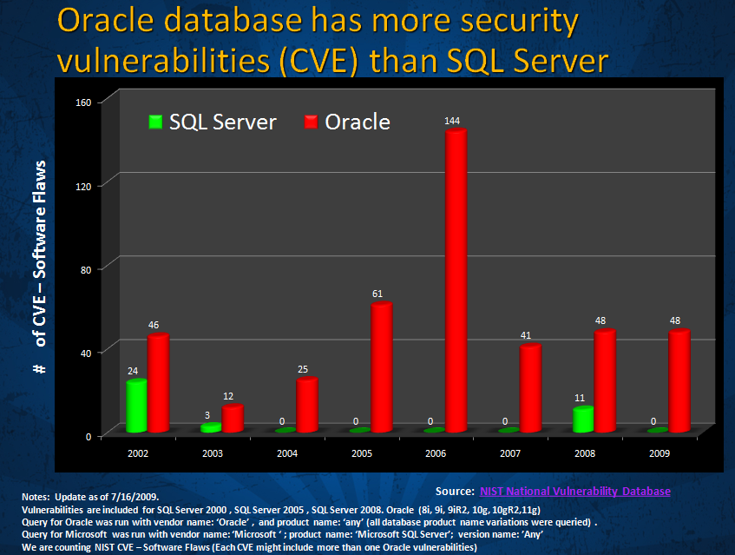

As seen in the chart, Oracle database consistently has more security vulnerabilities than Microsoft SQL Server. In fact, Microsoft SQL Server has very low vulnerability from 2003 – 2009 as a direct result of our implementation of [Trustworthy Computing Initiative](http://www.microsoft.com/mscorp/twc/default.mspx) (http://www.microsoft.com/mscorp/twc/default.mspx), which was started in [2002 by Microsoft Chairman, Bill Gates](http://www.microsoft.com/mscorp/execmail/2002/07-18twc.mspx) (http://www.microsoft.com/mscorp/execmail/2002/07-18twc.mspx). It is advised that real-world customers include security patching as part of the true cost of operating Oracle 11g and Microsoft SQL Server 2008.

## Unverifiable Metrics

The study uses workload weightings to convert steps into cost calculation. For example, if the task is performed more frequently it receives a higher weighting than other less frequent task. The weightings used in the Edison study are as follows:

* Setup and Configuration 5%
* Day-to-Day Administration 34%
* Backup & Recovery 14%
* Performance Tuning 26%
* Other 21%

To start, the weightings came from a study that was done in 2002 and might not represent the current weightings for database workloads today. What’s more, the weightings study is no longer accessible for review and verifications. Furthermore, the study did not include the weighting category of "Other". This category represents 21 percent of the total weight such as software license maintenance, security patching, and database upgrades. The study claimed that both products will produce results that will not favor one product over the other in this category.

With the questionable and dated “weighting” metrics and omission of a key category, it is prudent for real-world customers to question the assumptions and extrapolations of the metrics applied (and not applied) in this study.

## Inconsistent Interpretation of the Results

Edison published similar studies that compare [Oracle Database 11g with Microsoft SQL Server 2008](http://www.oracle.com/database/docs/edison-oracle-11g-vs-sql-server-2008-cmcs-whitepaper.pdf) (http://www.oracle.com/database/docs/edison-oracle-11g-vs-sql-server-2008-cmcs-whitepaper.pdf) and [Oracle Database 11g with IBM Enterprise DB2 9.5](http://www.oracle.com/database/docs/oracle11g-vs-db2-9.5-cmcs.pdf) (http://www.oracle.com/database/docs/oracle11g-vs-db2-9.5-cmcs.pdf). **Note**: **Both studies use the same version of Oracle database software, hardware, and methodology.** Customers should note there are many inconsistencies in how the steps and results were interpreted across the two comparison studies for the same task. In many cases Oracle database 11g scored different results on the same tasks when compared to Microsoft SQL Server 2008 and IBM Enterprise DB2 9.5

Some of the inconsistencies are shown in the following table.

|  |  |  |
| --- | --- | --- |
| Task | Results in Oracle 11g vs. SQL Server 2008 white paper | Results in Oracle 11g vs. IBM DB2 9.5 white paper |
| Installation and Simple “Out-of-Box” Setup Sub Total | Oracle scored 5 steps | Oracle scored 37 steps |
| Task no. 2 Create second database instance | Oracle scored 1 step | Oracle scored 20 steps |
| Task no. 4 Create user with roles, privileges | Oracle scored 1 step | Oracle scored 7 steps |
| Task no. 5 Create tablespace/filegroup | Oracle scored 1 step | Oracle scored 7 steps |
| Task no. 6 Add more space to the database | Oracle scored 1 step | Oracle scored 5 steps |
| Task no. 10 Load data from a text file | Oracle scored 2 steps | Oracle scored 15 steps |

# Real-World Customer Results for SQL Server Manageability

SQL Server is widely known for providing ease-of-use features and low manageability cost for customers.

[Microsoft SQL Server 2008](http://www.microsoft.com/sqlserver/2008/en/us/manageability.aspx) (http://www.microsoft.com/sqlserver/2008/en/us/manageability.aspx) introduced Policy-Based Management for proactively managing one or more instances of SQL Server along with tools for performance monitoring, troubleshooting, and tuning that help enable DBAs to streamline tasks related to ensuring continuous availability, security and compliance, deploying patch upgrades, and resource utilization.

Here are some of the feedback from SQL Server customers on manageability:

* “For us the top items have to be in the management tools. Policy-Based Management allows us to make sure that all of our SQL Server instances around the world are running with a configuration that is optimal.” – Bob Erickson, Senior Vice President for Software Development at [Mediterranean Shipping Company](http://www.microsoft.com/casestudies/Case_Study_Detail.aspx?CaseStudyID=4000003470) (http://www.microsoft.com/casestudies/Case_Study_Detail.aspx?CaseStudyID=4000003470)
* “SQL Server 2008 and the SQL Server 2008 Compliance SDK are significant resources for any organization seeking to tighten governance, risk management, and compliance.” – John D. Halamka, MS, MS, Chief Information Officer of the CareGroup Health System, and Chief Information Officer and Dean for Technology at [Harvard Medical School](http://www.microsoft.com/casestudies/Case_Study_Detail.aspx?CaseStudyID=4000003892) (http://www.microsoft.com/casestudies/Case_Study_Detail.aspx?CaseStudyID=4000003892)
* “Policy-Based Management enables us to ensure that everything is compliant with naming conventions and policies. We finally have a way to enforce our policies in a way that means a new application can’t be launched unless it follows our rules." – Thomas Grohser, Senior Database Engineer at [bwin](http://www.microsoft.com/casestudies/Case_Study_Detail.aspx?casestudyid=4000001470) (http://www.microsoft.com/casestudies/Case_Study_Detail.aspx?casestudyid=4000001470)

# Conclusion

Oracle commissioned Edison to publish a white paper comparing Oracle database 11g and SQL Server 2008 that contains many inherent flaws and questionable results. It is advised that customers look closely at the lab environment, methodology, and inconsistent results when reviewing this study. Real-world customer evidence and analyst reports have led SQL Server to be widely known for ease-of-use and low manageability advantages over Oracle database 11g.

**For more information:**

<http://www.microsoft.com/sqlserver/>: SQL Server Web site

<http://www.microsoft.com/sqlserver/2008/en/us/spotlight-on-cost.aspx> : Spotlight on SQL Server cost

<http://www.microsoft.com/sqlserver/2008/en/us/manageability.aspx> : SQL Server Manageability

<http://www.microsoft.com/sqlserver/2008/en/us/compare-oracle.aspx> : SQL Server Comparison with Oracle database

<http://www.microsoft.com/sqlserver/2008/en/us/case-studies.aspx>: SQL Server case studies

Did this paper help you? Please give us your feedback. Tell us on a scale of 1 (poor) to 5 (excellent), how would you rate this paper and why have you given it this rating? For example:

* Are you rating it high due to having good examples, excellent screen shots, clear writing, or another reason?
* Are you rating it low due to poor examples, fuzzy screen shots, or unclear writing?

This feedback will help us improve the quality of white papers we release.

[Send feedback](mailto:sqlfback@microsoft.com?subject=White%20Paper%20Feedback:%20Response%20to%20Oracle's%20Edison%202009%20Report).