Windows SideShow and Television and Set-Top Boxes

October 30, 2008

Abstract

This paper provides information about adding Windows® SideShow™ functionality to televisions and set-top boxes to enable compelling new scenarios. Along with this information are resources for hardware developers to help them implement Windows SideShow solutions for televisions and set-top boxes.

This information applies for the following operating systems:  
 Windows Server® 2008 (with Desktop Experience installed)  Windows Vista®  
 Windows 7

References and resources discussed here are listed at the end of this paper.

For the latest information, see:   
 <http://www.microsoft.com/whdc/>

Disclaimer: This is a preliminary document and may be changed substantially prior to final commercial release of the software described herein.

The information contained in this document represents the current view of Microsoft Corporation on the issues discussed as of the date of publication. Because Microsoft must respond to changing market conditions, it should not be interpreted to be a commitment on the part of Microsoft, and Microsoft cannot guarantee the accuracy of any information presented after the date of publication.

This White Paper is for informational purposes only. MICROSOFT MAKES NO WARRANTIES, EXPRESS, IMPLIED OR STATUTORY, AS TO THE INFORMATION IN THIS DOCUMENT.

Complying with all applicable copyright laws is the responsibility of the user. Without limiting the rights under copyright, no part of this document may be reproduced, stored in or introduced into a retrieval system, or transmitted in any form or by any means (electronic, mechanical, photocopying, recording, or otherwise), or for any purpose, without the express written permission of Microsoft Corporation.

Microsoft may have patents, patent applications, trademarks, copyrights, or other intellectual property rights covering subject matter in this document. Except as expressly provided in any written license agreement from Microsoft, the furnishing of this document does not give you any license to these patents, trademarks, copyrights, or other intellectual property.

Unless otherwise noted, the example companies, organizations, products, domain names, e-mail addresses, logos, people, places and events depicted herein are fictitious, and no association with any real company, organization, product, domain name, email address, logo, person, place or event is intended or should be inferred.

© 2008 Microsoft Corporation. All rights reserved.

Microsoft, Windows, Windows NT, SideShow, Windows Server, and Windows Vista are either registered trademarks or trademarks of Microsoft Corporation in the United States and/or other countries.

The names of actual companies and products mentioned herein may be the trademarks of their respective owners.

Contents

Compelling Television and Set-Top Box Solutions 4

The User and the Market for SideShow-Compatible Televisions and Set-Top Boxes 7

Components for Televisions and Set-Top Boxes 8

Resources 9

# Compelling Television and Set-Top Box Solutions

The Windows SideShow platform offers hardware and software developers the opportunity to create unique and compelling solutions for consumers that can be accessed via televisions and set-top boxes. SideShow makes it possible for computers running Windows Vista and Windows 7 to deliver SideShow gadgets to a SideShow-compatible device, so that users can interact with content from their computer and the Internet on their television.

SideShow can enhance the television experience via the TV itself, a set-top box, or a remote control.

## SideShow-Compatible Television

A television with SideShow in its firmware can receive and display fresh content and timely notifications from the computer for viewing on demand. Gadgets installed on the computer can deliver information such as news headlines, weather, sports scores, and e-mail messages directly to the television screen. Alerts from gadgets—such as upcoming appointments or TV shows, severe weather warnings, or incoming instant messages—can be unobtrusively overlaid onto the screen for a short period of time. For a richer interaction, the user could explicitly invoke the gadget functionality by using a remote control or a menu item in the television’s interface. In this mode, the gadget content could take up the majority (or all) of the screen, making it easy for the user to interact with detailed content.

As an example, imagine that a user participates in a fantasy sports league, but can watch only one game at a time. In order to help the user stay knowledgeable about all of the players on her team, a sports gadget can provide relevant updates as overlays. During a break in the action, the user could open the full gadget experience to quickly check her overall team statistics and rankings. This is just one of the many scenarios that are possible with a SideShow-compatible television.

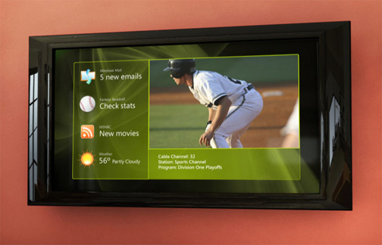

**Figure 1. SideShow content displayed from a home computer on to a television**

## SideShow-Compatible Set-Top Box

A set-top box with SideShow in its firmware can receive fresh content from the computer, and then deliver it on demand for display on the television. SideShow can accompany other technologies in the set-top box to help users integrate all their media sources and display them on a television to create a rich media experience. The scenarios for a SideShow-compatible set-top box are the same as for a SideShow-compatible television—the difference is in the implementation. With the proliferation of rich, interactive set-top boxes (such as DVRs) that already have network connections, adding SideShow functionality to these devices can require little more than writing some additional software. Yet it can enable a wealth of new and exciting interactive scenarios to further delight customers.

## SideShow-Compatible Remote Control

A remote control with SideShow allows users to control media played from their computer in addition to the entertainment content on their television. Users can control media played from their computer through Extender for Windows Media Center or other media playback software, such as Windows Media Player. Music on the computer can be played or otherwise controlled even when the television is off, and the media guide can be viewed directly on the remote control.

The remote control is also capable of displaying the same gadgets that can be shown on the television or set-top box, providing yet another outlet for content depending on the user’s needs.

[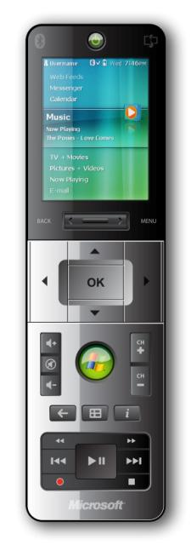](http://team/sites/sideshow/Pressready%20images2/Remote_front_closed.jpg)

**Figure 2. SideShow-compatible remote control that is being used to play music from a computer**

# The User and the Market for SideShow-Compatible Televisions and Set-Top Boxes

Windows SideShow on televisions and set-top boxes appeals to a broad range of consumers, including connected families and technical enthusiasts. Connected families are defined as consumers that have a computer that all members of the family use. They are motivated to purchase and use a computer for their children’s education and schoolwork, and they want to use parental controls on the computer. Technical enthusiasts are interested in the latest technology, excited about consumer electronics and digital devices, and are deeply involved in creating content (for example, blogging, and burning DVDs) and accessing networked files.

Connected families and technical enthusiasts make up 10 percent of U.S. households. 41 percent of connected families are willing to pay 1000 dollars or more for their next computer, and 58 percent of technical enthusiasts are willing to pay 1000 dollars or more for their next computer.[1] By the end of 2008, consumers worldwide will own 186 million devices that allow TVs to access web content.[2] For these groups of consumers, the most appealing benefits of adding Windows SideShow to televisions and set-top boxes are the enhanced entertainment experience, convenient access to information, and the integration of the media experience with the user’s computer content.

Convenient access to information on the computer.

Many consumers are already streaming media and accessing all their files over a network. They are motivated to purchase devices that allow them easy setup and access to movies, pictures, videos, and other media resources. By using SideShow with their television, consumers can have access to current and fresh media along with their home network content.

Centralized experience.

By using SideShow with their television, users can access their content on their television, which provides them all of their relevant computer information in a centralized location. No longer must the user get up during a commercial break to go check their e-mail in another room or see if a friend is trying to send them an instant message. When information is accessible to users where they are, they can be more efficient.

# Components for Televisions and Set-Top Boxes

To get started implementing SideShow technology for televisions and set-top boxes, see the Table 1. It outlines the components needed for each hardware solution.

Table 1. Windows SideShow Components for Televisions and Set-Top Boxes

| **Device** | [SideShow Device Components for Windows CE 5.0](http://go.microsoft.com/fwlink/?LinkID=132080) | [Windows SideShow Bitmap Driver](http://go.microsoft.com/fwlink/?LinkID=131592) | [Universal Driver for Windows SideShow 1.5](http://go.microsoft.com/fwlink/?LinkID=132083) | [Windows SideShow Device SDK for .NET Micro Framework 3.0](http://go.microsoft.com/fwlink/?LinkID=132085) |
| --- | --- | --- | --- | --- |
| TV |  | ✓ | ✓ |  |
| Set-top box | ✓ | ✓ | ✓ |  |
| Remote control | ✓ |  | ✓ | ✓ |

* SideShow Device Components for Windows CE 5.0

This is a set of component libraries for Windows CE 5.0 that works with the Universal Driver to communicate with a computer running Windows Vista. No user interface is provided.

* Windows SideShow Bitmap Driver

This solution renders pages on a computer and sends bitmap images to the SideShow-compatible device, so the device can be lower cost. The main trade off compared to other solutions is the lack of functionality when the computer is off or the device is otherwise disconnected. It is provided as a shared source project on CodePlex. A button-based sample user interface is provided and can be extended to support touch or other features.

This solution allows SideShow functionality to be easily adapted to existing, in-market hardware, in many cases without any hardware modifications.

* Universal Driver for Windows SideShow

The Universal Driver is a class driver provided by Microsoft that enables partners to easily implement SideShow functionality via USB, Bluetooth, or TCP/IP transports. The protocol specification is available royalty free via WHDC.

* Windows SideShow Device SDK for .NET Micro Framework

This is an end-to-end, extensible SideShow solution with button and touch driven interfaces. It persists data and allows read-only access when the computer is off. Wi-Fi, Bluetooth, and USB are supported.

# Resources

* [Windows SideShow Device SDK for .NET Micro Framework 3.0](http://go.microsoft.com/fwlink/?LinkID=132085)
* [Universal Driver for Windows SideShow](http://go.microsoft.com/fwlink/?LinkID=132083)
* [Windows SideShow Bitmap Driver](http://go.microsoft.com/fwlink/?LinkID=131592)
* [SideShow Device Components for Windows CE 5.0](http://go.microsoft.com/fwlink/?LinkID=132080)

1. Forrester Research, Inc., 2007.
2. Strategy Analytics Connected Home Devices Service, July, 2008.