Product Activation Using Volume Activation Management Tool 2.0

If you are planning to deploy Windows 7, Windows Server 2008 R2, or Office 2010 clients, you may be aware that Microsoft provides a free tool that can help you manage activation for these products, the [Volume Activation Management Tool (VAMT) 2.0](http://go.microsoft.com/fwlink/?LinkId=183042). However, you may not be very familiar with VAMT capabilities. This document covers how to use VAMT to perform Windows client and Windows Server product activation, including Windows Vista and Windows Server 2008. The functionality is similar for Office 2010 client suites and applications, Visio 2010 and Project 2010 clients.

VAMT 2.0 is a Microsoft Management Console (MMC) snap-in. You also have the option of using a scriptable Command Line Interface to schedule VAMT tasks.

Core benefits of VAMT include:

* The ability to protect product keys by retaining them only in the VAMT console, vs. including a key in an image or distributing it in plain text
* Perform activations without each system having to connect and activate with Microsoft activation services
* Inventory and monitor systems in the environment from an activation and licensing standpoint

Below we walk through discovering computers and installed products, then how to install a product key on those products. Next, we review the typical activation procedures that you would use in your environment—online, proxy, and Key Management Service (KMS) client activation. Last, we explain how to save the Computer Information List, and how to do local reactivations using that list.

Contents

Discovery 2

Prerequisites 2

Discover Computers 3

Discover Installed Products 4

Install a Product Key 6

Activation Options 8

Online Activation 8

Proxy Activation 9

KMS client activation 11

Save the Computer Information List (CIL) 12

Local Reactivation 13

More *Using VAMT 2.0* Guidance 13

# Discovery

To manage activation on the systems in your environment, you must discover and catalog those systems in VAMT. VAMT provides multiple ways by which physical and virtual systems and installed products can be discovered. However, VAMT does not have logic to determine whether or not the remote products are virtual. As long as the products respond to WMI calls they will be discovered and can be activated.

## Prerequisites

There are several prerequisites to enable VAMT to function correctly.

On the VAMT console

VAMT requires local administrator privileges on all managed computers to deposit Confirmation IDs (CIDs), get the client products’ license status, and install product keys. If you do not have administrator privileges, start VAMT with "elevated privileges by right-clicking the Volume Activation Management Tool shortcut and choosing Run as administrator. Running VAMT “as administrator” is different than running VAMT in the context of a user account which is listed as a member of the “administrators” group on all of the managed machines.  For common operations, there is no need for the VAMT console to be operating within administrative context.

On the managed end systems

* Enable WMI in the end systems’ firewall.
* For computers in a workgroup, create and properly set a registry key. This is detailed in the VAMT Help file. Otherwise, Windows User Account Control (UAC) will not allow remote administrative operations.

Enable VAMT to access client computers using the Windows Firewall in Control Panel. This change may be made in the master Windows image. The following instructions are for a Windows 7 client but are similar for other Windows and Windows Server systems.

1. Open Control Panel and double-click Windows Firewall.
2. Click Allow a program or feature through Windows Firewall.
3. Click the Change Settings.
4. Select the Windows Management Instrumentation (WMI) checkbox. This may be called “Remote Administration” in the firewall dialog.
5. Click OK.

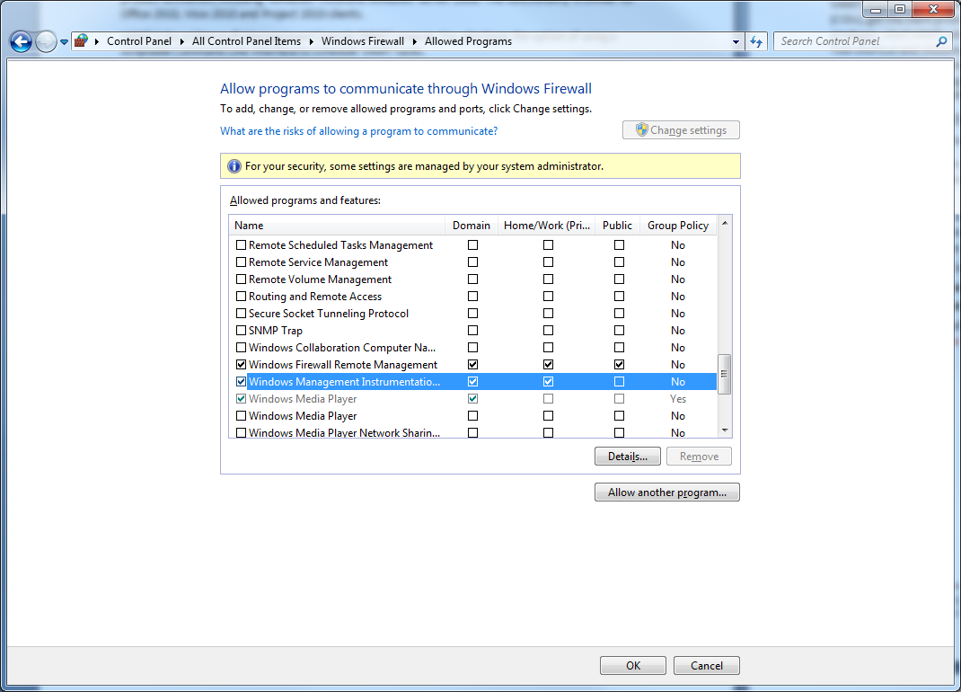

**Figure 1. Enabling WMI through the Windows Firewall**

## Discover Computers

This step locates computers on the network. VAMT will discover computers running Windows Vista and later, and Windows Server 2008 and later. VAMT also discovers computers running volume editions of Windows XP SP2 or Windows Server 2003 SP1 or later. This is because VAMT supports Office 2010 clients installed on these systems. However, the activation and genuine state of those operating systems cannot be managed by VAMT.

1. In the Add Computers center pane, select a search option in the drop-down menu. You can search for computers in a workgroup, in an Active Directory domain, by individual computer name or IP address, or via a general LDAP query. See Figure 2.
   1. If you are searching by individual computer name or IP address, enter that information in the text box below the drop-down menu.
   2. If you are searching a domain or a workgroup, select the domain or workgroup from the additional drop-down list displayed for those options. Use the Filter by computer name field to search for a specific computer within the domain or workgroup.
   3. If you are searching by LDAP query, copy and paste your LDAP query into the textbox below the drop-down list.
2. Click Add Computers.
3. VAMT will search for computers and add the computers it finds to the Computer Information List (CIL).

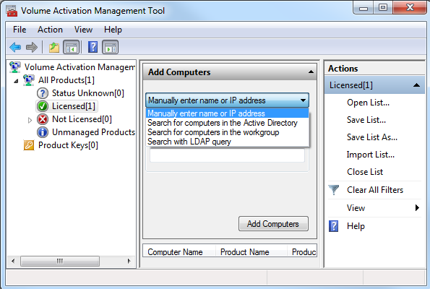

**Figure 2. Add computers to VAMT**

## Discover Installed Products

After you add computers, VAMT discovers the installed operating system (and any Office 2010 products). VAMT also indicates the current license status of the products.

1. Add computer(s) to the product list view in the center pane by clicking a node in the left pane
2. On the **Action** menu, select Update Status and choose a credential option. Choose Alternate Credentials only if you are discovering products that require administrator credentials different from the ones you are currently logged into the console with.
3. If you are supplying alternate credentials, at the prompt, type the appropriate user name and password and click OK.
4. VAMT will display the Collecting product information dialog box while it collects the status of installed products on the selected computers. This may take awhile depending on the number of systems. When the process is finished, the newly discovered products and their license status will appear in the product list in the center pane.

In Figure 3, we just added the contoso-kmshost computer and now need to update status to discover installed products and current license status.

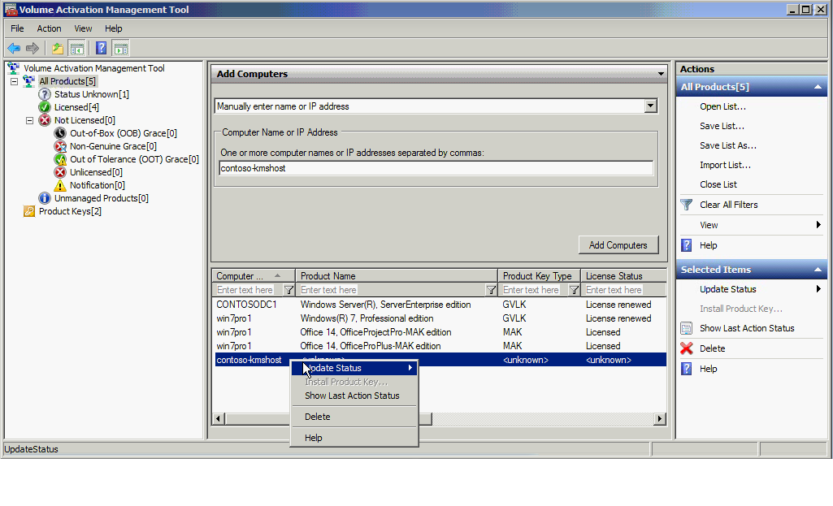

**Figure 3. Update status after adding computers**

In Figure 4, we see that VAMT discovered three products on contoso-kmshost, and the current license status for each. The installed products are:

1. Office 2010 – the KMS host key (CSVLK) is installed and the license status is licensed, so the product has been activated.
2. Windows Server Enterprise – the KMS host key (CSVLK) is installed and the license status is licensed, so the product has been activated.
3. Office 2010 ProPlus – the KMS client key (GVLK) is installed and the license status is Out of box grace, so the product has not yet been activated.

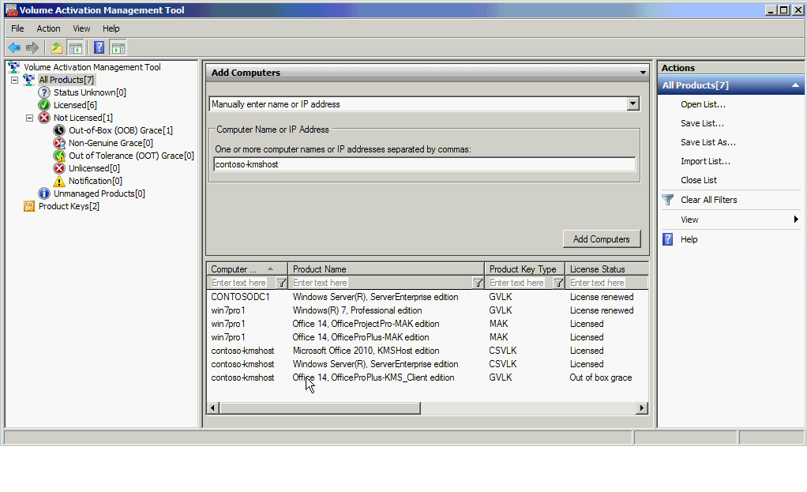

**Figure 4. VAMT discovered three products and current license status**

It’s easy to determine which computers are not yet activated. Click the appropriate node in the left pane to display the products in the product list. If you plan to activate those computers using a Multiple Activation Key (MAK), KMS host or retail key, the next step is to install it on the target system(s).

# Install a Product Key

For MAK, KMS host or retail activation, you must install a correct product key from the keys that you already added to VAMT. For information about adding product keys to VAMT, see the [*Manage Product Keys Using VAMT 2.0*](http://go.microsoft.com/fwlink/?LinkId=184609) document.

1. Click All Products or any sub-node and choose the desired products.
2. Choose Install Product Key from the Actions menu. See Figure 5.

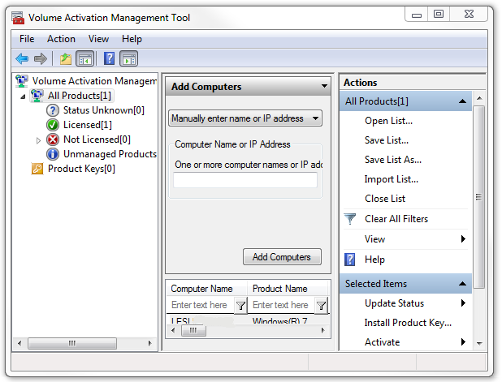

**Figure 5. Install a product key**

1. VAMT will display the available product keys in the next dialog box. See Figure 6.

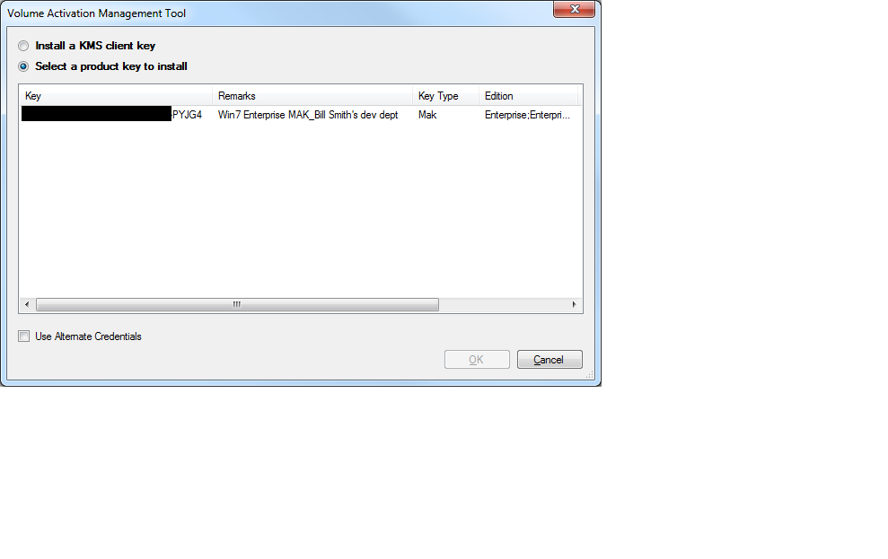

**Figure 6. Select a product key to install**

1. Select the product key you want to install and click OK. Only one key can be installed.
2. VAMT displays the Installing product key progress window while it attempts to install the product key to the selected products. When the process is finished, the status will appear in the Action Status column of the progress window. Click Close to close the progress window.

Notice in Figure 6 that VAMT gives you the option to install a KMS client key. These keys are already embedded in VAMT. You do not need to install a KMS client key unless you are switching from MAK to KMS activation. KMS client keys can be found in the [Volume Activation Deployment Guide](http://go.microsoft.com/fwlink/?LinkId=150083).

# Activation Options

You can use VAMT to manage MAK, KMS host and client, and retail activations, including transitioning a system from one volume activation method to another. To perform activations, VAMT utilizes two primary activation processes, online and proxy. Both activation processes follow the same basic steps:

1. Install a product key for each product to be activated
2. VAMT collects the Installation ID (IID) from each product and sends these to Microsoft activation service
3. Microsoft activation service returns a Confirmation ID (CID) for each IID
4. VAMT deposits the CID to the corresponding product, completing activation

You can optionally save activation information for future use or as a backup, in the Computer Information List (CIL). Microsoft recommends that you do. When you use proxy activation, the CID is saved in the CIL. However, with online activation the CID is not saved in the CIL.

VAMT enables you to locally reactivate a system by reapplying the CID, which conserves activations on the key. If you anticipate needing to reactivate, you should consider using proxy activation. You can also reactivate by installing the same key you initially used, and repeating the activation steps. This will use up another activation on the key.

## Online Activation

With online activation[1], each system individually connects to and activates with Microsoft activation servers. You can use online activation for MAK, KMS host, and retail activations. VAMT and the target systems must have internet access.

1. Select the individual products to be activated in the product list view in the center pane.
2. On the **Actions** menu, click Activate and then Online Activate, and select the appropriate credential option.
3. VAMT will display the Activating products dialog box until it completes the requested action. If you selected the Alternate Credentials option, you will be prompted to enter the credentials. The systems are now perpetually activated unless you make significant hardware changes that require reactivation.

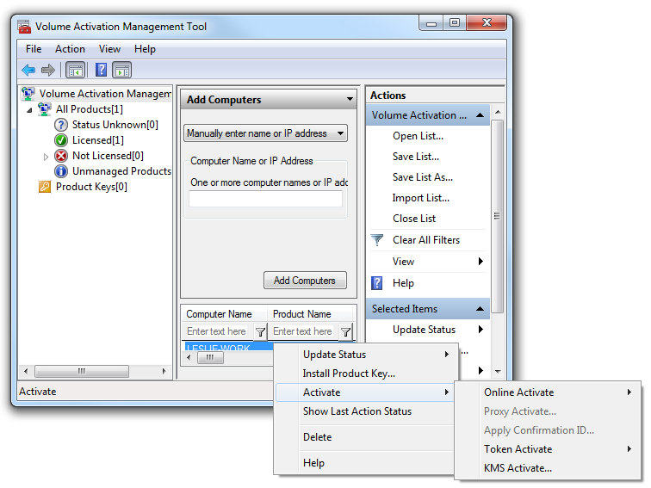

**Figure 7. Activation options in VAMT**

## Proxy Activation

With proxy activation, the VAMT host computer connects to Microsoft on behalf of multiple systems. VAMT sends the installation ID (IID) collected from each networked computer (Step 1) to Microsoft activation servers (Step 2). VAMT obtains the corresponding confirmation IDs (CID) (Step 3) and distributes them to the target systems (Step 4), completing activation. VAMT stores this information in a Computer Information List .xml file (CIL). The diagram below illustrates how proxy activation works.

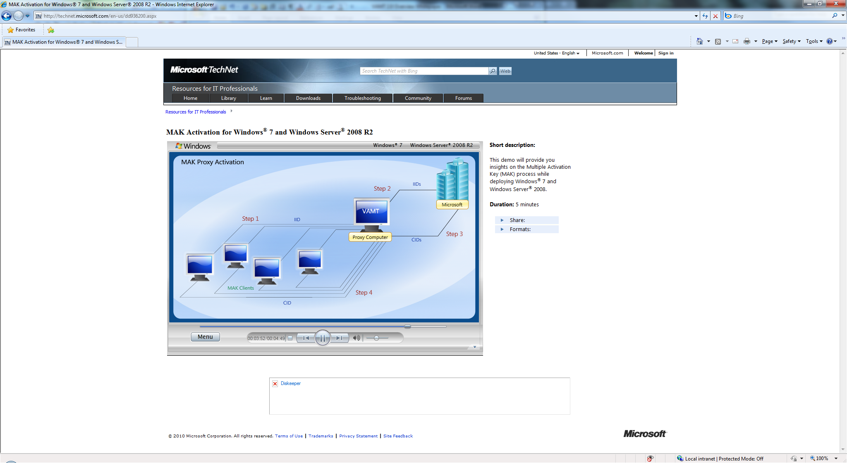

**Figure 8. Diagram of proxy activation**

Many organizations typically use proxy activation for MAK activations. However, you can proxy activate KMS host and retail machines. Proxy activation is an option if you prefer that computers not connect directly with Microsoft activation servers.

1. Select the individual products to be activated in the product list view in the center pane.
2. On the Actions menu, click Activate and then click Proxy Activate to display the Proxy Activate dialog box.

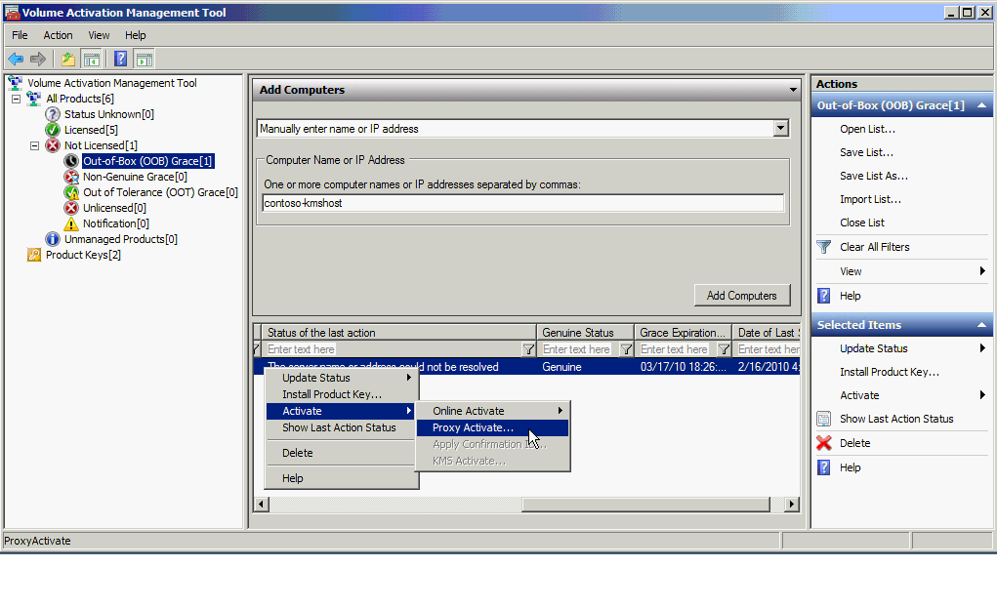

**Figure 9. Selecting to Proxy Activate**

1. Select the Apply Confirmation ID and Activate check boxes.

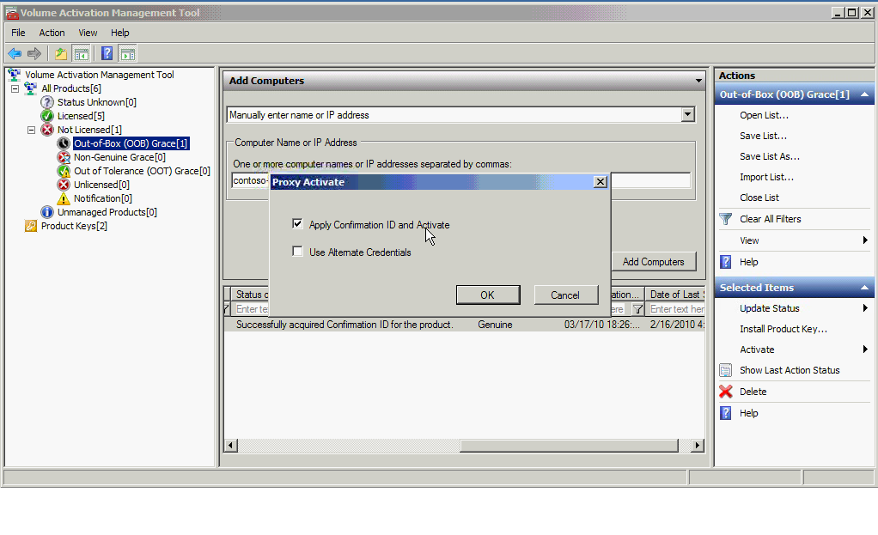

**Figure 10. Proxy Activate dialog menu**

1. If you are activating products that require administrator credentials different from the ones you are currently using, select the Use Alternate Credentials checkbox.
2. Click **OK**.
3. VAMT will display the Activating products dialog box until it completes the requested action. If you selected the Alternate Credentials option, you will be prompted to enter the credentials.

In Figure 9, we are going to proxy activate the Office 2010 ProPlus product from Figure 4. We first attempted online activation but the computer did not have internet access. Proxy activation is a great method to activate computers on the network but that do not have internet access.

After selecting Proxy Activate, check the Apply Confirmation ID and Activate in the dialog box (Figure 10). After clicking OK, the IID is sent to Microsoft activation servers by VAMT, and the returned Confirmation ID is applied to the product. This completes the activation process.

Proxy activation is required if you want to reactivate using VAMT after reimaging. It is also necessary if you want to save the CID for any of the activations that VAMT performs. Online activation does not save the CID in the CIL.

We cover a special scenario using proxy activation in the [*Activation in Disconnected Environments Using VAMT 2.0*](http://go.microsoft.com/fwlink/?LinkId=184609) document.

## KMS client activation

You can use VAMT to activate KMS clients with a KMS host. Because KMS is the default activation method for volume license editions of Windows and Windows Server, the KMS client key is already installed. You do not need to install a KMS client key unless you are switching from MAK to KMS activation.

1. Select the products to be KMS activated by selecting individual products in the product list view in the center pane.
2. On the Actions menu, click Activate and then click KMS Activation to display the Configure KMS host and port dialog box.
3. Select one of the two activation options:
   1. Auto-Discover KMS host using DNS. VAMT will first clear any previously configured KMS host on the target computer and instruct the computer to query the Domain Name Service (DNS) to locate a KMS host and attempt activation.
   2. Use specific KMS host and port. For environments which do not use DNS for KMS host identification, VAMT will set the specified KMS host name and KMS host port on the target computer, and then instruct the computer to attempt activation with the specific KMS host.
4. If you are activating products that require administrator credentials different from the ones you are currently using, select the Use Alternate Credentials check box.
5. Click OK.
6. VAMT will display the Activating products dialog box until it completes the requested action. If you selected the Alternate Credentials option, you will be prompted to enter the credentials.

# Save the Computer Information List (CIL)

You should save the CIL after proxy activation. You may also want to save a backup copy. The CIL enables you to reapply the CID if you need to reactivate systems.

1. Choose the **Save List** or **Save List As** menu from the **Actions** menu. VAMT will display Save the Computer Information List dialog box. See Figure 5.
2. Enter a desired CIL file name or select a directory and then enter a CIL file name such as “CentralRegion.CIL”.
3. Click Save only currently selected information if you wish to only save those selected products.
4. Click **Save**.

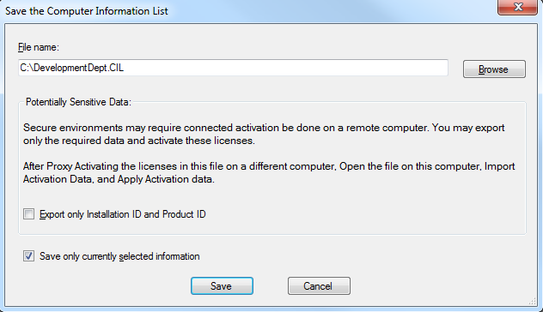

**Figure 7. Save the CIL**

We also recommend that you restrict access to VAMT and the CIL to only those personnel with a reason to see the product keys and activate products. Secure access to the CIL file on the local hard drive by encryption, or set permissions for the folder where the CIL is stored. Make sure that you similarly protect the backup location if you create a back up file e.g. for disaster recovery.

## Local Reactivation

You may need to reactivate a system after reimaging, for example, in testing or training labs. You can use VAMT to apply the same CID that was saved in the CIL file. You can reapply the CID without limit, if the hardware has not changed significantly. By applying the same CID, you conserve remaining activations on the product key. You can use local reactivation for systems initially activated with a MAK, retail or KMS host key.

1. Redeploy products to each computer, using the same computer names as before.
2. From the **Actions** menu, choose the Open List menu. The VAMT will display the Open a CIL File dialog box.
3. Select the desired CIL file.
4. On the Actions menu, click Apply Confirmation ID to display the Apply Confirmation ID dialog box.
5. Select the Force exact IID match check box, if the hardware has not changed since the initial proxy activation and you are using the same key to reactivate the computers. Clear this checkbox if the hardware has changed, but you would still like VAMT to attempt a reactivation using the previously stored CID. Note that the products might not be successfully reactivated in this scenario.
6. If you are activating products that require administrator credentials different from the ones you are currently using, select the Use Alternate Credentials check box.
7. Click OK.
8. VAMT will display the Applying Confirmation ID dialog while it installs the CIDs on the selected products.

# More *Using VAMT 2.0* Guidance

Check out the other [*Using VAMT 2.0*](http://go.microsoft.com/fwlink/?LinkId=184609) documents:

* Manage Product Keys Using VAMT 2.0
* Reporting Activation Information Using VAMT 2.0
* Activation in Disconnected Environments Using VAMT 2.0

You can watch video demos of several VAMT tasks at [www.technet.com/volumeactivation](http://www.technet.com/volumeactivation).[2] The Help file in the [VAMT 2.0 download](http://go.microsoft.com/fwlink/?LinkId=183042) has detailed information on how to perform many tasks using the tool.

1. Online activation is alternatively referred to as independent activation in other documentation on volume

   activation.
2. Several of these demos use VAMT 1.2 but the process is the same using VAMT 2.0.