Microsoft® Office PerformancePointTM Server 2007   
Analytics: Turning Business Information into Insight

Microsoft® Office PerformancePoint™ Server 2007 is an integrated performance management application that provides robust monitoring, analytics, and planning capabilities. Office PerformancePoint Server 2007 helps businesses to articulate goals, monitor business activity, identify and analyze issues, collaborate, and take action.

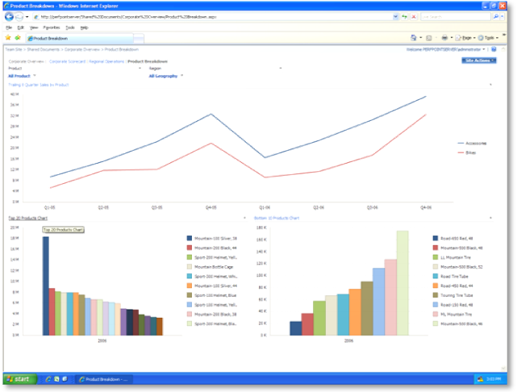

Answering the “why” of business change is easier with Office PerformancePoint Server 2007.

Analyzing Information with Office PerformancePoint Server 2007

Office PerformancePoint Server 2007 empowers business users to capture and share analytical best practices using the intuitive and collaborative environment of the Microsoft Office 2007 system. Simple data navigation, powerful server-based calculations, and advanced visualization help business users understand complex information faster.

Office PerformancePoint Server 2007 simplifies how people receive and interact with information. Employees can create analytics that include graphs, key performance indicators (KPIs), and data grids, and use advanced visualization functionalities. These rich capabilities help users rapidly identify trends, opportunities, and even threats to the business hidden within large quantities of data.

Simple-to-use tools designed to meet specific user needs—including thin Web clients, performance dashboards, reports, and scorecards—make it possible for people throughout the organization to analyze and gain insight into business performance.

Benefits

Office PerformancePoint Server 2007 provides a range of analytic benefits, helping users to:

* **Quickly build and share powerful analytics**Business users often depend on IT experts to provide the data they need to make decisions. Office PerformancePoint Server 2007 features a user-friendly design, easy–to-use wizards, and advanced data visualization tools that enable business users to quickly and easily build and share analyses without the need to rely on IT for continual support.
* **Understand information faster and make better decisions**  
  Office PerformancePoint Server 2007 advanced analytic capabilities range from multidimensional “slice and dice” to root-cause analysis, and prediction capabilities. These techniques can be deployed across the organization in the familiar environment of the Microsoft Office 2007 system, empowering all users to find the answers they need quickly. Because Office PerformancePoint Server 2007 is fast, has more security features, and is easy to use, the broadest number of users can gain valuable insight into corporate performance.
* **Built on the Microsoft Business Intelligence platform**Office PerformancePoint Server 2007 takes advantage of the enterprise-level reliability and security, high performance, and scalability of the Microsoft SQL Server™ 2005 Business Intelligence platform. Office PerformancePoint Server 2007 also makes broad adoption possible by providing robust analytic insights through the familiar and easy-to-use Microsoft Office system environment.

Key Features

Rich analysis, a key part of performance management, is available to all Office PerformancePoint Server 2007 users through these key features:

Web-based analysis  
Provide users with analytic functionality out of the box, minimizing help required from IT Staff. More secure access enables the right people to get the right amount of information at the right time.

Rich data exploration   
Analytics include multidimensional slice and dice, drill-across, drill-to-detail, root-cause analysis, and centralized business logic definitions.

Predictive analytics  
Leverage powerful data mining capabilities from SQL Server 2005 to forecast metrics and spot trends.

Guided and contextual analysis   
Provide users with analytic views tied to key performance metrics to give users more contextual information about the performance of those metrics.

Rich visualizations  
Provide data visualizations that make it easy for users to understand complex information faster, to discover highlights, trends and opportunities.

Distribution choices  
Analytical views can be shared and managed in SQL Server Report Manager, Microsoft Office SharePoint® Server 2007 Report Center, or distributed in PDF, HTML, or XML format. Users can collaboration with others through Microsoft Office Excel® and PowerPoint®.

System Requirements

|  |
| --- |
| Office PerformancePoint Server 2007 is based on the following Microsoft programs and technologies:  ●   Windows Server® 2003 SP1, Standard Edition, or later  ●   Microsoft Windows SharePoint® Services 3.0/ Microsoft Office SharePoint® Server 2007  ●   Microsoft Windows® XP Professional SP2, or later  ●   Microsoft Office 2003 SP2, or later  ●   Microsoft SQL Server™ 2005 SP2, Standard Edition, or later  ●   Windows Installer 3.1, or later  ●   Microsoft .NET Framework 2.0  ●   Microsoft Internet Information Services 6.0  ●   ASP.NET 2.0 |

For More Information

For more information about Office PerformancePoint Server 2007, visit

<www.microsoft.com/performancepoint>.

For more information about Microsoft business intelligence, visit [www.microsoft.com/ BI](http://www.microsoft.com/%20BI).

© 2007 Microsoft Corporation. All rights reserved. Microsoft, Excel, MSN, the Office logo, Outlook, PerformancePoint, SharePoint, SQL Server, Windows, and Windows Server are either registered trademarks or trademarks of Microsoft Corporation or the Microsoft group of companies. All other trademarks are property of their respective owners.