Agencies Across Europe Connect and Collaborate Using a Web Portal
European Union  Customer Profile  The European Regional Information Society Association (eris@) is a network of European regions committed to boosting information and communications technology (ICT) for social and economic purposes.  Situation  With more than 45 different regions represented by approximately 500 people, the nonprofit organization was challenged with connecting its various members so that they could collaborate effectively.  Solution  eris@ engaged with Microsoft on the Solutions Sharing Network program, which supports public sector organizations in sharing solutions and best practices.  Benefits  • More effective collaboration  • Better organization and greater efficiency  • A solid foundation for future growth  “The opportunities for networking, sharing opportunities, and developing partnerships are greater now than ever before.”  —Jordi Plana, Managing Director, Spenta Consulting  “Our members, who are very busy people, need access to Web-based services to communicate with each other across regions, collaborate more effectively, and be more competitive.”  —Gareth Hughes, Project Director and Chief Executive Officer of eris@  For more information  For general questions about Solutions  Sharing Network, please e-mail:  getssn@microsoft.com  The IANIS⁺ portal:  http://www.ianis.net/  (Registration is open to the public.)  Spenta Consulting:  http://www.spenta.es/  Published January 2008  This document is for informational purposes only. MICROSOFT MAKES NO WARRANTIES, EXPRESS OR IMPLIED, IN THIS SUMMARY. | “This is the age of Web 2.0; user participation is at the core. This portal allows people to express themselves and have their voices heard.”  Hervé le Guyader, President of eris@ and Co-Chairman, IANIS⁺ Steering Committee  The European Regional Information Society Association, which focuses on bringing information technology to development projects, needed a better way to connect its 500 members. The organization engaged with Microsoft on the Solutions Sharing Network program and deployed a collaborative portal that enables the free flow of solutions and ideas. Now, members can access and share information and collaborate with peers in other European regions.  Situation  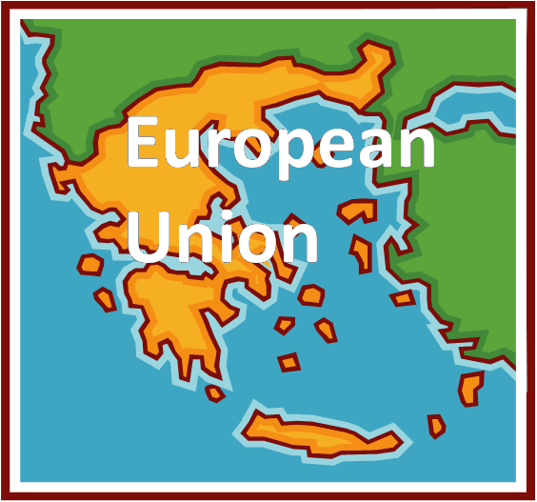  Founded in 1998, the European Regional Information Society Association (eris@) is a not-for-profit agency based in Brussels, Belgium that has a goal of promoting information and communications technology (ICT) throughout European Union (EU) member regions. With a focus on helping regions promote development—both social and economic—the organization offers its members a wide variety of activities and resources focused on policy development. These range from conferences, workshops, and thematic communities to sharing best practices and developing project proposals. Its year-to-year programs are financed through a combination of member subscriptions and EU project funding.  eris@ reaches about 45 different geographic areas and has a constantly changing roster of approximately 500 members. Although e-mail distribution lists kept everyone connected reasonably well, they were hard to keep current. Furthermore, eris@ had no centralized place for document libraries and other materials, and knew that members were often recreating work that had already been developed. This meant that the organization needed a better way to connect its far-flung members so that they could communicate, collaborate, and share ideas and best practices more effectively. “One of our challenges today is the speed at which technology is driving things forward, particularly in the face of global competition,“ explains Gareth Hughes, Project Director and Chief Executive Officer of eris@. “Our members, who are very busy people, need access to Web-based services to communicate with each other across regions, collaborate more effectively, and be more competitive.”  Solution  Microsoft was already a corporate member of eris@ when it first started engaging the organization through the Microsoft® Solutions Sharing Network program, an initiative that can help the public sector share IT solutions and best practices. Now, with a centralized repository of information on European regional topics, members can share knowledge, get instant access to information, and collaborate more effectively. Everyone agreed that it was the perfect solution. ”It was a perfect fit,” recalls Gordon McKenzie, Director of Local and Regional Government for Microsoft. “Developing a Solutions Sharing Network portal was the perfect way to use technology to reach all eris@’s members much more rapidly.”  Working with Microsoft Certified partner Spenta Consulting, eris@ deployed the portal to support the Innovative Actions Network for the Information Society (IANIS⁺) Web portal. This portal (www.ianis.net) was partially funded by the European Commission as part of the IANIS⁺ project work program, and represents a rich set of resources for all of the organizations’ members.  With the new portal, information is presented in clean, compelling ways that make it easy for people to access data. But for eris@, the benefits go well beyond just connecting people and providing a library of resources. The portal also focuses on a new ability to reuse content. This innovative move means that different regional entities do not have to recreate programs from scratch.  One example can be seen in a current project, the Innovation and Change: Network of One-Stop Shops project (ICHNOS) where the aim is to roll all governmental services for business, including registration, licensing, and business development aids, into a “one-stop shop” best practice. By using the IANIS⁺ portal, getting support in setting up regional one-stop shops is simple. Each region simply downloads all the documentation and information they need to get the solution started in their region.  Benefits  The IANIS⁺ portal is still in its infancy, but eris@ and its members are already reaping its benefits. From improving collaboration to boosting content reuse, the new portal takes the content management capabilities of Microsoft Office SharePoint® Server 2007 and extends them to governmental agencies. In addition, its unique combination of custom Web parts and content management features makes the portal much more than just a repository of information. It also now functions as a critical way to enhance the effectiveness of each member region through technologies such as Really Simple Syndication (RSS), e-mail notifications, multilingual support, and collaborative features.  More effective collaboration  Everyone agrees that the new portal offers much better collaborative technologies. “The opportunities for networking, sharing opportunities, and developing partnerships are greater now than ever before,” notes Jordi Plana, the Managing Director of Spenta Consulting.  However, collaboration is only as good as the people contributing, which is a point underscored by Hughes. “Of course our members collaborate, but they have to contribute as well,” he notes. Fortunately, as members become more comfortable with the tools at their fingertips, they are finding new ways to share ideas.  Greater efficiency  Many of the roles and responsibilities of different regional and local organizations are very similar. However, without a centralized repository of information and collaborative technology, people in each of these regions often duplicated efforts unnecessarily. With the new portal, members can access what other groups are doing, collaborate with each other to find the most effective solutions, and share best practices or tips. As a result, better organization is leading to greater efficiency. “There are huge benefits to sharing experiences, practices, solutions, and policy,” says Hughes.  A solid foundation  The new portal is not just faster, more reliable, and more efficient—it is also a solid foundation for future growth. Recognizing the potential for development, eris@ has its eye on emerging Web 2.0 technologies. And the IANIS⁺ portal is just the beginning. “This is the age of Web 2.0; user participation is at the core,” says Hervé le Guyader, President of eris@ and Co-Chairman, IANIS⁺ Steering Committee. “This portal allows people to express themselves and have their voices heard.”  In addition, the IANIS⁺ portal is extremely dynamic. For instance, the Web parts help push relevant content to the top, whether it is most recently updated pages or most viewed content. As a result, the portal does not just host information, it also provides dynamic access to it.  Firsthand experience  What better way to promote the use of ICT in development projects than by knowing firsthand how they can help? The new portal gives all its members firsthand knowledge of how ICT can benefit them, their organizations, and their communities—and as a result, they are better equipped to take their respective government entities into the 21st century.

