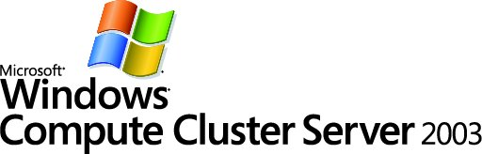

Parallel Debugging Using Visual Studio 2005
White Paper
Charlie Russel
Microsoft MVP for Windows Server
Author of Microsoft Windows Server 2003 Administrator’s Companion
(Microsoft Press, 2003)

Published: November 2005
For the latest version of this document, please see http://go.microsoft.com/fwlink/?LinkId=55932


Contents
Introduction 2
How Parallel Apps Are Different from Sequential Apps 2
How Visual Studio Supports Parallel Debugging 2
Installing and Enabling MPI Cluster Debugging 3
Debugging MPI Applications 4
Configuring Visual Studio to Debug an MPI Application 4
Starting and Debugging an MPI Application 5
Common Problems of Parallel Applications 6
Conclusion 7
References 8

Contributors and Acknowledgements
Ryan Waite, Microsoft
Kang Su Gatlin, Microsoft
Eric Lantz, Microsoft
Jason Zions, Microsoft
Peter Larson, Microsoft
Kyril Faenov, Microsoft
Anand Krishnan, Microsoft
Maria Adams, Microsoft
Elsa Rosenberg, Studio B
Carolyn Mader, Studio B
Kathie Werner, Studio B
David Talbott, Studio B

Introduction
Microsoft® Windows® Compute Cluster Server 2003 brings personal high-performance computing (HPC) to readily available and affordable x64-based computers. Windows Compute Cluster Server 2003 is available in a 2-CD package that includes Microsoft® Windows Server™ 2003 operating system, Compute Cluster Edition on the first CD and Microsoft® Compute Cluster Pack on the second CD. They can be purchased separately. The Compute Cluster Pack is a collection of tools for high-performance computing that enable deployment, management, job scheduling, and parallel programming. The Compute Cluster Pack can be installed on a server running any supported operating system, including Windows Server 2003, Compute Cluster Edition, Microsoft® Windows Server™ 2003 Standard x64 Edition, and Microsoft® Windows Server™ 2003 Enterprise x64 Edition.
Microsoft Visual Studio® 2005 is the most recent version of the Microsoft development system. Developers can use the included parallel debugger to directly debug parallel HPC applications on their local desktop or on a compute cluster.

How Parallel Apps Are Different from Sequential Apps
Parallel applications have many of the same characteristics and many of the same problems as those found in standard (or sequential) programs. They differ in that they are designed to be run on multiple processors in parallel, which improves the overall speed and capabilities of the program.
Most parallel programs are based on the single program multiple data (SPMD) model. In this model, each iteration of the program is running the same program image, but with different data. Each iteration operates independently from the others and shares results. Individual processes may be running different functions, and do not need to be operating at the same step at the same point in time.
The parallel task model is another model of parallel applications that is most commonly seen in multithreaded applications. Each thread performs a separate task, but they share global and static data.

How Visual Studio Supports Parallel Debugging
Visual Studio 2005 has several new features that support debugging of parallel applications. Parallel applications can be directly executed from Visual Studio. The Visual Studio Remote Debugger attaches to all processes and nodes in the application. Visual Studio 2005 also supports process-level and thread-level breakpoints and stepping.
Another important new feature is built-in security for debugging. All communications occur over an authenticated and encrypted channel to ensure that malicious code can’t be inserted into the debugging session.

Installing and Enabling MPI Cluster Debugging
Visual Studio 2005 Professional Edition and Visual Studio 2005 Team System support remote debugging of applications, including parallel applications. The Visual Studio remote debugging process for a Message Passing Interface (MPI) application uses the following:
- msvsmon—the remote debugging monitor application of Visual Studio.
- smpd—the MPI daemon process. Starts mpishim.exe.
- mpishim—the application that connects to msvsmon.exe and that starts mpiexec.
- mpiexec—the MPI job launcher that starts the user’s application.
To use remote MPI debugging on a CCS cluster, you will need to perform the following tasks:
- MPI must be installed and configured on each node of the cluster. Microsoft ® Message Passing Interface (MPI) software is included in Windows Compute Cluster Server 2003, but other implementations of MPI are available and supported.
- The MPIShim.exe file must be installed on each node in the cluster, and in the same location on each node. For example, mpishim.exe can be installed to C:\Windows\system32 on each node in the cluster.
- The Visual Studio Remote Debugging Monitor (msvsmon.exe) must be installed on each node in the cluster.
- The Visual Studio host computer (the one from which you are debugging) must be set up with an account that has sufficient privileges to execute jobs on the cluster, and must be on a network segment and subnet that gives it access to the compute nodes of the cluster.
The Remote Debugging Monitor is specific to each processor architecture. It’s important that you install the x64 version. To install all the required remote debugging components, do the following at each compute node:
- Insert the last disk of the Visual Studio 2005 installation set.
- Navigate to the Remote Debugger\x64 folder using Windows Explorer.
- Double-click rdbgsetup.exe to install the remote debugging components.
Note: If you have more than a few nodes, you should copy the contents of the Remote Debugger\x64 folder to a share available to all nodes and run the installation from there.

Debugging MPI Applications
Visual Studio 2005 includes features that make it an effective debugging tool for MPI applications. You can execute the MPI applications directly from the Visual Studio session and specify the number of processors to use for the application. And when you set breakpoints in the application, you can have those breakpoints apply to all processes or only to some processes by filtering the breakpoints.

Configuring Visual Studio to Debug an MPI Application
To configure an MPI job for debugging, you need to do the following:
- Open the solution containing your MPI application in Visual Studio.
- On the Properties page of your project, expand Configuration Properties, click Debugging, and then select MPI Cluster Debugger from the Debugger to launch list, as shown in Figure 1.
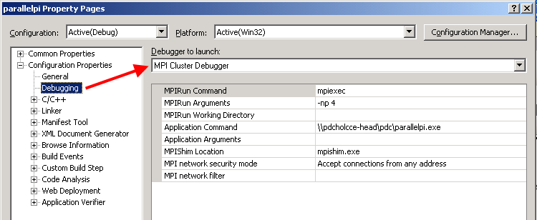
Figure 1. Debugging an MPI application using Visual Studio
- Fill in the arguments that will be used to execute the command, as shown above. The same arguments are used as in a regular job, except that the mpishim.exe file is added so the debugger can communicate with the MPI service.
- The Application Command field must be the same across the cluster, so it should be run from a central share. You must use UNC naming, not a mapped drive.
- On the Visual Studio 2005 menu, click Tools, and then click Options to open the dialog box shown in Figure 2.

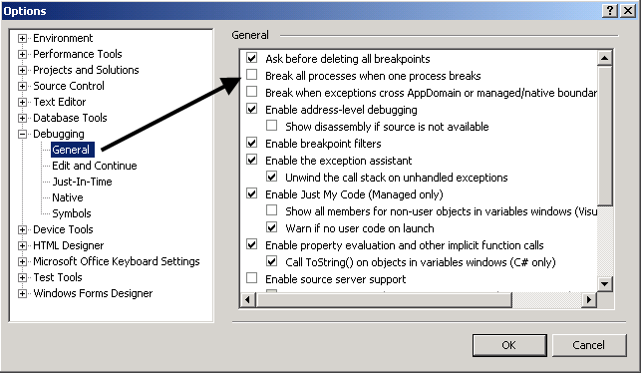
Figure 2. The Debugging Options dialog box
- Set any breakpoints, and rebuild the application.
A key feature of parallel debugging in Visual Studio lets developers set a per process breakpoint. For example, you can filter a breakpoint to only a particular Windows PID or set of PIDs, or set a breakpoint on a condition or variable that is present in a certain node.

Starting and Debugging an MPI Application
After you’ve configured the application in Visual Studio, you can start the application in debug mode by pressing F5. This will run the application using mpiexec, and the Visual Studio debugger will attach to the nodes running the application. When the application reaches a breakpoint, it will stop.
To view the processes of the application, press Ctrl-Alt-Z to open the Processes window, shown in Figure 3. Note that the ID shown in this window is the Windows Process ID and not the MPI rank ID.
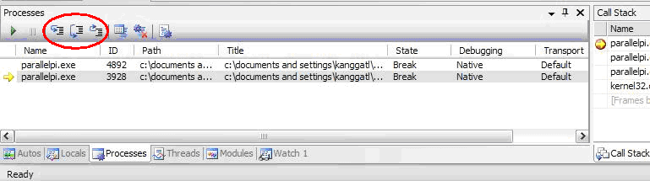
Figure 3. The Processes window
Set a breakpoint filter in Visual Studio to have the breakpoint active on only some of the processes.
The selected process in the Processes window sets the focus in the other windows, making it easy to examine the details of the process.
Note: Always use the step buttons in the process window, which are circled in red in Figure 3, to step through a breakpoint of a parallel application. Do not use the function key shortcuts.

Common Problems of Parallel Applications
Parallel applications have all the problems of serial applications, plus a whole new set of problems unique to their concurrency. Debugging a parallel application is an order of magnitude more difficult than debugging a serial application, so you should always do everything you can to debug the application as a sequential application first. It’s just smart to do as much debugging as possible on the application as if it were a serial application first. This can often be done for SPMD applications, at least, by setting the number of processors to one. Debugging the serial application will help identify any of the typical serial problems in your code that have nothing to do with concurrency, and will save time and complexity in overall debugging.
When you’ve done all you can to eliminate serial bugs in your application, you can use the Remote Debugging features of Visual Studio 2005 to address concurrency issues. Here are some of the more common problems that occur in parallel applications:
- Mismatched Communications. Parallel programs that use the SPMD model depend on communications between the processes. The MPI APIs are explicit message-passing APIs: each send must be explicitly received. If two sends go to a process that is expecting to only receive one, then only one message will be received. The result can be a process that hangs or becomes deadlocked.
- Deadlocks. A deadlock is a classic programming problem that can occur in sequential programs, but is potentially a greater problem in parallel applications. A deadlock occurs when two processes or threads are waiting for each other and neither can continue until the other does. Deadlocks generally result in a frozen or crashed program.
- Race Conditions. When two or more threads can access the same shared variable, and there is no control on the access order, you create a potential race condition where the value in the variable can be different depending on the order in which the threads access the variable. This condition is difficult to debug because even attaching the debugger changes the timing and can affect the result, making it difficult to reproduce the problem.
- False Sharing. False sharing occurs when two threads access and modify different portions of the cache, causing the cache to unnecessarily reload from main memory. This can have a dramatic performance implication for the application.

Conclusion
Visual Studio 2005 Professional Edition and Visual Studio 2005 Team System support remote debugging of parallel applications. The Visual Studio Remote Debugger uses the MPIShim.exe file to automatically attach to MPI processes running on multiple nodes in the cluster. A set of standard debugging features are extended to parallel applications, which makes process-level and thread-level breakpoints and stepping available. These features help in debugging the problems of concurrency, including communication mismatches, deadlocks, race conditions, and false sharing.

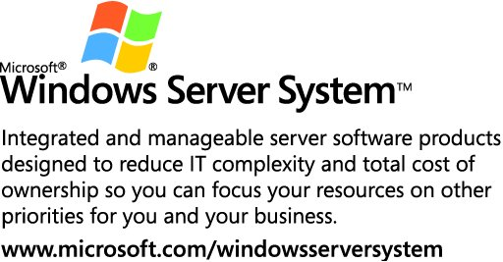

This is a preliminary document and may be changed substantially prior to final commercial release of the software described herein.
The information contained in this document represents the current view of Microsoft Corporation on the issues discussed as of the date of publication. Because Microsoft must respond to changing market conditions, it should not be interpreted to be a commitment on the part of Microsoft, and Microsoft cannot guarantee the accuracy of any information presented after the date of publication.
This white paper is for informational purposes only. MICROSOFT MAKES NO WARRANTIES, EXPRESS OR IMPLIED, IN THIS
DOCUMENT.
Complying with all applicable copyright laws is the responsibility of the user. Without limiting the rights under copyright, no part of this document may be reproduced, stored in, or introduced into a retrieval system, or transmitted in any form or by any means (electronic, mechanical, photocopying, recording, or otherwise), or for any purpose, without the express written permission of Microsoft Corporation.
Microsoft may have patents, patent applications, trademarks, copyrights, or other intellectual property rights covering subject matter in this document. Except as expressly provided in any written license agreement from Microsoft, the furnishing of this document does not give you any license to these patents, trademarks, copyrights, or other intellectual property.
© 2005 Microsoft Corporation. All rights reserved.
Microsoft, Visual Studio, and Windows Server are either registered trademarks or trademarks of Microsoft Corporation in the United States and/or other countries.
1105

References
The Trials and Tribulations of Debugging Concurrency (http://go.microsoft.com/fwlink/?LinkId=56103)
The Dining Philosophers; Classic Example of a Deadlock Problem (http://go.microsoft.com/fwlink/?LinkId=56102)
Message Passing Interface (MPI) Tutorial (http://go.microsoft.com/fwlink/?LinkId=56096)
How to Debug a Remote Cluster Application (http://go.microsoft.com/fwlink/?LinkId=56101)
Remote Debugging Components of Visual Studio 2005 (http://go.microsoft.com/fwlink/?LinkId=56100)
How to Run the Remote Debugging Monitor (http://go.microsoft.com/fwlink/?LinkId=56099)
Deploying & Managing Compute Cluster Server 2003 (http://go.microsoft.com/fwlink/?LinkId=55927)
Using the Compute Cluster Server 2003 Job Scheduler (http://go.microsoft.com/fwlink/?LinkId=55931)
Using Microsoft Message Passing Interface (http://go.microsoft.com/fwlink/?LinkId=55930)
Migrating Parallel Applications (http://go.microsoft.com/fwlink/?LinkId=55931)

