|  |  |  |  |
| --- | --- | --- | --- |
| Overview  **Country or Region:** Germany  **Industry:** Automotive  Customer Profile  Emotive provides a software tool for the rapid development of automotive diag­nostic applications. The company was founded in 2008, has four employees, and is based in Stuttgart, Germany.  Business Situation  Emotive needed an IDE in which to host its new tool for developing automotive diagnostic applications—and wanted to avoid the time and expense of develop­ing one from scratch.  Solution  Emotive chose to build on the Microsoft® Visual Studio® Shell, giving the company a running start in creating a tool that changes the way automotive diagnostic applications are built and managed.  Benefits   * An intuitive, easy-to-use solution for Emotive customers * Multiple deployment options (integrated with Visual Studio or stand-alone) * Lower development costs and shorter time-to-market |  |  | “We downloaded the Visual Studio Shell and quickly realized that it was exactly what we were looking for, in that it provided a basic IDE in which to host our specialized tools.”  Tobias Widmer, Managing Director, Emotive |
|  |  | When Emotive set out to develop a specialized framework to simplify the development of automotive diagnostic applications, it wanted to avoid the time and expense of developing an integrated development environment (IDE) from scratch. The company decided to use the Microsoft Visual Studio® 2008 Shell, a “container” for custom tools and programming languages. With its new solution, called Open Diagnostic Framework, Emotive is changing the way automotive diagnostic applications are developed and providing a faster and more cost-effective way to build and maintain such essential tools. By building its new tool using the Visual Studio Shell, Emotive is delivering its product more quickly and cost-effectively—and is providing customers with both a familiar developer experience and the flexibility to deploy Open Diagnostic Framework as a stand-alone tool or as an integrated component of Microsoft® Visual Studio 2008. |
|  |  |  |  |
|  |  |  | Microsoft logo |
|  |

Situation

Emotive provides specialized development tools for building automotive diagnostic applications. The company was started in 2008, when its founders realized there was strong demand for a tool that would enable automobile manufacturers and parts suppliers to build such applications in-house. “Outsourcing development can be costly and time-intensive, and makes it hard to maintain the application,” says Tobias Widmer, Founder and Managing Director at Emotive. “Our idea was to combine a graphical designer for building the application’s GUI with another designer for the diagnostic sequences and workflows behind that GUI.”

To get to market quickly, the founders wanted to find a suitable integrated development environment (IDE) on which to build, so that they could focus their development efforts on the unique features of their tool. “We had been thinking about building a similar product at our old jobs but were afraid to move forward without a container in which to combine all the parts,” says Widmer. “We had thought about using Eclipse, which is common in our industry, but past experience has shown that it’s not well suited for building GUIs. Besides, we come from a Visual Studio® background, as do many of our customers, and wanted to stay with some­thing that’s familiar. The other option was to develop an IDE from scratch, but that would have taken a significant amount of additional effort—enough work that it was preventing us from taking the leap and developing the product.”

|  |
| --- |
| “The Visual Studio Shell gives us a strong competitive advantage—it is helping us deliver a solution that is both useful and user friendly, and is helping us deliver this solution quickly and cost-effectively.”  Tobias Widmer, Managing Director, Emotive |

Solution

The event that convinced Emotive’s founders to start their own company came in November 2007, when Microsoft announced that the Microsoft Visual Studio 2008 Shell—a base IDE for hosting custom tools and programming languages—would be freely available as a complement to the Visual Studio 2008 Software Development Kit (SDK). “We downloaded the Visual Studio Shell and quickly realized that it was exactly what we were looking for, in that it provided a basic IDE in which to host our specialized tools,” says Widmer. “In June 2008, we founded Emotive and started to develop the tools we envisioned.”

Emotive began development of its new Open Diagnostic Framework in July 2008. Developers at Emotive are using the Microsoft® Visual Studio Team System 2008 Team Suite development system, along with Visual Studio Team System 2008 Team Foundation Server for source-code control, work-item tracking, and defect tracking. Code is written in the Visual C#® programming language and runs on the Microsoft .NET Framework version 3.5, where it takes advantage of both Windows® Forms and Windows Workflow Foundation—as well as the Visual Studio designers for those technologies. Version 1.0 of Open Diagnostic Framework shipped in June 2009.

“The Visual Studio Shell saved us enough time to take on a side project to develop a diagnostic application for a major auto­motive supplier, which we built using a prerelease version of our own IDE,” says Widmer. “Not only did this work help fund the development of our product, but it also helped us to better understand the needs of our customers.”

Benefits

Emotive is changing the way automotive diagnostic applications are developed, providing vehicle manufacturers and parts suppliers with a faster and more cost-effective way to build and maintain such essential tools. “Most of the specialized tools in our industry are based on Eclipse,” says Widmer. “The Visual Studio Shell gives us a strong competitive advantage—it is helping us deliver a solution that is both useful and user friendly, and is helping us deliver this solution quickly and cost-effectively.”

Figure 1. The Emotive Open Diagnostic Framework takes advantage of the Visual Studio Shell to provide a rich, graphical tool for developing automotive diagnostic applications.

An Intuitive, Easy-to-Use Solution

Emotive is delivering a tool that greatly simplifies the process of creating automotive diagnostic applications, enabling software developers without specialized experience to easily build such applications in-house.

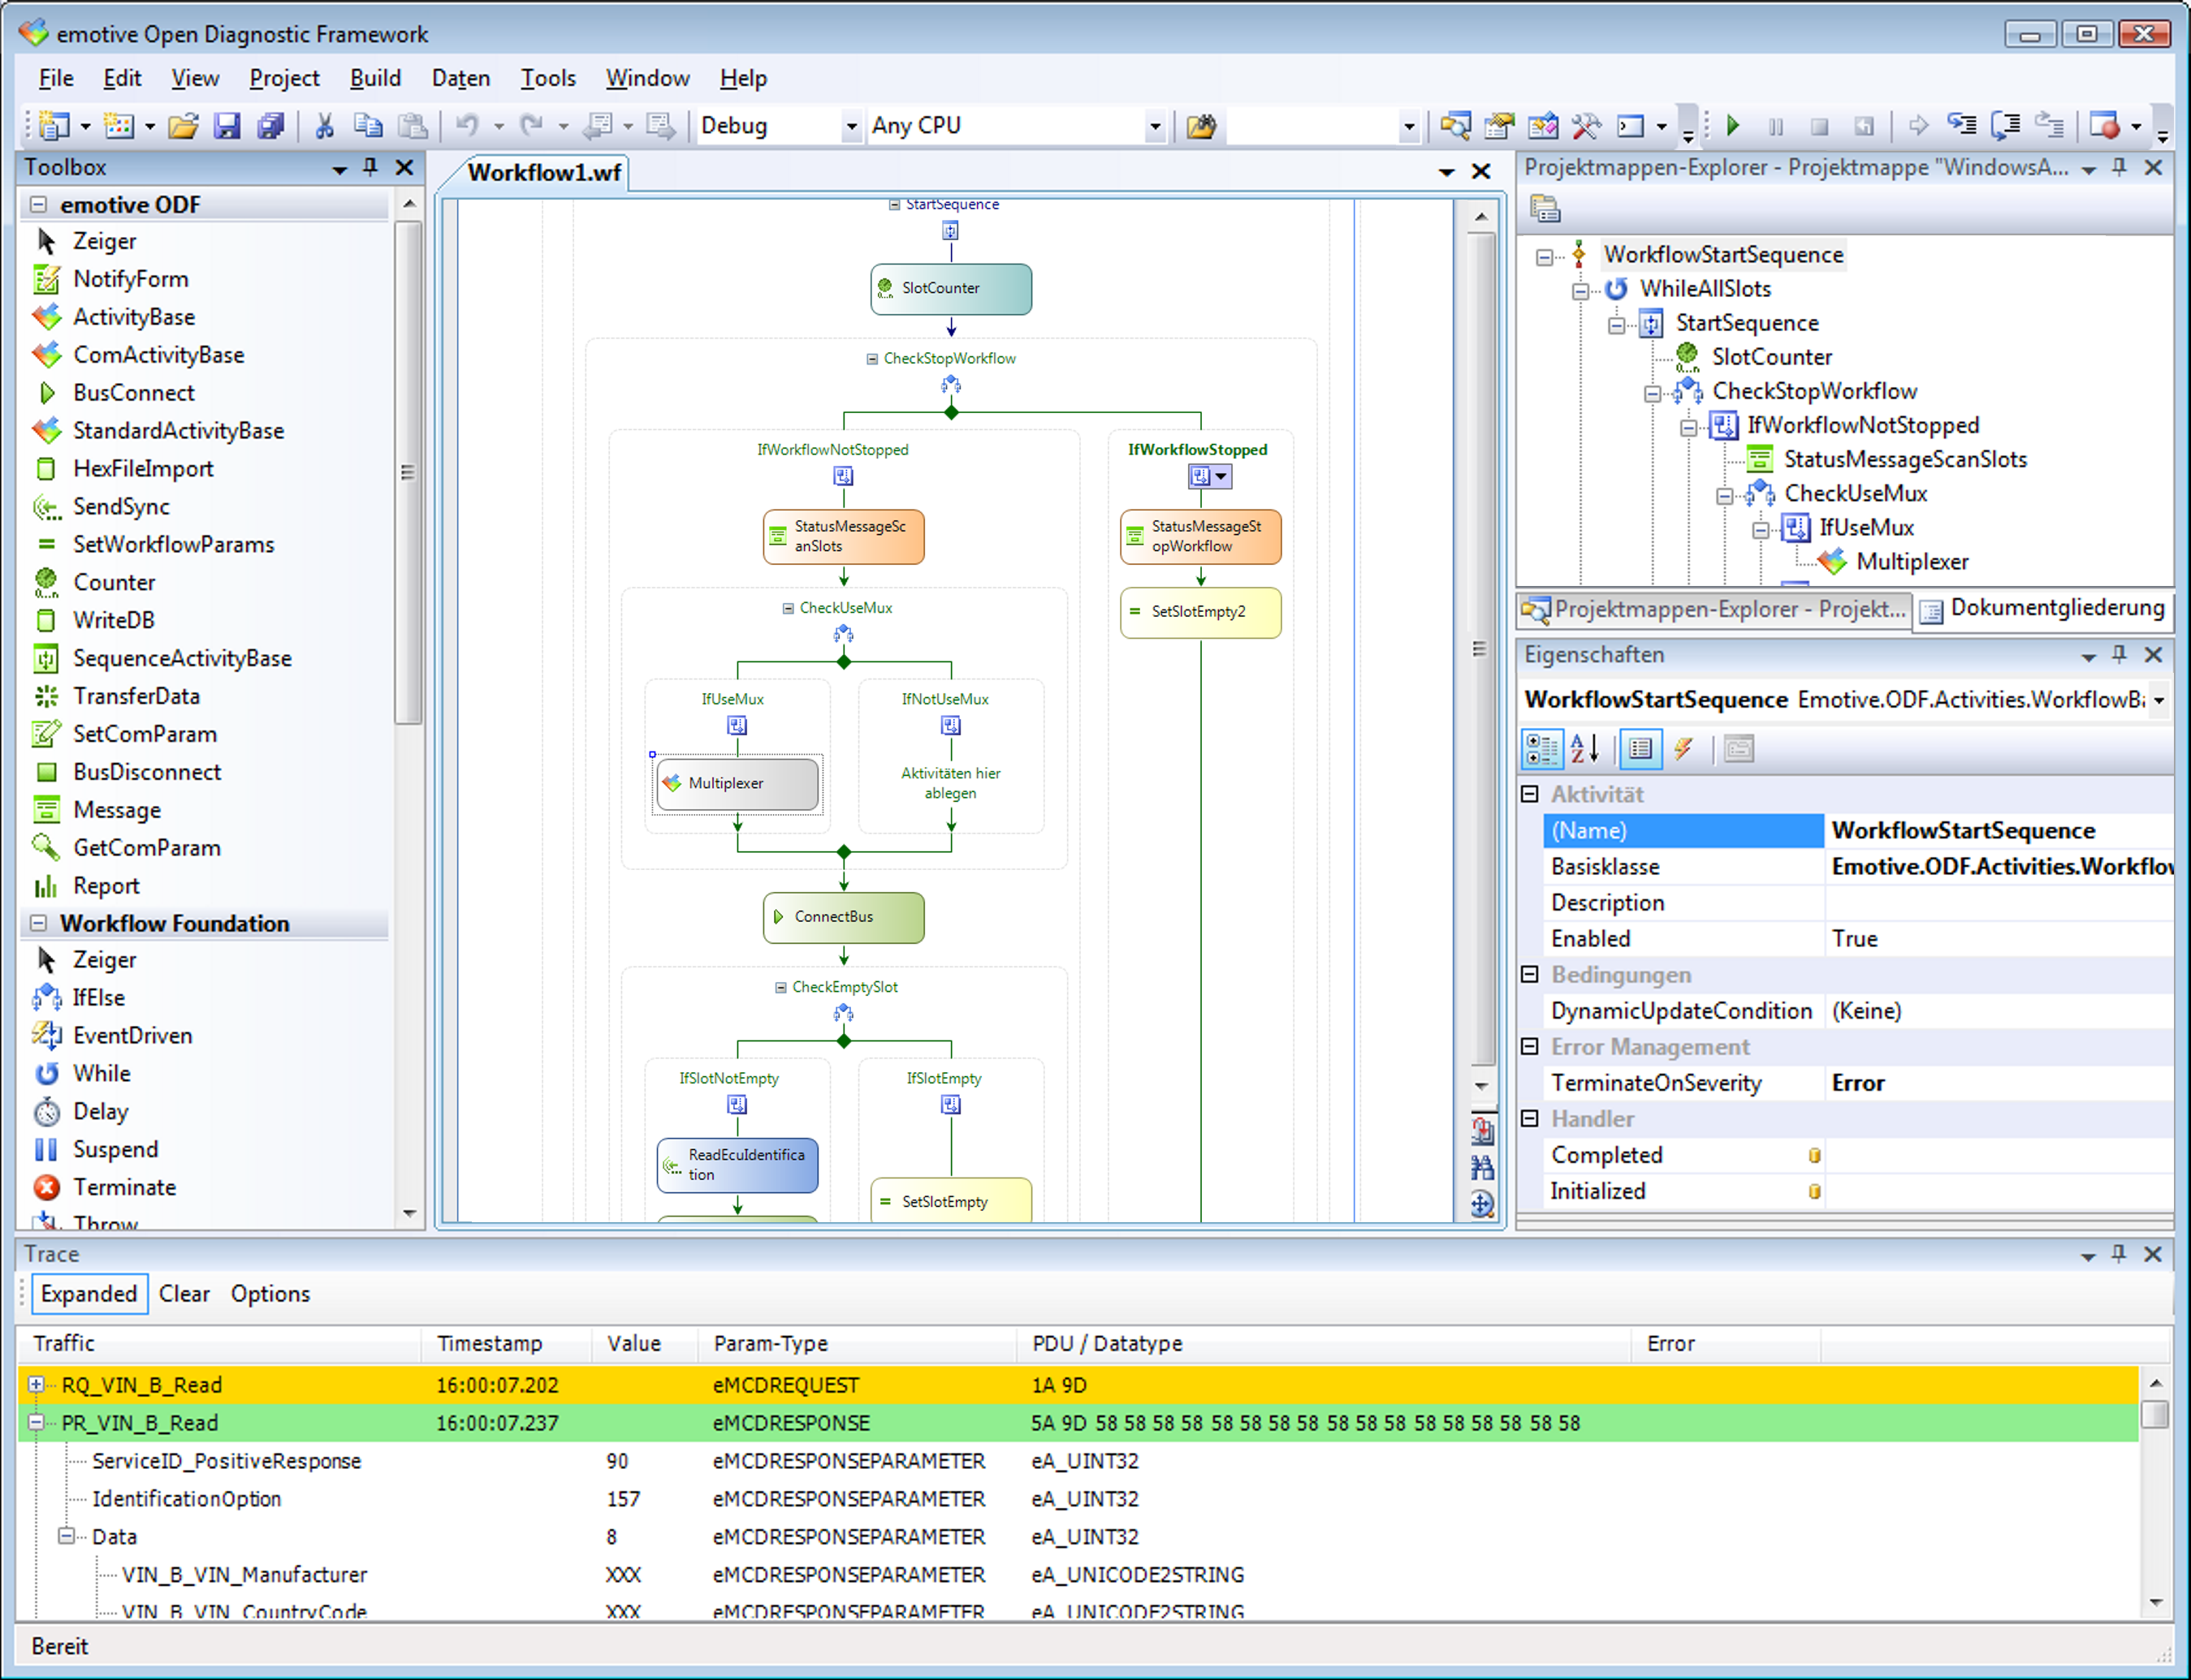

“The APIs for vehicle diagnostics are publicly available but are also highly com­plicated, easily encompassing thousands of pages of specifications—and thus are of little use on their own,” says Widmer. “Our solution eliminates that complexity, ena­bling developers to graphically design their diagnostic sequences and easily add a GUI. By building on the Visual Studio platform, with which developers around the world are already familiar, we’re making our solu­tion even more intuitive and easier to use.”

Here’s how Open Diagnostic Framework works: Developers use simple drag-and-drop gestures to first design the GUI, taking advantage of the Windows Forms designer included with the Visual Studio Shell. Next, they use similar drag-and-drop gestures to design the diagnostic sequences—functionality that builds upon the Windows Workflow Foundation designer. Developers then bind the GUI and the workflow together and compile the project to build a fully functional diagnostic application.

“Although our solution provides significant benefits in first building a diagnostic appli­cation, the benefits are even greater when it comes to maintaining the application,” says Widmer. “Companies no longer need to go back to the consulting company with a new purchase order and so on—they simply open up the existing project and make the changes they need. In this way, simple changes to an application can be made in just a few minutes or hours.”

Multiple Deployment Options

|  |
| --- |
| “We introduced our product in June 2009, and there’s no way we could have met that deadline without the Visual Studio Shell. In fact, without the Shell, we may not have formed the company and set out to build the product at all.”  Tobias Widmer, Managing Director, Emotive |

By using the Visual Studio Shell, Emotive can enable its customers to take advantage of Open Diagnostic Framework in multiple ways. The company will initially deliver its solution using the Visual Studio Shell isolated mode, in which applications built on the Shell contain only their own functionality—and run side by side with any other editions of Visual Studio that may be installed on the same machine. However, the company also plans to take advantage of the Visual Studio Shell integrated mode, in which applications built on the Shell automatically merge with any other editions of Visual Studio installed on the same machine. “After the code is finished for isolated mode, it won’t take any more work to support the integrated mode as well,” says Widmer. “In this way, we can meet the needs of customers regardless of whether they want a stand-alone tool or one that integrates seamlessly with editions of Visual Studio that are already on developers’ desktops—and being able to provide customers with more options is good for sales.”

For the next major version of Open Diagnostic Framework, Emotive will add support for Windows Presentation Foundation as well—work that will support yet a third mode of delivering the appli­cation. “Moving to Windows Presentation Foundation will put us in a good position to take advantage of Microsoft Silverlight™, with the eventual goal of being able to deliver our entire application within the browser,” says Widmer.

Lower Development Costs and Shorter Time-to-Market

Using the Visual Studio Shell helped Emotive to shave several months off the product development cycle, reduce development costs, and enable its developers to remain focused on the product’s core functionality. “It would have taken two of us at least three months to develop an IDE from scratch—and probably another three months to program our own designers,” says Widmer. “We introduced our product in June 2009, and there’s no way we could have met that deadline without the Visual Studio Shell. In fact, without the Shell, we may not have formed the company and set out to build the product at all.”

Microsoft Visual Studio 2008 Shell

|  |  |
| --- | --- |
|  | |
| Software and Services   * Microsoft Visual Studio * Microsoft Visual Studio Team System 2008 Team Suite * Microsoft Visual Studio Team System 2008 Team Foundation Server | * Technologies * Microsoft .NET Framework 3.5 * Microsoft Visual Studio 2008 Shell * Microsoft Visual Studio 2008 Software Development Kit * Visual C# * Windows Forms * Windows Workflow Foundation |

|  |  |
| --- | --- |
| This case study is for informational purposes only. MICROSOFT MAKES NO WARRANTIES, EXPRESS OR IMPLIED, IN THIS SUMMARY.  Document published April 2009, updated July 2009 |  |

For More Information

For more information about Microsoft products and services, call the Microsoft Sales Information Center at (800) 426-9400. In Canada, call the Microsoft Canada Information Centre at (877) 568-2495. Customers who are deaf or hard-of-hearing can reach Microsoft text telephone (TTY/TDD) services at (800) 892-5234 in the United States or (905) 568-9641 in Canada. Outside the 50 United States and Canada, please contact your local Microsoft subsidiary. To access information using the World Wide Web, go to:  
[www.microsoft.com](http://www.microsoft.com)

For more information about Emotive, visit the Web site at:   
[www.emotive.de](http://www.emotive.de)

If you create software development tools, you’ll want to consider building on the Visual Studio Shell. A streamlined Visual Studio development environment, the Visual Studio Shell provides the core foundation so you can focus on building your application’s unique features. The Visual Studio Shell accelerates the development of custom tools and helps you optimize the user interface to just the level of complexity—or simplicity—your customers want.

For more information about the Visual Studio 2008 Shell, go to:

[msdn.microsoft.com/en-us/vsx/bb933751](http://msdn.microsoft.com/en-us/vsx/bb933751)