Overview  Country or Region: United States  Industry: Information technology  Customer Profile  CDW is a U.S.$8.1 billion technology-solutions company that was founded in 1984 and today employs 6,300 people. Its Microsoft Practice employs 125 people.  Business Situation  The intranet site that CDW used to support sales didn’t enable its employees to find the information they needed quickly and easily, which contributed to longer and more costly sales cycles.  Solution  The company created an intranet sales portal. Based on Microsoft® Office SharePoint® Server 2007, the portal provides centralized access to product and sales data, and makes that data easy to search.  Benefits  - Saves each sales professional 10 hours per week  - Accelerates the creation of sales proposals; cuts the sales cycle in half  - Enables better business decisions based on better data |  |  | “By making more information more readily accessible, the portal extends the breadth of what we can sell and helps us accelerate the sales cycle.”  Jennifer Weis, Software and Solutions Sales Manager for the Central Region, CDW
 |  |  | Technology provider CDW supported its sales organization with a small intranet site that complicated the effort of sales professionals to find and use sales-related information—adding to the length and cost of the sales cycle. The company addressed this issue with an intranet sales portal based on Microsoft® Office SharePoint® Server 2007. The new site provides centralized access to comprehensive product information, proposal templates, and sales status; enterprise search that indexes a third-party sales application; and dashboards and reports for at-a-glance insights into sales performance. Each of the sales professionals saves 10 hours per week searching for information; the time to close sales has been slashed in half; and managers can make faster and better decisions about allocating resources, scheduling sales events, and maintaining the sales pipeline.
 |  |  | 

Situation
A few years ago, Berbee—then an independent company, now part of technology leader CDW—was a reseller of technology products and solutions, and one of its most successful business units was its Microsoft Practice. Berbee had a small intranet site on which it posted information about the solutions that the company sold based on Microsoft® technologies. That site was used by about 250 technical and sales professionals and was based on Windows® SharePoint® Services version 2.0.

The success of the Microsoft team at Berbee meant that the intranet site held increasing amounts of content; the amount of traffic on the site kept growing; and more and more personnel requested collaboration, search, content management, and business intelligence capabilities. As the site came to exceed its design limits, it became a victim of its own success. Many documents were stored on the site in a haphazard way in one huge document library. Users kept many other documents on their hard disks, which meant access to those documents was limited and users relied on e-mail to share them.

“We were putting so much information on the site that it became difficult to organize,” says Jaime Waterfield, Solutions Manager for Unified Communications, Security, and Core Infrastructure at CDW. “Our sales professionals wanted one set of data, our technology delivery staff wanted another—but there was no way to provide these role-based views. The site might have the information that someone wanted—but there might be no easy way for that person to find it.”

As a result, CDW personnel couldn’t always be sure that they were working with the current version of a statement of work (SOW) for the delivery of solutions or professional services delivery. They couldn’t be sure that they had the current information for a given customer contact. Multiple document versions caused reconciliation issues and time delays, and risked introducing inaccurate data into the system. And getting approval on documents such as customer proposals was a manual, time-consuming, and error-prone process that depended on numerous messages sent through e-mail.

“We would see a stream of requests for information sent in e-mail to broad groups of employees within the company,” says Jennifer Weis, Software and Solutions Sales Manager for the Central Region, CDW. “And we would see the same information requests repeated week after week because there was no single, central way to store information and make it easily accessible.”
“We would see the same information requests repeated week after week because there was no single, central way to store information and make it easily accessible.”
Jennifer Weis, Software and Solutions Sales Manager for the Central Region, CDW

Analyzing information—such as sales data—was equally challenging. Managers, analysts, and other employees would download sales data to spreadsheets, and then filter and manipulate the data to get to the specific information they wanted. They would upload the spreadsheets to the intranet site for use by others—but those other employees would need to know the name or location of the spreadsheet to find it. The existence of multiple spreadsheets led to inconsistent views of data, and the large size of spreadsheets—up to 12 gigabytes each—made them difficult to support on the intranet site.

When Berbee was acquired in 2006 by CDW—one of the largest private companies in the United States and a leading provider of technology solutions to business, government, and education—the barriers to information access only grew. Now, the information on Microsoft solutions had to be accessible not just to 250 Berbee employees, but to 3,000 CDW sales professionals, as well. Capabilities for content management, search, collaboration, and business intelligence all needed to be vastly expanded—and quickly. Addressing this challenge would also give the company a significant opportunity to optimize its technology infrastructure. And CDW employees also needed state-of-the-art portal technology for another reason: They would be most effective in selling this technology to their customers if they were using it themselves.

Solution
CDW found its solution for storing, finding, collaborating on, and analyzing information about Microsoft solutions in an intranet portal based on Microsoft Office SharePoint Server 2007. The company designed and developed the portal over a four-month period in early 2007, and put it into production in April 2007. The key steps in that process were designing a consistent way to classify the varied types of content that would go on the new site, building the infrastructure to enable coworkers from both CDW and legacy Berbee to access the portal, and building the site itself. Standardizing on Microsoft technology for the new sales portal also helped CDW to address another of its key goals: optimizing its technology infrastructure.
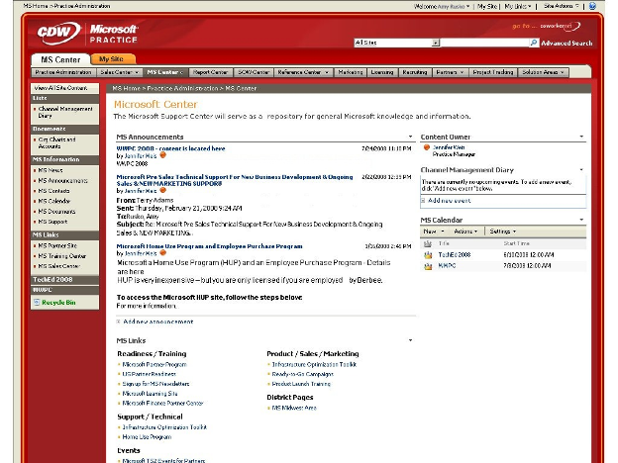
Figure 1. This detail from the Microsoft Support Center page of the CDW portal provides at-a-glance access to general Microsoft information.

Instead of a generic portal design with lists of libraries and documents, the CDW site has a markedly different look, one that echoes the company’s distinctive public Web site. The design is the result of a contest that CDW held within its Microsoft team. The winners were two coworkers in the company’s 18-month Microsoft Consultant Associates Training Program. The winning designers used the company’s existing design, plus Microsoft Office SharePoint Designer 2007, to create the site’s look and feel. Then, developers used built-in features of Office SharePoint Server, including Web parts, to implement the site. At least 95 percent of the site was created out-of-the-box, without any custom code, which not only accelerated the initial development, but also will help make upgrades and enhancements easier to implement.

Centralizing Content Management
When using the site, employees can go to four “practice areas” on the site to get in-depth information about the company’s information worker, unified communications, core infrastructure, and security offerings and how to sell those offerings. Each practice area includes several “practice administration” areas, which offer a full range of materials such a knowledge base of issues encountered during client engagements and resolved by the company’s consultants, best practices, training materials, a center of excellence on technology solutions, and practice-management content such as contracts and SOWs. CDW took advantage of standard features in Office SharePoint Server 2007 to capture both structured and unstructured content—that is, content in documents, spreadsheets, and other file types.
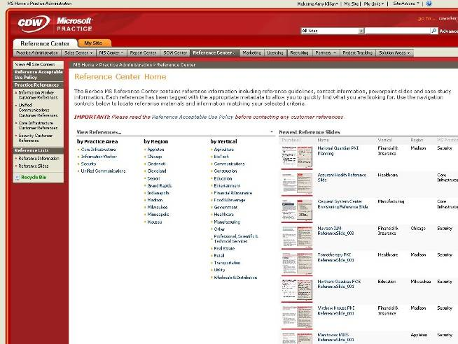

One of the most valuable components of the portal is the sales area within each practice area, which includes comprehensive information about the offerings of a particular practice. The type of information that a sales professional might find in a sales area includes a list of the solutions that the practice offers and comprehensive sales assets—such as templates, slide presentations, client references, white papers, data sheets, and competitive profiles—for each offering. For example, a sales professional can choose “health check” to see all relevant content related to the company’s health-check offerings.
Figure 2. This detail from the Microsoft Reference Center of the CDW portal contains reference guides, slide decks, case studies, and more to help sales personnel to initiate and respond to client requests.

The portal is also organized to enable sales coworkers to go directly to a single sales administration area that rolls up the relevant sales content from all four solution areas as well as general marketing and licensing information useful to the Microsoft team, making it even easier to have quick access to the sales information they require.

Search for Knowledge Management
The company uses several technologies to enhance the knowledge management capability that is central to delivering professional services. Sales professionals can easily search and find the information they need from the broad range of content. For example, role-based views, implemented by drawing upon a user’s profile in the Active Directory® service, give sales professionals and technology delivery professionals distinctive views of content based on their job categories.

The use of Office SharePoint Server enterprise search also helps to ensure fast access to content throughout the intranet. For example, the “Best Bets” feature gives users the most relevant results for their searches. When a user searches for a particular solution, the Best Bets feature returns a link to the statement of work templates associated with the offer and a link to the solution’s Offering home page. Expert people search functionality identifies employees within the company who can help a user solve a specific problem.
“We create higher-quality customer proposals, and we create them more quickly, now that we’re using the new SharePoint portal.”
Drew Jones, Information Worker Solutions Manager, CDW

Collaboration Tools
CDW included several features in the site that enhance collaboration among the company’s consultants, managers, and others. For example, the company automated several key processes—such as SOW development and approval—using the workflow capability built into Office SharePoint Server 2007. The status of all SOWs in process—including the status of required actions such as vetting and approving a SOW—is readily viewable in the SOW Center, and users receive automated notification when they are required to further the SOW process by contributing to or approving a SOW prior to its transmittal to a customer.

Consultants also take advantage of “wikis” in Office SharePoint Server to collaborate on the creation of best practices in each of the practice areas. Consultants view and discuss one another’s point of view online, and when a consensus is reached, it’s marked as the approved best practice. CDW also uses the MySites feature to create individual employee sites, which can be used for posting and sharing blogs and other content that doesn’t fit into the portal’s other content areas.

Another feature of the site that CDW consultants use frequently is slide libraries. Because employees can easily choose relevant slides for new proposals, the company has reduced the number of large presentations that it must maintain, thus freeing network storage space. Users also benefit by using the “link to source” feature of Office SharePoint Server to always have the latest slides in their presentation.

Centralized Business Intelligence Tools for Practice Performance
Just as the practice administration areas of the portal enable CDW employees to obtain content from centralized locations, the Reports Center of the portal enables them to gain centralized views into the status of the company and, in particular, the status of sales activity. The Reports Center provides dashboards that offer an immediate, color-coded indication of key performance indicators.

The dashboards are supported by Web parts running Excel® Services in Microsoft Office SharePoint Server 2007. The Web parts in turn receive sales data from client relationship management and other systems in the CDW environment, especially Changepoint, a third-party sales automation and professional services application. The Business Data Catalog in Office SharePoint Server 2007 extracts the data from Changepoint and makes it available to the Web parts on the SharePoint site.

Business intelligence insights into the sales pipeline, closure rates, business development, client relationships, and other content are integrated into a dashboard-style tool for ongoing sales opportunity management. As with other areas of the site, the use of the Active Directory service enables the company to provide users with only the information that is appropriate for their roles.

Integration Extends Use of Solution
The CDW sales portal integrates with many of the Microsoft technologies that the company already uses, such as the 2007 Microsoft Office suites, Office Communications Server 2007, Exchange Server 2007, and the Windows Vista® operating system. For example, sales professionals coordinate their personal calendars and contacts in Office Outlook® 2007 with the team calendars and contacts in the SharePoint site. And integration with Office Communications Server provides presence information from within Office SharePoint Server document libraries, so sales professionals can review a document, immediately check to see whether the author is available, and initiate an instant message or phone conversation to discuss the document.
“Because we’re also virtually eliminating the requests for information sent in e-mail, we’re saving time for the individuals who would otherwise receive and answer those requests.”
Jennifer Weis, Software and Solutions Sales Manager for the Central Region, CDW

Benefits
Managers and sales professionals at CDW are working faster, more productively, and more collaboratively to create higher-quality proposals. They have increased responsiveness to customers and cut the time of the sales cycle in half, now that the company is using the new intranet sales portal created with Office SharePoint Server 2007.

Sales Professionals Save 10 Hours Per Week Locating Information
By making it faster and easier for CDW sales professionals to find the information they need and to collaborate with one another, the new sales portal enables employees to work more productively than they could before.

“We create higher-quality customer proposals, and we create them more quickly, now that we’re using the new SharePoint portal,” says Drew Jones, Information Worker Solutions Manager, CDW.

For example, searching for the information needed to complete product-based or service-delivery-based SOWs—including sending e-mail requests for information to colleagues—used to take sales professionals up to three hours for each SOW. Now, because information has been centralized in the portal and is searchable, that time has been slashed to five minutes per SOW. Because each sales professional creates an average of three SOWs per week, that’s a savings of almost 10 hours per person per week—time that can be reinvested in pursuing additional sales opportunities.

“And that’s the least of the savings,” adds Weis. “Because we’re also virtually eliminating the requests for information sent in e-mail, we’re saving time for the individuals who would otherwise receive and answer those requests.”

Sales Proposals Are Accelerated, Sales Cycle Is Cut in Half
Beyond saving employees time in creating SOWs, the portal also helps CDW to close sales deals more quickly, according to Waterfield.

“By making more information more readily accessible, the portal extends the breadth of what we can sell and helps us accelerate the sales cycle,” says Weis. “We can now do in one sales meeting what used to take two or three. We can respond to customers in a day, when it might have taken a week before. If I have Internet access while I’m at a customer site, I can answer questions that would have required me to go back to the office before. We have cut the sales cycle by at least 50 percent.”

For example, Weis points to a day in which she returned to the office at 10:30 A.M. from a client meeting. Using packaged product and professional services offerings on the sales portal, she accelerated the sales proposal process, creating an SOW within an hour. Automated workflow in the portal notified the appropriate colleagues of the SOW’s creation and enabled them to vet and approve it within another hour. The client had the SOW within four hours; Weis estimates that it would have taken a week to accomplish that previously.
“If I have Internet access while I’m at a customer site, I can answer questions that would have required me to go back to the office before. We have cut the sales cycle by at least 50 percent.”
Jennifer Weis, Software and Solutions Sales Manager for the Central Region, CDW

Better Business Decisions Stem from Better Data
Managers at CDW now have greater trust in the information with which they make decisions that can boost sales, thanks to the SharePoint portal. For example, the dashboards display trends over a trailing six-week period. Managers can track these trends and spot potential problems before they become actual ones.

“If we’re seeing a sales dip in a particular district, we can decide to increase recruiting and staffing to bring our numbers back up to where they should be,” says Weis. “We can also watch the number of proposals in the pipeline to see if we’re active enough to generate the sales volume we want—and, if we’re not, we can take steps to respond.”

Similarly, managers can use the sales data available through the portal to track the success of sales events, and then use that information to make better decisions about which events to repeat.

“The business intelligence we gain through the portal makes it possible for us to make better marketing decisions, better staffing decisions, and better decisions about how to prioritize our resources,” says Waterfield.

Microsoft Office System
For More Information
For more information about Microsoft products and services, call the Microsoft Sales Information Center at (800) 426-9400. In Canada, call the Microsoft Canada Information Centre at (877) 568-2495. Customers who are deaf or hard-of-hearing can reach Microsoft text telephone (TTY/TDD) services at (800) 892-5234 in the United States or (905) 568-9641 in Canada. Outside the 50 United States and Canada, please contact your local Microsoft subsidiary. To access information using the World Wide Web, go to: www.microsoft.com

For more information about CDW products and services, visit the Web site at: www.cdw.com

This case study is for informational purposes only. MICROSOFT MAKES NO WARRANTIES, EXPRESS OR IMPLIED, IN THIS SUMMARY.

Document published September 2008

Software and Services  - Microsoft Office  - Microsoft Office Communications Server 2007  - Microsoft Office Outlook 2007  - Microsoft Office SharePoint Designer 2007  - Microsoft Office SharePoint Server 2007 | - Technologies  - Active Directory  - Business Data Catalog  - Excel Services in Microsoft Office SharePoint Server 2007

The Microsoft Office system is the business world’s chosen environment for information work, providing the programs, servers, and services that help you succeed by transforming information into impact.

For more information about the Microsoft Office system, go to:
www.microsoft.com/office

