

Understanding Mobile IPv6

Microsoft Corporation
Published: April 2004
Updated: November 2005

Abstract
Mobile Internet Protocol version 6 (IPv6) allows an IPv6 node to be mobile—to arbitrarily change its location on an IPv6 network—and still maintain reachability. Connection maintenance for mobile nodes is not done by modifying Transport layer protocols, but by handling the change of addresses at the Internet layer using Mobile IPv6 messages, options, and processes that ensure the correct delivery of data regardless of the mobile node's location. This article assumes an understanding of IPv6 as described in the "Introduction to IPv6" white paper.

This is a preliminary document and may be changed substantially prior to final commercial release of the software described herein.
The information contained in this document represents the current view of Microsoft Corporation on the issues discussed as of the date of publication. Because Microsoft must respond to changing market conditions, it should not be interpreted to be a commitment on the part of Microsoft, and Microsoft cannot guarantee the accuracy of any information presented after the date of publication.
This document is for informational purposes only. MICROSOFT MAKES NO WARRANTIES, EXPRESS OR IMPLIED, AS TO THE INFORMATION IN THIS DOCUMENT.
Complying with all applicable copyright laws is the responsibility of the user. Without limiting the rights under copyright, no part of this document may be reproduced, stored in or introduced into a retrieval system, or transmitted in any form or by any means (electronic, mechanical, photocopying, recording, or otherwise), or for any purpose, without the express written permission of Microsoft Corporation.
Microsoft may have patents, patent applications, trademarks, copyrights, or other intellectual property rights covering subject matter in this document. Except as expressly provided in any written license agreement from Microsoft, the furnishing of this document does not give you any license to these patents, trademarks, copyrights, or other intellectual property.
© 2004 Microsoft Corporation. All rights reserved.
Microsoft, Windows, Windows Mobile, and Windows Server are either registered trademarks or trademarks of Microsoft Corporation in the United States and/or other countries.
The names of actual companies and products mentioned herein may be the trademarks of their respective owners.

Contents
Mobile IPv6 Overview 1
Mobile IPv6 Components 1
Mobile IPv6 Transport Layer Transparency 3
The Microsoft Mobile IPv6 Technology Preview 3
Mobile IPv6 Messages and Options 4
Mobility Header and Messages 4
Mobility Header 4
Type 2 Routing Header 6
Home Address Option for the Destination Options Header 7
ICMPv6 Messages for Mobile IPv6 8
Home Agent Address Discovery Request 8
Home Agent Address Discovery Reply 9
Mobile Prefix Solicitation 9
Mobile Prefix Advertisement 10
Modifications to Neighbor Discovery Messages and Options 10
Modifications to the Router Advertisement Message 11
Modified Prefix Information Option 11
Advertisement Interval Option 12
Home Agent Information Option 13
Mobile IPv6 Data Structures 14
Binding Cache 14
Binding Update List 15
Home Agents List 15
Correspondent Registration 17
Return Routability Procedure 18
Detecting Correspondent Nodes that are not Mobile IPv6-Capable 19
Mobile IPv6 Message Exchanges 20
Data Between a Mobile Node and a Correspondent Node 20
Indirect delivery via the Home Agent 20
Direct Delivery 24
Binding Maintenance 27
Home Agent Binding Maintenance 27
Correspondent Node Binding Maintenance 29
Home Agent Discovery 31
Mobile Prefix Discovery 32
Mobile IPv6 Processes 35
Attaching to the Home Link 35
Moving From the Home Link to a Foreign Link 36
Attaching to the Foreign Link 36
Mobile Node Initiates Communication with a New Correspondent Node 38
A New Correspondent Node Communicates with a Mobile Node 40
A Node on the Home Link Communicates with the Mobile Node 41
Mobile Node Changes its Home Address 43
Moving to a New Foreign Link 44
Returning Home 46
Mobile IPv6 Host Sending Algorithm 49
Mobile IPv6 Host Receiving Algorithm 52
Summary 55
Related Links 56

Mobile IPv6 Overview
Mobile IPv6 allows an IPv6 node to be mobile—to arbitrarily change its location on an IPv6 network—and still maintain existing connections. When an IPv6 node changes its location, it might also change its link. When an IPv6 node changes its link, its IPv6 address might also change in order to maintain connectivity. There are mechanisms to allow for the change in addresses when moving to a different link, such as stateful and stateless address autoconfiguration for IPv6. However, when the address changes, the existing connections of the mobile node that are using the address assigned from the previously connected link cannot be maintained and are ungracefully terminated.
The key benefit of Mobile IPv6 is that even though the mobile node changes locations and addresses, the existing connections through which the mobile node is communicating are maintained. To accomplish this, connections to mobile nodes are made with a specific address that is always assigned to the mobile node, and through which the mobile node is always reachable. Mobile IPv6 provides Transport layer connection survivability when a node moves from one link to another by performing address maintenance for mobile nodes at the Internet layer.

Mobile IPv6 Components
Figure 1 shows the components of Mobile IPv6.
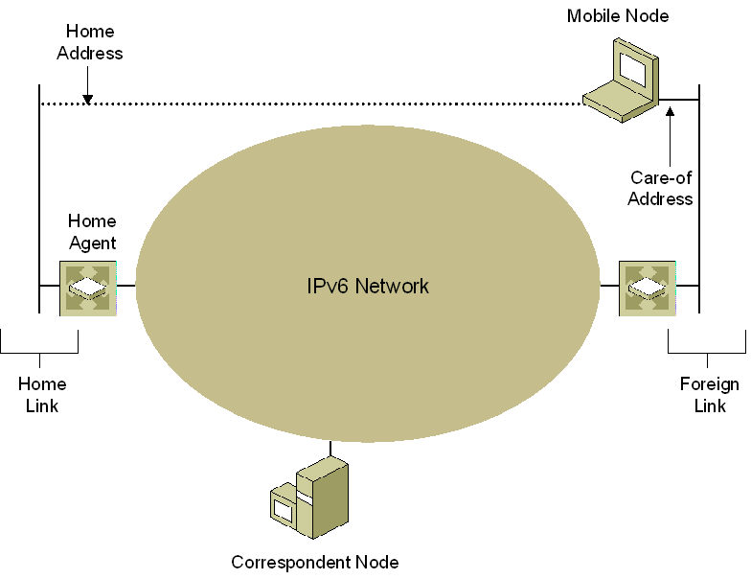
Figure 1 Components of Mobile IPv6
The components of Mobile IPv6 are the following:
- Home link
The link that is assigned the home subnet prefix, from which the mobile node obtains its home address. The home agent resides on the home link.
- Home address
An address assigned to the mobile node when it is attached to the home link and through which the mobile node is always reachable, regardless of its location on an IPv6 network. If the mobile node is attached to the home link, Mobile IPv6 processes are not used and communication occurs normally. If the mobile node is away from home (not attached to the home link), packets addressed to the mobile node's home address are intercepted by the home agent and tunneled to the mobile node's current location on an IPv6 network. Because the mobile node is always assigned the home address, it is always logically connected to the home link.
- Home agent
A router on the home link that maintains registrations of mobile nodes that are away from home and the different addresses that they are currently using. If the mobile node is away from home, it registers its current address with the home agent, which tunnels data sent to the mobile node's home address to the mobile node's current address on an IPv6 network and forwards tunneled data sent by the mobile node.
Although the figures in this white paper show the home agent as the router connecting the home link to an IPv6 network, the home agent does not have to serve this function. The home agent can also be a node on the home link that does not perform any forwarding when the mobile node is at home.
- Mobile node
An IPv6 node that can change links, and therefore addresses, and maintain reachability using its home address. A mobile node has awareness of its home address and the global address for the link to which it is attached (known as the care-of address), and indicates its home address/care-of address mapping to the home agent and Mobile IPv6-capable nodes with which it is communicating.
- Foreign link
A link that is not the mobile node's home link.
- Care-of address
An address used by a mobile node while it is attached to a foreign link. For stateless address configuration, the care-of address is a combination of the foreign subnet prefix and an interface ID determined by the mobile node. A mobile node can be assigned multiple care-of addresses; however, only one care-of address is registered as the primary care-of address with the mobile node's home agent. The association of a home address with a care-of address for a mobile node is known as a binding. Correspondent nodes and home agents keep information on bindings in a binding cache.
- Correspondent node
An IPv6 node that communicates with a mobile node. A correspondent node does not have to be Mobile IPv6-capable. If the correspondent node is Mobile IPv6-capable, it can also be a mobile node that is away from home.
Note The drawings in this white paper assume some sort of IPv6 network over which Mobile IPv6 messages or data is sent. This IPv6 network can be the IPv6 Internet, an IPv6-capable portion of a private intranet, or a public or private IPv4 infrastructure when using an IPv6 transition technology such as 6to4, Intra-site Automatic Tunnel Addressing Protocol (ISATAP), or Teredo. For more information, see the "IPv6 Transition Technologies" white paper.

Mobile IPv6 Transport Layer Transparency
To achieve Transport layer transparency for the home address while the mobile node is assigned a care-of address, Mobile IPv6-capable nodes use the following:
- When a mobile node that is away from home sends data to a correspondent node, it sends the packets from its care-of address and includes the mobile node's home address in a Home Address option in a Destination Options extension header. When the correspondent node receives the packet, it logically replaces the source address of the packet (the care-of address) with the home address stored in the Home Address option.
- When an Mobile IPv6-capable correspondent node sends data to a mobile node that is away from home, it sends the packets to the care-of address and includes a Type 2 Routing extension header containing a single address, the mobile node's home address. When the mobile node receives the packet, it processes the Type 2 Routing header and logically replaces the destination address of the packet (the care-of address) with the home address from the Type 2 Routing header.
If a correspondent node is not Mobile IPv6-capable, then packets sent between the correspondent node and the mobile node that is away from home are exchanged via the home agent. The correspondent node sends packets to the mobile node's home address. These packets are intercepted by the home agent and tunneled to the mobile node's care-of address. The mobile node tunnels packets destined for the correspondent node to the home agent, which forwards them to the correspondent node. This indirect method of delivery, known as bidirectional tunneling, although inefficient, allows communication between mobile nodes that are away from home and correspondent nodes that are not Mobile IPv6-capable.

The Microsoft Mobile IPv6 Technology Preview
A Mobile IPv6 Technology Preview has been developed by Microsoft Research and supports full correspondent node, mobile node, and home agent functionality for computers running various versions of Windows. However, the Mobile IPv6 Technology Preview is not currently available. Microsoft is considering making a version available for use with Windows Vista™ (now in beta testing) after the final version of Windows Vista has been released.

Mobile IPv6 Messages and Options
Mobile IPv6 requires the use of the following messages and message options:
- A new Mobility extension header with a set of Mobile IPv6 messages
- A set of mobility options to include in mobility messages
- A new Home Address option for the Destination Options header
- A new Type 2 Routing header
- New Internet Control Message Protocol for IPv6 (ICMPv6) messages to discover the set of home agents and to obtain the prefix of the home link
- Changes to router discovery messages and options and additional Neighbor Discovery options
For additional information about these messages and options, see Request for Comments (RFC) 3775, "Mobility Support in IPv6".

Mobility Header and Messages
To facilitate the sending of messages between mobile nodes, correspondent nodes, and home agents for the purposes of managing the set of bindings between home addresses and care-of addresses, the Internet Engineering Task Force (IETF) has defined a new Mobility extension header. This new header can contain one of several defined mobility messages to perform specific functions. Some mobility messages can contain one or more options.

Mobility Header
The new Mobility extension header is dedicated to carrying mobility messages and has the structure as shown in Figure 2. Setting the previous header's Next Header field to the value of 135 identifies the Mobility extension header.
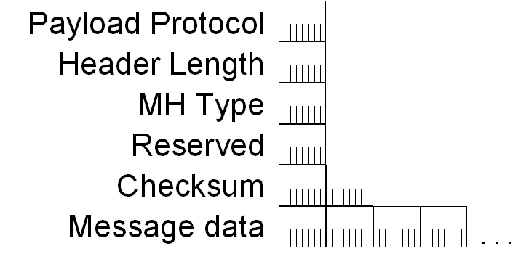
Figure 2 Structure of the Mobility extension header
Within the Mobility extension header:
- The Payload Protocol field, equivalent to the Next Header field in the IPv6 header, is always set to the value of 59 to indicate that the Mobility header is the last header in the packet.
- The MH Type field identifies the specific type of mobility message.
- The Message Data field contains a mobility message.
The following types of mobility messages are defined:
- Binding Refresh Request
Sent by a correspondent node or home agent to request the current binding from a mobile node. If a mobile node receives a binding refresh request, it responds with a binding update. A correspondent node sends a binding refresh request when a binding cache entry is in active use and the lifetime of the binding cache entry approaches expiration. A home agent sends a binding refresh request when the lifetime of its binding cache entry approaches expiration.
- Home Test Init (HoTI)
Sent by the mobile node during the Return Routability procedure to test the indirect path from a mobile node to a correspondent node via the home agent. For more information, see the "Return Routability Procedure" section of this white paper.
- Care-of Test Init (CoTI)
Sent by the mobile node during the Return Routability procedure to test the direct path from a mobile node to a correspondent node.
- Home Test (HoT)
Sent by the correspondent node during the Return Routability procedure to respond to the HoTI message.
- Care-of Test (CoT)
Sent by the correspondent node during the Return Routability procedure to respond to the CoTI message.
- Binding Update
Sent by a mobile IPv6 node that is away from home to update another node with its new care-of address. The Binding Update option is used for the following:
- To update the home agent with a new primary care-of address. This is known as a home registration binding update. The home agent uses the home address in the Home Address option and the care-of address in an Alternate Care-of Address mobility option to update its Home Address/Primary Care-of Address binding cache entry for the mobile node.
- To update a Mobile IPv6-capable correspondent node with which the mobile node is actively communicating with a binding that maps the home address of the mobile node to its care-of address. This is known as a correspondent registration binding update. The correspondent node uses the home address in the Home Address option and the source address of the packet to update its Home Address/Care-of Address binding cache entry for the mobile node.
- Binding Acknowledgement
Sent by a home agent or a correspondent node to acknowledge the receipt of a Binding Update message. Included in the binding acknowledgement is an indication of how long the node will cache the binding. For home agents, this lifetime indicates how long the home agent will be in service as the home agent for the mobile node. To refresh the binding, either the mobile node sends a new binding update or the correspondent nodes and home agent send Binding Refresh Request messages. The binding acknowledgement also includes an indication of how often the mobile node should send binding updates.
- Binding Error
Sent by a correspondent node to report errors in a binding update.
Mobility messages can contain mobility message options. RFC 3775 defines the following options:
- Pad1 Option
Used to insert a single byte of padding.
- PadN Option
Used to insert 2 or more bytes of padding.
- Binding Refresh Advice Option
Used in a Binding Acknowledgement sent from a home agent to indicate how long before the mobile node should send a new home registration.
- Alternate Care-of Address Option
Used to indicate the care-of address in the Binding Update message.
- Nonce Indices Option
Used to indicate information needed to determine binding keys.
- Binding Authorization Data Option
Used to contain cryptographic information from which the receiver can verify that the binding message originated from a node with which a Return Routability procedure has occurred.

Type 2 Routing Header
Mobile IPv6-capable correspondent nodes use a new Type 2 Routing header when sending a packet directly to a mobile node that is away from home to indicate the mobile node's home address. Correspondent nodes set the Destination Address field in the IPv6 header to the mobile node's care-of address when performing direct delivery.
Figure 3 shows the structure of the new Type 2 Routing header.
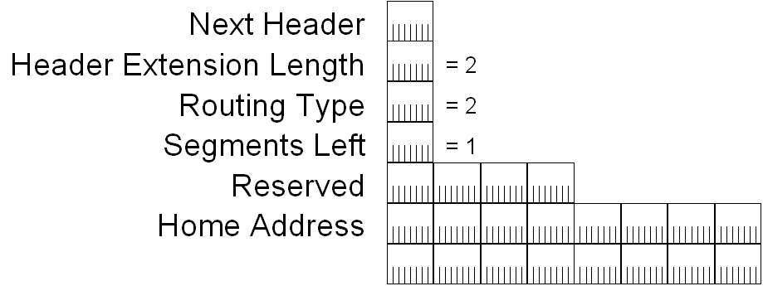
Figure 3 The structure of the new Type 2 Routing header
During the processing of a packet with a Type 2 Routing header, the mobile node replaces the Destination Address field with the value in the Home Address field. The Home Address field in the Type 2 Routing header is the actual destination address of the mobile node to which the packet has been sent (the care-of address stored in the Destination Address field of the IPv6 header is merely an intermediate delivery address).
The Type 2 Routing header is different from the Type 0 Routing header defined in RFC 2460 in that it can only store a single address and is only specified for use with Mobile IPv6. The Type 0 Routing header can store multiple addresses and is processed by routers for generalized source routing. Using a different routing type allows firewalls to treat source-routed packets differently from packets sent directly by Mobile IPv6-capable correspondent nodes to mobile nodes that are away from home.

Home Address Option for the Destination Options Header
The Home Address option in the Destination Options extension header is used to indicate the home address of the mobile node and is included in binding updates sent to home agents and packets sent directly to Mobile IPv6-capable correspondent nodes by a mobile node when it is away from home when a binding exists. When a mobile node sends a packet, the source address in the IPv6 header is set to the care-of address. If the source address in the IPv6 header were set to the home address, the router on the foreign link might discard the packet because the source address does not match the prefix of the link on which the mobile node is located. To help minimize Internet attacks in which the source address of attack packets is spoofed with an address that is not assigned to the attacking computer, peripheral routers can implement ingress filtering and silently discard packets that do not have topologically correct source addresses. Ingress in this instance is defined relative to the Internet for packets entering the Internet, rather than packets entering an intranet from the Internet.
Figure 4 shows the structure of the Home Address destination option.
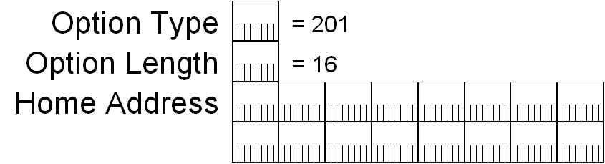
Figure 4 The structure of Home Address destination option
By using the care-of address as the source address in the packet (a topologically correct address on the foreign link), and including the Home Address destination option, the router on the foreign link forwards the packet to its destination. When the packet is received at the destination, the correspondent node processes the Destination Options header and logically replaces the source address of the packet with the address in the Home Address option before passing the payload to the upper layer protocol. To the upper layer protocol, the packet was sent from the home address.
In contrast to the Home Address field in the Type 2 Routing header, the Home Address field in the Home Address destination option is the actual source address of the mobile node from which the packet was sent (the care-of address stored in the Source Address of the IPv6 header is merely an intermediate address).
The Home Address option is also included with the binding update so that the home address for the binding is indicated to the receiving node.

ICMPv6 Messages for Mobile IPv6
The mobile node uses the following ICMPv6 messages for dynamic home agent address and home subnet prefix discovery:
- Home Agent Address Discovery Request
- Home Agent Address Discovery Reply
- Mobile Prefix Solicitation
- Mobile Prefix Advertisement
Dynamic home agent address discovery is a process by which the mobile node dynamically discovers the global address of a home agent on the home link. This process is only needed if the mobile node is not already configured with the address of its home agent or if the current home agent becomes unavailable.
Home subnet prefix discovery is the process by which a mobile node dynamically discovers the address prefix of its home link. This process is only needed when a mobile node's home address is about to enter the invalid state.

Home Agent Address Discovery Request
The mobile node uses the ICMPv6 Home Agent Address Discovery Request message to begin dynamic home agent address discovery. The ICMPv6 Home Agent Address Discovery Request message is sent to the Mobile IPv6 Home-Agents anycast address that is described in RFC 2526. The Mobile IPv6 Home-Agents anycast is composed of the 64-bit home subnet prefix and the interface ID of ::FEFF:FFFF:FFFF:FFFE. All home agents are automatically configured with this anycast address. The home agent that is topologically closest to the mobile node receives the request message.
Figure 5 shows the structure of the ICMPv6 Home Agent Address Discovery Request message.
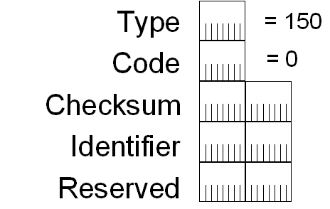
Figure 5 The structure of ICMPv6 Home Agent Address Discovery Request message
In the Home Agent Address Discovery Request message, the Type field is set to 150 and the Code field is set to 0. Following the Checksum field is a 16-bit Identifier field. The value of the Identifier field is chosen by the sending node and copied to the Identifier field of the Home Agent Address Discovery Reply message to match a reply with its request. Following the Identifier field is a 16-bit Reserved field that is set to 0 by the sender.
The Home Agent Address Discovery Request message is sent with the source address in the IPv6 header set to the mobile node's care-of address.

Home Agent Address Discovery Reply
The home agent uses the ICMPv6 Home Agent Address Discovery Reply message to complete the dynamic home agent address discovery process by informing the mobile node of the addresses of the home agents on the mobile node's home link.
Figure 6 shows the structure of the ICMPv6 Home Agent Address Discovery Reply message.
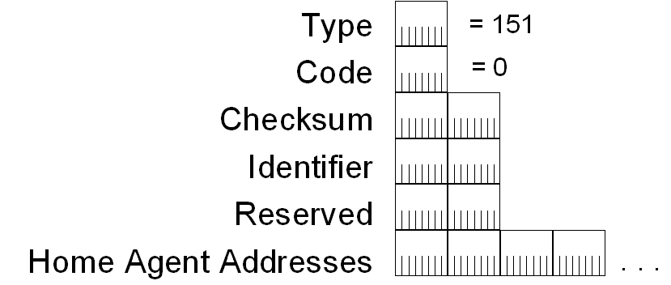
Figure 6 The structure of the ICMPv6 Home Agent Address Discovery Reply message
In the Home Agent Address Discovery Reply message, the Type field is set to 151 and the Code field is set to 0. Following the Checksum field is a 16-bit Identifier field. The value of the Identifier field is set to the same value as the Identifier field of the received Home Agent Address Discovery Request message. Following the Identifier field is a 16-bit Reserved field that is set to 0 by the sender, and one or more 128-bit Home Agent Address fields. The Home Agent Address fields contain the global addresses of home agents on the home link in preference order (highest preference first).
The Home Agent Address Discovery Reply message is sent with the source address in the IPv6 header set to the global address of the answering home agent, and the destination address set to the mobile node's care-of address. A Type 2 Routing extension header is not included.

Mobile Prefix Solicitation
A mobile node uses the ICMPv6 Mobile Prefix Solicitation message to obtain its home subnet prefix while it is away from home. The response to the ICMPv6 Mobile Prefix Solicitation message is an ICMPv6 Mobile Prefix Advertisement message from the home agent, which contains the home subnet prefix and other configuration information by which the mobile node can update or refresh its home address.
Figure 7 shows the structure of the ICMPv6 Mobile Prefix Solicitation message.
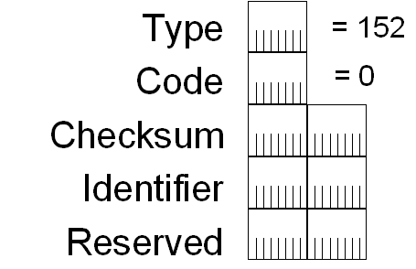
Figure 7 The structure of the ICMPv6 Mobile Prefix Solicitation message
The Identifier field is set by the mobile node and used to match a sent Mobile Prefix Solicitation message with its corresponding Mobile Prefix Advertisement message.

Mobile Prefix Advertisement
The home agent uses the ICMPv6 Mobile Prefix Advertisement message to advertise the home subnet prefix and other configuration options to mobile nodes that are away from home, either unsolicited or in response to a received ICMPv6 Mobile Prefix Solicitation message
Figure 8 shows the structure of the ICMPv6 Mobile Prefix Advertisement message.
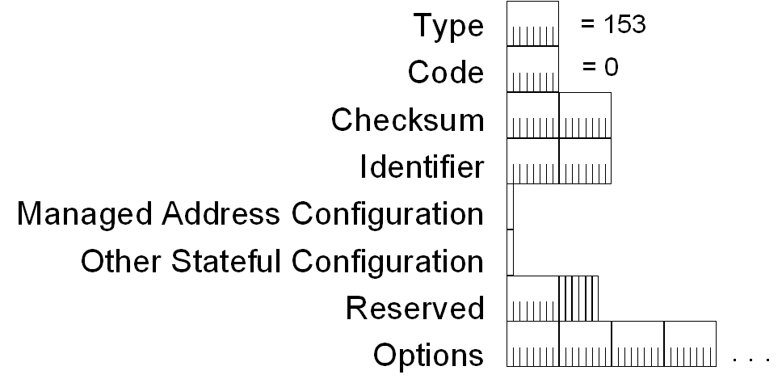
Figure 8 The structure of the ICMPv6 Mobile Prefix Advertisement message
The Identifier field is set to the value of the Identifier field of a received Mobile Prefix Solicitation message. The Managed Address Configuration, Other Stateful Configuration, and Options fields are the same as the corresponding fields of the Router Advertisement message as defined in RFC 2461, except that RFC 3775 defines the use of the Mobile IPv6-modified Prefix Information option, described in the next section.

Modifications to Neighbor Discovery Messages and Options
Mobile IPv6 defines the following changes to Neighbor Discovery (ND) messages and options:
- Modified Router Advertisement message
- Modified Prefix Information option
- New Advertisement Interval option
- New Home Agent Information option

Modifications to the Router Advertisement Message
Mobile IPv6 defines an additional flag in the Router Advertisement message to help facilitate home agent discovery by the home agents on a home link. The new flag, known as the Home Agent (H) flag, indicates whether the advertising router is capable of being a home agent. Each of the home agents on the home link set this flag when they send their router advertisements, and each home agent receives each router advertisement. Therefore, each home agent can compile the list of possible home agents.
Figure 9 shows the structure of the modified Router Advertisement message.
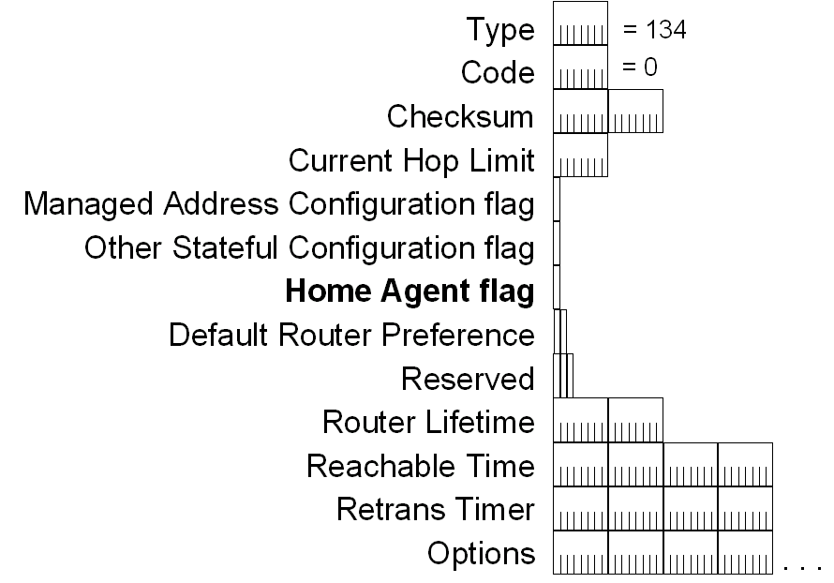
Figure 9 The structure of the modified Router Advertisement message
Additionally, Mobile IPv6 allows a router advertisement to be sent more frequently than every 3 seconds, as specified in RFC 2461. By sending router advertisements more frequently, mobile nodes can use a newly received router advertisement to detect movement to a foreign link more quickly. Recommended values for the pseudo-periodic router advertisement process for routers that might provide connectivity for mobile IPv6 nodes are a minimum of 0.03 seconds and a maximum of 0.07 seconds.

Modified Prefix Information Option
To indicate the global address of the advertising router, Mobile IPv6 defines an additional flag and a redefined use of the Prefix field in the Prefix Information option.
Figure 10 shows the structure of the modified Prefix Information option.
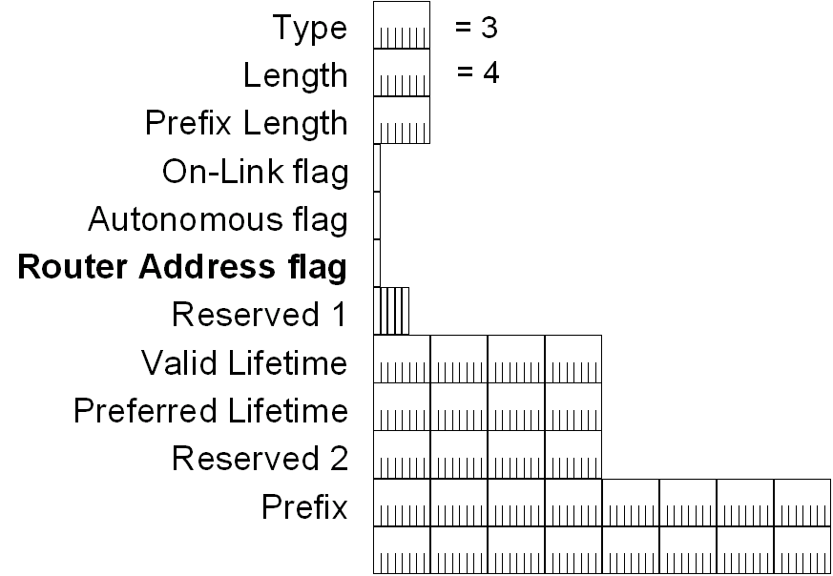
Figure 10 The structure of the modified Prefix Information option
According to RFC 2461, router advertisements are sent from the link-local address. However, the global address for a home agent must be indicated in the router advertisement it sends so that each home agent can compile a list of home agents. Mobile IPv6 defines the Router Address (R) flag in the Prefix Information option. When set, the R flag indicates to the receiver that the Prefix field contains the global address of the advertising router. In the originally defined Prefix field, the high-order bits corresponding to the value of the Prefix Length field are set to the appropriate values for the advertised prefix and the bits beyond the indicated prefix length are set to 0. With this new definition, the Prefix Length field is advertised in the same way, only the Prefix field contains the entire 128-bit global address of the advertising router.

Advertisement Interval Option
The Advertisement Interval option is sent in Router Advertisement messages to specify how often the router sends unsolicited multicast router advertisements. A mobile node that receives a router advertisement with the Advertisement Interval option can use the advertisement interval to detect whether it has moved to another link.
Figure 11 shows the structure of the Advertisement Interval option.

Figure 11 The structure of the Advertisement Interval option
The Advertisement Interval option contains a 32-bit field that indicates the maximum number of milliseconds between consecutive unsolicited multicast Router Advertisement messages sent by the router using the pseudo-periodic advertising scheme described in section 6.2.4 of RFC 2461.

Home Agent Information Option
The Home Agent Information option is sent in Router Advertisement messages sent by a home agent to specify the home agent's configuration. Figure 12 shows the structure of the Home Agent Information option.
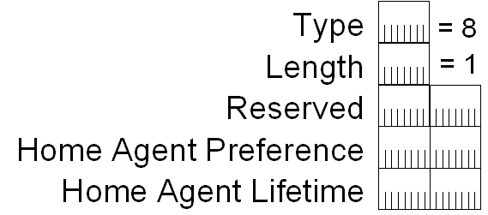
Figure 12 The structure of the Home Agent Information option
Included in the Home Agent Information option are the home agent preference (a number indicating a preference level for the advertising router to be a home agent) and the home agent lifetime (how long the home agent is acting as a home agent).
The home agents on a home link use the home agent preference values to order the list of home agents that are sent to the mobile node during home agent address discovery.

Mobile IPv6 Data Structures
The following data structures are needed to facilitate the processes of Mobile IPv6:
- Binding cache
- Binding update list
- Home agents list

Binding Cache
The binding cache is a table maintained by each correspondent node and home agent that contains the current bindings for mobile nodes. Each binding cache entry contains the following information:
- The home address for the mobile node
- The care-of address for the mobile node
- The lifetime of the binding cache entry
The lifetime is obtained from a Lifetime field of the last Binding Update message that was received for this cache entry.
- A flag indicating whether the binding is a home registration
This flag is set only for the binding cache entries on home agents.
- The time that the last binding request was sent
The actual implementation details for the binding cache are not specified, as long as the external behavior is consistent with RFC 3775. For example, you could either maintain a separate binding cache or combine the binding cache with the destination cache. If you have a separate binding cache, you could either check it before you check the destination cache or have a pointer from the destination cache entry to the corresponding binding cache entry.
In any case, the information in the binding cache takes precedence over the information in the neighbor cache. For mobile destinations that are away from home, packets should be sent to the mobile node's home address by way of its care-of address. If packets are sent directly to the home address while the mobile node is away from home, the home agent must intercept the packets and tunnel them to the mobile node, lowering the efficiency and performance of the communication between the correspondent node and the mobile node.
The IPv6 protocol for Microsoft® Windows® XP and Windows Server™ 2003 maintains a separate binding cache. Each binding cache entry stores the home address, its current care-of address, and a pointer to the entry in the destination cache for the care-of address. A destination cache entry for a home address of a mobile node that is away from home has a pointer to an entry in the binding cache. The entry in the binding cache maps the home address to its care of address and indicates the entry in the destination cache for the care-of address. The care-of address destination cache entry stores the next-hop address and interface for the care-of address.
For more information about how a node sends a packet in a Mobile IPv6 environment, see the "Mobile IPv6 Sending Algorithm" section in this white paper.

Binding Update List
The binding update list is maintained by a mobile node to record the most recent binding updates sent for the home agent and correspondent nodes. A binding update list entry contains:
- The address of the node to which the binding update was sent
- The home address for the binding update
- The care-of address sent in the last binding update
- The value of the Lifetime field in the binding update
- The remaining lifetime of the binding
The initial value is the value of the Lifetime field in the binding update. When the lifetime expires, the entry is deleted from the binding update list.
- The maximum value of the Sequence Number field sent in previous binding updates
- The time that the last binding update was sent
- An indication of whether a retransmission is needed for binding updates sent with the Acknowledge (A) flag set to 1 and when the retransmission is to be sent
- A flag indicating that no future binding updates need to be sent
This flag is set to 1 when the mobile node receives an ICMPv6 Parameter Problem-Unrecognized Next Header Type Encountered message in response to a Return Routability message or a binding update.

Home Agents List
Home agents maintain the home agents list and record information about each router from which a Router Advertisement message was received on the home link with the Home Agent (H) flag set to 1. Home agents maintain the home agents list so that they can send the list of home agents to a requesting mobile node away from home during home agent address discovery.
A home agents list entry contains the following:
- The link-local address of the router on the link, obtained from the source address of the received Router Advertisement message
- The global address or addresses of the home agent, obtained from the Prefix field in the Prefix Information options in the Router Advertisement message with the Router Address (R) flag set to 1
- The remaining lifetime of this entry
The initial lifetime is obtained from either the Home Agent Lifetime field in the Home Agent Information option or the Router Lifetime field in the Router Advertisement message. When the lifetime expires, the entry is deleted from the home agents list.
- The preference for the home agent, obtained from the Home Agent Preference field in the Home Agent Information option
If the router advertisement does not contain a Home Agent Information option, the preference is set to 0. Based on the definition of the Home Agent Preference field, 0 is a medium priority level. A mobile node uses the preference value to select the home agent. A home agent uses the preference value to order by preference value the list of home agents returned to a mobile node during home agent address discovery. When the mobile node receives the list of home agents, it chooses the first home agent in the list.

Correspondent Registration
There are two ways in which mobile nodes that are away from home can communicate with correspondent nodes:
- Directly
If the correspondent node is Mobile IPv6-capable, then data can be sent directly between the mobile node and the correspondent node. The mobile node sends data directly to the correspondent node using the correspondent node's address and includes the Home Address destination option to indicate its home address. The correspondent node sends data directly to the mobile node's care-of address and includes the Type 2 Routing header to indicate the mobile node's home address. The direct method of data delivery is referred to in RFC 3775 as route optimization.
- Indirectly
If the correspondent node is not Mobile IPv6-capable or the registration of the binding for the mobile node with the correspondent node that is Mobile IPv6-capable has not yet been completed, then data can be sent indirectly between the mobile node and the correspondent node via the home agent.
For traffic from the mobile node to the correspondent node, packets are tunneled to the home agent. The mobile node encapsulates the IPv6 packet sent from the mobile node's home address and to the correspondent node's address with an additional IPv6 header, with the source address of the mobile node's care-of address and the destination address of the home agent's global address. After receiving the packet, the home agent strips the outer IPv6 header and forwards the original IPv6 packet to the correspondent node.
For traffic from the correspondent node to the mobile node, the correspondent node sends the packet to the mobile node's home address. When the home agent intercepts the packet, it is encapsulated with an additional IPv6 header, with the source address of the home agent's address and the destination address of the mobile node's care-of address.
Indirect delivery via the home agent, although inefficient, allows communication between mobile nodes and correspondent nodes that are not Mobile IPv6-capable.
The indirect method of data delivery is referred to in RFC 3775 as bidirectional tunneling.
In order for direct delivery to occur, the correspondent node with which the mobile node is communicating must be Mobile IPv6-capable and must have a binding cache entry that maps the mobile node's home address to its care-of address. Correspondent nodes that receive packets that contain a Home Address option in a Destination Options header must have a corresponding binding cache entry, otherwise the packet is silently discarded. This behavior provides some protection against malicious users or programs that attempt to impersonate mobile nodes that are away from home.
The process of creating a binding cache entry on the correspondent node and a binding update list entry on the mobile node is known as correspondent registration and consists of the following:
- Return Routability procedure
The Return Routability procedure establishes proof to the correspondent node that the mobile node is reachable at both its home address (using the indirect path) and its care of address (using the direct path) and determines tokens that are used to derive a binding management key, which is used to calculate authorization data values for binding messages.
- Binding Update and Binding Acknowledgement message exchange
The Binding Update and Binding Acknowledgement message exchange uses the binding management key to prove that the messages were sent from the nodes that participated in the Return Routability procedure. For the binding update, the correspondent node verifies the included authorization data, updates its binding cache with an entry for the mobile node, and typically returns a Binding Acknowledgement message, which also contains authorization data calculated using the binding management key.
The end result of the correspondent registration is the following:
- On the mobile node, there is an entry in its binding update list for the correspondent node.
- On the correspondent node, there is an entry in its binding cache for the mobile node.
The binding management key can be used for subsequent binding maintenance as long as the mobile node's home address or care-of addresses do not change. When they do, the Return Routability procedure is performed again to ensure that the mobile node is reachable at its new addresses.

Return Routability Procedure
Figure 13 shows the Return Routability procedure.
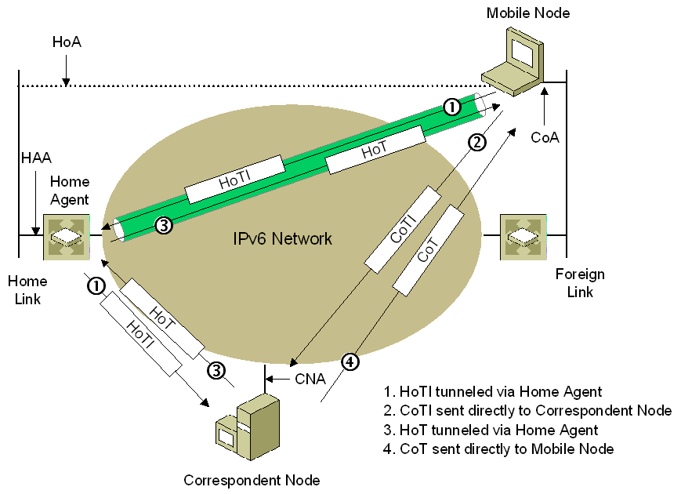
Figure 13 The Return Routability procedure
The full Return Routability process is the following:
- The mobile node sends a Home Test Init (HoTI) message indirectly to the correspondent node, tunneling the message through the home agent.
- The mobile node sends a Care-of Test Init (CoTI) message directly to the correspondent node.
- The correspondent node sends a Home Test (HoT) message in response to the HoTI message (sent indirectly to the mobile node via the home agent).
- The correspondent node sends a Care-of Test (CoT) message in response to the CoTI message (sent directly to the mobile node).
The correspondent node responds to the HoTI and CoTI messages as they arrive, independently of each other. The messages can arrive in any order. The correspondent node does not store any state information after responding to the HoTI or CoTI message.
The HoT message is sent to the mobile node's home address. To provide security for the HoTI and HoT messages in the path from the home agent to the mobile node, the home agent can use Internet Protocol security (IPSec) Encapsulating Security Payload (ESP) tunnel mode to provide data confidentiality, data origin authentication, and data integrity for the HoT message.
For information about how IPSec and ESP are used to protect Mobile IPv6 traffic, see RFC 3776, "Using IPsec to Protect Mobile IPv6 Signaling Between Mobile Nodes and Home Agents".
From the tokens in the HoT and CoT messages, the mobile node can derive a binding management key. From information in the Binding Update message, the correspondent node can derive the same binding management key and use it to verify authentication data stored in the Binding Update message.
Note The Return Routability procedure is designed to verify that the mobile node is reachable at both its home address and its care-of address. The home address must be verified to prevent spoofing of binding updates. The care-of address must be verified to protect against denial-of-service attacks in which the correspondent node is tricked to flood a false care-of address with packets.
The binding management key is derived from two separate token values, one value in the HoT message and one in the CoT message. The purpose of the HoT message is to verify that the mobile node is reachable at its home address. An attacker can only learn the home address token in the HoT message if it has access to the path from the correspondent node to the home agent. The purpose of the CoT message, on the other hand, is to verify that the mobile node is reachable at the care-of address. In order to learn the care-of address token in the CoT message, the attacker must have access to either the care-of address or the path from the correspondent node to the mobile node. If an attacker cannot capture both tokens, it cannot calculate the binding management key.

Detecting Correspondent Nodes that are not Mobile IPv6-Capable
If a correspondent node is not Mobile IPv6-capable, it will not recognize mobility messages, specifically the HoTI and CoTI messages sent by the mobile node that use the new Mobility header. Because the correspondent node does not recognize the new Mobility header, it responds with an ICMPv6 Bad Parameter-Unrecognized Next Header Type Encountered (ICMPv6 Type 4, Code 1) message. Upon receipt of the ICMPv6 message, the mobile node records the correspondent node's lack of support for Mobile IPv6 in its corresponding entry in the binding update list. Subsequent packets sent to the correspondent node are always tunneled via the home agent. Depending on the Mobile IPv6 implementation, the mobile node might periodically retry the Return Routability procedure to test for the correspondent node's current support for Mobile IPv6.

Mobile IPv6 Message Exchanges
Before understanding the various processes used for Mobile IPv6, it is important to understand the different sets of messages and data exchanged between mobile nodes and correspondent nodes and between mobile nodes and home agents. This section examines the following types of Mobile IPv6 message exchanges:
- Data between a mobile node and a correspondent node
- Binding maintenance
- Home Agent Discovery
- Mobile Prefix Discovery

Data Between a Mobile Node and a Correspondent Node
Data between a mobile node that is away from home and a correspondent node can be sent in the following ways:
- Indirect delivery via Home Agent because there is no binding (bidirectional tunneling)
- Direct delivery because there is a binding (route optimization)

Indirect delivery via the Home Agent
When a correspondent node either does not yet have a binding for the mobile node (correspondent registration is in progress) or does not support Mobile IPv6, it sends packets to the mobile node using only its home address. These data packets are forwarded to home address of the mobile node.
Figure 14 shows the correspondent node sending data packets to a mobile node that is away from home via indirect delivery.
Note In Figure 14 and subsequent figures, CNA is the correspondent node's address, CoA is the mobile node's care-of address, HoA is the mobile node's home address, and HAA is the home agent's global address.
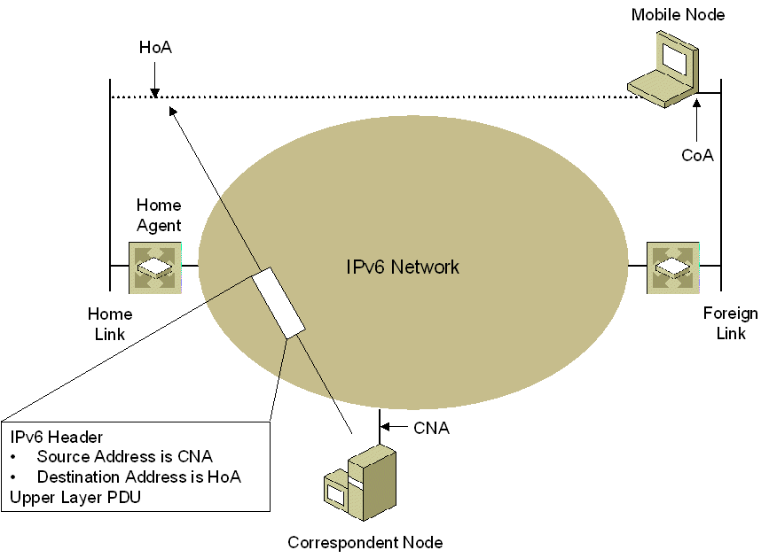
Figure 14 Data packets sent by a correspondent node to the mobile node's home address
These packets contain the following:
- IPv6 header
In the IPv6 header, the source address is the correspondent node address and the destination address is the mobile node’s home address. Because a binding cache entry does not exist, the correspondent node sends the packet as if the mobile node were physically attached to the home link.
- Upper layer PDU
The upper layer PDU contains the Application layer data sent from the correspondent node to the mobile node.
When the home agent intercepts a packet sent to a mobile node's home address, it tunnels the packet to the mobile node using the form shown in Figure 15.
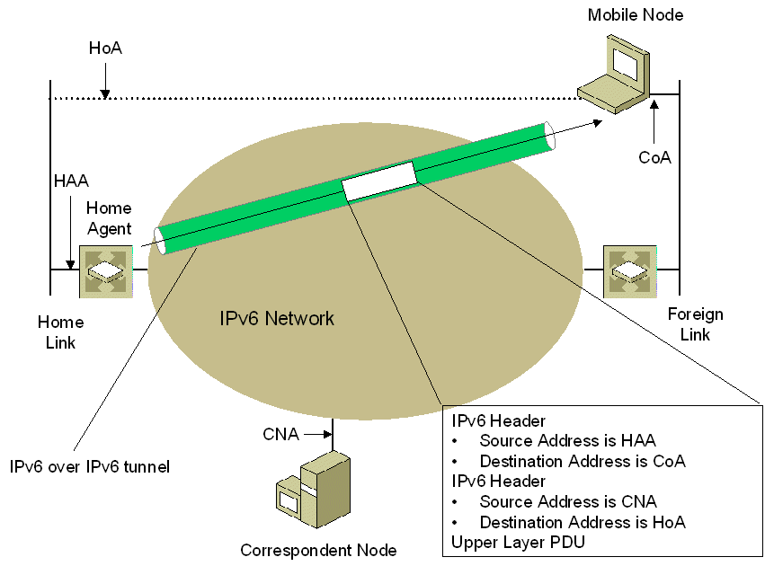
Figure 15 Intercepted packet tunneled to a mobile node by its home agent
These packets contain the following:
- IPv6 header (outer)
In the outer IPv6 header, the source address is the home agent's address on the home link and the destination address is the mobile node's care-of address.
- IPv6 header (inner)
In the inner IPv6 header, the source address is the correspondent node's address and the destination address is the mobile node's home address.
- Upper layer PDU
The upper layer PDU contains the Application layer data sent from the correspondent node to the mobile node at its home address. From the Application layer perspective, the data was addressed from the correspondent node address to the home address.
Optionally, the home agent can protect the packet by using IPSec ESP. In this case, an ESP header is placed between the outer IPv6 header and the inner IPv6 header (not shown in Figure 15).
When the correspondent registration process is not yet complete or the correspondent node is not Mobile IPv6-capable, the mobile node that is away from home sends packets to the correspondent node by tunneling them to the home agent, as shown in Figure 16.
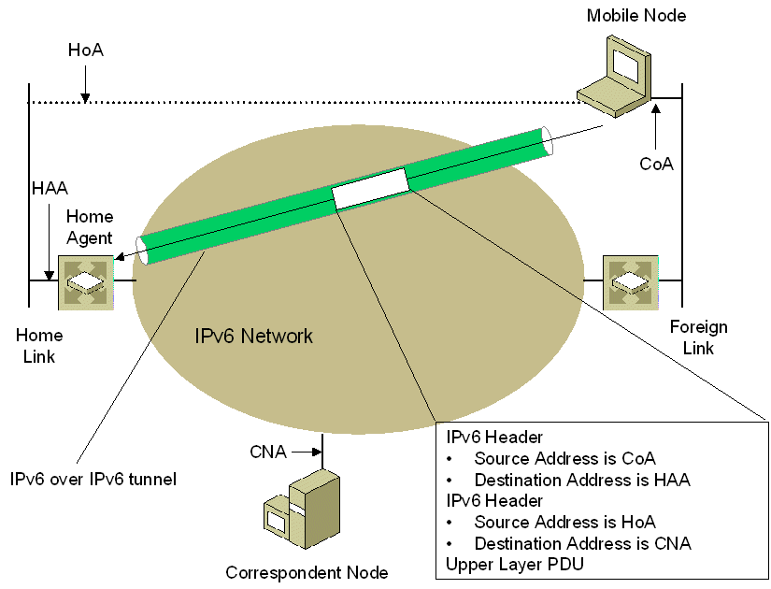
Figure 16 Tunneled packets to a home agent
These packets contain the following:
- IPv6 header (outer)
In the outer IPv6 header, the source address is the mobile node's care-of address and the destination address is the home agent's address on the home link.
- IPv6 header (inner)
In the inner IPv6 header, the source address is the mobile node's home address and the destination address is the correspondent node's address.
- Upper layer PDU
The upper layer PDU contains the Application layer data sent from the mobile node to the correspondent node.
Optionally, the mobile node can protect the packet by using IPSec ESP. In this case, an ESP header is placed between the outer IPv6 header and the inner IPv6 header (not shown in Figure 16).
The home agent forwards tunneled data packets from a mobile node that is away from home to a correspondent node using the form shown in Figure 17.
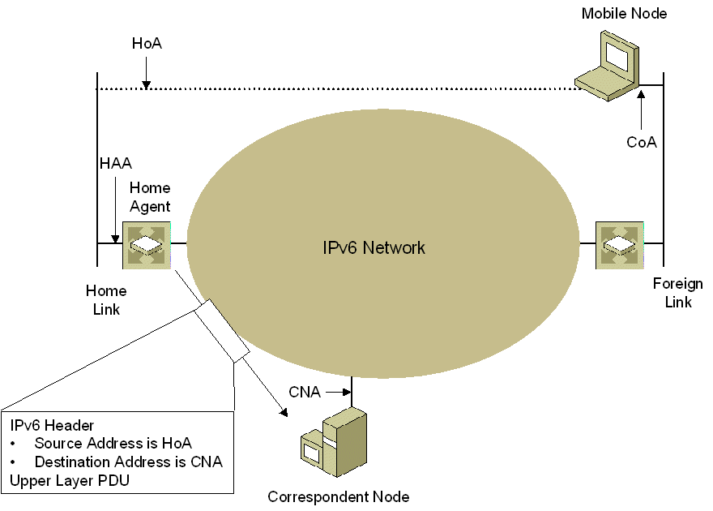
Figure 17 Forwarded packet from a home agent to a correspondent node
These packets contain the following:
- IPv6 header
The source address is the mobile node's home address and the destination address is the correspondent node's address.
- Upper layer PDU
The upper layer PDU contains the Application layer data sent from the mobile node to the correspondent node.

Direct Delivery
When the mobile node is away from home, it can choose to either send data from its home address using Mobile IPv6, or its care-of address without using Mobile IPv6, based on the following:
- For Transport layer connection data (such as TCP sessions) that is long-term and being sent to a correspondent node with which it has completed correspondent registration, the mobile node sends the data from its home address and includes the Home Address option.
- For short-term communication that does not require a logical connection, such as the exchange of Domain Name System (DNS) Name Query Request and Name Query Response messages for DNS name resolution, the mobile node can send data from its care-of address and not use a Home Address option. In this case, the mobile node is sending and receiving packets normally from its care-of address.
Figure 18 shows data packets sent directly from the mobile node to the correspondent node when the mobile node has a binding update list entry for the correspondent node's address.
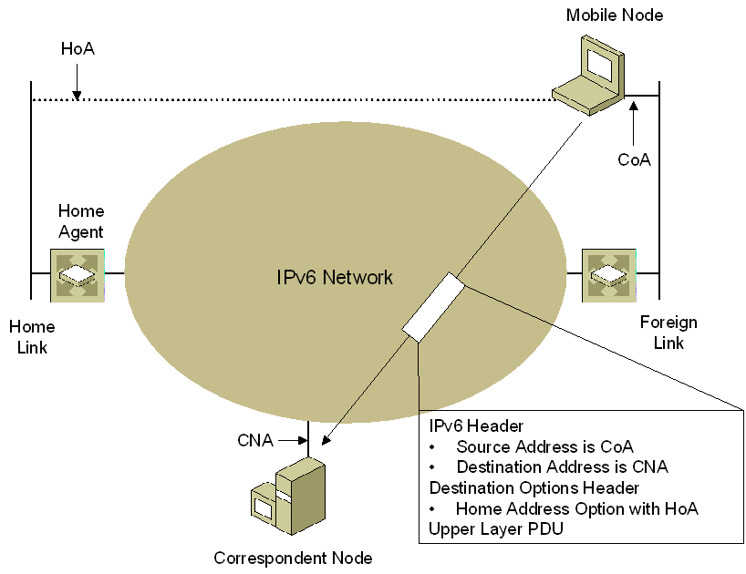
Figure 18 Data sent from the mobile node to the correspondent node
These packets contain the following:
- IPv6 header
In the IPv6 header, the source address is the mobile node's care-of address and the destination address is the correspondent node's address. By using the care-of address rather than the home address, ingress filtering by the foreign-link router does not prevent the packet from being forwarded.
- Destination Options header
In the Destination Options extension header, the Home Address option contains the home address of the mobile node. When the correspondent node processes the Home Address option, it replaces the source address of the packet with the home address.
- Upper layer PDU
The upper layer protocol data unit (PDU) contains the Application layer data sent from the mobile node to the correspondent node. From the Application layer perspective, the data was addressed from the home address to the correspondent node address.
Note The drawings in this white paper assume that the data packets being sent by the mobile node and the correspondent node do not contain additional IPv6 extension headers.
If the correspondent node is also a mobile node that is away from home, the destination address in the IPv6 header is set to the correspondent node's care-of address and the packet includes a Type 2 Routing header with the correspondent node's home address. The Type 2 Routing header is placed before the Destination Options header. This is not shown in Figure 18.
Figure 19 shows the form of data packets sent from the correspondent node to mobile node when the correspondent node has a binding cache entry for the mobile node's home address.
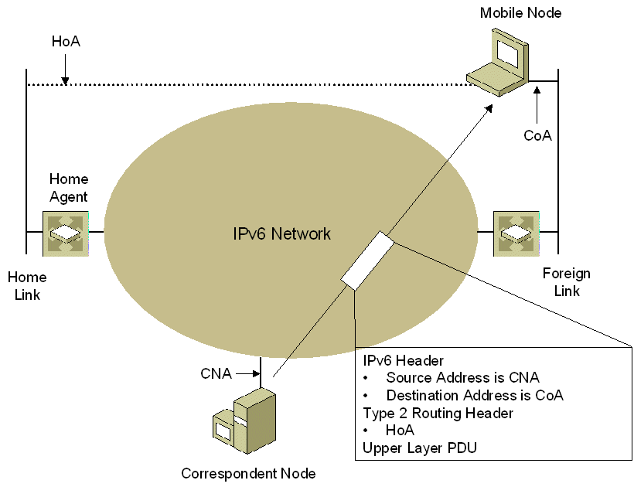
Figure 19 Data sent from the correspondent node when a binding cache entry for the mobile node is present
These packets contain the following:
- IPv6 header
In the IPv6 header, the source address is the correspondent node’s address and the destination address is the mobile node's care-of address. By using the care-of address rather than the home address, the packet is delivered to the mobile node's current location on an IPv6 network.
- Type 2 Routing header
In the Type 2 Routing header, the Home Address field is set to the mobile node's home address. When the mobile node receives the packet, it removes the Type 2 Routing header and replaces the care-of address with the home address as the destination address in the IPv6 header. When the packet is passed to the upper layer protocol, it appears to have been addressed to the mobile node's home address.
- Upper layer PDU
The upper layer PDU contains the Application layer data sent from the correspondent node to the mobile node. From the Application layer perspective, the data was addressed from the correspondent node address to the home address.
If the correspondent node is also a mobile node that is away from home, the source address in the IPv6 header is set to the correspondent node's care-of address and the packet includes a Destination Options header with the Home Address option containing the correspondent node's home address. The Destination Options header is placed after the Type 2 Routing header. This is not shown in Figure 19.

Binding Maintenance
Bindings with the home agent and the correspondent node must be created, refreshed, and when the mobile node returns home, removed. Bindings must be maintained with the home agent and with correspondent nodes.

Home Agent Binding Maintenance
Figure 20 shows Binding Update messages sent from the mobile node to the home agent for home registration.
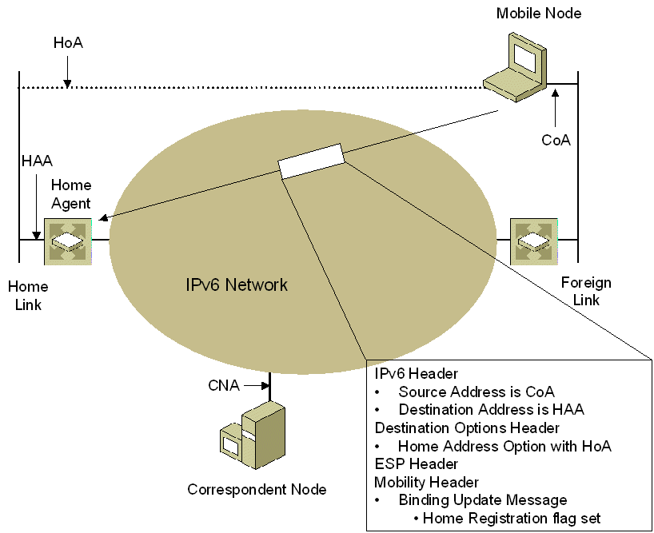
Figure 20 Binding updates sent from the mobile node to the home agent
The packets contain the following:
- IPv6 header
In the IPv6 header, the source address is the mobile node's care-of address and the destination address is the home agent's address. By using the care-of address rather than the home address, ingress filtering by the foreign-link router does not prevent the packet from being forwarded.
- Destination Options header
The Destination Options extension header contains the Home Address option. By including the Home Address option, the home address for the binding is indicated to the home agent.
- ESP header
An IPSec ESP header is used to provide data integrity protection, data origin authentication, data confidentiality, and replay protection for the Binding Update message.
- Mobility header
The Mobility header contains the Binding Update message with the Home Registration (H) flag set to 1, indicating that the sender is requesting that the receiver be the home agent for the mobile node. The Acknowledgement (A) flag is also set to 1 to request a binding acknowledgement from the home agent.
Binding maintenance messages sent from the home agent to the mobile node are either binding acknowledgments or binding refresh requests and are shown in Figure 21.
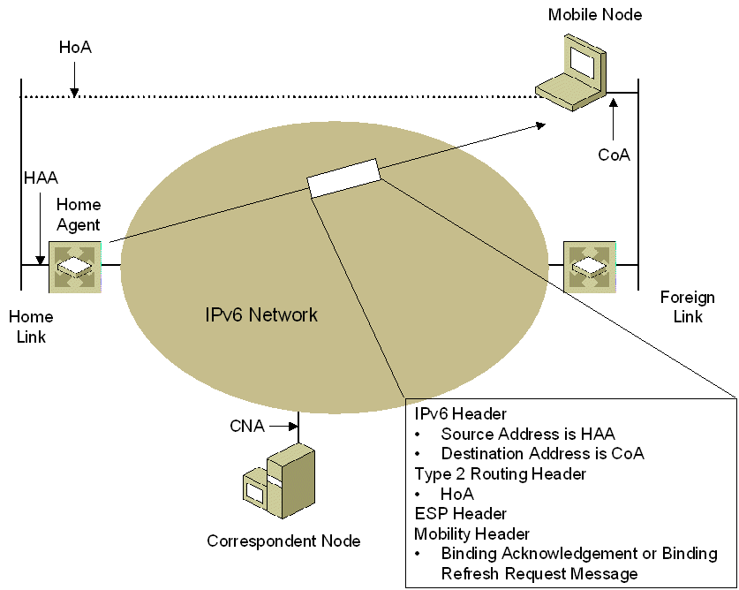
Figure 21 Binding maintenance packets sent from the home agent to the mobile node
These packets contain the following:
- IPv6 header
In the IPv6 header, the source address is the home agent's address and the destination address is the mobile node's care-of address.
- Type 2 Routing header
The Type 2 Routing header contains the mobile node's home address. The mobile node removes the Type 2 Routing header and logically replaces the care-of address with the home address as the destination in the IPv6 header.
- ESP header
An ESP header is used to provide data integrity protection, data origin authentication, replay protection, and data confidentiality for the binding acknowledgments or binding refresh requests.
- Mobility header
The Mobility header contains either a Binding Acknowledgement message (sent in response to a binding update) or a Binding Refresh Request message.

Correspondent Node Binding Maintenance
Figure 22 shows Binding Update messages sent from the mobile node to the correspondent node as part of correspondent registration.
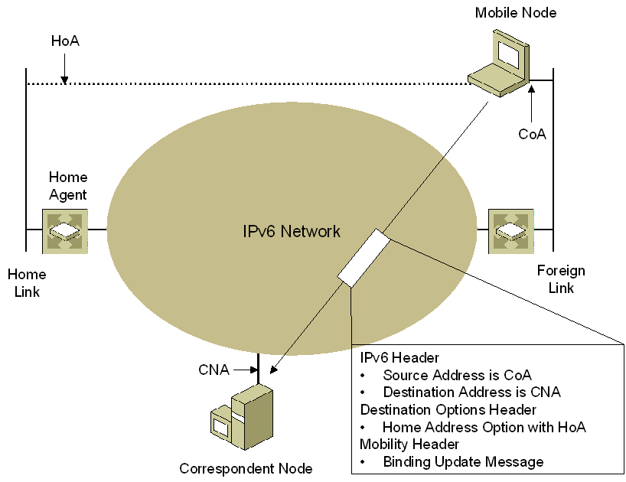
Figure 22 Binding updates sent from the mobile node to the correspondent node
These packets contain the following:
- IPv6 header
In the IPv6 header, the source address is the mobile node's care-of address and the destination address is the correspondent node's address. By using the care-of address rather than the home address, ingress filtering by the foreign link router does not prevent the packet from being forwarded.
- Destination Options header
The Destination Options extension header contains the Home Address option. By including the Home Address option, the home address for the binding is indicated to the correspondent node.
- Mobility header
The Mobility header contains the Binding Update message, which contains the cryptographic proof that the mobile node has knowledge of the binding management key derived from the Return Routability procedure performed with the correspondent node.
If the correspondent node is also a mobile node that is away from home, the destination address in the IPv6 header is set to the correspondent node's care-of address and the packet includes a Type 2 Routing header with the correspondent node's home address. The Type 2 Routing header is placed before the Destination Options header. This is not shown in Figure 22.
Binding maintenance messages sent from the correspondent node to the mobile node are either binding acknowledgments or binding refresh requests and are shown in Figure 23.
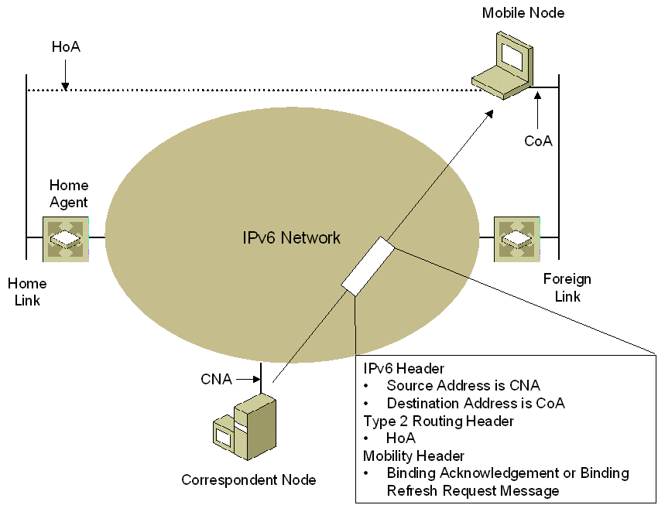
Figure 23 Binding maintenance packets sent from the correspondent node to the mobile node
These packets contain the following:
- IPv6 header
In the IPv6 header, the source address is the correspondent node's address and the destination address is the mobile node's care-of address.
- Type 2 Routing header
In the Type 2 Routing header, the Home Address field is set to the mobile node's home address. When the mobile node receives the packet, it removes the Type 2 Routing header and replaces the care-of address with the home address as the destination address in the IPv6 header. When the packet is passed to the upper layer protocol, it appears to have been addressed to the mobile node's home address.
- Mobility header
The Mobility header contains either a Binding Acknowledgement message (if a received binding request had the Acknowledgement [A] flag set to 1) or a Binding Refresh Request message.
If the correspondent node is also a mobile node that is away from home, the source address in the IPv6 header is set to the correspondent node's care-of address and the packet includes a Destination Options header with a Home Address option containing the correspondent node's home address. The Destination Options header is placed after the Type 2 Routing header. This is not shown in Figure 23.

Home Agent Discovery
When the mobile node sends an ICMPv6 Home Agent Address Discovery Request message, it has the form shown in Figure 24.
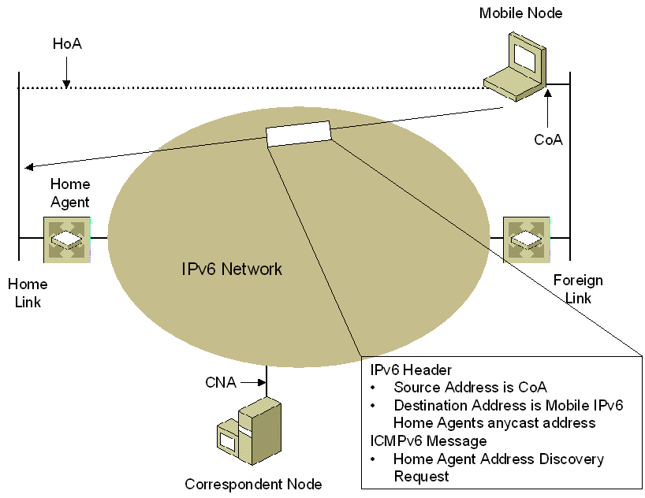
Figure 24 ICMPv6 Home Agent Address Discovery Request message sent from the mobile node
These packets contain the following:
- IPv6 header
In the IPv6 header, the source address is the care-of address of the mobile node and the destination address is the Mobile IPv6 Home Agents anycast address corresponding to the home link prefix.
- ICMPv6 Home Agent Address Discovery Request message
The mobile node uses the ICMPv6 Home Agent Address Discovery Request message to query the home link for a list of home agents. For more information, see the "ICMPv6 Messages" section in this white paper.
When the home agent sends an ICMPv6 Home Agent Address Discovery Reply message, in response to an ICMPv6 Home Agent Address Discovery Request message, it has the form shown in Figure 25.
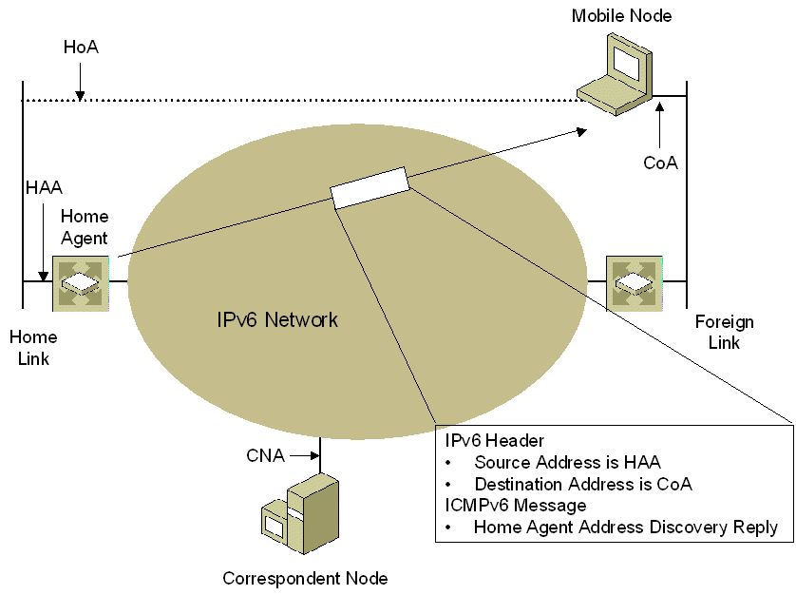
Figure 25 ICMPv6 Home Agent Address Discovery Reply message sent from the home agent
These packets contain the following:
- IPv6 header
In the IPv6 header, the source address is the home agent's address and the destination address is the mobile node's care-of address.
- ICMPv6 Home Agent Address Discovery Reply message
The ICMPv6 Home Agent Address Discovery Reply message contains the list of home agents on the home link in order of preference. For more information, see the "ICMPv6 Messages" section in this white paper.

Mobile Prefix Discovery
When the mobile node sends an ICMPv6 Mobile Prefix Solicitation message, it has the form shown in Figure 26.
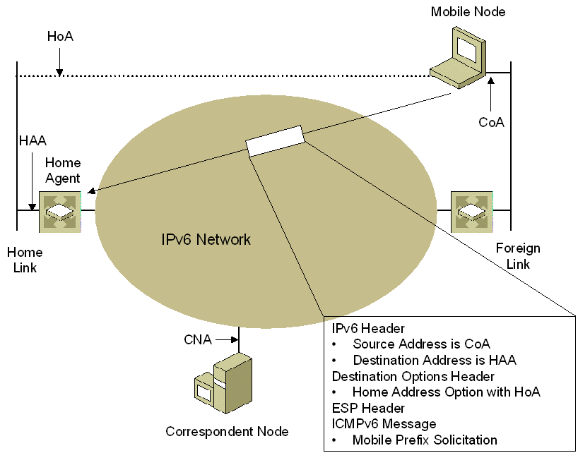
Figure 26 ICMPv6 Mobile Prefix Solicitation message sent from the mobile node
These packets contain the following:
- IPv6 header
In the IPv6 header, the source address is the care-of address of the mobile node and the destination address is the home agent's global address on the home link.
- Destination Options header
The Destination Options extension header contains the Home Address option. By including the Home Address option, the home address for the binding is indicated to the home agent.
- ESP header
An ESP header is used to provide data confidentiality, data integrity protection, and data origin authentication, and replay protection for the ICMPv6 Mobile Prefix Solicitation message.
- ICMPv6 Mobile Prefix Solicitation message
The mobile node uses the ICMPv6 Mobile Prefix Solicitation message to query its home agent for the current home subnet prefix. For more information, see the "ICMPv6 Messages" section in this white paper.
When the home agent sends an ICMPv6 Mobile Prefix Advertisement message, in response to a Mobile Prefix Solicitation message or periodically to refresh the mobile node's home address, it has the form shown in Figure 27.
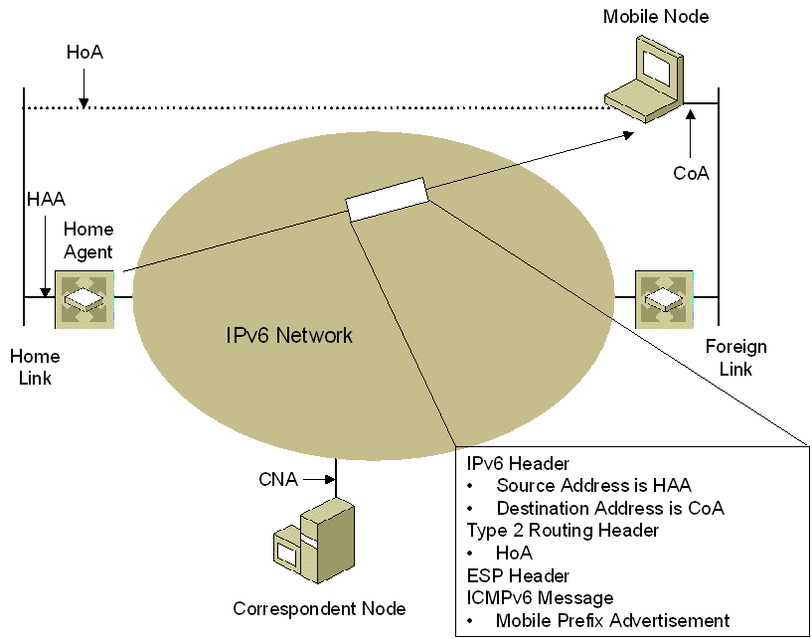
Figure 27 ICMPv6 Mobile Prefix Advertisement message sent from the mobile node
These packets contain the following:
- IPv6 header
In the IPv6 header, the source address is the home agents' address on the home link and the destination address is the mobile node's care-of address.
- Type 2 Routing header
The Type 2 Routing header contains the mobile node's home address. The mobile node removes the Type 2 Routing header and logically replaces the care-of address with the home address as the destination in the IPv6 header.
- ESP header
An ESP header is used to provide data confidentiality, data integrity protection, data origin authentication, replay protection, and replay protection for the ICMPv6 Mobile Prefix Advertisement message.
- ICMPv6 Mobile Prefix Advertisement message
The ICMPv6 Mobile Prefix Solicitation message contains the current home subnet prefix. For more information, see the "ICMPv6 Messages" section in this white paper.

Mobile IPv6 Processes
Mobile IPv6 provides a method for a mobile node to determine it is on its home link and message exchanges for the following processes:
- Moving from the home link to a foreign link
- Moving from a foreign link to another foreign link
- Returning home
Additionally, the sending host and receiving host processes are modified to include special processing for mobility support.
Note This section assumes that the correspondent node is not a mobile node that is away from home.

Attaching to the Home Link
The method used by a mobile node to determine that it is attached to the home link is not defined in RFC 3775. Once a mobile node determines that it is connected to its home link, it can store the home subnet prefix, home address, and the global address of their home agent. The following methods for configuring home link parameters are based on implementations in development or existence at the time of the writing of this white paper:
- Manual configuration
In the simplest case, the home subnet prefix, home address, and the address of the home agent are manually configured, typically through a keyboard-based command, and are permanent until manually changed. These implementations do not support the dynamic discovery of home agents or changes in the home subnet prefix.
- Pseudo-automatic configuration
For pseudo-automatic configuration, when an IPv6 node is attached to a link, the user has the option (typically through a button in the user interface of the operating system) to indicate to the IPv6 protocol that the node is now connected to the home link. Based on this indication, the IPv6 protocol stores the home subnet link prefix and home address and listens for additional router advertisements containing the Home Agent (H) flag set to 1. The home agent is the router advertising itself with home agent capabilities and has the highest preference level. Once determined, the IPv6 protocol stores the address of the home agent. These implementations may or may not support the dynamic discovery of home agents or changes in the home subnet prefix.
- Automatic configuration
With automatic configuration, the IPv6 node is always listening for router advertisements with the H flag set to 1. Based on additional protocol or operating system parameters, the IPv6 node determines that it is potentially on its home link. Next, it chooses the most preferred home agent and attempts to establish a security relationship with it. If the security relationship with the home agent fails, the IPv6 node must not be on its home link. If the security relationship succeeds, the IPv6 node is on its home link and stores its home subnet prefix, its home address, and the address of its home agent. These implementations may or may not support the dynamic discovery of home agents or changes in the home subnet prefix.

Moving From the Home Link to a Foreign Link
When the mobile node is at home, it autoconfigures its home address through the receipt of a router advertisement, and communication with other nodes occurs normally without the use of Mobile IPv6 functionality.

Attaching to the Foreign Link
When the mobile node attaches to the foreign link, it must perform the following functions:
- Receive a new care-of address.
- Discover a home agent on the home link (if needed).
- Register the primary care-of address with the selected home agent on the home link.
When the mobile node attaches to the foreign link, the following occurs:
- The mobile node sends a multicast Router Solicitation message on the foreign link. The mobile node might send a router solicitation either because the link layer indicated a media change or because the node received a router advertisement that contains a new prefix. Depending on the Mobile IPv6 implementation, the mobile node sends a router solicitation either from its link-local address (assuming that the link-local address of the mobile node is most likely unique on the foreign link) or from the unspecified address (::) (assuming that the link-local address of the mobile might not be unique on the foreign link).
- All routers on the foreign link reply with a Router Advertisement message. Depending on the source address of the Router Solicitation message, the reply is either unicast (because the Router Solicitation was sent from a link-local address) or multicast (because the router solicitation was sent from the unspecified address). Figure 28 shows the router advertisement being unicast to the mobile node. The stateless autoconfiguration and registration of solicited node multicast addresses on the foreign link introduces some latency in the process of obtaining a valid care-of address.
From the receipt of the Router Advertisement message(s), the mobile node determines that it has connected to a foreign link because the router advertisements contain new network prefixes. The mobile node forms care-of addresses from the advertised prefixes, verifies their uniqueness by using duplicate address detection, and joins the corresponding solicited node multicast groups (not shown in Figure 28).
- If the mobile node is already configured with the address of its home agent, go to step 5. If not, to determine the address of a home agent on the mobile node's home link, the mobile node uses the home agent discovery process.
Mobile nodes do not maintain a list of home agents while connected to the home link. To automatically discover the home agents on the home link, it is sufficient for the mobile node to learn its home subnet prefix. When the mobile node that uses automatic configuration of home agents leaves its home link and moves to the first foreign link, it sends an ICMPv6 Home Agent Address Discovery Request message to the Mobile IPv6 Home Agents anycast address formed from the home subnet prefix.
- A home agent on the home link that is using the Mobile IPv6 Home Agents anycast address corresponding to the home subnet prefix and is topologically closest to the mobile node receives the ICMPv6 Home Agent Address Discovery Request message. Next, it sends back an ICMPv6 Home Agent Address Discovery Reply message containing the entries in the home agent's home agent list in preference order.
Upon receipt of the ICMPv6 Home Agent Address Discovery Reply message, the mobile node selects the first home agent in the list as its home agent.
- Before the binding update is sent, an IPSec security association (SA) must be created between the mobile node and the home agent. If the mobile node and the home agent support the use of Internet Key Exchange (IKE) for Mobile IPv6, then an IKE negotiation takes place to create SAs for the ESP protection of packets sent between the mobile node and the home agent. The IKE negotiation is not shown in Figure 28.
If the mobile node and the home agent support the sending of binding updates without IPSec protection or the manual configuration of an IPSec SA, then this step is skipped.
- To register the primary care-of address with the home agent, the mobile node sends the home agent a binding update. In the binding update, the Home Registration (H) and Acknowledgement (A) flags are set.
- The home agent receives the binding update and updates its binding cache. To intercept packets destined for the mobile node's home address while the mobile node is away from home, the home agent performs duplicate address detection and proxy ND for the mobile node by answering neighbor solicitations on behalf of the mobile node. Depending on the implementation, the home agent might send an unsolicited multicast Neighbor Advertisement message as if it were the mobile node immediately or only respond to multicast neighbor solicitations for the mobile node’s home address. The duplicate address detection and proxy ND introduces an additional latency in the home registration process.
In the first case, to ensure that the nodes on the home link are updated with the new link-layer address of the home agent's interface on the home link, the home agent sends an unsolicited multicast Neighbor Advertisement message to the link-local scope all-nodes multicast address (FF02::1) with the Override (O) flag set to 1. Additionally, the home agent joins the multicast group for the solicited node multicast address corresponding to the mobile node's home address, and registers interest in receiving link-layer multicast frames to the multicast MAC address corresponding to the solicited node multicast address. This is shown in Figure 28.
In the second case, the home agent does not send an unsolicited multicast Neighbor Advertisement message. However, the home agent does join the multicast group for the solicited node multicast address corresponding to the mobile node's home address, and registers interest in receiving link-layer multicast frames to the multicast MAC address corresponding to the solicited node multicast address. If a node on the home link was communicating with the mobile node while it was at home, neighbor unreachability detection would eventually cause the home node to send 3 unicast neighbor solicitations (while in the PROBE state) and then send a multicast neighbor solicitation. The home agent answers the multicast neighbor solicitation on behalf of the mobile node. This is not shown in Figure 28.
If the mobile node has set the Link-Local Address Compatibility (L) flag in the binding update to 1, the home agent also performs duplicate address detection and proxy ND for the link-local address associated with the interface identifier (the last 64 bits) of the mobile node's home address.
- Because the binding update has the A flag set to 1, the home agent responds with a binding acknowledgement.
This process is shown in Figure 28.
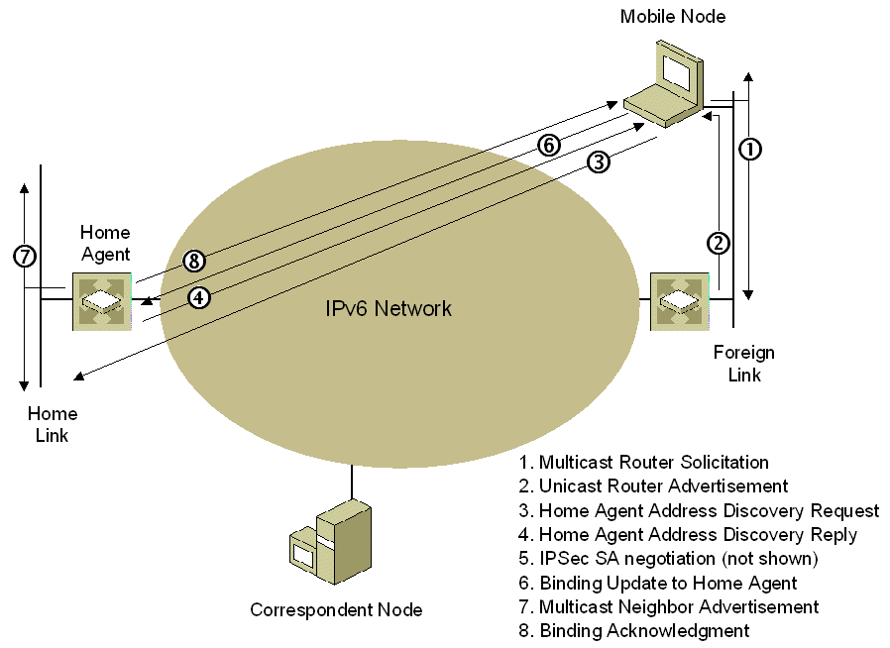
Figure 28 Mobile node attaching to the first foreign link
Because there are no entries in the binding update list, the mobile node does not send a binding update to all the nodes with which the mobile node was communicating when connected to the home link. The mobile node relies on subsequent data sent on existing connections or the receipt of traffic tunneled via the home agent to initiate correspondent registration with correspondent nodes.

Mobile Node Initiates Communication with a New Correspondent Node
When a mobile node initiates communication with a new correspondent node (a node for which no binding exists), it must perform a correspondent registration, which consists of the Return Routability procedure and the exchange of Binding Update and Binding Acknowledgement messages. Although this process must occur for any kind of communication that is initiated by a mobile node that is away from home, the following example is for a TCP connection.
When a mobile node that is away from home initiates a new TCP connection with a correspondent node, the following occurs:
- The mobile node begins the TCP connection by sending the initial TCP SYN (synchronize) segment to the correspondent node, tunneled via the home agent. Subsequent TCP handshake segments and the initial data communication between the mobile node and the correspondent node are sent using bidirectional tunneling until the correspondent registration is complete (see step 5). This is done so that the application that is attempting to communicate does not have to wait until the correspondent registration is complete before it can begin communicating.
- The mobile node adds an entry for the correspondent node to its binding update list and performs the Return Routability procedure with the correspondent node to determine the binding management key for binding management (not shown in Figure 29).
- The mobile node sends a Binding Update message to the correspondent node with the Acknowledgement (A) flag set to 1.
- The correspondent node updates its binding cache and sends a Binding Acknowledgement message back to the mobile node.
- After the correspondent registration is complete, subsequent TCP segments on the connection are sent directly between the mobile node and the correspondent node.
This process is shown in Figure 29.
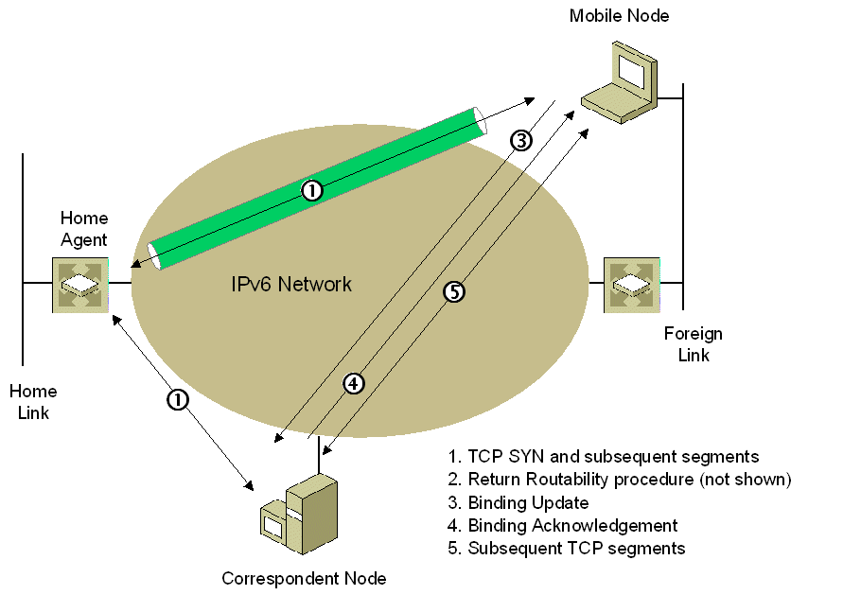
Figure 29 A mobile node initiating a new TCP connection with a new correspondent node
If the mobile node is resuming communication on an existing TCP connection, then the TCP segments of the continuing communication are bidirectionally tunneled until the correspondent registration is complete.
After correspondent registration is complete, data between the correspondent node and the mobile node is sent as follows:
- Data from the mobile node is sent from the mobile node's care-of address to the correspondent node's address and includes the Home Address option in the Destination Options header.
- Data from the correspondent node is sent to the mobile node's care-of address and includes a Type 2 Routing header containing the mobile node's home address.
Note If the mobile node is multihomed, it is possible for the mobile node to register different care-of addresses with different correspondent nodes. Which care-of address is chosen depends on the source address selection algorithm. The mobile node chooses the care-of address that is matched in scope and is topologically closest to the correspondent node.

A New Correspondent Node Communicates with a Mobile Node
When a new correspondent node either resumes communication or initiates communication with a mobile node using the mobile node's home address and the mobile node is away from home, the following occurs:
- The correspondent node begins the TCP connection by sending the initial TCP SYN segment to the mobile node, tunneled via the home agent. Subsequent TCP handshake segments and the initial data communication between the correspondent node and the mobile node are sent using bidirectional tunneling until the correspondent registration is complete (see step 5). This is done so that the application that is attempting to communicate does not have to wait until the correspondent registration is complete before it can begin communicating.
- The mobile node adds an entry for the correspondent node to its binding update list and initiates the Return Routability procedure (not shown in Figure 30).
- After the Return Routability procedure is complete, the mobile node sends the correspondent node a Binding Update message with the A flag set to 1.
- Upon receipt of the Binding Update message, the correspondent node updates its binding cache and sends back a Binding Acknowledgement message.
- After the correspondent registration is complete, subsequent TCP segments on the connection are sent directly between the mobile node and the correspondent node.
Because the TCP connection creation occurs separately from the correspondent registration, the subsequent segments in the TCP handshake (the SYN Acknowledge [ACK] and ACK segments) and the ensuing application data sent over the TCP connection are bidirectionally tunneled until the correspondent registration is complete.
This process is shown in Figure 30.
Figure 30 A new correspondent node communicating with a mobile node
After this process is complete, data between the correspondent node and the mobile node is sent as follows:
- Data from the mobile node is sent from the care-of address to the correspondent node's address and includes the Home Address option in the Destination Options header.
- Data from the correspondent node is sent to the mobile node's care-of address and includes a Type 2 Routing header containing the mobile node's home address.
If the upper-layer session is idle and no packets are sent for a while, the binding cache entry may expire. When the communication resumes, the same process is performed starting from step 1.

A Node on the Home Link Communicates with the Mobile Node
When a node on the home link either resumes or initiates communication with a mobile node using the mobile node's home address and the mobile node is away from home, the following occurs (example assumes a new TCP connection):
- The node on the home link sends a multicast Neighbor Solicitation message to the solicited node multicast address corresponding to the mobile node's home address.
- The home agent is acting as an ND proxy for the mobile node. It has registered the solicited node multicast address corresponding to the mobile node's home address as a multicast address to which it is listening. The home agent receives the neighbor solicitation and sends a unicast neighbor advertisement containing the home agent's link-layer address.
- The initial TCP SYN segment and subsequent TCP segments are sent between the node on the home link and the home agent using each other's link-layer address.
- The TCP segments are tunneled to and from the mobile node. The bidirectional tunneling of TCP segments continues until the correspondent registration is complete (see step 5)
- Upon receipt of the initial tunneled TCP SYN segment from the home agent, the mobile node performs a Return Routability procedure with the node on the home link (not shown in Figure 31).
- The mobile node sends the node on the home link a Binding Update message.
- The node on the home link sends a Binding Acknowledgement message.
- After the correspondent registration is complete, subsequent TCP segments on the connection are sent directly between the mobile node and the node on the home link.
This process is shown in Figure 31.
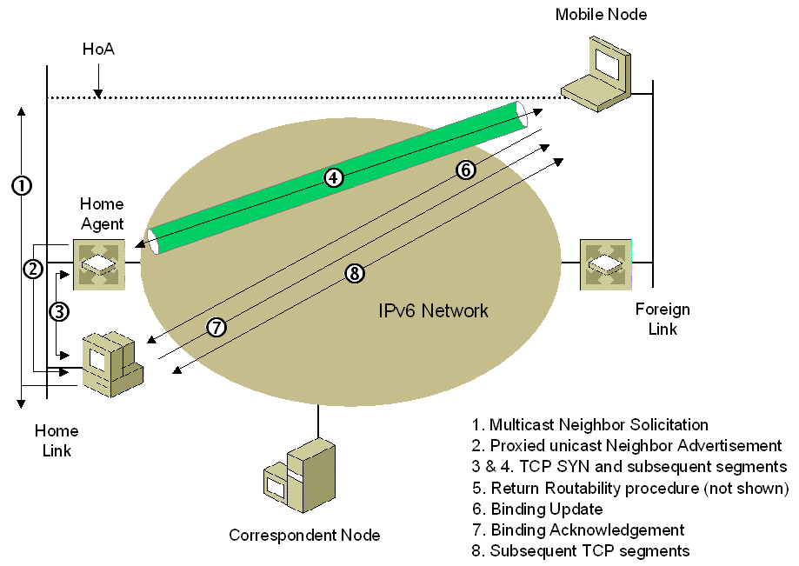
Figure 31 A node on the home link communicating with the mobile node
As previously described in "A New Correspondent Node Communicates with a Mobile Node," because the TCP connection creation occurs separately from the correspondent registration, the subsequent segments in the TCP handshake (the SYN ACK and ACK segments) and the ensuing application data sent over the TCP connection are sent indirectly via the home agent until the correspondent registration is complete.
This same process of intercepting a packet for the mobile node (steps 1 through 3) is also used when a packet addressed to the mobile node’s home address is delivered to the home link by a router that is not the mobile node’s home agent.

Mobile Node Changes its Home Address
To refresh a home address that is approaching the end of its valid lifetime or to receive a new home address following a change in the home subnet prefix, the following process is used:
- The mobile node sends an ICMPv6 Home Prefix Solicitation message to the home agent.
- The home agent sends back an ICMPv6 Home Prefix Advertisement message.
Upon receipt of the Home Prefix Advertisement message, the mobile node examines the Prefix Information option. If there is no change in the home subnet prefix and therefore no change in the home address, the mobile node refreshes the valid and preferred lifetimes of the stateless home address and this process ends.
If there is a change in the home subnet prefix, the mobile node must refresh the bindings at the home agent and all of the correspondent nodes in its binding update list.
- To register the new home address with the home agent, the mobile node sends the home agent a binding update. In the binding update, the Home Registration (H) and Acknowledgement (A) flags are set to 1.
- The home agent sends a binding acknowledgement.
- The mobile node must perform a new correspondent registration with each correspondent in its binding update list. Therefore, a Return Routability procedure is performed (not shown in Figure 32) with each correspondent node in the binding update list. Because only the path associated with the home address has changed, only the HoTI and HoT messages are exchanged.
- After the Return Routability procedure is successful, the mobile node sends a binding update to each correspondent node.
- Upon the receipt of the binding update, the correspondent node updates its binding cache and sends a binding acknowledgment.
This process is shown in Figure 32.
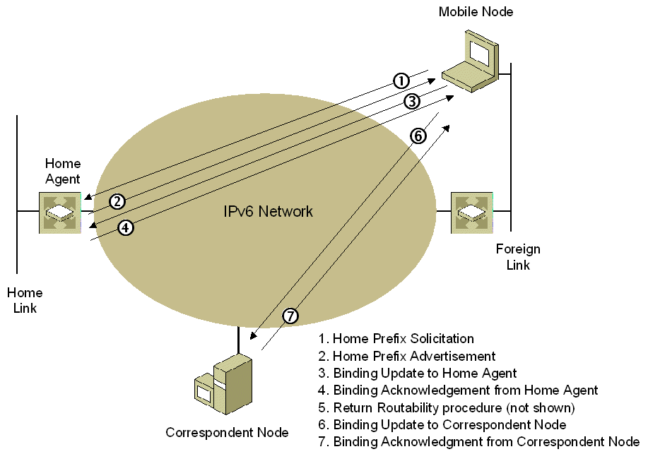
Figure 32 A mobile node changing its home address

Moving to a New Foreign Link
When the mobile node attaches to a new foreign link after being attached to another foreign link, it must perform the following functions:
- Receive a new care-of address.
- Register the new care-of address with its home agent.
- Send binding updates to all correspondent nodes.
When the mobile node attaches to the new foreign link, the following occurs:
- The mobile node sends a multicast Router Solicitation message on the new foreign link. Depending on the Mobile IPv6 implementation, the mobile node sends the router solicitation either from its link-local address (assuming that the link-local address of the mobile node is most likely unique on the new foreign link) or from the unspecified address (::) (assuming that the link-local address of the mobile might not be unique on the new foreign link).
- All routers on the new foreign link reply with a Router Advertisement message. Depending on the source address of the Router Solicitation message, the reply is either unicast (because the router solicitation was sent from a link-local address) or multicast (because the router solicitation was sent from the unspecified address). Figure 33 shows the Router Advertisement message being unicast to the mobile node.
From the receipt of the Router Advertisement message(s), the mobile node forms care-of address(es), verifies their uniqueness by using duplicate address detection, and joins the corresponding solicited node multicast groups (not shown in Figure 33).
- To register the new primary care-of address with the home agent, the mobile node sends the home agent a binding update. In the binding update, the Home Registration (H) and Acknowledgement (A) flags are set.
- The home agent sends a binding acknowledgement.
- The mobile node must perform a new correspondent registration with each correspondent in its binding update list. Therefore, a Return Routability procedure is performed (not shown in Figure 33). Because only the path to the care-of address has changed, only the exchange of CoTI and CoT messages is performed.
- After the Return Routability procedure is successful, the mobile node sends a binding update to the correspondent node.
- Upon the receipt of the binding update, the correspondent node updates its binding cache and, if requested by the mobile node, sends a binding acknowledgment.
This process is shown in Figure 33.
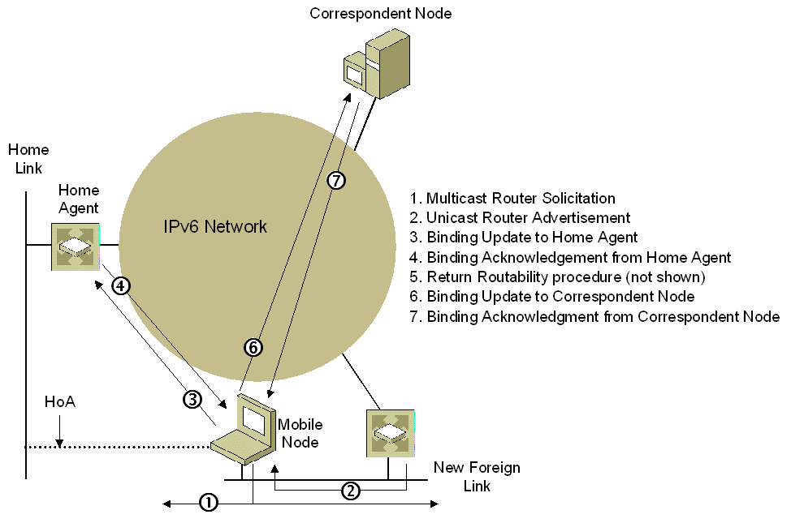
Figure 33 A mobile node attaching to a new foreign link
If the binding update sent by the mobile node to a correspondent node is dropped from the network, the correspondent node continues to send packets to the mobile node’s previous care-of address based on the contents of its now outdated binding cache entry. The packets are forwarded to the previous foreign link and the router on the previous foreign link attempts to deliver them. If the previous foreign link router still considers the mobile node reachable on the previous foreign link, packets are forwarded to the mobile node’s link layer address. Because the mobile node is no longer attached to the previous foreign link, the packets are dropped.
The methods for correcting this error condition are the following:
- The mobile node, after not receiving a binding acknowledgment from the correspondent node, retransmits a binding update. The correspondent node receives the retransmitted binding update and its binding cache is updated with the mobile node’s new care-of address.
- The previous foreign link router uses neighbor unreachability detection to determine that the mobile node is no longer attached to the previous foreign link. For a point-to-point link such as a wireless connection, the unreachability of the mobile node is indicated immediately by the lack of a wireless signal from the mobile node. For a broadcast link such as an Ethernet segment, the entry in the previous foreign link router’s neighbor cache goes through the REACHABLE, STALE, DELAY, and PROBE states. After the neighbor cache entry for the mobile node is removed, attempts to deliver to the mobile node’s previous care-of address are unsuccessful and the previous foreign link router will send an ICMPv6 Destination Unreachable-Address Unreachable message to the correspondent node. Upon receiving this message, the correspondent node will remove the entry for the mobile node from its binding cache and communication resumes as described in the “A New Correspondent Node Communicates with a Mobile Node” section of this white paper.
- All binding cache entries have a finite lifetime as determined by the Lifetime field of the last received binding update and the correspondent node’s local policy. After the lifetime expires, the binding cache entry is removed and communication resumes as described in the “A New Correspondent Node Communicates with a Mobile Node” section of this white paper. Alternately, the correspondent node can send a binding refresh request before the binding cache entry expires. When there is no response to the binding refresh request, the correspondent node removes the entry from the binding cache.

Returning Home
When the mobile node attaches to its home link after being away from home, it must perform the following functions:
- Send a binding update to the home agent to delete the binding for the mobile node.
- Inform home link nodes that the correct link-layer address for the home address is now the mobile node's link-layer address.
- Send binding updates to all correspondent nodes to delete the binding for the mobile node.
When the mobile node returns home (reattaches to its home link), the following occurs:
- The mobile node sends a multicast Router Solicitation message on the home link. The mobile node might send a router solicitation either because the link layer indicated a media change or because the node received a router advertisement that contains a new prefix. Depending on the Mobile IPv6 implementation, the mobile node sends a router solicitation either from its link-local address (assuming that the link-local address of the mobile node is most likely unique on the new link) or from the unspecified address (::) (assuming that the link-local address of the mobile might not be unique on the new link).
- All routers on the home link reply with a Router Advertisement message. Depending on the source address of the Router Solicitation message, the reply is either unicast (because the router solicitation was sent from a link-local address) or multicast (because the router solicitation was sent from the unspecified address). Figure 34 shows the Router Advertisement message being unicast to the mobile node.
Because the router advertisement contains the address prefix that matches its home address prefix, the mobile node determines that it is attached to its home link. Depending on the Mobile IPv6 implementation, the mobile node may or may not perform duplicate address detection for its home address because the home agent is acting as an ND proxy for the mobile node and defending the use of the mobile node's home address. If the mobile node does perform duplicate address detection, it must ignore the Neighbor Advertisement message sent from the home agent.
- To remove the binding cache entry from the home agent, the mobile node sends the home agent a binding update with the care-of address set to the mobile node's home address and with the Home Registration (H) and Acknowledge (A) flags set.
If multiple router advertisements are received, the mobile node can determine which router is its home agent from the router advertisement with the Prefix Information option that contains the home agent's global address in the Prefix field.
The mobile node determines the home agent's link-layer address from the Link-Layer Address field in the Source Link-Layer Address option in the router advertisement sent by the home agent. If the Source Link-Layer Address option is not included, the mobile node can determine the link-layer address of the home agent using address resolution because the global address of the home agent is known.
- Upon receipt of the binding update, the home agent removes the entry for the mobile node from its binding cache, stops defending the use of the mobile node's home address on the home link, and responds with a binding acknowledgement. This is shown in Figure 34. Additionally, the home agent leaves the multicast group for the solicited node multicast address corresponding to the mobile node's home address and stops listening for link-layer multicast frames addressed to the multicast MAC address corresponding to the solicited node multicast address.
- After receiving the binding acknowledgement from the home agent, the mobile node must inform nodes on the home link that the link-layer address for the home address has changed to the link-layer address of the mobile node. It sends an unsolicited multicast Neighbor Advertisement message to the link-local scope all-nodes multicast address (FF02::1) with the Override (O) flag set to 1.
The mobile node also joins the multicast group for the solicited node multicast address corresponding to the mobile node's home address and registers interest in receiving link-layer multicast frames to the multicast MAC address corresponding to the solicited node multicast address (not shown in Figure 34).
- Before sending a binding update to each correspondent node mobile node's binding update list to delete the binding for the mobile node, it performs a Return Routability procedure (not shown in Figure 34). Since the home address and the mobile’s new address are that same, it is sufficient to exchange only the HoTI and HoT messages. The CoTI and CoT messages are not sent when the mobile returns home.
- The mobile node sends a binding update to each correspondent node with the care-of address set to the mobile node's home address.
- Upon receipt of the binding update, the correspondent nodes remove the entry for the mobile node in their binding cache and send a binding acknowledgment.
This process is shown in Figure 34.
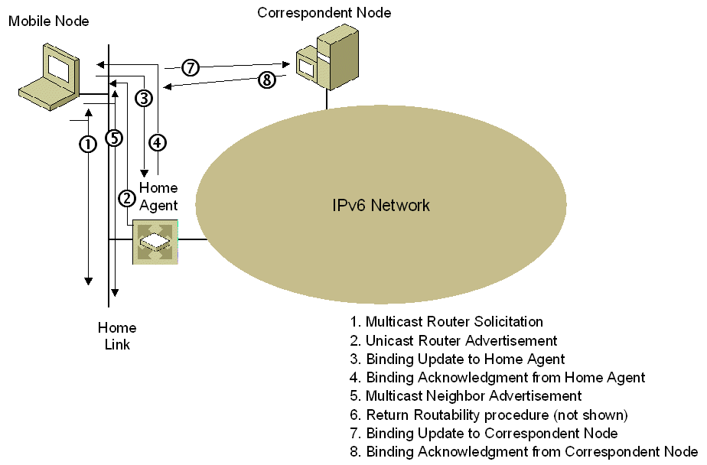
Figure 34 A mobile node returning home

Mobile IPv6 Host Sending Algorithm
The IPv6 host sending algorithm is described in the "Neighbor Discovery" section of the "Introduction to IPv6" white paper. However, the description does not include Mobile IPv6 functionality for the sending or receiving hosts. A Mobile IPv6 node can be both a mobile node and correspondent node at the same time. Therefore, the host sending algorithm for a Mobile IPv6 node must take into account the following:
- If the sending host is away from home
If so, the sending host must set the source address of the IPv6 header to the sending host's care-of address and include the Destination Options header with the Home Address option set to the node's home address.
- If the receiving node is away from home
If so, the sending host must set the destination address of the IPv6 header to the destination node's care-of address and include a Type 2 Routing header with the Home Address field set to the destination node's home address.
The sending host must also determine if the destination has already been determined to be Mobile IPv6-capable, and if not, whether or not a correspondent registration has already been initiated.
A Mobile IPv6 host uses the following algorithm when sending a unicast or anycast packet to an arbitrary destination:
- Check the destination cache for an entry matching the destination address.
- If an entry matching the destination address is not found in the destination cache, go to step 13.
- If an entry matching the destination address is found in the destination cache, check for a pointer to an entry in the binding cache (this algorithm assumes the use of separate destination and binding caches). This pointer will be present if the destination is a mobile node away from home.
- If there is a pointer to an entry in the binding cache, the sending host sets the destination address in the IPv6 header to the destination node's care-of address and inserts a Type 2 Routing header that includes the destination node's home address. The binding cache entry for the home address contains a pointer to the destination cache entry for the care-of address, from which the sending host obtains the next-hop address and interface for the care-of address.
- If there is no pointer to an entry in the binding cache, the sending host obtains the next-hop address and interface from the destination cache entry.
- If the packet is tunneled to the home agent, go to step 16.
- If the sending host is a mobile node that is at home, go to step 16.
- If the sending host is a mobile node away from home, it checks its binding update list for an entry matching the destination.
- If an entry is found, the sending host sets the source address in the IPv6 header to the sending host's care-of address and inserts a Destination Options header that includes the Home Address option containing the sending host's home address. Go to step 16.
- If an entry is not found, the sending host checks whether the destination has been determined to be Mobile IPv6 capable. If the destination is not Mobile IPv6-capable, go to step 12
- If the sending host has not yet determined whether the destination is Mobile IPv6-capable (the assumption is that it is capable until determined otherwise), it checks whether a correspondent registration has already been initiated with the destination, and if not, it initiates one.
- The sending host sets the source address to the home address and the destination address to correspondent node’s address, and then encapsulates the packets with IPv6 header from care-of address to home agent’s address. Go to step 1.
- Check the local IPv6 routing table for the longest matching route with the lowest metric to the destination address. If there are multiple longest matching routes with the lowest metric, IPv6 chooses a route to use.
- Based on the chosen route, determine the next-hop interface and address used for forwarding the packet.
If no route is found, IPv6 assumes that the destination is directly reachable. The next-hop address is set to the destination address and an interface is chosen.
- Update the destination cache.
- Check the neighbor cache for an entry matching the next-hop address.
- If an entry matching the next-hop address is found in the neighbor cache, obtain the link-layer address.
- If an entry matching the next-hop address is not found in the neighbor cache, use address resolution to obtain the link-layer address for the next-hop address.
If address resolution is not successful, indicate an error.
- Send the packet by using the link-layer address of the neighbor cache entry.
Figure 35 shows the Mobile IPv6 host sending algorithm.
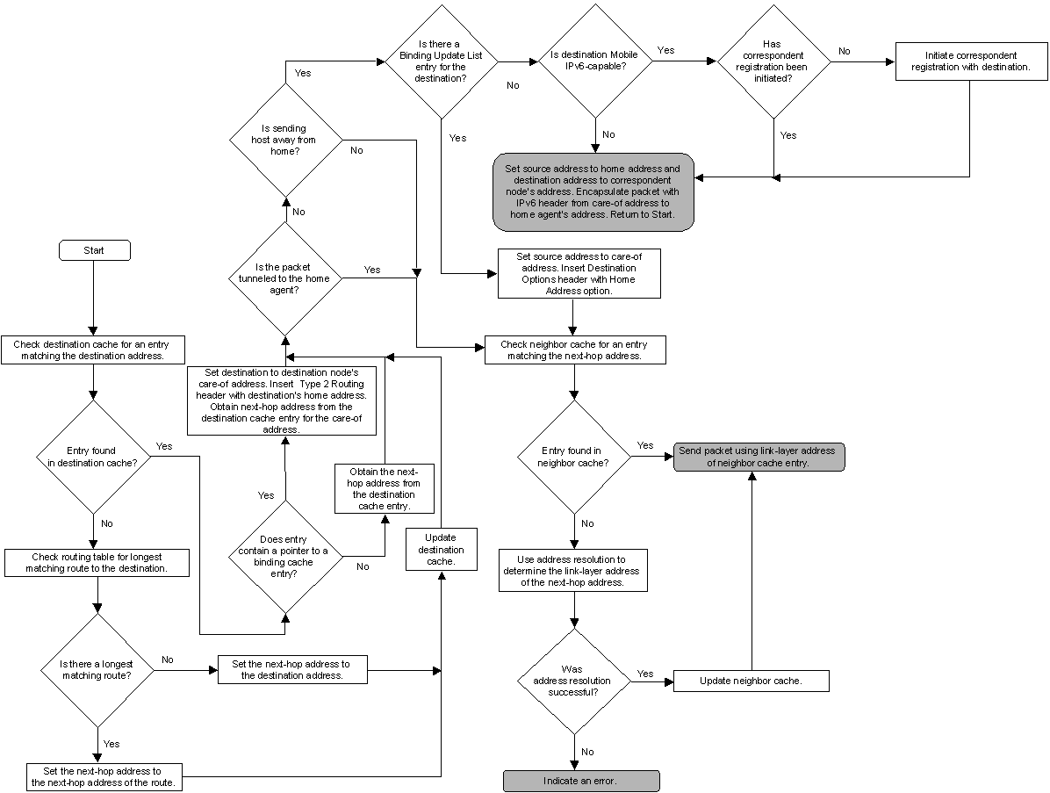
Figure 35 The Mobile IPv6 host sending algorithm

Mobile IPv6 Host Receiving Algorithm
A Mobile IPv6 node can be both a mobile node and correspondent node at the same time. Therefore, the host receiving algorithm for a Mobile IPv6 node must take into account the following:
- If the receiving node is away from home
If so, the receiving node processes the Type 2 Routing header in the IPv6 packet and logically sets the destination address of the IPv6 header to the value of the Home Address field in the Type 2 Routing header.
- If the sending host is away from home
If so, the receiving node processes the Destination Options header and logically sets the source address of the IPv6 packet to the home address contained in the Home Address option.
Additionally, a receiving Mobile IPv6 host must recognize a packet tunneled from its home agent in order to determine when to initiate a correspondent registration to a new correspondent node.
A Mobile IPv6 host uses the following algorithm when receiving a unicast or anycast packet from an arbitrary source:
- Verify whether the destination address in the IPv6 packet corresponds to an IPv6 address assigned to a local host interface.
If the destination address is not assigned to a local host interface, silently discard the IPv6 packet.
- Check to see if there is a Type 2 Routing header present. If so, process it and set the destination address of the IPv6 packet to the value of the Home Address field in the Type 2 Routing header.
- Check to see if the packet was tunneled from the home agent. If the packet was not tunneled from the home agent, go to step 8.
- If the packet is a Home Test message, process its contents.
- If the packet is not a Home Test message, check to see whether the sender has been determined to be Mobile IPv6-capable. If the sender is not Mobile IPv6-capable, go to step 7.
- If the sender has not been determined to be Mobile IPv6-capable (the assumption is that it is capable until determined otherwise), it checks whether a correspondent registration has already been initiated with the sender, and if not, the sender initiates one.
- Strip the outer IPv6 header (in which the destination address is set to the receiving node's care-of address and the source address is set to the home agent), and then process and remove the ESP header and trailer, if present.
- Check to see if there is a Destination Options header with a Home Address option. If so, logically set the source address of the IPv6 packet to the home address in the Home Address option.
- Based on the Next Header field, process extension headers (if present) and pass the upper layer PDU to the appropriate upper-layer protocol.
If the protocol does not exist, send an ICMPv6 Parameter Problem-Unrecognized Next Header Type Encountered message back to the sender and discard the packet.
- If the upper layer PDU is not a TCP segment or UDP message, pass the upper layer PDU to the appropriate protocol.
- If the upper layer PDU is a TCP segment or UDP message, check the destination port.
If no application exists for the UDP port number, send an ICMPv6 Destination Unreachable-Port Unreachable message back to the sender and discard the packet. If no application exists for the TCP port number, send a TCP Connection Reset segment back to the sender and discard the packet.
- If an application exists for the UDP or TCP destination port, process the contents of the TCP segment or UDP message.
Figure 36 shows the Mobile IPv6 host receiving algorithm.
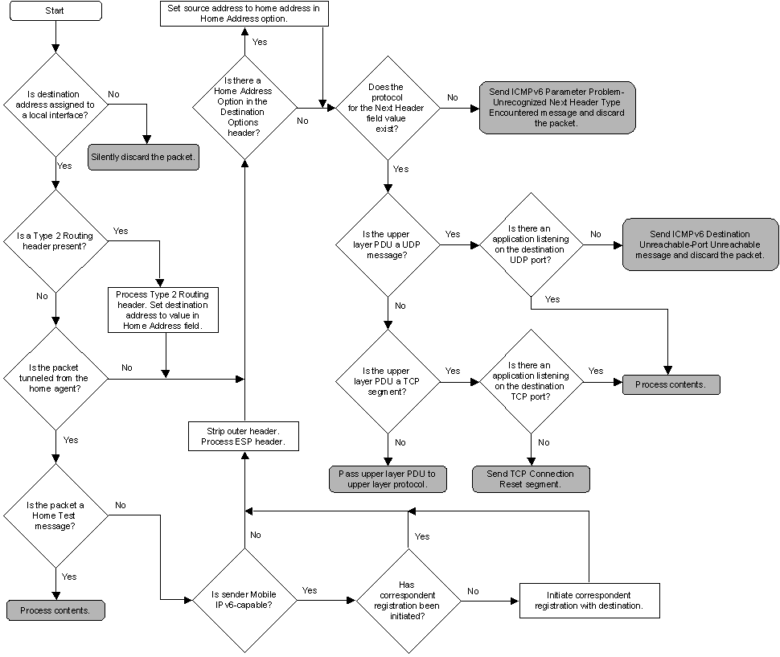
Figure 36 The Mobile IPv6 host receiving algorithm

Summary
Mobile IPv6 is a new protocol that allows IPv6 nodes to be mobile, to change their location on an IPv6 network and remain reachable. Mobile IPv6 defines a new Mobility header, new mobility messages, new ICMPv6 messages, and new and updated options to perform mobility functions and processes. Mobile IPv6 defines the processes and message exchanges for mobile nodes, home agents, and correspondent nodes when a mobile node changes its location from its home link to a foreign link, to another foreign link, and returns home. The host sending and host receiving algorithms need additional processing to account for sending and receiving nodes that are away from home.

Related Links
See the following resources for further information:
- Introduction to Mobile IPv6 at http://www.microsoft.com/technet/community/columns/cableguy/cg0904.mspx
- RFC 3775
- RFC 3776
- Mobility for IPv6 (mip6) IETF Working Group Web site at http://ietf.org/html.charters/mip6-charter.html
- Microsoft Internet Protocol version 6 Web page at http://www.microsoft.com/windowsserver2003/technologies/ipv6/default.mspx
- Introduction to IP Version 6 white paper at http://www.microsoft.com/windowsserver2003/technologies/ipv6/introipv6.mspx

For the latest information about Windows Server 2003, see the Windows Server 2003 Web site at http://www.microsoft.com/windowsserver2003.

