

Introducing the .NET Micro Framework

Product Positioning and Technology White Paper

September 7, 2007

Abstract
The Microsoft .NET Micro Framework is a bootable runtime module that brings the advantages of .NET programming to devices too resource-constrained to run other Microsoft embedded platforms. The benefits of developing with the .NET Micro Framework include the C# programming language, a managed execution environment, a substantial subset of the .NET libraries, and Visual Studio™ deployment and debugging. In this white paper we explain why the .NET Micro Framework is an ideal choice for embedded development and provide technical details of the platform’s Hardware Abstraction Layer (HAL) and Common Language Runtime (CLR).

Donald Thompson, Software Architect
Colin Miller, Product Unit Manager
Audience
This document is intended for two types of readers. The first is the information technology decision maker who wants to learn more about the benefits of developing embedded software using the Microsoft .NET Micro Framework. This reader may find the technical details in the latter sections of the document unnecessary.

The second is the more technical reader who wants details about how the .NET Micro Framework actually works and how it differs from other .NET platforms. This reader should find it useful to read the whole document.
Executive Summary
The Microsoft .NET Micro Framework is a bootable runtime module that brings the benefits of.NET programming to devices too resource-constrained to run other Microsoft embedded platforms, such as Windows Embedded CE or Windows XP Embedded. In contrast to other varieties of .NET, it does not require an underlying operating system.

Despite weighing in at a featherweight 300 KB, the .NET Micro Framework provides a full managed execution environment with automatic memory management, a substantial subset of the .NET Base Class Library, GUI classes based on the Windows Presentation Foundation, a managed device driver model, persistent storage, and support for numerous embedded interface standards for serial communication and networking. This is rounded out with extensible emulation and tight Visual Studio integration that includes automatic deployment and on-device debugging.

One of the primary goals of the .NET Micro Framework, like other .NET platforms, is to provide abstractions that allow applications to be decoupled from the hardware on which they run. Code that is specific to a particular hardware platform is factored into a hardware abstraction layer (HAL) so that the .NET Micro Framework (and applications) can be ported to new platforms with relative ease. This document contains a technical overview of the HAL as well as of the version of the common language runtime (CLR) included in the .NET Micro Framework.

Legal
The information in this document represents the current view of Microsoft Corporation on the issues discussed as of the date of publication. It should not be interpreted to be a commitment on the part of Microsoft, and Microsoft cannot guarantee the accuracy of any information presented after the date of publication.

This White Paper is for informational purposes only. MICROSOFT MAKES NO WARRANTIES, EXPRESS, IMPLIED OR STATUTORY, AS TO THE INFORMATION IN THIS DOCUMENT.

Without limiting fair use rights, no part of this document may be reproduced, stored in or introduced into a retrieval system, or transmitted in any form or by any means (electronic, mechanical, photocopying, recording, or otherwise), or for any purpose, without the express written permission of Microsoft Corporation.

Microsoft may have patents, patent applications, trademarks, copyrights, or other intellectual property rights covering subject matter in this document. Except as expressly provided in a written license agreement from Microsoft, this document does not give you any license to these patents, trademarks, copyrights, or other intellectual property.

© 2007 Microsoft Corporation. All rights reserved.

Microsoft, .NET, Visual Studio, and Windows are either registered trademarks or trademarks of Microsoft Corporation in the United States and/or other countries. The names of other companies and products mentioned may be trademarks of their respective owners.

Table of Contents

- Where the .NET Micro Framework Fits 1
The Evolution of Embedded Development 1
The .NET Platform for Smart, Connected Devices 2
Embedded Development for Fun and Learning 3
The Microsoft Embedded Continuum 3
Licensing 4
- Technical Overview of the .NET Micro Framework 5
The Bootable Runtime: HAL and PAL 6
The .NET Micro Framework CLR 7
Platform Integration and Porting 7
Libraries 8
Visual Studio Integration 9
System Requirements 10
- The .NET Micro Framework CLR in Detail 11
Basic Features 11
Extended Features 12
Omitted Features 12
Type System 12
Reflection 13
Serialization 14
Execution Engine 14
Memory Management 16
Resource Management 17
Security and Cryptography 18
Updating 18
- The .Net Micro Framework HAL in Detail 19
Continuations 19
ISR/DSR 19
Callbacks and Events 19
Drivers 20
Managed Drivers 20
Communications 20
Remote Procedure Call (RPC) 20
- Further Reading 21
.NET 21
Microsoft Embedded Platforms 21

1

Where the .NET Micro Framework Fits

The Evolution of Embedded Development
Not so long ago, embedded systems used the same processors and the same programming languages as general-purpose microcomputers. The first microprocessors were, in fact, designed for use in embedded applications. To make the most of early microprocessors’ limited processing power and storage, much commercial microcomputer software of the time was written in assembly language, a time-consuming and error-prone task demanding a high level of programming skill.

As personal computers became exponentially more powerful, programming tools followed suit, driving developer productivity higher. Among the most important innovations were:

- Ever more expressive high-level programming languages
- Integrated development environments (IDEs) with graphical user interfaces
- Widely-available high-level libraries and frameworks
- Managed execution environments with automatic garbage collection

For years, embedded development lagged behind. Due to cost and power constraints, it is still common for embedded systems to use 16-bit or even 8-bit processors. Programming for these chips is still mostly done in assembly language or C, and even today the available tools are often primitive. But this is beginning to change. Improved fabrication techniques have reduced the cost and power requirements of sophisticated 32-bit processors and higher-density memories. These advances make it possible to address the challenges of embedded development with modern languages, frameworks, and tools.

The .NET Micro Framework, the smallest .NET platform to date, brings the benefits of .NET and other modern computing paradigms—the modern C# language, a managed execution environment, and world-class Visual Studio® development tools—to diminutive embedded platforms. Now every .NET developer can also be an embedded developer!

Highlights of the .NET Micro Framework include:

- The smallest .NET footprint yet (about 300 KB of RAM)
- A version of the .NET class library tailored to embedded applications, including GUI classes modeled on the Windows Presentation Foundation (WPF)
- A bootable CLR that can run directly on hardware without an operating system
- Support for common hardware and interconnects (nonvolatile memory, GPIO, I²C, RS232, SPI)
- Managed device driver model for devices connected via the supported interconnects
- Seamless persistent storage through extended weak references
- Full Visual Studio integration, including live debugging of code running on a tethered device
- An extensible emulator that lets you test applications in a window on your PC

While per-unit manufacturing cost will always be paramount for some embedded applications, developers often find that the lower development cost and faster time to market, along with the reliability, and extensibility advantages offered by .NET, can more than offset a higher BOM cost. If you already use .NET for some of your development, the .NET Micro Framework now lets you use the same programming staff, tool chain, and possibly even your existing code to develop your smallest devices.

This isn’t just theory. Based on their long experience with embedded development, Leviton Manufacturing estimated that the development of a new home automation wireless gateway module, the Vizia RF Foyer, would take about a year. Using the .NET Micro Framework, Leviton’s software partner produced a working proof of concept in three days—and, by leveraging an existing .NET code base, completed the final application within three months.

The .NET Platform for Smart, Connected Devices
The .NET Micro Framework isn’t just about bringing embedded applications to market faster. From smart homes to home appliances, from sensor networks to networked watches, embedded applications are becoming more sophisticated than ever. New affordable, low-power wireless networking protocols are enabling a new class of small devices that seamlessly exchange data with other wireless-equipped devices whenever they are in range, whether the other devices are servers, desktop workstations, smart phones or PDAs, or other small devices.

The .NET Micro Framework, with its roots in Microsoft’s Smart Personal Objects Technology (SPOT) initiative, is an ideal platform for ambitious developers wanting to create a new generation of smart, connected devices. As functionality migrates to ever-smaller form factors and increasingly “walks around,” C# code can be moved from larger devices to smaller ones with relative ease, using the same development tools. Great opportunities exist for these types of devices in education, consumer electronics, home automation, healthcare, retail point-of-sale, logistics, and industrial automation.

Embedded Development for Fun and Learning
The .NET Micro Framework is ideal for hobbyists who are looking for a fast, reliable way to develop custom hardware controllers for a variety of applications. A full-featured development kit for a .NET Micro Framework hardware platform costs just a few hundred dollars (including a color LCD) and makes an incredibly flexible controller for all sorts of unique personal projects. Most development kits have serial and general-purpose input/output (GPIO) interfaces that make it easy to interface the device to motors, sensors, and other hardware. And with the reasonable educational pricing of Visual Studio, the .NET Micro Framework is also an excellent way to introduce students to the fun of programming by involving them in real-world projects such as robotics, lab instrumentation, and social applications.

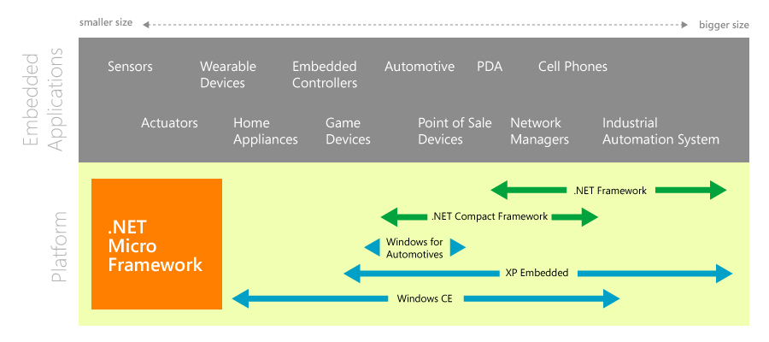
Figure 1: Microsoft Embedded Products

The Microsoft Embedded Continuum
Microsoft’s embedded platform offerings now come in a variety of sizes, ranging from Windows XP Embedded (potentially with the .NET Framework) to Windows Embedded CE (potentially with the .NET Compact Framework) to the .NET Micro Framework. Whereas Windows XP Embedded and Windows CE have very broad and deep support for operating system extensions, the .NET Micro Framework was developed with the explicit goal of being resource-light and as power-efficient as possible while preserving the major benefits of a managed code environment.

Windows CE, for example, provides a broad range of configurations through its Platform Builder. While the kernel can fit in 300K, useful platform configurations start at about 600 KB and may be as large as 64 MB depending on features. Windows CE configurations supporting managed code require at least 12 MB of RAM. On the other hand, the .NET Micro Framework running directly “on the metal” requires only about 300KB of RAM—about one fortieth of the Windows CE managed code footprint and only half of the smallest useful (unmanaged) Windows CE configuration. Additionally, the .NET Micro Framework does not require a memory management unit (MMU), so it can run on less expensive processors than can Windows CE.

In summary, then, the strengths of the .NET Micro Framework include:

- Lower hardware cost than other managed platforms
- Lower development costs than other embedded platforms
- Lower power consumption

Like Windows XP Embedded and Windows Embedded CE, the .NET Micro Framework is a fully-supported Microsoft platform and an important part of Microsoft’s embedded strategy. Microsoft is committed to advancing the .NET Micro Framework and plans ongoing customer-driven releases.

Licensing
Microsoft’s strategy for licensing the .NET Micro Framework is to make development as affordable as possible by allowing device makers to defer licensing costs until their products ship. To support this, the .NET Micro Framework SDK is available for download at no cost. The SDK requires Visual Studio 2005 (Standard Edition or better) and includes all the deployment, debugging, and device emulation features that developers need to develop applications for the .NET Micro Framework. There are no additional fees for developing .NET Micro Framework applications beyond the required Visual Studio license. Distributing devices containing the .NET Micro Framework runtime, however, requires a distribution agreement and a per-device licensing fee, which varies by expected volume.

To help maintain the standards of quality and reliability developers expect from .NET, Microsoft works closely with hardware partners to port the .NET Micro Framework runtime to their platforms. These partners then offer reference designs, development kits, and pre-built modules for customers who want to build .NET Micro Framework devices. As the porting process is fairly technical, Microsoft currently offers the .NET Micro Framework Porting Kit only to selected partners. A porting agreement is required, along with payment of an associated fee.

2

Technical Overview of the .NET Micro Framework
The architectural diagram in Figure 2 shows the components that make up the .NET Micro Framework bootable runtime.
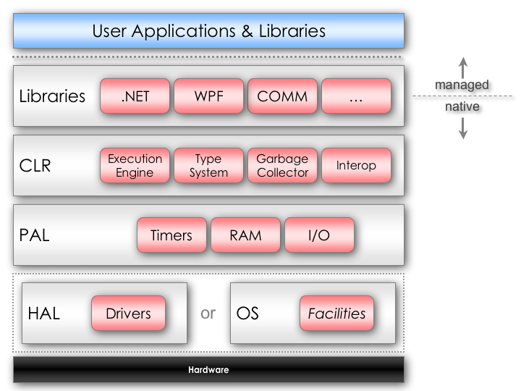

Figure 2: .NET Micro Framework Basic Architecture

The Bootable Runtime: HAL and PAL
The .NET Micro Framework provides services that are usually provided by an operating system, including environment initialization, interrupt handling, threading and process management, heap management, and other support functions necessary to run applications. This allows the .NET Micro Framework to run directly on hardware without an underlying operating system, although an operating system may still be used if desired.

The foundation layer of the .NET Micro Framework is a hardware abstraction layer (HAL), which is typically 20-30 KB. The only part of the .NET Micro Framework that is tightly coupled to hardware, the HAL provides generic access to all the device’s peripherals through opaque queued I/O, shielding the driver from interrupt service routine (ISR) and queue-locking details. The .NET Micro Framework HAL provides infrastructure for booting applications as well as for facilitating its interactions with the hardware and peripherals. (When running on an OS, of course, the HAL provides these functions by calling through to OS functionality.)

The infrastructure functions of a traditional OS have been split between the HAL and the Common Language Runtime (CLR). The HAL provides interfaces to hardware (for example, IRQs, timers, and I/O), but does not have a full kernel to manage processes and threads or any heaps of its own; these functions are provided by the CLR.

The HAL kernel supports two execution modes: single-threaded application and interrupt service routine (ISR). There is no scheduler per se, as there is only a single application thread. All user applications (the shell, network protocols, alerts, games, etc.) execute within the CLR, which has its own multithreading facilities. The single application thread also reduces locking overhead. However, it means that the application running on the HAL (that is, the CLR) must use cooperative multitasking, explicitly yielding execution periodically at idle time so that continuations can be processed.

Another key HAL design requirement is low CPU utilization to reduce power consumption. As a result, the HAL contains radically simplified code, uses deferred service routines (DSR) extensively rather than employing "do it now" or "sleep in place" approaches, reduces clock speed while doing short spins, and incorporates other power-saving tricks.

The layer above the HAL is the Platform Abstraction Layer (PAL), which exposes abstractions such as timers, memory blocks, asynchronous communication, and lists and other data structures to the .NET Micro Framework CLR, serving to further abstract the functionality exposed by the HAL.

The .NET Micro Framework CLR
The .NET Micro Framework common language runtime (CLR) is a small, highly optimized managed-code runtime based on industry-standard ECMA specifications. Like its larger cousins, this “tiny” CLR is the module that provides the main benefits of managed code: safety, security, resource protection, validation, recovery, and isolation.

The .NET Micro Framework CLR supports the C# programming language and includes a class library tailored to the needs of embedded applications. The library incorporates a substantial subset of the .NET base class library (BCL), as well as user interface classes modeled on the Windows Presentation Foundation (WPF), communication and networking classes, and more. Taken together, C#, the CLR, and the Base Class Library enhance developer productivity by eliminating the need to be concerned with infrastructure issues typical of native code development.

The primary design goals of the .NET Micro Framework CLR are:
- Minimal footprint
  - Implemented from scratch to be small (not a port)
  - Run without a traditional operating system
  - Runtime and library functionality appropriate to embedded development
- Able to run from ROM or flash memory
- Optimized for energy-efficiency in battery-powered devices
- Relatively easy portability by running on the HAL

Platform Integration and Porting
Since the .NET Micro Framework separates all code that touches the hardware into a HAL, changing the hardware under the .NET Micro Framework is, in theory, straightforward. However, it relies on a complete understanding of the hardware being used and requires exacting attention to detail. In practice, then, a full porting effort is generally something that will be undertaken by hardware platform vendors or porting specialists rather than directly by embedded application developers. This remains an active area of development; future releases of the .NET Micro Framework will incrementally add support for additional processors and peripherals and also provide tools to make porting easier.

Changing any aspect of the underlying hardware (such as the LCD part being used) will typically require significant changes to the HAL, and rarely some changes to the PAL. Changes to components above these layers are generally not necessary. Another approach is to use the capabilities of an underlying operating system for some or all the functions usually provided by the HAL. In this case, a HAL that calls through to the operating system can be developed.

The Porting Kit includes the source code for the HAL and PAL for a standard reference platform. Currently, the platform is built using the ARM toolset (version 1.2 or 3.0) with support for ARM7 and ARM9. The Porting Kit also includes a HAL that calls through to Win32 APIs, which is used for testing and debugging code using the emulator.

Libraries

.NET Base Class Libraries
The .NET Micro Framework includes partial or full implementations of the following .NET Base Class Libraries:

System
System.Collections
System.Diagnostics
System.IO
System.Net
System.Net.Sockets
System.Reflection
System.Resources
System.Runtime.CompilerServices
System.Runtime.Remoting
System.Text
System.Threading

Additionally, the Microsoft.SPOT namespaces include classes specific to the .NET Micro Framework, including classes for cryptography, hardware, input, and presentation.

User Interface Shell
The .NET Micro Framework provides robust support for the development of user interfaces for small devices via the Microsoft.SPOT.Presentation namespaces. This includes input, layout (content sizing, text flow, controls), fonts, images, pens, brushes, colors, drawing primitives, window management including pop-ups and alerts, and much more. Also included is a layout system that allows user interface elements to be allotted sizes and positions automatically, simplifying localization.

The application model is based on the Windows Presentation Foundation, but without the declarative markup features of XAML. Developers familiar with Windows Vista application development will find writing UI code for the .NET Micro Framework familiar.

Architecturally, the primary difference between the .NET Micro Framework layout system and full is the lack of distinction between core and framework class layers; the WPF two-layer architecture has performance costs which were deemed excessive for small devices. Furthermore, since the application will be part of a device, the interoperability and product lifecycle scenarios are greatly simplified compared to those of desktop applications, so the benefits of the layer separation are minimal.

The layout system adds support for user-specified sizing, positioning, and margins of specific layout elements. Among the more interesting features of this system are:

- Ability to size controls to content at runtime
- Universal properties for programmatically controlling the behavior and appearance of layout elements in a consistent, intuitive, and succinct manner
- Multiple device support, allowing a single codebase to be used on devices with different displays

Visual Studio Integration
.NET Micro Framework support for embedded devices in Visual Studio goes far beyond editing code and building your application. The .NET Micro Framework supports full emulation of your device on a PC, allows building and deploying .NET assemblies to the device, and permits debugging the code running on the device—all from within Visual Studio. Initial development can be done on the PC using the emulator, which allows application developers to write much of their code without concern for the device it will run on.

The emulator does not emulate the CPU of a target platform; at its heart, it is an Intel-native build of the Micro Framework CLR running on top of a hardware abstraction layer (HAL) that calls through to Windows APIs. The emulator can be customized to match the hardware you will be using—adding extra buttons or ports, changing the resolution of the display, and so on. Much of this can be done simply by editing an XML configuration file; the emulator can also be extended with custom components written in C#. The emulator lets you use your usual .NET tools for logging, heap analysis, and profiling.

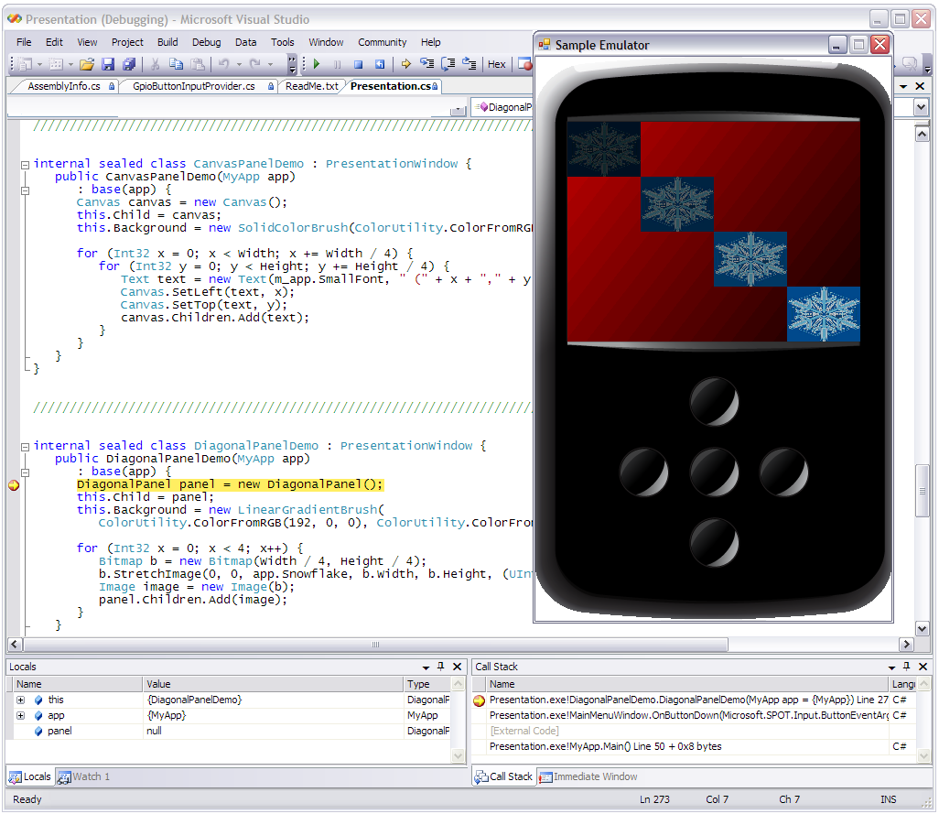

Figure 3: Extensible Emulation in Visual Studio 2005

While emulation has its advantages, it is not a perfect substitute for running the code on the device. Therefore, the .NET Micro Framework extends the project system of Visual Studio 2005 to directly support hardware devices, including application downloading and interactive source-level debugging, using a serial, USB, or network connection. The .NET Micro Framework includes a remote procedure call (RPC) subsystem that enables all of the expected features of visual debugging, including breakpoints and runtime variable inspection. When developing a device that communicates with the PC over Bluetooth, for example, you can step through both sides of the communication in a single session of Visual Studio, following PC breakpoints right into code running on the device.  The assemblies generated by Visual Studio cannot be used directly on a device. During deployment, an included tool seamlessly converts standard .NET assemblies into the format required by the .NET Micro Framework CLR, further reducing their size. | 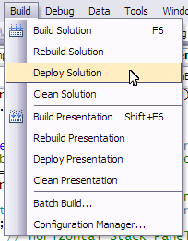  Figure 4: Build, deploy, and debug on  the device in Visual Studio

System Requirements

Runtime
Currently the .NET Micro Framework runs on several flavors of ARM7 and ARM9 microprocessors available from major embedded hardware vendors. The suggested minimal memory configuration (not counting application needs) is 300 KB RAM and 512K MB of flash memory. The device also needs a serial, USB, or network interface to support downloading and debugging the applications.

Development environment
The .NET Micro Framework development environment is a set of add-ins, help, and project templates for Visual Studio 2005. A serial or USB connection for connecting with the device is also required.
3

The .NET Micro Framework CLR in Detail
The .NET Micro Framework CLR implements all of the major features found in the “full-size” .NET CLR such as execution engine, type system, and memory management. It omits a few features that were deemed inappropriate or unnecessary for the class of device it supports, while adding a few features that are specific to embedded applications. This is not an exhaustive enumeration of the differences, but only a list of the most salient.

Basic Features
These features are common to all compliant .NET CLRs.
- Numeric types, Class types, value types, one-dimensional arrays, delegates, events, references, weak references
- Reflection
- Serialization
- Dynamic allocation, memory defragmenting, and garbage collection
- Exception handling
- Time-sliced thread management

Extended Features
These features are found in the .NET Micro Framework CLR but not in the full-size Microsoft .NET CLR.
- Execution constraints limit call durations to prevent lock-ups
- Strings are represented internally as UTF-8 and exposed as Unicode
- Value types are emulated by runtime, not first-class, allowing for garbage-collection optimization and lower RAM usage
- Global, shared string table for well-known values (types, methods, fields) reduces RAM/ROM usage and requires fewer cross-references between assemblies
- Support for patching, including assembly differencing, method and resource substitution, and new types
- No virtual tables for method resolution to save memory
- Extended weak references are prioritized and persisted in EEPROM or flash memory
- Specialized garbage collector provides automatic data management and persistent storage management
- Self-describing data is used rather than metadata for improved garbage collection performance
- Weak delegates; the CLR manages dangling references
- Custom serialization engine relying heavily on new attributes to guide encoding; produces a more compact representation than the full .NET implementation

Omitted Features
These features are commonly found in .NET CLRs but are absent from the .NET Micro Framework CLR.
- Machine-dependent types and unsafe instructions
- Symmetric multiprocessing
- MSCORLIB functionality has been reduced to what is appropriate for these devices
- Multi-dimensional arrays (sparse, jagged)
- Exception handling in native code; processor faults (traps) and external watchdog only
- MMU support

Type System
The .NET Micro Framework CLR implements a Common Language Specification-compliant common type system to represent and manage classes and other data structures used by the system and applications. In addition to supporting built-in (intrinsic), framework, and user-defined types, the type system also stores metadata used by the system to perform all other operations, such as program loading and execution, memory management, patching, and so on. The type system is tightly bound to the memory management and execution engine subsystems.

Intrinsic Types
The ECMA standard requires support for basic language and runtime features, including:
- Numeric types: integers (signed and unsigned, 8/16/32/64 bits) and single- and double-precision floating point values
- String types: UTF8 encoding (exposed as Unicode)
- Class types: including lock semantics
- Binary objects (blobs): image and sound data, for example
- Collections: Array Lists, Enumerators
- Arrays: one-dimensional only
- Delegates: function pointers
- Events: multiple dispatch
- References: including weak references

The .NET Micro Framework CLR also offers extended weak references. A reference is a pointer to some other object. A weak reference is a pointer to an object that might be reclaimed during garbage collection given sufficient memory pressure. This is useful if the referenced object is large but can be easily recreated if it is discarded (for example, a cache entry). Taking this model further, the extended weak reference allows the referenced object to be automatically stored to and retrieved from persistent memory—preserving it, for example, across a device reboot. This mechanism greatly simplifies programming patterns involving references.

Framework Types
The .NET Micro Framework CLR offers a subset of the Base Class Library (BCL) and .NET Framework, including many of the objects defined in the System namespace. This consists of approximately 70 classes representing about 420 methods, as opposed to the approximately 1450 classes and 22500 methods of the full .NET implementation. In practice, this has proven to be sufficient.

No support is yet provided for databases (System.Data.*), the Web (System.Web.*), or XML (System.XML.*). These features are under investigation for future releases. In the meantime, it is straightforward to add support for special features as needed.

Reflection
Reflection is the ability to obtain metadata for every object in the system—classes, methods, fields, and so forth. This functionality is made available to application programs and is also used for serialization.

Serialization
Serialization is the ability to convert an active object (in memory) into a compact representation for storage or transmission such that the object can be re-created at a later time or on a different device. The serialization engine in .NET Micro Framework CLR was specifically designed to create very compact representations, as it is used as a “wire protocol” to communicate with the device. Desktop and server systems aren’t as concerned with compactness, as they typically have much greater available bandwidth than do small devices. Using C# attributes, it is possible to provide hints to the serialization engine so it can produce optimally compact representations.

Execution Engine
As with all managed code runtimes, the .NET Micro Framework CLR provides a virtual machine abstraction for code compiled from a supported source language. Programs are compiled not to native machine code but into an intermediate language (IL), which is then executed by the CLR execution engine. One of the key benefits of this design is that it allows for code to be developed independently of the hardware on which it runs.

Since programs are compiled to run on a virtual machine, the execution engine must translate encoded IL operations into native operations—that is, instructions that can be performed by actual hardware. The two basic approaches to doing this are to interpret the code as it is executing an instruction at a time, or to compile it to native code as it is needed, referred to as just-in-time (JIT) compilation. Unlike the “full” .NET CLR, which offers both modes, the .NET Micro Framework CLR always uses an interpreter. This is not a “scaled-down” version of the interpreter from an existing CLR, but a completely new CLR implemented to ECMA standards specifically for embedded applications.

For the .NET Micro Framework CLR, the benefits of the interpretive approach are:

- Smaller code footprint
  - Managed code is represented in less space than native code
  - Avoids storing two copies of the program (IL and compiled)
  - More compact engine code
- Safer
  - Fine-grained control at the instruction level: the execution engine never passes control to native code, allowing increased determinism
  - Less complex engine code: fewer parts to have bugs

The primary disadvantage of the interpreter approach is lower-than-native execution speed. However, performance is more than adequate for the intended applications; see, for example, the Windows SideShow-compatible devices based on the .NET Micro Framework. Performance remains an area of ongoing research. Among other approaches, Microsoft is investigating ways to add native method support so that bottlenecks can be re-coded in a more efficient programming language.

Responsibilities
The execution engine is responsible for coordinating the actions of system components, such as:

- Instantiating the heap as part of the boot sequence
- Keeping track of the heap cluster that returned the memory for the last allocation, to speed up the next allocation and to minimize heap fragmentation
- Owning the list of all the weak references, used during garbage collection
- Owning the list of all the timers, and updating and scheduling the next timer to trigger (incorporates a timer cache to avoid constantly re-evaluating the timer settings)
- Owning the list of endpoints
- Owning the list of threads, organized by status (ready, waiting, and zombie)
- Owning the list of all the objects needing finalization and controlling the thread used to execute the finalizers
- Controlling the global lock used to implement the semantics behind the GloballySynchronized attribute
- Owning the list of all other dual objects
- Owning the set of breakpoints in a debugger-enabled build

The CLR execution engine also provides helper methods for commonly-used operations, including:

- Creating new objects
- Creating and rescheduling threads
- Initializing variables from metadata
- Cloning objects to emulate the ByVal semantic
- Accessing member fields via reflection
- Locking and unlocking objects
- Putting threads to sleep
- Suspending threads waiting for events
- Determining whether a given object is an instance of a type

Threading
The .NET Micro Framework CLR provides multi-threading support even when running on an underlying platform or OS that does not. While the execution engine is not a true multi-threaded kernel, it is a close simulation, offering time-sliced context switching using a 20ms quantum. Threads are prioritized and, due to instruction-level interpretation, interruptible.

Synchronization
Accesses to shared resources between multiple threads of execution are synchronized to avoid corrupting state.

Timers
The .NET Micro Framework CLR offers support for various timers through System.Threading.Timer and Microsoft.SPOT.ExtendedTimer. Available behaviors include:

- Recurring or one-shot
- Absolute time or relative time
- Int32 or TimeSpan time specification
- Event-based (second, minute, hour, time zone change, etc.)

Unlike timers in the full .NET framework, timers in the .NET Micro Framework CLR do not attempt to invoke callbacks at regular frequencies, which can sometimes lead to multiple callback threads running at once if callback processing runs longer than the timer frequency. Instead, recurring .NET Micro Framework CLR timers reschedule themselves for another execution after completing the callback, so there will never be more than one thread per timer. It is possible for the application to compensate for the inherent latency of this approach to improve latency.

Exception Handling
One of the keys to a safe execution environment is the ability to effectively handle exceptional runtime situations that might occur as a result of unforeseen operating conditions. Exception handling in the .NET Micro Framework CLR works in the same way as it does in the full-sized .NET. The execution engine manages the dispatching and cleanup associated with exceptions and has special mechanisms for protecting the integrity of the system as a whole from unruly programs. The CLR can gracefully clean up state that could be causing a program to misbehave, and if a program continues to fail according to a pre-determined heuristic, it will be “blacklisted.”

Memory Management
One of the advantages of .NET is that memory management is tied to the type system, making it possible to track memory at the object level. This allows the system to reclaim memory used by dead objects, removing this burden from the programmer. In addition, memory can be compacted to create contiguous free space for new objects, thereby avoiding out-of-memory conditions due to heap fragmentation. This process is known as garbage collection.

The approach to garbage collection used in .NET Micro Framework CLR differs from the automatic memory management provided by the full .NET CLR in several respects. Instead of a generational garbage collector, the .NET Micro Framework CLR uses a non-incremental mark-and-sweep algorithm. This simpler approach was chosen due to the limited availability of RAM in small devices. More sophisticated approaches were explored, but the tradeoffs required made them impractical. Several optimizations, such as embedding metadata directly into the heap blocks in order to avoid table look-ups, make garbage collection fast and efficient.

Support for persistent storage has been added to memory management system in the .NET Micro Framework CLR, making it trivial to store and recover data from non-volatile memory across device resets and reboots.

Persistent Storage
For small devices, it is sometimes useful for applications to retain information between active instances, as applications may start and stop based on user action or during a device reset. For example, in the MSN® Direct smart watch, the individual applications (channels) are not all active simultaneously; the user can switch between them. Each channel requires configuration information, as well as received content, to be persistent.

The .NET Micro Framework CLR’s garbage-collection mechanism has been enhanced to allow storing and retrieving objects in non-volatile storage (EEPROM or flash memory), transparently providing a backing store for RAM. (Since it is an extension of the CLR’s weak reference mechanism, the feature is referred to as extended weak references.) Persisted objects are prioritized and time-stamped so that non-volatile storage can itself be garbage collected. In practice, high-priority items are never removed.

This feature includes many safeguards to ensure robustness. Due to the physical characteristics of flash memory, it is possible to change individual bits from the “1” state to the “0” state, but not the reverse. For this reason, the system uses two identical storage banks. Each bank is treated like a tape, where most of the updates happen at the “tail.” When the end of a bank is reached, the other bank is erased, all the data is copied from the active bank to the spare bank, and the role of the two banks is reversed. This approach preserves the lifetime of the flash memory chip, which has a finite number of write cycles.

Object persistence provides much of the functionality for which programmers often use file systems, and does so in a way better suited to the needs of small devices. While the .NET Micro Framework does not support traditional file systems, the feature could be added as a library component.

Resource Management
A resource is any non-executable data deployed with an application. Resources make localization straightforward and also serve as a vehicle for fonts, bitmaps, and sounds. The .NET Micro Framework CLR treats resources much like the desktop CLR. The primary differences are:

- The .NET Micro Framework does not support extensible resources
- Resources are identified by 16-bit integers rather than by strings
- A different ResourceManager class is provided, in the SPOT.Native namespace, to handle managed resources from within code.

Visual Studio automatically generates type-safe code for accessing resources, thereby avoiding easy-to-make mistakes when accessing resources by number. Resources can be shared across applications, but each application is responsible for consistent resource naming conventions and orderings.

Security and Cryptography
Several features of the .NET Micro Framework are designed to assist the user in creating secure devices. For example, beyond the inherent security advantages of managed code, all assemblies that are loaded onto the .NET Micro Framework must be signed—currently, with a single key. This insures that only applications from one publisher are loaded into the system.

The .NET Micro Framework contains several cryptographic libraries to help secure the system. RSA libraries are included for key generation. XTEA symmetric encryption is supported. (XTEA is an extension of the Tiny Encryption Algorithm which corrects a weakness in the original TEA.) The hashing algorithm used is Davies-Meyer modified to support the block size of XTEA.

In the original watch devices built on this platform, each device has a symmetric key and an RAS key pair to support secure delivery of content only to devices that are authorized to receive it.

Updating
The .NET Micro Framework includes a tool, MFDeploy, that performs device firmware updates and can update the runtime components or your application. MFDeploy includes an engine class (DLL) that can be called from your own update application, if you prefer. Code can be signed to prevent unauthorized software from being installed on a device.

4

The .Net Micro Framework HAL in Detail

Continuations
Continuations are the primary way of deferring work from an interrupt service routine (ISR), which must execute very quickly, to the application thread, which typically isn't under strict time constraints. Continuations are implemented as a FIFO queue that can be scheduled within the application thread. The typical target is to execute less than 10 msec of work with a specifiable minimum contiguous duration.

ISR/DSR
ISRs are maskable and have a worst case latency of about 100 µsec. The longest ISR in the system is approximately 1 msec.

Deferred service routines (DSR) allow processing to be performed at a specific time or when a particular event occurs. They can be processed on either the application thread or from within an ISR. A time-deferred call has a granularity of 40 µsec. An idle CPU is treated as a consumable resource.

Callbacks and Events
The .NET Micro Framework HAL supports callbacks that are executed from continuation processing on the application thread. An event-conditional sleep mechanism allows the application thread to place the system in a dormant but alertable state, saving power during idle periods.

The .NET Micro Framework HAL can communicate with the CLR through event masks. Before entering into the interpreter loop, the .NET Micro Framework CLR checks for signals in any of the event masks. If any signals are found, the CLR calls the appropriate handler code for further context-specific processing.

Drivers
The drivers included with the .NET Micro Framework include:

- Buffered RS232 serial I/O
- Serial Peripheral Interface (SPI) at 13.8 MHz as a shared resource for peripherals
- Monochrome LCD (120x96)
- Battery monitoring (temperature, voltage, and state of charge)
- Flash (parallel) and EEPROM (serial) persistent memory
- Calibrated accurate time
- Boolean outputs (backlight, vibrator)
- Boolean inputs (pushbuttons, d-pad)
- Pulse-width modulation outputs (piezoelectric speaker, slow-start backlight, vibrator)

Drivers have also been written for a number of popular parts using various buses and interconnects such as SPI, HPPI and GPIO. OEM drivers are also available for some devices, including a heart rate monitor, an air pressure sensor, Ethernet, an accelerometer, and a touch screen. The .NET Micro Framework HAL also supports direct memory access (DMA) with processors that provide the feature.

Sound
Support for piezo-based sound effects is provided. An experimental polyphonic tone generator has also been developed.

Managed Drivers
The .NET Micro Framework CLR makes it possible to write drivers in managed code for devices connected via GPIO, PWM/VTU, I2C, SPI, USB 1.1, or USART.

Communications
Small devices are much more interesting when they can communicate with each other as components in larger systems. The .NET Micro Framework SDK includes sample drivers for several personal area networking protocols. These include Bluetooth for communications with PCs and mobile phones and 802.15.4 for communication with sensor networks.

Remote Procedure Call (RPC)
The .NET Micro Framework platform offers an RPC-like mechanism for communication between a host system (such as a PC) and a small device. Each endpoint has an address, and the RPC layer maintains a list of pending messages both to and from the endpoint. Applications normally use the endpoints through the Microsoft.SPOT.RpcServer and Microsoft.SPOT.RpcClient helper classes. The RPC layer ensures reliable delivery of messages across the link, serial or otherwise.
5

Further Reading

.NET
A discussion of the philosophy and benefits of .NET class libraries and the CLR is beyond the scope of this paper. For general information on .NET and managed code, please visit:

- .NET Overview
- ECMA Standards
- Managed code technical talk

Microsoft Embedded Platforms
For more information on Windows embedded platforms, including Windows XP Embedded, Windows Embedded CE, and the .NET Micro Framework, please see:

- Microsoft Windows Embedded
- Microsoft Windows Embedded Developer Center
- .NET Micro Framework

For details, see Microsoft Case Studies: Leviton Manufacturing.
Download the .NET Micro Framework SDK from MSDN.

