


Microsoft® Office
Small Business Accounting 2006

Accountant White Paper

How Microsoft’s easy-to-use financial management solution helps businesses better manage their finances and make smarter business decisions

Published: June 2005
For the latest information, please see http://www.microsoft.com/accountants.

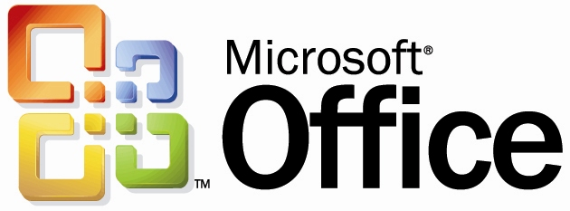

© 2005 Microsoft Corporation. All rights reserved.
Information in this document is subject to change without notice. The example companies, organizations, products, domain names, e-mail addresses, logos, people, places, and events depicted herein are fictitious. No association with any real company, organization, product, domain name, email address, logo, person, places, or events is intended or should be inferred.
This white paper is for informational purposes only. MICROSOFT MAKES NO WARRANTIES, EXPRESS OR IMPLIED, IN THIS DOCUMENT.
Microsoft, Excel, the Office logo, Outlook, and Windows are either registered trademarks or trademarks of Microsoft Corporation in the United States and/or other countries.
Other product and company names mentioned herein may be the trademarks of their respective owners.

Purpose of Document
Microsoft® is committed to helping accountants better serve their small business clients. We understand that you first must have a deep knowledge of any given software product in order to recommend it to your clients.
The purpose of this white paper is to:
- Familiarize you with the features and benefits of Microsoft Office Small Business Accounting 2006
- Describe the types of businesses that are most likely to benefit from using the software
- Help you understand how the product can help your clients better manage their finances
- Provide detailed product information to answer questions you or your clients may have about the application

Thank you for taking the time to consider Small Business Accounting 2006. We value your comments and feedback and look forward to serving you.

Please visit http://www.microsoft.com/accountants to receive product information or to learn about the Microsoft Professional Accountants’ Network, a new offering from Microsoft specific to accounting professionals.

Contents
Executive Summary 5
Designed with Input from Accounting Professionals 5
Benefits Your Clients Will Appreciate 5
Businesses That Will Benefit from Small Business Accounting 6
Integration with Microsoft Office 2003 Editions 7
Key Features and Benefits 8
Easy to Use 8
➲ Get Started Quickly 8
➲ Leverage Familiarity with Office Software 9
➲ Stay Up and Running with Multiple Support Options 9
Work More Efficiently 10
➲ Help Improve Financial Management across the Business 10
➲ Get an Overview of the Business with the Company Home Page 10
➲ Create Invoices and Sales Orders with a Few Clicks 11
➲ Create Professional-Looking Correspondence 11
➲ E-mail Forms and Letters 11
➲ Automate Bank Accounts and Bill Payments 12
➲ Track Complex Sales 12
➲ Track Job Profitability 12
➲ Manage Inventory 13
➲ Write Off Bad Customer Debts 14
➲ Support Up to 5 Concurrent Users 14
Gain Insights to Make Better Decisions 15
➲ Analyze Financial Data with Customizable Reports 15
➲ Forecast Cash Flow 16
Maintain Control Over Financial Information 18
➲ Track Changes with the Audit Trail 18
➲ Manage User Roles and Permissions 18
➲ Reconcile Accounts and Bank Statements 19
➲ Make Journal Entries 20
➲ Close the Books 20
➲ Back Up Company Data 21
Help Improve Customer Service 21
➲ View Contact, Sales, and Financial Information on One Screen 21
Take Advantage of Integrated Services 24
➲ ADP PayrollSM for Microsoft Office Small Business Accounting 2006 24
➲ Process Credit Cards 28
➲ Order Checks and Forms Online 28
Small Business Accounting Compared to Other Products 29
Feature Comparison Chart 29
Our Commitment to the Future 31
Pricing 32
System Requirements 32

Executive Summary
Microsoft® Office Small Business Accounting 2006 is a solid financial management program designed for small businesses with less than 25 employees. It is easy to set up and use, and it supports up to 5 users concurrently. Because Small Business Accounting has the familiar look and feel of widely used Microsoft Office programs, new users can get up to speed quickly.

Designed with Input from Accounting Professionals
When we set out to build a small business accounting solution, we asked accounting professionals like you what would most benefit their clients.
You told us you need:
- Accounting software that your clients find easy to learn and use, and is scalable as their business grows
- A way to alleviate inefficient or manual client activities
- Built-in approaches so clients can help control costs
- Financial software that goes beyond accounting and bookkeeping, and allows you to gain deep insight into your clients’ finances
We listened.
Based on feedback from accounting professionals like you, we designed Microsoft Office Small Business Accounting 2006 to help your clients better manage their financials, and ultimately to help you add greater value as their advisor.
Small Business Accounting 2006 provides sales, purchasing, inventory, banking, and payroll functionality and includes a chart of accounts that can be tailored to fit your clients’ needs. With core accounting features such as a general ledger, inventory management, and an audit trail, as well as optional enhancements like ADP payroll processing, credit card processing, and online check and form ordering. Small Business Accounting helps companies improve financial management across the business. In addition, the program draws on the breadth and depth of tracked data to provide reports and forecasts that give your clients insight into their business and help them make smarter decisions.

Benefits Your Clients Will Appreciate
Easy to Set Up
Your clients can easily install the program and get up and running quickly with a wizard that walks them through the setup process. The Startup Wizard allows for easy migration of master records, contact information, and beginning balances from QuickBooks. In addition, clients can import data directly from their existing Microsoft® Office Excel® 2003 spreadsheets.
Easily Create Invoices and Sales Orders
In Small Business Accounting, clients can easily turn quotes into sales orders or invoices with just a few clicks, utilizing existing customer information and reducing data re-entry.
Deep Integration with Office Programs
Small Business Accounting provides deep integration with the latest Microsoft Office programs. For example, your clients can export data into Microsoft Office Excel 2003 to take advantage of analytical tools and create charts. With Microsoft® Office Outlook® 2003 with Business Contact Manager Update, they can mark appointments in the Outlook Calendar as billable time and then create invoices from information in Small Business Accounting 2006.
Customized Home Page
Small Business Accounting 2006 provides a Company Home page, a customizable screen that gives clients a real-time view of critical business information such as cash flow, bank balances, payments due, reminders, and more.
Robust Audit Trail and Financial Controls
It’s important to keep tabs on how transactions are being entered. Small Business Accounting 2006 utilizes a change log that provides a comprehensive audit trail to help accounting professionals keep track of changes and easily figure out mistakes or other irregularities. The audit trail allows you to track transactions by user and can help you easily find and fix mistakes, before they compound themselves.
Customizable, Drill-Down Financial Reports
With more than 40 essential reports that drill into specific business data, Small Business Accounting provides multiple views into your clients’ business, helping you and your clients better understand financial health and cash flow and make better decisions.
Automate Bank Accounts and Bill Payments
The online banking tool in Small Business Accounting 2006 helps businesses consolidate online banking transactions and automate payments, helping reduce the time spent on repetitive tasks and making it easier to stay on top of payments.

Businesses That Will Benefit from Small Business Accounting
Small Business Accounting 2006 is designed for small businesses with less than 25 employees. It offers sales, purchasing, inventory, banking, and payroll functionality, so it should fit the needs of a wide range of businesses. The application supports up to 5 concurrent users, providing the capability for small businesses with more complex workflows to take advantage of the product. In addition, the chart of accounts can be customized to fit the specific needs of a business.
In general, Small Business Accounting is a good fit for businesses that:
- Have less than 25 employees. Small Business Accounting supports up to 24 employees and up to 5 concurrent users.
- Use or would like to use Microsoft Office software. Small Business Accounting looks and functions just like familiar Office software.
- Are looking for a way to move beyond pencils and spreadsheets. With its familiar interface and easy-to-use Startup Wizard, Small Business Accounting is a good choice for clients who want to make the switch to a full-featured accounting solution.
- Want to eliminate data re-entry and improve data reliability. Deep integration with Office means that data need only be entered once, helping improve reliability and save time.
- Currently use QuickBooks Basic 2005 or Pro 2005 or Peachtree Complete Accounting 2005 accounting solutions. Small Business Accounting provides similar functionality as other popular solutions, and may help enhance performance and optimization because it is part of the Microsoft Office System. In addition, the software allows users to import data directly from QuickBooks using a wizard, and from other accounting solutions, including Peachtree, via Excel 2003.
- Want a solution that includes powerful customer relationship capabilities. Small Business Accounting 2006 integrates with Microsoft Office Outlook 2003 with Business Contact Manager Update to enable businesses to get a complete view of customer information, including financial data, making it possible for employees to respond quickly to inquiries and improve customer service.

Integration with Microsoft Office 2003 Editions
With Small Business Accounting 2006 tools at hand, your clients can better manage their financial data. But integration with the latest Microsoft Office programs helps your clients expand on these tools by sharing financial and customer information across Microsoft Office programs. Small Business Accounting 2006 works with programs such as Microsoft Office Word 2003, Excel 2003, and Outlook 2003 with Business Contact Manager Update to help increase productivity, produce accurate and insightful financial data, and extend the value of the accounting features and services.
Create quotes and invoices in Outlook. Convert sales opportunities into quotes and invoices, and transfer them directly to Small Business Accounting 2006 or view past quotes, invoices, and sales information directly in Outlook.
Share customer contact information and financial data. Outlook 2003 with Business Contact Manager Update integrates with Small Business Accounting 2006 and enables users to view customer contact information, communications, and financial history in a single place.
Manage and track billable time. With Outlook 2003 with Business Contact Manager Update, you can mark appointments in the Outlook Calendar as billable time, and then create invoices from information in Small Business Accounting 2006.
Forecast and analyze financial scenarios in Excel 2003. The Cash Flow Forecast form in Small Business Accounting 2006 can be exported to Excel 2003 to take advantage of analytical tools and create charts.
Export quotes, invoices, and more to Word 2003. Financial documents created in Small Business Accounting 2006 can be exported to Word 2003 to create professional-looking, customized documents.

Key Features and Benefits
The following section provides detailed information about the key features and benefits of Microsoft® Office Small Business Accounting 2006 and how the software can help your clients better manage their finances. This is not a complete list of features. To further explore Small Business Accounting, we encourage you to visit http://www.microsoft.com/accountants.

Easy to Use
Small Business Accounting was built to be easy and intuitive to use, so that even a business owner with little or no finance background can effectively use it.

➲ Get Started Quickly
Using the six part Startup Wizard, which walks you through the setup process, a typical user will be up and running with the program in less than an hour. The wizard allows for easy migration of master records, contact information, and beginning balances from QuickBooks. Clients can also import master records and beginning balances using Microsoft Office Excel 2003. Ease of setup means you spend less time supporting your clients and more time providing higher value services.
In addition, the Startup Wizard enables you or your clients to tailor the software to your clients’ specific business needs. For example:
- When setting up the Chart of Accounts, you can choose to have Small Business Accounting automatically set up accounts based upon one of more than a dozen pre-defined business types, or you can choose to manually set up the Chart of Accounts. If you choose to have Small Business Accounting automatically set up accounts, you can also customize the pre-defined accounts.
- Choose whether or not to have Small Business Accounting track jobs.
- Set up Small Business Accounting to track the sale of products, services, or both.
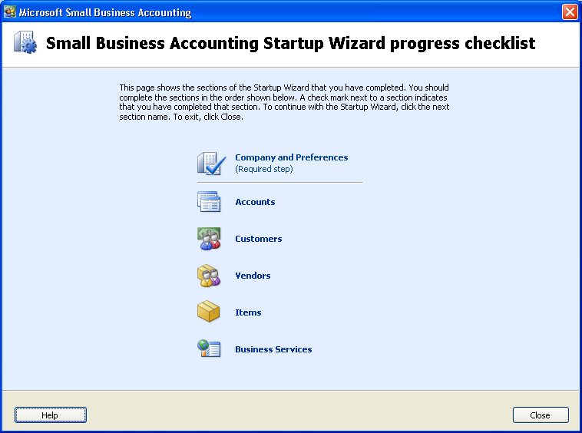
The Startup Wizard

➲ Leverage Familiarity with Office Software
Because it has the look and feel of familiar Microsoft Office software, new users familiar with other Office programs will find it easy to get up and running with Small Business Accounting.
Multiple Ways to Access Features
Like other Office software, Small Business Accounting provides multiple ways to access program areas and features.
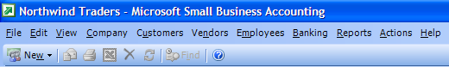
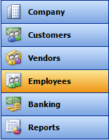
Familiar pull-down menu navigation provides fast access to program features and functionality.

A navigation pane, similar to that in Outlook, provides access to area home pages.

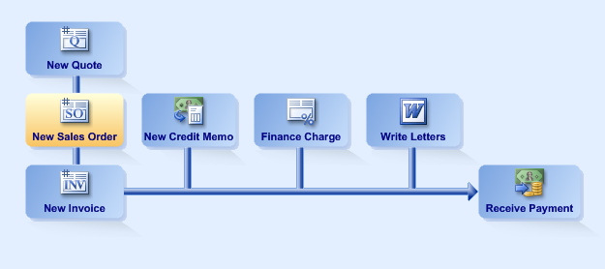

As well, Small Business Accounting offers navigation via a graphical workflow view.

➲ Stay Up and Running with Multiple Support Options
Small Business Accounting offers a wide range of support options designed to let your clients remain focused on core business tasks and let you spend less time walking clients through software issues. Businesses that purchase Small Business Accounting 2006 receive:
- Unlimited free installation support
- One free technical support incident
- A comprehensive online knowledge base
- A choice of affordable technical support plans
Microsoft Small Business Accounting Help. With Small Business Accounting 2006 Help, users can get quick answers to questions by simply pressing the F1 key. In addition, most windows and dialog boxes provide one-click access to contextual help.
Microsoft support plans. Microsoft offers a full range of support plans to meet your specific business needs. Find out about these plans by calling 1-800-MICROSOFT.

Work More Efficiently
Once set up, your clients will find that Small Business Accounting can help them better manage many aspects of their business.

➲ Help Improve Financial Management across the Business
Small Business Accounting 2006 helps your clients keep track of invoices, manage purchase orders, pay bills, track employees, and monitor jobs. From core accounting features such as a general ledger, inventory management, and an audit trail, to enhanced features like ADP payroll processing, credit card processing, and online check and form ordering, Small Business Accounting provides the tools your clients require to contribute to their success.

➲ Get an Overview of the Business with the Company Home Page
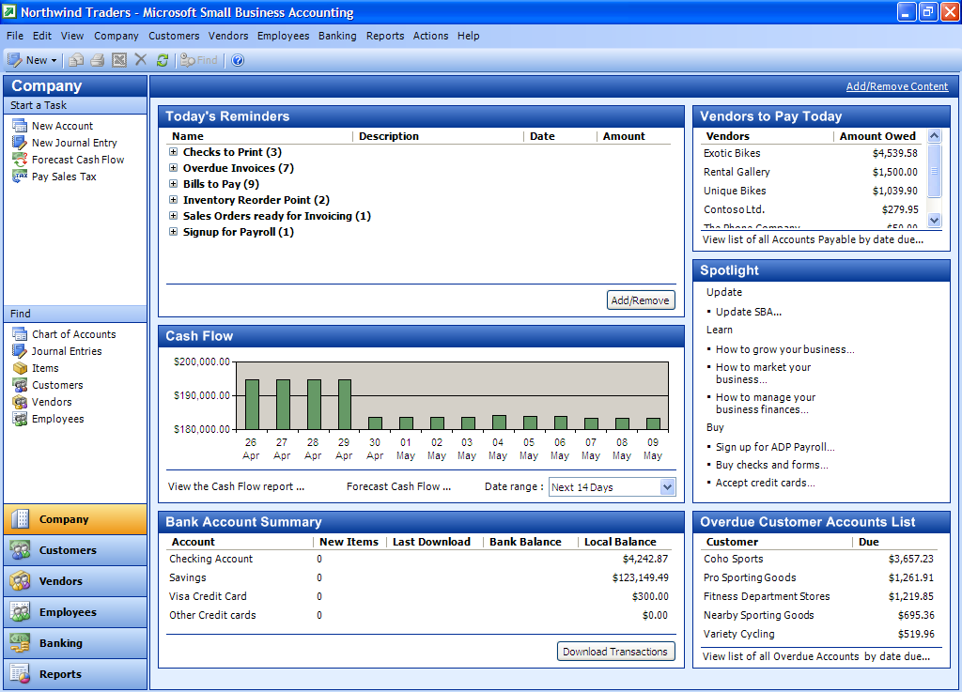
The customizable Company Home page provides a snapshot of the company's overall financial condition as well as the day-to-day accounts payable and accounts receivable information. In addition, the home page offers an overview of bank account information, cash flow, and daily reminders. And, if you would rather see information displayed in a different way, you can easily customize it to fit your needs.
Cash flow projection for the next 14 days.
Summary of bank account balances and other information.
Daily reminders, including overdue invoices, bills to pay, and inventory reorder points.
List of vendors to pay today.
List of overdue customer accounts.
Customize the page with the Add/Remove Content button

A sample Company Home page

➲ Create Invoices and Sales Orders with a Few Clicks
In Small Business Accounting 2006, you can easily turn quotes into sales orders or invoices with a few clicks, helping reduce data re-entry and utilizing existing customer information.
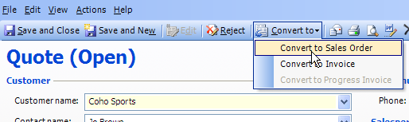
Converting a quote to a sales order

➲ Create Professional-Looking Correspondence
Using the Write Letters Wizard, it is easy to create professional-looking correspondence. The feature allows users to manage, create, or modify letters from Microsoft Word templates for customers, vendors, and employees. Microsoft® Office Word integration requires Word 2002 or 2003.
- Create collection notices, credit requests, appreciation letters for exemplary employees, and more.
- Quickly create and print correspondence for multiple recipients.
- Filter recipients by date range and active/inactive.
- Add a closing signature.
- Customize individual letters in Microsoft Word.
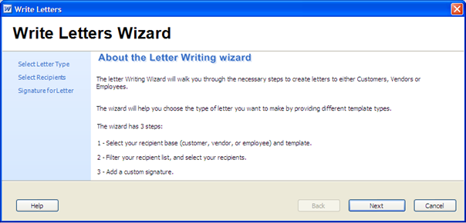
The Write Letters Wizard

➲ E-mail Forms and Letters
Small Business Accounting 2006 integrates with Microsoft Office Word and Microsoft Office Outlook and is designed to help businesses improve productivity by using e-mail for business correspondence. E-mailing forms and letters requires Word 2002 or 2003 and Outlook 2002 or 2003.
- E-mail quotes, sales orders, invoices, and credit memos to customers.
- E-mail purchase orders to vendors.
- Choose from a variety of professional-looking Word templates.
- Customize forms to include company logo, slogan, etc.

➲ Automate Bank Accounts and Bill Payments
The online banking tool in Small Business Accounting 2006 helps businesses consolidate online banking transactions and automate payments, which can help reduce the time spent on repetitive tasks and make it easier to stay on top of payments.

➲ Track Complex Sales
Small Business Accounting provides the features your clients need to track more complicated sales.
- Customize sales tax rates. Create different sales tax groups for different situations. You can apply different rates to different customers. You can also apply different tax rates to different items within a sale.
- Customize price levels. Businesses can set multiple price levels to tailor prices to their customers. For instance, a business might give volume purchasers a percentage price break or set higher price levels for less desirable customers.

➲ Track Job Profitability
For service-based businesses such as construction companies, designers, and consultants, Small Business Accounting provides powerful job monitoring tools. By setting up jobs, your clients can consolidate transactions by individual job, which enables them to track job profitability and progress. The Job form provides an overview of the project and includes the history of all financial transactions tied to the individual job. Jobs can be classified as either Fixed Fee or Time and Materials, and documents, spreadsheets, and other files can be linked to the job record for quick reference.
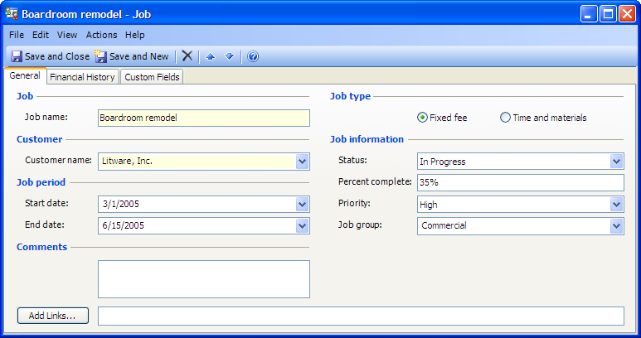
A sample Job form
Advanced Job Features
Small Business Accounting offers powerful, flexible job features.
- Create quotes. Your clients can use Small Business Accounting to create complex quotes that include a variety of products and services, each with a different markup and customer discount.
- Create progress invoices. For fixed fee jobs, your clients can convert a quote into a progress invoice by entering the percentage of the quote to fulfill, helping them to stay on top of invoices and improve cash flow.
Job Reports
Small Business Accounting includes powerful Jobs and Time reports to help your clients monitor profitability. Reports include:
- Profitability by Job, Summary and Detail
- Job Estimates vs. Actuals, Summary and Detail
- Job Progress Invoices vs. Quotes

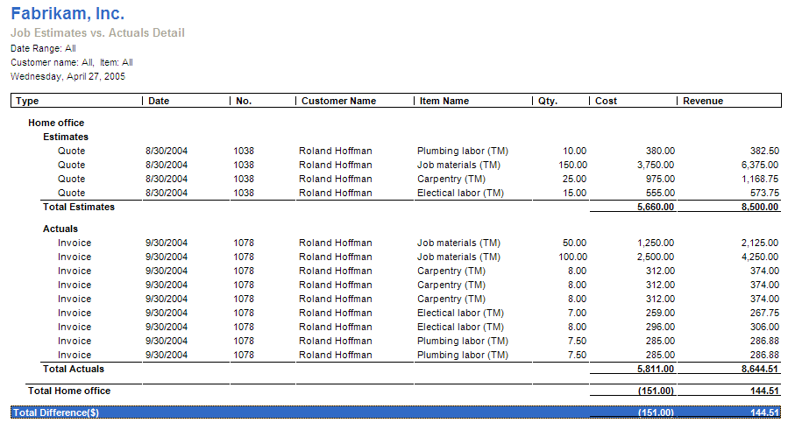
A sample Job Estimates vs. Actuals Detail report

➲ Manage Inventory
Small Business Accounting provides a full array of features for product-based companies to manage inventory.
- Track service and non-inventory items. In addition to tracking inventory items, the software allows businesses to track service items, such as installation or repair work, and also non-inventory items that are not kept in inventory.
- Easily adjust inventory. The Adjust Inventory Quantity and Value form makes it easy to adjust inventory quantities and values.
- Track physical inventory. The printable Physical Inventory Worksheet helps businesses keep track of actual quantities on hand.
- Quickly change item prices. The Change Item Price tool enables businesses to easily change prices for items by either a percentage or a dollar amount.
- Set reorder points for items. Small Business Accounting can track reorder points for inventory items. In addition, the program can be configured so that when the on-hand quantity of an item drops below a set number, a reminder appears on the Company Home page.

➲ Write Off Bad Customer Debts
For situations where a business isn’t able to collect from a customer, Small Business Accounting provides a Write Off tool so that the business can write off all or a portion of a customer’s bad debt.
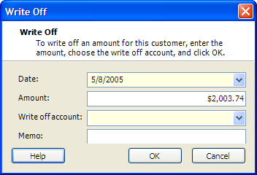
The Write Off dialog box

➲ Support Up to 5 Concurrent Users
For businesses where more than one employee needs access to the accounting software, Small Business Accounting allows up to 5 users to work with the company file from different computers at the same time.
- Help prevent conflicting data. When more than one user accesses Small Business Accounting and works with the same data at the same time, all other authorized users are locked out of the area in use. When there is a conflict, the last user to write data in the area will update that data.
- Help increase security of sensitive data. In order to gain access to Small Business Accounting, a user must belong to a Windows group with access to the computer running Small Business Accounting. In addition, the user must also be assigned a role in Small Business Accounting before access is allowed. These restrictions help ensure that only select users can view or edit sensitive data.
Note: Only members of the Windows Administrator group can set up user access to Small Business Accounting. All members of the Windows Administrator group have full access to Small Business Accounting, even though their user names do not appear in the Manage Users dialog box. To help safeguard your company records, make sure that only appropriate users are listed in the Windows Administrator group on the computer or in the domain where Small Business Accounting is installed.

Gain Insights to Make Better Decisions
In addition to helping them manage their day-to-day finances, your clients count on you to offer insightful business advice. Small Business Accounting provides tools and features to help you and your clients get a better handle on your clients’ business and, ultimately, to help you and your clients make better decisions.

➲ Analyze Financial Data with Customizable Reports
With more than 40 reports, including many that provide the type of information that accountants value highly, you and your clients can get a more complete view of your clients’ financial needs.
Small Business Accounting includes the following reports:
Company and Financial |  | Customers and Receivables
- Chart of Accounts |  | - A/R Aging Summary
- Profit and Loss |  | - A/R Aging Detail
- Balance Sheet |  | - Customer Transaction History
- Cash Flow Statement |  | - Profitability by Customer Summary
- Trial Balance |  | - Profitability by Customer Detail
- Transaction Detail by Account
- Transaction Journal |  | Vendors and Payables
- Change Log |  | - A/P Aging Summary
- Sales Tax Liability |  | - A/P Aging Detail
- Transaction Detail by Tax Code |  | - Vendor Transaction History
 |  | - 1099 Summary
Sales |  | - 1099 Detail
- Sales by Customer Summary
- Sales by Customer Detail |  | Inventory
- Sales by Salesperson Summary |  | - Item Price List
- Sales by Salesperson Detail |  | - Inventory Valuation
- Sales by Item Summary |  | - Inventory Stock Status by Item
- Sales by Item Detail |  | - Physical Inventory Worksheet
 |  | - Item Profitability
Purchases
- Purchases by Vendor Summary |  | Banking
- Purchases by Vendor Detail |  | - Deposit Detail
- Purchases by Item Summary |  | - Check Detail
- Purchases by Item Detail |  | - Bank Transactions
 |  | - Missing Checks
Jobs and Time |  | - Reconciliation Detail
- Profitability by Job Summary
- Profitability by Job Detail |  | Employees and Payroll
- Job Estimates vs. Actuals Summary |  | - Time Report
- Job Estimates vs. Actuals Detail
- Job Progress Invoices vs. Quotes

Drill-Down Functionality
Each report offers drill-down functionality, so you can quickly and easily review transactions and examine original transaction records.

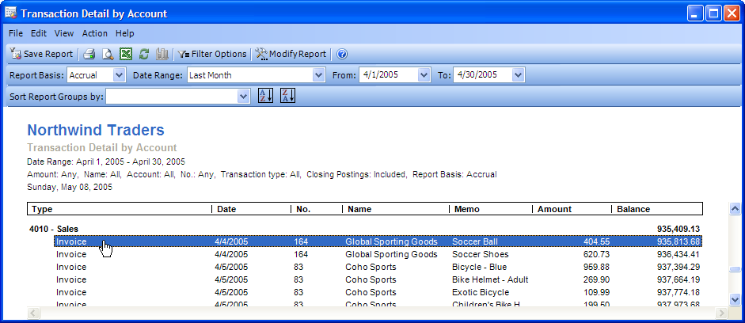
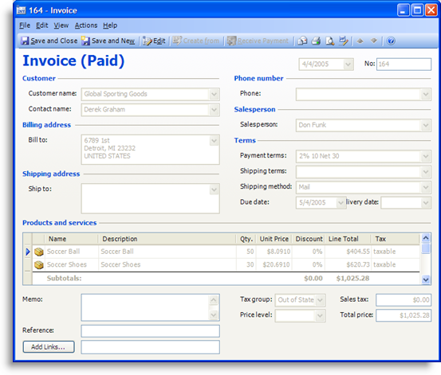
In this example, the user has clicked on a sales line item in the Transaction Detail by Account report to view Invoice No. 164.

➲ Forecast Cash Flow
As accounting professionals know, cash flow can often make or break a small business, so knowing ahead of time when to expect a shortage or an excess of cash is extremely important. Small Business Accounting includes a powerful cash flow forecasting tool that helps you and your clients better anticipate financial needs based on what-if scenarios, giving you valuable insight into the company’s future.
In forecasting cash flow, you can manipulate a wide range of variables, including:
- Beginning account balances
- Upcoming sales
- Cash inflows
- Upcoming expenses
- Cash outflows

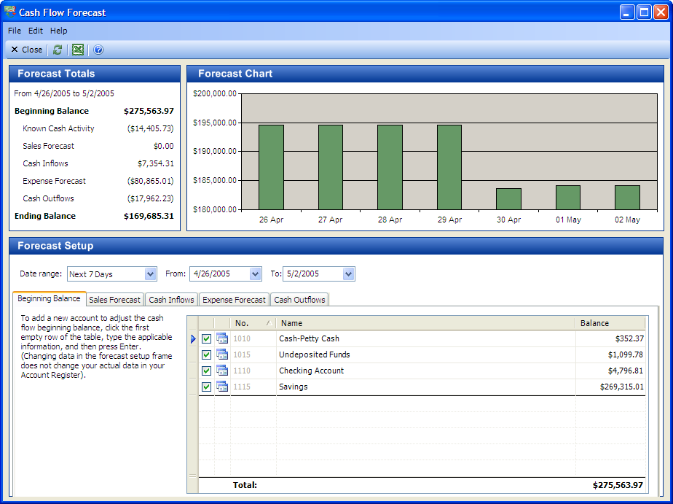
The Cash Flow Forecast tool

To see the effects of a possible upcoming sale worth $100,000, simply enter it into the forecast setup …
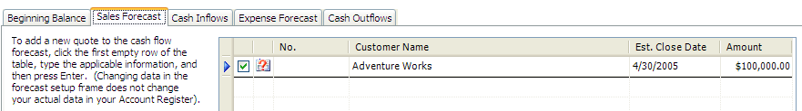

… and instantly see the projected results.
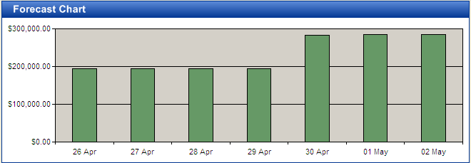

Maintain Control Over Financial Information
Simple enough to use for new business owners with little financial experience, Small Business Accounting also provides advanced accounting tools to help you and your clients maintain control over financial data.

➲ Track Changes with the Audit Trail
It’s important to keep tabs on how transactions are being entered. Small Business Accounting 2006 utilizes a change log that provides a comprehensive audit trail to help business owners and accounting professionals keep track of changes and easily figure out mistakes or other irregularities.
- Transaction details are automatically recorded. Details of accounting transactions, including such things as user, account, date, type, name, and number, are logged.
- Transactions are voided instead of deleted. When a user wants to remove a recorded invoice, payment, or receipt, instead of deleting it, the user voids the transaction. By voiding the transaction, the record is financially removed from the ledger, but the audit trail is preserved.
- Quickly find and fix mistakes. The audit trail allows you to track transactions by user and helps you easily find and fix mistakes, before they compound themselves.

➲ Manage User Roles and Permissions
Small Business Accounting 2006 helps businesses t control access to sensitive data based on employee role, creating a security-enhanced environment in which to share information. Permissions are based on Windows user names. All users must belong to a Windows group with access to the computer running Small Business Accounting, and users must also be assigned a role in Small Business Accounting before they can work in the application.
Employees can be assigned to the following preset roles:
Owner has limited access to all product features. An owner cannot create a new company, cannot install Small Business Accounting, and cannot manage user roles, unless he or she is an administrator on the computer running Small Business Accounting.
Office Manager is responsible for managing the day-to-day financial records of the company, including customer transactions, vendor transactions, banking transactions, and payroll. The Office Manager role has full access to most product areas but cannot set up the company, manage users, or restore or delete company data files.
Accountant is responsible for reviewing, updating, and managing the financial data of the company. The Accountant role has all of the permissions of the Office Manager role and can set up online accounts and download transactions.
Salesperson is responsible for handling customer transactions and most vendor transactions. The Salesperson role cannot carry out any banking, accounting (such as journal entries), or payroll transactions.
Read-only User can view customer and vendor transaction information but cannot add, delete, or update any information.
Note: All members of the Windows Administrator group have full access to Small Business Accounting, including installation, setting up the company, and managing users, even though their user names do not appear in the Manage Users dialog box. To safeguard company records, only appropriate users should be listed in the Windows Administrator group on the computer or in the domain where Small Business Accounting is installed.

➲ Reconcile Accounts and Bank Statements
The Reconcile Account tool helps you and your clients efficiently reconcile your clients’ bank and credit card accounts and track down discrepancies.
To use the feature, simply enter the beginning and ending balances for the account you’d like to reconcile in the Reconcile Account dialog box …
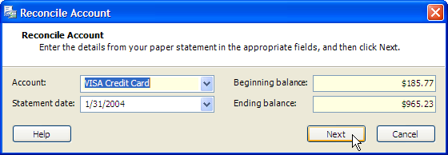

… and Small Business Accounting gives you a list of all transactions for that account.
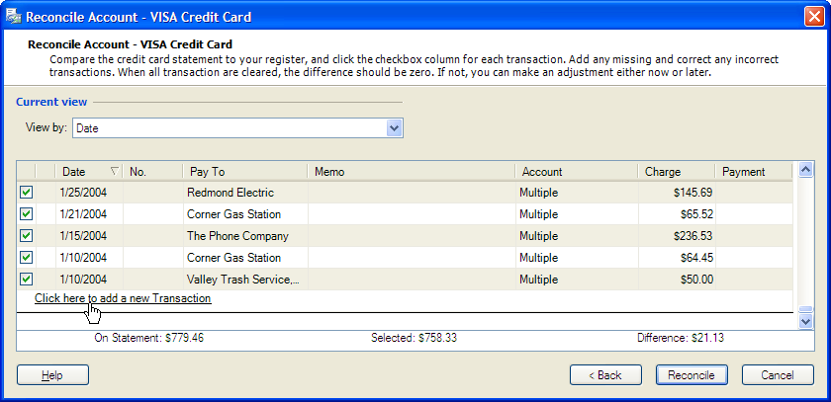

You can then compare the bank or credit card account to the statement, and add or correct any missing or incorrect transactions.

➲ Make Journal Entries
Small Business Accounting gives businesses and accounting professionals the power to make journal entries to record account opening balances, depreciation charges, sales of assets, adjust previously recorded entries, or make other adjustments. The application also makes it easy to edit or void journal entries.
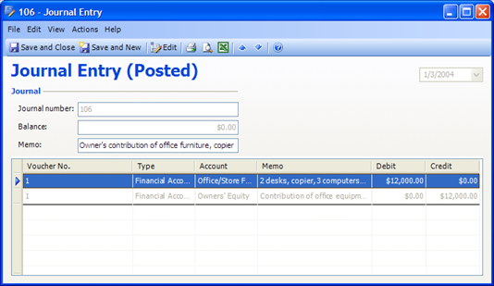
A sample journal entry

➲ Close the Books
To safeguard previous accounting periods against changes, Small Business Accounting enables you to close out accounts.
- Close the fiscal year. The Manage Fiscal Year dialog box allows users to close and open fiscal years. When you close a fiscal year, journal entries are created to zero out all income and expense accounts, and the resulting profit or loss is applied to the Retained Earnings account in the Equity section on the Balance Sheet. This means that you start the following year with a net income of zero.
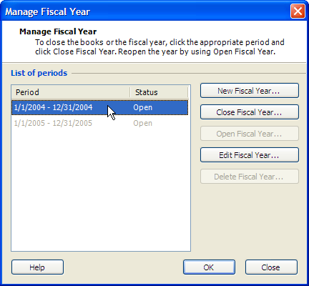
The Manage Fiscal Year dialog box
- Tightly control access to closed periods. Once a fiscal year is closed, the only user who can post in that fiscal year is a user who has the Owner, Accountant, or Office Manager role. To further increase security of data, in order to post to a closed fiscal year, the fiscal year must be reopened. After changes have been made, the fiscal year must be closed again, because the beginning balances for the following period may have changed.
- Close accounts as of any date. Small Business Accounting gives you the flexibility to close out accounts as of a specific date, so you can close the books on a quarterly or monthly basis if you like.
- Track changes to closed periods. When changes are made to a closed period, they are recorded in the Change Log. You can review changes to closed periods by viewing the Change Log report.

➲ Back Up Company Data
Small Business Accounting enables users to back up company data and to restore a backup file. You can choose to back up to a server or to a removable hard disk for protection in the event of hardware or software failure. You can also back up to your local hard drive and then copy the backup file to removable media or attach the backup file to an e-mail. For security, backup files can be password protected.
Businesses create a backup file:
- As part of regular system maintenance, to help protect data
- To create a copy of the company file to share with their accountant
- To import company data into a new company file
- To move Small Business Accounting to a different computer

Help Improve Customer Service
As an accounting professional, you realize that your clients’ customers are its lifeblood. Small Business Accounting helps your clients leverage the deep knowledge they have about their customers to provide better customer service.

➲ View Contact, Sales, and Financial Information on One Screen
For a small business, staying on top of customer commitments and opportunities can be a struggle. That is because their customer information may be scattered throughout their company—in someone’s personal computer at the office, in another’s laptop, even jotted on pieces of paper. Enter Microsoft® Office Outlook® 2003 with Business Contact Manager Update, which integrates seamlessly with Small Business Accounting 2006. Outlook 2003 with Business Contact Manager Update gives businesses a single clear view of customer financial information, sales pipeline, and cash flow.
Note: Business Contact Manager Update for Microsoft Office Outlook 2003 provides the latest updates to Outlook 2003 with Business Contact Manager. Licensed users of Microsoft Office Small Business Edition 2003 or Microsoft Office Professional Edition 2003 are eligible to upgrade to Outlook 2003 with Business Contact Manager Update by downloading it or ordering a CD (shipping and handling charges apply). Visit the Outlook 2003 with Business Contact Manager Update site for more information at:
http://www.microsoft.com/office/outlook/contactmanager/prodinfo/update.mspx.
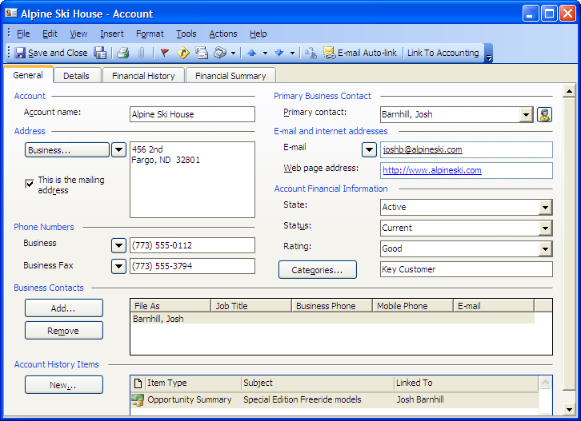
A sample business contact record
- Consolidate business information in one view. Through Microsoft Office Outlook 2003 with Business Contact Manager Update, small businesses gain the tools they require to effectively manage customer relations. It helps put customer information into one view, so it is easily located when needed. Outlook 2003 with Business Contact Manager Update organizes customer information into four tabs:
  - General. Provides customer contact information and links to associated sales opportunities, tasks, appointments, phone logs, and other files.
  - Details. Offers a place for employees to log information about how the account was found, the type and location of the business, and notes about the account.
  - Financial History. Once Outlook 2003 with Business Contact Manager Update is linked to Small Business Accounting, employees can view a customer’s complete financial history from the Financial History tab. Employees can double click any transaction to view it.
  - Financial Summary. Once Outlook 2003 with Business Contact Manager Update is linked to Small Business Accounting, employees can click on the Financial Summary tab to view a summary of a customer’s balance, sales, and credit information.
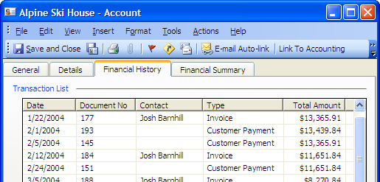
The Financial History tab of Business Contact Manager
- Track and submit billable time. Accountants know: the easier it is to track billable time, the more employees will capture their billable hours, and the less revenue will slip through the cracks. Outlook 2003 with Business Contact Manager Update allows employees to easily mark appointments in their Outlook calendars as billable time and transfer and record that information to the accounting program with a click of a button, giving your clients an easy way to facilitate accurate, timely billing.
- Share customer information. Authorized employees can share customer information through Outlook 2003 with Business Contact Manager Update, such as previous communications, recent orders, or financial information.
- Manage security of sensitive company data. Outlook 2003 with Business Contact Manager Update can be configured so that employees have access only to the information that the business owner permits.
- Share sales information. Each time a salesperson develops a lead, he or she can create an opportunity item. Then, by simply clicking on the form, the business owner can see details about the product or service being sold as well as information about the sales stage and the probability of closing the deal. Product pricing and other relevant information can be imported to the opportunity form, and each form is linked to an account or business contact. This helps build fast, accurate quotes and answer customer questions quickly.
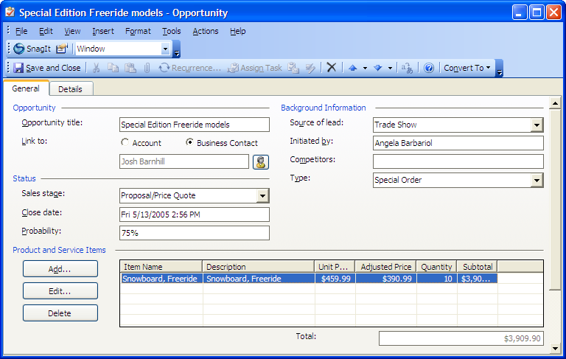
A sample opportunity record showing a potential sale of snowboards
- Track employee activity on customer accounts. Small business owners can use Outlook 2003 with Business Contact Manager Update to keep track of which employees are talking to which customers. Once Outlook 2003 with Business Contact Manager Update is linked to Small Business Accounting, quotes, invoices, and purchase orders created in Outlook 2003 with Business Contact Manager Update also appear in Small Business Accounting 2006. Inventory and sales information can also be shared by both programs, providing a real-time view of customer account changes as they occur.
- Synchronize with Pocket PC synchronization (NEW). Because Outlook 2003 with Business Contact Manager Update can integrate with Windows-based Pocket PCs and other Windows-based mobile devices, on-the-road employees can access customer and business information such as pending orders, customer contacts, and new product pricing that they’ve downloaded from their office computer. Plus, when the Pocket PC is returned to its cradle, all changes made to business contact data in the field automatically transfer to the office computer and automatically update the account information for everyone sharing their business contact information.

Take Advantage of Integrated Services
Small business owners want peace of mind, convenience, and control when it comes to tasks such as payroll processing, credit card transactions, or issuing checks. Microsoft® Office Small Business Accounting 2006 integrates these tasks and offers your clients flexible services based on their unique business needs.

➲ ADP PayrollSM for Microsoft Office Small Business Accounting 2006
ADP Payroll for Microsoft Office Small Business Accounting 2006 is a new, easy, and cost-effective way for your small business clients to process their payroll and taxes. This online service is simple to set up and use, and calculates federal, state, and local taxes. In addition, payroll and tax reminders help clients throughout the payroll and tax filing process.
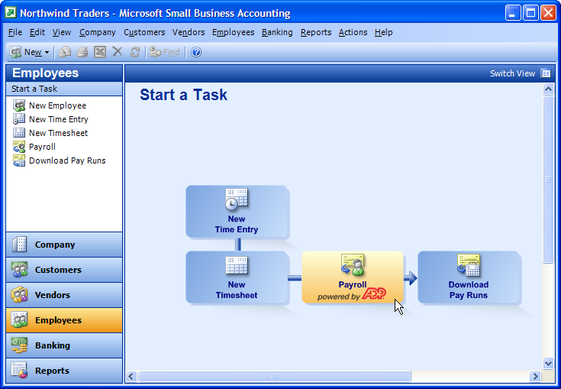
The Employees Home page, featuring payroll by ADP
ADP Payroll works with Microsoft Office Small Business Accounting 2006 so clients can seamlessly transfer employee and timesheet data into the payroll application and payroll and tax information to the general ledger.
Your clients can choose from two levels of payroll services based on the complexity of your clients’ financial and payroll needs: ADP Payroll or ADP Total Payroll.
ADP Payroll is a cost-effective, easy-to-use, do-it-yourself payroll solution for your small business clients who prefer full control over their payroll processing and tax filing. A comprehensive wizard helps your clients set up their payroll, and features offered through ADP simplify the process.
ADP Total Payroll is a full-service payroll solution for users who prefer to outsource their payroll completely. Once your clients submit payroll, ADP prints and mails paychecks (or provides direct deposit) and also files taxes with the appropriate agencies at the federal, state, and local levels. This option reduces the need for clients to manually complete forms and keep track of tax deadlines, and it helps ensure that the appropriate taxes are filed. The liability of tax filing transfers to ADP, resulting in more peace of mind for the client.
 | ADP Payroll—In-House | ADP Total Payroll—Outsourced
 | An in-house option for managing your payroll with ease and confidence with free support to get started* | All the benefits of ADP Payroll, plus outsourced tax filing and payroll processing along with unlimited toll-free support calls
Payroll processing | Earnings and deductions accurately calculated for you | Fully outsourced payroll
Payroll processing | Pay employees with checks or direct deposit** | ADP prints and delivers checks
Payroll processing | Payroll features on one simple screen | Schedule payroll in advance with full direct-deposit service
Tax compliance | Payroll and tax reminders of critical payroll dates or activity | ADP files and pays taxes to federal, state, and local government
Tax compliance | Automatic tax table updates | No need to worry about tax table updates
Tax compliance | Federal, state, and local taxes calculated | ADP assumes tax liability***
Tax compliance | Signature-ready federal and state tax forms | Automatic tax filing
Comprehensive reports and year-end processing | Comprehensive reporting utilizing Small Business Accounting 2006 | Comprehensive reporting utilizing Small Business Accounting 2006
Comprehensive reports and year-end processing | Print W-2s, W-3s, 1099s, and other tax forms | ADP prints and delivers all tax documentation

*First support call free. $35 per service call thereafter or $150 for 5 service calls.
**File creation only.
***If ADP should make an error that results in a payroll tax penalty, ADP will pay the penalty.
ADP Payroll Home Page
Featuring a look and feel similar to Small Business Accounting, the Home Page of ADP Payroll and ADP Total Payroll helps improve productivity by including one-click access to frequently used features and lists of daily tasks and reminders.
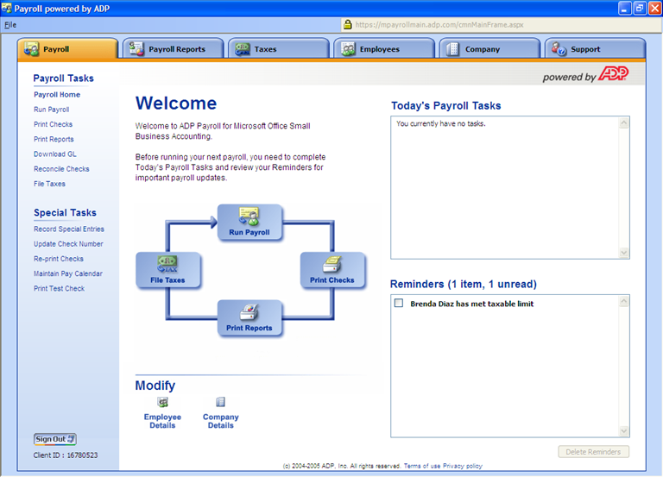
The ADP Payroll Home page
Built-In Payroll Reports
ADP Payroll and ADP Total Payroll offer detailed payroll reports, accessible via Small Business Accounting, to help business owners better understand how payroll is affecting their bottom line.
Payroll reports include:
- Payroll Summary
- Payroll Detail
- Earnings Record
- Deduction Summary
- Employee Paid Time Off
- Workers' Compensation Worksheet
- Wage and Tax Register
- Quarterly Local Withholding
- Quarterly Local Reconciliation
- Employee Summary
- W-2 Preview

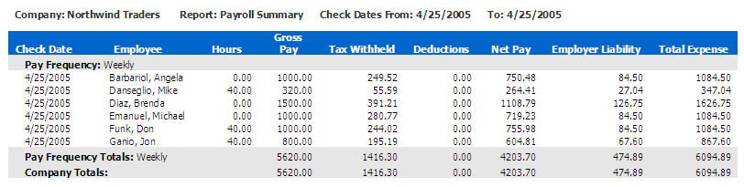
A sample payroll summary report

Easily Download Payroll Transactions into Small Business Accounting
Once your client has completed running their payroll, downloading the payrun from ADP to Small Business Accounting is simple. After clicking Download GL, your client selects the name of the payrun to download and clicks Download. Payroll transactions are instantly downloaded into the general ledger of Small Business Accounting.
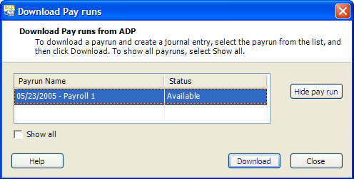

Advanced Payroll Features
ADP Payroll and ADP Total Payroll include advanced features for clients with specific needs.
- Set up deductions. You can set up the program to automatically deduct money from employee pay for things such as advances, pre-tax or post-tax health insurance, and retirement plans such as a 401(k) or a SIMPLE IRA. You can even set up an employer match for 401(k) contributions.
- Track paid time off. You have the option of tracking vacation, sick, and personal days.
- Track workers’ compensation. You can add workers’ compensation codes and descriptions to the program and assign codes to individual employees.
- Control how transactions are downloaded. With ADP Payroll and ADP Total Payroll, you control how payroll transactions are downloaded into Small Business Accounting. Though the payroll solutions default to the Small Business Accounting chart of accounts, you have the flexibility of changing the expense and liability accounts to which payroll transactions are downloaded.

➲ Process Credit Cards
Fully integrated with Small Business Accounting 2006, credit card processing is ideal for your small business clients who want to accept credit and debit card payments to better serve their customers and reduce cost. Integration with Small Business Accounting 2006 also:
- Eliminates certain data entry. Credit card transactions are automatically captured in Small Business Accounting 2006, which helps facilitate better reporting and reduction of data re-entry errors.
- Helps reduces costs. Your clients can get started quickly without the need for expensive and bulky credit card processing machines.
- Offers merchant flexibility. Clients can work with a wide range of banks. Clients who already have a credit card processing account don’t have to change banks.
Visit http://sba.microsoft.com for more information.

➲ Order Checks and Forms Online
Small Business Accounting provides an easy way for your clients to purchase professional, high-quality business checks, envelopes, business cards, forms, and other personalized products. In addition, all business check orders have enhanced protection against check order fraud and identity theft with automatic, exclusive Fraud Protection.
Benefits to your clients include:
- Full compatibility. Business checks and forms are completely compatible with Small Business Accounting 2006.
- Personalization. Choose from a large selection of colors, lettering, custom logos, and styles.
- Extensive selection. Get a range of business checks, envelopes, forms, and other personalized products.
- World-class customer service. Customer care representatives are available 24 hours per day (Monday through Friday), and there are four flexible ways to order (online, phone, fax, and mail).
Visit http://www.microsoftchecksandforms.com for more information.

Small Business Accounting Compared to Other Products
From core accounting features such as a general ledger, inventory management, and an audit trail, to enhanced features available for extra fees like ADP payroll processing, credit card processing, and online check and form ordering, Small Business Accounting 2006 provides the tools your clients require to be successful.
The feature set offered by Small Business Accounting is comparable to that of other products, such as QuickBooks Pro 2005 and Peachtree Complete Accounting 2005. However, Small Business Accounting offers the following advantages over competitors:
- Deep integration with Word, Excel, and Outlook
- Familiar interface similar to other Microsoft Office applications
- Works with Outlook 2003 with Business Contact Manager Update to enable businesses to track finances and customers in one place, which can improve customer service
- Offers the ability for up to 5 users to access data concurrently without purchasing additional instances of the software

Feature Comparison Chart
Accounting Software  Features | Small Business  Accounting 2006 | QuickBooks Pro 2005 | QuickBooks Basic 2005 | Peachtree Complete Accounting 2005
Priceª | ~$200 | $299.95  $199.95 Upgrade | $199.99  $99.95 Upgrade | $299.99  $239.95 Upgrade
Core accounting
Chart of accounts/general ledger | ✓ | ✓ | ✓ | ✓
Generate key reports such as profit and loss statement, balance sheet, cash flow | ✓ | ✓ | ✓ | ✓
Inventory management | ✓ | ✓ | ✓ | ✓
Accounts receivable/ accounts payable | ✓ | ✓ | ✓ | ✓
Quotes, sales orders, invoicing, and purchase orders | ✓ | ✓ | ✓ | ✓
Audit trail | ✓ | ✓ | ✓ | ✓
Cash flow projections | ✓ | ✓ |  | ✓
Ease of use
Import data from QuickBooks | ✓ | ✓ | ✓ | ✓
Setup Wizard | ✓ | ✓ | ✓ | ✓
Familiar Microsoft® Office interface | ✓
Track finances and customers
in one place

View up-to-date financial information on the Company Home page | ✓ | ✓ | ✓ | ✓
Access customer financial  information through Microsoft  Office Outlook® 2003 with Business Contact Manager | ✓^{b}
Submit sales orders, invoices, and billable time from Outlook 2003 with Business Contact Manager | ✓^{b}
Track sales data, sales opportunities, and customer jobs from Outlook 2003 with Business Contact Manager | ✓^{b}
Share financial information with Microsoft Office programs
Create and send letters to customers with Microsoft Office Word | ✓^{c} | ✓^{d} |  | ✓^{d}
E-mail forms, letters, and reports | ✓^{c} | ✓ | ✓ | ✓
Export data to Microsoft Office Excel® for analysis and charting | ✓^{c} | ✓^{d} |  | ✓^{d}
Customize quotes, orders, and invoices in Microsoft Office Word | ✓^{c}
Enhanced accounting

Easy backup and restore | ✓ | ✓ | ✓ | ✓
Online banking  (additional fees may apply) | ✓ | ✓ | ✓ | ✓
Pay bills, print checks, and credit card processing  (additional fees may apply) | ✓ | ✓ | ✓ | ✓
Manager payroll  (additional fees may apply) | ✓^{f} | ✓ | ✓ | ✓
Closing periods | ✓ | ✓ | ✓ | ✓
Multiple price levels | ✓ | ✓ |  | ✓
User security and views | ✓ | ✓ |  | ✓
Multi-user functionality^{e} | ✓ | ✓ |  | ✓
Job costing | ✓ | ✓ |  | ✓
Create and track inventory kits | ✓ |  |  | ✓

ª Estimated retail prices; actual retail prices may vary. Prices are accurate as of May 5, 2005. Exact pricing for Small Business Accounting 2006 to be announced.
^{b} Requires separate purchase of Outlook 2003 with Business Contact Manager Update.
^{c} Word and Excel integration require Word 2002 or 2003, and Excel 2002 or 2003.
^{d} Word and Excel integration requires Word 2000, 2002, or 2003 and Excel 2000, 2002, or 2003.
^{e} For multi-user functionality, customer must purchase one license per user.
^{f} Payroll service provided by ADP for an additional fee.

Our Commitment to the Future
Microsoft® is committed to helping accounting professionals reinforce their role as a trusted advisor to their small business clients. We will continue to expand and enhance Microsoft® Office Small Business Accounting to help small businesses and the accountants that serve them achieve success.
Please visit http://www.microsoft.com/accountants to find out more about Microsoft’s commitment to accounting professionals and to sign up to receive information relevant to accounting professionals.

Pricing
Microsoft® Office Small Business Accounting 2006 will cost under $200.

System Requirements
Here are the system requirements for Small Business Accounting 2006:
- Personal computer with an Intel Pentium 450-megahertz (MHz) or faster processor (Pentium III recommended)
- Microsoft Windows® 2000 with Service Pack 3 (SP3) or later, or Windows XP or later operating system
- 256 megabytes (MB) of RAM or more recommended
- Super VGA (800 × 600) or a higher-resolution monitor
- CD-ROM or DVD drive

Additional items or services are required to use certain features:
- Internet functionality requires dial-up or broadband Internet access provided separately; local or long-distance charges may apply.
- For certain integration functionality, including Export to Excel and Word, Office Professional Edition 2003 is required.
- Office Professional Edition 2003 is required to create customized invoices, sales orders, quotes, customer credit memos, customer statements, and purchase orders; Office XP or later is required to export data to Word or Excel; Outlook 2003 with Business Contact Manager Update is required to share financial data with the Outlook messaging and collaboration client.
- 3rd party services including ADP payroll are available for additional fees.

For sharing functionality:
- To enable sharing functionality, the host machine must be running Windows 2000 with Service Pack 3 or Windows XP Professional Edition.

Third party services including ADP payroll, credit card processing, and checks and forms are available for additional fees.
Third party services including ADP payroll, credit card processing, and checks and forms are available for additional fees.
Additional Payroll Reports provided by ADP; additional fees required with ADP payroll services.
Third party services including ADP payroll, credit card processing, and checks and forms are available for additional fees.
Additional fees required with ADP Payroll services.
If ADP should make an error that results in a payroll tax penalty, ADP will pay the penalty.
Third party services including ADP payroll, credit card processing, and checks and forms are available for additional fees. Visit http://sba.microsoft.com for more information.
Third party services including ADP payroll, credit card processing, and checks and forms are available for additional fees. Visit http://www.microsoftchecksandforms.com for more information.
Estimated retail price. Exact pricing for Small Business Accounting 2006 to be announced.

