Microsoft Service Delivery Platform
Technical Overview

October 2003
Microsoft Corporation

The information contained in this document represents the current view of Microsoft Corporation on the issues discussed as of the date of publication. Because Microsoft must respond to changing market conditions, it should not be interpreted to be a commitment on the part of Microsoft, and Microsoft cannot guarantee the accuracy of any information presented after the date of publication.
his White Paper is for informational purposes only. MICROSOFT MAKES NO WARRANTIES, EXPRESS, IMPLIED OR STATUTORY, AS TO THE INFORMATION IN THIS DOCUMENT.
Complying with all applicable copyright laws is the responsibility of the user. Without limiting the rights under copyright, no part of this document may be reproduced, stored in or introduced into a retrieval system, or transmitted in any form or by any means (electronic, mechanical, photocopying, recording, or otherwise), or for any purpose, without the express written permission of Microsoft Corporation.
Microsoft may have patents, patent applications, trademarks, copyrights, or other intellectual property rights covering subject matter in this document. Except as expressly provided in any written license agreement from Microsoft, the furnishing of this document does not give you any license to these patents, trademarks, copyrights, or other intellectual property.
©2003 Microsoft Corporation. All rights reserved.
Microsoft, Active Directory, BizTalk, SQL Server, Visual Studio, and Windows Server are either registered trademarks or trademarks of Microsoft Corporation in the United States and/or other countries.
The names of actual companies and products mentioned herein may be the trademarks of their respective owners.
Table of Contents
Executive Summary 1
Solution Overview 1
Concept 1
Approach 1
Solution Architecture 1
Components and Mechanisms 1
Service Execution Environment 1
Control Services 1
Service Orchestration 1
Integration Services 1
Service Creation Environment 1
Service Deployment Environment 1
Service Management Environment 1
Microsoft Product Strategy 1
Summary 1

Executive Summary
In order to increase average revenue per user and decrease customer churn rate, mobile and fixed-line network operators are increasingly investing in value-added data services—such as media download, messaging, mobile commerce, and collaboration—to create new revenue sources and increase customer satisfaction by enabling customers to access rich media content anytime, anywhere, and from any device, and as a result, driving network traffic and revenue growth. Operators need to differentiate through value-added data services. To maximize returns on investments and gain competitive advantages, network operators need a flexible and scalable service delivery platform to streamline the process of creating, deploying, and managing their value-added data services, including those for multimedia-on-demand, messaging, mobile commerce, and so on, in order to reduce the time-to-market of new services and lower operational costs.
Microsoft® Service Delivery Platform is a solution for helping mobile and fixed-line operators to cost-effectively create, deploy, and manage value-added data services and make them easily and securely accessible by consumers from anywhere, anytime, and on any device—PCs, mobile handsets/smart phones, PDAs, and so on. It integrates with content management service solutions to enable content providers to easily deliver content to customers by leveraging the operator’s network and systems. With the ability to integrate with a variety of OSS, BSS, and network service products based on industrial standards (such as XML, HTTP, and Web services), the Microsoft Service Delivery Platform gives operators the flexibility of leveraging their existing investments. Based on a suite of products and solutions from Microsoft and its partners, the Microsoft Service Delivery Platform is a secure and scalable platform that has been deployed by multiple network operators.
Microsoft Service Delivery Platform is based on implementations by Microsoft for some major network operators worldwide and collaborations with major system integration and technology partners. Microsoft Service Delivery Platform can be implemented through service offerings from Microsoft Consulting Services (MCS) and Microsoft’s premier system integration partners.

Solution Overview
Microsoft Service Delivery Platform is a solution based on products and technologies from Microsoft and its partners. It consists of the service creation, deployment, and execution environments for value-added data services for communications, commerce, collaboration, infotainment, and others. It provides a platform for content service solutions to integrate, manage, and provision content from third-party content providers. Based on industry standards such as XML, HTTP, and Web services, the Microsoft Service Delivery Platform can integrate with a variety of OSS, BSS, and network services products to provide end-to-end solutions for mobile and fixed-line operators.

Concept
The Service Delivery Platform is a platform that supports the development, deployment, and execution of value-added services. The Service Delivery Platform provides the following key functions:
- Creation of services
It is important for network operators to be able to quickly develop new services in order to gain competitive advantages in the market place. Service Creation Environment, based on Microsoft products and Microsoft Visual Studio® .NET as a popular development platform, significantly simplifies the service creation process and reduces the development costs.
- Deployment of services
The platform helps operators to deploy, monitor, and manage the value-added services.
- Execution of services
The platform provides a run-time environment for value-added services by providing support functions in the areas of identity management/access control, event motoring, orchestration, and integration with external systems such as OSS, BSS, and network elements.

Approach
The Service Delivery Platform solution is based on the following design principles:
- It is a solution framework that centers on service creation, service deployment, and service execution.
- It is a flexible integration framework for different products and technologies from Microsoft and third-party vendors based on open standards such as SOAP, HTTP, and XML.
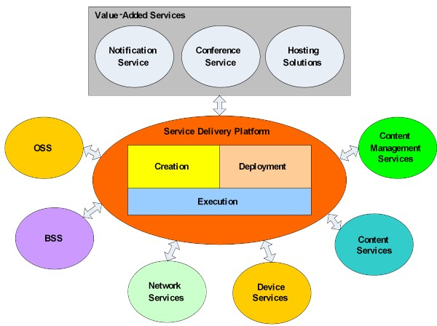

Figure 1: The Service Delivery Platform in an operator’s environment
- It is network-neutral—support for all mobile and fixed-line networks—but can be customized to meet the specific requirements of different network environments.
- It is a platform that supports services for both consumers and enterprise customers.
Essentially, the Service Delivery Platform is the foundation for value-added services, and it is complemented with OSS, BSS, content management, and network services.

Solution Architecture
The Service Delivery Platform consists of service components organized in the following layers:
- Service Creation Environment
This layer provides the service catalog that manages the services, an integrated development environment, and platform software development kits (SDKs) to facilitate the creation of new services. It also helps content providers create new content applications that leverage the services from the Service Delivery Platform.
- Service Deployment Environment
This layer provides the deployment services with deployment tools and mechanisms. It provides resource management that helps system administrators to manage deployed services in a distributed network. As an example, it supports the integration with content distribution networks to distribute services to operators’ edge networks on a global scale to enable customers to access services hosted by the nearest servers.
- Service Execution Environment
This layer consists of the control services that provide identity management for access control, metering service for creating billable data records, profile and personalization management, notification engine to support push-based alerts to customers, and content provider services that facilitate the integration of Service Delivery Platform with content providers. It also includes service orchestration that provides rule-based process scheduling, and integration services that integrate Service Delivery Platform with content management, BSS, OSS, and device management systems to provide end-to-end services to customers.
- Service Delivery Platform Management
This layer provides management functions to manage the deployment and execution of services in the operator’s network, which include security, service, and service level agreement (SLA) management.
The SDP supports the development, deployment, and execution of value-added services, such as those for infotainment, commerce, communications, business, and collaboration.
The following diagram describes the high level architecture of the Service Delivery Platform and its environment.
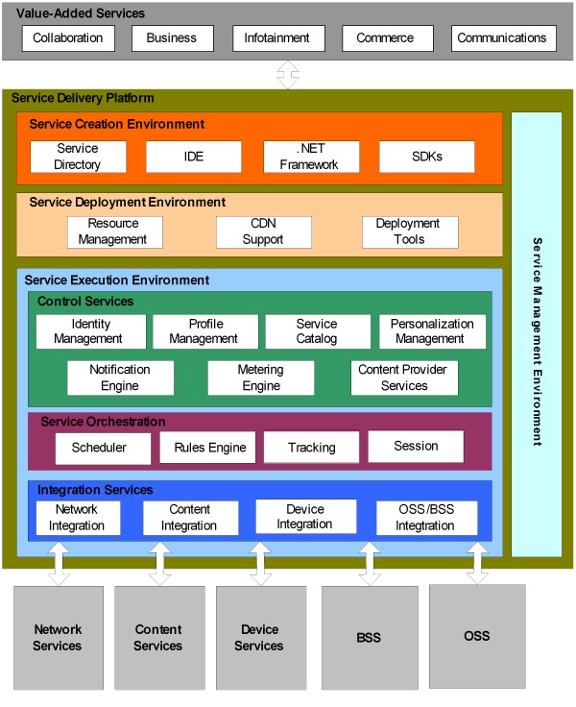
Figure 2: Microsoft SDP Architecture
The Service Delivery Platform architecture is a framework that allows different components to be mixed and matched in implementations and deployments.

Components and Mechanisms
This chapter provides an overview of the components and mechanism that comprise the Microsoft Service Delivery Platform solution.

Service Execution Environment
The service execution environment provides support for the execution of Service Delivery Platform and value-added services. It includes the following services:
- Control Services
- Service Orchestration
- Integration Services

Control Services
The control services provide the control functions, including identity management, personalization, event metering, and so on, to support the execution of value-added services in the operator’s network.

Service Catalog
The service catalog manages all the Service Delivery Platform–managed and external content provider services. It describes the features, content types, network locations, access mechanisms of each service. Based on Microsoft SQL Server™ and the Microsoft .NET Framework, the service catalog also provides search, selection, and routing services to other services.

Identity Management
Operators need an identity management solution to prevent unauthorized access to their services and protect the privacy of customer data. By providing effective security management for identity data, the identity management system also helps to prevent the revenue leakage problem that results from identity theft and malicious attacks, which has plagued operators on a global scale.
The identity management solution for Service Delivery Platform provides four major functions:
- Identity Administration
This applies to identity lifecycle management; that is, the provisioning and maintenance of digital identities for customers and content providers.
- Access Management
This is the service associated with establishing, enforcing, and managing the authentication, authorization, and auditing policies for customers and content providers.
- Confidentiality
This applies to protecting the privacy of connections between customers and services and securing identity data managed by Service Delivery Platform against unauthorized access.
- Identity Integration
Identity data is often distributed in multiple systems within an operator’s environment, or across different Internet communities. Identity integration represents a holistic approach to the management of distributed but interrelated identities in separate repositories by providing a consistent, accurate representation of identities across heterogeneous systems while recognizing the identity ownership roles of individual systems.
The Service Delivery Platform identity management solution is provided by Microsoft Windows Server™ 2003, Active Directory®, .NET Framework, and Microsoft Identity Integration Server.

Metering Engine
Metering service receives or captures events in call detailed record (CDR) format from other services for tracking and billing purposes. It integrates with the operator’s billing system by converting CDR data to billable data records and submitting them to the operator’s billing system for real-time charging and billing purposes. It supports multiple units of measurement by event type, volume (in bytes), time, locality, and content type, based on business requirements.
The metering engine is an orchestrated process that involves the following tasks:
- Event Collection
Receives and captures events from other services.
- Aggregation
May aggregate multiple CDRs or consolidate one CDR with other data into one billable data record.
- Transformation
Transforms CDR data into billable data record formats accepted by specific billing systems.
- Tracking
Records each CDR for tracking and auditing purposes.
- Submission
Submits billable data records to billing systems through the BSS Integration Service.
To provide operators maximum flexibility in integrating diverse billing systems, the metering service supports the use of Internet Protocol Detailed Record (IPDR) as the standard data format for billable data records. IPDR is a standard defined by IPDR.Org, an open consortium of leading service providers, equipment vendors, system integrators, and billing and mediation vendors collaborating to facilitate the exchange of usage and control data between network and hosting elements and business support systems. IPDR defines an XML-based schema to represent CDR details for billing purposes, and it is widely supported by many leading billing systems vendors.
The metering engine is provided by Microsoft BizTalk® Server, SQL Server, and Windows Server 2003.

Content Provider Services
In an open-garden environment—one that allows customers to directly access services hosted by content providers outside the operator’s network—operators must depend on content providers and content aggregators to create, aggregate, and deliver a large variety of content, such as ringtones, MP3 music, games, and greeting cards, to customers. Empowering content providers and aggregators in content creation and provision with access control, metering, and tracking services is essential to the operator’s success in increasing network traffic, collecting revenue from customers for accessing the content, and sharing the revenue with content providers.
Content provider services include the following:
- Access Management Service
This manages the provisioning and access control policies for each content provider and content aggregator as consumers of the content provider services. It leverages the profile management service to manage the profiles for each content provider and content aggregator.
- Access Control Web Service
This is a Web service that provides authentication, authorization, and auditing services to content providers to prevent unauthorized access. It leverages the identity management system in the control services.
- Metering Web Service
This Web service receives content access events from content providers and aggregators. It leverages the metering engine to track the events and submit them to the operator’s billing system.
- Service Catalog Web Service
This Web service provides content providers and aggregators access to the service catalog. Content creators can use the information in the service catalog to create new content services. Content providers and aggregators can register their new services through this service in the service catalog.
The following diagram describes the architecture of the content provider services.
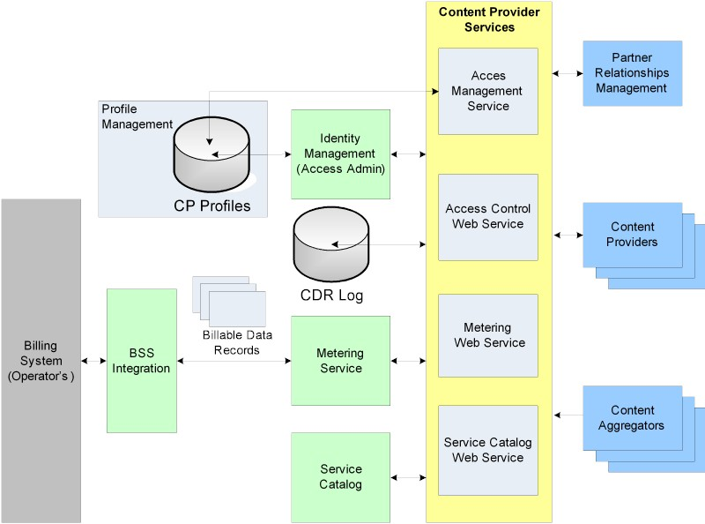
Figure 3: Content Provider Services
Each Web service publishes the Web Services Description Language (WSDL)-based Web service definitions, which are available to content providers when they develop software to integrate with the Service Delivery Platform. Developers and content providers can benefit from the integrated Web services development environment in Visual Studio .NET to easily integrate their systems with the content provider services in the Service Delivery Platform.
Besides the open-garden environment, Service Delivery Platform also supports the walled-garden service environment, where content is first aggregated from content providers and staged in the operator’s network by the content management services, before the content is provisioned to customers’ devices through the value-added services in the Service Delivery Platform. See Content Management Services Integration for details.
The content provider services are built on Windows Server 2003, SQL Server, Enterprise Instrumentation Framework, and .NET Framework.

Profile Management
Information about subscribers, networks, and services are managed in profiles. A profile is essentially a container of properties for a particular subject. Profile management service manages the following profiles:
- Subscriber
Each profile contains identity data about a subscriber, including the subscriber’s registered account name and access credential, address, and other identity data. It also contains preferences, subscriptions, summarized usage patterns, device configurations, and so on, for the subscriber.
- Content Providers
Each profile contains the identity data about a content provider, which is used by the content provider service to manage the access to the operator’s Service Delivery Platform system from content providers. See Content Provider Service for details.
- Network
This profile contains properties about the operator’s CDN that the Service Delivery Platform deployment environment supports for deploying services onto servers on edge networks. It also contains profiles for network elements in the operator’s network including SMS, MMS, HLS, and others.
- Service
All the services deployed by the operator need to be managed in profiles in order to facilitate operations management. The service profiles also facilitate access to each service from device applications.
Profile management provides the following features:
- Administration
Provides provisioning, de-provisioning, update, and view of profiles
- Programmability
Provides APIs that support queries and updates from service programs
- Access Control
Provides enforcement of access control based on role-based permissions
Profile management is provided by Microsoft SQL Server and Active Directory on Windows Server 2003.

Personalization Management
Providing personalized service to customers is an important goal for data service operators. Personalization management provides the foundation for effective customer targeting of information services, which leads to higher customer satisfaction and increased revenue for operators. Within the scope of Service Delivery Platform, personalization management enables operators to analyze service usage activities of subscribers based on access history, in order to generate abstract usage patterns and supply such valuable insight to value-added services for fine-tuning their personalization engines.
For example, a content management service may already support personalization in its content provisioning system based on preferences previously specified by subscribers. By mining a target subscriber’s usage pattern information from the personalization management system in Service Delivery Platform, the content services can dynamically discover new interests of the target subscriber and enable the operator to apply such knowledge towards fine-tuning the personalization rules for this subscriber. This can result in more effective personalization in content delivery and better customer experience.
A subscriber’s service usage history contains a wealth of information about what the subscriber is interested in. To meet the challenge of analyzing highly unstructured and complex information in order to discover distinct usage patterns and provide the derived valuable information in structured format to other services, high-performance analytical solutions can be developed based on these Microsoft products:
Personalization management service enables value-added services to improve customer experiences across different devices.

Notification Engine
The notification engine provides a high-performance platform for scalable notification services that generate messages customized to meet target subscribers’ specific needs. The notification messages, or alerts, can originate from a variety of sources such as external data feeds and data updates by value-added services, and they can be delivered to various devices including pocket PCs, PCs, phones, and so on, through multiple communication channels. Typical notification messages include those for appointment reminders, flight delays, and availability of new service or content.
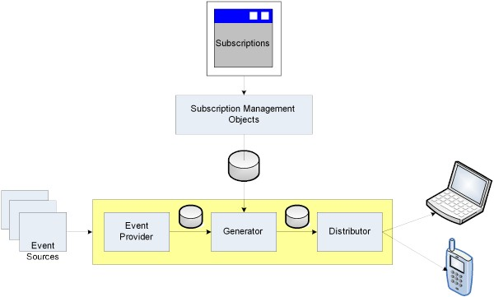
Figure 4: Notification Engine Architecture
The notification engine consists of these major components:
- Event Collection
This component collects events from multiple services as event providers by monitoring activities in them and captures data updates before passing them to the event generation component.
- Event Generation
This component generates events based on event subscription rules as defined by subscribers and identifies the subscribers who need to receive these events. It also transforms the event messages according to the format as specified by each target subscriber.
- Event Distribution
This component distributes the generated events through communication channels including SMS, e-mail, and instant messaging, to each subscriber’s device.
- Subscription Management Objects
These are part of the notification engine API that supports the custom subscription management services for managing notification subscribers and subscription rules.
The notification engine, based on SQL Server Notification Services (SQLNS) and SQL Server, supports a generic publish-and-subscribe mechanism, which enables value-added services to publish data as events and subscribers (as applications or other services) to define what events they are interested in, and when, in which format, and on which devices they want to receive the information. It enables subscribers to receive up-to-date personalized information anytime, anywhere, and on any device.

Service Orchestration
The service orchestration component in the control service lays the foundation for the orchestrating and managing various workflow processes. Service orchestration, based on Microsoft BizTalk Server and .NET Framework, enables operators to easily define and customize each workflow process according to business requirements. The service orchestration also enables operators to easily bring together components in Service Delivery Platform and external systems intelligently to deliver services to customers.
The service orchestration includes the following components:
- Scheduler
This component is responsible for starting, de-hydrating, and hydrating the workflow processes.
- Rules Engine
Each process consists of many tasks. The rules engine, using rules defined during the process creation, helps each process to execute its tasks during runtime.
- Tracking
This component tracks the run-time status of all processes and helps them to recover from failures.
- Session
This component is responsible for handling dynamic workflow between the dynamic set of process elements
The service orchestration supports integration through Web services. It also supports integration through custom adapters to external systems.

Integration Services
Integration services provide a common framework for integration with OSS, including device services; BSS, including billing system; and network service elements, including LBS, SIP, SMS/MMS, and HLS.

Integration Framework
The integration framework, implemented with Orchestration Services, provides a basic framework for each integration service that integrates Service Delivery Platform with external systems. The integration with external systems is through adapters, which support Web services as the standard mechanism. But it also supports other mechanisms.
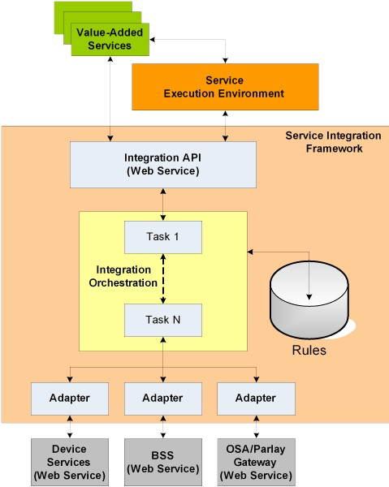
Figure 5: Service Integration Framework
The integration framework is provided by Microsoft BizTalk Server 2003, .NET Framework, and Windows 2003 Server.

Network Services Integration
It is necessary for the Service Delivery Platform to leverage the network service elements, such as those for MMS, SMS, HLS, SIP, and so on, to provide end-to-end solutions for customers.
Microsoft Service Delivery Platform makes use of Parlay/Open Service Access(OSA) gateway to connect to the network service elements. OSA/Parlay provides an abstraction layer between the network elements in the core telecom network and the application services.
Within the OSA architecture, service capability servers offer the API interface implementation.
To stimulate the development of services and applications, Service Delivery Platform exposes the network service integration via a standard-based Web service interface. This means that services can access core network functionality by means of an open interface, making it easier for value-added services and applications to be created and implemented by leveraging the network service elements from outside the traditional network operator domain.
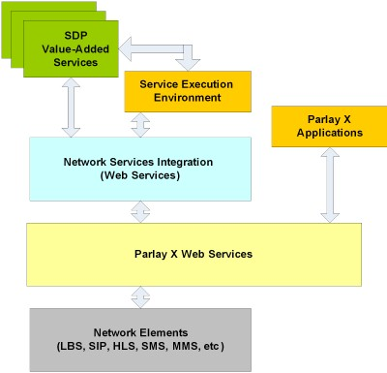
Figure 6: Network Services Integration

BSS Integration
The BSS integration service enables services in the service execution environment to integrate with business support systems, such as the billing system, in the operator’s network. The billable data records as created by the metering service in the control services are submitted through this interface to the back-end billing system for billing and real-time charging purposes. Billing integration with BSS allows operators to effectively monetize their services to customers based on their service usage and prevent revenue leaks due to missing service events.
The billable data records submitted to the operator’s business support systems can also be used in customer support, contact center, and fraud analysis systems.

OSS Integration
OSS integration provides operators the ability to control and manage services in the Service Delivery Platform execution environment. For example, an operator can de-activate a service through the service activation system in the operator’s OSS environment. In addition, the fault detection and performance monitoring systems in OSS can help system operators to administer the Service Delivery Platform services.

Devices Integration
It integrates with device services to provide device management and device adaptation for value-added services. Device managements provides the following functions to configure devices so that they can consume services supported by Service Delivery Platform.
- Fault management
Identify and fix device-related system or application problems and faults.
- Configuration
Provide device configurations.
- Accounting
Manage profiles and service usage of all devices.
- Performance
Identify network congestion or system performance issues and provide fixes.
- Security
Ensure that the people who need access to specific services are allowed to use them from their devices.
Device adaptation applies to adapting the presentation of data to each device according to the device settings. It helps value-added services to deliver the best user experiences to customers.

Content Management Services Integration
While not part of Service Delivery Platform, content management services is critical to the success for any operators who want to host content in their own walled-garden service environments. In a typical walled-garden environment, a content management system syndicates content from content providers before publishing them for use by value-added services in the operator’s Service Delivery Platform environment. The content management system manages the syndication process that includes the acquisition, aggregation, transformation, staging, rating, and publishing of a variety of content from content providers and aggregators. The challenge of content services integration is in providing a flexible environment to support a variety of content management solutions that complement the Service Delivery Platform services.
The content management services integration service, based on the integration framework described above, simplifies integration tasks. It connects through an adapter to a content management system to retrieve content, either from the content staging area inside content management system or from an external repository such as a content provider or a content aggregator, and provides the content to the value-added services which provision them to customers’ devices.
The following diagram describes the Content Management Services Integration architecture.
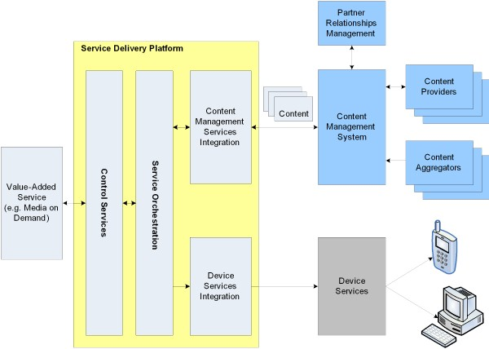
Figure 7: Content Management Services Integration

Service Creation Environment
The service creation environment provides a development environment for software developers to create new services and extend existing ones. It simplifies the creation and reduces the time-to-market of new services.
The service creation environment consists of:
- Service Directory
Provides definitions of value-added services that can be leveraged by software developers in creating new services.
- Integrated Development Environment (IDE)
Based on Visual Studio .NET; provides the development tools to help software developers to rapidly create new or extend existing services.
- .NET Framework
Provides a common language runtime (CLR) to support development with multiple program languages.
- Software Development Kits (SDKs)
Provides platform SDK and other product-specific SDKs that developers can leverage to develop services.

Service Directory
The service directory, based on the service catalog in the control service, manages all the value-added services within an Service Delivery Platform environment. It enables developers to discover, select, and reuse components from each service in creating new services and extending existing ones. It consists of a UDDI Web services directory that helps developers discover each service and its features, and WSDL files that describe the Web service interfaces and the access protocol of each Service Delivery Platform-managed service.
By accessing the service directory from Visual Studio .NET, developers from content providers can quickly develop Web service-enabled applications that consume services from the directory. An example is developers in a content provider that develops a movie preview application can discover the media-on-demand service through the service directory from their Visual Studio .NET development environment, and leverage that service by building a client with the service’s WSDL file in the application.

Integrated Development Environment
Microsoft Visual Studio .NET as the IDE tool—combined with ASP.NET, Enterprise Services, and SDKs from other Microsoft products—provides a RAD environment for service creation. Developers can develop new services with a variety of programming languages including C#, VB, C++, J++, and other languages that support .NET Framework. The ability of rapidly creating new and enhancing existing services with the SDP development environment allows operators to gain an important competitive advantage in the market place.

.NET Framework
The .NET Framework provides a language-neutral runtime environment for Service Delivery Platform-managed services. With .NET Framework, developers can create new services with any .NET-compliant programming languages, including C#, C++, VB, J++, and others. The .NET Framework provides a highly scalable, secure, high-performance platform for creating and deploying services within the Service Delivery Platform framework.

Software Development Kits (SDKs)
Developers can take advantage of many product-specific SDKs in creating new services. For example, in creating media-on-demand services, developers can leverage the API from the Media Technologies SDK to provide video-capturing, transcoding, and streaming services. They can also provide digital rights management protection for each video asset to prevent illegal copy or misuse of the streamed video files. Similarly, developers can leverage the Real-Time Communications (RTC) server SDK to create value-added video conferencing solutions that are deployed and managed within the Service Delivery Platform framework.

Service Deployment Environment
While it is important to enable developers to quickly develop new services under the Service Delivery Platform, it is equally important to enable operators to manage the deployment of new services in the core networks or content deployment networks.
The deployment environment provides the following functions:
- Deployment Tools
Help to automate the deployment process in order to reduce complexity and eliminate downtime.
- Support for Content Deployment Network
Content deployment network helps operators to deploy services on edge servers in the operator’s content deployment network or content deployment network-like environment, in order to improve accessibility, reduce latency, and customize data based on the customer’s locale. The service deployment environment of Service Delivery Platform supports deployment with third-party content deployment network systems.
- Resource management
Administrators must be able to manage information about the deployed services in terms of version numbers, OS, system configuration, hardware configuration, and so on.
The service deployment environment is provided by Windows Installer technologies, .NET Framework, and Application Center.

Service Management Environment
The service management environment provides management functions that span all the layers in the Service Delivery Platform framework. It provides the following functions for the Service Delivery Platform and the value-added services:
- Fault Management
Quickly identifies problems and faults in the network or services with real-time service monitoring and alerts systems administrators with accurate problem descriptions. Provides automatic fail-over services in the event of unexpected system failures.
- Configuration
Manages configuration, such as settings, policies, version controls, and so on, for all the services. Manages the change control for all the software components.
- Accounting
Tracks detailed activities and changes for all the services and provides historical logs for auditing purposes. Accounting is essential to measuring all aspects of the system to ensure SLA compliance.
- Performance
Monitors the performance of each service and the whole system, and identifies and reports performance-related problems to system administrators for trouble shooting and problem solving. Provides summarized reports on system performance for decision makers.
- Security
Manages the security implementation for all the services and the operator’s network to detect and prevent unauthorized intrusions, denial of service attacks, and any suspicious activities.
The management environment is provided by Microsoft Operations Manager and Windows Management Instrumentation.

Microsoft Product Strategy
The Microsoft Service Delivery Platform is provided by the following products and technologies from Microsoft.
Product | Benefit
Active Directory | A Local Directory Access Protocol (LDAP) directory service that manages identity data for customers. Active Directory is also the platform for single sign-on services for all value-added services.
Windows Server | A server platform for all the services. Windows Server supports many standards for authentication and privacy management, including Kerberos, SSL, X.509 certificates, RADIUS, and so on.
.NET Framework | Provides a language-neutral development and high-performance execution environments for both content providers and operators.
Microsoft Identity Integration Server | Integrates identity data from heterogeneous identity repositories to create a virtual unified directory. There are three aspects in the Identity Integration Server-based solution:  Connection  Supports communication between systems.  Brokerage  Involves translating and interchanging identity information between systems.  Ownership  Includes identifying authoritative roles of individual systems across the operator’s network with regard to managing identities.
BizTalk Server | A service orchestration platform that supports the definition, orchestration, and implementation of the service components.
Enterprise Instrumentation Framework | Provides a flexible mechanism for operators to measure and track events for services in the Service Delivery Platform in multiple destinations, including files, databases, and server event logs.
SQL Server | A data base management server to provide the data services for Service Delivery Platform.
SQL Analysis Server | Based on SQL Server, a platform for data analytics services and applications.
SQL Server Accelerator for Business Intelligence | Provides templates and tools that simplify the definition and creation of the extraction, transformation, and loading processes for extracting useful data from historic log files and loading them into a data mart, and the multi-dimensional representations of data to support data mining by other services.
SQL Server Notification Services | Provides event collection, generation, formatting, and distribution mechanisms for the notification engine. It also provides the subscription management objects to support custom subscription management.
Application Center Server | Provides a deployment platform to easily satisfy the scalability requirement for application services. Application Center enables operators to create a single image of services, and manages the process of deploying the image on multiple servers in different environments.
Microsoft Operations Manager (MOM) | Provides a distributed monitoring and administration service for all the services. It consists of both the agents on each system and a central monitoring server, which monitors all the systems through the agents.
Windows Management Instrumentation (WMI) | An interface that supports monitoring and administration by external systems. Systems that support WMI can be monitored and administrated by WMI-compliant management consoles in system management products.

Summary
The Microsoft Service Delivery Platform provides a cost-effective and scalable solution based on products and solutions from Microsoft and its partners. It helps operators increase customer satisfaction, improve profitability, and reduce deployment complexity and risks.
The Microsoft Service Delivery Platform is a solution that can be implemented for operators by Microsoft Consulting Services or Microsoft’s premier partners.

