

Internet Protocol Security Enforcement in the Network Access Protection Platform

Microsoft Corporation
Published: July 2005
Updated: December 2006

Abstract
Network Access Protection is a platform for Microsoft® Windows Server® "Longhorn" (now in beta testing) and Windows Vista™ that provides policy enforcement components to help ensure that computers connecting to a network meet administrator-defined requirements for system health. Internet Protocol security (IPsec) is a set of Internet Engineering Task Force (IETF) standards that provides cryptographic protection for IP-based traffic. This document provides an overview of the Network Access Protection platform and IPsec, and how IPsec Enforcement in the Network Access Protection platform works to provide system health policy enforcement for IPsec-protected communication.


This is a preliminary document and may be changed substantially prior to final commercial release of the software described herein.
The information contained in this document represents the current view of Microsoft Corporation on the issues discussed as of the date of publication. Because Microsoft must respond to changing market conditions, it should not be interpreted to be a commitment on the part of Microsoft, and Microsoft cannot guarantee the accuracy of any information presented after the date of publication.
This White Paper is for informational purposes only. MICROSOFT MAKES NO WARRANTIES, EXPRESS, IMPLIED OR STATUTORY, AS TO THE INFORMATION IN THIS DOCUMENT.
Complying with all applicable copyright laws is the responsibility of the user. Without limiting the rights under copyright, no part of this document may be reproduced, stored in or introduced into a retrieval system, or transmitted in any form or by any means (electronic, mechanical, photocopying, recording, or otherwise), or for any purpose, without the express written permission of Microsoft Corporation.
Microsoft may have patents, patent applications, trademarks, copyrights, or other intellectual property rights covering subject matter in this document. Except as expressly provided in any written license agreement from Microsoft, the furnishing of this document does not give you any license to these patents, trademarks, copyrights, or other intellectual property.
© 2005 Microsoft Corporation. All rights reserved.
Microsoft, Active Directory, Windows Vista, Windows, and Windows Server are either registered trademarks or trademarks of Microsoft Corporation in the United States and/or other countries.
All other trademarks are property of their respective owners.
Contents
Network Access Protection Overview 1
Scenarios for Network Access Protection 2
Network Access Protection Platform Architecture 3
NAP Client Architecture 4
NAP Server Architecture 5
IPsec Overview 8
IPsec Security Properties 8
How IPsec Protects IP Traffic 9
AH 9
ESP 10
Common Misconceptions about IPsec 11
Benefits of IPsec 11
IPsec Enforcement in NAP 13
Overview and Capabilities 13
IPsec Enforcement vs. VPN and DHCP Enforcement 13
Benefits of IPsec Enforcement 14
IPsec Enforcement Logical Networks 14
Communication Initiation Processes with IPsec Enforcement 17
Obtaining a Health certificate 20
IPsec-based NAP Client is Noncompliant 21
Using IPsec Enforcement with Existing IPsec Protection 21
Secure Server 22
Server Isolation 22
Domain Isolation 22
Appendix A: Frequently Asked Questions About IPsec Enforcement in NAP 23
Summary 26
Related Links 27

Network Access Protection Overview
One of the most time-consuming challenges that administrators face is ensuring that computers that connect to private network assets are up to date and meet health policy requirements. This complex task is commonly referred to as maintaining computer health. Enforcing requirements is even more difficult when the computers, such as home computers or traveling laptops, are not under the administrator’s control. Yet failure to keep computers that connect to the network up to date is one of the most common ways to jeopardize the integrity of a network. For example, attackers create software that targets out-of-date computers. Users who do not update their home computers with the most recent antivirus signatures risk exposing private network assets to viruses. Administrators frequently lack the time or resources to ensure that all the software they would like to require is, in fact, installed and up to date. Additionally, administrators cannot easily manage or change requirements as often as they want.
Network Access Protection for Windows Server "Longhorn" and Windows Vista provides components and an application programming interface (API) set that help administrators enforce compliance with health policies for network access or communication. Developers and administrators can create solutions for validating computers that connect to their networks, can provide needed updates or access to needed resources (called health update resources), and can limit the access of noncompliant computers. The enforcement features of Network Access Protection can be integrated with software from other vendors or with custom programs. Administrators can customize the systems they develop and deploy, whether for monitoring the computers accessing the network for health policy compliance, automatically updating computers with software updates to meet health policy requirements, or limiting the access of computers that do not meet health policy requirements to a restricted network.
Network Access Protection is not designed to secure a network from malicious users. It is designed to help administrators maintain the health of the computers on the network, which in turns helps maintain the network’s overall integrity. For example, if a computer has all the software and configurations that the health policy requires, the computer is considered compliant, and it will be granted the appropriate access to the network. Network Access Protection does not prevent an authorized user with a compliant computer from uploading a malicious program to the network or engaging in other inappropriate behavior.
Network Access Protection has three important and distinct aspects:
- Health Policy Validation When a user attempts to connect to the network, the computer’s health state is validated against the health policies as defined by the administrator. Administrators can then choose what to do if a computer is not compliant. In a monitoring-only environment, all authorized computers are granted access to the network even if some do not comply with health policies, but the compliance state of each computer is logged. In a restricted access environment, computers that comply with the health policies are allowed unlimited access to the network, but computers that do not comply with health policies or that are not compatible with Network Access Protection have their access limited to a restricted network. In both environments, computers that are compatible with Network Access Protection can automatically become compliant and administrators can define exceptions to the validation process. Network Access Protection will also include migration tools to make it easier for administrators to define exceptions that best suit their network needs.
- Health Policy Compliance Administrators can help ensure compliance with health policies by choosing to automatically update noncompliant computers with the missing requirements through management software, such as Microsoft Systems Management Server. In a monitoring-only environment, computers will have access to the network even before they are updated with required software or configuration changes. In a restricted access environment, computers that do not comply with health policies have limited access until the software and configuration updates are completed. Again, in both environments, computers that are compatible with Network Access Protection can automatically become compliant and the administrator can define policy exceptions.
- Limited Access Administrators can protect network assets by limiting the access of computers that do not comply with health policy requirements. Non-compliant computers will have their access limited as defined by the administrator. Network access limits can be based on a specific amount of time or whether the network access is limited to a restricted network, to a single resource, or to no internal resources at all. If an administrator does not configure health update resources, the limited access will last for the duration of the connection. If an administrator configures health update resources, the limited access will last only until the computer is brought into compliance. Administrators might use both monitoring and health policy compliance in their networks and configure exceptions.
Network Access Protection is an extensible platform that provides an infrastructure and an API set for adding components that verify and amend a computer’s health and that enforce existing policy systems. By itself, the Network Access Protection platform does not provide components to verify or amend a computer's health. Other components, known as system health agents (SHAs) and system health validators (SHVs), will provide health policy validation and health policy compliance. Windows Vista and Windows Server "Longhorn" include an SHA and SHV that provides health policy validation and health policy compliance for health attributes monitored by the Windows Security Center.
Note The Network Access Protection platform is not the same as Network Access Quarantine Control, which is a capability provided with Windows Server 2003 to provide additional protection for remote access (dial-up and virtual private network [VPN]) connections. For more information, see Network Access Quarantine Control in Windows Server 2003 at http://www.microsoft.com/technet/network/vpn/quarantine.mspx.

Scenarios for Network Access Protection
Network Access Protection is designed to be flexible. It can interoperate with any vendor’s software that provides SHAs and SHVs or that recognizes its published API set. Network Access Protection helps provide a solution for the following common scenarios:
- Check the health and status of roaming laptops Portability and flexibility are two primary advantages of laptops, but these features also present a health threat. Company laptops frequently leave and return to the company network. While laptops are away from the company, they might not receive the most recent software updates or configuration changes. Laptops might also be infected while exposed to unsecured networks, such as the Internet. By using Network Access Protection, network administrators can check the health of any laptop when it reconnects to the company network, whether by creating a VPN connection back to the company network or by physically returning to the office.
- Ensure the health of desktop computers Although desktop computers do not usually leave the premises, they still can present a health threat to a network. To minimize this threat, administrators must maintain these computers with the most recent updates and software the company wants to require. Otherwise, those computers are at higher risk of infection from Web sites, e-mail, files from shared folders, and other publicly accessible resources. By using Network Access Protection, network administrators can automate system checks to verify each desktop computer’s compliance with the health policies. Administrators can check log files to review what computers do not comply. With the addition of management software, automatic reports can be generated, updates can be made automatically to noncompliant computers, and when administrators change health policies, computers can be automatically provided with the most recent updates.
- Determine the health of visiting laptops Organizations frequently need to allow consultants and guests access to their private networks. The laptops that these visitors bring might not meet network requirements and can present health risks. By using Network Access Protection, administrators can determine that the visiting laptops are not authorized to access the network and limit their access to a restricted network. Generally, administrators would not require or provide any updates or configuration changes to the visiting laptops. The administrator might configure Internet access for visiting laptops in the restricted network, but not for other computers whose access is limited.
- Verify the compliance and health of unmanaged home computers Unmanaged home computers provide an additional challenge to network administrators because they do not have physical access to these computers. Lack of physical access makes enforcing compliance with network requirements (such as the use of antivirus software) even more difficult. Verifying the health of these computers is similarly challenging. By using Network Access Protection, network administrators can check for required programs, registry settings, files, or combinations of these every time a home computer makes a VPN connection to the network, and they can limit the connection to a restricted network until system health requirements are met.
Depending on their needs, administrators can configure a solution to address any or all of these scenarios for their networks.

Network Access Protection Platform Architecture
The main computers that interact to provide system health-validated network access consist of the following:
- NAP clients Computers that support the Network Access Protection platform for secure communication using IPsec, connections that require IEEE 802.1X authentication, remote access VPN connections, and Dynamic Host Configuration Protocol (DHCP) configuration.
- NAP servers Computers running Windows Server "Longhorn" that use a Network Policy Server (NPS) to determine whether a client is compliant or noncompliant. Examples of NAP servers are the Health Registration Authority for IPsec-based communication, an NPS server for IEEE 802.1X authentication, and NAP-capable VPN and DHCP servers.
- NPS servers Computers running Windows Server "Longhorn" that determine whether network access or communication is allowed, the health state of NAP clients, and the set of remediation actions that a noncompliant client must perform. NAP servers and NPS servers communicate through the IETF standard Remote Authentication Dial-In User Service (RADIUS) protocol. NPS is the Windows® implementation of a RADIUS server and proxy and is the replacement for the Internet Authentication Service (IAS) provided with Windows Server 2003.
- Policy servers Computers that provide current system health state for NPS servers.
- Remediation servers Computers that contain health update resources that NAP clients can access to remediate their noncompliant state. Examples include antivirus signature distribution servers and software update servers.
- Health Registration Authority A Health Registration Authority (HRA) is a computer running Windows Server "Longhorn" and Internet Information Services (IIS) that obtains health certificates from a certification authority (CA) for compliant computers.. The CA can be installed on the same computer as the health registration authority or it can be installed on a separate computer.

NAP Client Architecture
A NAP client is a computer running Windows Vista or Windows Server "Longhorn." Microsoft is currently beta testing a NAP client update for Windows XP with Service Pack 2 (SP2). Figure 1 shows the architecture of the Network Access Protection platform on a NAP client.
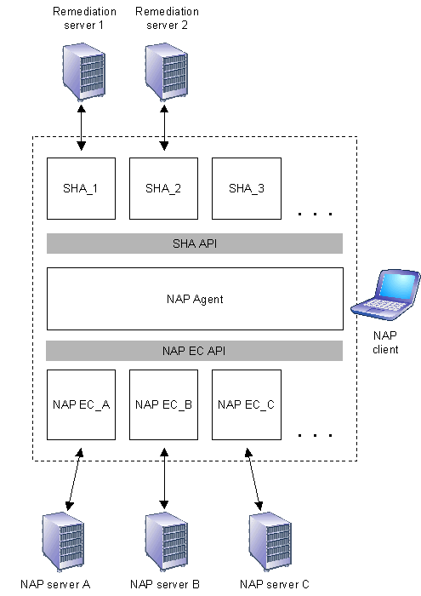
Figure 1 Network Access Protection platform architecture on the NAP client
The NAP client architecture consists of the following:
- A layer of NAP Enforcement Client (EC) components Each NAP EC is defined for a different type of network access or communication. For example, there is a NAP EC for VPN connections and a NAP EC for DHCP configuration. The NAP EC is typically matched to a specific type of NAP server. For example, the DHCP NAP EC is designed to work with a DHCP-based NAP server. Some NAP ECs are provided with the Network Access Protection platform and third-party software vendors can provide others.
- A layer of System Health Agent (SHA) components Each SHA is defined for a system health requirement or a set of system health requirements. For example, there might be an SHA for antivirus signatures and an SHA for operating system updates. A specific SHA might be matched to a remediation server. For example, an SHA for checking antivirus signatures is matched to the server that contains the latest antivirus signature file. SHAs do not have to have a corresponding remediation server. For example, an SHA can just check local system settings to ensure that a host-based firewall is enabled. Windows Vista and Windows Server "Longhorn" include a Windows Security Health Validator SHA. Third-party software vendors or Microsoft can provide additional SHAs to the Network Access Protection platform.
- NAP Agent Maintains the current health state of the NAP client and facilitates communication between the NAP EC and SHA layers. The NAP Agent is provided with the Network Access Protection platform.
- SHA API Provides a set of function calls that allow SHAs to register with the NAP Agent, to indicate system health status, respond to queries for system health status from the NAP Agent, and for the NAP Agent to pass system health remediation information to an SHA. The SHA API allows vendors to create and install additional SHAs. The SHA API is provided with the Network Access Protection platform.
- NAP EC API Provides a set of function calls that allow NAP ECs to register with the NAP Agent, to request system health status, and pass system health remediation information to the NAP Agent. The NAP EC API allows vendors to create and install additional NAP ECs. The NAP EC API is provided with the Network Access Protection platform.
To indicate the status of a specific element of system health, such as the state of the antivirus software running on the computer or the last operating system update that was applied, SHAs create a Statement of Health (SoH) and pass their SoH to the NAP Agent. Whenever an SHA updates its status, it creates a new SoH and passes it to the NAP Agent.

NAP Server Architecture
A NAP server is a computer running Windows Server "Longhorn" that uses an NPS server to determine the health state of NAP clients, whether network access or communication is allowed, and the set of remediation actions that a noncompliant client must perform.
Figure 2 shows the architecture of the server-side support for the Network Access Protection platform, consisting of components on a NAP server and an NPS server.
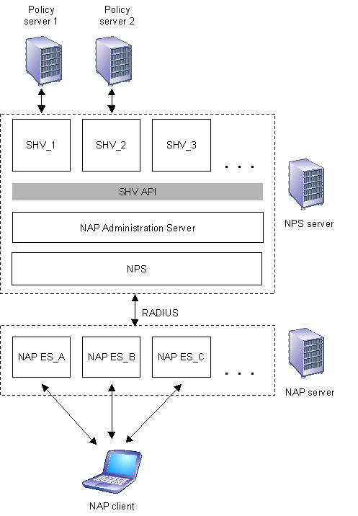
Figure 2 The server-side Network Access Protection platform architecture
The NAP server has a layer of NAP Enforcement Server (ES) components. Each NAP ES is defined for a different type of network access. For example, there is a NAP ES for VPN connections and a NAP ES for DHCP configuration. The NAP ES is matched to a specific type of NAP-capable client. For example, the DHCP NAP ES is designed to work with a DHCP-based NAP client. NAP ESs are provided with Windows Server "Longhorn."
As shown in Figure 2, the NPS server has the following components:
- NPS Exchanges RADIUS messages with NAP servers and interacts with the NAP Administration Server component. For example, a NAP ES on a NAP server obtains the list of SoHs from its corresponding NAP EC on a NAP client and sends them to an NPS server in a RADIUS Access-Request message. NPS receives the RADIUS Access-Request message, extracts the list of SoHs, and passes them to the NAP Administration Server. NPS is provided with Windows Server "Longhorn."
- NAP Administration Server Facilitates communication between NPS and the SHVs. The NAP Administration Server component is provided with Windows Server "Longhorn."
- A layer of System Health Validator (SHV) components Each SHV is defined for each type of system health requirement. For example, there might be an SHV for antivirus signatures and an SHV for operating system updates. A specific SHV might be matched to a policy server. For example, an SHV for checking antivirus signatures is matched to the server that stores the version number of the latest antivirus update. SHVs do not have to have a corresponding policy server. For example, an SHV can just instruct NAP-capable clients to check local system settings to ensure that a host-based firewall is enabled. Windows Server "Longhorn" includes a Windows Security Health Validator SHV. Microsoft and third-party software vendors can provide additional SHVs for the Network Access Protection platform. The NAP Administration Server forwards the SoHs received via NPS from a NAP client to the appropriate SHV. SHVs create Statement of Health Responses (SoHRs) containing either a confirmation of health or remediation instructions and pass them to the NAP Administration Server, which passes them back via NPS to the NAP client for evaluation and remediation.
- SHV API Provides a set of function calls that allow SHVs to register with the NAP Administration Server component, receive SoHs from the NAP Administration Server component, and to pass SoHRs to a corresponding SHA on a NAP client. The SHV API is provided with Windows Server "Longhorn."
To specify the set of system health requirements, the administrator configures network access protection policies on the NPS server.

IPsec Overview
IPsec is the Internet Engineering Task Force (IETF)-recommended security technology for protecting communications over IP networks through the use of cryptographic security services. The Windows Vista, Windows Server "Longhorn," Windows Server 2003, Windows XP, and Windows 2000 implementations of IPsec are based on RFCs 2401-2409, developed by the IETF IPsec working group.
IPsec is the long-term direction for IP version 4 (IPv4) and IP version 6 (IPv6) networking security. It provides protection against intranet and Internet attacks through end-to-end security. The only computers that must know about IPsec protection are the sender and receiver in the communication. IPsec can protect communications between computers in workgroups, Active Directory® directory service domains, branch offices (which might be physically remote), and extranets.

IPsec Security Properties
Both public and private networks are susceptible to unauthorized monitoring and access. Internal attacks might be a result of minimal or nonexistent intranet security. Risks from outside the intranet originate from connections to the Internet and extranets. Password-based user access controls alone do not protect data transmitted across a network.
IPsec was designed to address the lack of built-in security for IP-based traffic in the TCP/IP protocol suite. IPsec provides the following:
- Tampering and spoofing protection
Protects against tampering with or spoofing of IP packets. IP packets use checksums so that the receiving node can verify whether any of the bits were changed in error during transmission on a link. However, the checksums do not provide integrity or security for the IP packet. Therefore, an intermediate IP node can receive an IP packet, alter its contents, update the appropriate checksums and forward the packet to its destination. Because the checksum calculation does not provide integrity, the destination host cannot determine if the packet was tampered with in transit. IPsec uses a cryptographic checksum that incorporates a shared secret key known only to the two communicating IPsec peers. Any attempts to modify the packet contents or to spoof addresses can be detected because the attacker cannot easily calculate the correct cryptographic checksum for the changed packet.
- Payload encryption
An optional IPsec security service that encrypts IP packet payloads. Without encryption, a node between two IP hosts exchanging data can capture the packets sent between them, analyze the payload portion of the packet, and determine the data that is being exchanged. For example, a file sharing client makes a connection with a file server containing sensitive data. Access control lists on the file server computer determine which users or computers can access which files and what they are allowed to do. However, once a valid user has made a connection to the sensitive file server and begins copying a file across the network, an attacker between the file server and the client can capture the packet stream and reconstruct the file contents without needing the client's credentials to connect to the file server. With payload encryption, an attacker between the file server and the client can still capture the packet stream but cannot easily interpret and reconstruct the file contents.
- Peer authentication
Requires IP nodes to authenticate each other's computer credentials before any IP-based communication begins. IP has no built-in authentication of peers; IP hosts can initiate communications with other IP hosts without having to prove that they are members of a trusted security framework and have the correct credentials. With IPsec however, peers must authenticate each other with computer credentials before initiating communication. IPsec peer authentication reduces the number of computers from which communication can be initiated to those computers that provide correct peer credentials. This reduces the number of computers from which network attacks can originate. For example, if IPsec authentication requires a certificate issued from a specific CA, then only those computers that have been issued a certificate from the CA can initiate IP-based communication.

How IPsec Protects IP Traffic
Figure 3 shows an IP packet containing a Transmission Control Protocol (TCP) segment that is not protected with IPsec.
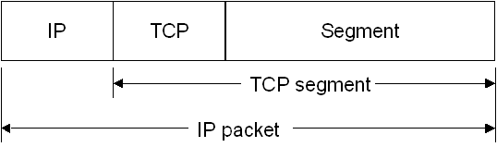
Figure 3 An IP packet without any IPsec protection
As previously described, there is a checksum in the IP header that allows detection of bit-level errors in the IP header and a checksum in the TCP header that allows detection of bit-level errors in the entire TCP segment. However, neither of these checksums is intended to provide security protection and the IP packet is susceptible to various types of network attacks such as spoofing, data modification, and data determination.
To provide security protection for the IP packet, IPsec typically adds one of the following to the IP packet:
- An extension header between the IP header and the IP packet payload (in our example, the TCP segment) known as the Authentication Header (AH).
- An extension header and trailer around the IP packet payload known as the Encapsulating Security Payload (ESP).

AH
Figure 4 shows the original IP packet of Figure 4 that has been protected with AH.
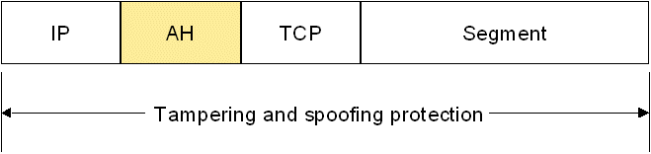
Figure 4 An IP packet with AH protection
AH provides tampering and spoofing protection for the entire IP packet, except for specific fields in the IP header that are allowed to change in transit. The AH includes a cryptographic checksum known as a hashed message authentication code (HMAC), whose calculation incorporates a shared secret key. The Windows implementation of IPsec supports the use of HMAC-Secure Hash Algorithm 1 (SHA1) and HMAC-MD5. Microsoft recommends using HMAC-SHA1 because it provides better protection than HMAC-MD5.

ESP
Figure 5 shows the original IP packet of Figure 4 that has been protected with ESP and encryption. ESP includes both a header and trailer.
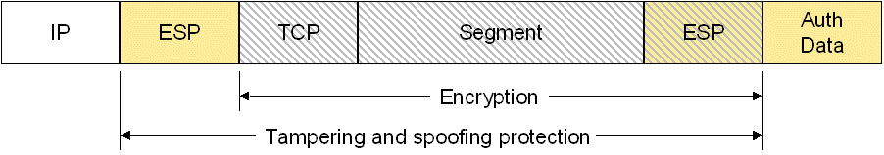
Figure 5 An IP packet with ESP and encryption protection
ESP with encryption provides tampering and spoofing protection for the IP packet payload, the ESP header, and part of the ESP trailer and encryption for the IP packet payload and part of the ESP trailer. The Auth Data field in the ESP trailer includes the results of the HMAC-SHA1 or HMAC-MD5 calculation. For the Windows implementation of IPsec, the IP packet payload and part of the ESP trailer is encrypted with either Data Encryption Standard (DES) or Triple-DES (3DES). Microsoft recommends using 3DES because it provides better protection than DES.
Encryption with ESP is optional. You can use ESP with no encryption, also known as ESP-Null. Figure 6 shows the original IP packet of Figure 4 that has been protected with ESP and no encryption.
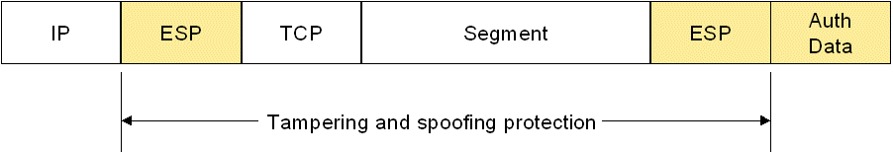
Figure 6 An IP packet with ESP and no encryption protection
ESP with no encryption provides tampering and spoofing protection for the IP packet payload, the ESP header, and part of the ESP trailer. Unlike AH, ESP does not provide protection for the IP header. However, the checksum calculation in the TCP header includes the values of the source and destination IP addresses in the IP header. Because the checksum field in the TCP header is protected from tampering, an attacker cannot change the IP addresses in the IP header without invalidating the protected TCP checksum value in the TCP header. Therefore, even though ESP does not directly protect the IP header, ESP does provide protection against attacks that modify IP addresses in the IP header.
If packet payload encryption is not required, Microsoft recommends using ESP with no encryption rather than AH because IPsec network address translator traversal (NAT-T) does not support AH-protected packets.

Common Misconceptions about IPsec
The most common misconceptions about IPsec are the following:
- IPsec is a virtual private network (VPN) technology
Although IPsec is used for VPN connections across the Internet to connect remote clients to an intranet or remote sites to each other, IPsec was designed to protect both intranet and Internet traffic in a variety of scenarios.
When using IPsec to protect IP traffic that is sent across the Internet, some VPN implementations use an additional mode of AH and ESP known as tunnel mode, in which an entire IP packet is encapsulated and protected. Computers running Windows Server 2003, Windows XP, or Windows 2000 can use Layer Two Tunneling Protocol (L2TP) with IPsec (L2TP/IPsec) for VPN connections. However L2TP/IPsec does not use tunnel mode. Instead, L2TP provides encapsulation for an entire IP packet and the resulting IP packet payload is protected with ESP and encryption.
- Using IPsec requires encryption
As described earlier in this paper, IPsec only encrypts IP packet payloads when you choose to use ESP with encryption. Encryption is optional but recommended in many circumstances, including when sending private data across a public network (such as the Internet) or when sending highly sensitive data across an intranet (such as personal or financial data).

Benefits of IPsec
IPsec support in Windows provides the following benefits:
- Defense-in-depth against vulnerabilities in upper-layer protocols and applications
IPsec protects upper layer protocols, services, and applications. With IPsec enabled, initial communication packets to access an application or service running on a server, for example, will not be passed to the application or service until trust has been established through IPsec authentication and the configured protection on packets for the application or service has been applied. Therefore, attempts to attack applications or services on servers must first penetrate IPsec protection.
- Requiring peer authentication prevents communication with untrusted or unknown computers
IPsec security requires peers to authentication their computer-level credentials prior to sending any IP-based data. By requiring peer authentication using credentials based on a common trust model, such as membership in an Active Directory domain, untrusted or unknown computers cannot communicate with domain members. This helps protect domain member computers from the spread of some types of viruses and worms being propagated by untrusted or unknown computers.
- IP-based network traffic is cryptographically protected
IPsec provides a set of cryptographic protections for IP-based traffic based on your choice of AH, ESP without encryption, or ESP with encryption. Your IP-based network traffic is either tamper proofed (using AH or ESP with no encryption) or tamper proofed and encrypted (with ESP and encryption). Requiring cryptographic protection of IP traffic helps prevent many types of network attacks.
- Applications do not need to be changed to support IPsec
IPsec is integrated at the Internet layer of the TCP/IP protocol suite, providing security for all IP-based protocols in the TCP/IP suite. With IPsec, there is no need to configure separate security for each application that uses TCP/IP. Instead, applications that use TCP/IP pass the data to IP in the Internet layer, where IPsec can secure it. By eliminating the need to modify applications, IPsec can save application development time and costs.
To specify IPsec behavior, the administrator must configure IPsec policies through Computer Configuration Group Policy for an Active Directory container (such as a domain, site, or organizational unit) or an individual computer. An IPsec policy specifies the types of IP traffic to allow, block, or protect. For protected traffic, an IPsec policy specifies how to protect the traffic (using AH or ESP) and how IPsec peers must authenticate each other.
The combination of IPsec policies to determine which traffic to protect and how to protect it and NAP system health policies to specify the requirements for system health determine IPsec Enforcement behavior.

IPsec Enforcement in NAP
Network Access Protection provides enforcement for the following technologies in Windows Vista and the Beta 2 release of Windows Server "Longhorn":
- IPsec
- IEEE 802.1X
- VPN connections
- DHCP
Administrators can use these technologies separately or together to limit the network access of noncompliant computers. NPS acts as a policy server for all of these technologies.

Overview and Capabilities
IPsec support in NAP consists of a Health Registration Authority (HRA) and an IPsec NAP EC on NAP clients. The HRA is a computer running Windows Server "Longhorn" and Internet Information Services (IIS). The HRA obtains X.509 certificates from a certification authority (CA) for NAP clients when the NPS server has determined the clients to be compliant. NAP clients use health certificates for IPsec authentication when they initiate IPsec-protected communications with other NAP clients on an intranet. Health certificates can also be used for IEEE 802.1X authentication or by applications. If a NAP client does not have a health certificate, the IPsec peer authentication fails and the NAP client cannot initiate communication with a compliant IPsec peer.
IPsec Enforcement confines the communication on your network to those computers that are considered compliant and protects network traffic from end-to-end, rather than just across a network connection. By leveraging IPsec and its configuration flexibility, IPsec Enforcement allows to you to define requirements for secure communications with compliant clients on a per-IP address or per-TCP or User Datagram Protocol (UDP) port number basis. For example, you could specify IPsec policy settings to secure all Remote Procedure Call (RPC) traffic, subject to IPsec Enforcement. IPsec Enforcement is the strongest and most flexible form of limited network access in Network Access Protection.

IPsec Enforcement vs. VPN and DHCP Enforcement
VPN Enforcement limits the access of noncompliant VPN clients that are attempting to access a private intranet through a VPN connection. DHCP Enforcement limits the access of noncompliant DHCP clients that are attempting to obtain a valid IP address configuration. In both of these cases, the access to a restricted network is based on a client-server relationship and implemented at the server through which network access or configuration is being requested. For VPN Enforcement, the VPN server enforces the limited network access of noncompliant VPN clients. For DHCP Enforcement, the DHCP server provides settings that limit the access of noncompliant DHCP clients.
With IPsec Enforcement, the communication attempt is made from end-to-end, rather from a specific type of client to a specific type of server. Unlike VPN and DHCP Enforcement, IPsec Enforcement is enforced by each individual computer, rather than at the point of entry into the network. Additionally, the determination of client health is performed via the HRA, a computer that is separate from the computer to which communication is being attempted.
IPsec Enforcement limits the access of noncompliant clients that are attempting to communicate after network access to the intranet has been successfully made and after a valid IP address configuration has been allocated. IPsec Enforcement limits communication for IPsec-based NAP clients by dropping incoming communication attempts that are sent from computers that do not have health certificates.

Benefits of IPsec Enforcement
The benefits of IPsec Enforcement are the following:
- Tamper-resistant enforcement
IPsec Enforcement cannot be bypassed by reconfiguring a NAP client. A NAP client cannot receive a health certificate or initiate communication with a compliant computer without a health certificate by manipulating settings on their local computer, even for a user with local administrator privileges. Additionally, IPsec Enforcement cannot be bypassed through the use of hubs or virtual computer technologies.
- No infrastructure upgrade needed
IPsec Enforcement works at the Internet layer of the TCP/IP protocol suite and therefore is independent of physical network infrastructure components such as hubs, switches, and routers.
- Flexible limitations on network access
With IPsec Enforcement, compliant computers can initiate communications with noncompliant computers but noncompliant computers cannot initiate communications with compliant computers. The administrator defines the type of traffic that must be authenticated with a health certificate and protected with IPsec through IPsec policy settings. IPsec policy allows for the creation of IP filters that can define traffic by source IP address, destination IP address, IP protocol number, source and destination TCP port, and source and destination UDP port. With IPsec policy and IP filter definition, it is possible to limit network access on a per-server or per-application basis.
- Optional end-to-end encryption
By specifying IPsec policy settings, you can encrypt IP traffic between IPsec peers for highly sensitive traffic. Unlike IEEE 802.11 wireless LANs, which only encrypt frames from the wireless client to the wireless access point, IPsec encryption is between IPsec peer computers.
- Protection for clients while roaming on the protected portion of the network
Clients that roam from one network access device to another on the protected portion of the network, such as wireless clients, cannot protect themselves with 802.1X authentication. Because IPsec Enforcement is performed at the computer, it is protected as it roams on the protected portion of the network.

IPsec Enforcement Logical Networks
IPsec Enforcement divides a physical network into three logical networks. A computer is a member of only one logical network at any time. The logical networks are defined in terms of which computers have health certificates and which computers require IPsec authentication with health certificates for incoming communication attempts. The logical networks allow for access limitation and remediation and provide compliant computers with a level of protection from noncompliant computers.
IPsec Enforcement defines the following logical networks:
- Secure network The set of computers that have health certificates, require that incoming communication attempts authenticate with health certificates, and share a common set of IPsec policy settings for providing IPsec protection. For example, most server and client computers that are a member of an Active Directory infrastructure would be in a secure network. For NAP, NPS servers and NAP policy servers are in a secure network. Because a secure network is defined by a common set of IPsec policy settings, there might be multiple secure networks on your network. For example, there might be one secure network that uses ESP with no encryption for normal traffic between domain members and another secure network that uses ESP with encryption for traffic between domain member clients and specific servers that store confidential data. To simplify the discussion, this paper assumes a single secure network.
- Boundary network The set of computers that have health certificates but do not require that incoming communication attempts authenticate with health certificates and use IPsec protection. Computers in the boundary network must be accessible to computers on the entire network. These types of computers are the servers needed to assess and remediate NAP client health or otherwise provide network services for computers in the restricted network, such as the HRA and remediation servers. Because computers in the boundary network do not require authentication and protected communication, they must be closely managed to prevent them from being used to attack computers in the secure network.
- Restricted network The set of computers that do not have health certificates. These are computers have not completed health checks, are guests, or are not NAP-capable computers such as computers running versions of Windows that do not support NAP, Apple Macintosh computers, or UNIX-based computers.
Figure 7 shows the IPsec Enforcement logical networks.
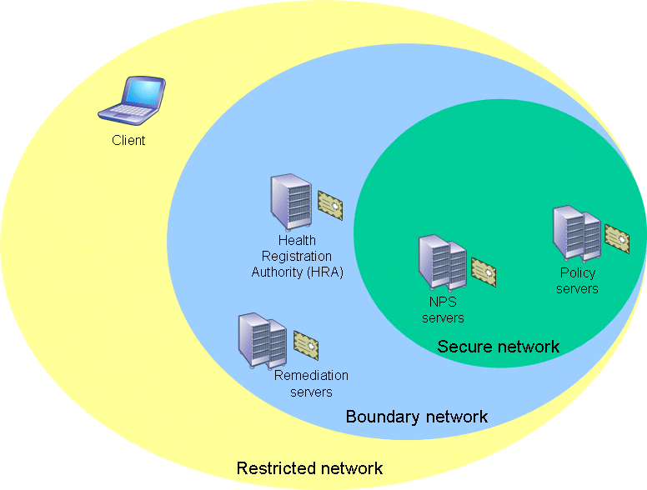
Figure 7 IPsec Enforcement logical networks
Figure 8 shows the computers of IPsec Enforcement and the NAP architectural components of the NAP client, the HRA, and the NPS servers.
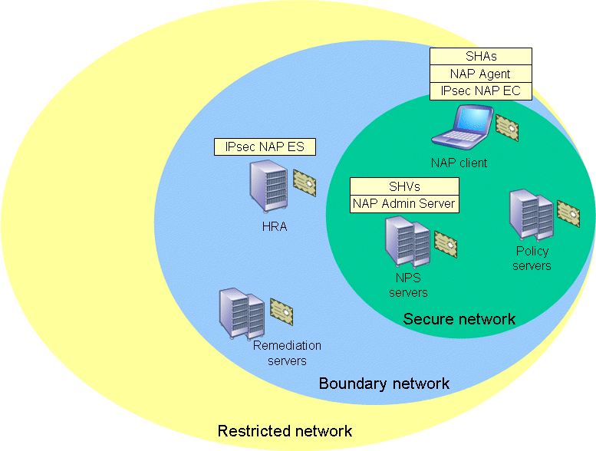
Figure 8 Computers and architectural components of IPsec Enforcement

Communication Initiation Processes with IPsec Enforcement
Based on the definition of the three logical networks, the following are the types of initiated communications and their resulting behavior with IPsec Enforcement:
- Within the secure network
Compliant computers within the secure network have health certificates. When a compliant computer in the secure network initiates communication with another compliant computer in the secure network, it attempts IPsec authentication using its health certificate. Both IPsec peers validate each other's health certificates. IPsec authentication is successful and subsequent data traffic is protected with IPsec. The result is authenticated peers and protected traffic.
- Secure network to boundary network
When a compliant computer in the secure network initiates communication with a computer in the boundary network, such as a remediation server, it attempts IPsec authentication using its health certificate. Because computers in the boundary network also have health certificates, both IPsec peers validate each other's health certificates. IPsec authentication is successful and subsequent data traffic is protected with IPsec. The result is authenticated peers and protected traffic when a computer in the secure network initiates communication with a computer in the boundary network.
- Secure network to restricted network
When a compliant computer in the secure network initiates communication with a computer in the restricted network, it attempts IPsec authentication using its health certificate. Because computers in the restricted network do not have health certificates, IPsec authentication fails. The computer in the secure network then initiates communication without IPsec protection. The result is unauthenticated peers and unprotected traffic when a computer in the secure network initiates communication with a computer in the restricted network.
- Within the boundary network
When a compliant computer in the boundary network initiates communication with another computer in the boundary network, such as a remediation server, it attempts IPsec authentication using its health certificate. Because computers in the boundary network have health certificates, both IPsec peers validate each other's health certificates. IPsec authentication is successful and subsequent data traffic is protected with IPsec. The result is authenticated peers and protected traffic.
- Boundary network to secure network
When a compliant computer in the boundary network initiates communication with a computer in the secure network, it attempts IPsec authentication using its health certificate. Because computers in the boundary network have health certificates, both IPsec peers validate each other's health certificates. IPsec authentication is successful and subsequent IPsec-protected data traffic can begin. The result is authenticated peers and protected traffic when a computer in the boundary network initiates communication with another computer in the secure network.
- Boundary network to restricted network
When a compliant computer in the boundary network initiates communication with a computer in the restricted network, it attempts IPsec authentication using its health certificate. Because computers in the restricted network do not have health certificates, IPsec authentication fails. The computer in the boundary network then initiates communication without IPsec protection. The result is unauthenticated peers and unprotected traffic when a computer in the boundary network initiates communication with a computer in the restricted network.
- Within the restricted network
Computers in the restricted network are either not NAP clients or are NAP clients that do not have a health certificate. Communications between computers that are not NAP clients are typically not protected with IPsec, unless the computers have their own IPsec policy. A NAP client that does not have a health certificate can initiate communications with computers that are not NAP clients and other NAP clients that do not have a health certificate. The result is unauthenticated peers and unprotected traffic.
- Restricted network to boundary network
When a computer in the restricted network initiates unprotected communication with a computer in the boundary network, the boundary network computer allows the unprotected communication and responds with unprotected traffic because the boundary network computer does not require IPsec protection for incoming communication requests. The result is unauthenticated peers and unprotected traffic when a computer in the restricted network initiates communication with a computer in the boundary network.
- Restricted network to secure network
When a computer in the restricted network initiates unprotected communication with a computer in the secure network, the secure network computer drops the unprotected communication packets because it requires IPsec protection for all incoming packets. Because there is no response to the communication requests of the restricted network computer, eventually the communication attempt fails.
Figure 9 shows the initiated communication behavior for computers in the secure, boundary, and restricted networks.
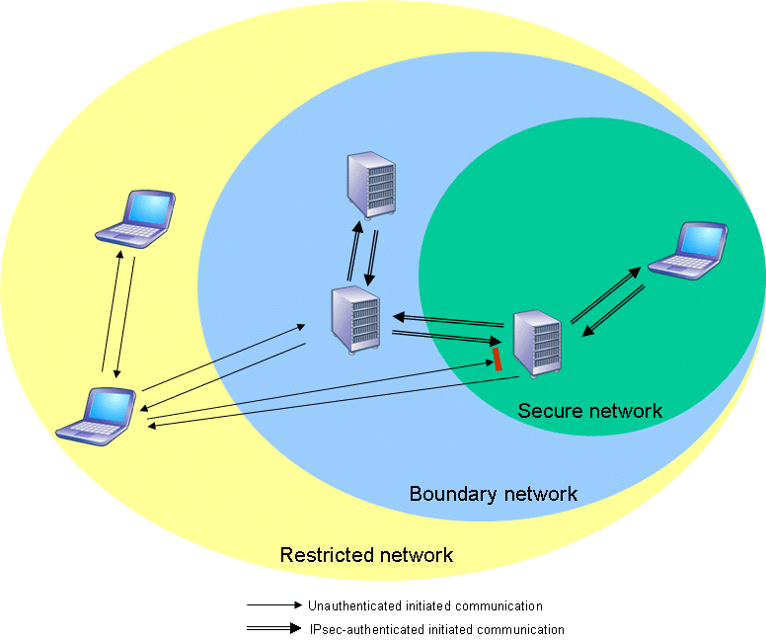
Figure 9 Initiated communication between computers in the IPsec Enforcement logical networks
The following is a summary of IPsec Enforcement:
- Peers use IPsec authentication and protection whenever they are located in the secure or boundary networks.
- IPsec authentication and protection is not used when any computer initiates communication to a computer in the restricted network and when a computer in the restricted network initiates communication with a computer in the boundary network.
- Computers in the restricted network cannot initiate communication with computers in the secure network.

Obtaining a Health certificate
To obtain a health certificate and become a member of the secure or boundary networks, a NAP client using IPsec Enforcement uses the following process:
- When the computer starts, the host-based firewall is enabled but does not allow any exceptions so that no other computer can initiate communications with it. At this point, the computer is in the restricted network because it does not have a health certificate. The computer can communicate with other computers in the restricted and boundary networks and can access the Internet. However, it cannot initiate communications with computers in the secure network.
- The NAP client obtains network access and an IP address configuration.
- The IPsec NAP EC on the NAP client creates an HTTPS secure communication channel with the HRA.
- The IPsec NAP EC sends its credentials, a certificate request for a health certificate, and its list of SoHs to the HRA over the HTTPS channel.
- The HRA passes the list of SoHs to the NPS server as RADIUS vendor-specific attributes (VSAs) in a RADIUS Access-Request message.
- The NPS server receives the RADIUS Access-Request message, extracts the list of SoHs from the RADIUS VSAs, and passes the list of SoHs to the NAP Administration Server component.
- The NAP Administration Server receives the list of SoHs and forwards the SoHs to the appropriate SHVs.
- Each SHV analyzes the contents of the SoH passed by the NAP Administration Server and then constructs and sends an SoHR to the NAP Administration Server component.
- The NAP Administration Server passes the list of SoHRs to NPS.
- NPS compares the list of SoHRs to a configured set of network access and system health policies and then makes a limited/unlimited network access decision.
- NPS constructs and sends a RADIUS Access-Accept message containing the System Statement of Health Response (SSoHR)—indicating whether the client has limited or unlimited network access—and the list of SoHRs as RADIUS VSAs.
- The HRA sends the SSoHR and the list of SoHRs back to the IPsec NAP EC on the NAP client. If the NAP client is compliant, the HRA obtains a health certificate from the existing public key infrastructure (PKI) and sends it to the NAP client.
If the NAP client is issued a health certificate via the HRA, it adds that certificate to its computer certificate store. If IPsec policy settings have not already been configured, the IPsec NAP EC configures IPsec settings to authenticate using the health certificate for IPsec-based communications. The IPsec NAP EC configures the host-based firewall to allow incoming communications from any peer that uses a health certificate for IPsec authentication. The NAP client is now a member of the secure network.
The IPsec NAP EC performs steps 3-12 whenever new SoH information arrives at the NAP Agent or when the health certificate is about to expire.

IPsec-based NAP Client is Noncompliant
If the IPsec-based NAP client is noncompliant, it does not have a health certificate and cannot initiate communication with computers in the secure network. The NAP client performs the following remediation process to become a member of the secure network:
- The IPsec NAP EC passes the list of SoHRs to the NAP Agent.
- The NAP Agent forwards the SoHRs to the appropriate SHA.
- Each SHA analyzes its SoHR, and based on the contents, performs the remediation as needed to correct the NAP client's system health state.
- After an SHA has performed the remediation function, it passes an updated SoH to the NAP Agent.
- The NAP Agent collects the updated SoHs from all of the SHAs that required remediation, creates a new list of SoHs, and passes it to the IPsec NAP EC.
- The IPsec NAP EC establishes a new HTTPS secure session with the HRA and sends the new list of SoHs.
- The HRA receives the list of SoHs and sends them to the NPS server.
- The NPS server receives the list of SoHs and passes them to the NAP Administration Server.
- The NAP Administration Server receives the list of SoHs, and assuming that it has not already cached the SoHRs, forwards the SoHs in the list to the appropriate SHVs.
- The SHVs analyze the contents of the SoH passed by the NAP Administration Server and then construct and send an SoHR to the NAP Administration Server,
- The NAP Administration Server passes the list of SoHRs to NPS.
- NPS compares the list of SoHRs to a configured set of network access and system health policies and then makes an unlimited network access decision.
- NPS constructs and sends a RADIUS Access-Accept message containing the SSoHR and the list of SoHRs.
- The HRA receives the RADIUS Access-Accept message, extracts the SSoHR and the list of SoHRs, and sends them to the NAP client over the HTTPS session. Because the NAP client is now compliant, the HRA obtains a health certificate and sends it to the NAP client.

Using IPsec Enforcement with Existing IPsec Protection
IPsec Enforcement can be used in conjunction with the following IPsec deployment scenarios:
- Secure server
- Server isolation
- Domain isolation

Secure Server
An IPsec secure server deployment uses IPsec policy to provide protection for traffic sent between specific sets of servers, such as the traffic sent between database servers or domain controllers. IPsec Enforcement can be deployed in conjunction with a secure server deployment so that a combination of IPsec policy settings and NAP policy settings ensure that the servers remain healthy and use IPsec to protect traffic sent between them.

Server Isolation
An IPsec server isolation deployment uses IPsec policy to provide protection for traffic sent between all domain members and a specific set of servers, such as the traffic sent between database client computers that are domain members and database servers. IPsec Enforcement can be deployed in conjunction with a server isolation deployment so that a combination of IPsec policy settings and NAP policy settings ensure that the domain members and specific sets of servers remain healthy and communication with compliant NAP client computers on a per-server or per-application basis is protected with IPsec.

Domain Isolation
An IPsec domain isolation deployment uses IPsec policy to provide protection for traffic sent between all domain members, including all client and server computers. IPsec Enforcement can be deployed in conjunction with a domain isolation deployment so that a combination of IPsec policy settings and NAP policy settings ensure that domain members remain healthy and that traffic sent between domain members is authenticated with domain credentials, a health certificate, or both and is protected with IPsec.

Appendix A: Frequently Asked Questions About IPsec Enforcement in NAP
Q: What is Internet Protocol security (IPsec)?
A: IPsec is a framework of open standards developed by the Internet Engineering Task Force (IETF) for ensuring private, secure communications over IP networks through the use of cryptographic security services.

Q: How does IPsec provide security for network traffic?
A: To provide security protection for an Internet Protocol (IP) packet, IPsec typically adds one of the following to the IP packet:
- An Authentication Header (AH) extension header between the IP header and the IP packet payload to provide tamper proofing for the entire IP packet, except for fields in the IP header that are allowed to change in transit.
- An Encapsulating Security Payload (ESP) extension header and trailer around the IP packet payload to provide tamper proofing and optional encryption for the IP packet payload.

Q: If I use IPsec, does that mean that all my traffic must be encrypted?
A: No. IPsec only encrypts IP packet payloads when you choose to use ESP with encryption. The other uses of IPsec, such as AH or ESP without encryption, provide tamper proofing of IP packets or payloads but do not encrypt the IP packet payloads. Encryption is optional and recommended when sending private data across a public network (such as the Internet) or when sending highly sensitive data across an intranet (such as personal or financial data).

Q: Isn't IPsec just used for VPN connections?
A: No. Although IPsec is used for VPN connections across the Internet to connect remote clients to a private intranet or remote site to each other, IPsec can also be used to protect intranet traffic.

Q: How is limiting network access for noncompliant clients achieved with IPsec NAP?
A: Compliant NAP clients use health certificates obtained through the Health Registration Authority (HRA) for IPsec authentication when they initiate IPsec-protected communications with other NAP clients on an intranet. If a computer does not have a health certificate, it cannot initiate communication with a compliant NAP client.

Q: How does IPsec Enforcement differ from VPN Enforcement and DHCP Enforcement?
A: IPsec Enforcement limits the access of noncompliant clients that are attempting to communicate after VPN-based network access to the private intranet has been successfully made and after a valid IP address configuration has been allocated. With IPsec Enforcement, the communication attempt is made from end-to-end, rather from a specific type of client to a specific type of server. The end-to-end protection provided by IPsec helps protect clients that roam. Unlike VPN and DHCP Enforcement, the HRA, a computer that is separate from the computer to which communication is being attempted, performs the determination of client health using an NPS server.

Q: How is IPsec Enforcement the most secure form of NAP protection?
A: IPsec Enforcement requires peer authentication and network traffic protection from end-to-end, not just from the NAP client to the server through which network access or IP configuration is being granted. IPsec Enforcement is enforced by each individual computer, rather than at the point of entry into the network.

Q: How is IPsec Enforcement the most flexible form of NAP protection?
A: Because IPsec Enforcement can take advantage of IPsec policy settings, the enforcement of health certificates for IPsec authentication can be done for all the computers in a domain, specific computers on a subnet, a specific computer, a specific set of TCP or UDP ports, or for a specific set of TCP or UDP ports on a specific computer. For example, you could roll out IPsec NAP to initially protect file and printer sharing traffic, and then expand protection to Web traffic and other types of traffic.

Q: In IPsec Enforcement, which NAP architectural components are located on which computers?
A: The NAP client contains the IPsec NAP EC, the NAP Agent, and the NAP ECs. The HRA contains the IPsec NAP ES. The NPS server contains the NAP Administration Server and the SHVs.

Q: What is the purpose of the HRA in IPsec Enforcement?
A: The HRA evaluates NAP client health in conjunction with an NPS server and obtains health certificates for IPsec Enforcement client computers from an existing public key infrastructure (PKI) after they have proven themselves to be compliant.

Q: How do I use IPsec Enforcement with an existing secure server IPsec deployment?
A: IPsec Enforcement can be deployed in conjunction with a secure server deployment so that a combination of IPsec policy settings and NAP policy settings ensure that the servers remain healthy and use IPsec to protect traffic sent between them.

Q: How do I use IPsec Enforcement with an existing server isolation IPsec deployment?
A: IPsec Enforcement can be deployed in conjunction with a server isolation deployment so that a combination of IPsec policy settings and NAP policy settings ensure that the domain members and specific sets of servers remain healthy and communication with compliant NAP client computers on a per-server or per-application basis is protected with IPsec.

Q: How do I use IPsec Enforcement with an existing domain isolation IPsec deployment?
A: IPsec Enforcement can be deployed in conjunction with a domain isolation deployment so that a combination of IPsec policy settings and NAP policy settings ensure that domain members remain healthy and that traffic sent between domain members is authenticated with domain credentials, a health certificate, or both and is protected with IPsec.

Summary
IPsec Enforcement uses the combination of the Network Access Protection platform and IPsec support in Windows to enforce system health requirements and to require that communication between compliant computers be authenticated and protected with IPsec. IPsec Enforcement works by requiring IPsec authentication with a health certificate obtained from the HRA for all incoming communication attempts. A computer without a health certificate cannot initiate communications with a compliant NAP client. IPsec Enforcement is the most secure and most flexible form NAP enforcement technology.

Related Links
See the following resources for further information:
- Microsoft Network Access Protection Web page at http://www.microsoft.com/nap
- Introduction to Network Access Protection at http://go.microsoft.com/fwlink/?LinkId=49884
- Network Access Protection Platform Architecture at http://go.microsoft.com/fwlink/?LinkId=49885
- Network Access Protection Frequently Asked Questions at http://go.microsoft.com/fwlink/?LinkId=49886
- http://www.microsoft.com/ipsec at http://www.microsoft.com/ipsec
- Server and Domain Isolation Web page on TechNet at http://www.microsoft.com/technet/network/sdiso/default.mspx


For the latest information about Windows Server System, see the Windows Server System Web site at http://www.microsoft.com/windowsserversystem.

