



Performance and Reliability for Excel Spreadsheets through High Performance Computing

Jeff Wierer
Sr. Product Manager
Windows Server Marketing

Published: March 2007

Abstract
This white paper describes how you can increase the computational power and reliability of Excel 2007 spreadsheets through the use of the Microsoft High Performance Computing platform composed of Microsoft Office Excel 2007, Microsoft® Windows® Compute Cluster Server 2003, and Excel Services, part of Microsoft Office SharePoint Server 2007. Specifically, the paper shows how an integrated solution built on this Microsoft platform enables performance and reliability scenarios in the Financial Services, Oil and Gas, and Life Sciences industries where spreadsheets are often used in to make business critical decisions.


This is a preliminary document and may be changed substantially prior to final commercial release of the software described herein.
The information contained in this document represents the current view of Microsoft Corporation on the issues discussed as of the date of publication. Because Microsoft must respond to changing market conditions, it should not be interpreted to be a commitment on the part of Microsoft, and Microsoft cannot guarantee the accuracy of any information presented after the date of publication.
This White Paper is for informational purposes only. MICROSOFT MAKES NO WARRANTIES, EXPRESS, IMPLIED OR STATUTORY, AS TO THE INFORMATION IN THIS DOCUMENT.
Complying with all applicable copyright laws is the responsibility of the user. Without limiting the rights under copyright, no part of this document may be reproduced, stored in or introduced into a retrieval system, or transmitted in any form or by any means (electronic, mechanical, photocopying, recording, or otherwise), or for any purpose, without the express written permission of Microsoft Corporation.
Microsoft may have patents, patent applications, trademarks, copyrights, or other intellectual property rights covering subject matter in this document. Except as expressly provided in any written license agreement from Microsoft, the furnishing of this document does not give you any license to these patents, trademarks, copyrights, or other intellectual property.
© 2007 Microsoft Corporation. All rights reserved.
Microsoft, Active Directory, Excel, Office, SharePoint, Windows, and Windows Server are either registered trademarks or trademarks of Microsoft Corporation in the United States and/or other countries.
All other trademarks are property of their respective owners.
Contents
Scaling Spreadsheets from Desktops to Servers 1
Improvements in Microsoft Office Excel 2007 1
Microsoft Office SharePoint Server 2007 – Excel Services 2
Microsoft® Windows® Compute Cluster Server 2003 3
Scenarios for Combining MOSS with WCCS 3
Detailed Scenario Descriptions 4
Understanding Industry Challenges 8
Solution: Server-grade spreadsheets through Excel Services in an HPC environment 8
Industry Challenge: Financial Services 10
Financial Services Solution Illustration: Excel Services and WCCS enable rapid market reaction 11
Industry Challenge: Oil and Gas 15
Solution: Server-grade spreadsheets through Excel Services and the Windows Compute Cluster Server 2003 15
Oil and Gas Solution Illustration: Excel Services and WCCS enable rapid market reaction 17
Industry Challenge: Life Sciences 20
Solution: Server-grade spreadsheets through Excel Services and the Windows Compute Cluster Server 2003 20
Conclusion 22
For more information 23
Product Information 23
Other Whitepapers 23
Blogs 23
Contributors and Acknowledgments
Sanjay Kulkarni, Microsoft
Mutlu Kurtoglu, Microsoft

Scaling Spreadsheets from Desktops to Servers
With an estimated 450M+ users, Excel has become a mission critical application for many organizations, with users pushing Excel to the limit and demanding enterprise performance and reliability. Typically, the requirements are to:
- Guarantee of the execution of mission critical calculations.
- Improve performance by completing parallel iterations on models or long-running calculations.
- Improve productivity of employees and resources by moving complex calculations off desktops.
These are some of the scenarios that Microsoft Office SharePoint 2007 combined with the Microsoft® Windows® Compute Cluster Server 2003 facilitates; each will be discussed in turn in this document. In particular, this document will focus on:
- Offloading analytical library calculations
- Scheduling overnight risk calculations
- Scaling-out Monte Carlo iterations and parametric sweeps

Improvements in Microsoft Office Excel 2007
Microsoft has made significant investments towards the improvement of Excel in the 2007 release. With Excel 2007 users will experience a redesigned interface that makes it easier and faster to create spreadsheets that match the growing needs of the enterprise. Here two that are bound to excite spreadsheets enthusiasts:
- Expanded capacity for spreadsheets. Previous releases of Excel were limited to 256 columns by 65,536 rows. Users can now create spreadsheets with columns going to XFD (that’s the last of 16,384 rows if you hadn’t already done the math) and include up to 1,048,576 rows.
- Maximized memory usage. Previous releases of Excel could only take advantage of 1 GB of memory. That limit has been removed and Excel can now take advantage of the maximum amount of memory addressed by the installed 32-bit version of Windows.
- Excel 2007 now includes a multi-threaded calculation engine. By default Excel will maximize the utilization of all CPUs on a machine. For customers running multi-core, multi-CPU, or hyper-threaded processes, linear improvements can be seen in performance, assuming parallelization of calculations.

For more detailed information on Excel 2007, visit:
http://office.microsoft.com/excel

Microsoft Office SharePoint Server 2007 – Excel Services
Excel Services, part of Microsoft® Office SharePoint® Server 2007 (MOSS), extends the capabilities of Excel 2007 by providing:
- Broad sharing of spreadsheets
- Improved manageability and security, and
- Re-use of spreadsheet models through a scalable server-based calculation service and interactive web-based user interface.
Excel Services provides both a web-based UI for browser-based access and a web services API for programmatic access that have robust options for controlling the data available to users and applications. As part of Microsoft Office SharePoint Server 2007, Excel Services also takes advantage of enterprise content management features such as: check-in/check-out, auditing, version control and retention policies.
The following illustration explains the publishing process and the different ways to access an Excel Services enabled workbook.
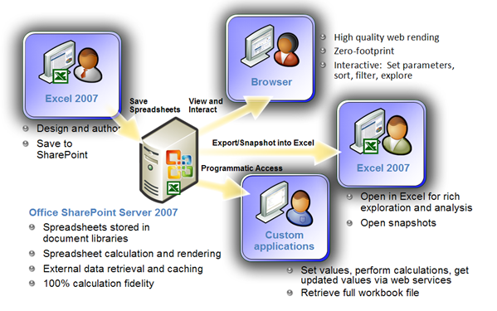
Figure 1 - Excel Services Overview

For more detailed information see the following whitepaper http://office.microsoft.com/search/redir.aspx?AssetID=XT102058301033&CTT=5&Origin=HA102058281033

Microsoft® Windows® Compute Cluster Server 2003
Microsoft® Windows® Compute Cluster Server 2003 (WCCS) provides an integrated application platform for deploying, running, and managing high performance computing applications. For customers who need to solve complex computational problems, Windows Compute Cluster Server 2003 accelerates time-to-insight by providing an HPC platform that is simple to deploy, operate, and integrate with your existing infrastructure. WCCS allows researchers to research and financial analysts to conduct analysis with minimal IT administration. WCCS operates on a a cluster of servers that includes a single head node and one or more compute nodes (see diagram). The head node controls and mediates all access to the cluster resources and is the single point of management, deployment, and job scheduling for the compute cluster. WCCS uses the existing corporate Active Directory infrastructure for security, account management, and overall operations management using tools such as Microsoft Operations Manager 2005 and Microsoft Systems Management Server 2003.
For more detailed information see the following whitepapers: http://www.microsoft.com/windowsserver2003/ccs/techresources/default.mspx

Scenarios for Combining MOSS with WCCS
This section describes the following three scenarios:
- Offloading Library Functions - Excel to WCCS Communication
- Scheduling Calculations - SharePoint running in a cluster
- Parametric Sweeps - End user scheduling of long running calculations

Detailed Scenario Descriptions

Offloading Library Functions - Excel to WCCS Communication
It is common for spreadsheets to rely on user defined functions, or Excel add-ons, that provide extended functionality and formulas. Complex formulas utilizing complex models can be resource intensive and slow. As a result, it has historically been necessary for users to maintain separate machines to perform simultaneous calculations.

User defined functions can be created and installed on 64-bit servers running in a WCCS. Using the new multithreaded calculation engine of Excel 2007, synchronous calls can be made to the cluster servers to perform remote calculations.
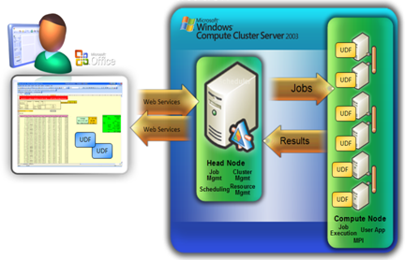
Since calculations may be performed in parallel by multiple servers, overall clock-time of spreadsheet calculations can be dramatically increased while the load on the local client machine can be significantly decreased. This provides users with faster results and allows them to use desktops to perform other activities resulting in higher productivity. With this solution, organizations are able to move formulas out of the Excel workbooks and store them on a set of servers. Additionally, since the processing is moved off the desktop, organizations have the option to lock-down access to the formulas used in the calculations and just provide user visibility to results.
Figure 2 - Offloading Library Functions
This scenario requires creating a local, client, User Defined Function (UDF) that will schedule jobs on the head node via the web services API. Additionally a server-version of the UDF will need to be created which will live on the cluster servers. The “server” UDF will perform the calculations and return the results back to Excel.

Scheduling Calculations - SharePoint running in a cluster
Financial services firms, Oil & Gas companies, and Life Sciences organizations are looking at better ways to manage risk associated with ever growing volumes of data, expanded portfolios, and new regulatory demands, all of which may require a historical record of spreadsheets.

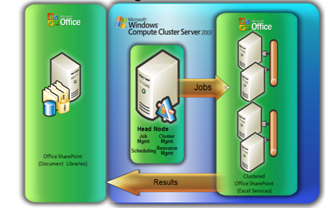
Office SharePoint Server 2007 and WCCS can help ensure timeliness of recurring spreadsheet processing by allowing the automating of spreadsheets refresh via job scheduling. Companies can create flexible schedules for intra-day, end of day, quarterly, or end of year calculations. These spreadsheets can be further managed in a SharePoint document library to maintain a single, secure historical record.
Figure 3 - Scheduling Calculations: SharePoint running in a cluster

Achieving this solution requires installing Office SharePoint Server 2007 on each of the compute nodes that will be performing the calculations. For migrating existing spreadsheets, server-side UDFs will need to be created if client side Excel Add-ins, or XLLs, were originally used. If client side Excel Add-ins, or XLLs, were being used in the client spreadsheet, server-side UDFs will need to be created. Since most XLLs are COM-based and server UDFs need to be managed (.NET) assemblies, the XLLs will either need to be re-written for .NET or have .NET wrappers created to allow existing libraries can be leveraged through COM Interop.

In order for end users to be able to schedule calculations a form will need to be created. Here’s an example of a web form hosted in SharePoint. 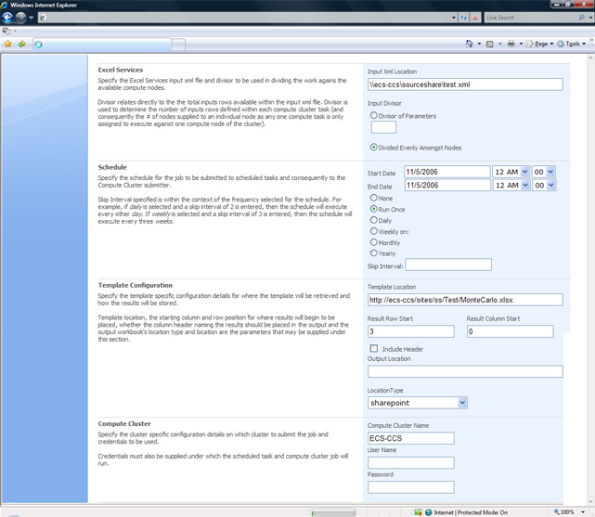
Figure 4 - Sample Web Scheduling Form for Excel Services

Parametric Sweeps - End user scheduling of long running, iterative calculations
Businesses today must conduct complex calculations that take considerable time to perform. Examples such as a Monte Carlo simulation, or parametric sweeps, can iterate through hundreds, sometimes millions, of values resulting in calculations that range from minutes to hours to complete. These calculations are often “scheduled” overnight by batch scripts which automate Excel to run in an unattended mode from desktop machines. Unfortunately, if an error occurs there isn’t a built in mechanism for failover or retry. Failures result in lost productivity when the worker returns the following day.
Excel Services, part of Office SharePoint Server 2007, provides a server-based version of the Excel 2007 calculation engine that can be scheduled using the Windows Compute Cluster Server 2003 scheduler. Once scheduled, Windows Compute Cluster Server 2003 will perform proactive monitoring of the Excel Calculation Services. If necessary, the scheduler can automate the re-queuing of failed jobs, maintain priority of queues, provide adaptive load balancing to prevent overloading a SharePoint Server, and provide dynamic aggregation and discovery of cluster nodes. This results in a reliable and fault tolerant means of spreadsheet calculations. The improved performance and reliability introduced by this solution can help move scheduled overnight computations into intra-work day calculations.
Achieving this solution requires installing Office SharePoint Server 2007 on each of the compute nodes that will be performing the calculations. As in the previous example, if client side Excel add-ins, or XLLs, were being used in the client spreadsheet, server-side UDFs will need to be created.
In order to schedule a calculation from Excel organizations need to create a client add-in that can create a set of parameters, such as a list packaged in XML, and schedule jobs against the cluster.

Understanding Industry Challenges
Microsoft Office Excel is the tool of choice across industries for data analysis and complex modeling capabilities. However as the results of the analysis become more mission critical, there is a need for improved performance and reliability. One of the main challenges faced by business professionals is the ability to quickly analyze increasingly complex market data and investment scenarios. The current market environment forces traders and portfolio managers to ask a staggering amount of “what if” questions over unknown market scenarios. Although evaluating business dependencies by peering into the future is necessary for success, increases in market complexity have not been matched by boosts in easy-to-deploy and computationally intense information management systems. Market professionals and their clients would greatly benefit from access to scenario simulations in real time. However the computational intensity required often overwhelms even the fastest computing environment for complex models on a typical trading desk or research desktop. With Microsoft High Performance Computing, complex market simulations, business interdependencies, and compliance reports can now be managed in a secure and scalable server environment where the reliability of calculations can be guaranteed.

Solution: Server-grade spreadsheets through Excel Services in an HPC environment
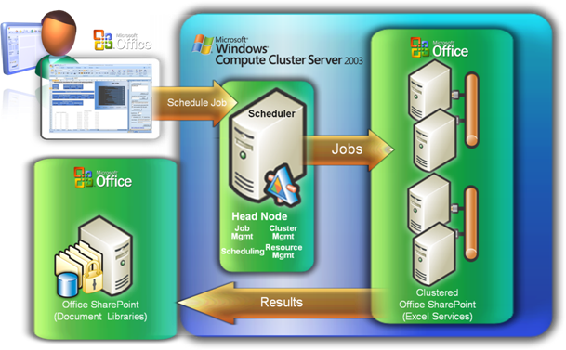
Coupling the new improvements in Excel 2007 with a comprehensive Microsoft High Performance Computing solution enables users to run increasingly complex, time sensitive models in a significantly reduced period resulting in improved responsiveness and user productivity. The end result transforms Excel into a computational powerhouse and rich document management platform that lets you do more in less time. A Microsoft High Performance Computing platform allows professionals, including traders and researchers, to ask more aggressive questions and demand quicker responses to drive increased competitive advantage. Additionally, by utilizing a familiar Windows environment for high performance computing organizations can leverage existing Windows Server administration skills. Dedicated, highly specialized and very expensive expertise is no longer needed.
Figure 5 - Parametric Sweeps: End user scheduling of long running calculations
Office SharePoint Server 2007 promotes the advantages of several Microsoft technologies including Microsoft Office Excel 2007 and Microsoft Windows Compute Cluster Server. The end result enables trading desks, engineering groups, and compliance teams within various industries to use familiar tools such as Excel with highest performance capabilities ever offered in a Windows environment. Now, tasks such as Monte Carlo simulations, “what-if” scenario testing, and counter-party credit risk analysis can be scaled effectively within a familiar Microsoft environment. More information on how solution such as this can be built using Microsoft technologies can be found in the Parametric Sweeps section below.

Industry Challenge: Financial Services
It takes innovations in the structuring, measuring, and exploitation of financial instruments for a capital trader to stay ahead. This need to quickly innovate has the adoption of Excel as the (almost) universal tool for high-risk financial analysis, including:
- The pricing of complex instruments  - Generation of Historic Derived Data  - Statistical Analysis & Arbitrage  - Custom Index/Basket Analysis  - Trade Blotters and Reporting | - VAR Risk Calculations such as Monte Carlo  - Algorithmic trading  - Fraud detection and money-laundering alerts  - General Econometrics
A platform including Microsoft Office Excel 2007, WCCS, and Microsoft Office SharePoint 2007 with Excel Services can significantly improve the financial professional’s ability to assess the economic landscape, stress-test current or potential trades, and quickly price a large array of complex securities. A key goal in financial services is to be “the first to call” a sales account or trading partner. A Microsoft High Performance Computing platform provides the performance and reliability to make that happen.
The computational problems faced by traders and financial engineers within the financial services industry also represent a type of computing problem commonly faced by other professionals across multiple industries. Due to the sheer size and complexity of contemporary business challenges, they often take several hours, and sometimes days, to accurately model. Moreover, accuracy alone no longer offers competitive advantage. Rather, processing speed, without sacrificing accuracy, has become a primary factor to success. With the advent of real-time market effect processes completion in hours, let-alone days, is simply no longer acceptable.
There are a variety of solutions to address the problem of overwhelming computational needs. One is to cut corners by running fewer simulations or using crude approximations. However, impractical analytics yield dangerously misleading results – there is no need for speed if it ultimately means inaccurate answers. Another method is to offload all computationally intense analytics to process on a supercomputer. Traditional supercomputers can certainly provide a computational boost and decrease overall processing time, yet the time it takes to re-code a spreadsheet for operation on a supercomputer may nullify the competitive advantage being sought, as well as making detailed ad-hoc analysis difficult. Support resources for traditional supercomputing are costly to hire and introduce an inefficient layer of administration between analysts and computational results.
Excel is simple to use and has large-scale adoption – what the industry needs is manageable, infinitely scalable, Excel.

Financial Services Solution Illustration: Excel Services and WCCS enable rapid market reaction
The following narrative is of a fictional organization, Contoso, and is intended to illustrate how Excel Services can be used with WCCS in an industry specific scenario.
Thomas Jensen is a fund manager for Contoso Investments. Tom wants to know how his portfolio will react over a wide variety of future market scenarios – all of which are unknown. To do this, Thomas frequently runs Monte Carlo simulations which “stress-test” his portfolio by taking “random-walks” through future market conditions. The ability to conduct this type of analysis is critical to his continued professional success and a requirement of his fiduciary responsibility. Thomas manages a group of high-tech growth funds, with multiple investment positions in each. It takes several hours for an average Monte Carlo analysis of his portfolio. For his colleagues in exotic derivative and fixed-income trading, processing can take days. This is a problem – an industry wide, critical problem.
Current market conditions, intense customer demand, and new regulatory requirements increase the need for analyzing results near, or at, real-time. Prior to the advent of a Microsoft high performance computing platform, the IT department of Contoso Investments would have to handle the multiple problems associated with a fragmented supercomputing or high performance platform using unfamiliar tools that might be optimized for one specific task – but have difficulty integrating with other specialized components. These persistent problems can now be addressed with the seamless integration of powerful and familiar tools that are easy to use. A scalable and cost-effective Microsoft High Performance Computing platform enables each business unit to do more in less time.
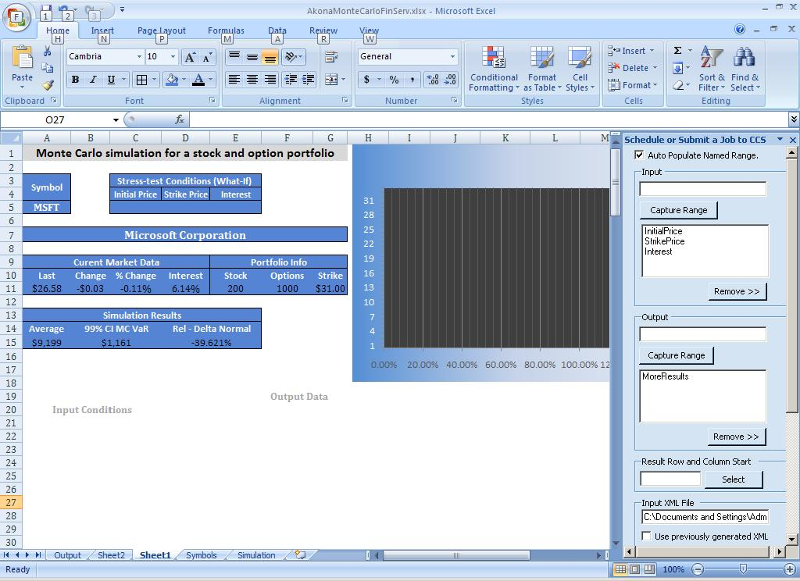
A breaking story suddenly shocks the markets Thomas actively trades in. With the deployment of Excel 2007, Excel Services, and the Windows Compute Cluster Server 2003 Thomas can re-price his large portfolio within minutes – right from the trading desk. Because Thomas is able to quickly assess his full portfolio in light of potential market changes from the breaking news, he can quickly locate a gap in his trading strategy and adjust within minutes. To address the gap in his strategy Thomas decides to run another Monte Carlo analysis on a new equity option position to evaluate a potential trade. He loads an equity options analytics model from his library into Microsoft Excel 2007 and quickly enters the relevant market data. Because a Microsoft High Performance Computing platform allows Thomas to request more iterations for increased insight in computed results, he simulates the behavior of his potential trade over 10,000 different market scenarios.
Immediate Processing from Excel to WCCS
After rapidly loading data into his model, Thomas quickly sends an immediate job to WCCS through a custom Excel task pane. The job is submitted to the WCCS head node which schedules jobs to be performed by nodes in the cluster. The cluster nodes quickly generate parallel results from 10000 “random” walks through different market scenarios. Thomas gets his results in significantly less time and can now more quickly respond to changing market conditions. Because of the dramatically reduced processing time, Thomas was able to quickly adjust to a market disruption. Within a few minutes he evaluated his overall portfolio, located a weak spot, evaluated a potential solution, and initiated new trades.
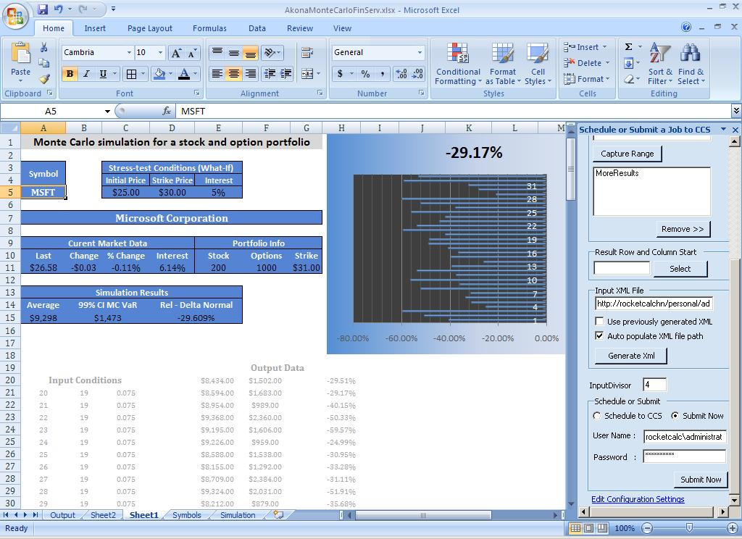
Thomas’ boss is Francois Ajenstat, Contoso’s Head Trader. Francois oversees each of Contoso’s trading desks and interacts with all fund managers. He interacts with a library of analysis already completed through the SharePoint 2007 site to monitor the performance of Contoso’s traders and scrutinize the positions held by its fund managers. In addition to the “on-the-fly” simulations and pricing analytics his traders run throughout the trading day, Francois requires an end-of-week analysis for each portfolio his traders and fund managers oversee. They can easily accommodate his request using the scheduling capabilities of Excel Services which seamlessly processes the model and migrates the finished analytics to the secured SharePoint Library for convenient review.
Results of Completed Pricing Model
Eli Bowen is one of several compliance supervisors ensuring Contoso’s employees – particularly its traders and fund managers – comply with current regulatory requirements. He often works with the SharePoint library to help manage Contoso’s significant compliance reporting and ensure a high level of fiduciary responsibility through periodic audits of the reports used by the trading desk.
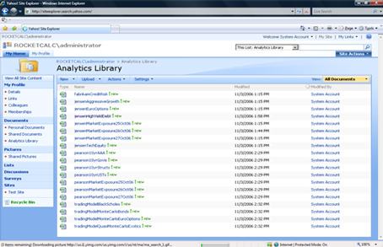
Eli and other compliance managers are under considerable regulatory pressure to ensure their organization’s financial reporting processes are both transparent and well-documented.
Recent legislative landmarks increasing compliance requirements, notably the Sarbanes-Oxley Act (United States, 2002) and the Basel Capital Accord (Basel II, 2006), have impacted most publicly-traded companies around the world. Moreover, corporate finance is only one of several areas affected by compliance legislation; separate industry and local regulations also exist. An organization must take into account all applicable policies and requirements when developing a regulatory compliance framework.
Office SharePoint 2007 Document Library
Implementing a sustainable spreadsheet compliance framework requires cooperation between each level of an organization, from executive management to the individual business user. Such a framework must meet the needs of both the business and the IT department. As part of Office SharePoint Server 2007, Excel Services help organizations achieve success in establishing spreadsheet control policies that meet both regulatory requirements and business needs. Office SharePoint Server 2007 includes a set of enterprise content management capabilities and Excel Services which help address the following regulatory challenges:
- Preventing unauthorized access to spreadsheets
- Managing and monitoring spreadsheet changes
- Retaining and archiving spreadsheets
When combined with a sound compliance strategy, Microsoft technology can help enforce organizational policies and increase business productivity by reducing time to insight. For Bond Portfolio Managers, running complex analytics such as calculating the price of a structured bond portfolio using a Monte Carlo simulation is nothing new. What is new is the ability to calculate this information significantly faster and dynamically serve that information to a multitude of users, thus facilitating the creation and use of a wide variety of specialized business dashboards while maintaining consistent business intelligence. This significant advantage is made available by using Microsoft Office Excel 2007, Windows Compute Cluster Server 2003, and Office SharePoint Server 2007 with Excel Services enabled.
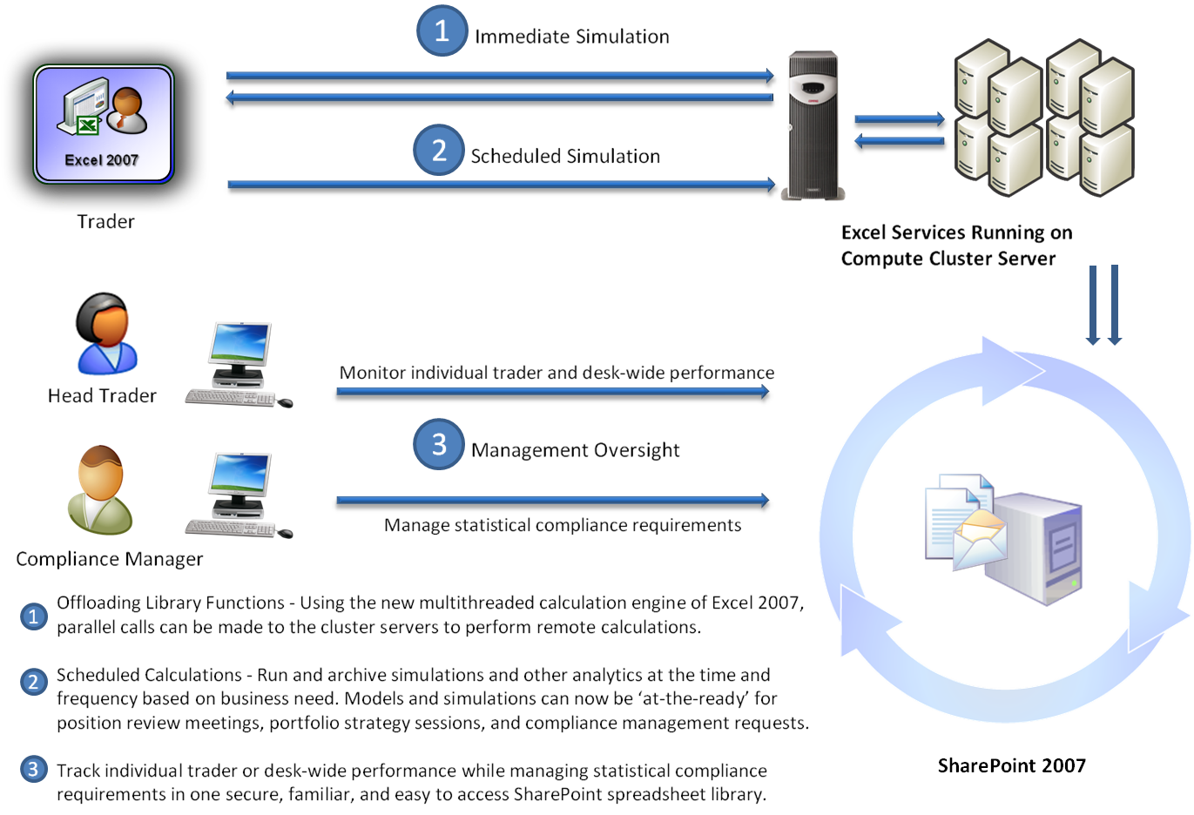
Figure 6 - Overview of Sample Financial Services Scenario

Industry Challenge: Oil and Gas
One of the main challenges faced by professionals in the Oil and Gas industry is the ability to quickly analyze increasingly complex resource data and energy market scenarios. The current market environment forces energy professionals to ask a staggering amount of “what if” questions over unknown market scenarios. Moreover, global energy demands mandate unprecedented levels of efficiency in the full value chain of resource discovery, production, and marketing. Although evaluating resource, market, and risk dependencies by peering into the future is necessary for success, increases in business complexity have not been matched by boosts in easy-to-deploy and computationally intense information management systems. Energy professionals and their clients would greatly benefit from access to scenario simulations in real time, however, the computational intensity required often overwhelms even the fastest computing environment on a typical analytics desk. The level of business complexity is staggering, and the need for speed is insatiable. With Microsoft High Performance Computing, complex energy demand and market simulations along with field scenarios and compliance reports can now be managed in a secure and scalable server environment where the reliability of calculations can be assured.

Solution: Server-grade spreadsheets through Excel Services and the Windows Compute Cluster Server 2003
Energy market and resource solutions can now be created for optimized spreadsheet performance and reliability by combining Excel 2007, Microsoft Office SharePoint Server 2007, and Windows Compute Cluster Server 2003. A comprehensive Microsoft High Performance Computing solution enables users to run increasingly complex, time sensitive, models in significantly less time. The end result transforms Microsoft Office into a computational powerhouse and rich document management platform that lets you do more in less time. A Microsoft High Performance Computing platform allows energy professionals to ask more aggressive questions and demand quicker responses to drive increased competitive advantage.
Excel Services promotes the advantages of several Microsoft technologies including Microsoft Excel 2007, Windows Compute Cluster Server 2003, and SharePoint Server 2007. The end result enables trading desks, financial engineering groups, and compliance teams within the Oil and Gas industry to use familiar tools such as Excel 2007 with the performance capabilities previously unavailable in a Windows environment. Now, tasks such as gas strategy and planning, energy trading, and enterprise risk management can be scaled effectively within a familiar Microsoft environment.
Microsoft’s HPC platform provides Oil & Gas organizations with familiar tools for analytics while vastly improving time to insight when deciding how much energy to produce, when to produce it, and how to price it. Server-grade spreadsheets from Excel Services combined with the Windows Compute Cluster Server 2003 provide significant performance improvements for the Windows environment enabling rapid modeling of increasingly complex market and resource phenomena within the geosciences and the correlating energy marketplace. Geosciences and energy professionals will now have the tools to ask more aggressive questions and simulate a wider array of resource and market scenarios.

Oil and Gas Solution Illustration: Excel Services and WCCS enable rapid market reaction
The following narrative is of a fictional organization, Litware, and is intended to illustrate again how Excel Services can be used with WCCS in an industry specific scenario.
Jim Hance is an energy trader for Litware Corporation. Jim wants to know how his portfolio will react over a wide variety of future market scenarios – all of which are unknown. To do this, Jim frequently runs Monte Carlo simulations which “stress-test” his portfolio of energy futures by taking “random-walks” through future market conditions. The ability to conduct this type of analysis is critical to his professional success and a requirement of his fiduciary responsibility. Jim manages a group of energy futures, with multiple investment positions in each. It takes several hours for an average Monte Carlo analysis of his portfolio. This is a problem – an industry wide, critical problem.
Current market conditions, intense customer demand, and new regulatory requirements increase the need for analyzing results near, or at, real-time. . Prior to the availability of a Microsoft High Performance Computing platform, the IT department of Litware Corporation would have to handle the multiple problems associated with a fragmented supercomputing or high performance platform using unfamiliar tools that might be optimized for one specific task – but have difficulty integrating with other specialized components. These persistent problems can now be addressed with the seamless integration of powerful and familiar tools that are easy to use. A scalable and cost-effective Microsoft High Performance Computing platform enables each business unit to do more in less time.
An emerging story with energy trading to Belarus is beginning to impact the markets Jim actively trades in. With the deployment of Excel 2007, Excel Services, and the Windows Compute Cluster Server 2003 Jim can re-price his large portfolio within minutes – right from the trading desk. Because Jim is able to quickly assess his full portfolio in light of potential market changes from the breaking news, he can quickly locate a gap in his trading strategy and adjust within minutes. To address the gap in his strategy Jim decides to run another Monte Carlo analysis on a new futures position to evaluate a potential trade. He loads an analytics model from his library into Microsoft Excel 2007 and quickly enters the relevant market data. Because a Microsoft High Performance Computing platform allows Jim to request more iterations for increased insight in computed results, he simulates the behavior of his potential trade over 10,000 different market scenarios.
After rapidly loading data into his model, Jim quickly sends an immediate job to the Windows Compute Cluster Server 2003 through custom Excel task pane. The job is submitted to the WCCS head node which schedules jobs to be performed by nodes in the cluster. The cluster nodes quickly generate parallel results from 10,000 “random” walks through different market scenarios. Jim gets his results in significantly less time and can now more quickly respond to changing market conditions. Because of the dramatically reduced processing time, Jim is able to quickly adjust to a market disruption. Within a few minutes he evaluates his overall portfolio, located a weak spot, evaluated a potential solution, and initiated new trades.
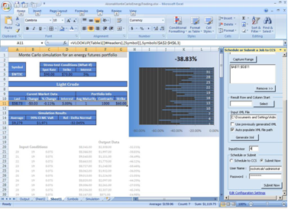
Jim’ boss is Amy Recker, Litware’s Head Trader. Amy oversees Litware’s energy trading and interacts with all futures traders. She interacts with a library of analysis already completed through the SharePoint 2007 site to monitor the performance of Litware’s traders and scrutinize the positions held by its managers. In addition to the “on-the-fly” simulations and pricing analytics his traders run throughout the trading day, Amy requires an end-of-week analysis for energy positions Litware’s managers oversee. They can easily accommodate her request using the scheduling capabilities of Excel Services which seamlessly processes the model and migrates the finished analytics to the secured SharePoint Library for convenient review.
Figure 7 - Energy Futures Simulation
Ed Meadows is one of several compliance supervisors ensuring Litware’s employees – particularly its futures traders – are compliant with current regulatory requirements. He often works with the SharePoint library to help manage Contoso’s compliance reporting and ensure a high level of fiduciary responsibility through periodic audits of the reports used by the trading desk.
Ed and other compliance managers are under considerable regulatory pressure to ensure their organization’s financial reporting processes are both transparent and well-documented.
Recent legislative landmarks increasing compliance requirements, notably the Sarbanes-Oxley Act (United States, 2002) and the Basel Capital Accord (Basel II, 2006), have impacted most publicly-traded companies around the world. Moreover, corporate finance is only one of several areas affected by compliance legislation; separate industry and local regulations also exist. An organization must take into account all applicable policies and requirements when developing a regulatory compliance framework.
Implementing a sustainable spreadsheet compliance framework requires cooperation between each level of an organization, from executive management to the individual business user. Such a framework must meet the needs of both the business and the IT department. As part of Office SharePoint Server 2007, Excel Services help organizations achieve success in establishing spreadsheet control policies that meet both regulatory requirements and business needs. Office SharePoint Server 2007 includes a set of enterprise content management capabilities and Excel Services which help address the following regulatory challenges:
- Preventing unauthorized access to spreadsheets
- Managing and monitoring spreadsheet changes
- Retaining and archiving spreadsheets
When combined with a sound compliance strategy, Microsoft technology can help enforce organizational policies and increase business productivity by reducing time to insight. For energy traders, running complex analytics such as calculating the price of natural gas futures using a Monte Carlo simulation is nothing new. What is new is the ability to calculate this information significantly faster and dynamically serve that information to a multitude of users, thus facilitating the creation and use of a wide variety of specialized business dashboards while maintaining consistent business intelligence. This significant advantage is made available by using Microsoft Office Excel 2007, Windows Compute Cluster Server 2003, and Office SharePoint Server 2007 with Excel Services enabled.

Industry Challenge: Life Sciences
One of the main challenges faced by professionals in the Life Sciences industry is the ability to quickly analyze increasingly complex biological, chemical, and environmental data. The current market atmosphere is characterized by increased regulatory control and intense market demand for continual research advancement. Moreover, global demand for access to life saving drugs, an increasingly complex patent processes, and constant price pressures mandate efficiency in the full spectrum of the life sciences research, discovery, and market spaces. Health care organizations and bioengineering firms are constantly under pressure to reduce costs and improve organizational profitability. The business of efficiently operating a company within the life sciences industry requires managers to drive better corporate and research results while maintaining to the highest level of quality. Managers today must run computationally intense analytics to assess and optimize fixed program costs and profit metrics along with choosing the best clinical equipment and means of acquisition. As with the other industries this paper has discussed, increases in business complexity have not been matched by boosts in easy-to-deploy and computationally intense information management systems. According to Thi Pham, systems engineer in the Space Technology sector at Northrop Grumman, “Scientists and engineers have huge unmet computing needs today.”

Solution: Server-grade spreadsheets through Excel Services and the Windows Compute Cluster Server 2003
With Microsoft High Performance Computing, complex business simulations, drug discovery management, bioinformatics, and genomics research can now be managed in a secure and scalable server environment where the reliability of calculations can be maintained. Server-grade spreadsheets and the intensive computational capacity of WCCS enable rapid modeling of increasingly complex market and resource phenomena within the life sciences and the correlating medical, pharmaceutical, and biotechnology marketplaces. Academics and life science market professionals will now have the tools to ask more aggressive questions and simulate a wider array of relevant scenarios.
The following example helps illustrate the impact of deploying a Microsoft High Performance Computing solution within the Life Sciences industries:
- The Computational Biology Service Unit in Ithaca, N.Y., is a core facility for computational biology and bioinformatics for Cornell University researchers, providing research and computational support to biology groups. A Microsoft High Performance Computing platform has been adopted for computational biology applications of a wide range of research activities in bioinformatics, including sequence-based data mining, population genetics and protein structure prediction. Many of the projects require lengthy calculations, so a massively parallel computing system, such as Windows Compute Cluster Server 2003, helps accelerate the pace of discovery and insights. “Adopting Windows Compute Cluster Server 2003 was a natural step for us since we use SQL Server™ for our database needs and Windows servers for hosting our Web interfaces,” said Jaroslaw Pillardy, Ph.D., senior research associate at the Computational Biology Service Unit. “In addition to serving massively parallel applications, I’ve found that Windows Compute Cluster Server is a convenient tool for serving the computational needs of many small projects, where installing the software, updating databases and managing other such tasks are much easier than on a set of separate computers.”

Conclusion
A Microsoft High Performance Computing platform with Excel Services and the Windows Compute Cluster Server 2003 offers scalable, secure, and familiar technology that is easy-to-deploy and simple-to-use. The new ‘big grid’ of Excel 2007 and its expanded memory utilization capability allow you to model more complex positions and conduct more exhaustive analysis within a single spreadsheet. The Windows Compute Cluster Server 2003 offers processing capabilities which have been optimized to boost Monte Carlo and other ‘parametric sweeps’ at a near 1:1 ratio – more speed is simply another node away! With Windows Compute Cluster Server, researchers and analysts can spend more time on research and analysis and less time on system administration. The IT benefits of the WCCS include: simplified cluster deployment and management, better integration with IT infrastructure, and a familiar development and management environment that utilizes existing skill sets. Excel Services harnesses the collaborative power of Office SharePoint 2007 to provide server-grade spreadsheets that lock-down a single version of “the truth” while seamlessly promoting multiple group relevant customizations and results archiving. With Excel Services, your proprietary formulas are visible only to those with “need-to-know” permissions, resulting in higher levels of protection for your intellectual property.
The end result is a seamless integration between the most familiar industry analysis tools - Excel - the most comprehensive enterprise level information collaboration environment available – Office SharePoint Server 2007 with Excel Services - and the Windows Compute Cluster Server 2003 - an easy to scale, easy to deploy and cost effective platform, which offers significant improvements to computing performance for the Windows environment.

For more information

Product Information
- http://office.microsoft.com/en-us/sharepointserver
- http://msdn.microsoft.com/office/server/moss
- http://www.microsoft.com/hpc

Other Whitepapers
- Excel Services Technical Overview
http://office.microsoft.com/search/redir.aspx?AssetID=XT102058301033&CTT=5&Origin=HA102058281033
- Overview of Windows Compute Cluster Server 2003
http://download.microsoft.com/download/9/e/d/9edcdeab-f1fb-4670-8914-c08c5c6f22a5/HPC_Overview.doc
- Windows Compute Cluster Server 2003 Reviewer’s Guide
http://www.microsoft.com/windowsserver2003/ccs/reviewersguide.mspx
- Deploying and Managing Windows Compute Cluster Server 2003
http://go.microsoft.com/fwlink/?LinkId=55927
- Spreadsheet Compliance in the 2007 Microsoft Office System
http://download.microsoft.com/download/8/d/7/8d7ea200-5370-4f23-bdca-ca1615060ec4/Excel%20Regulatory%20White%20Paper_Final0424.doc
- Improving Performance in Microsoft Office Excel 2007
http://msdn2.microsoft.com/en-us/library/aa730921.aspx

Blogs
- http://blogs.msdn.com/excel
- http://blogs.msdn.com/cumgranosalis
- http://windowshpc.net/
- http://blogs.msdn.com/hpc/

Thomas P. Joseph, “Using Monte Carlo Simulation to Assess and Manage Risk in the Clinical Laboratory.” Clinical Leadership & Management Review. May/June 2003. pp. 156-161
http://www.microsoft.com/presspass/press/2006/jun06/06-09ComputeClusterServer2003PR.mspx
Taken and Adapted from: http://www.microsoft.com/presspass/press/2006/jun06/09ComputeClusterServer2003PR.mspx

