Accessibility in Internet Explorer 8 |  | 
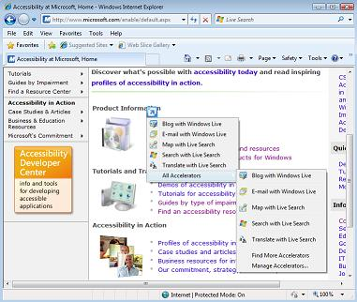 |   The Internet is easier to see and explore with accessibility settings and features in Internet Explorer 8. Internet Explorer 8 has better compatibility with assistive technology products and new and improved accessibility features including Caret Browsing, Accelerators, and Zooming to make Internet navigation easier than ever. Enhanced keyboard access can also be found in the default toolbar buttons, search box items, address bar, and tabs.
Accessibility Features in Internet Explorer 8
Select text and move around a Web page with the keyboard Rather than using a mouse to select text and move around within a Web page, you can use standard navigation keys on your keyboard—HOME, END, PAGE UP, PAGE DOWN, and the arrow keys. This feature is called Caret Browsing and is named after the caret—or cursor. This makes it easier to select, copy, and paste text to another document—without a mouse.  Zoom in on a Web page Zoom lets you enlarge or reduce the view of a Web page. Unlike changing font size, zoom enlarges or reduces everything on the page, including text and images.  Choose colors used on Web pages Make Web pages easier to see by changing the text, background, link and hover colors. Internet Explorer 8 supports the system link color, so high contrast mode and color preferences you have chosen in Windows will work in Internet Explorer.  Change text size on Web pages Choose from smaller, smallest, medium, larger, or largest. | Choose the font style and size used on Web pages  and documents Adjust to make them more legible.  Choose accessibility settings for Web pages Choose to ignore colors, font styles, and font sizes specified on Web pages to make the pages easier to see.  Format Web pages using a custom style sheet  Make color, test size, and picture handling work best for you with a custom style sheet.  Choose advanced settings Make Web pages easier to see and work with by adjusting accessibility settings for browsing, multimedia, printing and more in Internet Options.  Find text on a Web page using the Find on Page feature that highlights matches with a yellow background (easier to see) and scrolls the page to your first match, saving mouse moves and keystrokes.  Simplify common tasks Make tasks like copying, navigating, and pasting easier by using accelerators—accelerators save time and keystrokes.

Accessibility Resources from Microsoft
 | Find an Accessibility Center  www.microsoft.com/enable/centers/ |  | Tutorials  www.microsoft.com/enable/training/
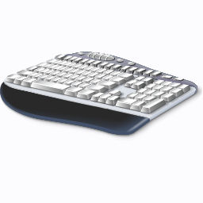 | Demos  www.microsoft.com/enable/demos/
Compatibility with Assistive Technology Products
Microsoft works closely with assistive technology (AT) manufacturers to ensure that AT products
are compatible with Microsoft products. Many AT products are compatible with Windows Vista,
Internet Explorer 8, and Office 2007. Be sure to check compatibility with your AT
manufacturer before upgrading.
For more information visit www.microsoft.com/enable/at/

