Overview  Country or Region: Gibraltar  Industry: Entertainment - Gaming  Customer Profile  Gibraltar-based bwin International provides online sportsbook services for the bwin Group, calculating the odds on more than 10,000 bets each day for more than 90 sports around the world.  Business Situation  Performance is paramount to bwin which during peak periods supports loads of more than 30,000 database transactions per second.  Solution  The company has started upgrading its 100-terabyte database infrastructure to Microsoft® SQL Server® 2008 Enterprise (64-bit).  Benefits  - World-class performance  - Ability to enforce policy with Policy-based Management  - Backup Compression  - Enhanced auditing and data encryption  - Reliability |  |  | “We’ve seen tables reduced in size by 80 percent using SQL Server 2008 Backup Compression. With 100 terabytes of data, we’re very happy to be able to reduce our backup footprint.”  Thomas Grohser, Senior Database Engineer, bwin
 |  |  | Sports enthusiasts around the world place up to 1 million bets a day using the online sports betting services of Gibraltar-based bwin International. Performance is paramount at bwin which hosts more than 100 terabytes of information on some 100 instances of Microsoft® SQL Server®. The company was happy with its deployment of SQL Server 2005, but after seeing 3-digit annual growth in 2005 and 2006, it is eager to take advantage of technological advancements to help it keep up with growth. The bwin Data Management Systems group has started upgrading its database infrastructure to SQL Server 2008 Enterprise (64-bit) to take advantage of Backup Compression, management tools, and other new features. During peak gaming periods SQL Server processes 30,000 database transactions per second, while supporting the reliability required by the bwin database group’s motto: “Failure is not an option.”
 |  |  | 

Situation
Fast Facts
Peak financial transactions | 6,000 per second
Peak database transactions | 30,000 per second
Databases | 851 SQL Server databases
Instances | 100+ SQL Server instances
Largest SQL Server database | 4 terabytes
Largest table | 2 billion rows
Total data stored on SQL Server | 100 terabytes
SQL Server 2008 Backup Compression rate | 80 percent table compression
Application Platform Capabilities | Development, Data Management

bwin Interactive Entertainment AG (“bwin”) is listed in the blue chip ATX index on the Vienna Stock Exchange. The Company operates platforms for sports betting, poker, casino games, soft games and skill games. Under various licenses (including in Germany, Italy and Gibraltar), it also
offers audio and video streaming of major sporting events (such as matches of the German Soccer League) through subsidiaries and associated companies.

bwin offers one of the most comprehensive and innovative gaming portfolios available, both on the Internet and via mobile devices. Products range from sports betting, poker and casino games to soft and skill games. The Company also leads the industry when it comes to developing user-friendly betting and payment options. This ensures that customers can enjoy online gaming entertainment coupled with maximum possible security.

Founded in 1997, the company was built upon a foundation of Microsoft® technology. The company’s rapid growth and continual need for scalability have been well supported by the Microsoft Application Platform, including Microsoft SQL Server® database software.

The company was well satisfied with its existing infrastructure, as it had seen a 50 percent performance increase after migrating from SQL Server 2000 to SQL Server 2005, and had been impressed with the stability and scalability of SQL Server 2005.

"Our company is enjoying very rapid growth,” says Michael Schneglberger, Head of Database Engineering at bwin. “For example, the gross gaming revenues [from sports betting, poker, casino and games] have increased by triple-digit percentages in recent years. SQL Server has scaled to meet our needs.”

The Sports Betting infrastructure at bwin includes some 170 integrated applications, supported by more than 1,600 server computers, including more than 100 instances of SQL Server to support more than 100 terabytes of data. The largest database contains 4 terabytes of data.

“About 95 percent of our databases are SQL Server,” says Thomas Grohser, Senior Database Engineer at bwin. “We’ve acquired a very few Oracle and MySQL databases from acquisitions, but if it handles money, we run the database on SQL Server.”

Needing to stay continually ahead of the global demand for its services, bwin is constantly looking for new ways to enhance its technology, and so was eager to see what SQL Server 2008 had to offer.

Solution
When bwin looked at SQL Server 2008 it saw several new features that could improve its operations. After testing a central online transaction processing (OLTP) database at the Microsoft SQL Server Testing Lab in Redmond, Washington, bwin decided to perform an early upgrade on the OLTP system to SQL Server 2008.
“These tables are capable of getting big. Our largest table has more than 2 billion rows, and we have multiple tables that exceed 1 billion rows.”
Thomas Grohser, Senior Database Engineer, bwin

The company was attracted to SQL Server 2008 because of the world-class performance bwin requires to support its operations, and because of new SQL Server 2008 features, including:
- Resource Governor. The Resource Governor feature of SQL Server 2008 enables bwin to define resource limits and place priorities on particular workloads to deliver predictable performance. This helps ensure that the right application is getting the performance it needs.
- Policy-based Management. New for SQL Server 2008, Policy-based Management provides a management framework that helps organizations set and enforce compliance with policies for system configuration, SQL Server databases, and other SQL Server objects. Administered from the SQL Server Management Studio, Policy-based Management can be used to set and enforce policy for internal and external database developers and administrators.
- Backup Compression. With SQL Server 2008 Backup Compression, the compression is performed in memory before the data is transferred to disk, enabling backups to run faster since less disk I/O is required. The Backup Compression feature reduces the storage required to keep backups online, reducing the overall cost of keeping disk-based backups, a significant factor for bwin, with more than 100 terabytes of database information.
- Enhanced Auditing. SQL Server 2008 provides comprehensive data auditing to help organizations monitor all events at the server and database levels, and scale-out auditing across the enterprise. Auditing is important to bwin as the gaming industry is subject to an array of regulations.

The company has begun upgrading its database infrastructure from SQL Server 2005 to SQL Server 2008 Enterprise (64-bit) running on the Microsoft Windows Server® 2003 Enterprise Edition for Itanium-based Systems operating system, and plans an early upgrade to Windows Server 2008 for Itanium-based Systems.

Mission-critical SQL Server instances are hosted on HP Integrity servers, each configured with anywhere from 4 to 32 Intel Itanium 2 processors, and from 64 to 256 GB of RAM.

Benefits
Upgrading to SQL Server 2008 is helping bwin to provide the world-class performance required to support daily loads that can exceed 1 million wagers. The company is also benefiting from the ability to enforce policy with Policy-based Management, and reduce hardware needs by using backup compression. The company also sees benefits from the Enhanced Auditing features of SQL Server 2008, and ongoing reliability.

World-Class Performance
The bwin Data Management Systems group uses SQL Server 2008 to continue its tradition of providing world-class performance for its sports betting customers. During peak loads SQL Server handles more than 6,000 financial transactions per second, which Grohser says translates into more than 30,000 database transactions per second.

In addition to global sporting events such as the soccer World Cup, and the games leading up to it, bwin sees soaring demand during other events such as soccer’s Champions Week, when the previous year’s winners in each country play each other.

“There can be 16 games starting at the exact same moment and ending at the same moment,” says Grohser. “You can imagine the demand SQL Server is handling one minute before these games begin, and in the first minutes after they end. The traffic is amplified by customers placing wagers on multiple games, and then checking all the results afterwards.”

To comply with various regulations across a number of nations, bwin must record and store the IP address, date, time, and other data from each customer transaction. “These tables are capable of getting big,” says Grohser. “Our largest table has more than 2 billion rows, and we have multiple tables that exceed 1 billion rows.”
World-class performance is required to support bwin customers around the globe.

The bwin databases must also support substantial query loads before and after games. “Customers want to see how they’ve done,” says Grohser. “After big games we sometimes see loads of 1,500 customers per second querying the system, each query with multiple joins, and SQL Server supports the demand nicely.”
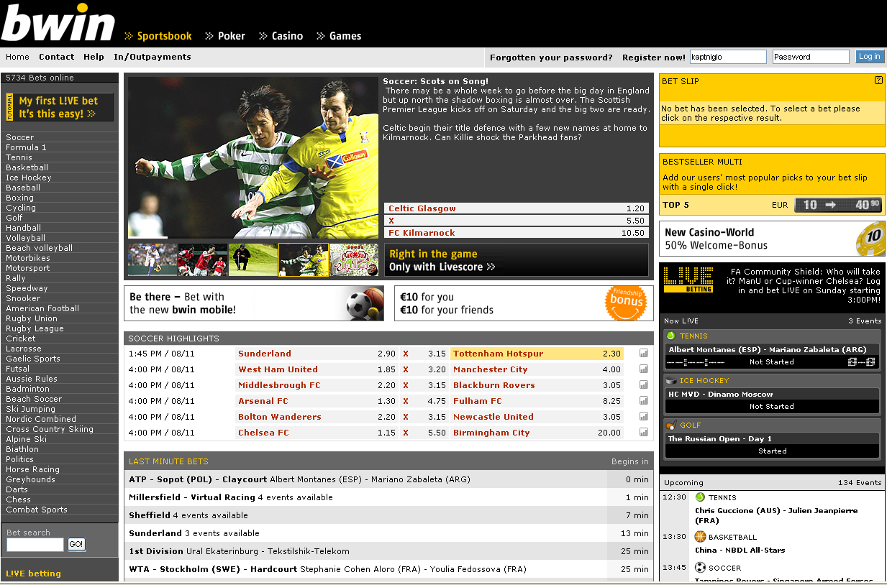

The company plans to use the Resource Governor feature of SQL Server 2008 to ensure that OLTP isn’t adversely affected during compression or by other loads. Resource Governor can also help the company’s data warehouse group. All bwin OLTP systems are copied into a data warehouse for reporting.

“The data warehouse supports hundreds of reports every day, and many users launch ad hoc queries against the data warehouse,” Grohser says. “The data warehouse team would love to be able to regulate the resources available to ad hoc queries.”

Ability to Enforce Policy with Policy-based Management
Sports betting operations at bwin are supported by 851 databases hosted on more than 100 instances of SQL Server, so the Data Management Systems group immediately saw the value of using the Policy-based Management feature of SQL Server 2008 to enforce policy.

“Policy-based Management enables us to ensure that everything is compliant with naming conventions and policies,” says Grohser. “We finally have a way to enforce our policies in a way that means a new application can’t be launched unless it follows our rules.”

One policy that Grohser is glad to be able to enforce is the one that stipulates that log and corresponding data files are never stored on the same drive. “On our team we all know the rules and work to enforce them, but sometimes even we can make a mistake. Policy-based Management will help prevent that.”
“The platform for sports betting is one of the core businesses of bwin, so downtime is absolutely taboo.”
Michael Schneglberger, Head of Database Engineering, bwin

Backup Compression
The company has been impressed with performance of the Backup Compression feature on SQL Server 2008. Backup Compression is important to bwin because of its aggregate database size.

“We’ve seen tables reduced in size by 80 percent using SQL Server 2008 Backup Compression,” says Grohser. “With 100 terabytes of data, we’re very happy to be able to reduce our backup footprint.”

Grohser notes that the Backup Compression feature should enable bwin IT to extend the life of its servers. “We are enjoying very rapid growth, so our Data Management Systems group is on a rapid hardware refresh schedule, but if we need less than a quarter of the space we used to for backups, we will be able to wait a bit longer between hardware upgrades.”

The company is also considering using the Table Partition feature, first introduced with SQL Server 2005, to automatically age data into compressed partitions. “We like to keep the active partition uncompressed,” says Grohser. “Combining Table Partitioning with Data Compression, we could easily compress just the historical data.”

Enhanced Auditing
With its broad international customer base, bwin operates in a complicated and demanding regulatory environment which changes from one country to the next and even between the states or provinces within a country.

“We are very interested to look at SQL Server 2008 Enhanced Auditing because we have so many compliance certifications and regulatory rules with which we must comply,” says Grohser. “We currently support compliance through statement traces, but this has system overhead. The Enhanced Auditing feature should simplify compliance while reducing system overhead.”

The company also is interested in the Transparent Data Encryption feature of SQL Server 2008, though Grohser notes the company currently performs data encryption at the application level, using a solution it created internally using Microsoft Visual Studio® 2005 development system and the Microsoft .NET Framework. The .NET Framework is an integral component of the Windows® operating system that provides a programming model and runtime for Web services. The company is planning a rapid upgrade to Visual Studio 2008 and the .NET Framework 3.0.

Reliability
The bwin data management group has a motto: "Failure is not an option." Schneglberger explains: “The platform for sports betting is one of the core businesses of bwin, so downtime is absolutely taboo.”

“SQL Server provides us with exceptional dependability,” says Grohser. “In 2007 we had only 2 hours of unscheduled downtime, and most of that was when someone mistakenly pulled out the wrong cable. On the rare occasion that we have to restart a database, usually because a separate application using the database goes awry, most of the elapsed time is with the hardware rebooting. When you have a quarter terabyte of memory it can take 20 minutes to come back on line. SQL Server virtually never crashes.”

Summary
In summary, bwin is using SQL Server 2008 to help it provide world-class performance for its international customer base that places more than 1 million bets a day, generating peak demands of more than 30,000 SQL transactions per second. The company supports more than 100 terabytes of data on SQL Server, with several tables exceeding 1 billion rows.
Windows Server 2008, SQL Server 2008, and Visual Studio 2008
For More Information
For more information about Microsoft products and services, call the Microsoft Sales Information Center at (800) 426-9400. In Canada, call the Microsoft Canada Information Centre at (877) 568-2495. Customers who are deaf or hard-of-hearing can reach Microsoft text telephone (TTY/TDD) services at (800) 892-5234 in the United States or (905) 568-9641 in Canada. Outside the 50 United States and Canada, please contact your local Microsoft subsidiary. To access information using the World Wide Web, go to: www.microsoft.com

For more information about bwin International products and services, visit the Web site at: www.bwin.com

This case study is for informational purposes only. MICROSOFT MAKES NO WARRANTIES, EXPRESS OR IMPLIED, IN THIS SUMMARY.

Document published February 2008

Software and Services  - Microsoft Servers  - Windows Server 2008 for Itanium-based Systems  - Microsoft SQL Server 2008 Enterprise (64-bit)  - Microsoft Visual Studio 2008 | - Technologies  - Microsoft .NET Framework 3.0  Hardware  - Intel-based computer servers with Itanium processors and up to 256 GB of RAM

Windows Server 2008, SQL Server 2008, and Visual Studio 2008 provide a secure and trusted foundation for creating and running your most demanding applications. Combined, the products offer advanced security technology, developer support for the latest platforms, improved management and Web tools, flexible virtualization technology to optimize your infrastructure, and access to relevant information throughout your organization.

For more information about Windows Server 2008, go to:
www.microsoft.com/windowsserver2008

For more information about SQL Server 2008, go to:
www.microsoft.com/sql/2008/default.mspx

For more information about Visual Studio 2008, go to:
www.microsoft.com/vstudio.

