

Microsoft® Windows® Small Business Server 2003

Reviewer’s Guide
June 2003

For more information, press only:

Sandi Cereghino
Waggener Edstrom
(503) 443-7000
sandic@wagged.com

Rapid Response Team

Waggener Edstrom
(503) 443-7070
rrt@wagged.com

The information contained in this document represents the current view of Microsoft Corp. on the issues discussed as of the date of publication. Because Microsoft must respond to changing market conditions, it should not be interpreted to be a commitment on the part of Microsoft, and Microsoft cannot guarantee the accuracy of any information presented after the date of publication.

This document is for informational purposes only. MICROSOFT MAKES NO WARRANTIES, EXPRESS, IMPLIED OR STATUTORY, AS TO THE INFORMATION IN THIS DOCUMENT.

Complying with all applicable copyright laws is the responsibility of the user. Without limiting the rights under copyright, no part of this document may be reproduced, stored in or introduced into a retrieval system, or transmitted in any form or by any means (electronic, mechanical, photocopying, recording, or otherwise), or for any purpose, without the express written permission of Microsoft Corp.

Microsoft may have patents, patent applications, trademarks, copyrights, or other intellectual property rights covering subject matter in this document. Except as expressly provided in any written license agreement from Microsoft, the furnishing of this document does not give you any license to these patents, trademarks, copyrights or other intellectual property.

© 2003 Microsoft Corp. All rights reserved.

Microsoft, Windows, the Windows logo, BackOffice, Windows Server, Windows Server System, SharePoint, Outlook, FrontPage, Windows NT, Active Directory, Visual Basic, Windows Mobile and Active X are either registered trademarks or trademarks of Microsoft Corp. in the United States and/or other countries.
The names of actual companies and products mentioned herein may be the trademarks of their respective owners.

Contents
Introduction 1
Key Trends 4
Small Business Server Adoption 4
Increasing Volumes of Data 5
Rising Demand for Wireless, High-Speed Connectivity 5
Do-it-Yourself Focus and the Changing Role of the Technology Provider 6
Design Goals for Windows Small Business Server 2003 8
Design Goal 1: Provide Small-Business Customers With Connectivity for Collaboration, Communication and Mobility 8
Design Goal 2: Provide Flexible Deployment Features to Support Both Small-Business Customers and Technology Providers 10
Design Goal 3: Provide Simplicity in Installation, Management and Use 12
Features of Windows Small Business Server 2003 15
E-Mail, Networking and Internet Connectivity 17
Small-Business Intranet With Microsoft Windows SharePoint Services v2 19
Remote Access 20
Mobility 21
Server Administration and Management 22
Setting Up Client Computers and Adding Users 23
Monitoring and Reporting 24
Backup and Restore 25
Setup 26
Setting Up Windows Small Business Server 2003 29
New OEM Preinstall 29
To Do List 34
Configure E-Mail and Internet Connection Wizard 35
Adding Users and Computers 42
Adding Client Computers 45
Monitoring and Reporting 48
Server Management Console 51
Technical Feature Comparison Chart 52
System Requirements 53

Introduction

Welcome to the Microsoft® Windows® Small Business Server 2003 reviewers guide. This guide describes the key capabilities and features of Small Business Server and how these features benefit the two main audiences for the product, small businesses and the technology providers who deliver IT services to small businesses. To help ensure that you have all the information you need to review Small Business Server 2003, this guide provides information on the following:
- Significant trends in the small-business technology industry
- Key design goals for Small Business Server 2003
- Small Business Server 2003 features at a glance
- A guided walk-through of Small Business Server 2003

In October 1997, Microsoft Corp. introduced BackOffice® Small Business Server 4.0. This was the world’s first integrated suite of server applications designed specifically for small businesses. Small Business Server 4.0 allowed small businesses to license a single product to address their networking, communications and Internet needs at a price that represented a tremendous value.

After two subsequent releases, the product increasingly has delivered that value, with return on investment (ROI) for small-business customers ranging from 57 percent to 268 percent, according to a study by Forbes.com. Users also recouped their investment in one accounting period or less, expanded their geographic reach, performed more revenue-producing tasks at no extra cost, and improved their quality of life through the ability to conduct business from wherever they happened to be.

With the vision of extending the return on investment to even more small-business customers, Microsoft actively worked to further break down the barriers to adoption, such as product complexity. The company visited hundreds of small businesses to learn how to enhance the usability of the product and conducted thousands of customer and partner interviews to understand how to maximize the value that Small Business Server provides to small businesses. Microsoft’s continued product development has been completely driven by this customer and partner feedback.

The result is Windows Small Business Server 2003, the fourth-generation release. It was designed to incorporate the highly dependable and manageable Microsoft Windows Server™ 2003 operating system as its core engine, as well as the robust and feature-rich messaging system, Microsoft Exchange Server 2003. As part of the Windows Server 2003 family, Windows Small Business Server 2003 delivers the familiar look of the Windows operating system that consumers already know. When small-business users look for the Windows Server product that is right for them, the clearly branded Windows Small Business Server 2003 will be the obvious — and most optimal — choice. Windows Small Business Server 2003 provides first-class technology in an integrated solution tailored to meet the needs of small businesses — whether it’s the only server or the center of a multiserver network — delivering great value to solve the problems that small businesses face every day.

A key benefit of Windows Small Business Server 2003 is that it offers the ability to integrate and tailor the powerful features of several core Windows Server System™ components to deliver the tremendous ease of use especially needed by small businesses. Thus, Windows Small Business Server 2003 delivers a new level of simplicity during the entire life cycle of product use, including setup, management and use.

With this new level of simplicity, the value of server technology can be reaped by nearly anyone. To better meet the variation in a larger population of small businesses, Windows Small Business Server 2003 is now available in two editions, Standard and Premium:
- Windows Small Business Server 2003 Standard Edition is a new version of Windows Small Business Server consisting of Windows Server 2003 and Exchange Server 2003 technology. Standard Edition is ideal for customers that do not require the higher-level functionality provided by the Premium Edition.
- Windows Small Business Server 2003 Premium Edition also includes Windows Server 2003 and Exchange Server 2003 technology, and adds Microsoft SQL Server™ 2000 and Internet Security and Acceleration (ISA) Server. Premium Edition is ideal for small businesses with more demanding IT needs, such as data-intensive line-of-business applications. The following chart provides an overview of the two editions and their included technologies.

Feature | Windows Small Business Server 2003 Standard Edition | Windows Small Business Server 2003 Premium Edition
Tools and technologies to help share, manage, secure and back up files on an internal network | Using Windows Server 2003 technologies
Rich team communications and collaboration environment | Using Windows SharePoint™ Services v2
Communication and collaboration infrastructure that helps increase productivity | Using Microsoft Exchange Server 2003 technology
A unified place to manage  e-mail, calendars, contacts and other personal and team information | Using Microsoft Office Outlook® 2003
Help secure Internet connections | Using Routing and Remote Access Services (RRAS) | Using ISA Server 2000 technology
Relational database supporting line-of-business applications |  | Using Microsoft SQL Server 2000
Tools for sophisticated Web site development or the creation of customized solutions for Microsoft Windows SharePoint Services v2 |  | Using Microsoft Office FrontPage® 2003

Key Trends

Four major industry trends serve as the backdrop for the design and development of Windows Small Business Server 2003.

Small Business Server Adoption
Rapid technology adoption by small business is a continuing trend with some new twists. While PC growth in small businesses will continue over the next few years — IDC projects that small-business PC adoptions will climb by almost 8 percent per year between 2001 and 2006 — small businesses will deploy servers even more quickly than they will PCs. IDC projects server growth at almost 10 percent per year through 2006. Within the small-business sector, the deployment of server-based local area networks (LANs) will climb the fastest for the smallest companies. Those with fewer than five employees will see annual server-based LAN growth of 11.7 percent through 2006, while all small businesses with fewer than 99 employees will see annual server-based LAN growth of 8.6 percent.

Several factors are fueling this growth. First, PC penetration in small businesses is high; small-business owners are now looking to increase the benefit and ROI they get from the PCs they already own. Linking them in server-based LANs is a key way to boost collaboration and productivity. Second, small businesses made their last major technology push in preparation for potential year 2000 issues. As technology continues to advance, those investments are now nearing the end of their useful lives and companies are looking to upgrade.

Third, the price of server hardware has plummeted — server prices are as low as 20 percent below what they cost a few years ago — and they’ve become simpler to use. According to D.H. Brown analyst Tony Iams, small businesses still operating on servers based on Windows NT® Server 4.0, for example, should seriously consider upgrading to Windows Server 2003 because of the persuasive benefits. Iams calls Windows Server 2003 “a platform that’s much easier and more cost-effective to operate today — a key benefit in smaller organizations that lack sizable IT staffs — but that’s also guaranteed to grow to meet expanding needs over time.”

Increasing Volumes of Data
One of the trends fueling small businesses to adopt servers is the explosive increase in the volume of data these organizations are now handling in digital form. This trend extends to data in e-mail, applications and documents. Previously, small businesses would have handled much of this data on paper. The move to electronic media necessitates server software and hardware to archive, access, affect and share this increasingly mission-critical information.

Not surprisingly, data backup and recovery is the most important future IT focus area for small businesses. According to industry observer Access Markets International Partners Inc., 43 percent of small businesses rank data backup and recovery as important to their businesses, making it the leading concern among small businesses. Small businesses are also conscious of the need to secure the information they’re managing electronically; 30 percent cite data security as a future focus, making it the second-highest-ranked concern of small businesses.

Rising Demand for Wireless, High-Speed Connectivity
With small businesses putting more of their data online and linking more of their PCs to boost collaboration and productivity, it is natural that these users would also want anytime, anywhere access to their data and applications so they can continue to work from home or while on the road. Indeed, a growing number of small-business owners and employees work mostly away from an office — and some have no office at all. The ability of technology providers to address the data security concerns of small businesses will further facilitate small-business adoption of wireless, mobile devices.

Accordingly, IDC projects that small businesses will increase their purchases of smart handheld devices by 18 percent per year through 2006 — more than twice the growth rate of their continued acquisition of PCs, making it the fastest-growing category of small-business technology adoption.

As broadband service becomes increasingly available and less expensive, it also will become more attractive to small businesses that can take benefit from the technology to further leverage the increasing amount of data they store and use online. IDC expects the number of small businesses using broadband technologies to climb by 19.3 percent each year through 2006, making it the fastest-growing technology segment that IDC tracks in the small-business sector. By 2005, the portion of small businesses with broadband access is expected to swell to 28.9 percent, up from 17.3 percent in 2001.

Do-it-Yourself Focus and the Changing Role of the Technology Provider
Although small businesses that adopt server technology are reaping significant benefits and ROI, many small businesses are deterred from server deployment by the perceived or actual costs of maintenance and support. Unlike their larger counterparts, small businesses are much less likely to have dedicated IT staffs and more likely to assign the IT function to a technology enthusiast whose formal responsibility lies elsewhere.

Most small businesses acquire their technology solutions through technology providers — but the role of those providers is changing. The trend for small businesses to operate without dedicated IT staffs, along with the growing recognition by these companies that they must adopt server technology to maintain competitive advantage, is creating both new opportunities and new challenges for technology providers.

With technology prices falling and more technology providers serving the small-business market, there is increasing revenue pressure on technology providers to find more strategic ways to add value to the small-business technology purchase. In addition to differentiating their solutions, technology providers are looking for better and more cost-effective ways to provide service and support to more customers. By decreasing the cost of that support to customers and gaining revenue from a broader customer base, technology providers can achieve a win-win for their cost-conscious customers, and for themselves.

Design Goals for Windows Small Business Server 2003

Microsoft understands that its small-business customers need collaboration components that make it possible to connect people to information and to each other, as well as to access their data and applications from wherever they may be. Technology providers in the small-business space need new and innovative ways to add value to the deployments they provide to their customers. And small businesses adopting “big company” technology without taking on the overhead of “big company” IT staffs need solutions that are easier to install, manage and use.

Microsoft took all these needs into consideration when designing Windows Small Business Server 2003. The software has been completely redesigned to incorporate the Windows Server 2003 operating system. What is more, Windows Small Business Server 2003 offers compelling benefits to small businesses that may be new to networking and concerned about their return on investment in new technology, as well as small businesses that may be upgrading an environment that already includes one or more servers.

Design Goal 1: Provide Small-Business Customers With Connectivity for Collaboration, Communication and Mobility
- Superb messaging solution. Windows Small Business Server 2003 incorporates Microsoft Exchange Server 2003 for a superb messaging solution for Internet and intranet e-mail. Further, the integration of Exchange Server 2003 and Microsoft Outlook 2003 delivers a variety of improvements including cached-mode synchronization; remote Web access to e-mail, scheduling and contacts through Outlook Web Access; and support for remote procedure calls (RPCs) over HTTP, which allows users to connect directly to their Exchange server over the Internet without needing to establish a virtual private network (VPN) tunnel. Users running Outlook 2003 can connect directly to an Exchange server within a corporate environment over the Internet.

Cached Exchange Mode and synchronization improvements allow users to read e-mail or perform other messaging tasks in low-bandwidth networks and in situations where network connectivity is lost. Request for information notifications from the Exchange server are eliminated on the Outlook client, thereby allowing users to work without interruption in low-bandwidth, high-latency networks. Another benefit of these improvements is that users work primarily from their local Exchange mailbox data file. If network connectivity is lost between the Outlook client and the network, Outlook 2003 will operate without interruption.

- Remote Web Workplace. Through the new Remote Web Workplace, users gain a dynamically created Web site that provides a single, consolidated entry point for authorized remote users anywhere in the world, using any device that can access the Internet. Users can connect to the Remote Web Workplace through an Internet address and take advantage of the remote access features of Windows Small Business Server, including Outlook Web Access and their own desktop. In addition to remotely accessing the desktop of their office computer, users can download Connection Manager, which automates the process of remotely connecting a client computer to the company network.

The new version of Outlook Web Access in Exchange Server 2003 represents a significant upgrade from Outlook Web Access in Exchange 2000. The new version is a full-featured e-mail client, with support for rules, spelling checker, signed and encrypted e-mail, and many other improvements. The interface also was redesigned to provide an enhanced user experience similar to that of Outlook 2003, including a new Reading Pane (previously called the Preview Pane in Outlook) and improved navigation pane.

Many small-business users want an intranet solution that seamlessly connects users, teams and knowledge so that people can leverage relevant information across business processes to help them work and collaborate more efficiently. The Remote Web Workplace in Windows Small Business Server 2003 includes a fully preconfigured intranet solution using Windows SharePoint Services v2 (WSS). Users can access the intranet as well as an Incoming Faxes document library.

Design Goal 2: Provide Flexible Deployment Features to Support Both Small-Business Customers and Technology Providers
- Server setup. Windows Small Business Server 2003 provides original equipment manufacturers (OEMs) and system builders with the ability to preinstall the entire product — in a streamlined fashion — on multiple computers. OEM customers and channel partners, therefore, have a simpler and faster way to get their customers up and running on Windows Small Business Server.

OEMs can now preinstall the full product before completing the imaging or disk duplication process. When users receive their server, all that remains is for them to enter the requested information during Setup and then complete the To Do list. The result is that users can have a fully working solution after just 30 minutes with the product.
Because many users will be migrating to Windows Small Business Server 2003 from a previous version of Small Business Server or Windows Server, the product includes tools to help users move data from their previous environments.
- Remote management. Remote management tools are important, whether technology providers are supporting their customers remotely or a small-business user is supporting a branch office or home user remotely. Windows Small Business Server 2003 includes a range of remote management tools, including a help desk built on Windows SharePoint Services v2. It enables the user to submit help desk tickets for noncritical issues. Windows Small Business Server 2003 also includes tools to monitor server activity and receive performance and usage reports in e-mail or online.
Beyond remote monitoring, users or technology providers can actually manage client computers and servers remotely via Terminal Services and via the Remote Desktop, a new feature in Windows XP Professional. Terminal Services enables users or technology providers to remotely manage Windows Small Business Server 2003 from any computer — even one outside the Windows Small Business Server 2003 network or one located on the Internet.
- Second Windows Server for additional workloads. Small-business users can choose to have additional servers running Windows Server 2003 and manage them remotely using Terminal Services or the Remote Desktop. Small businesses can deploy and manage a second server for intensive business applications or for local file and print functions in a second office.
By enabling technology providers and users to monitor and manage client and server sites from remote locations, the new tools and technologies in Windows Small Business Server 2003 help reduce the travel time and cost involved in providing maintenance. They also help business owners learn what is happening with their businesses and how their employees are working — even when they are away from the office.
- PC client setup. With Windows Small Business Server 2003, small-business users and technology providers can automatically add new clients, deploy applications and centralize system settings. Windows Small Business Server 2003 includes integrated wizards that make these tasks faster and easier. Users or technology providers can create user and computer accounts, deploy software, and configure settings for an entire group of computers at once, rather than working on one computer at a time. The Add User Wizard is one new tool that enables this capability. It creates the user account in Active Directory®, creates a mailbox in Exchange, grants access to network resources such as the intranet, shared files and printers, and creates a home folder on the server to store personal files. This wizard can be combined with the Set Up Computer Wizard to configure a client computer for new users.

Design Goal 3: Provide Simplicity in Installation, Management and Use
- Easy installation. The full-featured connectivity and collaboration solution in Windows Small Business Server 2003 is much easier to install and configure, thanks to the Configure E-Mail and Internet Connection Wizard. Using this one wizard, users can more easily configure settings for the network, firewall, secure Web sites and e-mail to connect computers running Windows Small Business Server 2003 to the Internet.
Once the server software installation is complete, Windows Small Business Server 2003 boots to a To Do List, which walks the user through the process of getting the complete network up and running, including adding users and client machines and setting up the Internet connection.
The Remote Access Wizard is a new feature in Windows Small Business Server 2003 that allows remote access via both virtual private network or dial-in access through a modem. The wizard automatically configures remote access features that were configured manually in earlier versions of Small Business Server. It creates a configuration package that can be deployed to client computers with the necessary connection information already configured, and it can install automatically even on mobile client computers.
As mentioned previously, the Add User Wizard provides an integrated way to add new user accounts. It can be started in bulk mode, enabling the user or technology provider to add multiple user accounts with one instance of the wizard.

- Easy management. A variety of features in Windows Small Business Server 2003 make it easier to manage. For example, the Remote Web Workplace is more than a location where users can gain remote access features. It also provides a central location for administrators to access management features, such as the Remote Desktop to access servers and client computers, Windows SharePoint Services v2 to administer the internal Web site, Help Desk to view requests generated by users, and performance and usage reports.
Windows Small Business Server 2003 provides two preconfigured management consoles to further simplify management tasks. The Server Management console contains a rich set of management tools for network management tasks, such as working with user accounts, printers, fax machines, files, shared folders, licensing, networking, e-mail monitoring, intranet updates and backups. The second console, Server Management for Power Users, enables the technology provider or administrator to delegate basic tasks to on-site power users. Most commonly, power users are assigned tasks such as adding a user or group account or viewing resource properties. The two consoles are organized based on the tasks that need to be performed, rather than on the technology subsystem, making them more intuitive for typical small-business users to navigate.
The Monitoring Configuration Wizard — one of the tools that facilitate remote management — sets up alert notifications and server performance and usage reports. It also configures application logging. Users can choose to receive performance and usage statistics reports on a scheduled basis and to receive immediate alerts when an issue arises on the server. Users can access the usage statistics reports on a secure Web page on their intranet.
These performance reports provide information about the general health of the server and can replace much of the “simple” monitoring that was performed using earlier versions of Small Business Server. Usage reports for business owners contain information to help owners understand how their networks are being used. These reports provide detailed information about employee Internet, e-mail and fax use, as well as details on remote connectivity. Because performance reports are clearly formatted, it’s much easier to note potential issues that require action.
In direct response to customer and technology provider feedback, Microsoft created an integrated backup and restore solution for Windows Small Business Server 2003. The solution helps customers back up their servers more easily and guides them through the restore process. The Windows Small Business Server 2003 Backup Wizard guides an inexperienced administrator through the creation and implementation of a successful backup strategy. By default, it will back up all of the system, application and data files needed to completely restore the server — potentially including file shares, My Documents folders redirected from client computers, and files stored in the company’s SharePoint site.

- Easy usage. The new intranet site made possible by Windows SharePoint Services v2 provides a major advance in ease of use and collaboration. SharePoint-based sites can be extended to customers and partners, augmenting the reach and efficiency of existing collaboration methods. Information workers now have a central location in which to collaborate and share documents, empowering them to work collectively between geographies and across organizational boundaries. For example, users can post documents into shared document libraries, view the company’s vacation calendar, enter a request to the Help Desk and participate in a survey or discussion group. Users get shared document libraries that can be used out of the box by most small businesses for presentations and other needs; shared lists for information such as announcements, events, links and vacation calendar; fax routing to route received faxes into the Incoming Faxes document library; and sample and prepopulated content, including sample lists and libraries that describe how users can use the features and tailor them to their needs.
New features in Outlook 2003 and Exchange 2003 further simplify e-mail use while providing added functionality. For example, users can search for specific content in their mailbox, such as all messages from a particular sender, and then save the search results as a Search Folder for later use. Search Folders appear in a special section of the Outlook Folder List.

Features of Windows Small Business Server 2003

Microsoft built Windows Small Business Server 2003 with considerable input from small-business technology providers and customers about what they envisioned in a small-business server operating environment. This section provides an overview of key features in Windows Small Business Server 2003. It also includes information about how the features differ from similar features in earlier versions of Small Business Server.

E-Mail, Networking and Internet Connectivity

Internet access is a must for small businesses in today’s marketplace. Windows Small Business Server 2003 has everything a business needs to take advantage of Internet connectivity. The out-of-the-box tools provide a manageable solution for shared access to the Internet, a firewall to help protect local networks, Internet e-mail based on Exchange Server, and access to Web sites such as Outlook Web Access and the Remote Web Workplace on the server.

Small-Business Intranet With Microsoft Windows SharePoint Services v2

Windows Small Business Server 2003 provides a preconfigured internal Web site based on Windows SharePoint Services v2. Using this intranet site, co-workers can share information in a collaborative environment. This site includes shared document libraries, announcements, events and links.

Remote Access

To accommodate an increasingly mobile work force, Windows Small Business Server 2003 provides the new Remote Web Workplace, which enables remote users to access e-mail and remote desktops, and allows administrators to manage the server remotely. Windows Small Business Server 2003 also includes VPN capabilities that are simpler to set up and use through the Remote Access Wizard.

Mobility

Windows Small Business Server 2003 provides a compelling mobile user solution that enables users to access e-mail, schedule, calendar and task information using their cell phones and other portable devices while away from the office. This feature is built on the Exchange Server 2003 Outlook Mobile Access feature. Windows Small Business Server 2003 simplifies the setup and configuration of the portable devices.

Server Administration and Management

Windows Small Business Server 2003 includes updated, end-to-end network administration features to help ensure that the network runs efficiently. Wizards simplify common or repetitive tasks, and preconfigured management consoles provide the necessary tools to manage the network.

Adding Users and Setting Up Computers

Windows Small Business Server 2003 includes updated Client Setup features that enable administrators to create user accounts and set up client computers quickly and efficiently. New features include client networking configuration using a Web site instead of a floppy disk, user templates, the ability to preconfigure client applications, integrated wizards, and enhanced mobile and remote-use tools. These new features make it easier to deploy, configure and administer user and computer accounts.

In previous versions of Small Business Server, only one user account could be added at a time. In Windows Small Business Server 2003, administrators can add multiple user accounts based on the same user template with the help of the Add User Wizard.

Monitoring and Reporting

Windows Small Business Server 2003 provides enhanced tools that enable technology consultants and business owners to monitor server activity and receive performance and usage reports in e-mail or online. The monitoring and reporting tools can be used to ensure that the server remains healthy and can help reduce downtime by enabling administrators to respond quickly when issues arise. These tools help increase business productivity and customer satisfaction.

Backup and Restore

Windows Small Business Server 2003 offers an integrated backup solution to help technology providers and inexperienced administrators develop their backup strategy, prepare complete backups, and restore the entire Windows Small Business Server and all of the data that was backed up. This backup solution also provides a reminder for the on-site tape changer and reports the success or failure of each backup operation via e-mail.

Setup

The improved Windows Small Business Server 2003 Setup experience provides an end-to-end solution, new tools to improve productivity and the ability for OEMs to fully preinstall Windows Small Business Server 2003.

E-Mail, Networking and Internet Connectivity
Out-of-the-Box E-Mail and Secure Internet Connectivity
Windows Small Business Server 2003 provides a robust e-mail solution using Exchange Server 2003. In addition, with one wizard, users can more easily configure settings for their network, firewall, secure Web sites and e-mail to properly connect the computer running Windows Small Business Server to the Internet. This helps ensure that connectivity and security are properly set up, right from the start.

E-Mail, Networking and Internet Connectivity
Description | The Configure E-Mail and Internet Connection Wizard enables users to more easily configure the Windows Small Business Server network to connect to the Internet. This wizard provides the following:  - Support for using dial-up and broadband Internet connections — including Point-to-Point Protocol over Ethernet (PPPoE) connections and external router devices  - Automatic configuration of networking services, such as Domain Name System (DNS), Dynamic Host Configuration Protocol (DHCP) and Wireless Integrated Network Sensors (WINS)  - Easier configuration of firewall services on the server  - Support for configuring a server’s Web site so that Internet users can access Outlook Web Access, Remote Web Workplace and the company’s internal Web site  - Support for configuring secure sockets layer (SSL) to help protect connections between Web browsers and a user’s Web site  - Easier configuration of Exchange Server for Internet e-mail  - Support for configuring a server to a “known good” state when trying to troubleshoot network issues  Configure E-Mail and Internet Connection Wizard script. Each time the wizard runs, a Visual Basic® script is generated. Businesses can use this script (config.vbs) with its current settings to restore the configuration of the computer from which the script was generated, or they can customize this script and use it to configure another computer running Windows Small Business Server 2003.  Microsoft Connector for POP3 mailboxes. Users can migrate their existing POP3 mailbox accounts to use Exchange. Using the connector, they can regularly download e-mail from existing POP3 accounts and have the e-mail delivered to the recipient’s Inbox in Microsoft Office Outlook 2003, creating an integrated e-mail experience.
How It’s Enhanced | The Configure E-Mail and Internet Connection Wizard provides several new security enhancements:  - Support for SSL to configure Web sites  - Support for filtering file attachments from incoming e-mail messages  - New scripting capabilities. Users can now configure a computer running Windows Small Business Server 2003 to connect to the Internet by using a script file to replicate networking configuration across multiple Windows Small Business Server 2003 sites.  - Support for PPPoE Internet connections  Configure E-Mail and Internet Connection Wizard script. This is a new feature for Windows Small Business Server 2003.  Microsoft Connector for POP3 mailboxes. This feature provides the following enhancements:  - Support for Secure Password Authentication  - Improved reliability through a complete redesign

Internet E-Mail Using Exchange Server
Description | Exchange Server 2003 provides a messaging solution for Internet and intranet e-mail. Exchange also integrates with Microsoft Office Outlook 2003 for scheduling meetings or having online conferences. In addition, Exchange Server provides users with remote Web access to e-mail, scheduling and contacts through Outlook Web Access.
How It’s Enhanced | - Rich, Internet-enabled e-mail. When using Outlook 2003 with Exchange Server 2003, users can access new features:  - Search Folders are virtual folders that find content based on set criteria across multiple physical folders. For example, one of the default search folders is Large Messages. When users click on this search folder, all large messages in their mailbox are displayed. Users can create new search folders to find messages based on custom options.  - Cached mode is a combination of online and offline modes and is the default mode in Outlook 2003. When a user starts a client computer, Outlook 2003 registers its presence with Exchange Server and receives new e-mail notifications. However, instead of reading all folder data directly from the server, the mailbox folders are downloaded into a cache on the local computer. The advantage is that when the user attempts to reopen the message, or if server connectivity is lost, the message can be opened locally without any server interaction.  - Smart Change Synchronization by Outlook 2003 is done on a per-item basis, which means that if changes occur to a message object or any part of the headers, the item has to be resynchronized. This has an unfortunate side effect when messages are flagged for follow-up or when a message is replied to or forwarded (and the icon indicator changes in the Inbox view). For example, if a mobile user synchronizes a large message to a local Offline Folder Storage (OST) file and then replies to it, the large message has to be resynchronized with the server even though only a portion of the header was changed. Outlook 2003 treats reply/forward header information and message flags as special attributes. When these change, a synchronization of the entire object does not recur.  - Outlook Web Access offers a redesigned user interface, attachment blocking, content filtering, address book enhancements (including Global Address List property sheets), session inactivity timeout, and the ability to create and read messages with digital signatures and encryption.  - RPCs over HTTP. Exchange Server 2003 and Outlook 2003 combined with Windows Server now support RPCs over HTTP. This enables Outlook 2003 to securely connect across the Internet to RPC server programs and execute remote procedure calls. If the client computer can make an HTTP connection to a computer on a remote network running Internet Information Services (IIS), it can connect to any available server on the remote network and execute remote procedure calls. The RPC client and server programs can connect across the Internet — even if both are behind firewalls on different networks.  - Multiple public folder trees. Exchange supports multiple public folder trees, giving users greater flexibility when deploying collaborative applications. Users can now group collaboration databases by function, business or geography. For example, one public folder tree could hold all applications for the human resources department, another for accounting, and a third for research and development. This provides users with better administration, replication and organization of data.

Small-Business Intranet With Microsoft Windows SharePoint Services v2
Improved Productivity Through Knowledge Sharing and Team Collaboration
Windows Small Business Server 2003 provides an internal Web site, or intranet, based on Windows SharePoint Services v2. This site provides a centralized location where users can collaborate and share documents in a rich environment. For example, users can post documents into shared document libraries, view the company’s vacation calendar, enter a request to the Help Desk and participate in a survey or discussion group.

The Internal Web Site
Description | - Shared document libraries provide a set of predefined document libraries that can be used out of the box by most small businesses. Included in this default list are general documents, projects, presentations and archived documents. If these sample libraries do not meet a particular customer’s needs, new document libraries can be created.  - Shared lists provides a set of lists within Windows SharePoint Services v2 that knowledge workers can use to share information. By default, these lists include announcements, events, links, a vacation calendar and a Help Desk.  - Sample and prepopulated content includes not only a number of sample lists and libraries, but also sample content populated into each of these libraries. This sample content describes how users can use the features and tailor them to their needs.  - Shared picture libraries provide a rich graphical interface to share images among the team. These image libraries provide previewing and viewing capabilities.  - Alerts enable users to subscribe to content stored in lists or document libraries, which will provide e-mail notification if content changes or new files are added.  - Fax routing enables users to route received faxes into the Incoming Faxes document library.  - Import Files to SharePoint makes the transition of these documents into the company intranet easier by including an Import Files Wizard, which copies content from the file system into document libraries, where all the features of Windows SharePoint Services v2 can be leveraged.  - End user Help topics include a Web-based set of Help topics designed to provide assistance with the most relevant tasks in the Windows Small Business Server 2003 environment.
How It’s Enhanced | A company’s internal Web site is a new feature in Windows Small Business Server 2003.

Remote Access

Out-of-the-Box Remote Access Solution
The Remote Web Workplace is a dynamically created Web site that provides a single, consolidated entry point for remote users to access Windows Small Business Server features. It empowers external users by providing one place from which Windows Small Business Server features, Outlook Web Access and the user’s desktop can be accessed from outside the network firewall.

Administrators also can configure computers running Windows Small Business Server to allow authorized users to connect to the network and use resources as if connected locally. The Remote Access Wizard configures the server for VPN and dial-in access.

Remote Access
Description | - The Remote Web Workplace enables designated users to access the following Windows Small Business Server features from any location, using an Internet-enabled computer:  - Outlook Web Access. Users can access an Internet version of Microsoft Office Outlook 2003.  - Windows SharePoint Services v2. Users can access their company’s internal Web site.  - Remote Desktop. Users can access the desktop of their computer at work, using the Internet.  - Connection Manager. Users can download Connection Manager, which automates the process of remotely connecting a computer to the company network.  - Administrator access. The Remote Web Workplace enables administrators to access additional features:  - Remote Desktop. Access to the desktops of servers and client computers on the company network  - SharePoint Team Services. Administer the company’s internal Web site  - Help Desk. View a list of Help Desk requests generated by network users  - Monitoring Reports. View the performance and usage reports for the company network  - The Remote Access Wizard configures the server to allow remote access via both VPN or dial-in access through a modem. It configures the Routing and Remote Access service for remote access and configures the necessary settings for the firewall on the Windows Small Business Server. In addition, the wizard creates a configuration package that can be deployed to client computers with the necessary connection information already configured. The Set Up Computer Wizard can automatically install this on mobile client computers.
How It’s Enhanced | - The Remote Web Workplace is a new feature for Windows Small Business Server 2003, providing a single location where users can access remote access features.  - The Remote Access Wizard is a new feature for Windows Small Business Server 2003. The wizard automatically configures remote access features that were manually configured in earlier versions of Small Business Server.

Mobility

Compelling Out-of-the-Box Remote Access Solution Using Portable Devices
Users of portable devices can access their e-mail, calendar and task information, from their Windows Small Business Server 2003 network, over the Internet. Windows Small Business Server’s mobility solution simplifies the setup and provisioning of devices running Windows MobileTM 2003 software.

Mobility
Description | - Users of Windows Small Business Server 2003 can more easily configure their portable devices to access e-mail, schedule and task information.
How It’s Enhanced | - Mobility is a new feature in Windows Small Business Server 2003 that provides an easier way for technology professionals to support their customers’ mobile devices. The Windows Small Business Server 2003 mobility feature is built upon the Exchange Server 2003 Outlook Mobile Access feature.

Server Administration and Management
Increased Flexibility and System Reliability at a Lower Cost
Windows Small Business Server 2003 provides two preconfigured management consoles. The first, Server Management, contains a rich set of management tools for network management. The second, Server Management for Power Users, enables administrators to delegate basic tasks to on-site power users. Most commonly, power users are assigned tasks such as adding a user or group account or viewing resource properties.

Management Tools
Description | Consoles  - Server Management is used to configure and manage the server and the network. It contains the tools used to work with user accounts, printers, fax machines, files, shared folders, licensing, networking, e-mail, monitoring, an intranet and backups. This console also contains advanced tools for working with Exchange, IIS and the Active Directory service.  - Server Management for Power Users includes a subset of Server Management tools. This console includes the most common management tools for handling user accounts, group accounts, computers, printers and shared folders.  - Console Customization enables administrators to grant or deny specific tasks to power users. Server Management for Power Users can be customized and tools can be added or removed to meet business needs. For example, if a company uses a line-of-business application, its administrator can add the management snap-in provided by this application to the console so that power users also can perform management tasks involving this application. Similarly, if administrators do not want power users to manage the fax machines, they can remove the fax server snap-in from the console.  Remote Access  - Terminal Services provides remote computers with access to Windows-based programs running on the server. As deployed in Windows Small Business Server 2003, Terminal Services enables administrators to remotely manage the server from any computer, even one outside the Windows Small Business Server 2003 network. Administrators can access the server via Terminal Services from any computer on the Internet.  - Remote Desktop Web Connection is a Web application, based on an ActiveX® control, which enables users to create a Terminal Services connection within Microsoft Internet Explorer, even if a Terminal Services client program is not installed on the user’s computer.  - Remote management of client computers is possible because of the Remote Desktop, a new feature of Microsoft Windows XP Professional. This feature is based on the same technology used in Terminal Services. It enables users to manage client computers remotely, saving trips to the site. If a small business has additional servers running Windows Server 2003, these also can be managed remotely.  User Accounts  - The Change User Permissions Wizard provides the ability to change a single user’s or multiple users’ access rights and file permissions.  - Enable Password Policies increases the security of the network by enforcing strong password policies.
How It’s Enhanced | - Server Management was primarily a technology-oriented console in Windows Small Business Server 2000, whereas the new console is more task-oriented. New tools to manage backups, an intranet and additional servers are also now available.  - The Remote Desktop Web Connection feature was only available from the local network. With Windows Small Business Server 2003, users can access this feature from any computer connected to the Internet.  - Remote Management of Client Computers Running Windows XP Professional is a new feature in Windows Small Business Server 2003 and is only available for computers running Windows XP Professional and Windows Server 2003.

Setting Up Client Computers and Adding Users
Increasingly Flexible and Faster Client Computer Deployment
Windows Small Business Server 2003 includes a number of integrated wizards that make deploying applications and adding client computers to the domain faster and easier. These tools enable administrators to create user and computer accounts, deploy software, and configure settings for an entire group of computers, rather than creating accounts and deploying applications on one computer at a time. Because these wizards are simple to use, power users can access the administration tools.

Setting Up Client Computers
Description | - Deploy and configure client applications. The Set Up Computer Wizard deploys the client applications included with Windows Small Business Server 2003. Users can run the Set Up Client Applications Wizard to add other applications to the server so that they can be automatically deployed to client computers.  - Connect client computers. Instead of using a floppy disk to connect client computers to the Windows Small Business Server network, users can browse to a Web site and access all the necessary tools to configure networking settings.  - Configure mobile client computers. When running the Set Up Computer Wizard, users can configure client computers for mobile use. Access to Outlook 2003 makes contact information available to users even when they are offline. The Create a Remote Connection Disk option enables users to create a floppy disk to configure connectivity on a remote computer (such as a user’s home computer). Alternatively, users can access the Remote Web Workplace, where they can download Connection Manager. Both options place an icon on the client computer’s desktop that points to the server via a VPN or dial-up connection. Users simply type their username and password to connect remotely.  - Advanced Configurations Option. When running the Set Up Computer Wizard, users can deselect options, such as printer configuration or specific Internet Explorer Favorites. This gives administrators more control over what is configured on client computers. These options are also available using View Client Computer Settings.  - View Client Computer Settings. Users can display the applications and settings that were chosen for a specific client computer by clicking on View Client Computer Settings in the Manage Client Computers taskpad in Server Management. This information is especially useful after initial deployment to ensure that the proper settings and applications were distributed.  - Save configurations performed by a wizard. The configurations performed by a wizard are saved to a file, which users can send (via e-mail) or print. This enables administrators to create a log of the changes made to server configurations. If a problem occurs, this information can be helpful in troubleshooting the server.
How It’s Enhanced | The Set Up Computer Wizard has many improvements since Small Business Server 2000. The wizards have been simplified, and the user interface is more intuitive.

Adding Users
Description | Windows Small Business Server 2003 includes the Add User Wizard, providing an integrated way to add new user accounts. This wizard creates the user account in Active Directory; creates a mailbox in Exchange; grants access to network resources, such as the intranet, shared files and printers; and creates a home folder on the server to store personal files. This wizard can be combined with the Set Up Computer Wizard to configure a client computer for the new user. User templates make the process of adding users faster, as common settings can be defined and reused multiple times. The Add User Wizard can be started in bulk mode, which enables administrators to add multiple user accounts with one instance of the wizard. It also can be used by power users in simple mode, which restricts the type of accounts that power users can add.
How It’s Enhanced | The ability to add multiple users at the same time by using the Add User Wizard is new in Windows Small Business Server 2003.

Monitoring and Reporting
Efficient Monitoring and Reporting of Server Activity and Status
Windows Small Business Server 2003 provides tools that enable users to monitor server activity and receive performance and usage reports in e-mail or online. The monitoring and reporting tools enable users to monitor customer sites from remote locations. Remote monitoring helps reduce travel time, which saves money for both the technology consultant and the business owner. It also helps business owners learn what is happening with their business and how their employees are working — even when they are away from the office.

Monitoring and Reporting
Description | - The Monitoring Configuration Wizard sets up alert notifications and server performance and usage reports. It also configures application logging. Users can choose to receive performance and usage statistics reports on a scheduled basis and receive immediate alerts when an issue arises on the server. Business owners can view the usage statistics report on a secure Web page on their intranet.  - Alerts are used to send an immediate e-mail notification when there is a critical issue with the server. When configured, Windows Small Business Server 2003 automatically sends an alert when a service set to start automatically is stopped or when a performance counter threshold is exceeded.  - Performance reports provide information about the general health of the server and can replace much of the “simple” monitoring that was performed using earlier versions of Small Business Server. Performance reports can be viewed on the server and can be sent to designated recipients in e-mail. The reports include Health Monitor alerts and critical event log entries from the previous 24 hours. They also include summary information about important performance counters and the top five processes that are consuming memory.  - Usage reports for business owners contain information to help owners understand how their network is being used. These reports provide detailed information about employee Internet, e-mail and fax usage, as well as remote connectivity. Usage data is gathered from application logs once a day, and statistics are displayed in a report. Business owners and other authorized users can receive usage reports in e-mail or view the reports from a Web page on their intranet. The latest report also can be viewed in Server Management.  - The Monitoring and Reporting Taskpad provides a central location for viewing monitoring and usage data and lists tasks for configuring reports and alerts. The taskpad also contains links to more information and other troubleshooting tools, such as Event Viewer, Task Manager and Service Manager.  - The Import/Export Health Monitor Configuration Wizard enables users to export all Health Monitor thresholds and alerts from a computer running Windows Small Business Server 2003 and import them to another computer running Windows Small Business Server 2003. This wizard can be used to save and install a preconfigured set of custom Health Monitor alerts quickly on a customer’s server.
How It’s Enhanced | - The Monitoring Configuration Wizard, Monitoring and Reporting Taskpad, and usage reports for business owners are new features in Windows Small Business Server 2003. These features simplify the task of setting up, configuring and distributing monitoring reports and alerts.  - Windows Small Business Server 2003 delivers a preconfigured set of Alerts and alert thresholds. Also, a user interface has been added to help fine-tune the configuration. Business owners do not need to learn about Health Monitor to use this feature.  - Performance reports contain a preconfigured list of relevant performance counters and metrics. The reports are enhanced with additional information to give a more complete picture of server status. The reports are clearly formatted so that it is easier to note problems that require action.

Backup and Restore
Integrated Backup and Restore Solution to Help Ensure the Success of Backup Strategies
The Windows Small Business Server 2003 backup solution was created as a direct result of customer and technology provider feedback. This solution is designed to help customers back up their servers more easily and successfully and to guide them through the restore process, ensuring the success of their backup strategy.

The backup solution prompts administrators to create a backup strategy and leads them through the process of deciding what to back up, when to perform backups and where to store the backed up information. It simplifies the task of redirecting the users’ My Documents folders to shares on the server to ensure that client data is also backed up. By default, it backs up all of the data on the server that is needed to completely restore that server.

Windows Small Business Server 2003 allows backup to tape, another hard drive in the server or a shared folder on any computer in the network. It also reminds the appropriate person when it is time to change the tape and notifies the designated person of the success or failure of each backup. The final part of the backup solution is a document that completely describes the process of restoring individual files or the entire server.

Backup and Restore
Description | - The Small Business Server Backup Wizard guides beginning administrators through the creation and implementation of a successful backup strategy. By default, it will back up all the system, application and data files needed to completely restore the server. This can include file shares, My Documents folders redirected from client computers, and files stored in the company’s SharePoint site. In this wizard, administrators can configure the following:  - What files and folders to back up  - How often and what time to perform backups  - Where to store the backed up files and how many to keep  - Reminders for the person responsible for changing the backup tapes  - How long to keep items deleted from Exchange  - How much disk space to assign to the Volume Shadow Copy service  In addition, administrators benefit from the following features:  - The ability to back up to tape, local hard drive or a network share  - Integration of success or failure reports for individual backups into the Windows Small Business Server 2003 Monitoring and Reporting feature  - Restoration of individual items from Exchange using the Exchange deleted item retention feature  - Restoration of individual files and folders using the Volume Shadow Copy service  - Steps to successfully restore the entire server
How It’s Enhanced | - The Small Business Server Backup Solution is a new feature in Windows Small Business Server 2003 that helps administrators develop a complete backup strategy and helps ensure their ability to restore their data or their entire server.

Setup
Fully Integrated Tools Ensure a Smooth Installation
Windows Small Business Server 2003 provides an integrated Setup solution for installing and configuring the small-business network. It is designed to guide administrators through the task configuring an entire small-business network, providing an end-to-end solution. To do this, Setup is optimized for installing and configuring the operating system and installing the server applications and tools based on best practices for a small-business network. However, administrators can customize their installation to fit their business needs. Setup also addresses factors important to the successful completion of a Windows Small Business Server installation, such as disk space, system compatibility and application dependencies.
These installation features are designed for technology consultants who set up the solution for their small-business customers and for technically savvy business owners who like to do things themselves.

Windows Small Business Server 2003 provides OEMs with the ability to fully preinstall the entire product, giving both royalty OEMs and systems builders a streamlined way to install Windows Small Business Server 2003 on multiple computers. Thus, OEM customers and channel partners have a simpler and faster way to get Windows Small Business Server 2003 set up and running.

Integrated Setup
Description | Setup provides an integrated and complete installation and configuration of Windows Server 2003 for Small Business Server, Exchange Server 2003, Windows SharePoint Services v2 and Outlook 2003. Setup first installs the Windows Server 2003 for Small Business Server operating system. Setup then configures the operating system in preparation for installing the tools and applications. The last step of Setup is the To Do List, which automatically appears following the installation of server applications.  - Windows Server. Windows Small Business Server 2003 is built upon Windows Server 2003 for Small Business Server. Setup configures the operating system based on best-practice implementations for installing server tools and applications. For example, during Setup, the domain is automatically installed and configured.  - Exchange Server. Windows Small Business Server 2003 tailors Exchange Server for the small-business environment. This includes such options as setting the deleted items retention, setting mail quotas for the Exchange mailboxes and enabling circular logging.  - Windows SharePoint Services v2. Windows Small Business Server 2003 provides businesses with a preconfigured intranet solution using Windows SharePoint Services v2. This solution helps configure the subscription service, gives Windows Small Business Server users access to the intranet and creates an Incoming Faxes document library.  - Outlook 2003. During Setup, Outlook 2003 is placed in a shared folder that is used when deploying the application to client computers.
How It’s Enhanced | Setup has been significantly improved since Small Business Server 2000. Several wizard pages have been modified and some redesigned to show the progress of Setup. For example, users can easily find out what was installed, what is being installed and what is left to install. Some pages no longer display automatically because default settings appropriate for a small business have been implemented. For example, the Directory Services Restore Mode password page is no longer displayed. Instead, the default password is the password of the built-in Administrator account so small businesses do not have to manage two passwords. The Internal Domain Information page has been redesigned to provide default settings and information to help the user choose the DNS name for the internal domain. Also, the To Do List has been completely redesigned since the release of Small Business Server 2000. Customer feedback has been incorporated into the new design, making it easier to use and customizing it for small businesses. Also, the product keys now have to be entered only once.  - Windows Server 2003 for Small Business Server combines the robust features of Windows Server 2003 with the easier installation and management provided by Windows Small Business Server 2003.  - Exchange Server 2003 incorporates support for the newest features in Exchange and also makes smarter decisions about the format of e-mail addresses.  - Windows SharePoint Services v2 is new for Small Business Server 2003. It provides the company’s internal Web site.  - Outlook 2003 includes new features, such as the ability to search across multiple folders, the cached mode option and smarter synchronization.

Fully Preinstalled Server Available Through OEMs
Description | Windows Small Business Server 2003 is now available through OEMs, providing Microsoft channel partners and business owners with a fully preinstalled version of Windows Small Business Server 2003. The result is that all users will be able to have a fully working solution in approximately 30 minutes.  - OEMs can preinstall the full Windows Small Business Server 2003 product before completing the imaging or disk duplication process using the tools provided by Windows Small Business Server.  - When end users receive the server that the OEM preinstalled using the new method, they only need to enter the requested information during Setup and then complete the To Do List.
How It’s Enhanced | - Availability through OEM partners has been significantly improved since Small Business Server 2000. In Small Business Server 2000, the solution from OEMs provided only a preinstallation of the operating system. In this release, the complete preinstallation of Windows Small Business Server 2003 will be supported.

Setting Up Windows Small Business Server 2003
Microsoft Windows Small Business Server 2003 is a server solution that provides small businesses with great features such as e-mail capabilities, secure Internet connectivity, business intranets, remote connectivity, support for mobile devices, file and printer sharing, backup and restore, great ease of use, and an application platform for collaboration.

New OEM Preinstall

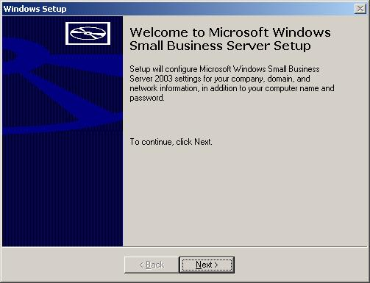

With the new OEM preinstallation tools, OEMs and systems builders can greatly simplify customers’ first experience with Windows Small Business Server 2003. Previously, installing Small Business Server 2000 on a new server could take between two and three hours and involve many CDs and a wide range of installation options requiring input from the installer. Now, technology providers and their customers can opt for a more simplified and faster approach.

This screen shows the start of this new, simplified installation, and the following four screen shots show specific details of the Small Business Server 2003 setup. For brevity, the licensing, regional and time screens have been omitted — these screens are identical to their counterparts in Windows XP desktop or Windows Server 2003.

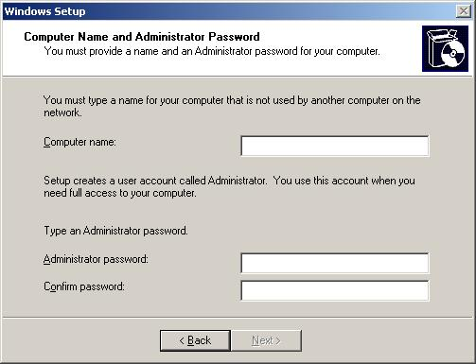

This screen shows the Computer Name window, which is very important in Windows Small Business Server 2003. It specifies the NetBIOS server name for the small-business network and is frequently used by end users to access files and data on the server.
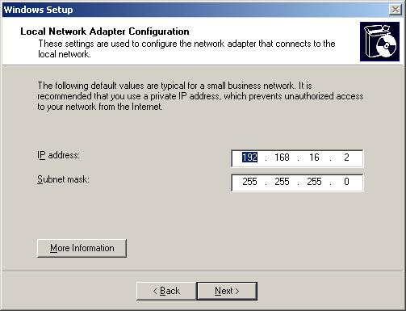

This screen shows the internal network settings for the small-business network. Windows Small Business Server 2003 has been built with a set of best practices in mind. One of these best practices is security; configuring the server with two network interface cards helps ensure strong security. The internal network is, therefore, configured on an internal private network, separating internal network traffic from external network traffic. This also helps make PCs within the small-business network invisible to external networks (with the exception of the Remote Web Workplace and other Web sites under the control of the Configure E-Mail and Internet Connection Wizard, Windows Routing and Remote Access, and Internet Security and Acceleration Server).
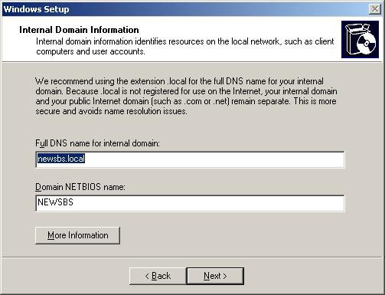

As part of the server setup, including the simplified OEM preinstallation, Small Business Server 2003 installs and configures the Active Directory. This screen shows the default DNS and NetBIOS network names, which have been derived from the installer’s name and organization name (presented on a common preinstallation screen for Small Business Server 2003, Windows XP and Windows Server 2003, not shown here).

To help ensure network security, the best practice is to separate the local/internal DNS zone from external addresses, hence the .local extension on the DNS name for the internal network.

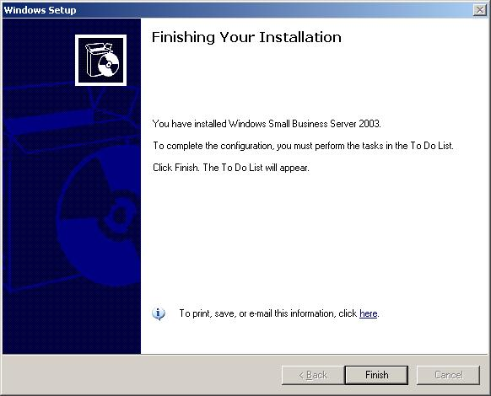

Here is the completion of the new OEM preinstall. At this stage, Windows Server 2003, Active Directory and Exchange Server 2003 have been installed and are running on the system.

To complete the small-business network configuration, the following steps remain:
- Add user and computer accounts
- Connect Small Business Server 2003 to the Internet for outbound Web traffic, inbound and outbound e-mail, and remote access services
- Configure backup, monitoring and reporting

To Do List

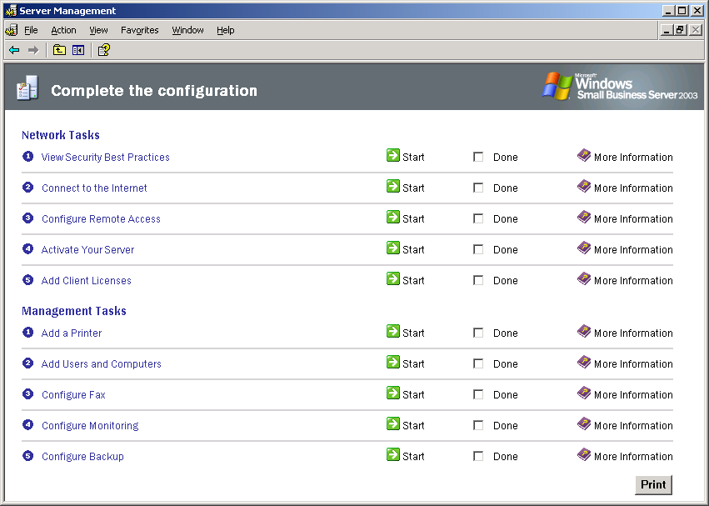

The To Do List appears the first time an administrator’s console is launched. It guides the user through all post-installation tasks necessary to get the network up and running. Extensive help is available for all of the steps.

Configure E-Mail and Internet Connection Wizard

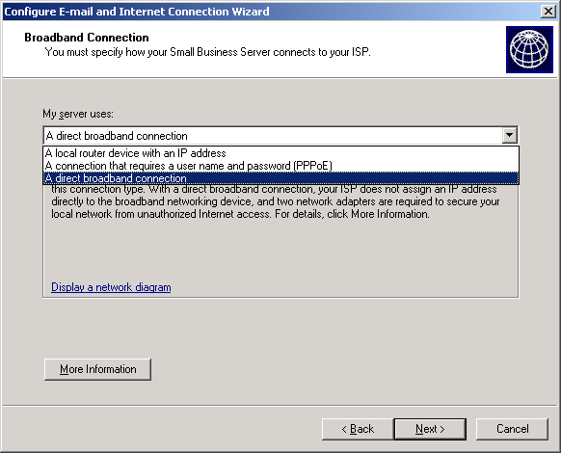

One of the most common post-setup steps is to connect the small business network to the Internet. Windows Small Business Server 2003 supports many Internet connection methods including dial-up and high-speed. Here is the screen for selecting a particular network type.

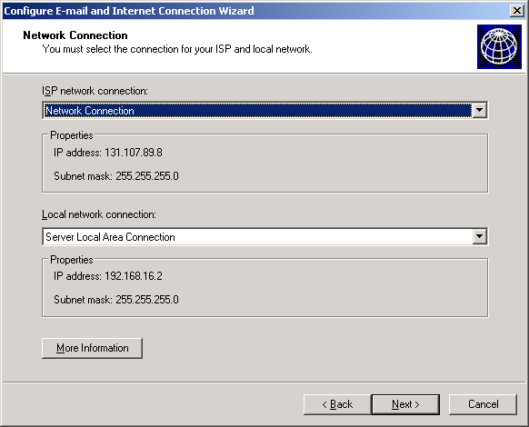

Windows Small Business Server 2003 is optimized for two network interfaces. With two network Internet cards (NICs), Small Business Server 2003 acts as the central point for Internet connections and helps enforce network security. Here is the screen for selecting the network cards for the external and internal Internet connections.

Windows Small Business Server 2003 can also be configured for use with a single network interface card. In this configuration (not shown here), the server relies on a separate hardware firewall. If this firewall supports Universal Plug and Play (UPnP), then Windows Small Business Server 2003 can discover and configure many of the settings necessary for the most secure operation.

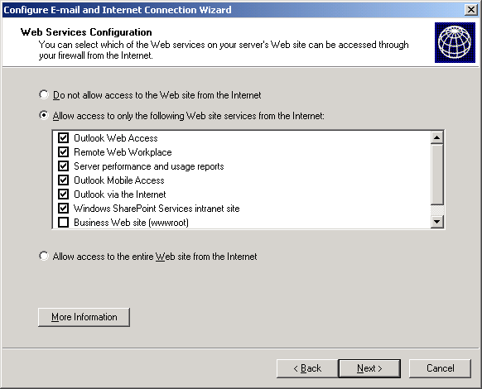

With the Configure E-Mail and Internet Connection Wizard, administrators may choose which internal Web sites to make available externally. Here is a typical configuration with the Remote Web Workplace and its common options enabled.

Access to many of these Web sites is restricted to secure encrypted connections (https:// and 128-bit encryption).

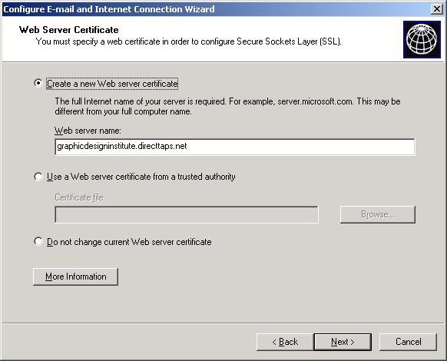

Windows Small Business Server 2003 provides two options for the 128-bit encrypted sessions enabled by the Remote Web Workplace. Administrators can choose to create their own untrusted certificate, or they can use a certificate issued by a trusted authority such as VeriSign Inc.

While an untrusted certificate is less expensive, each Internet Explorer session that connects to the Remote Web Workplace will receive a security warning, informing the user that the certificate is not trusted. For PCs that connect regularly, the certificate can be installed locally to suppress the warning.
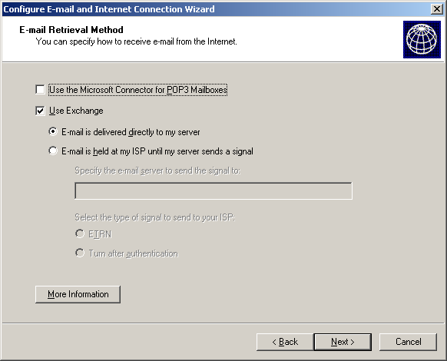

Exchange Server technologies are also configured as part of the wizard. Windows Small Business Server 2003 supports a number of alternative connection methods for e-mail. The screen above shows the default SMTP-based e-mail delivery.

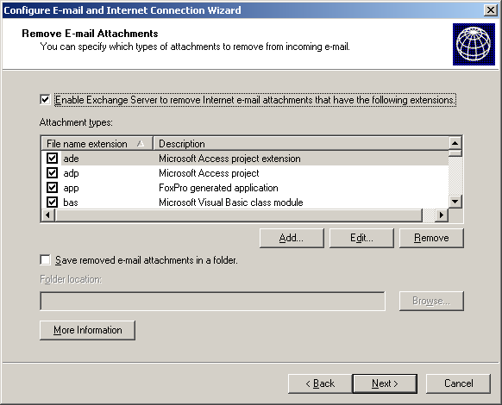

Windows Small Business Server 2003 supports the best practice of removing attachments that are highly likely to contain executable code. The window above shows the default attachment settings. These attachments will be removed on any incoming e-mail from the Internet. These attachments can simply be discarded or saved to a file directory on the server.
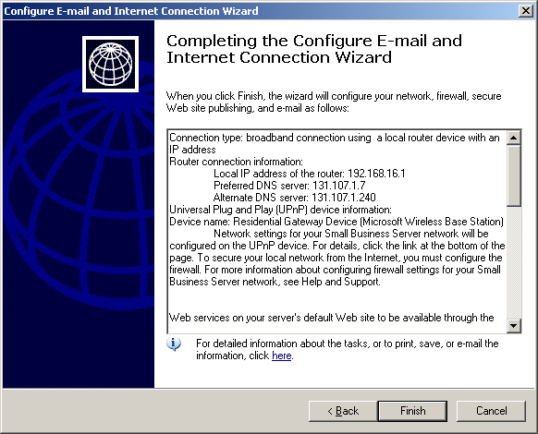

The last step of the Configure E-mail and Internet Connection Wizard, along with all the wizards provided in Windows Small Business Server 2003, is to confirm all of the actions that each wizard will take. This summary page can be printed or sent via e-mail, as shown above.

Adding Users and Computers
Several enhancements have been made to the function of adding new users through the Add User Wizard.

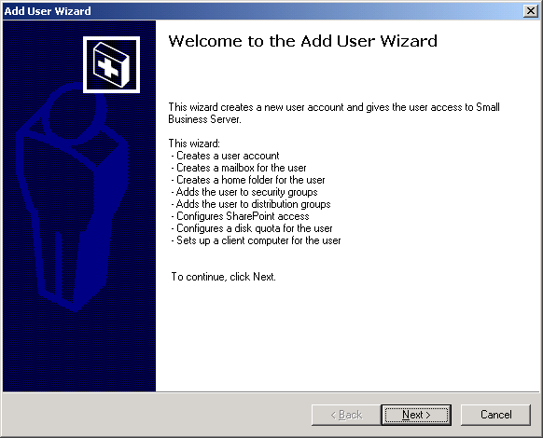

As this screen explains, Windows Small Business Server 2003 provides a single wizard to configure all of the server components to support a new user account.
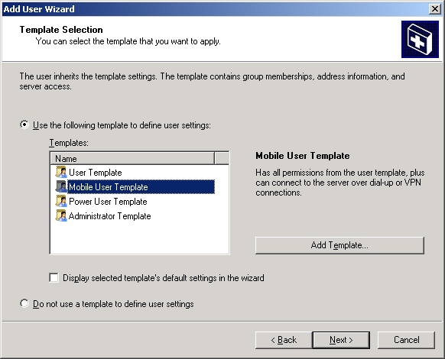

When adding a new user, administrators can select a specific template such as mobile user to define user settings. This particular template has additional privileges, including remote access.

Windows Small Business Server 2003 also supports a new option of particular benefit to value-added providers (VAPs) and value-added resellers (VARs): the ability to add multiple users at the same time.

In addition, these templates are extensible.
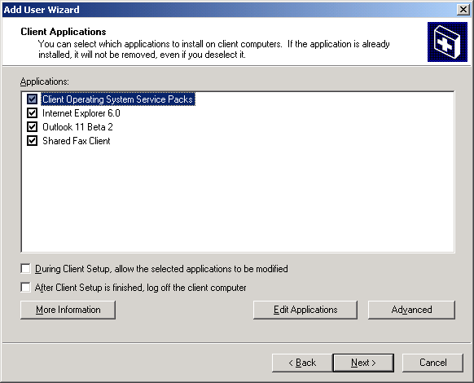

The Add User Wizard also steps administrators through the process of configuring a client computer for new users on the small-business network. This screen shows the default applications and service packs that Windows Small Business Server 2003 deploys automatically to desktop PCs as they are joined to the Small Business Server domain using the Connect Computer Wizard.

A VAP or VAR typically will add applications, such as the Microsoft Office 2003 Suite or line-of-business applications such as Microsoft Business Solutions Customer Relationship Management (CRM) or Microsoft Business Solutions–Great Plains.

Adding Client Computers

Previously, with Windows Small Business Server 2000, a floppy disk was required to add new client machines. With Windows Small Business Server 2003, this requirement has been superseded with a special Web page and ActiveX control. The following screen shows the new Connect Computer Wizard, which automates adding client computers to the small-business network.

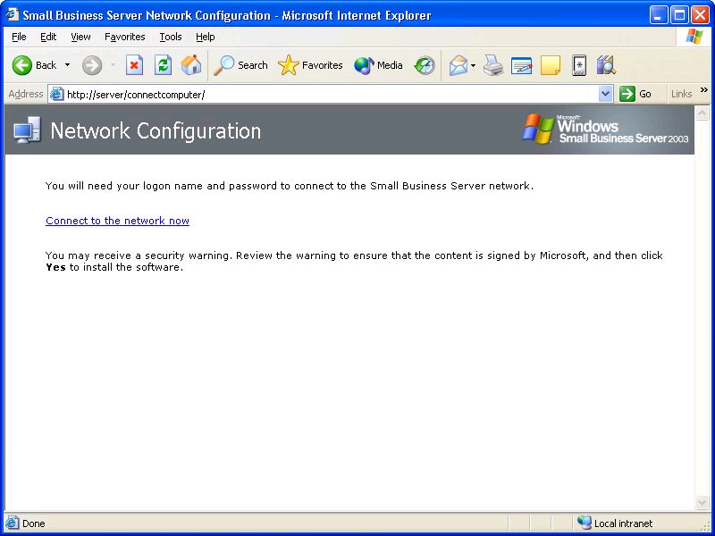

Windows Small Business Server 2003 now supports migration of client profiles during use of the Connect Computer Wizard. Migrating profiles is one way that Windows Small Business Server 2003 provides a migration story from a peer-to-peer network that may exist in a small business buying its first server. The following screen shows the existing client PC profile selection, along with which users from the small-business network will be able to log on locally.

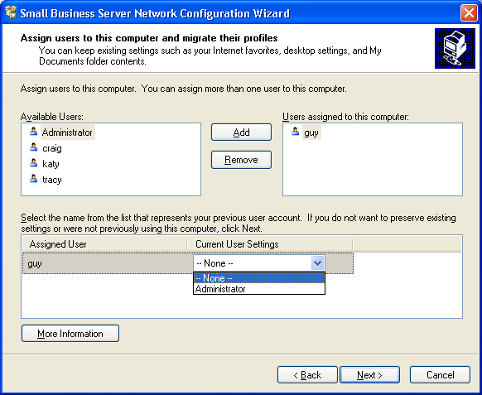
Backup

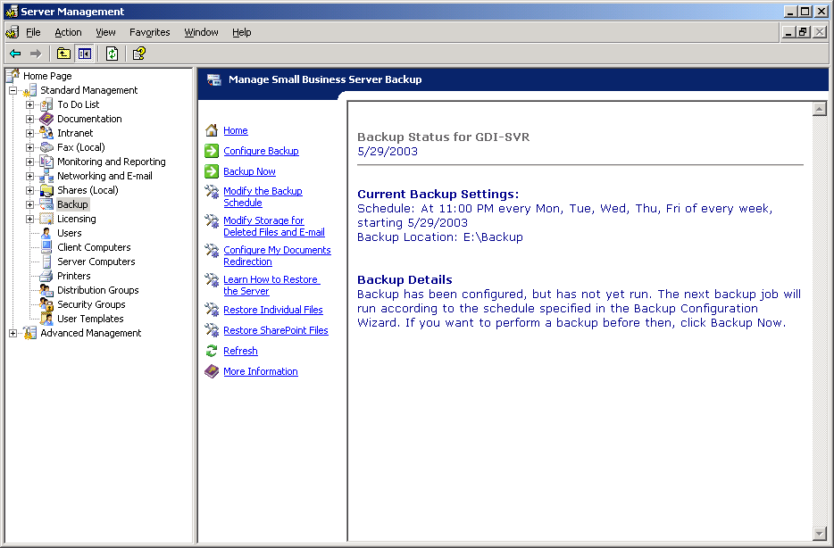

Windows Small Business Server 2003 facilitates backup and restore scenarios to help ensure that all server-based data is successfully backed up. This is one of the key IT concerns among small businesses today. This screen shows a typical report generated after an automated server backup, which is configured using a new wizard.

As part of the backup wizard (not shown here) the deleted item recovery limits for Exchange Server 2003 and the volume shadow copy limits for Windows Server 2003 are configured. This is another example of applying best practices on top of the raw technology capabilities provided by the server components.

Monitoring and Reporting 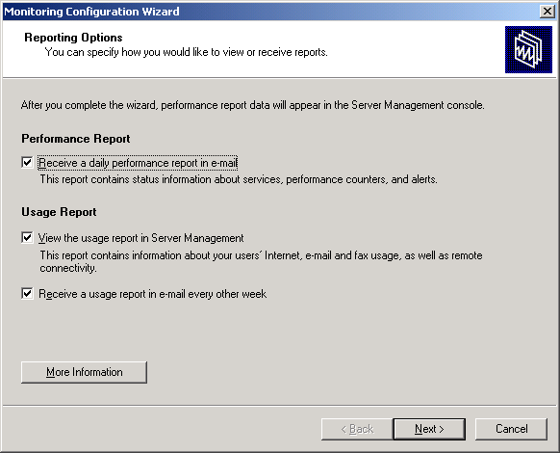

Windows Small Business Server 2003 offers sophisticated usage and performance reporting, including two preconfigured reports. In this version, Microsoft has applied significant research and feedback from small businesses to build these preconfigured reports. The first is focused on server performance, CPU, memory, disk space and any alerts from the server event logs. Its primary purpose is to report on the health of the server.

The second is a usage report that highlights Web traffic and e-mail volumes by date and time. This screen shows the configuration steps for both reports. Typically, performance reporting is set up to send the report via e-mail directly to the service provider. In addition, the wizard provides for immediate alerts to be configured.

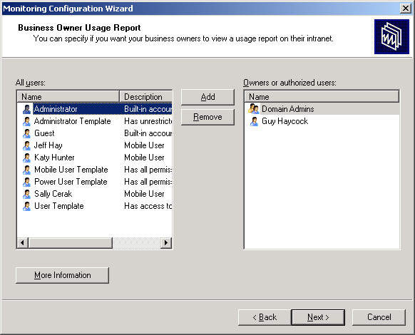

The usage report also can be made available on the Remote Web Workplace to administrators or even to a select group of users such as the small-business owner or power users who share some of the IT administration tasks. This window shows the users who will be able to view the report on the Remote Web Workplace.
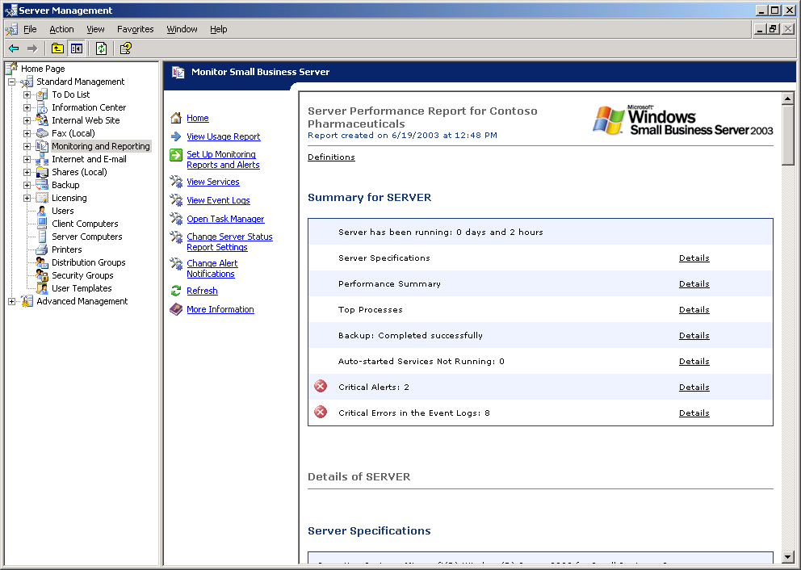

The Server Performance report, shown here, shows critical alerts in highlights. This report is available in several locations, including the server management console, the Remote Web Workplace and also via e-mail for VAPs and VARs.

Server Management Console
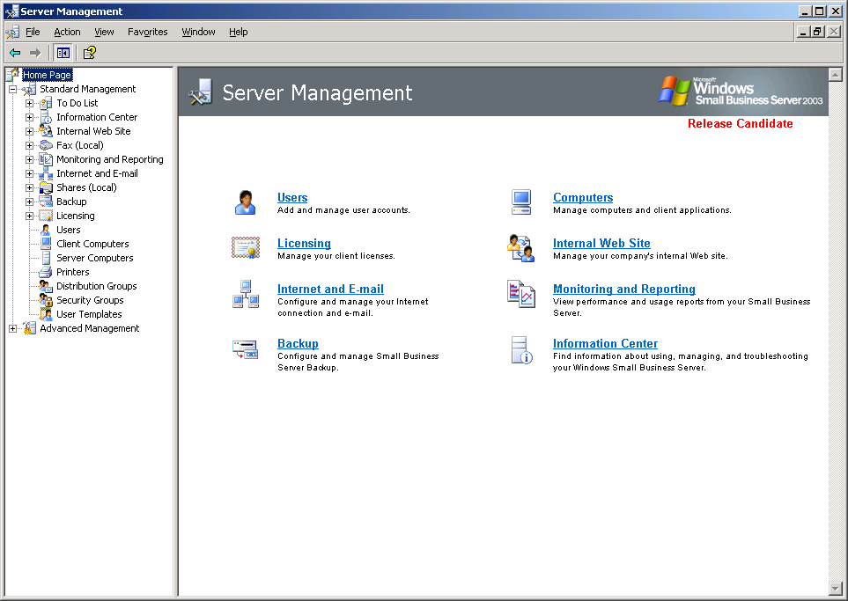

The Server Management Console is the comprehensive site for ongoing management of the small-business network and server. The Server Management Console is organized around a task-based approach as shown.

Advanced IT staff, as well as VAPs and VARs, have the choice of using either the simplified wizard-based management tools shown in the right pane above or the full set of Microsoft Management Console (MMC)-based management tools (accessed by expanding the Advanced Management in the bottom of the left-hand pane). The simplest experience is available through the To Do list, which is the third option in the left pane.

Technical Feature Comparison Chart

Product/Component | Windows Small Business Server 2003 Standard Edition | Windows Small Business Server 2003 Premium Edition
Windows Server 2003 | √ | √
Exchange Server 2003 | √ | √
Outlook 2003 | √ | √
Small Business Server-specific components (e.g., setup wizards, monitoring tools, shared fax) | √ | √
Windows SharePoint Services v2 | √ | √
FrontPage 2003 |  | √
SQL Server 2000 SP3 |  | √
ISA Server |  | √
Includes 5 CALs | √ | √

System Requirements

Microsoft Windows Small Business Server 2003 Standard and Premium Editions

- 550MHz or faster processor clock speed recommended; 300MHz minimum; Intel Pentium/Celeron family, AMD K6/Athlon/Duron family, or compatible processor (Windows Small Business Server 2003 Standard and Premium Editions support up to two CPUs on one server.)
- CD-ROM or DVD-ROM drive
- Super VGA (800x600) or higher-resolution monitor recommended; VGA or hardware that supports console redirection required
- Keyboard and Microsoft Mouse or compatible pointing device, or hardware that supports console redirection
- Ethernet network interface card from the Windows Server 2003 Hardware Compatibility List

Standard Edition
- 384 MB of RAM or higher recommended (256 MB minimum: 4 GB maximum)
- 4 GB of available hard disk space*

Premium Edition
- 512 MB of RAM or higher recommended (256 MB minimum; 4 GB maximum)
- 5 GB of available hard disk space* (2 GB required if upgrading from Microsoft Small Business Server 2000)

* Actual requirements will vary based on system configuration and the applications and features selected for install. More information is available at http://www.microsoft.com
/sbserver/.

Businesses with 50 or fewer desktops
“ROI That’s Off the Charts: The Business Value of Microsoft Windows 2000 Servers for Small and Mid-Size Businesses,” Aug. 7, 2002, http://www.forbes.com/whitepapers/microsoft/index.shtml
http://www.microsoft.com/presspass/features/2003/apr03/04-16dhbrown.asp

