Efficiency Through Technology Enables Pediatric Office to Deliver Comprehensive Care
Microsoft Office System Customer Solution
Case study

Case Study

M ost traditional medical practices suffer from a common malady: a paper-based documentation and communication infrastructure that breeds inefficiencies. Despite the best efforts of caregivers, a paper-bound practice can severely limit dedicated patient time. The ability to efficiently retrieve information from this volume of paperwork is a significant challenge as well.
“We needed a more efficiently run office in order to deliver the quality of care we were seeking in our new practice, and we turned to technology to help us with that goal.”
Stacia Dearmin
M.D., Cofounder
Advanced Pediatrics

Opening a new children’s medical office in a suburb of Cleveland, Ohio, the founders of Advanced Pediatrics had an opportunity to use technology to manage costs and increase overall efficiency. The approach gave doctors the freedom to care for patients in a more comprehensive way. The end result not only saved money, but it also reduced the stress level for the staff and enabled the entire practice to revolve around delivering the highest quality healthcare—and caring—possible for the patient.
Advanced Pediatrics
Customer Profile | Business situation | Solution | benefits
Advanced Pediatrics is a pediatric office located in Beachwood, Ohio (Cleveland). The focus of the practice is general pediatrics, newborn medicine, adolescent medicine, behavior and development, and allergy and asthma. The clinic first opened its door in January 2003. | Three major issues drove the adoption of various technologies: limited information access due to paper overload, poor interoffice communication, and the desire to stay connected to the patient, especially as care extended beyond normal business hours. | A Microsoft® Windows® Small Business Server 2003–based client/server network in combination with Tablet PCs and key line-of-business software puts all office and patient information at users’ fingertips. Office Small Business Edition 2003 provides full integration with component applications and an out-of-the-box intranet solution, helping to solve communications problems. | - Comprehensive software solution reduces staff-to-provider ratio, with savings estimated at $60,000 per year  - Complete information access improves quality of care for patients—and life for doctors  - Improved internal communications helps staff to care for patients needs more efficiently  - Staying connected to patients results in high patient satisfaction and referrals


Opened in January 2003, the Advanced Pediatrics office is located on the east side of Cleveland, Ohio, in the suburb of Beachwood. The practice was started by doctors Arthur Lavin and M. Stacia Dearmin, who are Fellows with the American Academy of Pediatrics (AAP).
AAP and its member pediatricians dedicate their efforts and resources to the health, safety, and well-being of infants, children, adolescents, and young adults. AAP has 57,000 members in the United States, Canada, and Latin America. More than 41,000 members are board certified and are called Fellows.
“Imagine a situation where each patient created another layer of paper on a desk. Now imagine the difficulty in quickly retrieving a specific document when you have 2,500 individuals to keep track of. The volume of paperwork makes the task incredibly daunting and inefficient. That’s what most doctors’ offices face each day.”
Arthur Lavin
M.D., Cofounder
Advanced Pediatrics

Just as doctors Lavin and Dearmin have dedicated themselves to alleviating patient pain, previous experience taught them to address specific business pains as they opened the new practice.

Paper Frenzy Causes Information Access Problems
Most traditional medical practices suffer from a common malady: paper-based documentation and communication infrastructure that breeds inefficiencies.
“Imagine a situation where each patient created another layer of paper on a desk,” says Dr. Lavin, owner of Advanced Pediatrics. “Now imagine the difficulty in quickly retrieving a specific document when you have 2,500 individuals to keep track of. The volume of paperwork makes the task incredibly daunting and inefficient. That’s what most doctors’ offices face each day.”
Another daily occurrence is the need to extend patient care beyond normal business hours, which means needing access to information in a secure environment around the clock. But patient charts were not easily accessed after hours. “The need to care for patients doesn’t stop at 5 P.M.,” says Dr. Dearmin.
The paper frenzy had continually challenged Lavin and Dearmin in previous practices, in the form of difficult-to-locate notes, phone messages, lab reports, e-mail, and staff meeting decision and action items. “How do you efficiently track staff meetings?” asks Lavin. “We have all these great ideas about how to improve the practice, but no one can find the meeting notes or remember what we were going to do.”

Staying Connected Is Difficult
“The relationship we have with our patients is everything,” says Dearmin. “But after they leave the office, the ability to communicate with them has been limited and somewhat difficult. Our challenge was finding both the time and the appropriate way to stay in touch with our patients and families.”
Kelley Rieger, a nurse practitioner at Advanced Pediatrics, remembers wishing she had more time associated with her job. “I wanted to do more for my patients, but I seldom had time for lunch, let alone extra time to stay connected with patients outside the office,” Rieger says.

Operational Costs Must Be Managed
“Medical office staffs typically grow to address problems such as patient record management, billing, and insurance issues,” says Lavin. “Unless we’re careful, growth of staff-to-provider ratios can significantly reduce profitability.” Advanced Pediatrics also must carefully manage its IT expenditures.


“Overall, we needed a more productive and efficiently run office in order to deliver the quality of care we were seeking in our new practice,” says Dearmin, “and we turned to technology to help us with that goal.”
Advanced Pediatrics has eight computers—three Compaq Tablet PC
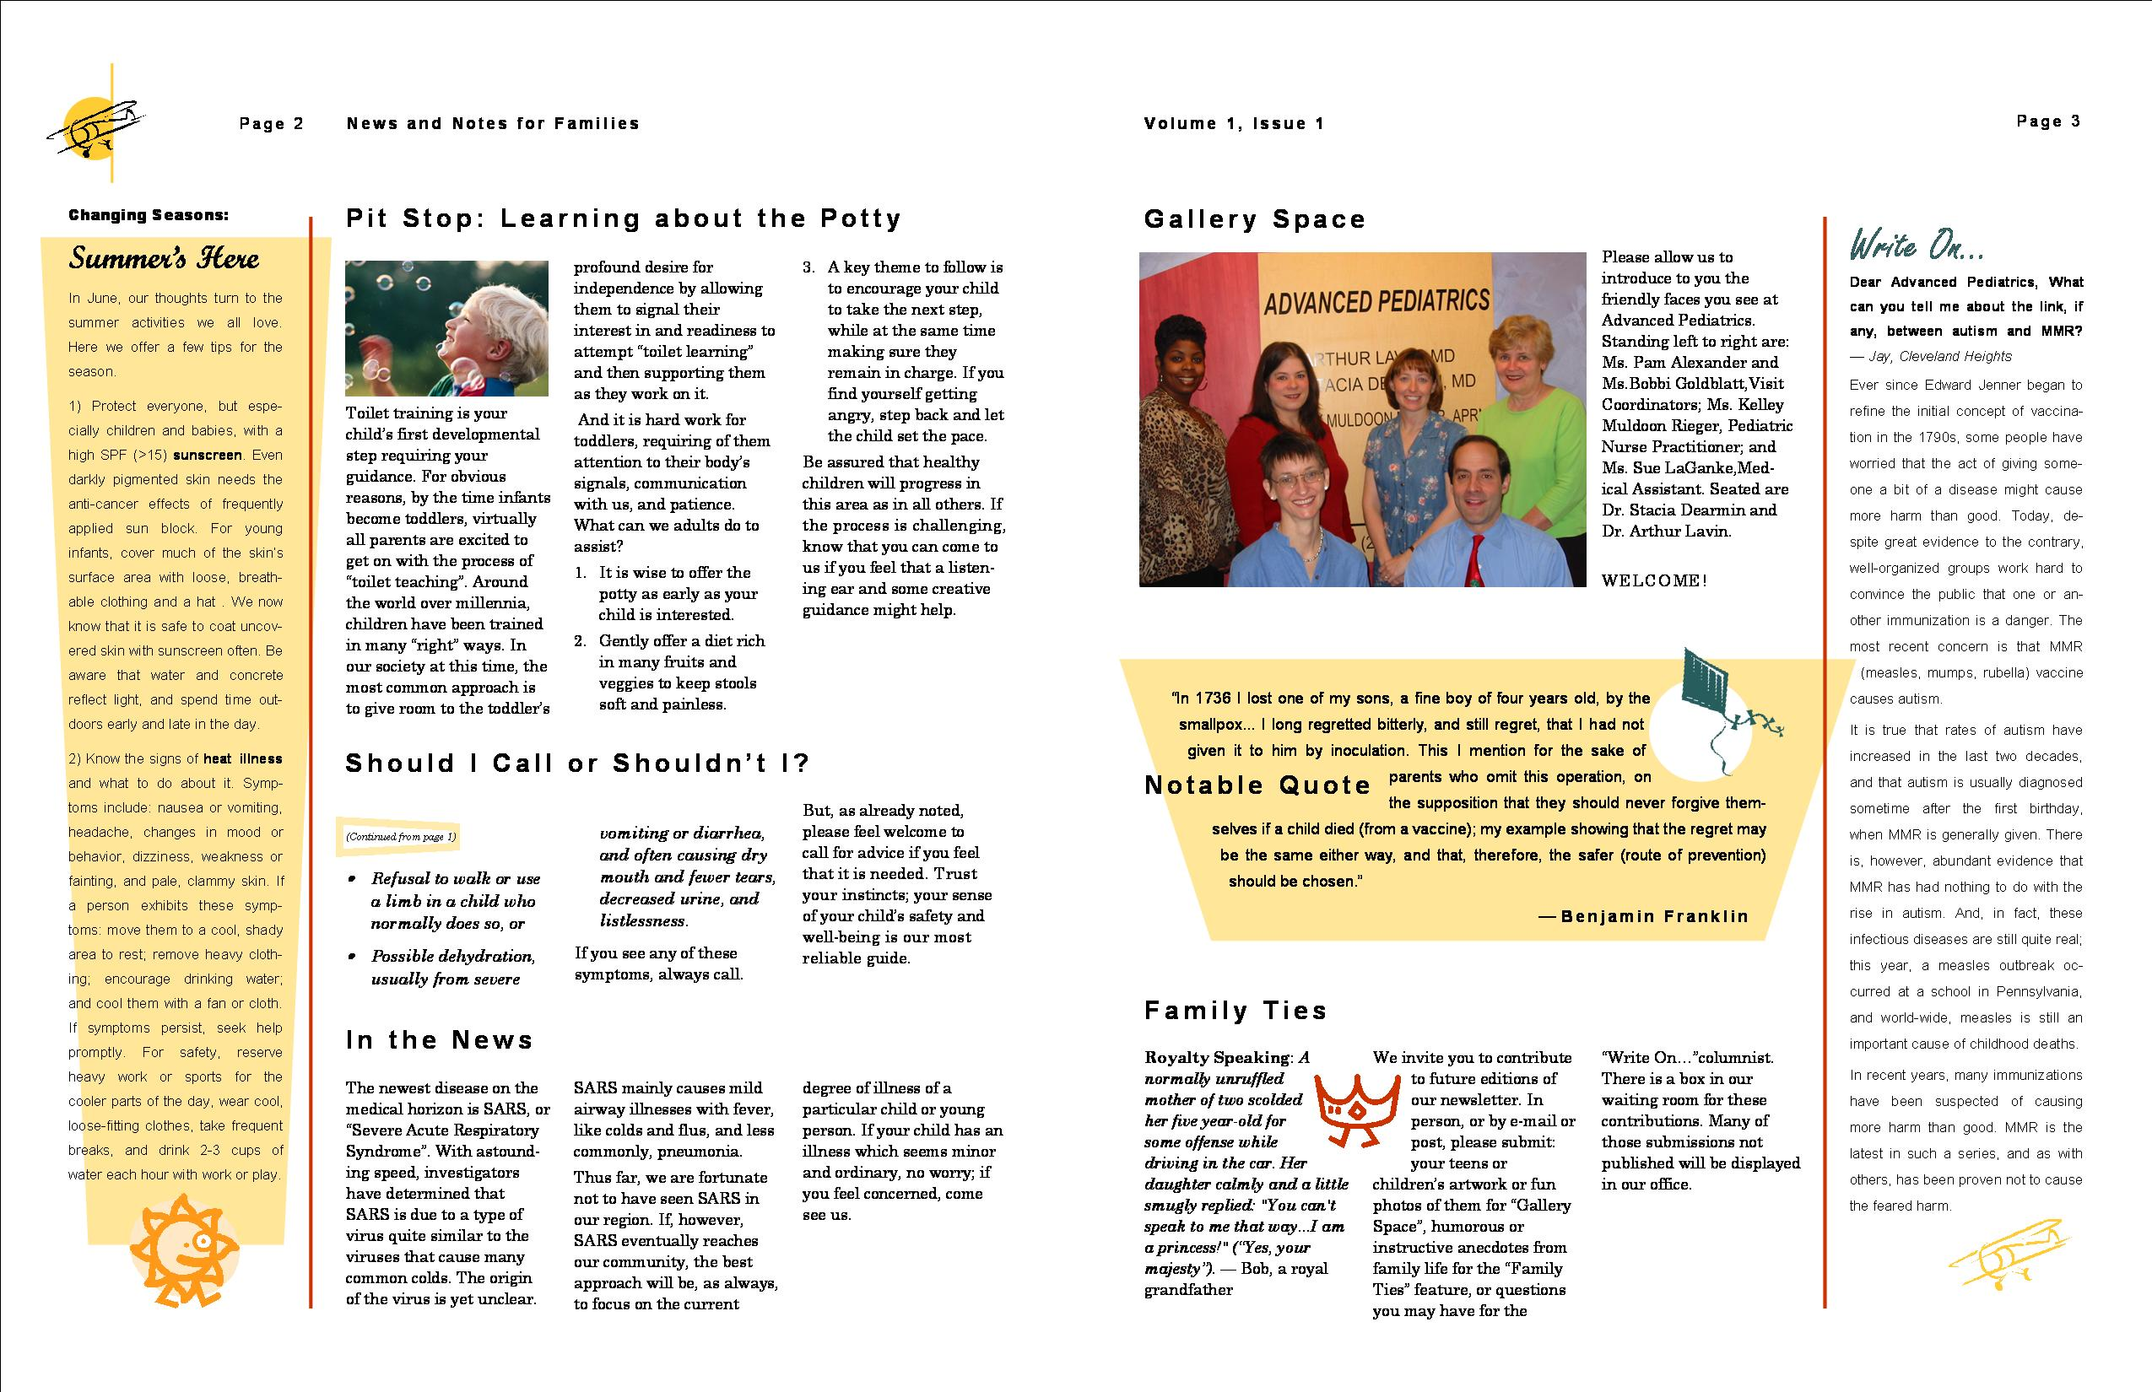
TC1000s and five Compaq desktops running on a Microsoft® Windows® Small Business Server 2003–based network with Windows SharePointTM Services. The wireless practice uses Cisco Wireless LAN, with four access points located throughout the office. Six of the computers run the Windows XP Professional operating system, while the other two run Windows 2000 Professional.
All computers are using Microsoft Office Small Business Edition 2003. In addition, the clinic has two main line-of-business software packages that it relies on for electronic medical records (EMRs) and scheduling/billing: Wang Healthcare’s EMR solution and SSIMed billing and scheduling solution.
Publisher 2003 is used to create a quarterly family newsletter, which serves as a powerful communications tool that helps to deliver comprehensive care to Advanced Pediatrics’ families.



Lower Operational Costs
“Small Business Server 2003 was a perfect fit for Advanced Pediatrics because of simple setup and operation, especially for a company that didn’t have resident IT support and was on a limited budget,” says Fredrick Johnson, President of Cleveland-based Ross-Tek, the clinic’s IT consultant.
With Small Business Server 2003, setup and management of remote users was painless. And the Health Monitor feature allowed Ross-Tek to remotely solve network issues without making a service call.
“New capabilities in Small Business Server 2003 and Microsoft Office Outlook® 2003 created Outlook Web Access that looks just like the familiar Outlook interface, but with the added benefit of access anywhere,” notes Johnson. In addition, Advanced Pediatrics can easily back up its data.
Advanced Pediatrics estimates it will save more than $500 per month in reduced IT operational costs because of Small Business Server 2003.
“The total software solution used by the clinic combines to reduce staffing needs by two-thirds versus a traditional paper-based medical practice.” said Lavin. “The technology we’re now using has reduced our staff-to-provider ratio from the traditional 4:1 to 2:1, an annual savings of more than $60,000.”

Complete Information Access
With the Windows Small Business Server 2003 solution, caregivers have 24-hour-a-day access to all patient records, allowing them to attend to after-hour patient needs faster and better.
Three Tablet PCs are used in a wireless environment within the clinic. The instant access to patient chart information and the ability to use the Internet to access medical libraries allows patient questions to be answered immediately. Often information on topics such as weight control, immunization, and allergies is printed on the spot or sent by e-mail directly to a family for later reference.
“Wang’s Healthcare Information Systems Electronic Medical Records not only allows us to have access to a patient’s complete file and history, but we can automatically check for adverse drug interactions across all known drugs. It will even stop us from writing the prescription until we address the exception,” says Lavin.

Improved Internal Communications
Dr. Lavin uses Microsoft Office OneNoteTM 2003 on his Tablet PC. It enables him to capture, organize, and reuse notes electronically.
“OneNote is the cure for misplaced notes and great ideas generated in our staff meetings,” says Lavin. “Notes and action items are tabbed and searchable. The effectiveness of our meetings has tripled.”
Meeting notes, vacation calendars, newsletter issues, company photos, presentations, and faxes are more easily shared with staff through the use of Small Business Server 2003 and its Windows SharePointTM Services. The site has become a central source of shared documents and files for the office.

Staying Connected to Patients
Microsoft Office Publisher 2003 was used to create business cards, letterhead, envelopes, and thank-you cards. A quarterly family newsletter is proving to be a powerful communications tool, helping to deliver an array of wellness and healthcare information, an integral part of Advanced Pediatrics’ concept of total patient care. The newsletter also helps the practice to stand out in its community.
Publisher templates help to coordinate the look and feel of all the materials. Preselected font sets and color palettes make it easy to create professional-looking documents on a consistent basis, regardless of who is using the software or what needs to be created.
“Until a few months ago, I had avoided computers, except to do simple things such as write letters,” says Dearmin. “However, I needed to get savvy very quickly if technology was going to help me enrich my practice as I had envisioned. The learning curve to become proficient on the Tablet PC, Office 2003, and Publisher was surprisingly small because the interface was familiar.”

Microsoft Office is the business world’s chosen environment for information work that provides the software, servers, and services that help you succeed by transforming information into impact.
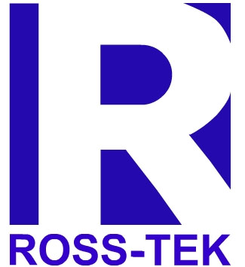

For more information about the Microsoft Office System, go to:
http://www.microsoft.com/office/


For more information about Microsoft products and services, call the Microsoft Sales Information Center at (800) 426-9400. In Canada, call the Microsoft Canada Information Centre at (877) 568-2495. Customers who are deaf or hard-of-hearing can reach Microsoft text telephone (TTY/TDD) services at (800) 892-5234 in the United States or (905) 568-9641 in Canada. Outside the 50 United States and Canada, please contact your local Microsoft subsidiary. To access information using the World Wide Web, go to:  http://www.microsoft.com/ | For more information about Ross-Tek products and services, call (216) 812-2122 or visit the Web site at:  www.rosstek.com  For more information about Advanced Pediatrics products and services, call (216) 591-1515 or visit the Web site at:  http://www.advanced-pediatrics.yourmd.com/ | © 2003 Microsoft Corporation. All rights reserved.  This case study is for informational purposes only. MICROSOFT MAKES NO WARRANTIES, EXPRESS OR IMPLIED, IN THIS SUMMARY.  Microsoft, the Office logo, OneNote, Outlook, SharePoint, and Windows are either registered trademarks or trademarks of Microsoft Corporation in the United States and/or other countries. The names of actual companies and products mentioned herein may be the trademarks of their respective owners.
Published: October 2003


Microsoft® Windows® Small Business Server 2003 with Windows SharePointTM Services
Microsoft Windows XP Professional and Windows 2000 Professional
Microsoft Office System
- Office Small Business Edition 2003
- Office OneNoteTM 2003

Hardware
Compaq Proliant ML370 File Server
Compaq EVO PCs
Compaq Tablet PC TC1000
HP LaserJet 4300n network printer
HP Deskjet 1100 personal printers
Fujitsu 4220 scanner
Efficient Networks DSL router

Partner
Ross-Tek

