Microsoft Corporate Logo Guidelines



As a general rule, third parties may not use the Microsoft Corporate Logo (“Logo”). Listed below are the limited circumstances under which third parties may use the Microsoft Corporate Logo. The Logo must always be used pursuant to the specifications in this document to identify Microsoft Corporation, or Microsoft products or services. Any use that falls outside of these specifications is strictly prohibited.

Third parties may only use the Logo without a license under the following limited circumstances:

- At the bottom of advertising, marketing collateral, or a web site that references your connection with Microsoft (for example, the material states that you are an authorized distributor or reseller of Microsoft products) provided that the area in which the Microsoft logo is used includes the corporate logos of two (2) or more software or hardware companies with which you have a similar relationship.

- In an area of a web site, advertising, or marketing collateral exclusively dedicated to the sale of Microsoft products, and in such a manner that associates licensed Microsoft software with the Microsoft Corporate logo.

The following guidelines must be followed for all use of the Logo:

- The Logo may not be used in any manner that might imply that any non-Microsoft materials, including but not limited to goods, services, web sites, or publications, are sponsored, endorsed, licensed by, or affiliated with Microsoft.

- The Logo may not be displayed as a primary or prominent feature on any non-Microsoft materials. Companies using the Logo pursuant to these guidelines must also display in the primary and more prominent position, their own logo(s), business name, product names, or other branding.

- The Logo may not be imitated, or used as a design feature in any manner.

- The Logo may not be used in a manner that would disparage Microsoft Corporation or its products or services.

- The Logo must be used as provided by Microsoft Corporation with no changes, including but not limited to changes in the color, proportion, or design, or removal of any words, artwork, or trademark symbols. The Logo may not be animated, morphed, or otherwise distorted in perspective or appearance.

- Use only approved Microsoft logo artwork.
- The Logo may only appear in black or reversed out to white. The Logo may never be screened back, built out of four-color process screens, or broken into multiple colors.
- The Logo must always be accompanied by the registered trademark symbol (®).

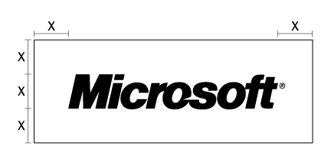
- To properly stage the Logo, a minimum clearance between the Logo and other elements must be maintained. The cap height of the M in the Logo indicates the measurement of minimum clearance between the Logo and other elements on all sides of the Logo.
- The Logo must always be at least 60 pixels in width.

- The Logo must only appear in a horizontal position.

- The Logo must stand alone and may not be combined with any other object, including but not limited to other logos, words, graphics, photos, slogans, numbers, design features, or symbols. The Logo must never be used to represent the word “Microsoft” in text, including in a headline, product-name logotype, or body copy.

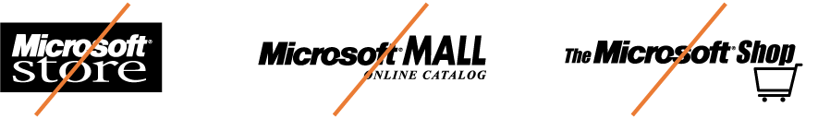

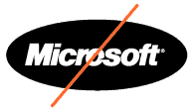
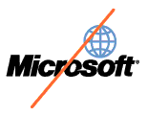
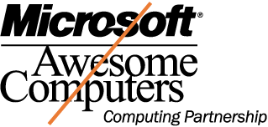
- The Logo must not be incorporated or used in any manner as part of, or in close proximity to another company’s name, domain name, product or service name, logo, trade dress, design, slogan, or other trademarks. The Logo must never appear with any other symbol or icon (except the registered trademark symbol); contained within a box, circle, or other shape; or combined with any other name, logo, or icon to create a co-branded logo.

- The attribution clause “Microsoft is a registered trademark of Microsoft Corporation” must accompany use of the Logo.

- Neither the Logo nor the Microsoft name may be used in any other company name, product name, service name, domain name, web site title, publication title, or the like.

- Non-Microsoft materials should not mimic any Microsoft advertising, product packaging, or web site design.

- Under no circumstances may third parties use, imitate, or play off of the Microsoft corporate tagline (“Your Potential. Our Passion.”). This tagline is reserved for exclusive use by Microsoft Corporation.

If you wish to use the Logo, and your use falls within these guidelines, contact brand@microsoft.com to obtain the Logo.

Microsoft reserves the right in its sole discretion to terminate or modify permission to display the Logo, and may request that third parties modify or delete any use of the Logo that, in Microsoft’s sole judgment, does not comply with these guidelines, or might otherwise impair Microsoft’s rights in the Logo. Microsoft further reserves the right to object to unfair uses or misuses of its trademarks or other violations of applicable law.

Microsoft and Your Potential. Our Passion are either registered trademarks or trademarks of Microsoft Corporation in the United States and/or other countries. The example companies, organizations, and/or products, people and events depicted herein are fictitious. No association with any real company, organization, product, person or event is intended or should be inferred.

