

PowerPivot for SharePoint – Single Server Installation

SQL Server Technical Article

**Writers:** Leon Cyril, Dave Wickert, Denny Lee

**Technical Reviewers:** Lee Graber, Jennifer Chu, Kathy MacDonald, Artur Pop, Heidi Steen

**Published:** September 2010

**Applies to:** SQL Server 2008 R2

**Summary:** PowerPivot for SharePoint enables the sharing and collaboration of BI solutions created by information workers in a Microsoft SharePoint Server 2010 environment. It also provides management tools that empower IT organizations. This white paper will guide you through the procedure involved in the installation and configuration of PowerPivot for SharePoint on a new single-server SharePoint 2010 farm.

Copyright

The information contained in this document represents the current view of Microsoft Corporation on the issues discussed as of the date of publication. Because Microsoft must respond to changing market conditions, it should not be interpreted to be a commitment on the part of Microsoft, and Microsoft cannot guarantee the accuracy of any information presented after the date of publication.

This white paper is for informational purposes only. MICROSOFT MAKES NO WARRANTIES, EXPRESS, IMPLIED, OR STATUTORY, AS TO THE INFORMATION IN THIS DOCUMENT.

Complying with all applicable copyright laws is the responsibility of the user. Without limiting the rights under copyright, no part of this document may be reproduced, stored in, or introduced into a retrieval system, or transmitted in any form or by any means (electronic, mechanical, photocopying, recording, or otherwise), or for any purpose, without the express written permission of Microsoft Corporation.

Microsoft may have patents, patent applications, trademarks, copyrights, or other intellectual property rights covering subject matter in this document. Except as expressly provided in any written license agreement from Microsoft, the furnishing of this document does not give you any license to these patents, trademarks, copyrights, or other intellectual property.

Unless otherwise noted, the example companies, organizations, products, domain names, e-mail addresses, logos, people, places, and events depicted herein are fictitious, and no association with any real company, organization, product, domain name, e-mail address, logo, person, place, or event is intended or should be inferred.

© 2010 Microsoft Corporation. All rights reserved.

Contents

Introduction 3

1. Install SharePoint 2010 3

2. Install SQL Server 2008 R2 5

3. Install the Microsoft Access Database Engine 2010 Redistributable (Optional) 8

4. Install ADO.NET Data Services 3.5 SP1 (Optional) 8

5. Configure File Size Limits (Optional) 9

6. Configure Reporting Services on Your Farm (Optional) 10

I Install Reporting Services 10

II Configure Your Reporting Services Instance 11

III Integrate Reporting Services with SharePoint 16

Conclusion 17

# Introduction

Installing PowerPivot for Microsoft SharePoint on a new single server SharePoint farm is the simplest way to setup your PowerPivot server. The step-by-step procedure presented in this paper should ensure that you are up and running in less than an hour. Before you start on the installation, make sure that:

* You have a clean 64-bit Windows Server 2008 with Service Pack 2 (SP2) or a Windows Server 2008 R2 machine that has all the latest updates. (These are the only operating systems supported by SharePoint 2010.)
* You have a domain account that you can use (a domain account is required to successfully configure SharePoint) and that your computer is connected to that domain.
* Port 80 is available.

# Install SharePoint 2010

1. Double-click **PrerequisiteInstaller.exe** from your SharePoint Server 2010 setup location to launch the SharePoint 2010 Products Preparation Tool. Note that you will need network connectivity to run PrerequisiteInstaller.exe.
2. After the preparation tool completes successfully, open **Setup.exe**.
3. Enter a product key, accept the terms and conditions, and then click **Continue**.
4. Click **Server Farm**, and then click **Next**.

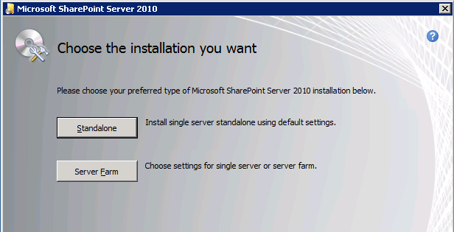

1. On the **Server Type** tab, click **Complete**, and then click **Install Now**.

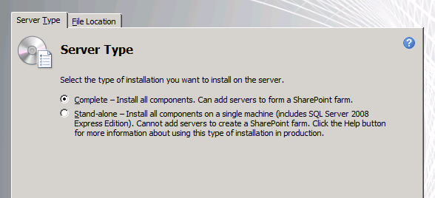

1. **Important**: After the installation is complete, a message appears, asking whether you want to run the Configuration Wizard. Do *not* run this. Clear the **Run the SharePoint Products Configuration Wizard now** check box, and then click **Close**.

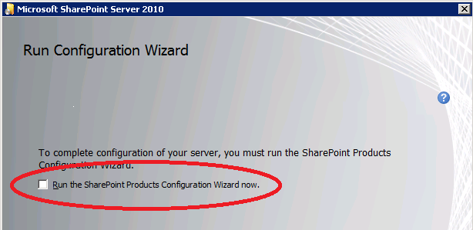

# Install SQL Server 2008 R2

This step will configure your SharePoint farm and install PowerPivot. It will also customize your farm with recommended settings for PowerPivot.

1. Launch Microsoft SQL Server setup, click the **Installation** tab, and then click **New features or add features to an existing installation**.
2. Enter the product key when prompted and navigate through Setup, selecting the defaults until you reach the **Setup Role** page.
3. Click **SQL Server PowerPivot for SharePoint**, and then next to **Add PowerPivot for SharePoint to**, click **New Server**. Click **Next**.

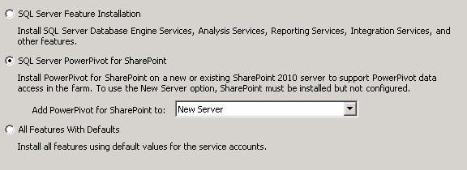

1. On the **Feature Selection** page, click **Next**, and then continue navigating through the defaults until you reach the **New SharePoint Farm Configuration** page.
2. On the **New SharePoint Farm Configuration** page, enter the account you are using to configure your server and specify a pass phrase that meets your organization’s standard password requirements. (**Important**: Make a note of this pass phrase, because you will need it if you want to add additional machines to your single server farm later.)

You can leave the default port number chosen for the central administration website or enter a port number of your choice. Note that you should write down the port number if you want to remotely administer the system, or if you will be frequently administering the system from several sites, consider selecting a number that is easy to remember. For example, 55000 would result in a remote Central Administration URL of http://<server>:55000.

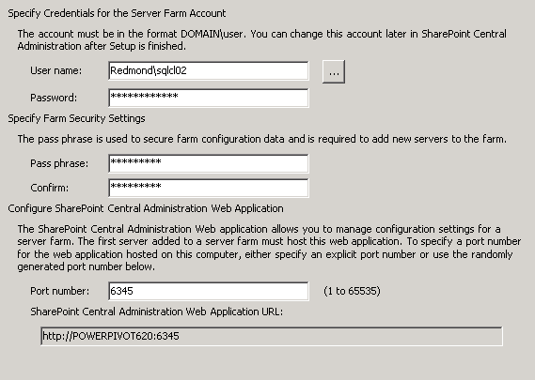

1. On the **New SharePoint Farm Configuration** page, click **Next**, and then continue navigating through the defaults until you reach the **Server Configuration** page.
2. On the **Server Configuration** page, enter service accounts for each SQL Server Service. To simplify the installation, use the same account you specified in Step 2e. Due to a known bug, if you select a different account you receive an error when the data refresh attempts to access the stored credentials. Click **Next** to go to the **Database Engine Configuration** page.

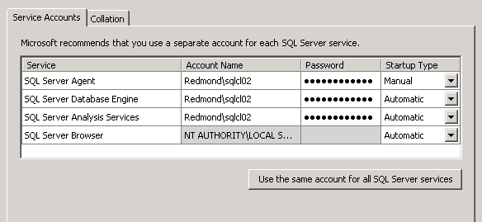

1. On the **Database Engine Configuration** page, enter the name of an administrator for SQL Server (You can click on **Add Current User** to ensure that you are a SQL Server system administrator). Click **Next** to go to the **Analysis Services Configuration** page.

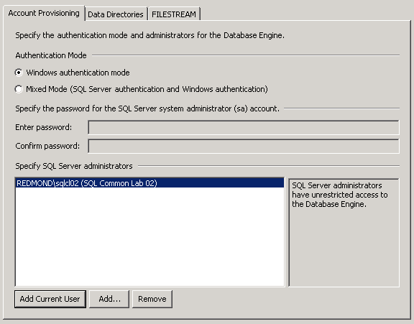

1. On the **Analysis Services Configuration** page, enter the name of an administrator for Analysis Services. To ensure that you are (or the account you are using is) an Analysis Services administrator, click **Add Current User**. Continue to navigate through Setup.

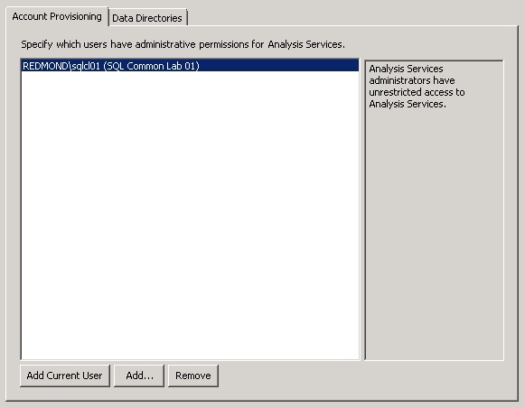

1. On the **Ready to Install** page, click **Install** to begin installation.

After the installation is complete, your PowerPivot Server is configured and ready to use. You can perform the following *optional* steps if you need to.

# Install the Microsoft Access Database Engine 2010 Redistributable (Optional)

The Microsoft Access Database Engine 2010 Redistributable must be installed if you want to schedule data refresh for workbooks that have Microsoft Access or Microsoft Excel as their data source. You can install the 64-bit version of ACE (that is, AccessDatabaseEngine_X64.exe) from the following location:

<http://www.microsoft.com/downloads/details.aspx?familyid=C06B8369-60DD-4B64-A44B-84B371EDE16D&displaylang=en>

# Install ADO.NET Data Services 3.5 SP1 (Optional)

ADO.NET Data Services 3.5 with Service Pack 1 (SP1) must be installed if you want to use a SharePoint List as an ATOM feed. You can install it from the following locations:

**Windows Server 2008 R2**:

<http://www.microsoft.com/downloads/details.aspx?familyid=79d7f6f8-d6e9-4b8c-8640-17f89452148e&displaylang=en>

**Windows Server 2008:**

<http://www.microsoft.com/downloads/details.aspx?familyid=4B710B89-8576-46CF-A4BF-331A9306D555&displaylang=en>

# Configure File Size Limits (Optional)

Out of the box, SharePoint allows you to upload files up to 50 MB in size, and Excel Services allows you to view files as large as 10 MB within a browser. SQL Server Setup (in New Server mode) changes these defaults to 200 MB while it configures your farm for PowerPivot. If users will be publishing and interacting with even larger files, you will need to change these settings.

**To increase Web Application limits**:

1. Click **SharePoint** **Central Administration > Application Management > Manage Web Applications.**
2. Click **SharePoint-80**, and then on the ribbon at the top of the page, click **General Settings > General Settings**.
3. Change the **Maximum Upload Size** setting to the MB limit you want to set. (The maximum allowed by SharePoint is 2047 MB.)



**To increase Excel Services limits**:

1. Click **SharePoint** **Central Administration > Application Management > Manage Service Applications**.
2. Select your ExcelServiceApplication (e.g. **Excel Services Application**),and then on the ribbon on the top of the page, click **Manage**.
3. Click **Trusted File Locations**, and then on the following page, select your trusted location. (Typically, this is listed as http:// in the **Address** column.)
4. In **Workbook Properties**, under **Maximum Workbook Size**, type **2000**, and then under **Maximum Chart or Image Size**, type **100**.

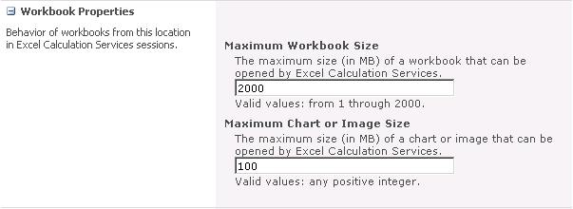

# Configure Reporting Services on Your Farm (Optional)

Configuring Reporting Services in SharePoint Integrated mode on your farm will allow you to use Report Builder to create reports using PowerPivot workbooks that you have been published to a PowerPivot Gallery as data sources. After installation, you can design reports by entering the URL of the PowerPivot workbook as the server in your Report Builder or Report Designer data source. The underlying PowerPivot infrastructure will make the appropriate connection to the embedded PowerPivot database residing within the workbook.

## I Install Reporting Services

1. Launch SQL Server Setup, click the **Installation** tab, and then click **New installation or add features to an existing installation.**
2. Navigate through Setup until you reach the **Installation Type** page, and then click **Add features to an existing instance of SQL Server 2008 R2**. Click **Next** to go to the **Feature Selection** page.
3. Select *only* **Reporting Services**, click **Next**, and then continue navigating through the defaults until you reach the **Server Configuration** page.

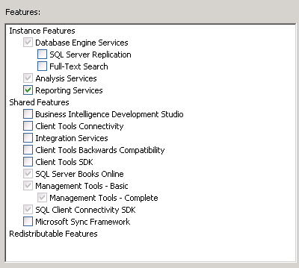

1. Enter a service account for SQL Server Reporting Services, click **Next**, and then continue navigating through Setup, selecting the defaults on each page.

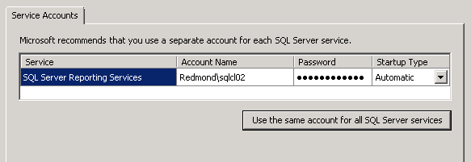

1. On the **Ready to Install** page, click **Install** to begin installation.

## II Configure Your Reporting Services Instance

1. Click **Start**, point to **All Programs**, point to **Microsoft SQL Server 2008 R2**, point to **Configuration Tools**, and then click **Reporting Services Configuration Manager**.
2. In the **Reporting Services Configuration Connection** dialog box, specify the server name (Machine Name), select the Report Server instance, and then click **Connect**.

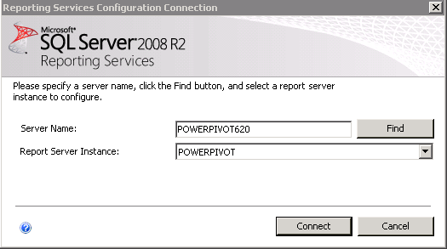

1. Under **Connect**, click **Database**, and then under **Current Report Server Database**,click **Change Database**.

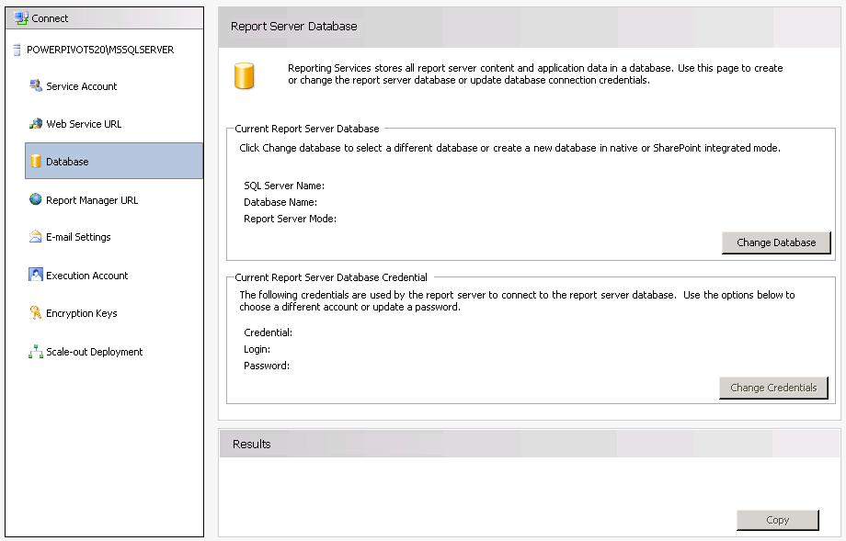

1. Click **Create a new report server database**, and then click **Next**.

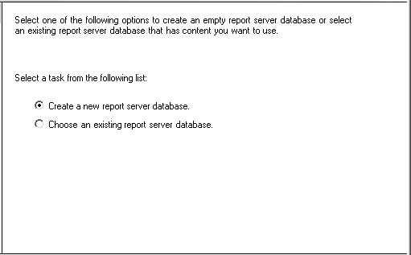

1. Next to **Server Name**,enter a valid Database Server instance name (that is, the machine and instance on which you want to host your Report Server database), and then click **Next**.

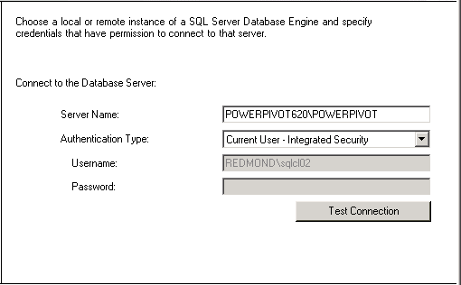

1. Next to **Database Name**, enter a database name of your choice, and then next to **Report Server Mode**, click **SharePoint Integrated Mode.** Click **Next**.

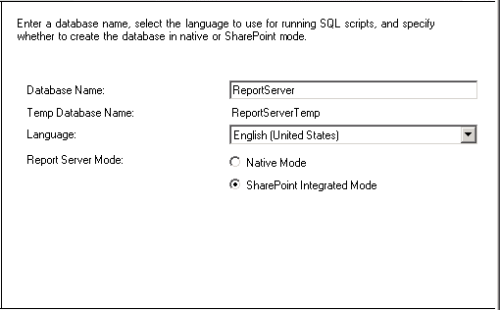

1. Next to **Authentication Type**, select **Windows Credentials**, and then enter information about the account that will be used to connect to the Report Server database.

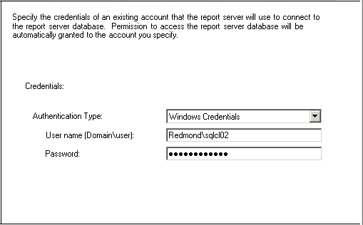

1. On the **Summary** page, click **Next**, and then after the configuration wizard completes, click **Finish**.

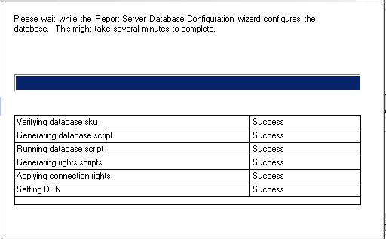

1. Under **Connect tab**, Click **Web Service URL**, and then click **Apply**.

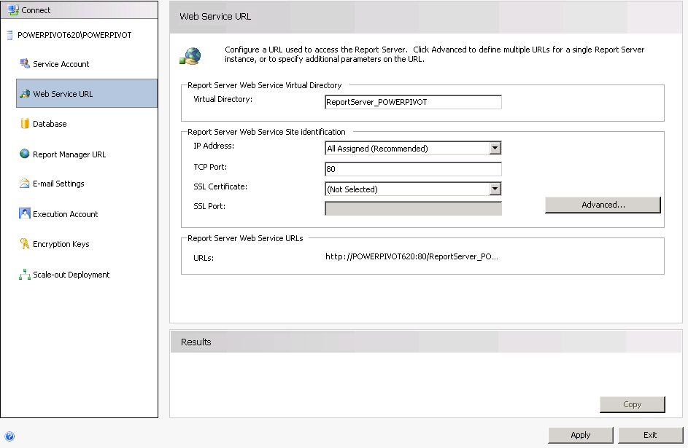

**Note:** You should see the “The URL was successfully reserved” message at the bottom of the page.

**Important**: Do not close this dialog box, because you will need the information it contains to complete the next step.

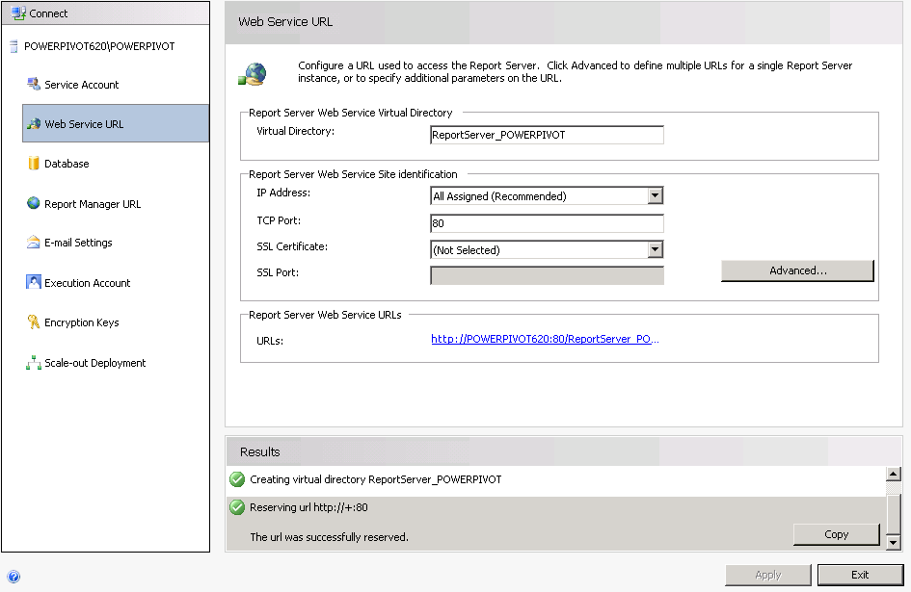

## III Integrate Reporting Services with SharePoint

1. Open the **SharePoint** **Central Administration** website, click **General Application Settings**, and then select **Reporting Services Integration**. If this option is not available, open a command prompt window as administrator, navigate to the location where you copied the SQL Server 2008 R2 Reporting Services Add-in for SharePoint, and then run rsSharePoint.msi.
2. In the **Report Server Web Service URL** box, enter the Web Service URL from the previous section.
3. Confirm that **Windows Authentication** is selected, specify the account you want to use, and then click **OK**.

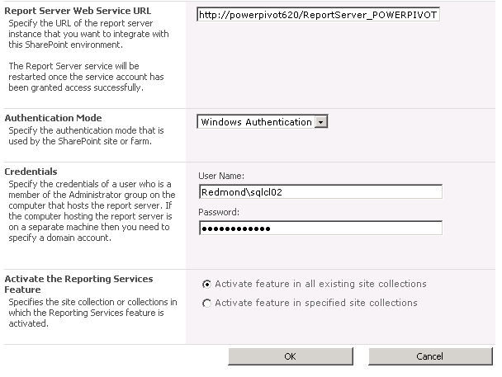

# Conclusion

You should now have PowerPivot for SharePoint installed and configured on your server. You can grant users permissions to your PowerPivot website and allow them to publish and share the BI solutions they create using PowerPivot for Excel.

**For more information:**

<http://www.microsoft.com/sqlserver/>: SQL Server Web site

<http://technet.microsoft.com/en-us/sqlserver/>: SQL Server TechCenter

<http://msdn.microsoft.com/en-us/sqlserver/>: SQL Server DevCenter

Did this paper help you? Please give us your feedback. Tell us on a scale of 1 (poor) to 5 (excellent), how would you rate this paper and why have you given it this rating? For example:

* Are you rating it high due to having good examples, excellent screen shots, clear writing, or another reason?
* Are you rating it low due to poor examples, fuzzy screen shots, or unclear writing?

This feedback will help us improve the quality of white papers we release.

[Send feedback](mailto:sqlbp@microsoft.com?subject=White%20Paper%20Feedback:%20[PowerPivot%20for%20SharePoint%20-%20Single%20Server%20Installation]).