

[www.microsoft.com/commerceserver](http://www.microsoft.com/commerceserver)

Commerce Server 2009 offers powerful comprehensive e-commerce solutions for B2C (business-to-consumer), B2B (business-to-business) and B2X scenarios (combining B2C and B2B).

|  |
| --- |
| Why Commerce Server 2009? |
| * Reduce time-to-market with a new out-of-the-box   default site and features |
| * Reduce costs in site development and deployment   using pre-built components |
| * Increase your reach through multi-channel awareness |
| * Integrate with Microsoft® ecosystem: Microsoft SharePoint® Server, Bing™, Windows Live™ ID, Microsoft® BizTalk® Server |
| * Engage and interact via Web 2.0 community features |
| * Flexibility to design your solution the way you want |
| * High availability and performance |
| * Upgrade easily from Commerce Server 2007 |

Let your company focus on what’s important: the customer shopping experience.

Whether your customers shop using a computer, a mobile device, a gaming system or other channels, Microsoft® Commerce Server 2009 delivers full multi-channel support – allowing your business to centrally manage your cross-channel strategy.

Discover new features designed to make selling your merchandise quicker and easier

New default site and easy page skinning features get you up and running quickly. Native integration with Microsoft SharePoint Server (with the availability of 30 new Web Parts and controls) and integration with Bing Maps and Windows Live ID) allows you to pick and choose a range of pre-built functionality without impacting the entire site.

* The default site comes with standard e-commerce functionality plus a few extras, including browsing, searching, site maps, profile management and registration, address lists, carts and mini-carts, check-out, split shipping, order histories, advertisements and discounts, product reviews and ratings, integrated Search, Bing Maps for store locations, and Windows Live ID integration for single sign-on.
* Commerce Server 2009 has two Template Packs available as a separate download: a Template Pack for SharePoint 2010 and a Template Pack for SharePoint Server 2007. Both templates contain a contemporary look for the default site as well as page templating technology and SharePoint Master Pages to quickly re-skin the site to your desired look and feel. The contemporary site is designed for viewing in both desktop browsers and mobile devices (specifically Windows Mobile and iPhone devices). Using the multi-channel environment, you can very quickly create new event-specific ‘microsites’ that allow for the quick build-up and tear-down of event-specific or season-specific sites.
* Collectively known as SharePoint Commerce Services, Commerce Server 2009 ships with more than 30 different Web Parts and controls that offer a building-block approach within SharePoint to deliver contemporary e-commerce Web site functionality.
* Integration with Bing Maps allows shopping sites have detailed maps of store locations.
* Attract a larger consumer base with integration to Windows Live ID; allowing single sign-on to your shopping site.
* Integrated search that searches both the e-commerce site and static content seamlessly.
* Display reviews and ratings for individual products, and ability for shoppers to submit their own reviews and ratings, with administrative workflow for management discretion.
* Display advertisements and discounts that are relevant to both the current shopper and current site context, and that work in conjunction with Marketing Manager and campaigns.
* 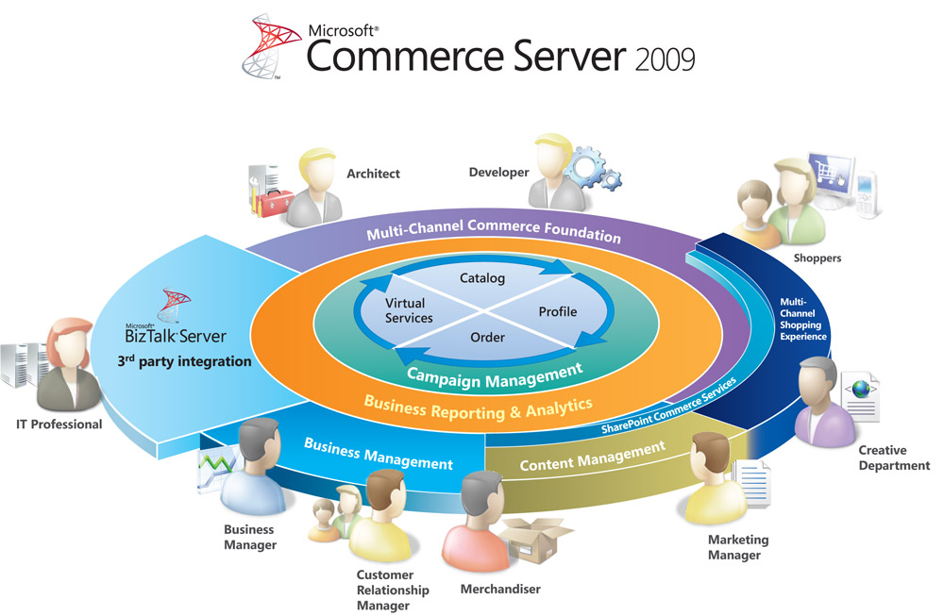Shoppers and managers can take advantage of Profile Administration features, including the ability to add and edit addresses, view and launch credit card information, a registration wizard, and the ability to reset passwords.

## Introducing the Commerce Foundation

* With the new unified run-time model, all run-time calls follow the same calling pattern across subsystems. The new model allows for multiple operations in a single call.
* Multi-channel awareness throughout all levels of Commerce Server 2009 means one can name and target specific channels. The presentation and business layers, and the data, are all aware of the channel name and each can be configured or customized to reflect any uniqueness needed for that channel.
* The new functional abstraction, called *Commerce Entities,* allow developers to extend and add new properties or relationships in a unified way. This can be prepared without the creation of new classes.
* Because Commerce Entities are not strongly typed, developers may introduce new ones without introducing new classes.
* Complete Web service support for Commerce Server Core Systems; Windows Authorization-enabled security; and Agent APIs for abstraction and easy programming.
* Commerce Server 2009 fully integrates with development environments through Visual Studio® 2008. Integration with Visual Studio and the Microsoft .NET Framework 3.5 (including ASP.NET) reduces the coding needed to customize commerce solutions.

## Business User Functionality and Analytics

* The Commerce Server 2009 default site offers on-the-site editing of product information, advertisements and other static content. This allows Merchandisers and Marketers to get a better sense of how their products and brands are being portrayed.
* Business user toolssuch as Customer and Orders Manager, Catalog and Inventory Manager, Marketing Manager, and Reports and Analytics help business users interact directly with Web-based business applications.
* Commerce Server 2009 comes with 35 packaged, user-customizable and highly scalable reports. The reports cover business trends to system diagnostics, including aggregation of IIS Clickstream and

E-Commerce Business Data, allowing your business to better understand what customers are buying.

* SQL Server® Reporting Services, the reporting engine used by Commerce Server 2009, is a comprehensive, server-based solution that enables the creation, management and delivery of both traditional, paper-oriented reports and interactive, Web-based reports displayed through SharePoint.
* Commerce Server 2009 offers an integrated data warehouse across customer profile, catalog, order, marketing, and Web log data.

## Commerce Server 2009 Core Systems

* Commerce Server 2009 allows you to more easily manage multiple sites from multiple catalogs, or a single site with multiple catalogs. Each site has its own base catalog and includes the ability to create a virtual catalog, where you can override specific information for different sites, channels, locales, or unique business reasons. All catalogs have price/product include and exclude rules that can be defined. And each catalog is multi-channel aware, allowing for targeting of products to different channels.
* Commerce Server 2009’s catalog definition is highly flexible, allowing for multiple SKU’s through base products and variants. Each product can be easily sequenced or re-sequenced to appear wherever you want it to in your catalog taxonomy. All product attributes have full-text search support, and tie back to the default site.
* Inventory control is available in Commerce Server 2009 through Inventory Catalogs. This separates the product definition from quantity management, giving you separate, fine-grain control of taxonomy and inventory. It also allows for a clear and distinct integration point to existing inventory systems in your business. The inventory system supports quantity in stock, and back-ordered and pre-ordered products, withconfigurable stock-out business logic.
* Commerce Server 2009 comes with built-in discounts, advertisement management and a direct mailer – all with multi-lingual support. Ads and Discounts are also available through the default site.
* Commerce Server 2009 allows you to set up different marketing campaigns for different brands or different customer segments – or both. This makes it easier to customize marketing to customer segments.
* Shoppers can take advantage of a more personalized buying experience using Commerce Server’s expressions. These allow you to target any customer profile information, personalize and target any advertisement or discount.
* Commerce Server 2009 has built-in revenue generating ad support, offering a new revenue channel to your business.
* Use Commerce Server 2009 to create and manage built-in public and private coupon types. Coupons –tied to discounts –offer an opportunity to build loyalty with your customers, or to use as an outbound marketing device.
* With Commerce Server 2009’s “pipeline” componentized approach and built-in multiple payment types, businesses can quickly and easily integrate with shipping services, tax calculation services, payment authorizations, fraud detection, address validations and more.
* Commerce Server 2009’s profile system is designed to offer your business a single view of customers, orders or any other type of profile data unique to your business. With its data-agnostic set up and flexible data schema structure, Commerce Server can centralize any type of product or customer data. In addition, Commerce Server supports ASP.NET forms authentication to more easily validate profiles.
* Commerce Server 2009’s profile system can talk with multiple data sources including SQL, OLEDB/ODBC, AD, ADAM, and LDAP, allowing you to work with virtually any data source in your enterprise.

## IT Pro and Development Tool Support

* Commerce Server 2009 supports side-by-side deployment with existing Commerce Server 2007 sites, minimizing upgrade risk while maximizing upgrade value.
* Commerce Server 2009 Staging allows for coordinated transactional content, Web application settings, and business data replication from a “staging” environment to your production environment across Web farms, networks and behind firewalls. The Staging system is fully configurable, has a robust, extensible event model, MMC, command-line, scripting support, and public APIs.
* BizTalk® Server Adapters solve the issues of end-to-end connectivity and communication with other line-of-business applications and trading partners, and allow for bidirectional synchronization and orchestration of Order, Catalog, Inventory, and Profile objects.
* Microsoft Management Console (MMC) fully integrates Commerce Server with other Microsoft Windows Server System™ products and provides easy, centralized management.
* System Center (formerly Microsoft Operations Manager (MOM) 2005 Management Pack) delivers enterprise-class operations management that incorporates years of administrative experience in the form of management rules and real-time monitoring.
* Securityfeatures include Secure Sockets Layer (SSL) support and profile data encryption for improved protection of passwords, credit card numbers, and other data. The Security Configuration Wizard helps better deployment of Commerce Server 2009.

Product Comparison Chart

|  |  |  |  |  |  |
| --- | --- | --- | --- | --- | --- |
| Commerce Server 2009 Feature (32-bit and 64-bit) | Benefit | | Standard |  | Enterprise |
| FUNCTIONALITY | | | | | |
| New Multi-Channel Commerce Foundation | | Unifies the run-time calling model across all Commerce Server systems, introduces new commerce entities, built-in multi-channel awareness and meta data for commerce entities. | **✓** | **✓** | |
| SharePoint Commerce Services | | 30 Web Parts and controls (including source code for extensibility), a Template Pack for SharePoint Server 2010 and Template Pack for SharePoint 2007. Both templates contain a contemporary presentation skin for the out-of-the-box default Web site and mobile site integrated into Microsoft SharePoint, with optional sample data. | **✓** | **✓** | |
| Marketing, Campaigns, Direct Mail | | Allows for different marketing campaigns for different brands or different customer segments – or both. Comes with built-in discounts, advertisement management, and a direct mailer, with expression-based lists; all with multi-lingual support. | **✓** | **✓** | |
| Sharing of Catalog and Marketing Campaigns Across Web sites | | Easily manage multiple sites from multiple catalogs, or a single site with multiple catalogs. |  | **✓** | |
| Content Staging | | Allows for coordinated transactional content, Web application settings, and business data replication from a “staging” environment to production environment. |  | **✓** | |
| Data Warehousing and Analytics Functions | | Offers an integrated data warehouse across customer profile, catalog, order, marketing, and Web log data. |  | **✓** | |
| DEPLOYMENT | | | | | |
| Can Deploy to Production Environment | | Production license. | **✓** | **✓** | |
| Side-by-side Deployment with Commerce Server 2007 SP2 | | Install Commerce Server 2009 into existing Commerce Server 2007 SP2 deployments with no changes; and incrementally take advantage of the new features. | **✓** | **✓** | |
| Commerce Server Applications per Commerce site | | Specific “applications” within Commerce Server can be created for better performance handling. | **1** | **Unlimited** | |
| Maximum Number of Physical Processors per Server (can be hyper-threaded or dual-core) | |  | **2** | **Unlimited**  **(Based on OS Max)** | |
| Number of Physical Servers per Web Farm | |  | **2** | **Unlimited** | |
| Number of Commerce Server Sites per Server | | Specific “sites” within Commerce Server can be created for better performance handling. | **10** | **Unlimited**  **(Bound only by hardware or IIS limits)** | |

# How to Buy

Commerce Server 2009 is available to Microsoft Volume Licensing Agreement customers.  Commerce Server 2009 is licensed on a per-processor basis just the same as Commerce Server 2007 SP2. Commerce Server 2009 does not require licenses for any other previous versions of Commerce Server.  For existing users of Commerce Server 2007 Standard or Enterprise, you only need to install Commerce Server 2009.

For more information on Commerce Server 2009 licensing and pricing please contact your Microsoft channel partner or visit: <http://www.microsoft.com/commerceserver>.

# Specifications

## To use Commerce Server 2009 Standard and Enterprise Edition, you need:

* Microsoft Windows Server 2008, Microsoft Windows Server 2003 with SP2, or Microsoft Windows Server 2003 R2 with SP2, and Microsoft Windows critical updates
* IIS 6.0 with Microsoft Windows Server 2003 or IIS 7.0 with Microsoft Windows Server 2008
* Microsoft Commerce Server 2007 already installed (any version)
* Microsoft SQL Server 2005 SP2 Standard and Enterprise (32-bit or 64-bit) or Microsoft SQL Server 2008 Standard and Enterprise (32-bit or 64-bit)
* Microsoft .NET Framework 3.5 with SP1
* Recommended: Microsoft Windows SharePoint Services 3.0 (WSS) SP1 or Microsoft Office SharePoint Server 2007 SP1 with December 2008 Cumulative Update OR Microsoft SharePoint Foundation 2010 or Microsoft SharePoint Server 2010.