

Microsoft Office Small Business Accounting 2006
Product Guide
Table of Contents
Introduction 3
Accounting Designed for the Small Business 4
Small Business Accounting 2006 Highlights and Features 4
Integration with Microsoft Office 2003 Editions* 6
Easy-to-Use, Comprehensive Accounting 7
Customer Scenario: Northwind Traders 10
Save Time and Reduce Errors 12
Customer Scenario: Northwind Traders 15
Make More Informed Business Decisions 17
Customer Scenario: Northwind Traders 22
System Recommendations 24
Additional Items or Services 24
Sharing Functionality 24
Additional Resources 24

The information contained in this document represents the current view of Microsoft Corporation on the issues discussed as of the date of publication. Because Microsoft must respond to changing market conditions, it should not be interpreted to be a commitment on the part of Microsoft, and Microsoft cannot guarantee the accuracy of any information presented after the date of publication.
This White Paper is for informational purposes only. MICROSOFT MAKES NO WARRANTIES, EXPRESS, IMPLIED OR STATUTORY, AS TO THE INFORMATION IN THIS DOCUMENT.
Complying with all applicable copyright laws is the responsibility of the user. Without limiting the rights under copyright, no part of this document may be reproduced, stored in or introduced into a retrieval system, or transmitted in any form or by any means (electronic, mechanical, photocopying, recording, or otherwise), or for any purpose, without the express written permission of Microsoft Corporation.
Microsoft may have patents, patent applications, trademarks, copyrights, or other intellectual property rights covering subject matter in this document. Except as expressly provided in any written license agreement from Microsoft, the furnishing of this document does not give you any license to these patents, trademarks, copyrights, or other intellectual property.
Unless otherwise noted, the example companies, organizations, products, domain names, e-mail addresses, logos, people, places, and events depicted herein are fictitious, and no association with any real company, organization, product, domain name, email address, logo, person, place, or event is intended or should be inferred.
© 2005 Microsoft Corporation. All rights reserved.
Microsoft, Excel, Outlook, PowerPoint, and Windows are either registered trademarks or trademarks of Microsoft Corporation in the United States and/or other countries.
The names of actual companies and products mentioned herein may be the trademarks of their respective owners.

Introduction
Financial management and accounting are critical aspects of any business, no matter the size. The complexity of budgeting, inventory, payroll, taxes, expenses, billing, and more is enough to overwhelm any business owner, especially the small business owner. Small businesses are often resource-restrained. With limited money and employees, the small business owner ends up managing most of the day-to-day tasks of running the business, including handling the finances.
While it is easy for small business owners to recognize the value of well-managed accounting and finances, most don’t have the time to devote the level of attention and detail required to truly understand and make use of their financial information. And hiring a full-time accountant or bookkeeper to take care of the finances is another cost that small business owners often cannot afford.
The key to successful accounting in a small business is to simplify the process and make it easier for the business owner to attain the benefits of this information. Accounting software such as Intuit QuickBooks or Peachtree Accounting can help in performing key accounting tasks, but those still don’t provide all the answers. Day-to-day data has to be collected from documents and other sources and manually entered. Because account information must be researched, customer communication is rarely timely. Also, small businesses need a way to connect functions like invoicing and billable time tracking directly to the customer accounts, without having to enter the information multiple times. Finally, they need a way to simply and quickly get a complete view of the business, as well as comprehensive customer account information, from just one source.
The answer to all of these needs is Microsoft® Office Small Business Accounting 2006, the newest program in the Microsoft Office System. Small Business Accounting 2006 is a full-featured business management program that allows small business owners to manage their business financials using out-of-the-box software. It is designed for any company with less than 25 employees, and requires no accounting training to use it—although it has features and functionality that would be appreciated by experienced accountants. Best of all, the familiar Microsoft Office interface makes it easy to learn and it offers complete integration with the other Microsoft Office programs.

Accounting Designed for the Small Business
Small Business Accounting 2006 is designed to meet the financial management needs of a small business. This package goes beyond the key features expected from a business accounting software program, such as a general ledger, accounts receivable, accounts payable, payroll management, sales order processing, purchase order processing, inventory management, employee management, banking, and reporting. In addition to all of these features, it includes numerous strategically informative ways to use and understand financial data—from forecasting tools to more than 60 customizable lists and reports—helping the small business owner or manager make better informed business decisions.
With Small Business Accounting 2006, the business owner or manager can better put the company’s financial data to work for the company:
  - Easy-to-use, comprehensive accounting. Small Business Accounting 2006 is a full-featured accounting program designed to meet the unique needs of the small business owner or manager by combining the familiar Office 2003 interface with powerful accounting, payroll, banking, job tracking, inventory management, and sales and purchase order tools, all in one location.
  - Save time and reduce errors. Small Business Accounting 2006 integrates with and works like the other Microsoft Office 2003 programs, allowing small businesses to share information across the programs they use most and helps ensure that they’re always using the most accurate, up-to-date data from the accounting software. Financial documents, such as invoices and quotes, can be exported from Small Business Accounting 2006 and edited in other Office programs, enabling companies to save time and decrease errors by eliminating data re-entry.
  - Make more informed business decisions. With Small Business Accounting 2006, companies can access the information they need when they need it, helping them work more effectively and efficiently, and enabling them to better respond to customer needs and requests. And with the most up-to-date data on desktop computers, business owners and managers can make more accurate forecasts about customers and the business.
Small Business Accounting 2006 Highlights and Features
- Complete accounting tools
  - Create quotes, invoices, and purchase orders
  - Manage payroll and government taxes easily, with ADP payroll services (for an additional fee)
  - Track and forecast inventory
  - Automate bank accounts and customer payments
  - Handle credit card purchases, print receipts and checks, and pay bills
  - Monitor and forecast cash flow
  - View, modify, and print more than 60 reports
  - Track profit and loss
  - Track edits and changes made to transactions, and create an audit trail
- Get started right away
  - Use the Startup Wizard to get up and running quickly
  - Work in the familiar Microsoft Office environment
  - Import data from other software, including QuickBooks and Microsoft Office Excel® 2003
- Keep track of finances and customers in one place
  - View up-to-date financial information on the Company Home page
  - Share customer contact information, financial information, and other business data with true multi-user access
  - Track billable time and manage employee time records
  - Manage sales data, opportunities, and customer jobs

Integration with Microsoft Office 2003 Editions*
Because Small Business Accounting 2006 integrates fully with Microsoft Office 2003 Editions, data can be exported or shared between the accounting program and the Office programs that small businesses use daily. Small businesses can capitalize on integration with those programs to bring a wide range of additional ways to input, use, customize, and interpret financial data. As examples, integration with other Microsoft Office applications enables small business owners to:
  - Forecast and predict financial scenarios in Excel 2003 using exported data.
  - Share customer contact and account information, including financial history, when used with Microsoft Office Outlook® 2003 with Business Contact Manager Update.
  - Create templates in Microsoft Office Word 2003 for professional-looking customer documents such as sales orders, credit memos, quotes, customer statements, and packing slips.
  - Import the latest accounting data to Microsoft Office Access 2003 to analyze, share, and organize the latest information across the company.
Small Business Accounting 2006 is available as a fully integrated component of Microsoft Office Small Business Management Edition 2006, a new Office Edition designed to meet the needs of the small business owner or manager. Office Small Business Management Edition 2006 combines Small Business Accounting 2006 with the familiar Microsoft Office programs—Word 2003, Excel 2003, Microsoft Office PowerPoint® 2003, Microsoft Office Publisher 2003, Microsoft Office Access 2003—and an updated version of Outlook 2003 with Business Contact Manager. For companies who already use an Office 2003 Edition, such as Microsoft Office Professional Edition 2003 or Microsoft Office Small Business Edition 2003, they can purchase Small Business Accounting 2006 as a stand-alone product that integrates into a company’s existing system in minutes.

* These and other Microsoft Office programs must be acquired separately, or as part of a Microsoft Office 2003 Edition.

Easy-to-Use, Comprehensive Accounting
It sometimes seems that more useful the data, the more difficult it is to locate. Even in many small companies, finding needed business data and putting it to use often is more work than it needs to be. Employees have varying methods of keeping financial information: a variety of computer programs, e-mail printouts, even sticky notes. Many business functions, such as quotes, statements, orders, or invoices, are often done on paper forms. Even automating systems is not necessarily the answer—many small businesses have inventory management on one system, purchasing on another, sales orders on a third, and so on. In addition, small businesses don’t have the luxury of hiring Information Technology staff to install and deploy the new solution. They need a do-it-yourself solution that will begin solving their problems right out of the box, with minimal ramp-up time.
The way to put business financial data to work is to make it accessible and usable to the parts of the company that need it. Small Business Accounting 2006 provides a quick and easy way to do that. Because it is a Microsoft Office System product, it integrates completely with other Microsoft Office programs, which already are used in many small businesses.
Small Business Accounting 2006 works well with Microsoft Office programs such as Excel, Word, Outlook with Business Contact Manager, and Access, to automate nearly all of the business processes a small company needs and unify them into one easy-to-use system. That means the small company does not need to invest in specialized programs to handle particular tasks—and subsequently does not need to spend the effort of integrating it into the company network. It also means the company using Small Business Accounting 2006 does not have to struggle to find and use business information, because Small Business Accounting 2006 and the other Office Edition programs use the same data. As a result, systems interoperate seamlessly and business processes can be streamlined.
The ability of Small Business Accounting 2006 to integrate company business information quickly and easily enables the business owner to:
  - Get up and running quickly. Most small businesses don’t have the budget for technology consultants, IT specialists, or systems integrators to install business software. That’s why Small Business Accounting 2006 is designed to be installed in-house by the small business itself. An easy Startup Wizard helps get it set up, connected, and working so companies can get started using it right away. Customers can be writing their first invoice within 10 minutes. Once it is running, it looks and works just like the other familiar Microsoft Office programs used in small businesses everywhere. The program is intuitive and easy to use, and doesn’t require extensive training or a steep learning curve to become proficient.
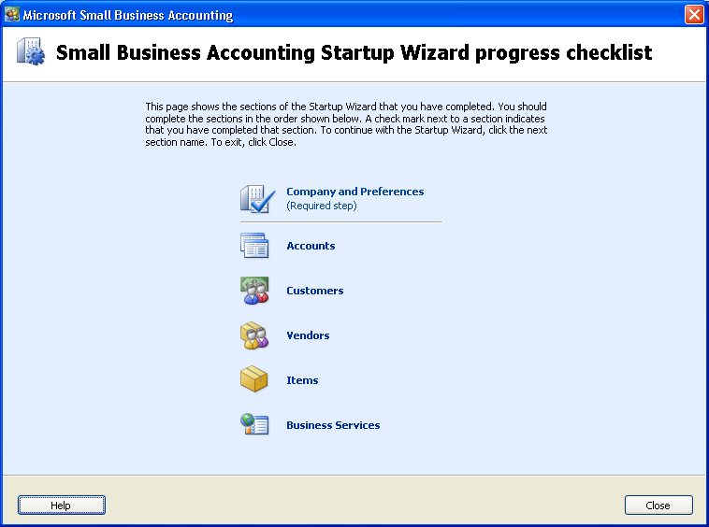
The Startup Wizard covers many important business functions automatically, getting Small Business Accounting 2006 running quickly and easily.
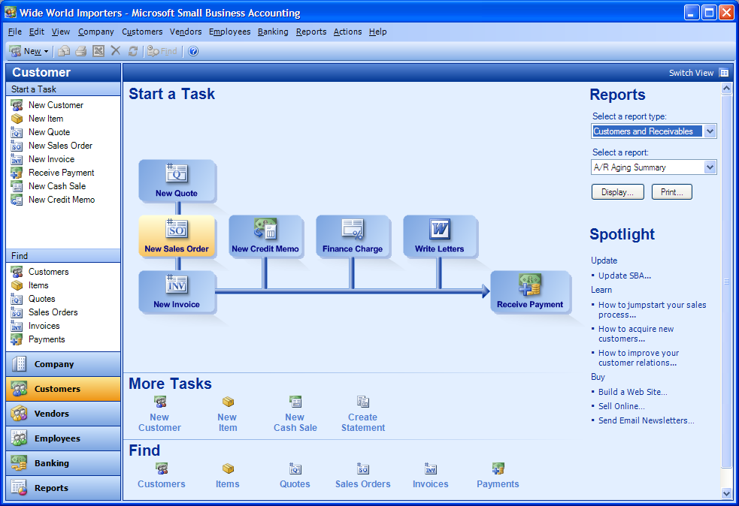
Small Business Accounting 2006 provides a familiar, intuitive interface, so users can get up to speed quickly.
  - Utilize existing financial information. Small Business Accounting 2006 is designed to incorporate financial information from other sources. This includes not just other Office programs such as Excel, but also accounting software such as QuickBooks. The Small Business Accounting 2006 Startup Wizard helps import master records such as chart of accounts, customers, vendors, items, employees, and supporting tables as well as beginning balances, and helps users get started using existing information immediately.
  - Customize reports, invoices, and letters. Using the templates in Small Business Accounting 2006, business owners and managers can easily create quotes, invoices, and purchase orders and use existing, up-to-date customer data to populate the forms. Quotes can easily be converted to sales orders and invoices with the click of a button. These documents, along with customer letters, can be customized in Word to sharpen the professional appearance of marketing materials and financial documents, helping the company attract new customers and retain and existing customers.
  - Manage payroll and government taxes easily. Companies using Small Business Accounting 2006 can also choose online-based payroll functionality powered by payroll-industry leader ADP for an additional fee. The Process Payroll tool in Small Business Accounting 2006 provides a full-featured payroll and tax processing application that is simple to set up and use yet able to calculate federal, state, and local taxes. ADP offers multiple payroll options so that small businesses will be able to select a service that meets their needs. In addition, seamless integration between Small Business Accounting 2006 and ADP allows users to import timesheet data directly into the payroll application, and payroll and tax information to the general ledgers.
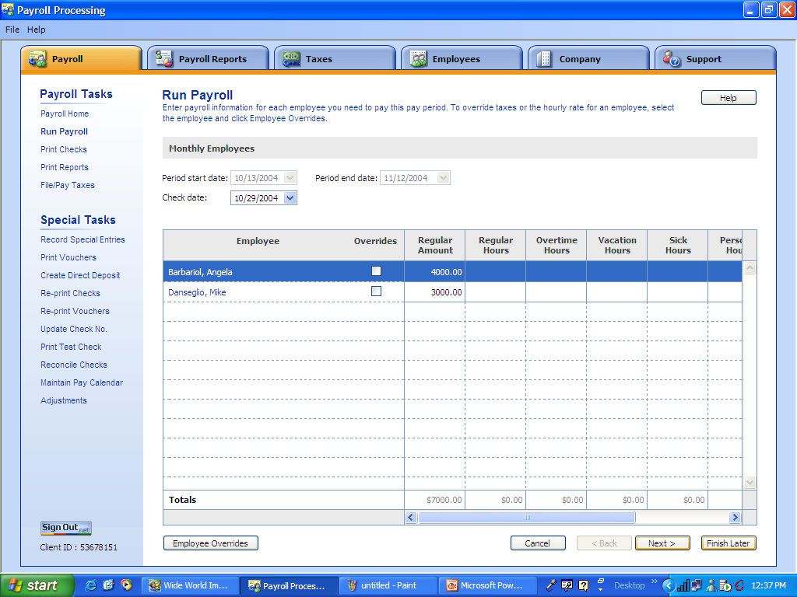
With ADP Payroll for Microsoft Office Small Business Accounting 2006, timesheet data can be imported directly into the payroll application.
  - Automate bank accounts and customer payments. Small Business Accounting 2006 helps small business owners manage multiple company bank accounts and maintain one consolidated view of their various accounts. This includes writing and printing checks from those accounts. Small Business Accounting 2006 also enables the business owner to customize and organize customer payments, even allowing for credit card purchases—it will print receipts and create customer credit memo templates for future transactions.
  - Track data by job. Many companies, such as consulting firms and contractors, organize their businesses around specific customer jobs. Small Business Accounting 2006 helps business owners track revenues and expenses by job, and monitor and compare total job profitability. They can also track estimated versus actual job costs, and compare job progress invoices versus quotes. This data becomes useful for business planning, for example, or to increase accuracy of future job estimates.
  - Accommodate novice and experienced accountants. Small Business Accounting 2006 is so easy to use that novices with no prior accounting knowledge can start right in. Even so, it has advanced features that make work easier for experienced accountants and bookkeepers.
  - Track all transactions. Users can see detailed views of each transaction, to show which accounts are being posted. More advanced users can also take advantage of the audit trail feature, to see what transactions were entered on specific days as well as any changes made to the records. This makes it easier to work with a bookkeeper, to find and fix mistakes, or to view recent changes.
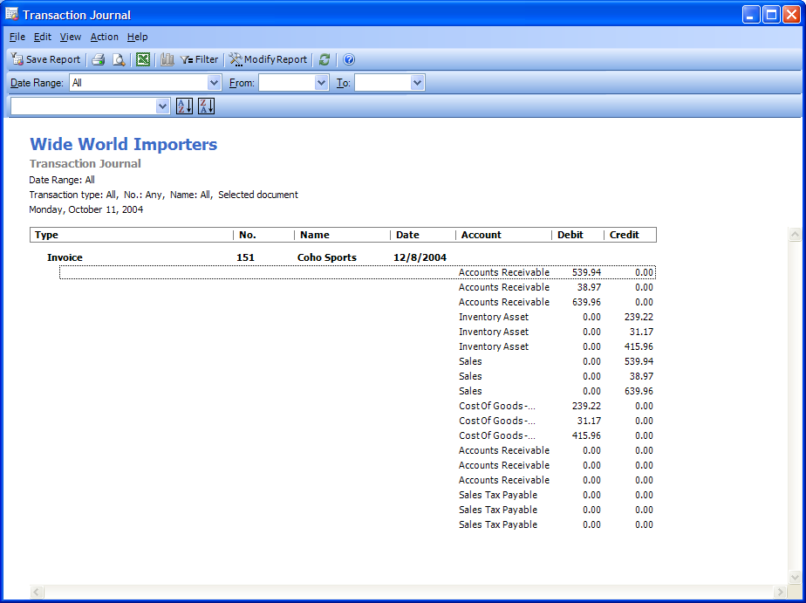
The transaction journal provides a view of business activity, along with insight into the details of each transaction.
Customer Scenario: Northwind Traders
PROBLEM: Jumbled islands of data
Northwind Traders is a six-employee company specializing in high-end sports equipment. For years, company founder Brenda Diaz ran the business off a single computer, but with new employees she has acquired more computers as well.
Brenda and her staff all use the Microsoft Office System, but as each person developed his or her own set of contacts and processes, they also developed their own ways of keeping track of information. Documents one person created in Word were built by another in Excel. Sometimes documents were simply hand-written in a notebook on the sales manager’s desk. Customer and prospect lists could be in Excel or Access.
In addition, a significant amount of company information was kept on often-unorganized pieces of paper throughout the office. All of that data had to be entered manually into the appropriate system, a chore which often got postponed as other business activities took precedence.
SOLUTION: Easy-to-use accounting with Small Business Accounting 2006
Brenda needed a solution that would allow her to use existing data and continue using the Microsoft Office programs she and her company were familiar with, and wouldn’t require large amounts of training or downtime after installation. She decided on Small Business Accounting 2006 because the integration with other Microsoft Office programs would allow her employees to reuse templates and data they used every day, and she would be able to get started working right away with the familiar Office interface.
Get Started Quickly
Using the Startup Wizard, Brenda was able to get and could import data directly from their existing Excel spreadsheets. Brenda didn’t experience any downtime, because once she imported her files, she could get right to work. And she didn’t have to complete the entire setup to get started: she can come back to setting up her online banking when her part-time bookkeeper arrives at the office.
Easily Create Financial Documents
In Small Business Accounting 2006, Brenda can create a quote, using the existing customer information that immediately populates the form with customer address and information already in the accounting program. With the click of a button, Brenda can convert the quote to a purchase order or invoice. She no longer has to re-enter data in separate forms, and can even export the invoice directly to Microsoft Word, enabling her to add the Northwind Traders logo and a personal note before e-mailing it to the client.
Automate Payroll and Other Financial Processes
With Small Business Accounting 2006, Brenda was able to choose the payroll solution that matched her needs through payroll-industry leader ADP. Seamless integration between Small Business Accounting 2006 and ADP allows Brenda to automate everything, from timesheets to taxes to direct deposits, for an additional fee. It eliminates the mess of paperwork on her desk and ADP makes it easy for her to pay employees on schedule. It automatically supplies her with the latest tax forms and calculates her state, local, and government taxes. With this taken care of, Brenda now has time to look beyond her day-to-day tasks and can spend more time planning for her company’s future.

Save Time and Reduce Errors
Losing a customer connection or missing a sales opportunity because of insufficient information or inadequate time is always frustrating. Attracting existing clients and retaining new ones depends on accurate, timely response to customer requests, and ample time to process sales leads. Without access to the right information when it is needed, companies often miss opportunities that could help them grow as a business. Transactions can be lost or delayed if not tracked efficiently, and customers don’t want to work with a company that is slow to process orders. Customers don’t like getting conflicting information or duplicate communications. Small business owners don’t want customers to be put on hold while an employee searches for an answer to a customer inquiry. They need to ensure that the business works efficiently and makes the best use of the time and resources available.
Companies need a centralized location for information and a solution that helps them make the most of that information. Although Small Business Accounting 2006 can be used as a standalone product, it integrates fully with familiar Microsoft Office 2003 Editions programs*, such as Word, Excel, and the updated version of Outlook with Business Contact Manager, allowing employees to share data among the programs they use everyday. In addition, companies need features to help them work more productively and simplify processes. With easy-to-use reports and lists, invoices, and tracking tools, Small Business Accounting 2006 helps businesses stay on top of changing business and customer needs.
Small Business Accounting 2006 helps keep the small company on top of its transactions, by helping the small business owner to:
  - Get a complete view of the customer. Using the Customer Home page in Small Business Accounting 2006, businesses can get an immediate view of the state of each account. From a financial summary to information about any outstanding payments or balance information, companies can stay up-to-date on the latest customer needs.
  - Manage employee time tracking. Billable time is the lifeblood of service businesses. Business owners and managers can track and manage billable time and monitor employee time records directly in Small Business Accounting 2006. Employees can manage timesheets in Small Business Accounting 2006 or with Outlook 2003 with Business Contact Manager Update integration. They can mark appointments in their Outlook calendars as billable time, and then transfer that information to the accounting program with a single button click. A time slip can be created in Small Business Accounting 2006 from an appointment in the Outlook Calendar. With all these features, companies can achieve more accurate, timely billing of time and therefore lose less services revenue.
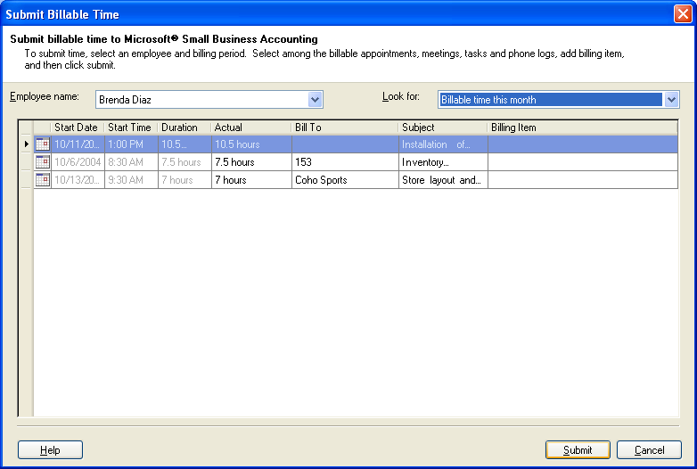
Appointments can be marked as billable in the user’s Outlook Calendar, and easily submitted as billable time directly from Outlook into Small Business Accounting 2006.
  - Manage vendors effectively. Small Business Accounting 2006 enables tracking of vendor transactions, so small business can keep on top of the supply chain. Users can customize vendor lists, print checks, and create new purchase orders and credit memos. In addition, they can share records with Outlook with Business Contact Manager Update, making it easier to monitor orders, deliveries, invoices, and outstanding payments.
  - Get detailed reports on customer accounts. Small Business Accounting 2006 offers more than 60 customizable, pre-formatted business reports and lists that help small companies keep track of the sales pipeline, account history, neglected accounts, and more. For example, to accurately measure and predict sales activity across opportunities and existing customers, users can run reports that show sales status, order information, and probability of closing. Salespeople can filter data to view status for accounts they’re working on, or to show customers and opportunities that haven’t been contacted recently. Results can be exported to Excel 2003 or Excel 2002 for further analysis or formatting.
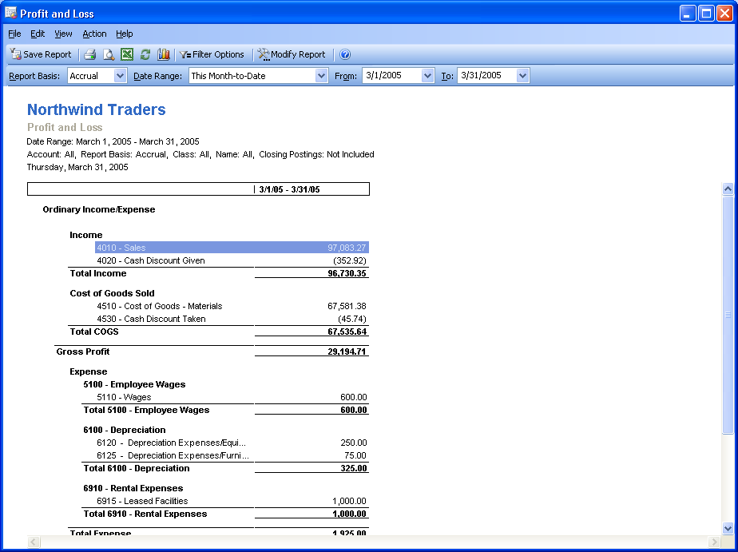
With more than 60 customizable, pre-formatted business reports, small businesses can keep track of their company’s Profit and Loss Statements, Balance Sheet, Cash Flow Statement, and more.
  - Authorize access for multiple simultaneous users. Small Business Accounting 2006 enables business owners to control access to sensitive data based on employee role, without limiting employees’ ability to be effective. When access is granted, up to five users can simultaneously access the information they need for their specific tasks, without having to wait for others to exit the program. What’s more, new multi-user access functionality in Outlook with Business Contact Manager Update gives employees direct visibility into the company’s sales pipeline. Sales leads can easily see who is working on what, and what stage each account is in, giving them better information for forecasting revenues and allocating resources.
  - Export quotes, invoices, and more to Word. Because Small Business Accounting 2006 fully integrates with other Microsoft Office 2003 Edition programs, users can export information from the accounting software to their existing Microsoft Office programs. Financial documents created in Small Business Accounting 2006 can be exported to Word with the click of a button and companies can customize templates that come with Small Business Accounting 2006 to create professional-looking marketing materials and documents.
  - Analyze data with Excel integration. Integration with Excel allows for additional customization of reports and lists, to facilitate analysis. Users can also export lists and reports o Excel, maintaining rich formatting and formulas, for additional tracking and information.
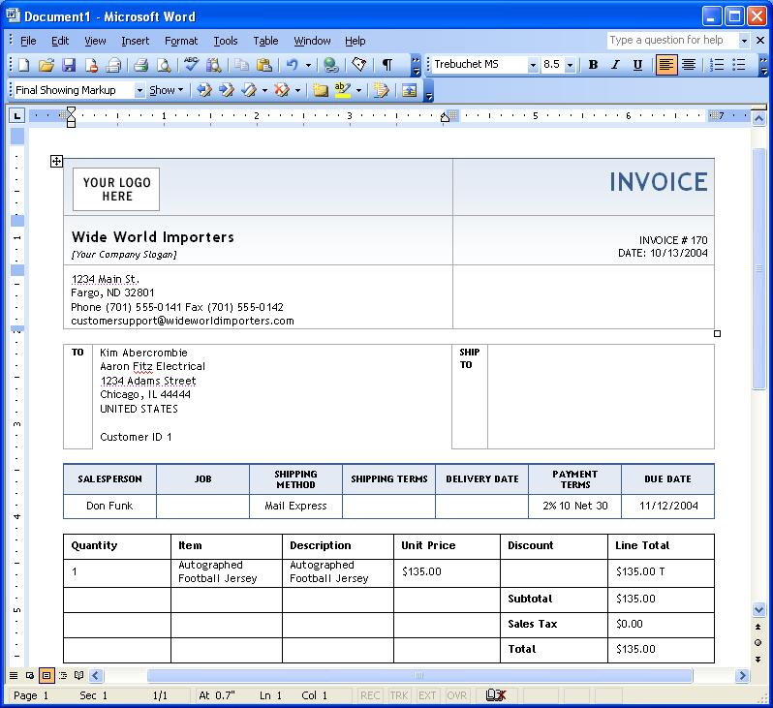
Integration with Word makes it easy to create consistent, accurate documents to communicate with customers, vendors, employees, and partners.
Customer Scenario: Northwind Traders
PROBLEM: Supporting customer service and sales
Northwind Traders has always managed its customer and sales information the same way it handles financial data: primarily manually. Most customer-facing employees, including the sales manager and sales assistants, have different ways of taking notes and recording activities, some even jotting down notes on slips of paper. Employees often respond to customer e-mail queries without keeping a good record of what has been sent.
As the owner, Brenda knows that in the competitive sporting goods industry, customer service is paramount, and missing sales opportunities means missing revenue that is hard to make up. Meanwhile, the growth of the business has resulted in more and more phone calls and e-mail inquiries about new product lines. And because Northwind Traders now is dealing with vendors, Brenda has found that some clients deal with three our four contacts within her company: one for sales, another for purchasing, and so on. So revenue is suffering, and she worries that she’s over-billing some customers and under-billing others.
SOLUTION: Easy access to customer information
With Small Business Accounting 2006, Brenda can review customer information to resolve outstanding issues, look for unfulfilled orders or late payments, investigate discrepancies in an account, and more. And with role-based permissions, Brenda can share that information with key employees, making sure that everyone who needs to know is informed of the latest changes. Brenda can also use the reporting functionality in Small Business Accounting 2006 to analyze and organize the same information for investors and employees.
In addition, salespeople can easily create quotes and then transfer them to purchase orders or invoices without retyping any information. Using inventory lists and inventory forecasting tools, the sales team can also plan for each transaction, determining when they need to reorder items based on different sales projections.
Track and Manage Employee Time
Small Business Accounting 2006 helps Brenda manage her employee timesheets directly in the accounting program. Because Brenda is using ADP Payroll for Microsoft Office Small Business Accounting 2006, she can import the timesheets directly to ADP for processing. Among other tasks, ADP calculates her government, state, and local taxes, and manages direct deposit for her employees for an additional fee. She can also run time reports to analyze her employees’ billable time using payroll reports in Small Business Accounting 2006.
Share Information and Help Reduce Employee Error
With true multi-user access in Small Business Accounting 2006, Brenda can select and authorize employee access to sensitive data based on responsibility. Users don’t have to wait for each other to log in and out, but can access the same information simultaneously. For instance, Brenda’s sales team can access vendor and inventory information at the same time, so that they can all respond accurately and quickly when speaking to customers. They can update the inventory lists, making sure that Brenda knows when Northwind Traders needs to place product orders.

Make More Informed Business Decisions
It’s best to go into any decision fully informed. Small business owners want nothing less when it comes to decisions about the companies. For a small business, every decision is big—from how to allocate the month’s vendor payments to whether to bring on new staff or bring a new focus to the business. The small business owner wants to be confident about any decision, with all relevant information in consideration.
Small Business Accounting 2006 provides a wealth of information for small business owners to use in day-to-day operations as well as in business-critical decisions. Detailed information is quickly and easily available not only about the company itself—including rich financial reports, sales and supply chain data, employee management, and forecasting—but also about customers, including account data, communication histories, contact information, and more. Best of all, these features come in the easy-to-use, familiar Microsoft Office interface. This means company owners can collect the information that’s needed when they need it, without leaving the programs they use every day.
Small business owners looking for a broad range of detailed financial information will find a number of benefits from Small Business Accounting 2006, including:
  - Get one view of the company. When business and financial data is unified in one place, the business owner or manager can get a look at the fiscal health of the company on a single screen. With Small Business Accounting 2006, a quick overview is always just a click away, in the Company Home page. This is a customizable window into the business, showing reminders; recent cash flow with forecasting ability; information on bank accounts, vendors, and customers; and more. The Company Home page gives a snapshot of the important information and captures the critical tasks and reminders in one location, so business owners and managers can always stay on top of changing customer and accounting information and get an overall sense of the company on one screen.
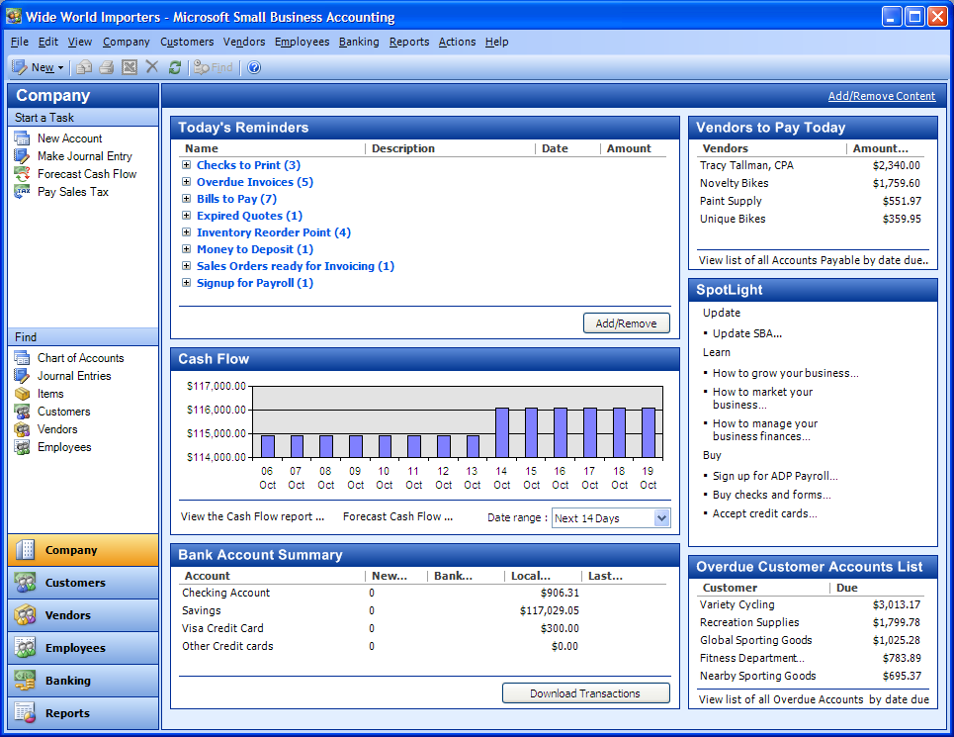
The Company Home page provides a centralized, customizable view of critical business information.
  - Analyze data with modifiable reports. Small Business Accounting 2006 also has templates for more than 60 reports for detailed breakout of data. With reports ranging from profit-and-loss and cash flow to item profitability and customer transaction history, small business owners and managers can get a range of different views of their information. In one easy-to-use source, owners and managers are empowered with many kinds of financial information from across the company. In addition, the reports can be modified, allowing users to set filters, change fonts and formatting, and more, allowing companies to customize reports to meet their unique needs.
  - Forecast cash flow, inventory, and sales. Small Business Accounting 2006 includes tools that help with complete and accurate analysis of history and trends. Its cash flow management tool keeps track of invoices, bills, and payments to help businesses manage and predict cash flow easily. Small business owners can model rich “what if” scenarios for different time periods to help forecast future cash flows and easily make decisions about which customers to contact or which bills to pay. Plus, an inventory tool automatically updates quantities when invoices are created. Companies can track and adjust their overall inventory quantities in the system, in real time, and can use the physical inventory worksheet to perform a physical count.
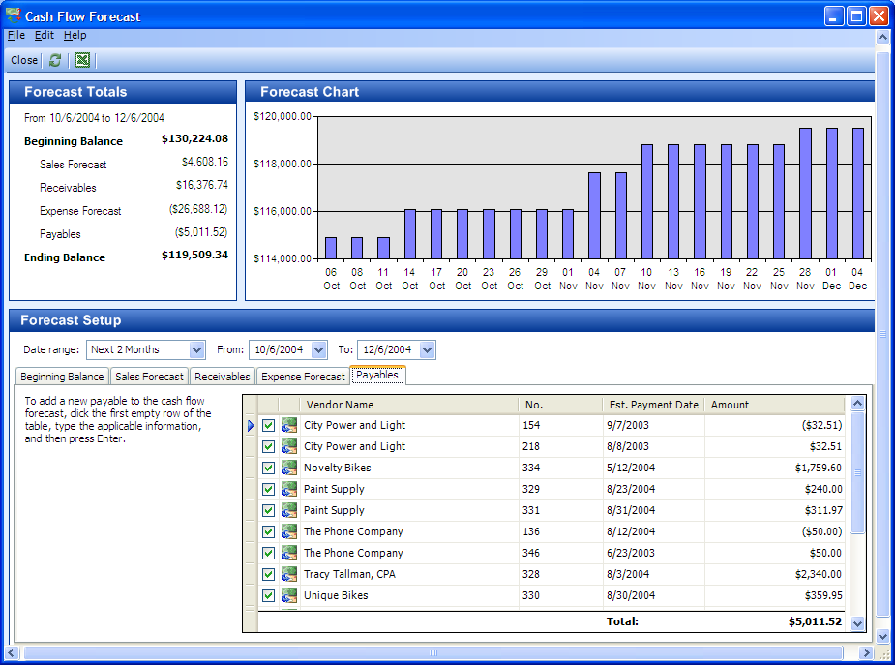
The cash flow management tool helps owners understand, manage, and predict the company’s cash position.
  - Track customer financial history. Within each account in Small Business Accounting 2006, small business owners and managers can access the latest financial history, including a record of all customer payments, invoices, and quotes, along with a financial summary of the latest information to date for each client. This allows sales leads and office managers to easily access all of the most up-to-date customer information in one location and immediately see the status of each account.
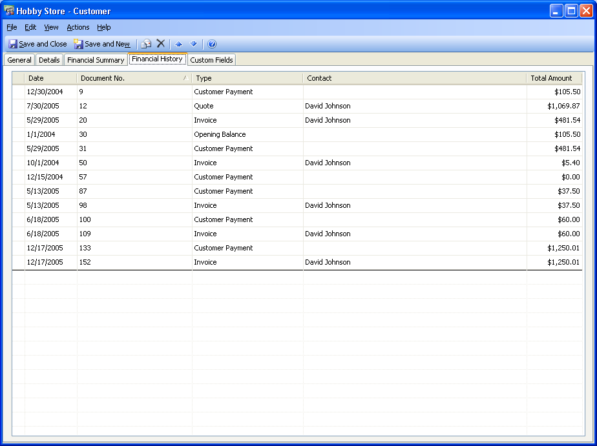
Small Business Accounting 2006 provides a complete view of each customer’s financial history.
  - Access and share account and contact information. When used with Outlook 2003 with Business Contact Manager Update, Small Business Accounting 2006 provides many rich data-sharing and account management features that help companies manage each opportunity throughout the sales cycle, stay on top of communications, and maximize sales potential. Users can associate business contacts with the account to allow a comprehensive view of a customer account, including contact information, e-mail and other communication, activity history, and notes, all linked to the account in Small Business Accounting 2006. This keeps business owners and managers informed of account and customer changes and provides a central location for critical information, which can also be shared with employees selectively, based on their role.
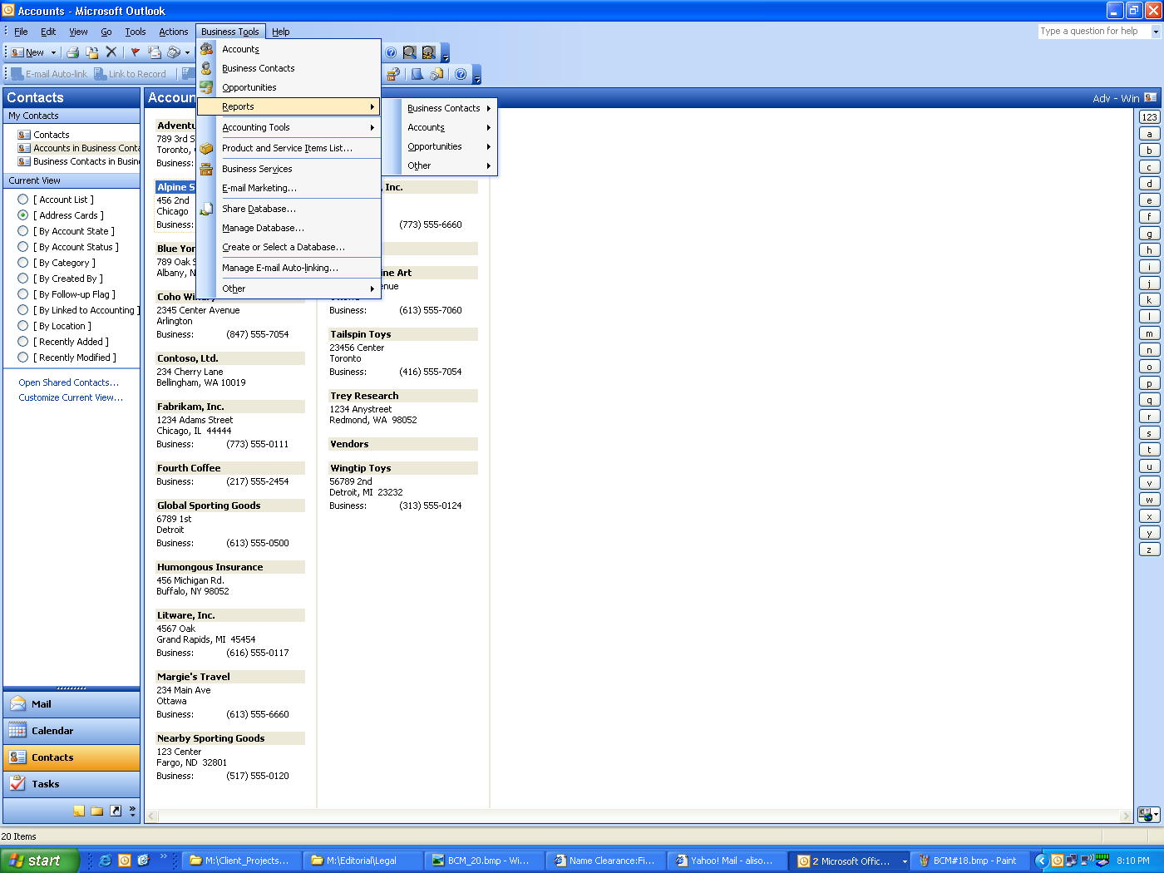
Microsoft Outlook with Business Contact Manager Update allows companies to create and manage accounts, business contacts and sales opportunities, and establish associations between companies and individual contacts—all within Outlook 2003.
  - Track customer communications and financial activity. Small Business Accounting 2006 can be used with Outlook with Business Contact Manger Update to provide an Activity History feature, which captures activities and communications related to an account, business contact, or business opportunity. Salespeople have instant access to all the information they need to work effectively with customers and other business contacts. Extensive information related to interactions with individuals or companies—including e-mail messages, calendar items, notes—can be accessed, viewed, and updated from one location and compared to any financial history or financial activity that is tracked in Small Business Accounting 2006.
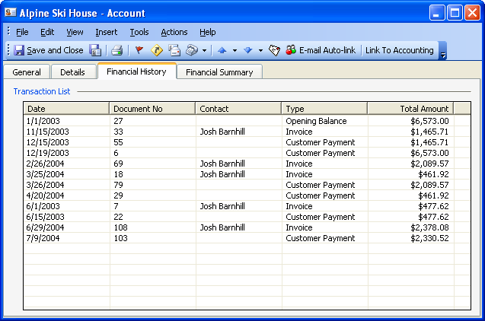
Business Contact Manager Update provides a complete view of each customer’s financial history.
  - Benefit from fast, reliable data processing. Small Business Accounting 2006 is built on the desktop version of Microsoft SQL Server™, a leading business database. This means that the program can handle a large amount of information while providing strong performance and stability, and that there is substantial room for high volumes of transactions. Small Business Accounting 2006 is designed to accommodate busy short-term times as well as long-term company growth.
Customer Scenario: Northwind Traders
PROBLEM: Planning for the future
At Northwind Traders, Brenda, the company owner, was always swamped by the day-to-day tasks of keeping her company afloat; she never had the time or resources to plan more than a week ahead. Brenda had packed days: between meetings to brief employees on the latest client changes and the time spent weeding through the daily paperwork, she barely had time to analyze the numbers and make decisions about the direction she was taking her company. Brenda knew that if she wanted to grow her company and attract new clients, she had to devote some of her day to strategic planning, but the day-to-day work never seemed to let up. And often, when talking to clients, Brenda didn’t feel that she had a complete view of what was going on across the company and knew she needed to be better informed when talking to her clients.
SOLUTION: A complete view of the company
Now that Brenda is using Small Business Accounting 2006, she gets an instant view of the day’s most critical items on the Company Home page. Brenda has customized her Company Home page, so now she has a view of her cash flow, overdue customers, vendors to pay, and a list of reminders, such as checks to write and bills to pay. Small Business Accounting 2006 takes care of Brenda’s daily task list and, because it’s all stored in the accounting software, allows her to pay bills or check in on overdue customer accounts with a single click.
Track Customer Communications
With the combination of Small Business Accounting 2006 and the updated version of Outlook 2003 with Business Contact Manager, Brenda can share her customer contact database with the sales team so that everyone who needs to can get a clear picture of the latest customer activity. With Outlook with Business Contact Manager Update, everyone working with a particular account can attach the latest notes, e-mail messages, scanned documents, and more to the account in Outlook. And with the full integration with Small Business Accounting 2006, all employees with granted access have a complete view of each customer’s financial status and financial history—including quotes, invoices, credit history—attached directly to the account in Outlook.
Forecast Cash Flow, Inventory, and Sales
With her Company Home page, Brenda can immediately see the changes to the company’s cash flow. It is easy for Brenda and her managers to make quick, informed decisions about the business using the cash flow forecast tool. Brenda can monitor sales flow, forecast expenses, and determine how potential sales will change the inflow and outflow of cash. In addition, the inventory tool automatically updates when changes are made by her sales team, so Brenda can use her inventory reports to make up-to-date projections on item profitability and more. Now when customers call, Brenda can make quick decisions about accounts, sales, and inventory needs—and make sure she plans for the future of her company.
Room to Grow and Adapt
Northwind Traders’ bookkeeper can take advantage of the more sophisticated features in Small Business Accounting 2006 to monitor different company transactions and create an audit trail to track who made what edits to which transaction and when. As the company grows, the SQL Server database on which Small Business Accounting 2006 is based is capable of greater storage. And as the company’s needs become more sophisticated, the company can migrate seamlessly to enhancements offered by Microsoft Business Solutions.

System Recommendations
Here are the system requirements for Small Business Accounting 2006:
  - Personal computer with an Intel Pentium 450-megahertz (MHz) or faster processor (Pentium III recommended)
  - Microsoft Windows® 2000 with Service Pack 3 (SP3) or later, or Windows XP or later operating system
  - 280 MB of available hard disk space (hard-disk use will vary depending on configuration; custom installation choices might require more or less hard-disk space)
  - 256 megabytes (MB) of RAM or more recommended
  - Super VGA (800 × 600) or a higher-resolution monitor
  - CD-ROM or DVD drive
Additional Items or Services
Additional items or services are required to use certain features:
- Internet functionality requires dial-up or broadband Internet access provided separately; local or long-distance charges may apply.
- For certain integration functionality, including Export to Excel and Word, Office Professional Edition 2003 is required.
- Office Professional Edition 2003 is required to create customized invoices, sales orders, quotes, customer credit memos, customer statements, and purchase orders; Office XP or later is required to export data to Word or Excel; Outlook 2003 with Business Contact Manager Update is required to share financial data with the Outlook messaging and collaboration client.
- 3rd party services including ADP payroll are available for additional fees.
Sharing Functionality
To enable sharing functionality, the host machine must be running Windows 2000 with Service Pack 3 or Windows XP Professional Edition.
Additional Resources
Visit www.microsoft.com/office/accounting where you will find much more information about Small Business Accounting 2006.

