Microsoft® Office PerformancePointTM Server 2007   
Planning: Model Future Performance with Streamlined Planning, Budgeting, and Forecasting

**Microsoft® Office PerformancePoint™ Server 2007 is an integrated performance management application that provides robust monitoring, analytics, and planning capabilities. PerformancePoint Server 2007 helps businesses to articulate goals, monitor business activity, identify and analyze issues, collaborate and take action.**

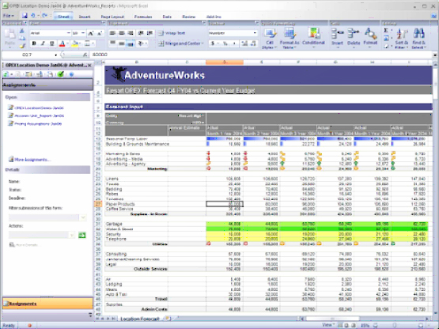

*Easily plan and monitor budgets with Microsoft Office Excel®.*

Planning, Budgeting, and Forecasting with PerformancePoint Server 2007

Effective planning, forecasting, and budgeting are essential to business success. But too often many organizations view planning and budgeting as a once-a-year financial process. Business users often spend more time collecting and validating data than analyzing and planning.

PerformancePoint Server 2007 makes planning, budgeting, and forecasting part of a dynamic, ongoing performance management process.

Built on the stability, security, and scalability of the Microsoft SQL Server™ Business Intelligence platform, PerformancePoint Server 2007 enables business users to interact with and continuously contribute to business planning, budgeting, and forecasting in real time—all through the familiar and easy-to-use Microsoft Office environment. The Business Modeler simplifies business modeling by guiding users through the process so they can test multiple approaches and view a variety of possible outcomes.

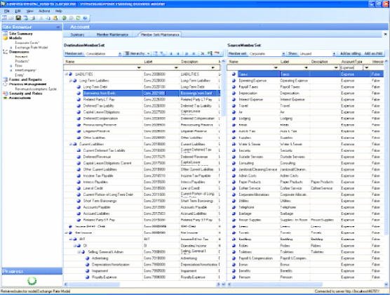

PerformancePoint Server 2007 simplifies business modeling.

Key Features

Users gain powerful planning, budgeting, and forecasting information in real time through these key PerformancePoint Server 2007 features:

Build, modify, and maintain without coding

The user-friendly design and wizards enable users to create plans, budgets, and other business documents without the need for programming, and users can customize their plans and budgets according to how they work.

Flexibility

Create plans and budgets, and test different scenarios using top-down, bottom-up, or across-business models.

Single view of business

Easily integrate information from multiple data sources (internal and external) and multiple versions of plans and budgets into a single view for easy analysis and reporting.

Collaborative environment

Integration with Microsoft Office Excel, Microsoft Office Outlook®, and Office SharePoint Server 2007 makes it easy for users to collaborate when planning, budgeting, and forecasting.

Benefits

PerformancePoint Server 2007:

* Drives consistency throughout the performance management process

Server-side business rules and real-time calculations scale to support a wide range of users with consistent processes and data, and simplify the consolidation of multiple budgets into corporate rollup. Data entry forms, workflow, submissions, approvals, templates, and other forms streamline the planning, budgeting, and forecasting process.

* Drives consistency throughout the performance management process

Server-side business rules and real-time calculations scale to support a wide range of

users with consistent processes and data, and simplify the consolidation of multiple budgets into corporate rollup. Data entry forms, workflow, submissions, approvals, templates, and other forms streamline the planning, budgeting, and forecasting process.

Spans from single to enterprise-level model

Office PerformancePoint Server 2007 supports simple business models to enterprise-level scenarios. The unique model-to-model mapping capabilities help the application handle sophisticated scenarios easily.

Extends your Microsoft investment

Users benefit from the power and familiarity of the Microsoft Office system, Microsoft Office SharePoint® Server 2007, and the performance, scalability, and enhanced security of SQL Server.

System Requirements

|  |
| --- |
| PerformancePoint Server 2007 is based on the following Microsoft programs and technologies:  ●   Windows Server® 2003 SP1, Standard Edition, or later  ●   Microsoft Windows® XP Professional SP2, or later  ●   Microsoft Office 2003 SP2, or later  ●   Microsoft SQL Server™ 2005 SP2, Enterprise Edition, or later  ●   Windows Installer 3.1, or later  ●   Microsoft .NET Framework 2.0  ●   Microsoft Internet Information Services 6.0  ●   ASP.NET 2.0 |

For More Information

For more information about Office PerformancePoint Server 2007, visit <www.microsoft.com/performancepoint>.

For more information about Microsoft Business Intelligence, visit www.microsoft.com/bi