For customers solving complex computational problems, Microsoft® Windows® Compute Cluster Server 2003 (CCS) accelerates time-to-insight by providing a high-performance computing (HPC) platform that is simple to deploy, operate, and integrate with existing infrastructure and tools.
In 1991, 10 Gflops of computing power cost approximately $40,000,000. Today, that level of computing power can be achieved by combining four x86 machines at a cost of roughly $4,000 (USD), bringing the hardware acquisition cost of supercomputing down to the personal desktop level.
Windows Compute Cluster Server 2003 includes prescriptive setup procedures, a complete suite of management tools, and an integrated job scheduler. CCS integrates with Active Directory® and uses Microsoft Management Console (MMC) for cluster management. Additionally, Microsoft Visual Studio® 2005 includes support for parallel job development and debugging.
For more information about Windows Compute Cluster Server 2003 and high-performance computing visit the Microsoft Windows High-Performance Computing Web site at: http://www.microsoft.com/hpc.
Benefits of Windows Compute Cluster Server 2003
Windows Compute Cluster Server 2003 provides a cost-effective and powerful high-performance computing solution that runs on commodity x64-based computers. CCS can be deployed, managed and extended using familiar tools and technologies.
Faster Time-to-Insight
Wizards simplify and speed the initial installation of the head node. Compute nodes can be installed manually or by using automated deployment tools, Windows Compute Cluster Server 2003 leveraged RIS for automated deployment, but administrators can use non-Microsoft tools as well.
Better Integration with IT Infrastructure
Windows Compute Cluster Server 2003 uses Active Directory and MMC 3.0 to provide a simple and familiar interface for managing and administering the cluster. Integration with Active Directory enables role-based cluster management by assigning Administrator and User roles.
Familiar Development Environment
Developing applications for Windows Compute Cluster Server 2003 allows developers to use their Windows-based skills and experience. Visual Studio is the most widely used integrated development platform (IDE) in the industry, and Visual Studio 2005 includes support for developing HPC applications including parallel compiling and debugging. Additionally, Windows Compute Cluster Server 2003 supports the industry-leading MPI2 standard.
Microsoft Message Passing Interface
The Microsoft Message Passing Interface (MS MPI) in Windows Compute Cluster Server 2003 is derived from the Argonne National Labs implementation (MPICH2) of the MPI2 standard. MS MPI uses the WinSock Direct protocol for best performance and CPU efficiency. MS MPI can utilize any Ethernet interconnect that is supported on Microsoft Windows Server™ 2003. Support for low-latency, high-bandwidth interconnects, such as InfiniBand or Myrinet, is enabled through Winsock Direct drivers provided by the hardware manufacturers.
Job Scheduler
Windows Compute Cluster Server 2003 includes both a command-line job scheduler and the Compute Cluster Job Manager: a Win32 GUI that provides access to the Job Scheduler for the creation, submission, and monitoring of jobs in the cluster. The Command-Line Interface (CLI) supports Perl, FORTRAN, C/C++, C#, and Java. Key scheduler features include error recovery, automated cleanup, and security.
Security
Windows Compute Cluster Server 2003 uses Active Directory to enable role-based security for all cluster jobs and administration. All jobs run under the context and credentials of the submitting user. Credentials are stored with the job and deleted at the completion of the job.

Architecture
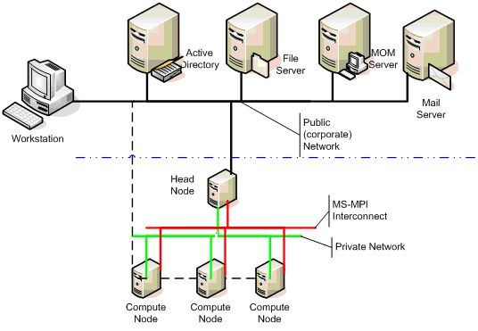
The Windows Compute Cluster Server 2003 head node:
- Controls and mediates all access to the cluster resources.
- Is the single point of management, deployment, and job scheduling for the compute cluster. Windows Compute Cluster Server 2003 uses the existing corporate infrastructure and Active Directory for:
  - Security
  - Account management
  - Operations management using tools such as MOM 2005 and System Management Server (SMS) 2003

System Requirements
The minimum system hardware requirements are similar to the hardware requirements for Windows Server 2003, Standard x64 Edition. Windows Compute Cluster Server 2003 supports up to 32 gigabytes (GB) of RAM. Supported processors include AMD Opteron, AMD Athlon 64, Intel Xeon with Intel EM64T, and Intel Pentium with Intel EM64T.
Windows Compute Cluster Server 2003 Requirements
CPU Requirement | 64-bit architecture computer  Intel Pentium, or Xeon family with Intel Extended Memory 64 Technology (EM64T) processor architecture, or  AMD Opteron family, AMD Athlon family, or compatible processor(s).
Minimum RAM | 512 MB
Maximum RAM | 32 GB
Multiprocessor Support | Up to 4 processors
Disk Space for Setup | 4 GB
Disk Volumes | Head node requires a minimum of two volumes (C:\ and D:\). For additional roles, additional partitions are recommended.  Compute node requires a single volume.  RAID 0/1/5 may be used, but is not required.
Network Interface Cards | All nodes require at least one network interface card.  Each node may require additional network interface cards as appropriate depending upon network topology or for public network access or in support of an MPI network.

