
A New Era in Visual Simulation
Microsoft® ESP™ is a visual simulation software development platform that brings immersive games-based technology to training and decision support for commercial, government, and education organizations.

Microsoft ESP is a developer-ready platform that enables the creation of powerful, affordable solutions to augment real-world training and support decision making. The ESP™ platform’s engine, tools and content are already used today in Microsoft Flight Simulator X, a popular entertainment platform for immersive simulation and visualization.
Full Simulation Platform
Microsoft ESP delivers a complete, all-in-one platform: a powerful simulation engine, software tools and realistic world content that enable developers to affordably and rapidly create compelling simulation solutions for their customers.
ESP runs on Microsoft Windows® and supports rapid simulation development, rich extensibility and built-in integration with industry standard hardware devices, including joysticks, game controllers, yokes, and much more.
ESP models the entire world, while also allowing developers to easily add their own content, objects, scenery, simulation functionality, and scenarios to create custom training solutions.

Dynamic, Immersive Environments
Solutions built on Microsoft ESP engage users in immersive experiences with very realistic land, sea, and air environments. ESP solutions are ideal tools for training, evaluating, and preparing personnel for optimal performance in the real world.
The platform offers highly accurate 3-D geography, a modifiable weather system, continuous time of day, five seasons, a dynamic living world, detailed cities, realistic scenery objects, and wildlife. ESP also supports 5.1 surround sound. Multiplayer interactivity is enabled via built-in Voice Over IP and chat capabilities. Using ESP, organizations can provide team-based training and rehearsal to personnel around the globe—regardless of their physical location.
Improved Training ROI and Outcomes
Business today is all about outcomes, and the best outcomes are often delivered by a well-trained workforce. Unfortunately, much of today’s training fails to deliver the improved performance that enables organizations to create and maintain a competitive advantage.
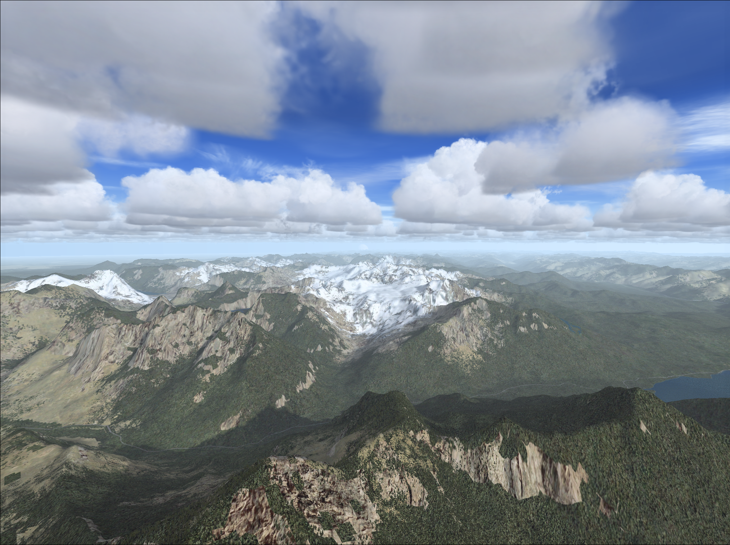
The training tools and processes often used today have not changed substantially in decades. Few organizations have exploited the significant advances in immersive, games-based technologies and computer portability for their training. Yet such technologies can deeply immerse students in their learning, appreciably enhance their retention, promote ongoing training and rehearsal, and improve overall outcomes.
Successfully preparing today’s multitasking workforce to respond well in real-world situations requires more than just books and lectures. With quality immersive training experiences, learners can engage their minds, emotions, and senses so training outcomes support and advance your organization’s mission.

Key Microsoft ESP Features
Microsoft ESP brings immersive games-based technology to training and learning, decision support, and research and development modeling for government and commercial organizations.
A Complete Platform. Take advantage of a proven client simulation engine, development tools, and ready-to-use baseline dataset/content.
Powerful Tools. Control object placement and activation, scenery and terrain, AI movement, special effects, and environmental attributes.
Rich World-Wide Content. ESP ships with several gigabytes of scenery data, vector data, buildings, landmarks, navigational aids, and over 24,000 civil and military airports.
Extensibility and Integration. Design ESP simulations that can integrate with external solutions. Enhance realism using DEM, satellite imagery, vector data, and 3-D objects.

Economical, Windows-Based Platform. Achieve exceptional results in less time by putting your Windows development skills to use on commercial off-the-shelf (COTS) systems.
High Fidelity Simulation. A full 6DoF extensible physics model enables robust, real-time modeling of air, sea, and land-based vehicles.
Extensible, Synthetic Cockpit Simulation. Exhaustive library of instruments and gauges plus a robust toolset that allows for detailed customization of cockpit functionality and appearance.
Comprehensive Simulation System. Macro-simulation of planetary model includes magnetic variation, weather and atmospheric effects on vehicle subsystem simulation.
Dynamic Living World. A landscape teeming with moving vehicles, birds, and animals, weather, and continuous time of day add to the immersion.
Dynamic, 3-D Immersion. Experience “you are there” realism with the latest in PC graphics technology, including dynamic lighting, volumetric shadows. and native support for DirectX 10 technology.
Configurable, User-Adjustable Weather System. Use ESP’s near-real-time weather, select your own weather pattern, or import weather data from your preferred source.
Automatic Scenery Fill-In Capability. Microsoft’s patented AutoGen technology provides geotypical object and texture coverage over the whole surface of the Earth.
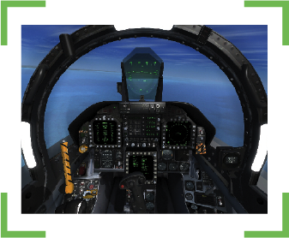
Create Custom Missions. Build realistic, repeatable training scenarios on land, air, or sea using powerful toolsets native to ESP.
After-Action Review (AAR). Record every action during a simulation experience for effective post-simulation review, evaluation, and measurement of user performance. Analyze data, capture video or digital images, and replay simulations.
Flexible Input/Output Hardware Integration. Incorporate third party hardware devices that support immersive experiences, including head- and eye-movement tracking devices, yokes, joysticks, pedals, and more.
Established Partner Ecosystem.
ESP has a rapidly growing network of developers and partners around the world, many of whom have already developed add-ons for Microsoft Flight Simulator X.
Licensing Information
As a client-only platform, ESP users must acquire one Microsoft ESP client license per desktop. A separately licensed SDK provides the tools you need to begin creating your world.

For more information on Microsoft ESP go to: http://www.microsoft.com/esp
© 2008 Microsoft Corporation. All rights reserved. Microsoft, ESP, and Windows are either registered trademarks or trademarks of Microsoft Corporation in the United States and/or other countries. This document is developed prior to the product’s release to manufacturing, and as such, we cannot guarantee that all details included herein will be exactly as what is found in the shipping product. The information contained in this document represents the current view of Microsoft Corporation on the issues discussed as of the date of publication. Because Microsoft must respond to changing market conditions, it should not be interpreted to be a commitment on the part of Microsoft, and Microsoft cannot guarantee the accuracy of any information presented after the date of publication. The information represents the product at the time this document was printed and should be used for planning purposes only. Information subject to change at any time without prior notice. This data sheet is for informational purposes only. MICROSOFT MAKES NO WARRANTIES, EXPRESS OR IMPLIED, IN THIS SUMMARY.

