
Unlocking Workforce Potential with Employee Performance Reviews Using the Microsoft Office System
Technical Discussion Guide

Information in this document, including URL and other Internet Web site references, is subject to change without notice. Unless otherwise noted, the example companies, organizations, products, domain names, e-mail addresses, logos, people, places, and events depicted herein are fictitious, and no association with any real company, organization, product, domain name, e-mail address, logo, person, place, or event is intended or should be inferred. Complying with all applicable copyright laws is the responsibility of the user. Without limiting the rights under copyright, no part of this document may be reproduced, stored in or introduced into a retrieval system, or transmitted in any form or by any means (electronic, mechanical, photocopying, recording, or otherwise), or for any purpose, without the express written permission of Microsoft Corporation.

Microsoft may have patents, patent applications, trademarks, copyrights, or other intellectual property rights covering subject matter in this document. Except as expressly provided in any written license agreement from Microsoft, the furnishing of this document does not give you any license to these patents, trademarks, copyrights, or other intellectual property.

© 2005 Microsoft Corporation. All rights reserved.

Microsoft, BizTalk, Excel, InfoPath, JScript, Outlook, SharePoint, Visual Basic, Windows, and Windows Server are either registered trademarks or trademarks of Microsoft Corporation in the United States and/or other countries.

All other trademarks are property of their respective owners.

1 Executive Summary 4
Purpose of This Guide 5
2 Business Challenges and Solutions 6
Business Challenges 6
Lack of Alignment with Company Goals 6
Trapped Information 6
Inability to Recognize Employee Skills 7
Inefficient Processes and Non-Compliance 7
Addressing the Business Challenges 8
Employee Performance Reviews Using Microsoft Technologies 9
Benefits 10
3 Architectural Overview 12
Example of a Solution Architecture 12
Example of a Solution in Action 13
Managing Performance Reviews 14
Initiating a Performance Review 14
Filling Out a Performance Review 14
Mapping Individual Goals to Corporate Objectives 17
Providing Employee Self-Reviews 18
Managing Goals 20
Linking Objectives 20
Updating a Performance Review 21
Finalizing Performance Reviews 22
Providing Managerial Feedback 22
Reviewing and Signing a Performance Review 24
Extending the Architecture 26
4 Software Considerations 27
Client Software Considerations 27
Server Software Considerations 28
Operations Considerations 30
Security Considerations 32
5 Next Steps 33
Resource and Skill Set Considerations 33
Business Analyst 33
Developer 33
Application Administrator 34
Potential Partner Solutions 34
Solution Showcase for the Microsoft Office System 35

1 Executive Summary
An organization’s most valuable asset is its employees. Performance reviews can offer a powerful way to optimize employee achievement and ensure that each employee’s work contributes to the growth and profit of the organization. When corporate goals are effectively communicated in reviews, employees can work more efficiently toward them. In addition to assessing performance and managing goals, reviews provide an opportunity for workforce planning. If managed well, reviews can also help an organization retain top performers. Many organizations, however, lack the tools to take full advantage of the potential of performance reviews.
Too often, organizations find that:
● Employee performance is not tied to strategic company goals.
● Important workforce data is trapped in documents, making reporting difficult.
● It is difficult to recognize employee skills, talents, or gaps.
● The process is inefficient or there is a lack of compliance in the process.
All of these issues can be addressed using a solution built on familiar Microsoft® technologies. The solution described in this guide provides an example of how the Microsoft Office System can manage performance review data so that it is more accessible to authorized stakeholders and is integrated with existing line-of-business tools and enterprise resource planning (ERP) tools. This integration of review data with existing technologies can help companies improve their review process, align their workforce with company objectives, and help improve bottom-line results.
Using familiar technology in Microsoft Office 2003 can help reduce the amount of time spent on manual processes by pre-populating Microsoft Office InfoPath® forms with known employee metadata and providing automated workflow and routing of forms. Managers, executives, and human resources departments can use Microsoft SharePoint® Products and Technologies to share and access all the related data to create and view reports on employee capabilities. This can help can managers and executives to communicate the company goals and set employee expectations.
Managers can use the portal to quickly gain insight into an employee's review to measure against the expectations. This makes data more easily available for downstream management functions such as compensation management and planning. Human resources departments can report on these efforts to help ensure the company is providing a consistent and compliant process, and it can plan for workforce needs.
Employees also benefit from using familiar tools in Office 2003. These benefits include easy access to company policies and procedures, pre-population of review forms with related manager goals or other known information, and storage of past reviews are that are easy to access. Both employees and the IT department benefit from using familiar tools because this reduces the amount of time spent implementing and training on a new performance review solution.

Purpose of This Guide
This guide provides conceptual information to help decision makers evaluate and recommend information technology solutions that can help companies manage their performance review processes more efficiently. The information in this guide does not include detailed implementation procedures of a performance review solution. However, it does provide information to help you understand the business challenges that you can address using the Microsoft Office System.
This guide is published as part of the Solution Showcase for the Microsoft Office System. The Solution Showcase for the Microsoft Office System highlights how leading organizations can use the Microsoft Office System to help solve important business challenges. Specifically, the Solution Showcase illustrates how partners are tapping into the value and power of building solutions based on the Microsoft Office products their customers already know and use every day.
The concepts described in this guide were developed in cooperation with Microsoft technology partners that can help your organization create a performance review solution based on Office and provide subject matter expertise and deployment and customization support. To learn more about partners, see the “Potential Partner Solutions” section in Chapter 5, “Next Steps.”
This guide details the following information:
● Business challenges and solutions: The chapter on business challenges and solutions describes the business challenges associated with existing performance review processes and systems and how you can use the Microsoft Office System to create a solution that addresses these challenges.
● Architectural overview: The chapter on the architectural overview describes a possible architecture for a performance review solution and how it might work at your company.
● Infrastructure considerations: The chapter on infrastructure considerations describes the various infrastructure considerations, such as software products to consider when envisioning and building a performance review solution and considerations related to the scalability and security of a solution.
● Next steps: The chapter on next steps provides possible approaches that you can use to implement your own solution using the Microsoft Office System.

2 Business Challenges and Solutions
This chapter highlights several challenges organizations face when implementing performance reviews. It also explains how a solution built with the Microsoft Office System can address these challenges and how an Office-based performance review solution can help organizations unlock the potential of their workforce.

Business Challenges
Forty-nine percent of companies felt that employee performance management was the most important human capital management investment they would make in 2004. Given increased global competition, companies realize that performance review processes are strategic to helping optimize their workforce. Many employee review processes, however, currently suffer from:
● A lack of alignment of employee work to the organization’s goals.
● Information that is trapped in documents.
● An inability for management to recognize employee skills, talents, and gaps.
● Inefficient processes or lack of compliance with HR regulations.

Lack of Alignment with Company Goals
Traditionally, aligning employee performance with corporate objectives has been an elusive goal. If an organization’s business goals and changing priorities are not communicated effectively, the organization fails to work as part of a coordinated effort, and performance suffers. Managers have difficulty measuring performance against organization goals, including peers and other stakeholders in employee reviews, and tracking employee goals and commitments between review periods. As a result, employees can become unhappy if they think they are doing well but their goals are not aligned with company goals, if it is difficult to maintain past review information, and if the review process becomes a burden with slow manual processes or a large amounts of time spent learning new tools to complete their reviews.

Trapped Information
Information is often locked away in documents where it is difficult to find and analyze. In an AMR Research report released in July of 2004, 44 percent of companies said they use Microsoft Word or Microsoft Excel® for employee performance management, and another 24 percent use paper forms. When important review data is trapped in documents and review forms are not designed for data extraction, it becomes a challenge to re-use that data, report on it, and use it for workforce planning. Paper forms and other forms that are not designed for integration with line-of-business applications also require a manual process for routing, workflow, and storage that can be chaotic and inconsistent. When review data is not accessible to other line-of-business applications and the review process becomes slow and inefficient for key stakeholders, it is difficult for employee measurement to be aligned with corporate goals. This makes it hard to apply employee skills and talent where they are most needed.

Inability to Recognize Employee Skills
Investing in the ability to meet company goals no longer means investing in only the physical production of goods. In today's information era, it is the employees’ intellectual capital that often holds the most value. And many times this knowledge is not formally documented; for instance, it might lie in the personal relationships an employee has built with customers or the resources the employee knows of to find specific information. So if an employee leaves, this information is lost and costly to reproduce. To help retain the top performers in a company, managers and human resources need to be aware of employee performance and able to identify when top performers are not being rewarded appropriately.
Organizations also find it difficult to recognize the gaps in skills and talents that their business requires. Some organizations are too focused on talent management, and have no method for identifying the skills they have in employees and company-wide and no way of identifying what skills are missing. Gap analysis is extremely beneficial to planning because identifying gaps in employee skills informs training needs and identifying company-wide gaps informs both recruiting and training needs.
Another result of high employee turn-over is that if a top performer leaves a company, it can be increasingly difficult to find another skilled employee. A majority of human resource departments agree that a shortage of skilled workers is approaching within the next five years. To prevent future shortages of skilled workers, companies must ensure that whatever solution they use to manage the performance assessment and review process, top performers can be identified and rewarded.

Inefficient Processes and Non-Compliance
Because organizations are trying to maximize their human capital, human resources departments are experiencing a transition in today's business environment from a largely administrative function to a becoming a strategically oriented business partner. The result is that human resource departments have to not only continue to manage administrative functions like payroll but also need to actively participate in the development and achievement of company goals. The demands on human resources are further increased by regulations such as the Sarbanes-Oxley Act and the Health Insurance Portability and Accountability Act (HIPAA) in the United States. To make this transition and handle the growing workload, human resources departments will need better tools that offer greater reporting capabilities and tighter integration of systems. Most human resources departments have accomplished automation of compensation, benefits, and time tracking, but still have work to do in implementing other areas such as employee assessments and performance management.
Human resources departments also suffer from a lack of ability to contribute to business goals because their time is spent manually tracking and maintaining too many paper-based documents. These manual processes also make it difficult for them to enforce corporate policies, and they increase the legal risk associated with human resources processes and procedures.

Addressing the Business Challenges
Software solutions to automate performance management are available today. However, many of these solutions fail to provide offline access to review data and easy change management tools. Offline access is critical for any organization where content is being created offline, such as when an employee is traveling or working at home from a laptop that is not connected to the corporate network. When an organization changes the way it manages reviews, if the solution does not also make use of tools that everyone in the organization is familiar with, the solution may not be readily adopted due to significant implementation and retraining efforts.
Implementing a company-wide performance management solution requires the use of tools that can display known information, capture new information, and are familiar and easy to use. An ideal solution should provide:
● A central location for all employees to manage reviews. A central location can help with problems that occur when performance management processes differ drastically from one department to another. Having one place where all company employees access review policies and forms can help drive consistent performance management policies.
● An automated review process. This can provide managers with a real-time status for each employee during the review process, reduce paperwork, reduce time spent on manual processes, and reduce the overall time to complete reviews.
● Standardized review forms. Templates and libraries of competencies and performance standards can significantly reduce the time to complete reviews as well as improve the quality of the overall performance evaluations.
● Reporting. Information captured during the review process should be available to enable managers and HR departments to create reports on employee capabilities. This can help an organization quickly identify top performers and areas for improvement.
These components can help address the challenges of aligning the organization's strategic goals with individual employee goals. While some organizations might have a solution that addresses a few of these components, a solution built with the Microsoft Office System can address all the components—including providing familiar tools for employees to use offline and on a daily basis.

Employee Performance Reviews Using Microsoft Technologies
All of the issues that are part of the performance review process—including data management, automation, standardization, and reporting—can be addressed using the technologies in Microsoft Office System. If your organization already has some tools to address a few of these issues, Office can still be used to extract information from the various documents, databases, and tools and enable that information to be used in familiar Office technologies. The following Microsoft products can be used to create an integrated solution for all key stakeholders in the performance review process:
● Microsoft SharePoint Products and Technologies can be used to create a centralized review portal where all employees can go to review policies, start a review, and check on the status. Employees can personalize the portal to display the information that applies to them, and the portal can also display different information for employees based on their roles. For example, managers can access the portal to see their own individual objectives and to access their employees’ reviews. SharePoint Products and Technologies can also act as a central place to store review form templates.
● Microsoft Office can be used to integrate key information into review forms, link employee goals to company goals, and provide automatic routing and approval. The following Office components can be used to create structured documents so that data can be shared with other applications securely, and inefficiencies due to manual re-keying of data are avoided:
● Microsoft Office InfoPath: Through the use of its XML support, known data can be populated into review forms and new data can be captured and stored.
● Microsoft Office Excel: Excel provides a familiar way to organize and sort data.
● Microsoft Office Outlook: Outlook provides a way to notify reviewers when there is a task to be completed.
● Microsoft Windows Server™, Microsoft Internet Information Services (IIS), and Microsoft .NET Web services support the use of Web services so that SharePoint Products and Technologies application programming interfaces (APIs) can interact with various data sources and line-of-business applications.
● Enterprise application integration tools such as Microsoft BizTalk® and the .NET Authorization Manager tool can be used to perform business logic and help to secure information using role-based rules to access data.
● Microsoft SQL Server™ or other database technologies can be used to store data in a central location that can be accessed by Web services and shared when appropriate.
The goal of a solution that uses Microsoft technology is to make data available to other applications in a secure manner so that all employees in the organization can understand the business goals and can align their performance with them as easily as possible.

Benefits
With an employee performance review solution based on the Microsoft Office System, organizations can:
● Link employee goals to manager goals and company goals.
● Quickly access key information from documents and integrate it into review forms, with automatic routing and approval of reviews.
● Contain employee skill sets in a central location for mapping and reporting against company goals for employee rewards and future talent gap identification.
● Make review processes structured and efficient, which reduces the time spent on the review process and improves the outcome.
Aligning employee goals with company goals to create a performance-driven culture relies on the integration of information, the use of tools that all employees are familiar with, and the ability to report on employee efforts. Using a solution based on Office enables you to provide a central, personalized review portal. This is the central location for starting and managing your employees’ review processes.
Using Office products such as InfoPath enables organizations to gain substantial improvement over old processes because now reviews can be filled out online and stored as data, rather than hidden away in a filing cabinet or on somebody's hard drive. This also means that the data in the review form can quickly be converted to information in reports to help optimize performance for an individual, workgroup, or the entire organization.
All stakeholders in the review process will benefit from a Microsoft Office-based solution, as shown in Figure 2.1
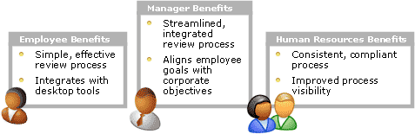
Figure 2.1
Stakeholders who benefit from a Microsoft Office-based solution
Employees will benefit from a simple, effective review process integrated with desktop tools that makes it easy to complete their review. Managers will benefit from a streamlined, integrated review process that enables aligning employee goals with company objectives. Human resources departments will benefit from a consistent, compliant process with improved process visibility.
With an Office-based employee performance review solution, organizations can better align human capital to corporate goals and unlock the potential of their most valuable asset, their employees.

3 Architectural Overview
The example described in this chapter builds a solution for performance reviews on a combination of technologies that includes Microsoft Office System, Microsoft SharePoint Products and Technologies, BizTalk, and Microsoft SQL Server. The example demonstrates one way to streamline the performance review process by enabling stakeholders to access review data using familiar Office technologies.

Example of a Solution Architecture
An employee performance review solution based on the Microsoft Office System could have components configured in a typical three-tier architecture that includes a client tier, a middle business logic tier, and a data services tier. The example described in this guide integrates components as shown in Figure 3.1.
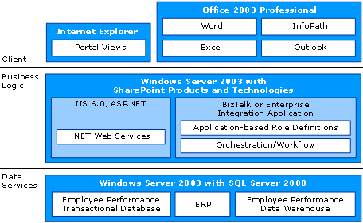
Figure 3.1
An example of an architecture for a performance review solution based on the Microsoft Office System
As shown in Figure 3.1, the client layer could consist of Windows XP and Microsoft Office System applications. Windows XP includes Internet Explorer 6, which can be used to access the review portal and interact with Web Parts. The Microsoft Office System applications could be used to:
● Create reviews using Microsoft Office Word or InfoPath.
● Create views of review data in Excel.
● Respond to notifications in Microsoft Office Outlook®.
● Automate review forms using InfoPath 2003.

The XML support and application extensibility of Word 2003, Excel 2003, and InfoPath 2003 are especially important for linking the client layer to business data. This link enables capturing information, such as employee information and corporate objectives, from a user in the client layer, which can be made available to the applications that perform the business logic, such as performance and compensation management systems.
In the example, the middle business logic tier consists of SharePoint Products and Technologies, Web services supported by ASP.NET, and Windows Server 2003. Microsoft Windows® SharePoint Services interacts with its repositories in the data services layer and Web services to provide the client layer and an enterprise application integration platform such as BizTalk 2004 access to line-of-business data. This enables a staff member in human resources to access information on the review portal that is extracted from and processed by an enterprise resource planning (ERP) system or a human capital management system. All of the business process orchestration, authentication, permissions control, and transaction processing of data are handled in this middle tier. To store the line-of-business data captured on the client and processed by an enterprise application integration platform such as BizTalk, the middle tier also interacts with the data services layer using Web services.
The data services layer in this example uses Windows Server 2003 and SQL Server to manage data stores. While SQL Server is used to store review related SharePoint Products and Technologies data, it is common for ERP data stores and other performance or human capital management data stores to exist in this layer. Data that is stored in this layer can be used across platforms. For example, ASP data stored in an Oracle database in the layer can be accessed by a Microsoft Office-based solution as long as the data is stored in XML format.

Example of a Solution in Action
This section describes how data can flow through a solution based on the solution architecture example provided in the previous section. A fictional company called Contoso Technologies has implemented an employee performance review solution using the Microsoft Office System. Contoso will use this solution to perform the following steps of its performance review process:
● Manage performance reviews
● Manage goals
● Finalize performance reviews

This solution helps to provide managers with a comprehensive view of employee performance in a system that is easy to implement and use.

Managing Performance Reviews
At Contoso, employees start and complete their reviews using the following steps:
● Initiating a performance review
● Filling out a performance review
● Mapping individual goals to corporate objectives
● Providing employee self-reviews

The following sections describe each of these steps and explain how Alan Brewer, an employee at Contoso, would use Contoso's solution based on the Microsoft Office System and the architecture provided in this example.

Initiating a Performance Review
While checking his e-mail, Alan sees a message from human resources notifying him that it is time to start his annual performance review. In the e-mail, there is a link Alan can click to open a personalized Web page on the company's performance review workspace, as shown in Figure 3.2.
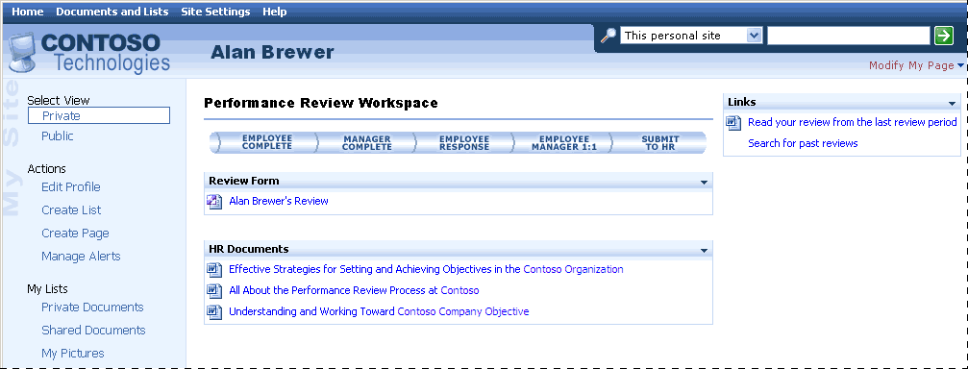
Figure 3.2
Alan Brewer's page on Contoso's performance review site
This workspace is a Microsoft SharePoint Portal Server site that provides Alan with easy access to everything he needs to start his review. Alan can work on his review using Microsoft Office productivity tools that he already uses every day.
To start on his review, Alan can click the Alan Brewer's Review link in the Review Form section. This opens an InfoPath form that Alan can use to fill out his review.

Filling Out a Performance Review
When Alan opens his review, he is opening an InfoPath form that is stored on SharePoint Products and Technologies. This form is shown in Figure 3.3.
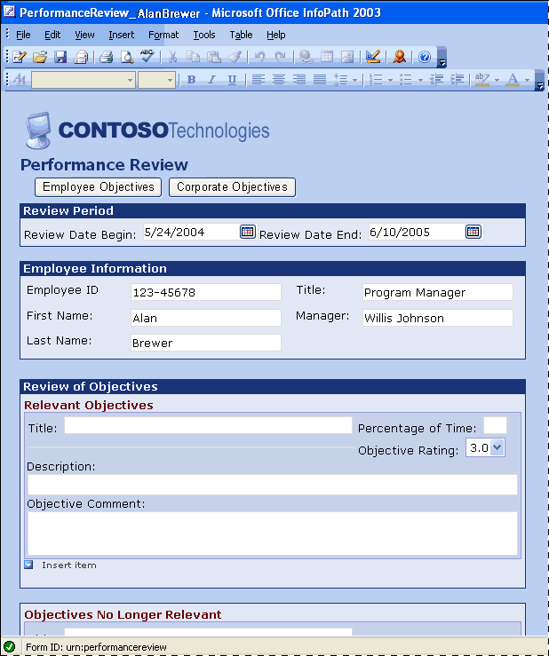
Figure 3.3
Alan's pre-populated review form
In Figure 3.3, information the company already knows about Alan is pre-populated, such as his employee ID, name, title, and manager. This means that Alan can spend his time on the most important aspects of the form instead of filling in administrative details. Other known information, such as Alan's objectives from his last review, can be accessed from this form. To see those objectives, Alan clicks the Employee Objectives button. This opens an InfoPath task pane on the right side of the form, as shown in Figure 3.4.
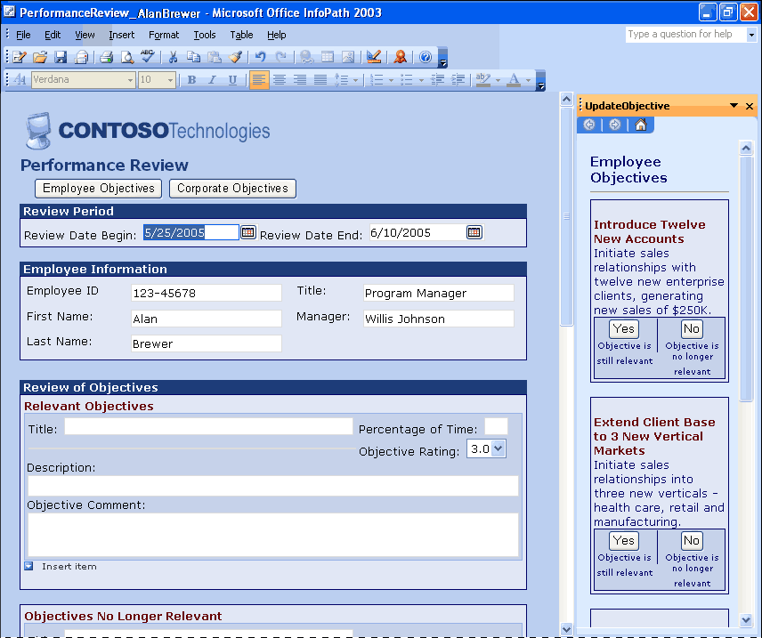
Figure 3.4
Alan's review form with objectives from his last review
In the InfoPath task pane, Alan can see his objectives from his last performance review and simply click a button to indicate if it is still relevant. For objectives that are still relevant, Alan can click Yes and the form will remove the objective from the task pane and populate it into the current review form, as shown in Figure 3.4.
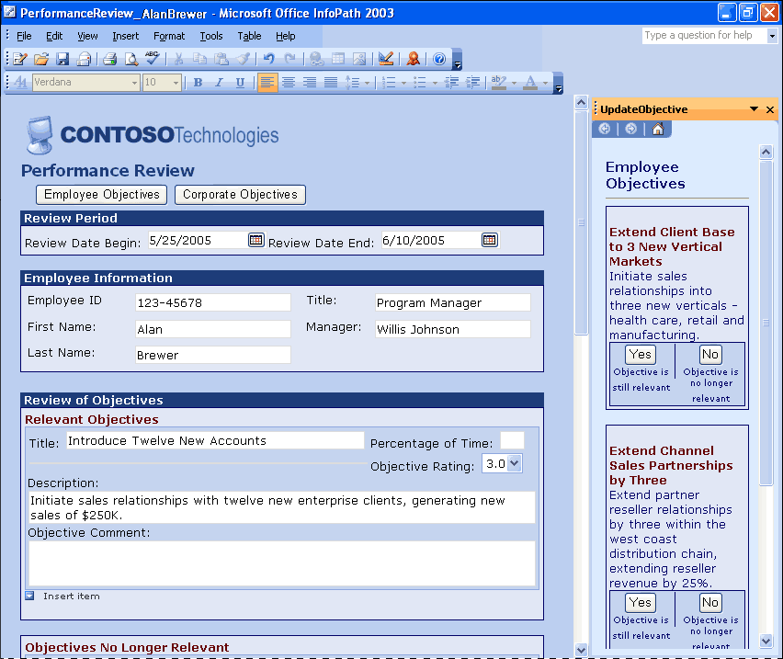
Figure 3.5
Alan's review form with relevant objectives from his last review populated into his current review
For objectives that are not still relevant, Alan can click No and the objective is removed from the list of Employee Objectives from the previous performance review. After all relevant objectives have been added to the review, Alan can go back into the form, and for each objective type in a comment.
Contoso designed its review forms to gather other kinds of data that it needs. For example, in Figure 3.5, there is a field called Percentage of Time to track how much of his time Alan spent during the review cycle working toward this objective. Including this field provides a way to enable employees to quickly provide specific information that Contoso needs. And because of the XML support in Microsoft Office System, this information is easy to route and store for reporting purposes.

Mapping Individual Goals to Corporate Objectives
Next Alan must look at the development plan for his next review. Contoso wants all employees to make sure that they link their personal goals and objectives with those of the company. To ensure this happens, Contoso designed the review form to display the company-wide objectives, as shown in the task pane in Figure 3.6.
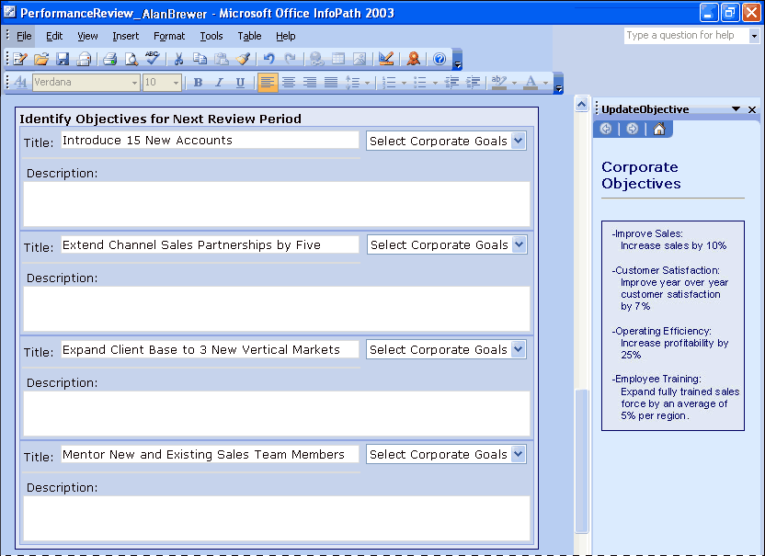
Figure 3.6
Alan's review of corporate objectives
Previously (as shown in Figure 3.5), Alan clicked a button to display the Corporate Objectives task pane. Now he can scroll down through his review form to the section shown in Figure 3.6 where he identifies his objectives for the next review period. By displaying this task pane, Alan can quickly see the goals of the company and his own.
When Alan has identified his objectives for the next review cycle, he can also link them to the corporate goals. In this case Contoso has made it very easy for him to accomplish this task by providing a drop-down box next to each objective. Once Alan and the other employees submit reviews, the HR department can quickly create reports that can help Contoso gather information such as how many employees are working toward any given corporate goal and which employees on the sales force are not working toward sales objectives.
This information can also help Contoso identify other reports that might be useful to make sure that employee efforts contribute to bottom-line results.

Providing Employee Self-Reviews
In addition to capturing information on how employees perform and linking employee goals to company goals, Contoso has also decided that there are certain skills that should be tracked. For Alan, providing this information is quick and easy, because the InfoPath form gives him a quick, one-click way to capture this information for each skill, as shown in Figure 3.7.
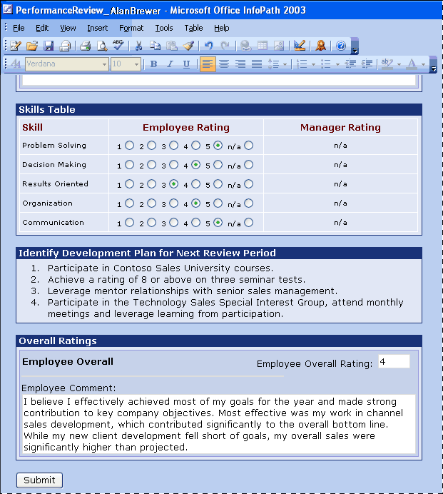
Figure 3.7
Alan's review form with his skill ratings
In Figure 3.7, Alan has scrolled down through his review form to the section where he rates his skills for the current review period, called Skills Table.
By capturing this information in the InfoPath review form, where that data is stored in a database upon submission, Contoso can then run reports comparing skills needed to perform certain functions against actual employee skills. This type of information is vital to Contoso’s efforts to optimize its workforce, and it can help Contoso direct training programs or set new hiring requirements.
Finally, Alan will estimate his overall rating, make any additional comments, and submit his form. As shown in Figure 3.7, there is also a place for Alan to enter his own comments about the quality of his performance. Upon submission, InfoPath closes and Alan's personalized performance review page is displayed, as shown in Figure 3.8.
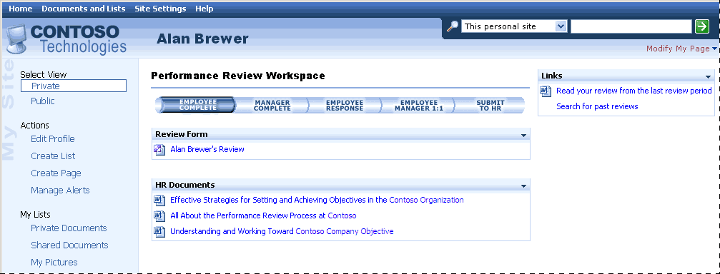
Figure 3.8
Alan's review status is updated on his performance review workspace page
After submitting the review, the status of Alan's review process is updated, as shown by the highlighting of the Employee Complete item.

Managing Goals
At Contoso, managers can review and contribute to employee reviews using the following steps:
● Linking objectives
● Updating a performance review

The following sections describe these steps and explain how Willis Johnson, Alan Brewer's manager at Contoso, would use Contoso's solution based on the Microsoft Office System and the architecture provided in this example.

Linking Objectives
As soon as Alan finishes his review, Willis gets an automatic e-mail notification. The ability to automate business processes in this way is another strong advantage of the Microsoft Office System. In the same way that Alan used the link within his e-mail to access his portal page, Willis uses the link in his e-mail to open his personal page on the portal. Figure 3.9 shows how Willis can see at a glance where the review process stands.
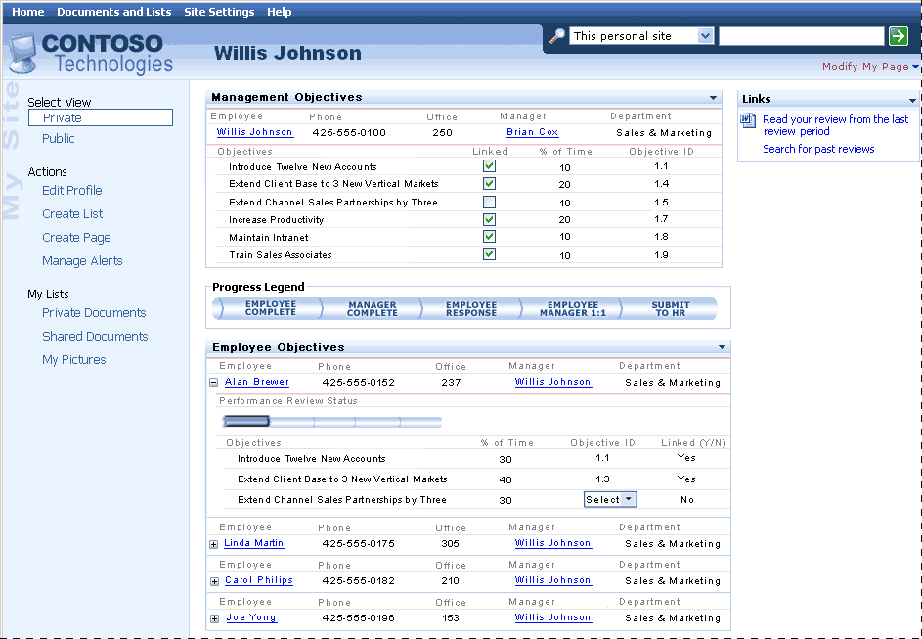
Figure 3.9
Willis Johnson's page on Contoso's performance review site
As shown in Figure 3.9, Willis has his own personal objectives shown at the top of the page. To make sure that his team is optimally working to support them, he needs to link his employees’ objectives to his own. Since Alan has just submitted his review, Willis can see Alan's objectives and make sure that they are linked to his own. As shown in Figure 3.9, Willis can select each of Alan's objectives in the Employee Objectives Web Part and link it to his own. In this case, Willis’s objective of extending the sales channel is not linked yet but can be using the fields on this Web Part.
Because managers can quickly see and link goals and Alan can link his own objectives to company goals, employee objectives can be aligned with the objectives of the team and the company's strategy as a whole.

Updating a Performance Review
At Contoso, the company has communicated to all managers that personnel in the Business Development department should have a goal that supports Contoso’s efforts to improve customer satisfaction. Willis notices that Alan’s goals do not focus heavily enough on this, so he sends Alan an e-mail asking him to modify his review to reflect this change.
Using the same steps he took to initiate a review, Alan can quickly open his review form and make changes. After he does this, he can submit the review and his manager can make sure it addresses his concerns about focusing more on the corporate objective of customer satisfaction.
This scenario describes how Alan and Willis were able to quickly work together to set appropriate goals that will help the company move in its new direction using a solution based on Microsoft Office System.

Finalizing Performance Reviews
At Contoso, managers and employees finalize reviews using the following steps:
● Providing managerial feedback
● Reviewing and signing a performance review

The following sections describe these steps and explain how Willis Johnson, the manager, and Alan Brewer, his employee, would use Contoso's solution based on the Microsoft Office System and the architecture in the example to finalize a performance review.

Providing Managerial Feedback
After Willis reviews Alan's changes, he can send Alan an e-mail telling him the changes are acceptable and asking if he is comfortable with his portion of the review before Willis submits the review. Alan replies that he is comfortable with the changes. It is time for Willis to provide comments and set up a meeting to discuss the review. The InfoPath form again makes this as easy as possible. As shown in Figure 3.10, Willis can use the review form Contoso has designed to enter his comments and set up an appointment to discuss it in person.
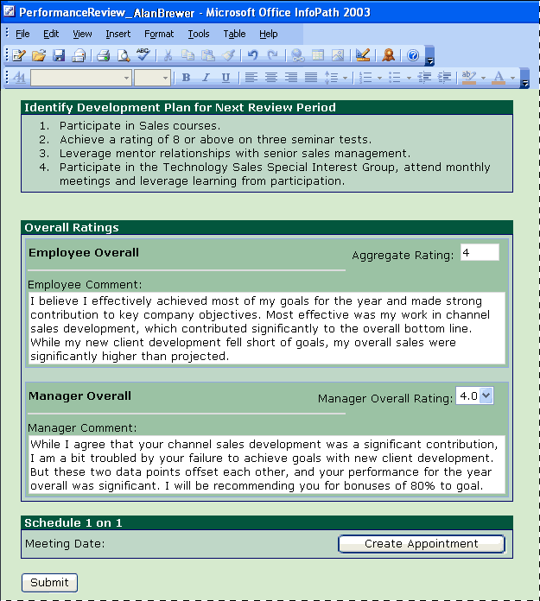
Figure 3.10
Alan Brewer's review opened by his manager
When Willis clicks Create Appointment, Outlook automatically opens and Willis can quickly create and send a meeting invite to Alan for them to talk about the review.
After Willis types in all of his comments and the meeting has been set up, Willis can submit the form. Upon submission, the workflow tools embedded into this solution automatically prompt Alan in e-mail that the review is ready for his response and signature.

Reviewing and Signing a Performance Review
To finalize the review, Alan must read his manager's comments and sign his performance review. As shown in Figure 3.11, on the Performance Review Workspace the status is updated and a meeting schedule is displayed.
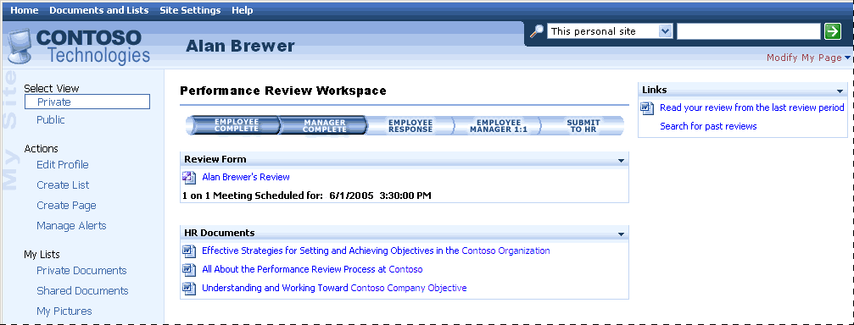
Figure 3.11
Alan's review status is updated and his review meeting scheduled
On the portal page, both the Employee Complete and Manager Complete items are now highlighted. Also, under Alan Brewer's Review, the page also displays that a meeting has been scheduled and displays the date and time. To provide a way for employees to securely sign a review, Contoso uses digital signatures. InfoPath supports digital signatures, making it easy to ensure the security and integrity of data in InfoPath forms. To review and sign the form, all Alan has to do is open his review again. As shown in Figure 3.12, the InfoPath form now includes a place for Alan to respond to his manager's comments and sign the form.
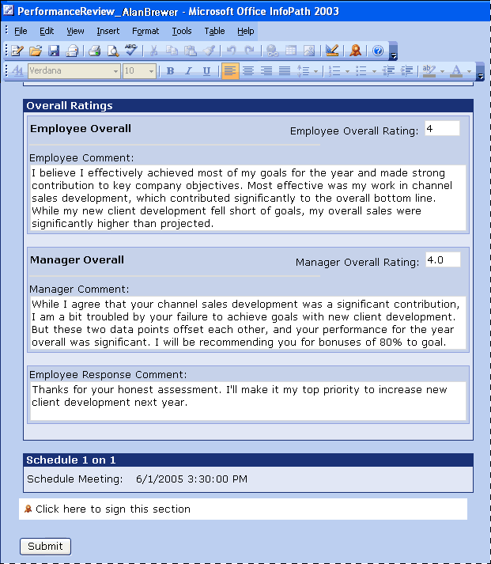
Figure 3.12
Alan Brewer's review ready to sign
To sign the form, Alan completes a quick Digital Signature wizard. After submitting the review, Alan completes Contoso's review process and his review status is updated on his manager's portal page.

Extending the Architecture
The basic architecture described in the example provides core functionality for stakeholders to post information about corporate goals, create review form templates, initiate reviews, automate review routing, and report on review data by sharing data between the client applications and other line-of-business applications. To make the performance review solution richer, a company, system integrator, independent software vendor (ISV), partner, or developer can build on this example. Some of the ways to extend the architecture could include the following options:
● Build employee performance review and human resources add-ins to the Microsoft Office System to improve process automation; data flow; and employee, manager, and human resources collaboration.
● Integrate an employee performance review solution with other components in the organization's infrastructure.
● Integrate existing data into an employee performance review solution.
● Extend SharePoint Products and Technologies for use with other key human resources solutions.
● Make use of Office 2003 across more desktops through other human resources solutions.
All of these options are ways to customize and extend Microsoft Office System products in a solution to address specific challenges when automating the employee performance review processes.

4 Infrastructure Considerations
This chapter describes issues an organization or partner should consider when planning to implement or deploy a solution similar to the solution in the example based on the Microsoft Office System. This section describes the software, operational, and security considerations that an organization or partner must resolve before implementing a solution similar to the example. If an organization or partner is planning to develop its own solution, then some requirements or considerations might not apply.

Software Considerations
This section lists software that was used to create the architecture described in the “Example of a Solution Architecture” section in Chapter 3.

Client Software Considerations
One or more clients accessing a performance review solution can use the following software and technology.
Table 4.1 Client Software Considerations
Software and Technology | Description
Microsoft Windows XP Professional | Windows XP brings the convergence of Windows operating systems by integrating the strengths of Windows 2000—standards-based security, manageability, and reliability with the best features of Windows 98 and Windows Millennium Edition—Plug and Play, easy-to-use user interface, and innovative support services to create the best Windows yet.  In the example of a solution, Windows XP Professional can be the operating system on the client computer. For more information, see:  http://www.microsoft.com/windowsxp/pro/default.mspx
Microsoft Office Professional Enterprise Edition 2003 | Office 2003 Editions can help organizations and their employees transform information into impact. New and familiar products, features, and functionality improve how people and organizations connect to coworkers, information, and business processes. Microsoft Office Professional Enterprise Edition 2003 is the most comprehensive version of Office, and it includes InfoPath.  The example of a solution uses InfoPath 2003 as the interface in which the employee and manager fill out the performance review electronic forms. For more information, see:  http://www.microsoft.com/office/editions/prodinfo/enterprises/default.mspx

Server Software Considerations
One or more servers running a performance review solution can use the following software.
Table 4.2 Server Software Considerations
Software | Description
Microsoft Windows Server 2003 | The Windows Server 2003 operating system takes the best of Microsoft Windows 2000 Server technology and makes it easier to deploy, manage, and use. The result is a highly productive infrastructure that helps make your network a strategic asset for your organization.  In the sample solution, Windows Server 2003 is the server operating system of the computer running SharePoint Products and Technologies, BizTalk Server 2004, and SQL Server 2000. For more information about Windows Server 2003, see:  http://microsoft.com/windowsserver2003/evaluation/sysreqs/default.mspx
Microsoft ASP.NET 1.1 | ASP.NET is a technology for creating dynamic Web applications. It is part of the .NET Framework; you can author ASP.NET applications in any .NET compatible language, including Visual Basic® .NET, C#, and J#. ASP.NET pages (Web Forms) are compiled, providing better performance than with scripting languages. Web Forms enable you to build powerful forms-based Web pages. When building these pages, you can use ASP.NET server controls to create common UI elements, and program them for common tasks. These controls enable you to rapidly build a Web Form out of reusable built-in or custom components, simplifying the code of a page.  http://msdn.microsoft.com/asp.net/gettingstarted/default.aspx
Internet Information Services (IIS) 6.0 | Internet Information Services (IIS) 6.0 is a powerful Web server that provides a highly reliable, manageable, and scalable Web application infrastructure for all versions of Windows Server 2003. IIS helps organizations increase Web site and application availability while lowering system administration costs. IIS 6.0 supports the Microsoft Dynamic Systems Initiative (DSI) with automated health monitoring, process isolation, and improved management capabilities.  http://www.microsoft.com/windowsserver2003/iis/default.mspx
Microsoft Windows SharePoint Services 2.0 | Windows SharePoint Services enables enterprises to develop an intelligent portal that seamlessly connects users, teams, and knowledge so that people can take advantage of relevant information across business processes to help them work more efficiently.  In the example of a solution, Windows SharePoint Services hosts the team collaboration site.  For more information, see:  http://www.microsoft.com/windowsserver2003/technologies/sharepoint
Microsoft SharePoint Portal Server | Microsoft SharePoint Portal Server 2003 enables enterprises to develop an intelligent portal that seamlessly connects users, teams, and knowledge so that people can take advantage of relevant information across business processes to help them work more efficiently. SharePoint Portal Server 2003 provides an enterprise business solution that integrates information from various systems into one solution through single sign-on and enterprise application integration capabilities, with flexible deployment options and management tools.  SharePoint Portal Server 2003 uses Microsoft Windows SharePoint Services 2003 sites to create portal pages for people, information, and organizations.  http://office.microsoft.com/en-us/FX010909721033.aspx
Microsoft BizTalk Server 2004 | BizTalk Server 2004 helps organizations efficiently and effectively integrate systems and business processes, enabling them to automate and orchestrate interactions in a highly flexible and highly automated manner.  In the example of a solution, BizTalk Server 2004 orchestrates the data and business processes through the integrated systems. For more information, see:  http://www.microsoft.com/biztalk/default.mspx
Microsoft SQL Server 2000 | SQL Server 2000 provides the enterprise data-management platform your organization needs to adapt quickly in a fast-changing environment.  In the example of a solution, SQL Server supports SharePoint Products and Technologies and serves as the primary repository for documents and data. For more information, see:  http://www.microsoft.com/sql/default.mspx

Operations Considerations
This section provides high-level guidelines for partners or organizations who are interested in implementing a performance review solution based on the Microsoft Office System.
An organization should plan for or consider these issues:
● Pre-deployment planning: During the planning phase, an organization or partner should determine the steps and the sequence required to successfully implement a performance review solution, based on the needs of the organization. An organization or partner should then assign personnel to specific areas of planning, based on their technical skills. An organization or partner should also document the organization's existing processes and requirements. After this is complete, an organization or partner should determine the specific personnel required.
● Client tier development: The user interface layer described in this guide uses forms created with Microsoft Office InfoPath 2003 and team Web sites created with Microsoft SharePoint Products and Technologies. To create a user interface layer similar to the example, an organization or partner will need personnel with technical knowledge about XML, XSL, HTML, Microsoft JScript®, InfoPath 2003, and Microsoft Office 2003 Web Parts and Components.
● Business logic tier development: The middle tier in the example of a solution described in this guide uses Windows Server 2003 with SharePoint Products and Technologies, IIS 6.0, ASP.NET, and BizTalk. Each organization should decide which of these products are necessary based on how automated they want their workflow process. To create a business logic layer similar to the example, an organization or partner will need personnel with technical knowledge about .NET Web services, enterprise integration applications, application-based role definitions, and business orchestrations and workflows.
● Data services tier development: The data services layer described in this guide uses a database composed of SQL tables, stored procedures, and user-defined functions that are used to interact with those tables. When deciding whether to use a SQL database as the primary integration method for replicating data between the solution and an organization's ERP or other line-of-business applications, organizations should evaluate what new data they need to store. For example, if performance scores have never been captured electronically and a solution enables you to now store this data, an organization will need to decide where the data is going to be stored. To create a data services layer similar to the example, an organization or partner will need personnel with technical knowledge about Microsoft SQL Server 2000 SP3 and the existing ERP, or other external data source, in use.
● Deployment planning: When planning for the deployment of a performance review solution, an organization or partner should assess the software, hardware, and organizational limitations and requirements. An organization or partner should implement a pilot program to aid in testing and preparing for full deployment. Integration of the storage layer's database with an organization's existing line-of-business applications might involve a significant effort.
● Operations planning: The operation of a performance review solution should be handled by the organization's personnel who has technical knowledge of the applications used in the solution. In addition, database administrators must design a strategy to properly maintain data replication between a performance review solution and any existing line-of-business application or other external data source.
● Test planning: An organization or partner should develop a comprehensive test plan to ensure that their implementation of a performance review solution is fully operational.

Security Considerations
Standard security precautions should be addressed in solutions that use Web pages in the user interface layer, the Web services of the Web services layer, and the database of the storage layer.
The following resources provide general security information for Microsoft products and technologies:
● Microsoft TechNet Security Resource Center: TechNet provides security resources at the Security Resource Center. Check this site regularly for the latest security headlines and for information about updates at:
http://www.microsoft.com/technet/security/default.mspx
● General security guidance: Microsoft offers a wide variety of security guidance for IT professionals and developers at the Security Guidance Center at:
http://www.microsoft.com/security/guidance/default.mspx

5 Next Steps
This chapter reviews steps that organizations can take if they decide to pursue implementation of an employee performance review solution built using the Microsoft Office System. This chapter describes some of the resources and skills required to develop, implement, and maintain a solution. It also provides information about partners.

Resource and Skill Set Considerations
Developing, implementing, and operating a performance review solution similar to the example in this guide requires personnel for three primary roles: business analyst, developer, and administrator. The specific functions and required skill sets for these roles are described in the following sections.

Business Analyst
The following describes the business analyst's functions and skill set:
● Functions: Analyzes business processes and defines the rules and behaviors required within processes. Identifies the information that must be sent to each application, determines the process flow required, and maps out how Microsoft applications and proprietary applications are related.
● Skill set: Knowledge of the review process and the strategic goals of the company. Familiarity with HR departments and existing line of business applications in use.

Developer
The following describes the developer's functions and skill set:
● Functions: Implements the business processes defined by the business analyst. Defines XML schemas for the required business documents, and creates ways for Microsoft applications and proprietary applications to share data and tasks necessary to implement the business processes.
● Skill set: Microsoft InfoPath form design techniques. Familiarity with Microsoft Windows Server 2003, and the Microsoft .NET Framework. Expertise with XML, XSL, HTML, Microsoft JScript, Microsoft Office 2003 Web Parts and Components, and development skills in Web services. Familiarity with existing line-of-business applications in use.

Application Administrator
The following describes the administrator's functions and skill set:
● Functions: Sets up communication among the components specified by the developer and deploys SharePoint Products and Technologies as required.
● Skill set: Knowledge of InfoPath implementations. Familiarity with Windows Server 2003, SharePoint Products and Technologies, and the Microsoft .NET Framework. Familiarity with HR departments and existing line of business applications in use.
To help organizations become more successful in delivering business-driven technology solutions, Microsoft has created the Microsoft Solutions Framework (MSF). MSF is a deliberate and disciplined approach to technology projects based on a defined set of principles, models, concepts, guidelines, and proven practices from Microsoft. MSF resources are available at:
http://www.microsoft.com/technet/itsolutions/msf/default.mspx

Potential Partner Solutions
Microsoft industry partners can play an important role in developing a solution for performance reviews. A partner can provide subject matter expertise and deployment support, customize a solution by adding custom Web Parts and other tools, enhance the workflow and security of a solution, and assist in understanding and automating important business processes that are currently manual.
Some examples of features and functionality that partners can add to the Microsoft Office System platform to provide a solution beyond integration services include the following:
● Add cascading goals visibility
● Extend review forms on mobile devices using Internet Explorer and on tablet PCs, using InfoPath
● Include audio reviews for those not easily able to type reviews due to job location or circumstance
● Provide compensation calculation system integration to make the assignment and adjustment of compensation by review scores easier
● Include compensation modeling
● Provide budget integration with goal setting
● Create organization charts or reporting charts that many companies do not create dynamically
You can find more information about partner solutions at:
http://www.microsoft.com/office/showcase/performance/partnersol.mspx

Solution Showcase for the Microsoft Office System
The Solution Showcase for the Microsoft Office System highlights how leading organizations solve business challenges using the Microsoft Office System. The Solution Showcase provides information about how Microsoft customers can obtain more value from their investments in the Microsoft Office System.
For more information about the Solution Showcase, see:
http://www.microsoft.com/office/showcase/default.mspx
For more information on how partners can get involved with the Solution Showcase, see:
http://www.iwsolve.com/

AMR Research. Human Capital Management Applications Report 2003-2008. July 2004.
AMR Research. Human Capital Management Applications Report 2003-2008. July 2004
Symons, Craig. “Trends 2005: Human Capital Management.” Forrester Research, November 2004.

