TRAVEL JOURNAL
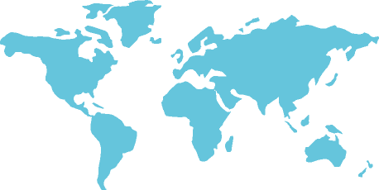
Destination:
Start date of trip:
Traveling companions:
Goal of trip:
Location:

Day 1

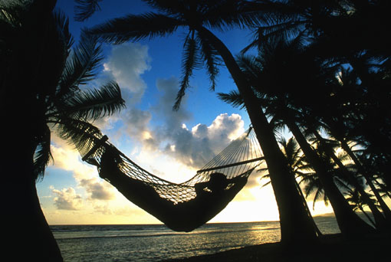

Day 2
Location:
Photo and video notes:

Day 3
Location:
Photo and video notes:

Day 4
Location:
Photo and video notes:

Day 5
Location:
Photo and video notes:

Day 6
Location:
Photo and video notes:

Day 7
Location:
Photo and video notes:

Day 8
Location:
Photo and video notes:

Day 9
Location:
Photo and video notes:

Day 10

Location:
Photo and video notes:

Comments on tour company/transportation:

Items to add to packing list:

People to correspond with:

