M Y
L I F E

T
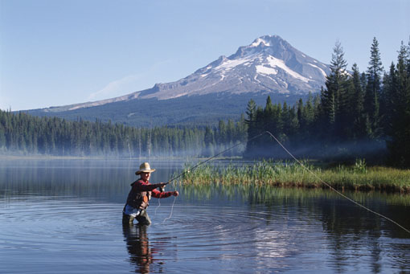
hink how exciting it would be to discover a book that told all about the family of your great-great-grandmother or grandfather, or anyone else in your family line. This book is a chance for you to make such a discovery possible for descendants. Fill it in, add pages of your own, then pass it on to your children. They’ll probably put it in a box and then, in 100 years or so, a great-great-grandchild will rediscover the book to his or her great delight. Use these paragraphs to write an introduction for the book, or delete them if you want.

CONTENTS
Introduction
(message from the author) Page 0

About Me
Vital Statistics Page 0
The Story of My Life Page 0
My Courtship and Marriage Page 0
My Children Page 0
My Friends Page 0
Places I’ve Lived Page 0
My Pets Page 0
Things I’ve Liked a Lot Page 0
Collections Page 0
Places of Worship Page 0
Special Memories Page 0
Education Page 0
Clubs and Organizations Page 0
Sports Page 0
Hobbies Page 0
On the Job Page 0

Special Events: The Complete Story
Family Gatherings and Reunions Page 0
Vacations Page 0
Weddings Page 0
Religious Events Page 0

Photographs
Photos of Myself Page 0
Photos of My Family Page 0
Photos of Ancestors Page 0
Other Photos Page 0

A B O U T M E

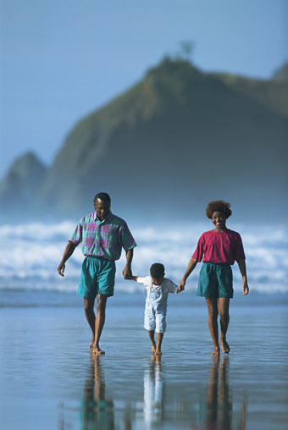

VITAL STATISTICS
This is you, the author’s page. Fill in information about yourself and describe the thoughts you had as you started and continued working on this family book.
If you have a scanned photo of yourself, insert it into the cell to the left. Or you can paste a photo on the page after printing. Replace this paragraph with information about when and where the picture was taken, and anything else that is interesting or important.

N A M E:
Age: Type here.
Date: Type here.
HEIGHT |  | WEIGHT
HAIR COLOR |  | EYE COLOR
WAIST SIZE |  | CHEST/BUST SIZE
SUIT/DRESS SIZE |  | SHIRT/BLOUSE SIZE
HAT SIZE |  | RING SIZE
FAVORITE COLOR |  | FAVORITE FOOD
FAVORITE PLACE |  | FAVORITE PERSON
FAVORITE PERFUME |  | FAVORITE COLOGNE
FAVORITE FLOWER |  | FAVORITE DAY
OTHER

Type any stories or additional information here.

THE STORY OF MY LIFE
If you have a scanned photo of yourself, insert it into the cell to the left. Or you can paste a photo on the page after printing. Replace this paragraph with information about when and where the picture was taken, and anything else that is interesting or important.

H E A D I N G
Write your story on the following pages. Describe your childhood, where you were born, where you have lived, the things you did, what made you happy, what made you cry. Don’t just write about events—include how you felt and how you reacted.
Insert headings as needed. The heading above uses the Page Subhead 2 style. For subsequent headings, use the Page Subhead 1 style. Use the Page Text style for paragraphs like this.
If you have pictures to go with the story, insert them as appropriate.

MY COURTSHIP AND MARRIAGE
If you have a scanned photo of yourself while dating or getting married, or of another appropriate scene, insert it into the cell to the left. Or you can paste a photo on the page after printing. Replace this paragraph with information about when and where the picture was taken, and anything else that is interesting or important.

H E A D I N G
It’s love that makes the world go around, according to an old song, and a good love story never grows old. Here’s a chance to write your own. If you’re not yet married, leave this section until later.
Type your story, inserting headings as needed. The heading above uses the Page Subhead 2 style. For subsequent headings, use the Page Subhead 1 style. Use the Page Text style for paragraphs like this.
If you have pictures to go with the story, insert them as appropriate.

MY CHILDREN
“The joys of your life” or “the arrows in your quiver” they’re called, but however you refer to your children, there is no doubt that they are a large part of your life. Write about them, using information from their baby books to fill in some of the details. But don’t stop there. Tell the circumstances of their birth, their growing up, the strengths you see in them, and the hopes you have for them.
If you have a scanned photo of your children, insert it into the cell to the left. Or you can paste a photo on the page after printing. Replace this paragraph with information about when and where the picture was taken, and anything else that is interesting or important.

N A M E
Write about this child. If you have a scanned picture, insert it into the cell to the left. Or you can paste a photo on the page after printing. Replace this paragraph with information about when and where the picture was taken, and anything else that is interesting or important. To add other children, select the name heading and this table, copy them, then paste them on the page below.

MY FRIENDS
N A M E
Describe this friend, when and where you met the person, why you liked them, some of the things you did together, and so on. If you have a scanned photo of your friend, insert it into the cell to the left. Or you can paste a photo on the page after printing. Replace these paragraphs with a description of the picture, the date and place it was taken, and any other information. To add other friends, select the name heading and this table, copy them, and then paste them on the page below.

PLACES I’VE LIVED
T O W N O R C I T Y
From: Date you moved there
To: Date you left
Describe this home, when you moved there, what you liked about it, what you didn’t like, and so on. If you have a scanned picture of the house, insert it into the cell to the left. Or you can paste a photo on the page after printing. Replace this paragraph with information about when and where the picture was taken, and anything else that is interesting or important. To add other homes, select the name heading and this table, copy them, and then paste them on the page below.

MY PETS
N A M E
Describe this animal, how you got it, how long you had it, why you liked it, some of the things you did together, and so on. If you have a scanned picture of your pet, insert it into the cell to the left. Or you can paste a photo on the page after printing. Replace this paragraph with a description of the picture, the date and place it was taken, and anything else that is interesting or important. To add other pets, select the name heading and this table, copy them, and then paste them on the page below.

THINGS I’VE LIKED A LOT
What is the first toy you can remember? Do you have something that you have kept for years and years? Wouldn’t it be nice to remember it 40 years from now? You and your descendants can if you describe it, tell how you got it, and how long you had it.
N A M E
If you have a scanned photo of this item, insert it into the cell to the left. Or you can paste a photo on the page after printing. Replace this paragraph with information about when and where the picture was taken, and anything else that is interesting or important. To add other items, select the name heading and this table, copy them, and then paste them on the page below.

COLLECTIONS
Do you have collections that you’re proud of, that you hope to pass on to others, or some items you want to remember? Describe how you got started collecting, when you started, and any especially interesting items. Describe each collection below.
N A M E
If you have a scanned photo of this collection, insert it into the cell to the left. Or you can paste a photo on the page after printing. Replace this paragraph with information about when and where the picture was taken, and anything else that is interesting or important. To add other items, select the name heading and this table, copy them, and then paste them on the page below.

PLACES OF WORSHIP
A person’s spiritual beliefs have a great impact on his or her life and describing yours can provide an important legacy for your descendants. Replace this paragraph with one describing your beliefs.
N A M E
If you have a scanned photo of a special place of worship, insert it into the cell to the left. Or you can paste a photo on the page after printing. Replace this paragraph with information about when and where the picture was taken, and anything else that is interesting or important. To add other items, select the name heading and this table, copy them, and then paste them on the page below.

SPECIAL MEMORIES
What events are special to you? Write them down here so that you can share them with others.
If you have a scanned photo that reminds you of a special memory, insert it into the cell to the left. Or you can paste a photo on the page after printing. Replace this paragraph with information about when and where the picture was taken, and anything else that is interesting or important.

H E A D I N G
Write your memories, inserting new headings as needed. The heading above uses the Page Subhead 2 style. For subsequent headings, use the Page Subhead 1 style. Use the Page Text style for paragraphs like this.
If you have pictures to go with your memories, insert them as appropriate.

EDUCATION
School days, school days! Many people spend nearly a third of their lives in school, so it’s not surprising that there are lots of memories tied up in those school years. Use this section to describe your formal education and to relate specific experiences. Replace this paragraph with an introduction to the section if you like. Describe how well you did in school overall, the important events, and the highlights.

If you have a scanned photo of your favorite school, or perhaps a graduation picture, insert it into the cell to the left. Or you can paste a photo on the page after printing. Replace this paragraph with information about when and where the picture was taken, and anything else that is interesting or important.

S C H O O L
Town or city
DATE STARTED
DATE LEFT
DATE GRADUATED
GRADE/TEACHER
GRADE/TEACHER
GRADE/TEACHER
GRADE/TEACHER
GRADE/TEACHER
GRADE/TEACHER

Type any stories, memories, or additional information here. To insert information about another school, select the headings and table above and this paragraph, then paste them on the page below.

CLUBS AND ORGANIZATIONS
Are you the type of person who likes to participate? Do you do volunteer work, belong to a professional association, or work in youth organizations? Describe the groups that you have been associated with and the work you have done.
If you have a scanned photo from your work in a club or organization, insert it into the cell to the left. Or you can paste a photo on the page after printing. Replace this paragraph with information about when and where the picture was taken, and anything else that is interesting or important.

O R G A N I Z A T I O N
Location
DATE JOINED
DATE LEFT
POSITIONS

Type any additional information here. To insert information about another organization, select the headings and table above and this paragraph, then paste them on the page below.

SPORTS
Having fun is … well, it’s fun! Use this section to describe the sports you have participated in and the teams you have belonged to.
If you have a scanned photo of your favorite sport or a team picture, insert it into the cell to the left. Or you can paste a photo on the page after printing. Replace this paragraph with information about when and where the picture was taken, and anything else that is interesting or important.

S P O R T O R T E A M N A M E
Location if applicable
If you have a scanned picture of yourself participating in this sport, insert it into the cell to the left. Or you can paste a photo on the page after printing. Replace these paragraphs with information about when and where the picture was taken, and anything else that is interesting or important.

Describe this sport, what positions you played (if applicable), why you liked it, how well you or your team did, interesting events, and so on. To add other sports, select the headings, the table, and this paragraph, copy them, and then paste them on the page below.

HOBBIES
What do you like to do in your spare time? How do you relax when the work is all done? Use this section to tell about your hobbies, past and present.
If you have a scanned photo of your favorite hobby or project, insert it into the cell to the left. Or you can paste a photo on the page after printing. Replace these paragraphs with information about when and where the picture was taken, and anything else that is interesting or important.

H O B B Y N A M E
If you have a scanned picture of yourself participating in this hobby, insert it into the cell to the left. Or you can paste a photo on the page after printing. Replace this paragraph with information about when and where the picture was taken, and anything else that is interesting or important.

Tell about this hobby, why you liked it, what it entailed, how you got started, and so on. To add other hobbies, select the headings, the table, and this paragraph, copy them, and then paste them on the page below.

ON THE JOB
If you’ve already worked on your genealogy, you’ve probably noticed that a 100 years ago workers usually had one job throughout their lives, and were listed as a farmer, a professor, a shoemaker, a carpenter, and so on. Nowadays, it’s common to have several different jobs or work for several different companies. Create headings and a table like this to tell about each of your jobs, both good and bad. Replace this paragraph with information about your employment interests and how you decided on your profession.
J O B N A M E
Company, city or town
Date started, date quit
If you have a scanned picture, insert it into the cell to the left. Or you can paste a photo on the page after printing. Replace this paragraph with information about when and where the picture was taken, and anything else that is interesting or important. To add other jobs, select the job headings and this table, copy them, and then paste them on the page below.

S P E C I A L
E V E N T S
The Complete Story

I
n previous pages, you told about events in your life, but there wasn’t room to tell the whole story. This part of the book is designed to give you a place to fill in all of the details of family gatherings, weddings, vacations, and any other event you want to describe.
Use these paragraphs to write an introduction for this section, or delete them if you want.
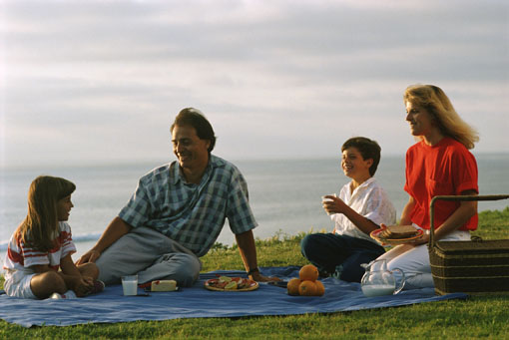

FAMILY GATHERINGS AND REUNIONS
Is your family one that gets together often? Do people come from across the nation or from other countries for reunions? Or do you just have quiet get-togethers now and then? Whatever the case, these gatherings can be important events and great places to learn more about your family.
E V E N T N A M E
Location
Date

If you have scanned pictures of the event in question, insert them into the cells above. Or you can paste photos on the page after printing. Replace this paragraph with a description of the event and anything interesting that happened. Describe the pictures you have inserted, note the date and place they were taken and any other information. To add other events, select the event headings and this table, copy them, then paste them below.

VACATIONS
Where do you go when you want to get away? Do you head for the hills and solitude, or are you attracted by the bright lights of the big city? Wherever you go, the stories will make interesting reading for your descendants. In this paragraph, describe your vacations in general, what you liked to do the most, and how you planned them.
L O C A T I O N
Date

If you have scanned pictures of your vacation, insert them into the cells above. Or you can paste photos on the page after printing. Replace this paragraph with a description of the vacation—where you went and what you did. Include any interesting events. Describe the pictures you have inserted, note the date and place they were taken, and any other information. To add other vacations, select the headings and table, copy them, and then paste them below.

WEDDINGS
Almost everyone has wedding pictures to look at, but not many have a written account of the event. Think of how great it would be to read about your parents’, your grandparents’, or even your great grandparents’ wedding. As you write about the weddings that are important in your life, you will be providing just such an opportunity for your descendants.
N A M E S O F B R I D E A N D G R O O M
Location of wedding
Date

If you have scanned pictures from the wedding, insert them into the cells above. Or you can paste photos on the page after printing. In this paragraph, describe the pictures you have inserted, note the date and place they were taken, or any other information.

H E A D I N G
As you write about the wedding, insert headings to highlight and organize your information. Describe the service, who officiated, who attended, and what the bride wore. List the gifts, record the toasts, and so on. To add other weddings, select the headings, table, and paragraphs, copy them, and then paste them below. If you want to start each wedding on a new page, position the insertion point in the paragraph below and press CTRL+ENTER.

RELIGIOUS EVENTS
If you have an active religious affiliation, then you probably take part in events that you will want to record. Describe individual events, the program, who participated, your special memories and feelings.
E V E N T
Person or persons participating
Date
If you have a scanned picture, insert it into the cell to the left. Or you can paste a photo on the page after printing. Replace this paragraph with a description of the picture, the date it was taken, the place, or any other information about it. To add other events, select the event headings and this table, copy them, then paste them in the paragraph below.

P H O T O G R A P H S

I

f you have scanned pictures, insert them into the following pages. You can also paste photographs on the pages after printing. If the boxes on the pages are not the size you want, use the Table menu commands to resize, merge, or delete them. To create additional pages in any section, select the contents of an entire page, insert a new page, and then paste the copied text and tables into the new page. You can insert a new page at any place in the document by pressing CTRL+ENTER.
Use these paragraphs to write an introduction for this section, or delete them if you want.
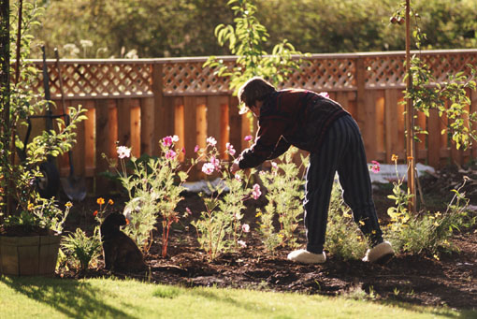

PHOTOS OF MYSELF
Describe the picture, who is in it, where and when it was taken, etc. | Describe the picture, who is in it, where and when it was taken, etc. | Describe the picture, who is in it, where and when it was taken, etc. | Describe the picture, who is in it, where and when it was taken, etc.
Describe the picture, who is in it, where and when it was taken, etc. | Describe the picture, who is in it, where and when it was taken, etc. | Describe the picture, who is in it, where and when it was taken, etc. | Describe the picture, who is in it, where and when it was taken, etc.
Describe the picture, who is in it, where and when it was taken, etc. | Describe the picture, who is in it, where and when it was taken, etc. | Describe the picture, who is in it, where and when it was taken, etc. | Describe the picture, who is in it, where and when it was taken, etc.

If you have scanned pictures of yourself, insert them in the cells above, or paste pictures on this page after printing. For wider pictures, merge two or more cells (select the cells and, on the Table menu, click Merge). To create additional pages, select this page, copy it, and then paste it below.

PHOTOS OF MY FAMILY
Describe the picture, who is in it, where and when it was taken, etc. | Describe the picture, who is in it, where and when it was taken, etc. | Describe the picture, who is in it, where and when it was taken, etc. | Describe the picture, who is in it, where and when it was taken, etc.
Describe the picture, who is in it, where and when it was taken, etc. | Describe the picture, who is in it, where and when it was taken, etc. | Describe the picture, who is in it, where and when it was taken, etc. | Describe the picture, who is in it, where and when it was taken, etc.
Describe the picture, who is in it, where and when it was taken, etc. | Describe the picture, who is in it, where and when it was taken, etc. | Describe the picture, who is in it, where and when it was taken, etc. | Describe the picture, who is in it, where and when it was taken, etc.

If you have scanned pictures of yourself, insert them in the cells above, or paste pictures on this page after printing. For wider pictures, merge two or more cells (select the cells and, on the Table menu, click Merge). To create additional pages, select this page, copy it, and then paste it below.

PHOTOS OF MY ANCESTORS
Describe the picture, who is in it, where and when it was taken, etc. | Describe the picture, who is in it, where and when it was taken, etc. | Describe the picture, who is in it, where and when it was taken, etc. | Describe the picture, who is in it, where and when it was taken, etc.
Describe the picture, who is in it, where and when it was taken, etc. | Describe the picture, who is in it, where and when it was taken, etc. | Describe the picture, who is in it, where and when it was taken, etc. | Describe the picture, who is in it, where and when it was taken, etc.
Describe the picture, who is in it, where and when it was taken, etc. | Describe the picture, who is in it, where and when it was taken, etc. | Describe the picture, who is in it, where and when it was taken, etc. | Describe the picture, who is in it, where and when it was taken, etc.

If you have scanned pictures of yourself, insert them in the cells above, or paste pictures on this page after printing. For wider pictures, merge two or more cells (select the cells and, on the Table menu, click Merge). To create additional pages, select this page, copy it, and then paste it below.

OTHER PHOTOS
Describe the picture, who is in it, where and when it was taken, etc. | Describe the picture, who is in it, where and when it was taken, etc. | Describe the picture, who is in it, where and when it was taken, etc. | Describe the picture, who is in it, where and when it was taken, etc.
Describe the picture, who is in it, where and when it was taken, etc. | Describe the picture, who is in it, where and when it was taken, etc. | Describe the picture, who is in it, where and when it was taken, etc. | Describe the picture, who is in it, where and when it was taken, etc.
Describe the picture, who is in it, where and when it was taken, etc. | Describe the picture, who is in it, where and when it was taken, etc. | Describe the picture, who is in it, where and when it was taken, etc. | Describe the picture, who is in it, where and when it was taken, etc.

Describe the picture, who is in it, where and when it was taken, etc. | Describe the picture, who is in it, where and when it was taken, etc. | Describe the picture, who is in it, where and when it was taken, etc. | Describe the picture, who is in it, where and when it was taken, etc.
Describe the picture, who is in it, where and when it was taken, etc. | Describe the picture, who is in it, where and when it was taken, etc. | Describe the picture, who is in it, where and when it was taken, etc. | Describe the picture, who is in it, where and when it was taken, etc.
Describe the picture, who is in it, where and when it was taken, etc. | Describe the picture, who is in it, where and when it was taken, etc. | Describe the picture, who is in it, where and when it was taken, etc. | Describe the picture, who is in it, where and when it was taken, etc.

If you have scanned pictures of yourself, insert them in the cells above, or paste pictures on this page after printing. For wider pictures, merge two or more cells (select the cells and, on the Table menu, click Merge). To create additional pages, select this page, copy it, and then paste it below.

PHOTOS OF MY FAMILY
Describe the picture, who is in it, where and when it was taken, etc. | Describe the picture, who is in it, where and when it was taken, etc. | Describe the picture, who is in it, where and when it was taken, etc. | Describe the picture, who is in it, where and when it was taken, etc.
Describe the picture, who is in it, where and when it was taken, etc. | Describe the picture, who is in it, where and when it was taken, etc. | Describe the picture, who is in it, where and when it was taken, etc. | Describe the picture, who is in it, where and when it was taken, etc.
Describe the picture, who is in it, where and when it was taken, etc. | Describe the picture, who is in it, where and when it was taken, etc. | Describe the picture, who is in it, where and when it was taken, etc. | Describe the picture, who is in it, where and when it was taken, etc.

If you have scanned pictures of yourself, insert them in the cells above, or paste pictures on this page after printing. For wider pictures, merge two or more cells (select the cells and, on the Table menu, click Merge). To create additional pages, select this page, copy it, and then paste it below.

PHOTOS OF MY ANCESTORS
Describe the picture, who is in it, where and when it was taken, etc. | Describe the picture, who is in it, where and when it was taken, etc. | Describe the picture, who is in it, where and when it was taken, etc. | Describe the picture, who is in it, where and when it was taken, etc.
Describe the picture, who is in it, where and when it was taken, etc. | Describe the picture, who is in it, where and when it was taken, etc. | Describe the picture, who is in it, where and when it was taken, etc. | Describe the picture, who is in it, where and when it was taken, etc.
Describe the picture, who is in it, where and when it was taken, etc. | Describe the picture, who is in it, where and when it was taken, etc. | Describe the picture, who is in it, where and when it was taken, etc. | Describe the picture, who is in it, where and when it was taken, etc.

If you have scanned pictures of yourself, insert them in the cells above, or paste pictures on this page after printing. For wider pictures, merge two or more cells (select the cells and, on the Table menu, click Merge). To create additional pages, select this page, copy it, and then paste it below.

OTHER PHOTOS
Describe the picture, who is in it, where and when it was taken, etc. | Describe the picture, who is in it, where and when it was taken, etc. | Describe the picture, who is in it, where and when it was taken, etc. | Describe the picture, who is in it, where and when it was taken, etc.
Describe the picture, who is in it, where and when it was taken, etc. | Describe the picture, who is in it, where and when it was taken, etc. | Describe the picture, who is in it, where and when it was taken, etc. | Describe the picture, who is in it, where and when it was taken, etc.
Describe the picture, who is in it, where and when it was taken, etc. | Describe the picture, who is in it, where and when it was taken, etc. | Describe the picture, who is in it, where and when it was taken, etc. | Describe the picture, who is in it, where and when it was taken, etc.

If you have scanned pictures of yourself, insert them in the cells above, or paste pictures on this page after printing. For wider pictures, merge two or more cells (select the cells and, on the Table menu, click Merge). To create additional pages, select this page, copy it, and then paste it below.

