
Streamlining Retail Store Openings Using the Microsoft Office System
Technical Discussion Guide

Information in this document, including URL and other Internet Web site references, is subject to change without notice. Unless otherwise noted, the example companies, organizations, products, domain names, e-mail addresses, logos, people, places, and events depicted herein are fictitious, and no association with any real company, organization, product, domain name, e-mail address, logo, person, place, or event is intended or should be inferred. Complying with all applicable copyright laws is the responsibility of the user. Without limiting the rights under copyright, no part of this document may be reproduced, stored in or introduced into a retrieval system, or transmitted in any form or by any means (electronic, mechanical, photocopying, recording, or otherwise), or for any purpose, without the express written permission of Microsoft Corporation.

Microsoft may have patents, patent applications, trademarks, copyrights, or other intellectual property rights covering subject matter in this document. Except as expressly provided in any written license agreement from Microsoft, the furnishing of this document does not give you any license to these patents, trademarks, copyrights, or other intellectual property.

© 2005 Microsoft Corporation. All rights reserved.

Microsoft, BizTalk, Active Directory, Excel, MSDN, Outlook, PowerPoint, SharePoint, Visio, Visual Basic, Visual C#, Visual J#, Visual Studio, Windows, and Windows Server are either registered trademarks or trademarks of Microsoft Corporation in the United States and/or other countries.

All other trademarks are property of their respective owners.

1 Executive Summary 4
Purpose of This Guide 5
2 Business Challenges and Solutions 7
Business Challenges 7
Addressing the Business Challenges 8
Streamlining the Retail Store Opening Process Using Microsoft Technologies 9
Benefits 11
Reduce Operational Costs 11
Improve Performance of Store Opening Tasks 11
Better Manage Corporate Governance 12
3 Architectural Overview 14
Example of a Solution Architecture 14
Client Layer 15
Server Layer 15
Data Layer 16
Example of a Solution Architecture in Action 16
Assigning a Task to a Resource 17
Routing Assignments 19
Reporting on Project Status 20
Extending the Example of a Solution Architecture 22
4 Infrastructure Considerations 23
Software Considerations 23
The Enterprise Project Management Solution 23
Client Software Considerations 24
Server Software Considerations 25
Operations Considerations 27
Security Considerations 28
5 Next Steps 29
Resource and Skill Set Considerations 29
Project Manager 29
Business Analyst 29
Developer 30
Application Administrator 30
Potential Partner Solutions 30
Solution Showcase for the Microsoft Office System 30

1 Executive Summary
In the retail industry, opening new stores and remodeling existing stores are critical to achieving revenue growth. It takes many coordinated, discrete tasks to get each of those stores open and running. Some of these tasks include installing point of sales (POS) systems, arranging shelf layout, hiring employees, and installing store signs. To achieve revenue growth and avoid delays in store openings, organizations must have a standardized set of processes that streamline how to execute specific tasks from store to store.
Many tasks associated with a new store opening or remodel are the same from one store to another. However, retailers often lack the appropriate set of tools and processes to efficiently manage these repetitive tasks. Without a solution to help manage store openings, retailers often encounter the following issues:
● Lack of a centralized repository for task-related documents
● Lack of centralized, enterprise-level reporting of tasks
● Increased corporate governance and compliance pressure

All of these issues contribute to poor communication and collaboration between project, store, and headquarter teams. The result can lead to delays with new and remodeled store openings and a loss of a significant amount of money and time due to inefficient processes.
To improve business results and see a return on investment, organizations must have an efficient structure for managing store operations. According to an AMR Research article:
Retailers with high levels of maturity in store operations can see 10 percent to 15 percent increases in market baskets, 20 percent reductions in out-of-stocks, and 10 percent to 20 percent improvement in employee productivity. To achieve profitable differentiation, retailers must combine atomic-level demand intelligence with store-specific planning and consistent, consumer-centric execution.
All of these issues can be addressed using a solution built on familiar Microsoft® technologies. The solution described in this guide provides an example of how the Microsoft Office System and the Microsoft Office Enterprise Project Management (EPM) solution can help streamline and refine the business processes of store opening projects. An EPM solution is ideal for organizations that need strong coordination and standardization between projects and project managers, centralized resource management, or higher-level reporting about projects and resources.
An EPM solution includes products such as Microsoft Office Project Server 2003 and Microsoft Office Project Professional 2003, which organizations can use to create customizable business process templates that capture best practices and enable them to be re-used from store to store. Microsoft SharePoint® Products and Technologies can be used to create a central location for task assignment and to gain visibility of task status. Integrating a SharePoint Products and Technologies portal with SQL Server™ databases or other databases creates a centralized document repository. By using a central location for tasks, issues, and schedules, organizations can improve teamwork and create more consistent reports.
Using familiar technology in Microsoft Office 2003 can help streamline communication and collaboration between all stakeholders in the store opening process. End users will be able to complete their tasks more easily by integrating line-of-business (LOB) applications with familiar tools; there is less impact on IT departments through use of existing software; and everyone involved in the process can resolve issues and tasks quicker through the improved visibility of information on store opening portals. For the retail organization, this translates to opening stores faster within the given budget, performing every task in a standardized and repeatable fashion, and taking better advantage of existing technology assets to help manage corporate governance and compliance requirements.

Purpose of This Guide
This guide provides conceptual information to help decision makers evaluate and recommend information technology solutions that can help retail organizations manage their store opening processes more efficiently. The solution described in this guide is an example of one way that Microsoft Office System products can be used to create a solution. The information in this guide does not include detailed implementation procedures of a store opening solution. However, it does provide information to help you understand the business challenges that you can address using the Microsoft Office System.
This guide is published as part of the Solution Showcase for the Microsoft Office System. The Solution Showcase for the Microsoft Office System highlights how leading organizations can use the Microsoft Office System to help solve important business challenges. Specifically, the Solution Showcase illustrates how partners are tapping into the value and power of building solutions based on the Microsoft Office products their customers already know and use every day.
The concepts described in this guide were developed in cooperation with Microsoft technology partners that can help your organization create a store opening solution based on Microsoft Office and provide subject matter expertise, deployment, and customization support. To learn more about partners, see the “Potential Partner Solutions” section in Chapter 5, “Next Steps.”
This guide details the following information:
● Business challenges and solutions: The chapter on business challenges and solutions describes the business challenges associated with existing store opening processes and systems and how you can use the Microsoft Office System to create a solution that addresses these challenges.
● Architectural overview: The chapter on the architectural overview describes a possible architecture for a store opening solution and how it might work in your organization.
● Infrastructure considerations: The chapter on infrastructure considerations describes the various infrastructure considerations, such as software products to consider when envisioning and building a store opening solution, and considerations related to the scalability and security of a solution.
● Next steps: The chapter on next steps provides possible approaches that you can use to implement your own solution using the Microsoft Office System.

2 Business Challenges and Solutions

This chapter highlights several challenges that organizations face when opening new or remodeled stores. It also explains how a solution built with the Microsoft Office System can address these challenges and can help organizations streamline the process for continuously opening new or remodeled stores.

Business Challenges
When a retail organization wants to open a new or remodeled store, it must be able to manage a multitude of tasks. Planning for the opening can include creating project tasks and identifying resources, time frames, dependencies, and risks related to the project. Once the project plan is created, there are basic issue-tracking and reporting tasks to manage, such as notifying users of their assigned tasks, notifying users if tasks are not completed on schedule, tracking tasks when the timeline or the project plan shifts, generating multiple reports, and generating views showing task status and the impact of delays.
Many organizations communicate all of this project information manually, which is inefficient and time-consuming. This leads to the following challenges:
● Lack of a centralized repository: Information about project tasks is often spread out between line-of-business applications and spreadsheets, which requires project coordinators to devote almost all of their time managing the different sources, organizing the tasks, communicating the assignments to users, and scheduling meetings to report on progress. In this situation, project coordinators do not have the resources to provide the status on a task, such as who is assigned a task and in which department he or she works.
● Lack of real-time reporting tools: Up-to-date reports can facilitate effective and timely communication and give all stakeholders visibility into the project-related information. If real-time reporting tools are not available to all stakeholders, the project coordinator must manually configure the report to give managers and executives information about the project (such as delayed tasks and project issues).
● Inability to effectively manage increased corporate governance and compliance pressure: When information is being communicated manually, the ability to meet compliance regulations can become difficult. The project coordinator must constantly spend time updating information in line-of-business applications and spreadsheets from phone calls and e-mail messages. When the store is closer to opening, the project coordinator must also make sure that the information from daily meetings on issues and their resolutions are updated in line-of-business applications and spreadsheets.
Many of the tasks associated with a new store opening are the same from store to store. Providing the project coordinator with tools to manage this repetitive process can reduce the amount of time and money spent on managing store openings. Organizations can also reduce expenses by addressing the challenges faced by other stakeholders in the retail organization. Figure 2.1 illustrates the business challenges faced by key stakeholders.
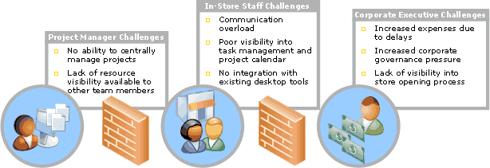
Figure 2.1
Business challenges faced by key stakeholders
Without a way to manage the store opening process for all its key stakeholders—from project manager to corporate executives—organizations often experience poor execution of store openings, which results in negative customer impressions, delays, and reduced revenues.

Addressing the Business Challenges
To address the business challenges associated with streamlining communication and collaboration between project, store, and corporate teams, retail organizations must overcome obstacles—including a lack of tools and methodologies—that contribute to poorly defined business processes and a lack of overall accountability. When these challenges are addressed, organizations can improve their ability to open new and remodeled stores without delays, reduce store opening costs, and increase revenue opportunities.
Implementing a store opening solution requires tools that can store, organize, and display up-to-date information in a central location; provide the ability to generate reports; and improve the organization’s ability to comply with government regulations. An ideal solution should provide the following components:
● Centralized document repository: A centralized document repository can help project managers deal with current and relevant documents that are scattered across different groups and locations, a lack of cross-group collaboration tools and methodologies, and too many undocumented steps in the business process. Managing information in a central location can help managers ensure that tasks are completed fully and consistently.
● Enterprise task assignments and reporting: A reporting tool that can gather up-to-date task assignment status can help managers and executives avoid inconsistent and manual reporting and distribution systems. Such a tool empowers managers and executives to analyze information quickly and make timely decisions.
● Robust project management tools: By using a solution that enables an organization to create and customize business process templates, changes can easily be made across the organization to accommodate new regulatory and compliance requirements that protect shareholders and company stakeholders. This enables compliance and corporate governance to become an integral part of any store opening operation.
These components can help address the challenges of streamlining communication and collaboration within an organization to improve the store opening process. While some organizations might already have tools that address a few of these components, all components can be implemented with the use of the Microsoft Office. And they can be implemented using tools that employees are familiar with and already use on a daily basis.

Streamlining the Retail Store Opening Process Using Microsoft Technologies
All of the issues that are part of the store opening process—including data management, automation, standardization, and reporting—can be addressed using the technologies in the Microsoft Office System. If your organization already has some tools to address a few of these issues, Office can still offer the advantages of integration and a familiarity to users. Using Office, you can extract information from the various documents, databases, and tools and enable that information to be used in familiar Office technologies.
The following Microsoft products can be used to create an integrated solution for all key stakeholders in the store opening process:
● Enterprise Project Management (EPM) Solution Technologies integrates leading products, technologies, and services into a customizable solution designed to meet your unique business challenges.
● Core products that comprise an EPM Solution include:
● Microsoft Office Project Server 2003
● Microsoft Office Project Professional 2003
● Technologies that enable richer EPM solutions include:
● Microsoft Windows Server™ operating system (Microsoft Windows 2000 Server™ or Microsoft Windows Server™ 2003)
● Microsoft Windows SharePoint Services (requires Windows Server 2003)
● Microsoft SQL Server 2000 – for data management
● Microsoft Office Outlook® 2003 – integration of Outlook with Microsoft Office Project Server 2003 enables rich features such as viewing Project tasks directly in Calendar
● Additional products in the Microsoft Office System –Project 2003 Professional and Project Server are designed to work with other Microsoft Office System programs, including Microsoft Office Excel® 2003, Microsoft Office PowerPoint® 2003, and Microsoft Office Visio® 2003, so that you can effectively share and communicate project information to a wider audience.
● Microsoft SharePoint Products and Technologies can be used to create a centralized portal where all stakeholders can go to view project plans, calendars, and reports. SharePoint Products and Technologies can also act as a central place to store form templates.
● Microsoft Office 2003 can be used to integrate key information into business forms, organize and sort data, and provide e-mail services. The following Office components can be used to create structured documents so that data can be shared with users and other applications securely, and so that inefficiencies due to manual re-keying of data are avoided:
● Microsoft Office Project Professional 2003: Integrates with Microsoft Office Project Server 2003 to manage business process templates, project portal sites, resource assignments, and project plan creation. Project Professional 2003 provides all the capabilities in Project Standard 2003. In addition, when used with Project Server 2003 and Microsoft Office Project Web Access, it provides enterprise project management (EPM) capabilities such as up-to-date information on resource availability as well as skills and project status.
● Microsoft Office Excel: Excel provides a familiar way to organize and sort data.
● Microsoft Office Outlook: Outlook provides a way to notify employees when they have a task to complete.
● Microsoft Windows Server, ASP.NET, and Microsoft .NET Web services support the use of Web services so that SharePoint Products and Technologies application programming interfaces (APIs) can interact with various data sources and line-of-business applications.
● Microsoft Project Server 2003 enables organizations to store project and resource information centrally and consistently. It supports the portfolio management, resource management, and collaboration capabilities in the EPM Solution. Project Server includes a component called Project Web Access. Project Web Access organizes information stored in Project Server into different pages, such as the Projects page or the Tasks page. On each page, information is displayed in Project Web Access views. Much like views in Project, these views include a variety of fields and filters and are formatted to focus on specific areas of the project. Project Server also integrates with Microsoft Windows SharePoint® Services for file management and collaboration capabilities, helping team members to work together more effectively.
● Microsoft SQL Server 2000 SP3a or other database technologies can be used to store data in a central location that can be accessed by Web services and shared when appropriate.
The goal of a solution that uses Microsoft technology is to make data available to users and other applications in a secure manner so that everyone in the organization has visibility into the store opening process and can complete his or her assigned tasks or job functions as easily as possible.

Benefits
A store opening solution using the Microsoft Office System provides retailers with tools and methodologies to assign, monitor, and report on the multitude of store opening tasks. This can enable retail organizations to:
● Reduce operational costs associated with store opening operations to stay within budget.
● Improve performance of store opening tasks through standardized and repeatable processes.
● Better manage corporate governance and compliance requirements by using existing technology assets.
The end result for organizations is that they are able to open new or remodeled stores faster and take advantage of more revenue opportunities through market expansion.

Reduce Operational Costs
To reduce costs, all stakeholders in the store opening process must be able communicate and collaborate with each other to avoid duplication of effort and loss of time communicating tasks, status, and issues. By using familiar Microsoft Office tools that are integrated with line-of-business applications, organizations can streamline communication and collaboration. For example, when project data is exposed through Outlook and users can see their tasks in their inboxes, they can respond to the tasks quicker. Organizations can:
● Improve end-user satisfaction through integration with familiar tools.
● Lower IT impact through use of existing software.
● Ensure quicker task resolution through higher, simpler visibility.
By getting project teams working together to improve the overall store opening process, organizations can open more new or remodeled stores faster.

Improve Performance of Store Opening Tasks
To improve the ability perform tasks, all stakeholders in the store opening process must have a defined business process that is clearly visible to all stakeholders, easy to track and report, and easy to use. By using Microsoft Office System tools such as Project, organizations can quickly create business process templates that can be customized. Organizations can also use Microsoft Project Server to improve processes for task assignment and reporting.
Creating customizable business process templates with Microsoft Project enables a retail organization to use pre-configured project templates. Organizations can:
● Set up projects faster.
● Improve on-time store opening rates by capturing and reusing best practices.
● Quickly allocate resources through pre-assigned tasks.
Integrating all the discrete tasks of store opening into an end-to-end business process also enables dynamic tracking.
To improve the processes of assigning enterprise tasks reporting, retail organizations can use Project Server to create a project site. A project site will enable you to easily assign resources to a pre-configured project plan and check the status of tasks in a visual format for quicker identification. This adds business value in the following ways:
● Begin projects faster through task assignment
● Increase teamwork efficiency through a central location for tasks, issues, and schedules
● Improve visibility to task status
● Quickly resolve issues associated with tasks
Another way to improve performance of tasks is to host a centralized repository of documents that enables all project team members—current and new—to always find the right resource at the right time. Hosting a centralized repository also helps organizations in the effort to comply with government regulations.

Better Manage Corporate Governance
To help retail organizations comply with government regulations, a solution must be able to improve the ability of managers and executives to track and report on the store opening process. This ability relies on using a centralized document repository to store data that can be accessed securely by users and applications that create reports to comply with government regulations. By using Microsoft technologies such as SQL Server to create structured databases, information can be integrated into SharePoint Products and Technologies team sites to enable better visibility. Project Server can also be used with SharePoint Products and Technologies to provide access to project templates and improve data management. This adds value to the businesses in the following ways:
● More consistent reports through easily accessible templates
● Continuous improvement through a central environment for sharing ideas and best practices
Most importantly, using Microsoft technologies together in this way can enable employees to share best practices during the store opening process so that successes can be repeated and revenue can be increased.

3 Architectural Overview
An example of a solution for store openings can be built on a combination of technologies that includes Microsoft Office System, Microsoft SharePoint Products and Technologies, Microsoft Project Server, and Microsoft SQL Server. The example described in this chapter demonstrates one way to streamline the process of opening a store by enabling stakeholders to access tools and information using familiar Office technologies.

Example of a Solution Architecture
A store opening solution based on the Microsoft Office System could have components configured in a client and server architecture. The example described in this guide integrates components as shown in Figure 3.1.
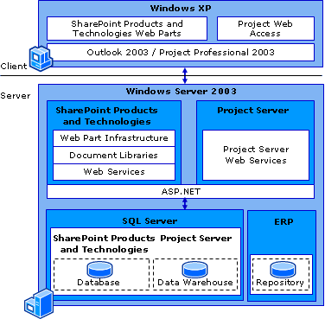
Figure 3.1
Logical architecture for the example of a store opening solution
Each layer of this architecture is described in the following sections.

Client Layer
The client layer could consist of Windows® XP, Microsoft Office System applications, and the Project Server component called Project Web Access. Windows XP includes Internet Explorer 6, which can be used to access the Web Parts on SharePoint Products and Technologies team sites.
Microsoft Office and Microsoft Project files can be saved directly to a server-based document repository, such as Microsoft SharePoint Products and Technologies databases, or the data contained in them can be submitted to another data store through Web service calls.
The Microsoft Office System applications could be used to:
● Create and manage project data using Microsoft Project Professional.
● Respond to task notifications in Microsoft Office Outlook.
Project Web Access can be used to display information stored in Project Server to users who participate in the store opening. A Project Server administrator can define and control the pages and views and assign user permissions so that team members, executives, and stakeholders can see the information they need. This can enable users to see some information, depending on the assigned permissions, even if they do not own or manage a store opening process.

Server Layer
The server layer could consist of one or more servers running Windows Server 2003, SharePoint Products and Technologies, Web services supported by ASP.NET, Project Server, and SQL Server. The server-side layer includes data integration and business logic application components using XML Web services that are integrated with Microsoft Windows Active Directory for authentication and user role identification.
Microsoft Windows SharePoint Services can interact with its content and configuration databases and Web services to provide the client layer with access to Microsoft Project and line-of-business data. To supply line-of-business data to the client through Web services, custom code must be written to expressly expose that data. Project can also be integrated directly to an ERP by writing custom code if this integration is necessary. Adapters for the Microsoft enterprise integration platform, BizTalk® Server, provide a framework for establishing connectivity between specific ERP systems and other external data sources. For a complete list of adapters created by Microsoft as well as Microsoft partners see: http://www.microsoft.com/biztalk/evaluation/adapter/default.mspx
Using a BizTalk adapter has specific advantages to authoring completely custom integration components:
● Transactional data movement and modification ensures that user actions are not lost even if connectivity is interrupted
● Support for fully custom business rules and work flow
● Microsoft Visual Studio® .NET development environment for customizing adapters and easy deployment
● Each adapter is designed for connectivity to a specific application or for customizing connectivity through a specific protocol or technology standard
This enables a manager to access information on the team sites that is extracted from and processed by Project Server or another existing line-of-business application. All of the business process templates and data storage are handled on the server. To store project and line-of-business data captured on the client, SharePoint Products and Technologies and Project Server also interact with ASP.NET Web services.

Data Layer
The data layer on the server consists of multiple data repositories including SharePoint Products and Technologies configuration and content databases and Web folders for storing Office application files such as reports, project templates, documents, and spreadsheets. Microsoft Project Server databases also reside in the data layer, both the transactional database and any data warehouses that might be necessary for further reporting. The server in this example uses Windows Server 2003 and SQL Server to manage data stores. While SQL Server is used to store site-related SharePoint Products and Technologies data, it is also common for data to be stored in Project databases and other line-of-business applications such as an enterprise project management (ERP), Customer Relationship Management (CRM), or supply chain management application.
Also hosted on the servers are business process templates—in the form of site templates—that enable project teams to quickly start the next store opening projects using pre-defined templates for plans, workflows, and diagrams.

Example of a Solution Architecture in Action
This section describes how data can flow through a solution based on the architecture example provided in the previous section.
A fictional company called Contoso Enterprises has implemented a retail store opening solution using the Microsoft Office System. Contoso has a growing retail store business with thousands of branches all across the country. Contoso’s continued success depends upon its ability to quickly take advantage of new markets by opening stores in new areas. Before each new store can open, there are hundreds of tasks to complete. Managing these tasks is a significant effort, and a few store openings have been delayed due to poor execution. Corporate headquarters, frustrated by encountering the same delays over and over again, has identified the following issues that contribute to poor execution:
● Some team members are new to the company and/or the store opening process
● Project teams are having a hard time tracking projects and establishing accountability
● At the stores themselves, employees are not always aware of their responsibilities
● Increasingly aggressive regulatory compliance standards put additional pressure on the company to document its processes
The end result of poor execution and store delays for Contoso is lost revenue opportunities, increased costs, and a poor first impression with customers. In order to improve the situation, Contoso has implemented a project management solution for store openings. Its goal is to be able to consistently open stores faster and within budget by improving operational efficiency and project management.
Contoso will use this solution to improve project management in the following steps of its store opening process:
● Assigning a task to a resource
● Routing assignments
● Reporting on project status
This solution helps to provide managers and team members with a comprehensive view of store opening procedures and tasks in a system that is easy to implement and use.

Assigning a Task to a Resource
Chris Ashton is a project manager in charge of opening new Contoso retail stores. He has a huge number of discrete tasks that he has to oversee for each project. If Chris can't get quick visibility into what's happening with each store opening, he can’t do his job. Fortunately, the new project management solution includes a SharePoint Products and Technologies site built for Contoso that gives Chris access to the information he needs.
The home page of this site enables Chris to see project status at a glance. The home page also includes a list of other SharePoint Products and Technologies sites for new stores, organizaed by location. Chris wants to check on the status of the North Carolina store opening, so he selects it from the list. This opens a new page for only the North Carolina store opening, as shown in Figure 3.2.
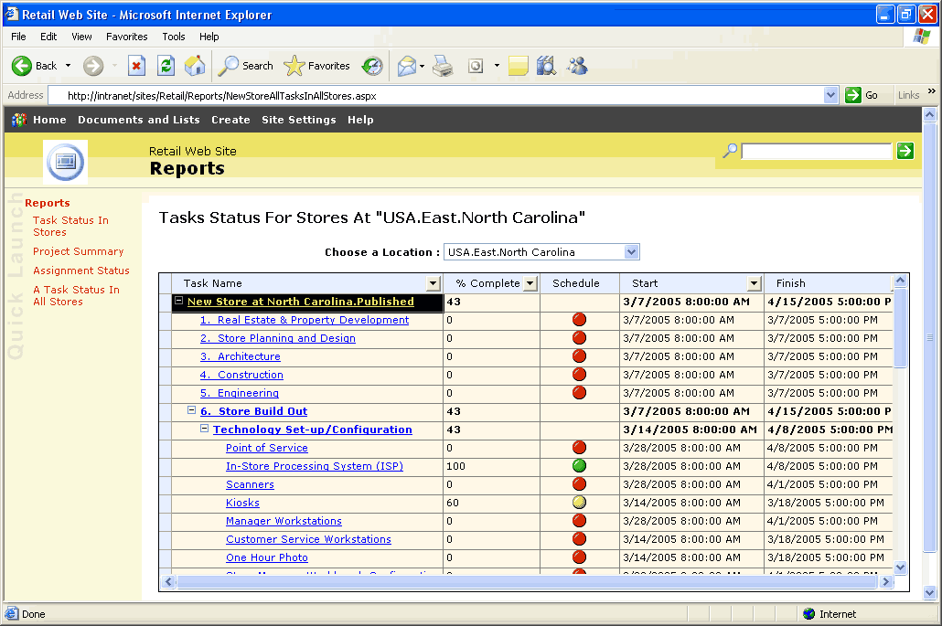
Figure 3.2
The project management site for the North Carolina store opening
The Tasks Status home page for North Carolina stores has a partner-built Project Web Access Web Part intended to integrate with Microsoft Project Server and show the tasks associated with this project and their status. To get more details on each task quickly, Chris can simply click a task name to see who is assigned to it. This establishes clear accountability for the task.
Chris notices that no one has been assigned to set up point of service at this store yet, so he needs to assign that task. The Contoso solution saves documents containing task information centrally on a server running SharePoint Products and Technologies. To assign the task, Chris can use the links on the Web pages to open the Microsoft Project document for the North Carolina location.
Each of the project plans was created from a template. Since the bulk of the tasks in each store opening are the same, Contoso has been able to turn this process into a repeatable set of project tasks, making the entire process much more efficient.
In the project schedule, Chris can see the schedule in detail. He wants to assign the point of service task to Christian Jene, an engineer on the project team. As shown in Figure 3.3, Chris can easily do this from within the project plan.
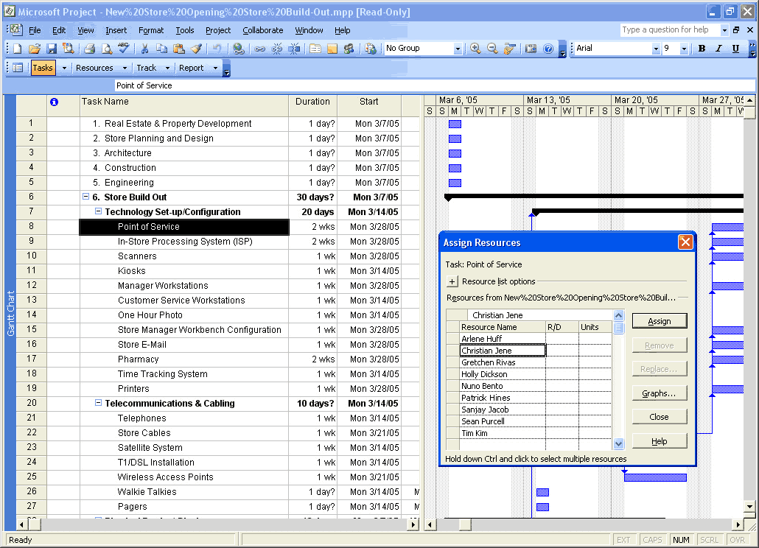
Figure 3.3
The project plan for the North Carolina store opening
To assign the task to Christian, in the Contoso solution, all Chris has to do is click the task name, select Christian's name from the list of available resources, and click the Assign button. The great thing about this solution is that the information is stored centrally on the server. That means there is no confusion about who has the most current document or where it can be found.
Now that Chris is done, he can use Project to publish the updated project plan with a few button clicks.

Routing Assignments
As soon as Chris assigns a new task to Christian, in the Contoso solution an e-mail notification is automatically sent to Christian's inbox. This enables Christian to immediately see that he has a new assignment.
For the Contoso solution, a partner wrote custom code to display a new option on the Outlook toolbar. This button, called Import New Assignments, is enabled on the toolbar when Christian receives his task assignment notification. The Import New Assignments button is shown in Figure 3.4, on the Outlook toolbar near the upper-left portion of the screen.
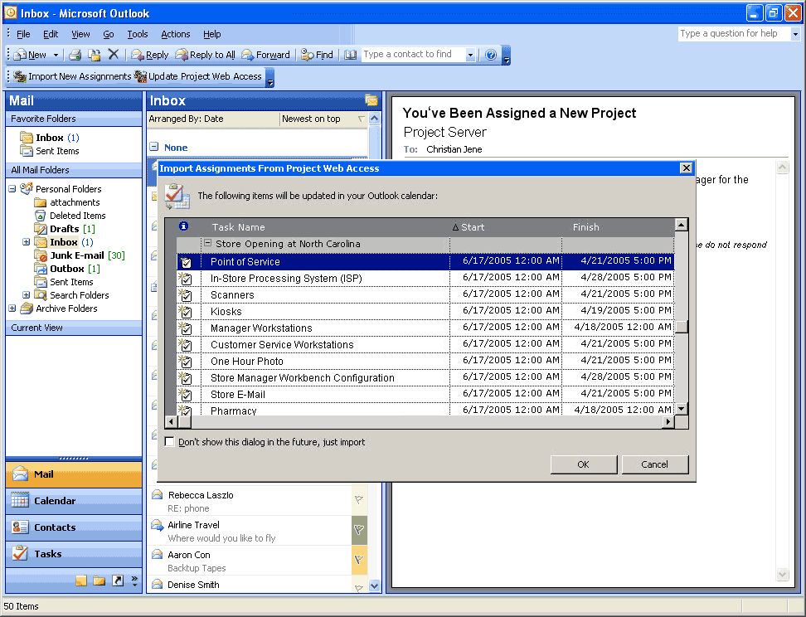
Figure 3.4
Christian Jene's inbox showing his task notification and import options
This custom code enables Christian to import changes to the local installation of Project with simply the click of a button. The Import Assignments from Project Web Access window, also created by a partner, shows that Christian has accepted the assignment, which helps to further establish accountability.

Reporting on Project Status
Another big challenge Contoso has had with store openings is tracking project status. Before implementing the Microsoft solution, getting an up-to-date view of a project was nearly impossible. Problems were not detected right away, which resulted in delays. The new solution enables stakeholders to view the project in real time.
Chris wants to check on the status of the new assignments for the North Carolina store opening. From the Retail Web site, Chris can access a reporting page for the North Carolina store and quickly see the tasks in the project and a detailed status. The Contoso Reports page for the North Carolina store is shown in Figure 3.5.
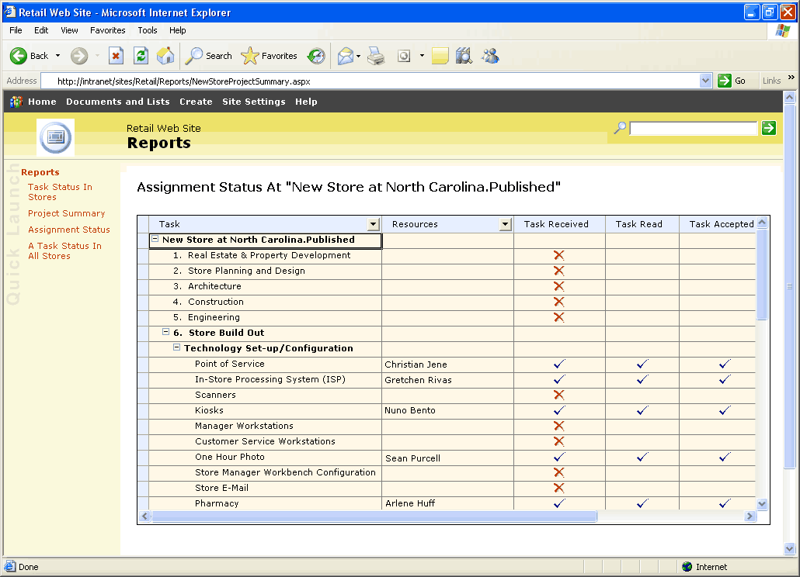
Figure 3.5
The Contoso Reports page for the North Carolina store
As shown in Figure 3.5, Chris can see at a glance the tasks that have been assigned, who is assigned to the task, as well as tracking information. Chris can see from this report that Christian has read, received, and accepted this point-of-service task. By scrolling to the right to see more columns, Chris will be able to track other milestones for this task, such as percent of work completed, and track Christian's status to make sure that the project continues to function smoothly. This form of centralized reporting will help Contoso managers identify bottlenecks and further refine the store opening process in the future.
With its retail store solution based on Microsoft Office products, Contoso has been able to greatly streamline the process of opening new retail stores in the following ways:
● Standardization and coordination of the large number of tasks by using project templates
● Greater control for managers over how resources are used and how accountability is established for project tasks
● Greater oversight for how projects are doing in real time
● Reduced confusion and delays by using a central location for all project documents
Streamlining its process has improved operational efficiency and has a positive impact on the bottom line. Stores are consistently opening on time and on budget. Contoso has been able to take advantage of new markets and expand its business. Because projects are completed on time and within budget, costs are kept under control and profits have improved.

Extending the Example of a Solution Architecture
The basic architecture described in the example provides core functionality for stakeholders to manage project data related to the store opening process. To make the store opening solution richer, a company, system integrator, independent software vendor (ISV), partner, or developer can build upon this example. Some of the ways to extend the architecture could include the following options:
● Build in features for supply chain management.
● Integrate project data with inventory and order management data.
● Include tools for space and floor planning.
● Build in tools to help prevent fraud.
● Integrate with tools for merchandising management.

4 Infrastructure Considerations
This chapter describes issues an organization or partner should consider when planning to implement or deploy a solution similar to the solution in the example based on the Microsoft Office System. This section describes the software, operational, and security considerations that an organization or partner must resolve before implementing a solution similar to the example. If an organization or partner is planning to develop its own solution, then some requirements or considerations might not apply.

Software Considerations
This section lists software that was used to create the example of a solution described in the “Example of a Solution Architecture” section in Chapter 3.

The Enterprise Project Management Solution
This solution brings together client, server, and Web-based technologies to enable your organization, department, or team to manage company-wide projects and align business initiatives for better results. It is an alternative to deploying Project Professional 2003, Project Server 2003, and Project Web Access separately. These products are designed to work together to make up the enterprise project management (EPM) Solution. The EPM Solution consists of the following Project 2003 products, each of which can be obtained separately:
● Project Professional 2003
● Project Server 2003
● (Optional) Project Server 2003 Client Access Licenses
● (Optional) Project Server 2003 External Connector
One or more clients and servers accessing a store opening solution can use the software and technology listed in the following table.
Table 4.1 The EPM Solution
Software and Technology | Description
Enterprise Project Management (EPM) Solution | The Microsoft Office Enterprise Project Management (EPM) Solution is ideal for organizations that need strong coordination and standardization between projects, centralized resource management, or higher-level reporting about projects and resources. The EPM Solution integrates leading products, technologies, and services into a customizable solution designed to meet your unique business challenges.  In the example of a solution, the EPM Solution can provide Project Professional 2003 on the client computer, Project Server 2003 on the server computer, and an external connector for other line-of-business applications. For more information, see:  http://www.microsoft.com/office/project/prodinfo/EPM/overview.mspx

Client Software Considerations
One or more clients accessing a store opening solution can use the following software and technology.
Table 4.2 Client Software Considerations
Software and Technology | Description
Microsoft Windows XP Professional | Windows XP brings the convergence of Windows operating systems by integrating the strengths of Windows 2000—standards-based security, manageability, and reliability, with the best features of Windows 98 and Windows Millennium Edition—Plug and Play, easy-to-use user interface, and innovative support services to create the best Windows operating system yet.  In the example of a solution, Windows XP Professional can be the operating system on the client computer. For more information, see:  http://www.microsoft.com/windowsxp/pro
Microsoft Office Professional Enterprise Edition 2003  with:  ● Project Professional  ● Outlook | Office 2003 Editions can help organizations and their employees transform information into impact. New and familiar products, features, and functionality improve how people and organizations connect to coworkers, information, and business processes. Microsoft Office Professional Enterprise Edition 2003 is the most comprehensive version of Office, and it includes Project and Outlook.  The example of a solution provides Project for managers to create project information and Outlook to notify employees that a task has been assigned to them. For more information, see:  http://www.microsoft.com/office/editions/prodinfo/enterprises

Server Software Considerations
One or more servers running a store opening solution can use the following software:
Table 4.3 Server Software Considerations
Software | Description
Microsoft Windows Server 2003 | The Windows Server 2003 operating system takes the best of Microsoft Windows 2000 Server technology and makes it easier to deploy, manage, and use. The result is a highly productive infrastructure that helps make your network a strategic asset for your organization.  In the example of a solution, Windows Server 2003 is the server operating system of the computer running SharePoint Products and Technologies, Project Server, and SQL Server 2000. For more information about Windows Server 2003, see:  http://microsoft.com/windowsserver2003/evaluation/sysreqs
Microsoft ASP.NET 1.1 | ASP.NET is a technology for creating dynamic Web applications. It is part of the .NET Framework; you can author ASP.NET applications in any .NET compatible language, including Microsoft Visual Basic® .NET, Microsoft Visual C#®, and Microsoft Visual J#® . ASP.NET pages (Web Forms) are compiled, providing better performance than with scripting languages. Web Forms enable you to build powerful forms-based Web pages. When building these pages, you can use ASP.NET server controls to create common UI elements, and program them for common tasks. These controls enable you to rapidly build a Web Form out of reusable built-in or custom components, simplifying the code of a page.  http://msdn.microsoft.com/asp.net/gettingstarted
Microsoft Windows SharePoint® Services 2.0 | Windows SharePoint Services enables enterprises to develop an intelligent portal that seamlessly connects users, teams, and knowledge so that people can take advantage of relevant information across business processes to help them work more efficiently.  In the example of a solution, Windows SharePoint Services hosts the team collaboration site.  For more information, see:  http://www.microsoft.com/windowsserver2003/technologies/sharepoint
Microsoft SharePoint® Portal Server | Microsoft SharePoint Portal Server 2003 enables enterprises to develop an intelligent portal that seamlessly connects users, teams, and knowledge so that people can take advantage of relevant information across business processes to help them work more efficiently. SharePoint Portal Server 2003 provides an enterprise business solution that integrates information from various systems into one solution through single sign on and enterprise application integration capabilities, with flexible deployment options and management tools.  SharePoint Portal Server 2003 uses Microsoft Windows SharePoint Services 2003 sites to create portal pages for people, information, and organizations.  The example of a solution uses SharePoint Portal Server as the search engine to find templates from other projects, from outside the collaborative site, or between corporate and branch sites.  For more information, see:  http://office.microsoft.com/en-us/FX010909721033.aspx
Microsoft Project Server | Project Server is part of the enterprise project management platform that provides centralization and standardization of project and resource information to enable:  ● Enterprise resource management.  ● Web-based time and status reporting.  ● Web-based views of portfolio, and project performance data.  ● Portfolio analysis and modeling.  ● Customization and integration with line-of-business (LOB) systems.  In the example of a solution, Project Server enables stakeholders to create and manage project information. For more information, see:  http://www.microsoft.com/office/project/prodinfo/serverreq.mspx
Microsoft SQL Server 2000 | SQL Server 2000 provides the enterprise data-management platform your organization needs to adapt quickly in a fast-changing environment.  In the example of a solution, SQL Server supports SharePoint Products and Technologies and serves as the primary repository for documents and data. For more information, see:  http://www.microsoft.com/sql

Operations Considerations
This section provides high-level guidelines for partners or organizations who are interested in implementing a store opening solution based on the Microsoft Office System.
An organization should plan for, or consider, these issues:
● Pre-deployment planning: During the planning phase, an organization or partner should determine the steps and the sequence required to successfully implement a store opening solution, based on the needs of the organization. An organization or partner should then assign personnel to specific areas of planning, based on their technical skills. An organization or partner should also document the organization's existing processes and requirements. After this is complete, an organization or partner should determine the specific personnel required.
● Client layer development: The client layer in the example of a solution described in this guide uses Windows XP, Microsoft Office System applications such as Outlook and Project Professional, Project Web Access, and SharePoint Products and Technologies Web Parts. To create a client layer similar to the example, an organization or partner will need personnel with technical knowledge about Web parts, Project Web Access, and Outlook development.
● Server layer development: The server layer in the example of a solution described in this guide uses Windows Server 2003 with SharePoint Products and Technologies, ASP.NET, Project Server, and SQL Server. To create a server layer similar to the example, an organization or partner will need personnel with technical knowledge about .NET Web services, application-based role definitions, and Project Server. Knowledge of SQL Server tables, stored procedures, and user-defined functions that are used to interact with those tables is also necessary.
● Deployment planning: When planning for the deployment of a store opening solution, an organization or partner should assess the software, hardware, and organizational limitations and requirements. An organization or partner should implement a pilot program to aid in testing and preparing for full deployment. Integration of databases with an organization's existing line-of-business applications might involve a significant effort.
● Operations planning: The operation of a store opening solution should be handled by the organization's personnel with technical knowledge of the applications used in the solution. In addition, database administrators must design a strategy to properly maintain data replication between a store opening solution and any existing line-of-business application or other external data source.
● Test planning: An organization or partner should develop a comprehensive test plan to ensure that their implementation of a store opening solution is fully operational.

Security Considerations
Standard security precautions should be addressed in solutions that use Web pages, Web services, and databases.
The following resources provide general security information for Microsoft products and technologies:
● Microsoft TechNet Security Resource Center: TechNet provides security resources at the Security Resource Center. Check this site regularly for the latest security headlines and for information about updates at:
http://www.microsoft.com/technet/security
● General security guidance: Microsoft offers a wide variety of security guidance for IT professionals and developers at the Security Guidance Center at:
http://www.microsoft.com/security/guidance

5 Next Steps
This chapter reviews steps that organizations can take if they decide to pursue implementation of a store opening solution built using the Microsoft Office System. This chapter describes some of the resources and skills required to develop, implement, and maintain a solution. It also provides information about partners.

Resource and Skill Set Considerations
Developing, implementing, and operating a retail store opening solution similar to the example in this guide requires personnel for three primary roles: business analyst, developer, and administrator. The specific functions and required skill sets for these roles are described in the following sections.

Project Manager
The following describes the project manager's functions and skill set:
● Functions: Works with the business analyst, developer, and IT staff to develop, maintain, and execute the project master plan and schedule. Manages the development project to ensure the solution is ready to deploy on time. Facilitates communication and negotiation within the development team and drives the determination of critical trade-off decisions.
● Skill set: Expert at delivering solutions within project constraints. Knowledge of project management, solution architecture, and process assurance. Familiarity with maintaining project schedules, reporting project status, assessing risks and managing risks.

Business Analyst
The following describes the business analyst's functions and skill set:
● Functions: Analyzes business processes and defines the rules and behaviors required within processes. Identifies the information that must be sent to each application, determines the process flow required, and maps out how Microsoft applications and proprietary applications are related.
● Skill set: Knowledge of the store opening process and the strategic goals of the company. Familiarity with project plans and existing line-of-business applications in use.

Developer
The following describes the developer's functions and skill set:
● Functions: Implements the business processes defined by the business analyst. Creates ways for Microsoft Office applications and proprietary applications to share data and tasks necessary to implement the business processes.
● Skill set: Familiarity with Microsoft Windows Server 2003, and the Microsoft .NET Framework. Expertise with Microsoft Project Server, EPM, Microsoft Office 2003 Web Parts and Components, and development skills in Web services. Familiarity with existing line-of-business applications in use.

Application Administrator
The following describes the administrator's functions and skill set:
● Functions: Sets up communication among the components specified by the developer and deploys SharePoint Products and Technologies as required.
● Skill set: Familiarity with Windows Server 2003, SharePoint Products and Technologies, and the Microsoft .NET Framework. Familiarity with Project Server and existing line-of-business applications in use.
To help organizations become more successful in delivering business-driven technology solutions, Microsoft has created the Microsoft Solutions Framework (MSF). MSF is a deliberate and disciplined approach to technology projects based on a defined set of principles, models, concepts, guidelines, and proven practices from Microsoft. MSF resources are available at:
http://www.microsoft.com/technet/itsolutions/msf

Potential Partner Solutions
Microsoft industry partners can play an important role in developing a solution for store openings. A partner can provide subject matter expertise and deployment support, customize a solution by adding custom Web Parts and other tools, enhance the workflow and security of a solution, and assist in understanding and automating important business processes that are currently manual.
You can find more information about partner solutions at:
http://www.microsoft.com/office/showcase/storeopening/partnersol.mspx

Solution Showcase for the Microsoft Office System
The Solution Showcase for the Microsoft Office System highlights how leading organizations can solve business challenges using the Microsoft Office System. The Solution Showcase provides information about how Microsoft customers can obtain more value from their investments in the Microsoft Office System.
For more information about the Solution Showcase, see:
http://www.microsoft.com/office/showcase
For more information on how partners can get involved with the Solution Showcase, see:
http://www.iwsolve.com

Langdoc, Scott. “Retail Industry Outlook: Better Demand Data and Store Execution Create a Superior Shopping Experience.” AMR Research. September 2004.

