Windows PC Accelerators
November 30, 2006
Abstract
This paper provides an overview of the Microsoft® Windows® PC Accelerators, a collection of three features introduced in Windows Vista™ that directly address performance and responsiveness in PCs. This paper describes the key benefits and implementation considerations for each feature.
The features include Windows SuperFetch™, an innovative new memory manager that analyzes usage patterns over time to optimize what data is kept in memory; Windows ReadyBoost™, a feature to support the use of flash storage devices like USB flash drives to boost PC performance; and Windows ReadyDrive™, a feature to support hybrid hard disk drives.
This paper is intended for PC and storage device manufacturers that want to develop products to take advantage of the Windows PC Accelerator features.
The current version of this paper is maintained on the Web at:
http://www.microsoft.com/whdc/system/sysperf/perfaccel.mspx
References and resources discussed here are listed at the end of this paper.

Contents
Overview 3
Windows SuperFetch 4
Memory Management before Windows Vista 4
Proactive Memory Population Using SuperFetch 4
Implementation Considerations 5
Windows ReadyBoost 5
Key Benefits 7
Implementation Considerations 7
Supported Form Factors and Busses 7
Flash Performance 8
Flash Capacity 8
Flash Wear 8
PC System Considerations 8
Windows Hardware Quality Labs 8
Windows ReadyDrive 8
Key Benefits 9
Improved Performance 9
Longer Battery Life 12
Improved Ruggedness and Reliability 12
Implementation Considerations 12
ATA Command Set 12
Windows Hardware Quality Labs 13
NV Cache Size 13
NV Cache Performance 13
NV Cache Run-time Performance Assessment Process 14
NV Cache Flash Wear 14
PC System Considerations 14
Desktop PC Considerations 15
Requirements and Recommendations 15
Resources 16
Disclaimer

This is a preliminary document and may be changed substantially prior to final commercial release of the software described herein.

The information contained in this document represents the current view of Microsoft Corporation on the issues discussed as of the date of publication. Because Microsoft must respond to changing market conditions, it should not be interpreted to be a commitment on the part of Microsoft, and Microsoft cannot guarantee the accuracy of any information presented after the date of publication.

This White Paper is for informational purposes only. MICROSOFT MAKES NO WARRANTIES, EXPRESS, IMPLIED OR STATUTORY, AS TO THE INFORMATION IN THIS DOCUMENT.

Complying with all applicable copyright laws is the responsibility of the user. Without limiting the rights under copyright, no part of this document may be reproduced, stored in or introduced into a retrieval system, or transmitted in any form or by any means (electronic, mechanical, photocopying, recording, or otherwise), or for any purpose, without the express written permission of Microsoft Corporation.

Microsoft may have patents, patent applications, trademarks, copyrights, or other intellectual property rights covering subject matter in this document. Except as expressly provided in any written license agreement from Microsoft, the furnishing of this document does not give you any license to these patents, trademarks, copyrights, or other intellectual property.

Unless otherwise noted, the example companies, organizations, products, domain names, e-mail addresses, logos, people, places and events depicted herein are fictitious, and no association with any real company, organization, product, domain name, email address, logo, person, place or event is intended or should be inferred.

© 2006 Microsoft Corporation. All rights reserved.

Microsoft, HotStart, ReadyBoost, ReadyDrive, SuperFetch, Windows, Windows Server, and Windows Vista are either registered trademarks or trademarks of Microsoft Corporation in the United States and/or other countries.

The names of actual companies and products mentioned herein may be the trademarks of their respective owners.

The names of actual companies and products mentioned herein may be the trademarks of their respective owners.

Overview
Windows Vista™ introduces the Microsoft® Windows® PC Accelerators, a collection of features that directly address performance and responsiveness problems found in PCs running previous versions of Windows. The features include:
- Windows SuperFetch™, an innovative memory manager that analyzes usage patterns over time to optimize memory content
- Windows ReadyBoost™, a feature to support the use of flash storage devices to boost PC performance
- Windows ReadyDrive™, a feature to support the use of hybrid hard disk drives (H-HDDs)

SuperFetch is included in all versions of Windows Vista, and storage devices enhanced for ReadyBoost and ReadyDrive can be installed individually or in combination to improve a PC’s performance. Devices enhanced for ReadyBoost and H-HDDs enhanced for ReadyDrive are those that meet the performance and implementation requirements described in this document. Optimal performance can be achieved through a combination of such devices and ample system main memory. Requirements and recommendations for using all three of the Windows PC Accelerators are discussed throughout and summarized at the end of this paper.
Although many factors can influence the responsiveness and performance of a PC, Microsoft research has shown that demand paging—a method for implementing virtual memory that involves swapping pages of data between disk storage and main memory as they’re needed—is a key contributor to poor performance. Demand paging generates many requests to the disk and creates a usage pattern that resembles random disk I/O, with long latencies caused by seeks on the disk.
Although latencies associated with this paging process can be a result of limited memory capacity, it’s often a result of less-than-optimal memory content. The Windows PC Accelerators limit the latencies associated with demand paging in two ways. They provide memory management logic to analyze usage patterns and actively optimize memory content, and they also support various implementations of nonvolatile flash memory in PC hardware to provide high-performance disk caching. Although not as fast as main memory, nonvolatile flash memory significantly outperforms disk media in random I/O.
Memory type | Latency (milliseconds)
Main memory (DRAM) | ~0.0001
Flash memory | ~0.5–1
Disk media (HDD) | ~0.5–24

Windows SuperFetch
SuperFetch analyzes memory usage patterns to determine the optimal memory content for a given user and works continuously to maintain that content in memory for the user. SuperFetch also automatically recognizes and uses any capacity afforded by storage devices enhanced for ReadyBoost and ReadyDrive for high-performance disk caching.
Windows ReadyBoost
ReadyBoost supports the use of flash storage devices such as USB flash drives, Secure Digital cards and CompactFlash cards to improve performance. Devices enhanced for ReadyBoost provide a dedicated space where SuperFetch can keep a copy of performance-crucial data.
Windows ReadyDrive
ReadyDrive supports the use of H-HDDs, which include both disk media and an integrated cache of nonvolatile flash storage (NV cache). The NV cache provides space for several uses: as additional capacity for SuperFetch, as a write buffer to the hard disk, and as additional capacity where OEMs can pin preferred blocks of data for launching preferred programs and experiences.

Windows SuperFetch
SuperFetch is the memory manager in Windows Vista. It analyzes memory usage patterns over time to determine the optimal memory content for a given user and works continuously to maintain that content at any given date or time of day. This differs from the prefetch technique used in Microsoft Windows XP, which preloads data into memory without analyzing usage patterns.
SuperFetch also automatically recognizes and uses any additional capacity afforded by nonvolatile flash storage devices enhanced for ReadyBoost and ReadyDrive. SuperFetch in effect improves the performance of the storage layer of the computer’s memory.

Memory Management before Windows Vista
Historically, memory management systems have been designed to mitigate the fact that programs frequently requested more memory than the operating system could provide. The operating system used memory management algorithms to mitigate the effects of running low on memory. As a machine ran out of available physical memory, the operating system would free up memory by copying data that wasn’t currently in use and storing it in a pagefile on the disk. This allowed the operating system to give the physical memory capacity to a more active program, while still being able to pull the data back from the pagefile if a program requested it. This process is known as on-demand paging, or least recently used (LRU) memory management.

Proactive Memory Population Using SuperFetch
Cheaper memory and larger, more demanding programs have resulted in greatly increased amounts of physical memory in current PCs. Although it is still possible to use all the physical memory in current PCs, it is more common to have a significant amount of memory that is unused. The challenge for Windows Vista became how to be more proactive and efficient about memory management.
SuperFetch uses a lightweight, sophisticated tracking algorithm to determine which pages a user uses most frequently. As a user goes about her daily activities, SuperFetch builds a history of what information is most likely to be needed. To build an effective page list, SuperFetch tracks several aspects of the user’s computing session including but not limited to foreground application, time of day, day of the week, and even whether the user is currently using the PC.
When the PC has free physical memory, SuperFetch places candidate pages into the physical memory cache so Windows Vista can move them directly into the working set instead of pulling them from disk. This provides data when the user needs it, makes the PC more responsive, and eliminates delays caused by random disk I/O.
To illustrate the difference between the memory management techniques of Windows XP and Windows Vista, consider the common scenario when a user returns to her PC after a lunch break.
While the user is away at lunch, the PC becomes idle, which is an ideal time for maintenance tasks to run without interrupting the user. These programs need memory to run, so the operating system pages the user’s currently open programs out of memory.
In Windows XP, which has no concept of importance or timing, the operating system keeps these programs on disk until the user returns to the PC. Transferring those pages back into memory takes considerable time, during which the PC appears unresponsive.
With Windows Vista, SuperFetch knows what the user tends to do when resuming the PC from an idle state, so as soon as the idle tasks are finished, the operating system can begin to page the user’s programs back into active memory. When the user returns to the PC, her programs are more responsive.

Implementation Considerations
SuperFetch is included in all versions of Windows Vista. PC and hardware manufacturers do not need to consider any particular factors in their designs.
However, to take full advantage of the performance benefits created by SuperFetch, PCs should include as much main memory as possible, and a combination of a flash storage device enhanced for ReadyBoost and an H-HDD enhanced for ReadyDrive.

Windows ReadyBoost
ReadyBoost supports the use of nonvolatile flash storage devices to boost system performance. Devices enhanced for ReadyBoost provide dedicated space outside main memory where SuperFetch can store a cache of performance-crucial data for fast random access. Although not as fast as main memory, nonvolatile flash memory significantly outperforms conventional disk media in random reads by avoiding the rotational and seek latencies. All data written to the cache is compressed at a 2:1 ratio and encrypted by using AES-128 to ensure security of the data.
When flash storage devices enhanced for ReadyBoost are installed in PCs, Windows Vista AutoPlay shows a dialog box to the users asking them whether they would like to use the devices with ReadyBoost to improve performance. Although multiple flash storage devices can be supported as logical drives, Windows Vista supports a maximum of one of these logical drives as a ReadyBoost device.
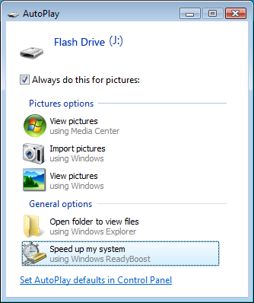
The subsequent property sheet for the device provides options for users to select an appropriate cache size to put on the device.
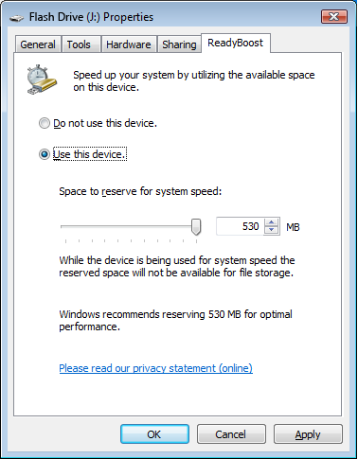
Cache sizes can range from 230 MB up to 4 GB. Microsoft recommends at least a 1:1 ratio of ReadyBoost cache size to main memory (RAM) capacity. Higher ratios up to 3:1 will realize optimal performance benefits.
Every page of data in the ReadyBoost cache is a copy of a page on disk. If the device is removed from the computer, no data is lost, but the computer loses the performance boost and the operating system reverts to sending requests to the disk.

Key Benefits
Devices enhanced for ReadyBoost accelerate the launching of frequently used programs and opening of frequently accessed files and settings.
Integrated (built-in) devices enhanced for ReadyBoost, which will not be removed routinely, can be configured to improve performance during the time immediately after a resume-from-hibernate. Integrated devices enhanced for ReadyBoost retain data through power state transitions and can therefore provide faster access to data that would otherwise require disk I/O.
User experience | Description of performance improvement
Heavy usage of multiple programs at once | The flash storage device enhanced for ReadyBoost provides a dedicated space for SuperFetch data, which can be accessed at times when the main memory hasn’t been populated with SuperFetch data yet, or when SuperFetch data has recently been forced out of main memory by another request.
Poor program launch performance while using other programs | During disk contention when many programs are trying to access the disk contents, Windows Vista can still access frequently used programs and files in the flash storage device, resulting in more responsive user experiences.

Using a simulated workload on a PC running Windows Vista with 512 MB of main memory, storage devices of various capacities enhanced for ReadyBoost significantly improve performance as shown in this table.
ReadyBoost capacity | Time to complete workload (seconds) | Percent improvement
0 MB | 42.45 | --
512 MB | 27.12 | 36.12
1,024 MB | 25.21 | 40.61
2,048 MB | 24.72 | 41.78

Note: Running Windows Vista with 512 MB of main memory and a multi-application simulated workload places the system under main memory pressure. Under these conditions, ReadyBoost can provide considerable benefit. The benefit provided is configuration dependent, so the percent improvement is variable.

Implementation Considerations
Computer OEMs and hardware manufacturers interested in implementing or developing flash storage devices enhanced for ReadyBoost should be aware of the following implementation considerations.
Supported Form Factors and Busses
ReadyBoost supports USB flash drives, Secure Digital cards, CompactFlash cards, Memory Stick over PCI, and PCIe and SSA busses, which effectively includes most internal card readers in mobile PCs. ReadyBoost does not support cards attached to external USB readers or devices attached to a USB 1.0 and USB 1.1 bus.
In general, any flash storage device that exposes a volume to Windows and meets minimum performance limits will be supported by ReadyBoost.
The following are requirements for USB flash devices enhanced for ReadyBoost:
- USB flash drives themselves and the host controllers they are inserted into must both use the USB 2.0 standard.
- USB flash drives must have at least 230 MB of free space.

Flash Performance
Flash storage devices must meet minimum performance requirements to support ReadyBoost, including 2.5 MB/s throughput for random 4K reads and 1.75 MB/s for random 512-K writes.
Higher performance requirements must be met for the device to be designated as “enhanced for ReadyBoost”: 5 MB/s for random 4K reads and 3 MB/s for randmon 512-K writes. Microsoft recommends that users use devices enhanced for ReadyBoost to take full advantage of the benefits provided by ReadyBoost.
Flash Capacity
ReadyBoost can support devices with cache sizes ranging from 230 MB to 4 GB. Microsoft recommends at least a 1:1 ratio of ReadyBoost cache size to main memory (RAM) capacity. Higher ratios up to 3:1 will realize the optimal performance benefits.
Flash Wear
Some types of NVRAM (such as NAND) are rated for a limited number of write-erase cycles before individual cell failure occur. To limit the possibility of cell failure, ReadyBoost has been designed to carefully manage when it writes to the cache. Initial testing of devices enhanced for ReadyBoost indicates that users can expect many years of use under typical workloads. The absolute lifetime of each device will vary depending on device capacity and manufacturer.
PC System Considerations
ReadyBoost is included and enabled by default in all versions of Windows Vista except Windows Vista Starter. ReadyBoost is included but not enabled by default in Microsoft Windows Server® code named “Longhorn” via an add-in client pack.
Windows Hardware Quality Labs
The Windows Vista Logo Program for flash storage devices describes the specific performance and capacity requirements discussed in this document. By using the Driver Test Manager (DTM) in the Windows Driver Kit (WDK), hardware partners can perform the appropriate tests with their flash storage devices. Visit the following link for more information and documentation about the Windows Vista Logo program: http://www.microsoft.com/whdc/winlogo/default.mspx

Windows ReadyDrive
ReadyDrive is the software in Windows Vista that supports hybrid hard disk drives (H-HDDs). An H-HDD is a traditional hard disk drive with integrated nonvolatile flash memory that acts as a high-performance cache for writes and low-latency reads. The nonvolatile cache (NV cache) provides better responsiveness by avoiding the rotational and seek latencies of traditional HDDs.
Using the NV cache also allows for significant power savings. When the PC is running on battery, an H-HDD can serve read/write requests from the NV cache and keep the disk spun down, reducing the drive’s power consumption. The H-HDD spins up only when the write buffer becomes full or when a read request can’t be satisfied from the NV cache, or anytime an ATA flush command is issued.
No end-user action or configuration is required to set up or maintain the contents of the NV cache. The nonvolatile memory contents persist even after power loss, and is flushed and refreshed opportunistically any time the disk needs to spin up. Here is a simplified logical profile of the usage of NV caches of various sizes.
Sample NV cache contents | 64 MB | 128 MB | 256 MB | 1 GB
H-HDD firmware | ~10 MB | ~10 | ~10 | ~24
Write cache:  ReadyDrive uses this space to buffer write requests to the disk, which allows the disk to stay spun down longer and save power. | 32 MB | 32 | 32 | 32
OEM-pinned data:  PC OEMs can use this space to pin key data for quickly launching preferred user experiences and Windows HotStart™ experiences. | 1 MB | 1 MB + [(NV Cache Size - 100)/2]
SuperFetch pinned data:  SuperFetch uses this space while it works to maintain optimal memory content to support a given user’s usage patterns and to accelerate the boot and resume processes. | Remainder | Remainder | Remainder | Remainder

Key Benefits

Improved Performance
With dedicated space for both SuperFetch-pinned data and OEM-pinned experiences, the integrated NV cache on an H-HDD can improve system responsiveness in a variety of usage scenarios. The exact performance gains during any given scenario depend largely on the relevance of that scenario for a given user and the capacity and performance (data transfer rate) of the NV cache.

Usage scenario | Description of performance improvement
System startup | The contents of the NV cache are nonvolatile and persist after power loss, so upon restarting, the cache still contains an optimal set of data to start the boot or resume process without waiting for the disk to spin up.
Main memory transitions | The NV cache provides a dedicated space for SuperFetch data, which can be accessed at times when the main memory hasn’t been populated with SuperFetch data yet or when SuperFetch data has recently been forced out of main memory by another request.
During disk contention (heavy use) | During disk contention, when many programs are trying to access the disk contents, Windows Vista can access frequently used programs and files in the NV cache without incurring any disk latency, resulting in more responsive user experiences.
PC OEM-specified experiences | PC manufacturers can use a dedicated section of the NV cache to pin key blocks of data for launching programs and other experiences without incurring disk latency.
Windows HotStart experiences | PC manufacturers can also use a dedicated section of the NV cache to pin files associated with Windows HotStart experiences for faster and more consistent system startup directly into programs from keyboard commands.

Boot Performance
ReadyDrive can significantly accelerate the boot process for systems equipped with an H-HDD. Before system shutdown, ReadyDrive adds data required early in the boot process to the NV cache on the H-HDD. Upon system startup, that data can be quickly accessed from the NV cache while the hard disk spins up to retrieve the remaining data.
The amount of data accessed during the boot process is large enough that it’s neither practical nor necessary to add of all of that data to the NV cache. Attempting to add all of the data before shutdown can delay shutdown significantly, resulting in a poor user experience. Also, the hard disk can outperform the NV cache in sequential I/O operations, so adding sectors that are accessed sequentially does not necessarily improve overall performance.
Boot optimization data added to the NV cache includes three sets:
- There is a small amount of data that is accessed randomly and early in the boot process, and this data is kept in the NV cache at all times.
- There is significant overlap between what data is added to the NV cache during normal use and what data is accessed during boot, so the normal use data remains in the NV cache at all times.
- Part of the NV cache is apportioned to serve as a write cache. Upon system shutdown, ReadyDrive uses that space for some additional sectors (up to 24 MB) that are accessed during boot process.

Program Launch Performance
ReadyDrive can significantly accelerate the program launch performance for systems equipped with an H-HDD.
Important: The following charts illustrate program launch times for a prototype H-HDD versus a traditional HDD. The prototype used to create these samples does not meet Windows Logo Program requirements for performance and is used only to illustrate the potential benefits of H-HDDs. Production H-HDDs perform significantly better.
The first chart illustrates program launches in a cold launch scenario, where main memory contents are cleared before launching the programs.
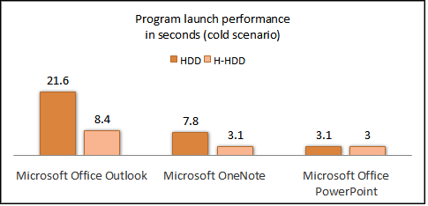
The second chart illustrates program launches in a light disk contention scenario, where the disk is put under contention by creating random I/O to simulate light usage before launching the programs.
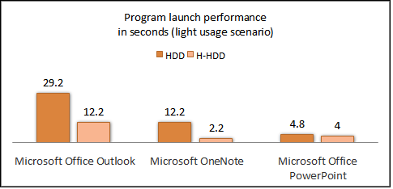
The third chart illustrates program launches in a heavy disk contention scenario, where the disk is put under contention by creating random I/O to simulate heavy usage before launching the programs.
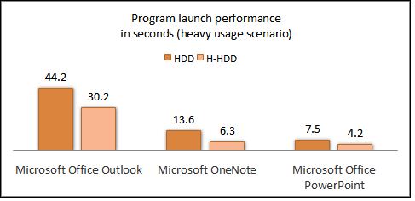

Longer Battery Life
For most mobile PCs, Windows Vista does not represent a noticeable change in power consumption from earlier versions of Windows. However, mobile PCs equipped with H-HDDs enhanced for ReadyDrive can achieve significant power savings. When a PC equipped with an H-HDD is running on battery power, ReadyDrive puts Windows Vista into a power-savings mode called NV cache mode, which aggressively spins down the H-HDD’s disk spindle and attempts to satisfy all read and write requests by using the NV cache. While in NV cache mode, the drive’s power consumption can be reduced by 70–90%. Depending on the usage scenario and the percentage of time the disk can remain spun down, overall computer power consumption can be reduced by 12%.
This additional power savings mode, NV cache mode, is controlled by Power Options in Windows Vista and is enabled by default whenever the computer is operating on battery power. Users can change default behavior in the Control Panel Power Options application in Windows Vista.
The following chart illustrates how much time the disk spindle can remain spun down with various NV cache sizes.
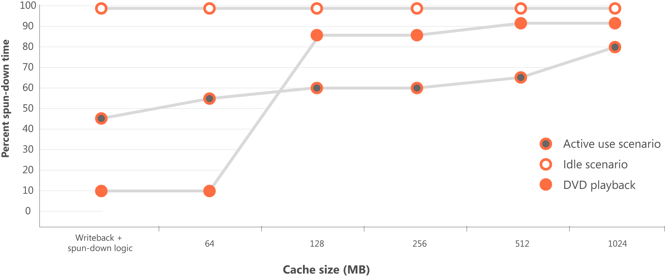

Improved Ruggedness and Reliability
Market research by Gartner Research (“Benchmarking PC Hardware Reliability,” June 20, 2006) shows that the most common parts to fail in computers less than two years old are motherboards and hard disk drives. ReadyDrive improves the ruggedness and reliability of a drive by keeping the disk spindle powered down and the read/write head parked for as long as possible. Traditional hard disk drives remain spun up for longer periods of time, with the read/write head in motion.
Due to reduced drive use and wear and lower operating temperature, H-HDDs can expect improved mean-time-before-failure ratings. This translates into significant reassurance for customers as well as reduced support and warranty costs for both computer and hard disk manufacturers.

Implementation Considerations
Computer OEMs and hard disk manufacturers interested in implementing or developing H-HDDs enhanced for ReadyDrive should be aware of the following implementation considerations.

ATA Command Set
ReadyDrive uses a new NV cache command set standardized in the ATA8-ACS command specification. This new command set allows ReadyDrive to do two important things: control what data is pinned for retention in the NV cache at any given time and control whether the drive is put into the NV cache power mode.
Windows Hardware Quality Labs
The Windows Vista Logo Program for H-HDD devices describes the specific requirements for performance, capacity, and command set support introduced in this document. By using the DTM in the WDK, hardware partners can perform the appropriate tests with their H-HDDs. Visit the following link for more information and documentation about the Windows Vista Logo Program: http://www.microsoft.com/whdc/winlogo/default.mspx
NV Cache Size
Microsoft recommends an NV cache size of at least 128 MB to realize performance benefits for Windows Vista. To take advantage of the NV cache for the purposes of launching OEM-specified programs and to realize further performance benefits, an NV cache size as large as 256 MB to 1 GB would be more effective.
The larger the NV cache size, the more ReadyDrive can take advantage of the NV cache to deliver user benefits. However, NV cache sizes as small as 50 MB are supported by ReadyDrive in Windows Vista. It is anticipated that future price reductions in the cost of flash memory and the increasing benefits from better performing flash technology will soon make NV cache sizes of 1 GB (or more) practical and desirable. ReadyDrive can support NV cache sizes up to 2 TB.
NV Cache Performance
The performance benefits of ReadyDrive largely depend on the underlying read and write performance of the NV cache. Low latency and high read and write throughput from the NV cache, particularly for access to random block addresses, translate into faster and better experiences for the end user.
The interfaces to NAND flash memory, which is likely to be used to implement the NV cache, have been doubling in performance every 12 months and are expected to continue doing so. Already it is possible to buy NAND flash memory with faster sequential data access and much faster random data access than mobile PC HDDs. Continued innovation in flash memory interfaces will allow for dramatically better performance from the NV cache and will enable ReadyDrive to deliver increasingly compelling performance benefits.
To ensure tangible performance benefits and to preclude the possibility of negatively affecting the performance of the system, the following minimum performance requirements have been specified in the Windows Vista Logo Program for H-HDDs.
Scenario | Sustained throughput (MB/second)
4-kb random reads to a file pinned in the NV cache | >4
4-kb random writes to a file pinned in the NV cache | >4
64-kb sequential reads to a file pinned in the NV cache | >16
64-kb sequential writes to a file pinned in the NV cache | >8

Note: The run-time assessment tests that Windows Vista performs to verify an H-HDD’s capability are more forgiving than the logo program tests. This is to account for background I/O that will likely occur during run time and the fact that the H-HDD will be regarded as the system drive, as opposed to a secondary drive as it is in the logo program tests.
NV Cache Run-time Performance Assessment Process
When an H-HDD is installed in a PC, Windows Vista recognizes it immediately and attempts to assess the performance of the onboard NV cache.
If the NV cache passes the assessment, ReadyDrive enables support for the H-HDD, and the assessment is not performed again.
If the NV cache does not pass the performance assessment, the H-HDD is regarded as a traditional HDD, and none of the benefits of H-HDDs are realized. Upon subsequent reboots, as long as the H-HDD is still installed, Windows Vista continues to perform the assessment.
Before the assessment can begin, the disk spindle must be idle. Windows Vista waits for a period of low activity lasting at least five minutes, verifies that the disk is idle and that the computer is not in NV cache power mode, and then begins.
The assessment involves creating a test file, pinning it in the NV cache, sending a series of I/O requests to the file, and then monitoring the service times. The series of requests includes four basic tests and 128 requests per test. There is a 100-ms delay between each test:
- Random read of 4 K
- Random write of 4 K
- Sequential read of 64 K
- Sequential write of 64 K (If the NV cache fails this part of the assessment, ReadyDrive still supports it, provided it passes the other parts of the assessment.)

This run-time performance assessment differs from the Windows Vista logo test in several ways. The logo test waits for the disk spindle to become idle between each of the four types of tests, and there is only a 50-ms delay between each request. Also, the NV cache must pass all four tests in order to pass.
NV Cache Flash Wear
NAND flash memory is rated for a limited number of write-erase cycles before individual cell failures can occur. Heavy use of the NV cache can deplete the available capacity over time. To avoid this happening, H-HDD manufacturers should consider employing wear-leveling algorithms that spread the wear across all of the available flash blocks to extend the useful life of the entire cache. ReadyDrive algorithms have also been designed to limit the writing and erasing of contents in the NV cache, so even for the smallest NV cache sizes, the useful life of the cache is expected to extend far beyond the useful life of the device it is packed in. Initial testing of H-HDDs enhanced for ReadyDrive indicates that users can expect many years of use under typical user workloads. The absolute lifetime of each device will vary depending on device’s NV cache capacity and the drive manufacturer.
If the NV cache does experience any cell failures due to wear, the NV cache size is reduced. If the capacity drops below a minimum requirement, Windows Vista treats the drive as a standard HDD. For larger NV cache capacities, proper wear-leveling algorithms ensure that this outcome is even less likely during the life of the drive.
PC System Considerations
Windows Vista automatically detects an H-HDD and enables the ReadyDrive feature following the first boot. No other system software or hardware modifications are required, and no additional training of field technicians is required. The H-HDD can be removed from the system at any time, and it will maintain a coherent store of the user’s and operating system data.
Windows Vista supports a maximum of one H-HDD in a PC. The H-HDD can be installed in conjunction with, or as a replacement for, a standard PATA or SATA mobile HDD. However, the H-HDD must be configured as the system drive.
To achieve optimal power savings, it is recommended that the computer have at least 1 GB of main memory, which allows SuperFetch to minimize the number of read requests to the disk.
To optimize the boot and resume from hibernate performance, the PC OEM should consider implementing a fast POST BIOS (<1 sec) that passes execution to the operating system loader as quickly as possible.
ReadyDrive is included and enabled by default in all editions of Windows Vista except Windows Vista Starter. ReadyDrive is included but not enabled by default in Windows Server Longhorn.

Desktop PC Considerations
Although ReadyDrive is aimed primarily at the mobile hard disk drive market (2.5-inch drives), desktop hybrid hard disk drives (3.5-inch drives) will see similar performance benefits due to the performance of the NV cache for serving disk I/O requests.
To realize the power savings benefits, users can adjust settings to the appropriate power policy in Windows Vista Power Options.

Requirements and Recommendations

Feature | Requirements | Recommendations
SuperFetch | None | For PC OEMs:  As much main memory (RAM) as possible; at least 1 GB
ReadyBoost | For PC OEMs:  - USB host controllers must use USB 2.0 standard  For flash storage OEMs:  - USB flash drives must use USB 2.0 standard  - USB flash drives must contain 230 MB of free capacity  - Flash storage devices must perform at 2.5 MB/s for random 4-K reads and 1.75 MB/s for random 512-K writes  - Cache sizes from 256 MB to 4 GB are supported  Additional requirements for flash storage devices “enhanced for ReadyBoost”:  - USB flash drives must contain 512 MB of physical flash; less is acceptable after formatting  - Flash storage devices must perform at 5 MB/s for random 4-K reads and 3 MB/s for random 512-K writes | For PC OEMs:  At least 1:1 ratio of ReadyBoost cache size to main memory capacity
ReadyDrive | For hybrid hard disk OEMs:  - At least 50 MB of NV cache capacity  - NV caches must perform at 4 MB/s for random 4-K reads and writes, 16 MB/s for 64-K sequential reads, 8 MB/s for 64-K sequential writes | For PC OEMs:  - Fast POST BIOS <1 sec  - At least 1 GB of main memory (RAM)  For hybrid hard disk OEMs:  - 256 MB to 1 GB of NV cache capacity; more is better  - Wear-leveling algorithms to ensure longevity of the NV cache

Resources
HDD manufacturers should consult the ATA8-ACS Command Set, which supports a command set for controlling the NV cache in an H-HDD.
http://www.t13.org/
By using the Driver Test Manager (DTM) in the Windows Driver Kit (WDK), hardware partners can perform the appropriate tests with their H-HDDs and flash storage devices. Visit the following link for more information and documentation about the Windows Vista Logo Program: http://www.microsoft.com/whdc/winlogo/default.mspx
For general or more technical inquiries about the Windows PC Accelerators, contact the feature teams directly.
- For SuperFetch, contact sftch@microsoft.com
- For ReadyBoost, contact rbinfo@microsoft.com
- For ReadyDrive, contact mshybrid@microsoft.com
Manufacturers of PCs, flash storage devices, and hybrid hard disk drives that want to market their devices as enhanced for ReadyDrive or Boost should read the following guidelines available on the Microsoft Partner Web site.
- Windows ReadyDrive Usage Guidelines
- Windows ReadyBoost Usage Guidelines

