Windows Vista Rules for
Enabling Windows Aero
With Guidelines for Troubleshooting
November 30, 2006
Abstract
This document describes the process that Windows Vista™ uses to automatically enable Aero and the conditions under which it will notify users of performance problems and possibly scale back the experience. Also included is a detailed troubleshooting guide for Aero-related problems.
This information applies for the Windows Vista operating system.
The current version of this paper is maintained on the Web at:
http://www.microsoft.com/whdc/device/display/aero_rules.mspx
References and resources discussed here are listed at the end of this paper.
Contents
Introduction 3
Fundamental Requirements for Desktop Composition 4
Automatic Conditions 4
Aero Over Remote Desktop Connections 5
User Configuration 5
Measured Performance 6
Other Issues That Can Dynamically Inhibit Composition 7
Performance Issues That Cause the DWM to Scale Back 8
User Notifications 8
Composition and DirectX Exclusive Mode 10
Troubleshooting Aero 10
Is Composition Running? 10
Is Any Application Set to Disable Composition? 13
Does the System Have a WDDM Driver? 14
Did Setup Detect a WDDM Driver? 15
When the WDDM Installer Does Not Automatically Run WinSAT 15
Running WinSAT on Adapter or Driver Changes 16
Is the Color Depth Set to 32 Bits Per Pixel? 17
Is the Monitor Refresh Rate Greater Than 10 Hz? 17
Has the DWM Logged Any Errors or Other Events? 17
Did WinSAT Run Successfully? 18
Glossary 19
References 21

Disclaimer

This is a preliminary document and may be changed substantially prior to final commercial release of the software described herein.

The information contained in this document represents the current view of Microsoft Corporation on the issues discussed as of the date of publication. Because Microsoft must respond to changing market conditions, it should not be interpreted to be a commitment on the part of Microsoft, and Microsoft cannot guarantee the accuracy of any information presented after the date of publication.

This White Paper is for informational purposes only. MICROSOFT MAKES NO WARRANTIES, EXPRESS, IMPLIED OR STATUTORY, AS TO THE INFORMATION IN THIS DOCUMENT.

Complying with all applicable copyright laws is the responsibility of the user. Without limiting the rights under copyright, no part of this document may be reproduced, stored in or introduced into a retrieval system, or transmitted in any form or by any means (electronic, mechanical, photocopying, recording, or otherwise), or for any purpose, without the express written permission of Microsoft Corporation.

Microsoft may have patents, patent applications, trademarks, copyrights, or other intellectual property rights covering subject matter in this document. Except as expressly provided in any written license agreement from Microsoft, the furnishing of this document does not give you any license to these patents, trademarks, copyrights, or other intellectual property.

Unless otherwise noted, the example companies, organizations, products, domain names, e-mail addresses, logos, people, places and events depicted herein are fictitious, and no association with any real company, organization, product, domain name, email address, logo, person, place or event is intended or should be inferred.

© 2006 Microsoft Corporation. All rights reserved.

Microsoft, DirectX, Windows, and Windows Vista are either registered trademarks or trademarks of Microsoft Corporation in the United States and/or other countries.

The names of actual companies and products mentioned herein may be the trademarks of their respective owners.

Introduction
Windows Vista™ is the first Microsoft® Windows® operating system that provides a range of user experiences that gracefully scale based on a system’s hardware capabilities while still giving the user full control over configuration options. All computers that meet the Windows Vista minimum supported hardware requirements will run the Windows Vista Basic user experience. Computer systems with more capable hardware—in terms of performance and video memory capacity—will run the Windows Vista Aero experience. Aero provides an additional level of visual sophistication and a more responsive and manageable user interfaces.
Desktop Composition in Windows Vista. Aero is based on a new and innovative window-management technology in Windows Vista called desktop composition. Desktop composition supports the Aero features including smooth and tear-free window transitions and management, transparent window borders and client areas, Windows Flip and Flip 3D, and live taskbar thumbnails. All these items are collectively referred to as Windows Aero.
Composition-based window management is much more demanding than the Graphics Device Interface (GDI)–based window management techniques in Microsoft Windows XP and Windows Vista Basic. Not all systems will be able to run Aero well on a single monitor, scale to larger monitors, or scale to multiple monitors. This is especially true for more demanding user scenarios and for older or less capable graphics adapters. To help ensure a good user experience, Windows Vista uses a set of rules to determine whether to automatically enable Aero. These rules are designed to make the best tradeoff between performance and the user experience.
Assuming that the fundamental requirements to support desktop composition are met, users can enable composition themselves in the relatively rare cases when Windows Vista does not automatically enable it for them.
Note: Not all Windows Vista SKUs support desktop composition or the Aero features. For example, Windows Vista Home Basic edition supports composition, but not the Aero features. For full details, refer to the latest information on the Microsoft Web site.
The Desktop Window Manager. If Aero is enabled automatically, the desktop window manager (DWM)—which is the operating system component that implements composition and related features—monitors the system configuration and may scale back the user experience if the configuration changes in such a way that performance might suffer. For example, the DWM may automatically enable Aero on a particular system with a single monitor, but scale back the experience if a second monitor is attached.
The DWM also monitors composition performance and may scale back some feature if performance suffers. For some problems, the DWM notifies the user, giving the user the opportunity to continue running with composition or disable it.
This paper describes the process that Windows Vista uses to automatically enable Aero and the conditions under which it notifies users of performance problems and possibly scales back the experience. This paper also includes a detailed troubleshooting guide for Aero-related problems.

Fundamental Requirements for Desktop Composition
Desktop composition requires hardware support beyond that for Windows XP or the Windows Vista Basic user experience. Desktop composition cannot run at all unless the following conditions are met:
- The system’s primary graphics adapter supports Microsoft DirectX® 9.
- The system’s primary graphics adapter supports pixel shader 2.0 in hardware.
- The system is running with Windows Vista Display Driver Model (WDDM) graphics driver.
- The system is configured for a color depth of 32 bits per pixel.
- The primary monitor refresh rate is greater than 10 Hz.
- Composition is enabled by group policies (the default configuration).

Automatic Conditions
The DWM automatically enables desktop composition and transparency when the preceding six conditions are met and:
- The system has more than 512 MB of system memory available to the operating system.
- There is enough graphics memory to support the current monitor configuration (see Table 1).
- There is enough measured performance to support the current monitor configuration (see Table 1).

Note that these conditions are checked dynamically, such as when a user adds or removes monitors or changes monitor resolution.
Table 1. Memory and Performance Thresholds for Desktop Composition and Transparency
 |  |  | Opaque window borders |  | Transparent window borders
 | Total pixels | Equivalent  resolution | Graphics memory threshold (MB) | Perfor-mance threshold (MB/s) | Graphics memory threshold (MB) | Perfor-mance threshold  (MB/s)
Single monitor | 480,000 | 800x 600 | 32 | 55 | 32 | 269
Single monitor | 786,432 | 1024x 768 | 32 | 89 | 32 | 363
Single monitor | 1,310,720 | 1280x1024 | 32 | 146 | 64 | 500
Single monitor | 1,764,000 | 1680x1050 | 64 | 196 | 128 | 60
Single monitor | 1,920,000 | 1600x1200 | 64 | 213 | 128 | 641
Single monitor | 2,280,000 | 1920x1200 | 64 | 255 | 128 | 724
Dual monitors | 960,000 | 800x 600 | 32 | 83 | 32 | 351
Dual monitors | 1,572,864 | 1024x 768 | 64 | 135 | 64 | 477
Dual monitors | 2,621,440 | 1280x1024 | 64 | 223 | 128 | 665
Dual monitors | 1,764,000 | 1680x1050 | 128 | 299 | 128 | 812
Dual monitors | 3,840,000 | 1600x1200 | 128 | 325 | 128 | 860
Dual monitors | 4,608,000 | 1920x1200 | 128 | 390 | 256 | 976

The data in Table 1 is derived from a set of equations and rules that the DWM uses internally. The DWM itself does not use a table-driven approach. This allows the DWM to handle any combination of monitor size, number of monitors, and memory configuration

Aero Over Remote Desktop Connections
The Windows Aero user interface is also available to users who access a Windows Vista system by using a remote desktop connection. The requirements for Aero over remote desktop connections are that:
- Both systems are running Windows Vista.
- The local system (the "client" or "display" system) has Aero enabled.
- The remote (or "server" system) meets the minimum DWM memory requirements.
- The remote (or "server" system) is an Enterprise or Ultimate client SKU.
- The connection is one to one; desktop composition is not supported for "multi-hop” scenarios.

User Configuration
If the three automatic conditions are not met, then Windows Vista does not automatically enable desktop composition or transparency. In this case, a user can enable Aero so long as the six fundamental requirements are met.
To enable Aero
1. In Control Panel, open Appearance and Personalization, click Personalization, click Window Color and Appearance, and then click Open Classic Appearance Properties for More Color Options.
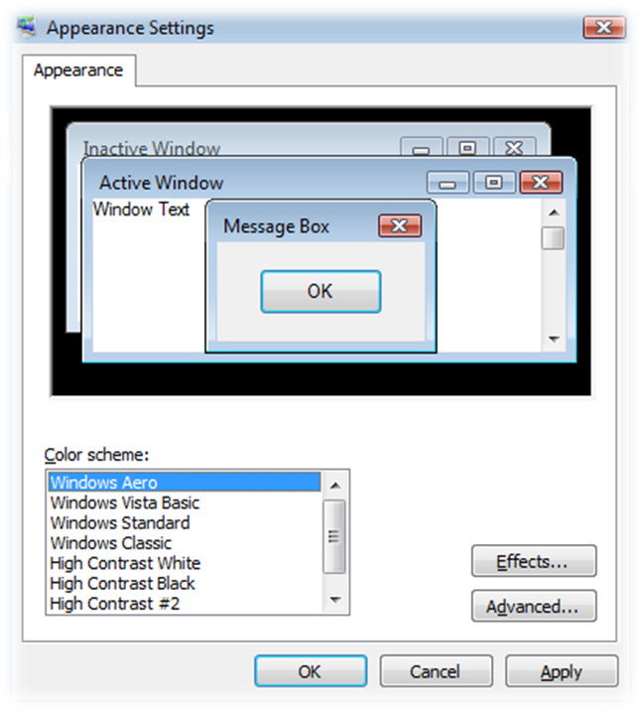

2. On the Appearance tab, under Color scheme, select Windows Aero.
If the fundamental requirements for running Aero are not met, then Windows Aero is not available in the Color scheme list.

Measured Performance
The performance threshold shown in Table 1 earlier in this paper is the measured video memory bandwidth expressed in megabytes per second (MB/s). This data is computed by the Windows System Assessment Tool (WinSAT) DWM assessment. WinSAT is a performance assessment tool built in to Windows Vista. The DWM assessment is run as one of the full set of WinSAT assessments. The full set of assessments, called the formal assessment, runs as part of Setup after the machine out-of-box experience (MOOBE) user interface sequence. A user sees this UI before logging on to a Windows Vista system for the first time. The WinSAT formal assessment runs during the billboards (after MOOBE) when the UI reads “Please wait while Windows checks your computer’s performance”.
When the DWM assessment completes, it saves the measured video memory bandwidth and the amount of graphics memory to the registry and then restarts the DWM. The registry values that the DWM uses are:
HKLM\SOFTWARE\Microsoft\Windows NT\CurrentVersion\
Winsat\VideoMemoryBandwidth
HKLM\SOFTWARE\Microsoft\Windows NT\CurrentVersion\
Winsat\VideoMemorySize

Both values are DWORD values. The VideoMemoryBandwith value is in MB/s multiplied by 1,000. For example, a video memory bandwidth value of 1920 MB/s is represented by a decimal value of 1,920,000 (001D4C00 hex).
Note: A value of zero written to the VideoMemoryBandwidth value by WinSAT is caused by a bug in the WDDM graphics driver. A zero here means that WinSAT could not to measure the graphics subsystem’s video memory bandwidth. These issues should be reported to the graphics adapter vendor.
The video memory size is the sum of dedicated graphics memory and dedicated system memory for graphics, in bytes. For example, a video memory size of 256 MB is represented by a decimal value of 268,435,456 (10000000 hex). This value does not include the amount of currently allocated shared system memory. For more details on how Windows Vista reports graphics memory by using WDDM drivers, see the white paper Graphics Memory Reporting through WDDM.
When WinSAT restarts the DWM, the DWM reloads the video memory bandwidth and video memory size from the WinSAT registry locations and reevaluates the rules for automatically enabling Aero. It then enables or disables Aero, as appropriate. Note that the user’s preferences are always honored. For example, Aero remains enabled if a user sets it manually, even if the automatic performance thresholds are not met.
You can change the WinSAT registry values directly for testing purposes. If you manually change the above WinSAT registry values, you must restart the DWM. You can do this from a command prompt with elevated privileges by running the following command:
net stop uxsms & net start uxsms

Note: Manually changing WinSAT registry values is not a supported method for changing the system configuration and should be used only for testing.
A user can also run the formal assessment on demand from the Control Panel Performance Information and Tools application.
Both the formal and the DWM assessments can be run from an elevated command prompt window by using the following commands:
winsat formal
winsat dwm

The winsat formal command runs the full set of formal assessments, including the DWM assessment. The winsat dwm command runs just the DWM assessment. In this case, the Windows Experience Index scores are not updated, but the assessment does update the VideoMemoryBandwith and VideoMemorySize values in the registry.

Other Issues That Can Dynamically Inhibit Composition
Application behavior and user configuration changes can affect the composition state and user experience. The following table lists these events and the actions that Windows Vista takes when they occur.
Table 2. Events That Affect Composition
Event | Effect on composition
An application locks the primary DirectX surface. | Composition is disabled until the surface is unlocked.
An application enters DirectX exclusive mode. | Composition is paused until the application leaves exclusive mode. When composition is paused, the DWM does not lose state.
An application uses a mirroring driver. | Composition is disabled until the application is closed.
An application deliberately disables composition by calling the DwmEnableComposition() Windows API. | Composition is disabled until the application restores composition or the application is closed. The user is notified that composition was disabled due to an application issue.
An application is run that has the Disable desktop composition option set in its properties. | Composition is disabled until the application is closed. The user is notified that composition was disabled due to an application issue.
The user changes to noncomposited theme or appearance. | Composition is disabled until the user changes the theme or appearance back to one requiring composition.
The user changes the color depth to anything less than 32 bits per pixel. | Composition is disabled until the user reverts to 32 bits per pixel.

Performance Issues That Cause the DWM to Scale Back
The DWM dynamically monitors key performance and system configuration attributes and scales back the user experience as follows:
Table 3. Events That Cause the DWM to Scale the User Experience
Event | Effect on user experience
The user changes resolution or adds a larger monitor (or additional monitors) so that the video memory bandwidth thresholds or graphics memory thresholds in the preceding table are no longer met. | Composition or transparency is disabled based on the limits that are no longer met. Composition or transparency is restored if the system configuration changes so that the thresholds are met.
The user opens enough windows of sufficient size to cause the DWM to use more than 25 percent of available system memory for window surfaces. | The user is notified that Windows has detected that the computer’s performance is slow. If the user clicks the notification, then a dialog box appears that explains the situation in more detail; the user can choose Keep the current color scheme (composition stays on) or Change the color scheme to Windows Vista Basic.
The user opens enough windows of sufficient size to cause the DWM to use more than 30 percent of available system memory for window surfaces. | Composition is automatically disabled. The user is notified with text that says Your color scheme has been changed to Windows Vista Basic. If the user clicks the notification, then the Windows Help system presents detailed help.
The composition frame rate cannot be consistently maintained for a given period of time. | The DWM displays a dialog box to the user that contains an option to disable desktop composition.
The system transitions to DC (battery) power and the current power policy is “Power Saver”. | The DWM scales back to opaque window borders. Transparent window borders (glass) return if the power policy is changed to something other than Power Saver or when the system changes to AC power.

User Notifications
The following notification appears if an application is run with the Disable desktop composition attribute set on the Compatibility tab of the Shortcut Properties dialog box or if an application specifically disables desktop composition by calling the DwmEnableComposition API.
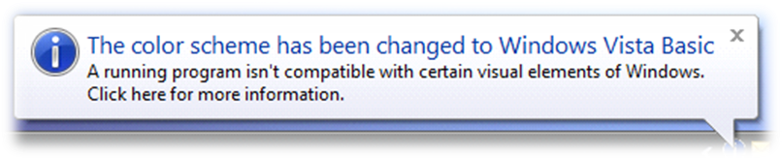

If the DWM’s memory usage reaches 25 percent of available system memory, then Windows Vista displays the following notification to users:


If the user clicks the above notification, then the following dialog box appears.
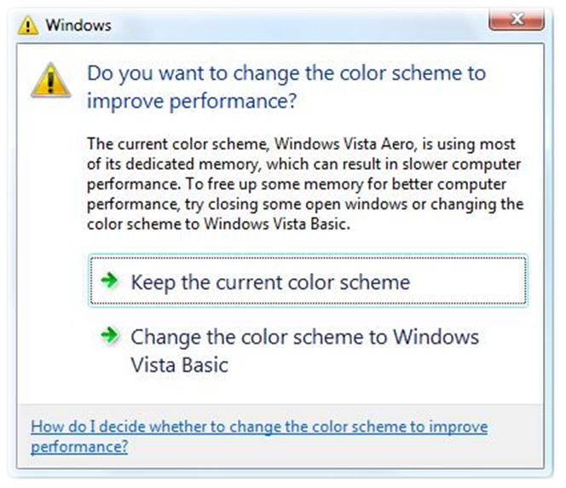

If the DWM’s memory usage reaches 30 percent of available system memory, then Windows Vista automatically disables composition, switches to the Windows Vista Basic color scheme, and displays the following notification to the user:
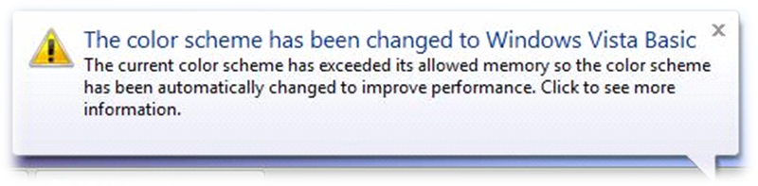

If the user clicks the notification box, then the following help text appears.
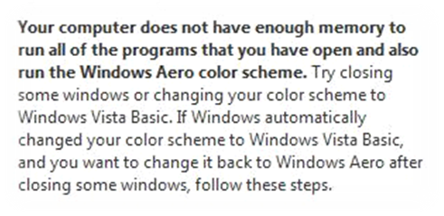
Note that you can find the full help text by clicking Help and Support from the Start menu, and then searching for the following questions:
“Why are some visual elements being automatically turned off?”
“How do I decide whether to change the color scheme to improve performance?”

The relevant help should appear at or near the top of the result list.

Composition and DirectX Exclusive Mode
DirectX-exclusive full-screen mode is a feature of the Microsoft DirectX API that enables the windowing system to be suspended so that drawing can be done directly to the screen. In this mode, a single application is responsible for the entire image on one or more monitors. Exclusive mode occurs on a per-monitor basis. Windows Vista Media Center is a good example of an application that uses DirectX exclusive mode. Exclusive mode allows applications to take advantage of hardware acceleration for enhanced video and graphics performance.
When an application takes one or more monitors into exclusive mode, the DWM becomes dormant but does not stop. In the dormant state, the DWM retains state such as the thumbnail images for top-level windows.
With a single monitor, this transition to exclusive mode is seamless because the application occupies the entire screen surface so that no other applications are visible. For systems with multiple monitors, the windows on the monitors in nonexclusive mode remain visible and the window manager reverts to a noncomposited theme on those monitors. In other words, desktop composition runs on all monitors or on none.

Troubleshooting Aero
This section is a guide to troubleshooting problems with Aero.

Is Composition Running?
In the Windows Vista editions that support Aero, it is easy to determine if desktop composition is running. Just press the WIN+TAB button to see if the system goes into Flip 3D mode. The screen will look something like the following screen shot.
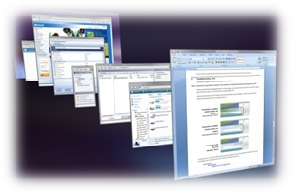

However, composition might be running, but window border transparency might be set to opaque. Users often view this as “glass is off” and assume that composition is off (even if they do not realize what composition is). This common misunderstanding occurs because the distinction between the two states is subtle; only the caption button shapes and positions are different. The following screen shots illustrate the differences between the three operational modes.
Composition is enabled and window borders are transparent (informally called “glass”). | 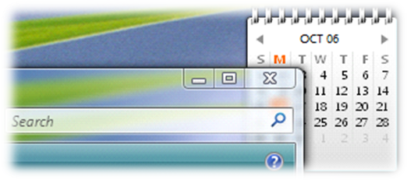  Obvious difference;  composition on in both cases.
Composition is enabled and window borders are opaque (informally called "opaque"). | 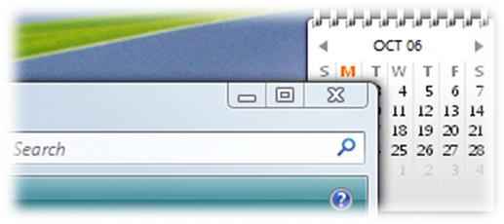  Subtle difference:  Composition on in middle example, off in lower example.
Composition is off. This is the Vista Basic Theme. | 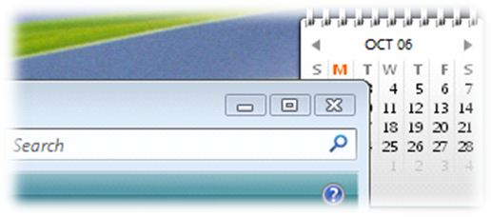

If composition is on but the window borders are simply opaque, then they can be made transparent.
To enable transparency
1. In Control Panel, open Appearance and Personalization, click Personalization, and then click Window Color and Appearance.
2. Select the Enable transparency check box.
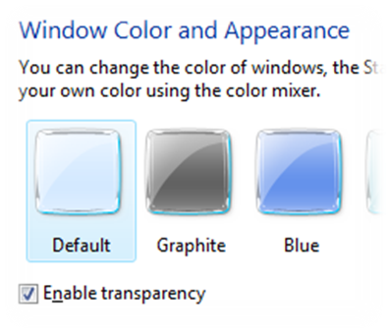

If composition is not on (the color scheme is Vista Basic), then ensure that the Windows Aero color scheme is selected.
To select the Windows Aero color scheme
1. In Control Panel, open Appearance and Personalization, click Personalization, click Window Color and Appearance, and then click Open Classic Appearance Properties for More Color Options.
2. On the Appearance tab, under Color scheme, ensure that Windows Aero is selected.
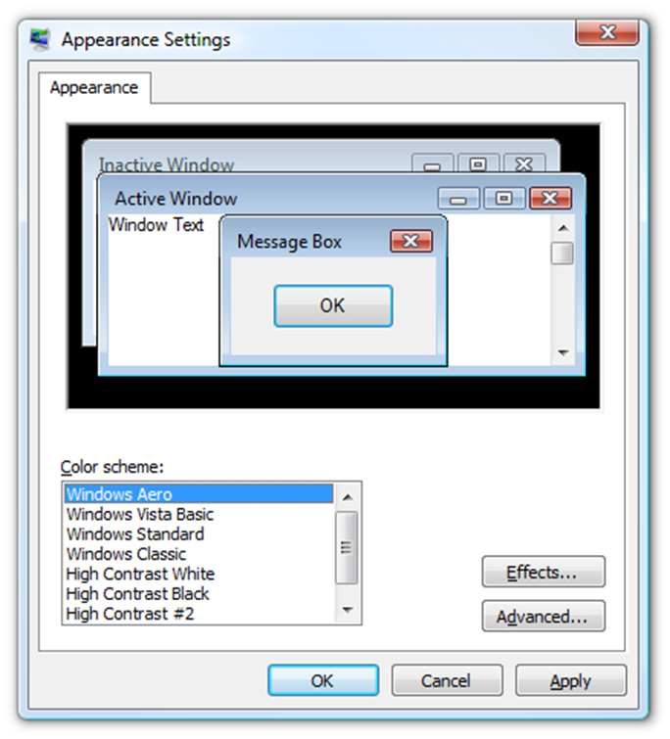

If the Windows Aero color scheme is selected, then composition or glass may have been disabled in the Performance Options dialog box.
To enable composition or glass
- In Control Panel, open System and Maintenance, click Performance Information and Tools, and then select Adjust Visual Effects in the left task pane.
Note that the Enable desktop composition settings are preferences and do not override the color scheme. If the color scheme is not set to Windows Aero, then even if the Enable transparent glass check box is selected, Aero is not enabled.
User has selected Adjust for best performance, which turns off composition and transparency. | User has selected Custom And manually turned off composition and transparency.
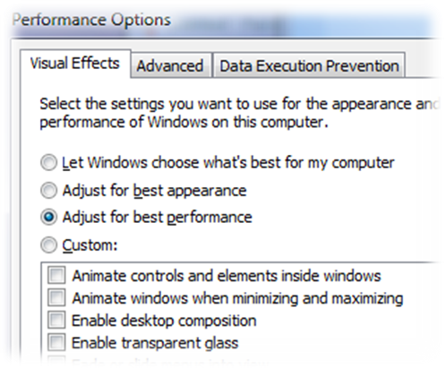 | 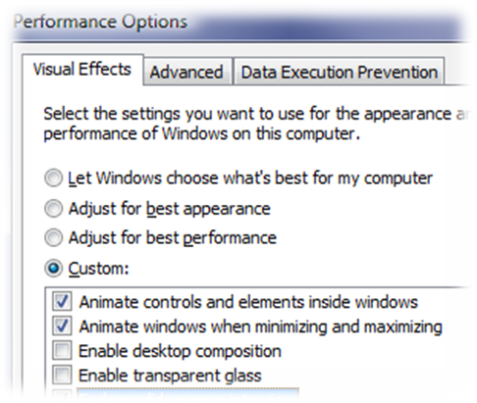

Composition can also be controlled from the Theme Settings dialog box.
To use Theme Settings
1. In Control Panel, open Appearance and Personalization, click Personalization, and then click Theme.
2. On the Themes tab of the Theme Settings dialog box, ensure that Windows Vista is selected. This is the only theme that enables desktop composition.
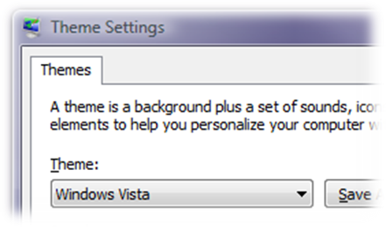

Is Any Application Set to Disable Composition?
Applications can be flagged to disable composition when they are running. Windows Vista then disables composition when these applications are running and reenables composition when these applications have been closed.
To enable composition in an application
1. In the Properties dialog box for the application, select the Compatibility tab.
2. On the Compatibility tab, under Settings, clear the Disable desktop composition check box.
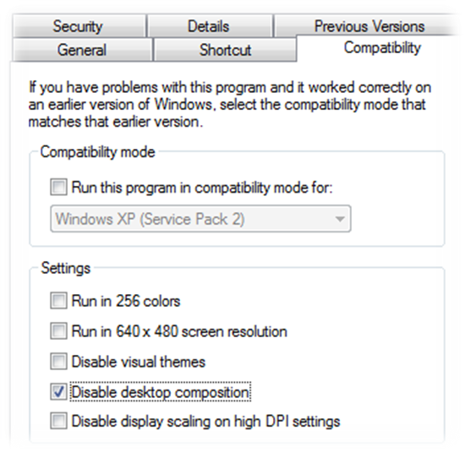

Does the System Have a WDDM Driver?
If desktop composition is not running and no application is set to disable composition, then the next thing to consider is whether the system has a WDDM driver. If the system’s graphics driver is not a WDDM driver, then desktop composition cannot be enabled at all. There are several ways to do this.
Use Control Panel
- In Control Panel, open Appearance and Personalization, click Personalization, click Display settings, and then select Advanced Settings.
- Look at the Adapter type string. An entry of WDDM indicates that the system has a WDDM driver.

Use the device manager
- Press the WIN+R key.
- Run devmgmt.msc. (This command requires administrative privileges.)
- Under Display adapters, look at the Adapter type string. An entry of WDDM indicates that the system has a WDDM driver.

Use the WinSAT tool
- Run the following command from a command prompt with elevated privileges:
winsat features
- In the WinSAT console output, check whether the Has WDDM driver line shows Yes or No.

If the system does not have a WDDM driver, then do one of the following:
- Use Windows Update to download the latest driver.
- See if the graphics adapter vendor has a WDDM driver on its Web site.

Did Setup Detect a WDDM Driver?
The only time Windows Vista runs WinSAT automatically is during the last phase of Setup during the billboards (after machine OOBE). This is the phase when the UI reads Please wait while Windows checks your computer’s performance.
If the resident driver during this phase is not a functional WDDM driver, then WinSAT cannot assess the graphics adapter’s performance and might be unable to obtain the graphics memory sizes. This can occur in two situations:
- Windows Vista was installed as an upgrade from Windows XP. In this situation, Windows Vista retains the Windows XP driver and WinSAT does not assess its DWM performance during Setup.
- No in-box WDDM driver is available during a Windows Vista clean installation and the user elected not to update the driver via Windows update, Windows Update was not accessible, or no WDDM driver is available from Windows update. In this situation, Windows Vista uses the basic SVGA driver. This driver supports only basic functionality and is used only when a more capable driver is not available.

In both situations, the DWM does not have the data that it needs to make its decisions until the system has been updated with a WDDM driver and a new performance assessment is run.
You can determine the driver type that is resident during Setup by looking at the “initial” WinSAT assessment data. This is the earliest XML file in %systemroot%\performance\winsat\datastore and has the text "(initial)" at the end of the file name.
The <LDDM> tag contains the value of "1" if the driver at the time of the assessment was a WDDM driver and a "0" if it was an XPDM driver. (Note that the tag is "LDDM" (not WDDM). LDDM stands for "Longhorn Device Driver Model". The acronym LDDM was changed to WDDM in early 2006, but the XML tag name was not changed because other tools and Windows components had dependencies on the original tag.)
Most graphics driver installers automatically run WinSAT after the new WDDM driver is running. This places updated performance and memory size data in the registry and then restarts the DWM, allowing it to determine whether to automatically run composition. For a discussion of why Windows Vista does not do this automatically, see the following section.

When the WDDM Installer Does Not Automatically Run WinSAT
On systems where the WDDM installer does not automatically run WinSAT, a user can run a new performance assessment in one of the following ways:
- In Control Panel, open System and Maintenance, click Performance Information and Tools, and select Update my score. This runs a full formal assessment, including the DWM assessment.
- Open a command prompt window with elevated privileges and run the winsat formal command. This runs a full formal assessment, including the DWM assessment.
- Open a command prompt window with elevated privileges and run the winsat dwm command, which runs only the DWM assessment.

A user can determine whether to run a new formal assessment by looking at Performance Information and Tools in Control Panel. If a new assessment is required, the UI indicates that the system’s hardware configuration has changed and a new assessment is needed, as shown in the following image.
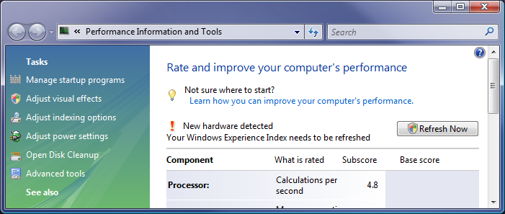

Running WinSAT on Adapter or Driver Changes
Windows Vista does not automatically detect graphics adapter or driver changes and rerun WinSAT for two reasons:
- Windows Vista needs to prompt the user with UI such as: "Windows Vista has noticed you have changed your graphics hardware/driver. Would you like to rerun the Windows Vista performance assessment so Windows Vista can automatically update your settings?” Assuming that the user says yes, then a user account control (UAC) elevation prompt follows.
This type of prompt is not very effective because users usually answer “No” to this kind of question. Even if users answer "Yes," the following UAC prompt gives them another opportunity to say “No”. Therefore, this UI rarely results in a new assessment being run.
- It is very difficult to determine when a new assessment should automatically be run. Graphics adapter changes require at least one reboot and often two. WinSAT would have to run after the new driver is fully installed and operational. This is further complicated because installing a new graphics card usually includes installing software such as screen resolution changers, rotators, color adjuster control panels, DVD players, and game samples.
It is difficult to determine when all the other software that accompanies a graphics card is finished installing and any necessary reboots are complete.

The best solution for hardware vendors is to integrate running a new assessment with the installation process for their graphics drivers and related software. In this way, the assessment occurs during the normal flow of installing the graphics adapter software and a UAC prompt is not required. Integration is straightforward because WinSAT provides a COM-based API to run a DWM assessment. This 10-second process updates the performance data that the DWM needs and then restarts the DWM. This also allows graphics driver updates from XPDM drivers to WDDM drivers to automatically enable Aero for the user when appropriate.
Note that the data in the registry usually reflects the data in the most recent WinSAT XML file. However, other issues unrelated to graphics can cause WinSAT to fail after it has successfully run the DWM assessment but before it saves all the data to the XML file. In this case, the WinSAT registry data is not coherent with the XML data.

Is the Color Depth Set to 32 Bits Per Pixel?
Desktop composition cannot run if the color depth is not set to 32 bits per pixel.
To set color depth
1. In Control Panel, open Appearance and Personalization, click Personalization, and then click Display Settings.
2. On the Monitor tab, under Colors, select Highest (32 bit).
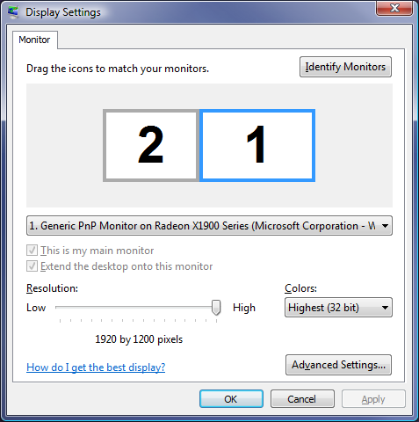

Is the Monitor Refresh Rate Greater Than 10 Hz?
Desktop composition cannot run if the monitor refresh rate is set to 10 Hz or lower.
To set the monitor refresh rate
1. In Control Panel, open Appearance and Personalization, click Personalization, and then click Display Settings.
2. In the Display Settings dialog box, click Advanced Settings, and then click the Monitor tab.
2. On the Monitor Settings tab, under Screen refresh rate, select 60 Hertz.
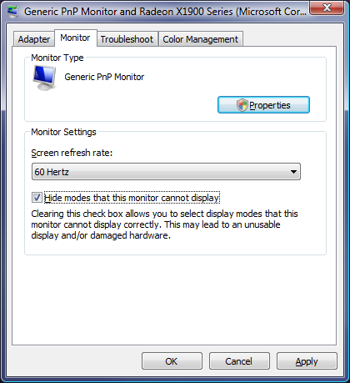

Has the DWM Logged Any Errors or Other Events?
The DWM logs events to the system event log when it cannot enable Aero, when the system does not meet the conditions for automatically enabling Aero, or when it detects other problems. The most common DWM events include:
- Did not start because an analysis of the hardware and configuration indicated that it would perform poorly.
- Used an opaque colorization because an analysis of the hardware and configuration indicated that a transparent colorization would perform poorly.
- Could not start because a composited theme is not in use.
- Could not start because WDDM is not in use.
- Could not start for some other reason.

To find the DWM event log messages
1. Press WIN+R to display the Run dialog box and then enter the following command:
eventvwr.msc
2. In Event Viewer, under Event Viewer (Local), select Windows Logs, and then select Application.
3. In the right panel of Event Viewer, select Filter Current Log and, in the Event Sources box, select Desktop Window Manager and then click OK to filter the event log for Desktop Window Manager events.

4. Examine the DWM events in the log to look for problems. Events are listed in chronological order.
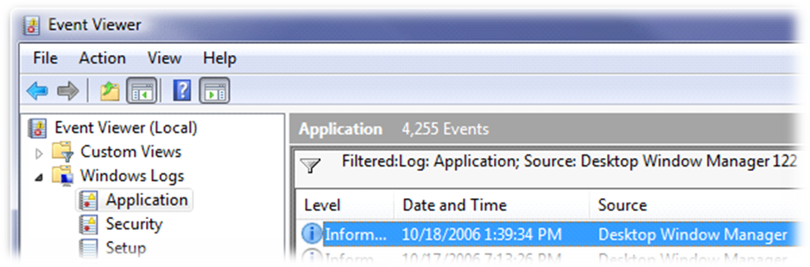

Did WinSAT Run Successfully?
The DWM cannot automatically enable Aero if WinSAT was unable to compute and place the video memory bandwidth and graphics memory size in the registry. Three common problems can cause this process to fail:
- Some graphics drivers have bugs that prevent WinSAT from correctly assessing the performance of the graphics adapter. This typically happens in new or beta drivers (production drivers rarely have this problem). If the driver does not correctly support the WinSAT assessment and WinSAT can recover from the failure, then WinSAT produces a video memory bandwidth score of zero. It places the zero value in the registry and in its XML output. If you find a zero value for video memory bandwidth, contact the graphics driver to report the problem or obtain an updated driver.
- Infrequently, problems in the graphics driver can cause a crash or a hang during Setup, causing the user to reset the system. WinSAT is designed to recover from this. It does so by detecting that the first run during Setup was not successful and immediately exiting from any subsequent run during Setup. However, in this scenario, WinSAT cannot save the data that the DWM needs in the registry, so the DWM thus cannot automatically enable Aero. This can be easily diagnosed: both the VideoMemoryBandwidth and the VideoMemorySize values will be absent from the WinSAT registry key. You can also see this by looking in the WinSAT.log file stored at %systemroot%\performance\winsat.
- Some rare graphics driver bugs cause the system to misreport the amount of available graphics memory. This often manifests itself by zero values. You can detect this by looking for the value zero for the VideoMemorySize registry value. You can also verify this by looking in the most recent XML results file at %systemroot%\performance\winsat\datastore. The relevant values are DedicatedVideoMemory and DedicatedSystemMemory. The WinSAT DWM assessment saves the sum of these two values in the VideoMemorySize registry value.

These values can be checked in two places:
- The WinSAT registry keys:
HKLM\SOFTWARE\Microsoft\Windows NT\CurrentVersion\Winsat\VideoMemoryBandwidth
HKLM\SOFTWARE\Microsoft\Windows NT\CurrentVersion\Winsat\VideoMemorySize

- The most recent WinSAT XML file stored at:
%systemroot%\performance\winsat\datastore

The relevant XML tags are <VideoMemoryBandwith>, <DedicatedVideoMemory>, and <DedicatedSystemMemory>. Note that the video memory size registry value is the sum of dedicated video memory and dedicated system memory.

Glossary
These key terms will help you better understand Aero, composition, and troubleshooting-related problems.
Aero
The name of the Windows Vista native color scheme, which includes the following collection of features:
- Desktop composition
- Transparent window borders
- Flip 3D
- Windows Flip
- Task bar thumbnails

Window border transparency, Flip 3D, Windows Flip, and task bar thumbnails all depend on composition and are enabled only when desktop composition is running.
desktop composition
A process in which each window and the desktop background is drawn separately and then composed by using the 3-D graphics engine to create the image on a system’s monitor (or monitors). Composition is the fundamental technology that enables the Windows Vista new visual effects and smoothness.
transparent window borders
A view in which the borders of each window appear to be transparent. It is commonly called “glass”. To see this view, desktop composition must be running.

Flip 3D
The Windows Vista new window summary view. It lets the user see all the windows and flip through them. To see this view, desktop composition must be running.
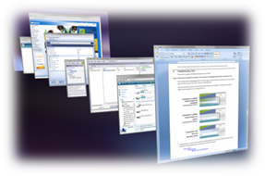

Windows Flip
A view in which the images of each window are taken directly from the windows themselves and are "live." When desktop composition is running, the ALT+TAB key activates the Windows Flip view. This is very similar to the standard ALT+TAB Windows view.
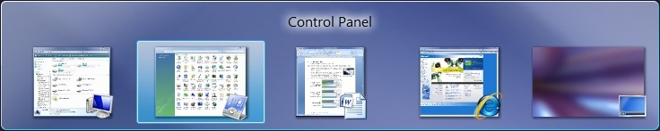

taskbar thumbnails
A view in the taskbar in which the images of each window are taken directly from the windows themselves and are "live." To see this view, desktop composition must be running.
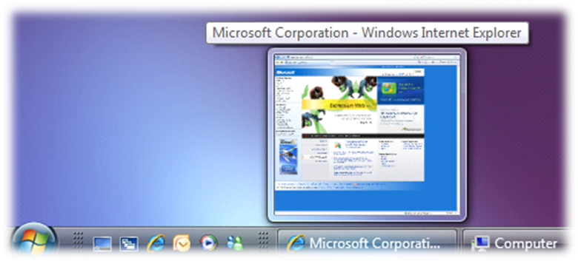

Windows Display Driver Model (WDDM)
The Windows Vista new graphics device driver type. Desktop composition requires that the system have a WDDM driver.

References
Graphics Memory Reporting through WDDM
http://www.microsoft.com/whdc/device/display/graphicsmemory.mspx
Display and Graphics - Architecture and Driver Support
http://www.microsoft.com/whdc/device/display/default.mspx

