Microsoft HD Audio Pin Configuration Implementation Test Procedure Guidelines
August 15, 2006
Abstract
This document provides information about how to validate pin configuration register programming for vendor implementations of Intel High Definition Audio (HD Audio) systems. Validation ensures that logical devices are correctly exposed by the Universal Audio Architecture (UAA) HD Audio class driver and that the system will pass the UAA compliance portion of the Microsoft® Windows® Logo Program tests.
This information applies for the following operating systems:
Microsoft Windows Vista™
Microsoft Windows Server® 2003
Microsoft Windows XP
Microsoft Windows 2000
The published version of this paper will be maintained on the WHDC audio Web site at:
http://www.microsoft.com/whdc/device/audio/PinConfig_test.mspx
References and resources discussed here are listed at the end of this paper.
Contents
Introduction 3
A Recommended Validation Procedure for System and Board Designers 5
Step 1: Download the Tools and Drivers 5
Step 2: Install the HD Audio Drivers 5
Step 3: Get the Current Pin Configuration Information 6
Step 4: Parse the Codec 8
Step 5: Compare the Parsed Codec Information to the Physical Audio Jacks 9
Step 6: Understand How Pin Configuration Registers Expose Logical Devices 9
Step 7: Create a Pin Configuration 10
Step 9: Parse the Code to Register the Changes 11
Step 10: Save the Pin Configuration Values 12
Step 11: Assign the Correct Driver Instance Value 12
Step 12: Load the New Pin Configuration 14
Step 13: Check Whether the Devices Are Correctly Exposed 15
Step 14: Incorporate the Final Pin Configuration Settings into the BIOS 17
A Recommended Validation Procedure for System and Board Hardware Testers 17
Conclusion 18
Call to Action 19
Resources 19
Disclaimer

This is a preliminary document and may be changed substantially prior to final commercial release of the software described herein.

The information contained in this document represents the current view of Microsoft Corporation on the issues discussed as of the date of publication. Because Microsoft must respond to changing market conditions, it should not be interpreted to be a commitment on the part of Microsoft, and Microsoft cannot guarantee the accuracy of any information presented after the date of publication.

This White Paper is for informational purposes only. MICROSOFT MAKES NO WARRANTIES, EXPRESS, IMPLIED OR STATUTORY, AS TO THE INFORMATION IN THIS DOCUMENT.

Complying with all applicable copyright laws is the responsibility of the user. Without limiting the rights under copyright, no part of this document may be reproduced, stored in or introduced into a retrieval system, or transmitted in any form or by any means (electronic, mechanical, photocopying, recording, or otherwise), or for any purpose, without the express written permission of Microsoft Corporation.

Microsoft may have patents, patent applications, trademarks, copyrights, or other intellectual property rights covering subject matter in this document. Except as expressly provided in any written license agreement from Microsoft, the furnishing of this document does not give you any license to these patents, trademarks, copyrights, or other intellectual property.

Unless otherwise noted, the example companies, organizations, products, domain names, e-mail addresses, logos, people, places and events depicted herein are fictitious, and no association with any real company, organization, product, domain name, email address, logo, person, place or event is intended or should be inferred.

© 2006 Microsoft Corporation. All rights reserved.

Microsoft, Windows, Windows Server, and Windows Vista are either registered trademarks or trademarks of Microsoft Corporation in the United States and/or other countries.

The names of actual companies and products mentioned herein may be the trademarks of their respective owners.
Introduction
Intel High Definition Audio (HD Audio) codecs are flexible hardware devices. They can be configured by system BIOS routines to implement a variety of logical audio devices to support individual systems designs. The BIOS loads the pin configuration registers in an HD Audio codec with default settings that identify the audio devices that the codec implements on the system. When a system vendor sets up HD Audio solutions correctly, Microsoft® Windows Vista™ can expose details that are not possible with legacy audio solutions. It can enable compelling dynamic device behavior and multistreaming support. Figures 1 through 3 show some of the details that Windows Vista can expose.
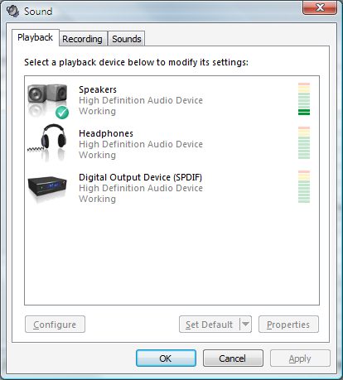
Figure 1. Windows Vista Sound dialog box, Playback tab
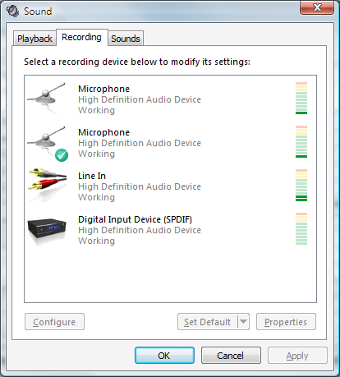
Figure 2. Windows Vista Sound dialog box, Recording tab
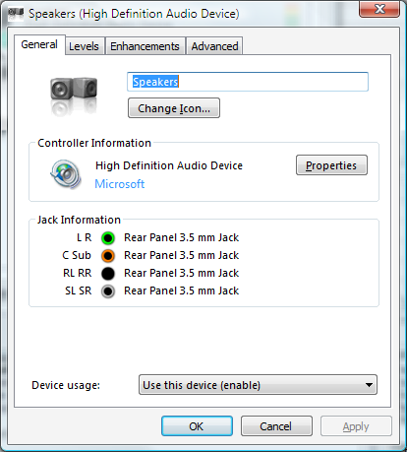
Figure 3. Windows Vista Speakers (High Definition Audio Device) dialog box
Windows Vista can expose these details only if the pin configuration registers are properly programmed. This paper provides information about how to validate pin configuration register programming for vendor implementations of HD Audio systems. Validation ensures that logical devices are correctly exposed by the Universal Audio Architecture (UAA) HD Audio class driver and that the system will pass the UAA compliance portion of the Microsoft Windows® Logo Program tests.

A Recommended Validation Procedure for System and Board Designers
This section is a walkthrough of a recommended procedure that system and board designers can use to validate HD Audio pin configuration implementation for Windows Vista.

Step 1: Download the Tools and Drivers
The first step in the process is to download the Beta Microsoft HD Audio 1.1 class and bus drivers and the accompanying UAA HD Audio pin configuration validation tools. They are available from a Microsoft Extranet Webfolder: https://home.ep.microsoft.com/.
Note: If you do not have access to this Webfolder, contact uaa@microsoft.com. Obtaining access to the Webfolder is quick and easy, and its content might be updated more frequently than Windows Vista prerelease builds.

Step 2: Install the HD Audio Drivers
Before starting the validation procedure, you first must have the correct Microsoft HD Audio bus and class drivers installed on your system.
1. Launch Device Manager to check whether your build of Windows Vista has the HD Audio bus driver already installed. If not, install the latest version from the package that you downloaded in Step 1.
2. After the bus driver is installed, the function device should appear in Device Manager, but it will be marked as disabled. The validation tools must have the checked version of the Microsoft HD Audio class driver installed on the system. Use Device Manager to install the checked version of the class driver (hdaudio.sys) from the download package.

After you have the correct bus and function drivers installed, Device Manager should look like Figure 4.
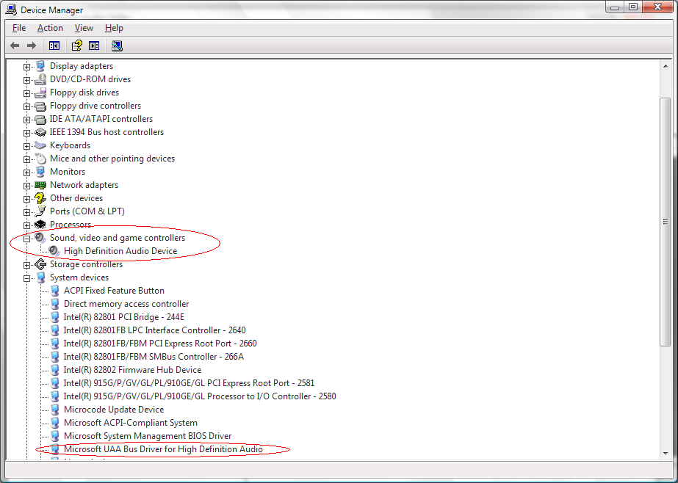
Figure 4. Device Manager view with bus driver and function driver installed

Step 3: Get the Current Pin Configuration Information
Now that the correct bus and function drivers have been loaded, you need to get the system's current pin configuration information. This information will be validated by the following test procedure.
To obtain the current pin configuration, use the HD Audio utility, HDAU.exe, which is included in the download package that was discussed in Step 1. Launch HDAU.exe, and click the Selected Device menu. This action should display a hardware ID, as shown in Figure 5. The hardware ID is the actual hardware ID for the HD Audio codec that is on your test system. If this procedure does not display a hardware ID, make sure that the checked version of the Microsoft UAA HD Audio class driver is properly installed.

Figure 5. High Definition Audio Utility 2.2 window showing the hardware ID
Click the hardware ID to display the codec information. It will look like the one that is shown in Figure 6, but the contents may be slightly different depending on the type of HD Audio codec.
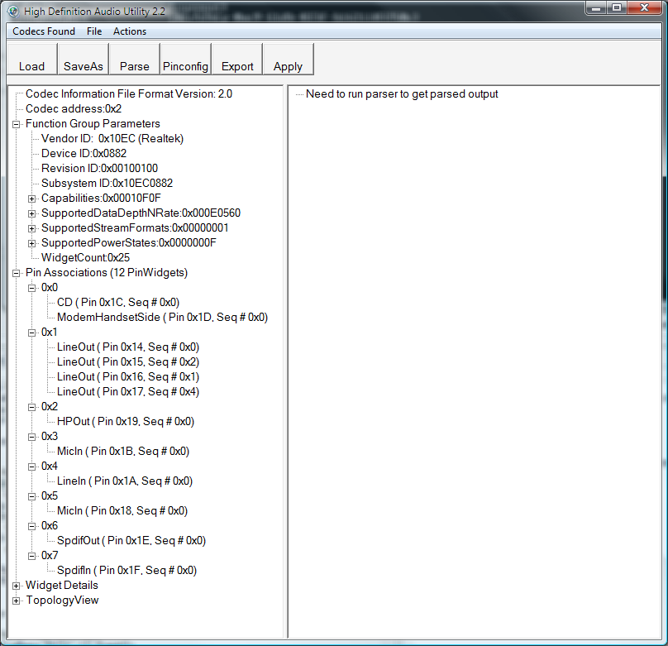
Figure 6. A high-level codec view

Step 4: Parse the Codec
To get detailed information on the codec, on the Actions menu, click Parse Codec. This parses the codec and the codec’s pin configuration register default values in the same way that the Microsoft UAA HD Audio class driver does for real device coverage.
The High Definition Audio Utility 2.2 window should now look much like Figure 7. The actual values in the two panes will vary, depending on the particular HD Audio codec and the pin configuration register values that the system BIOS set. Note that the pin configuration register values are not set during the system's startup phase.
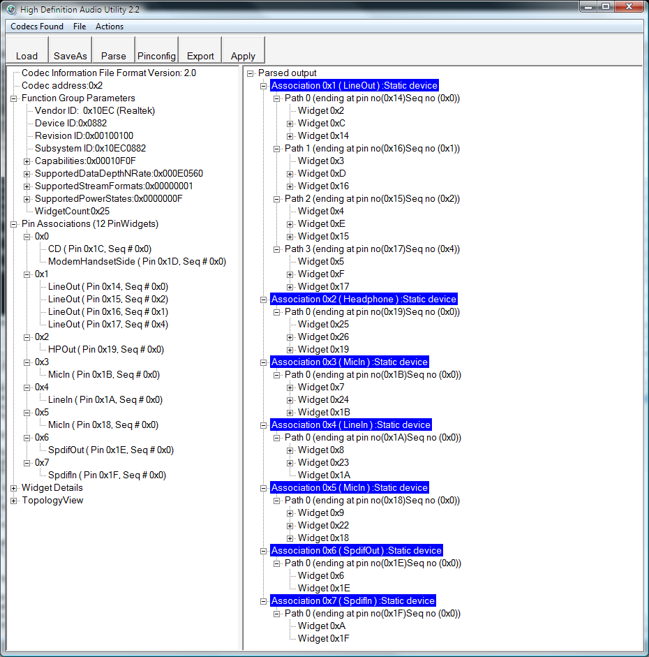
Figure 7. The parsed codec information

Step 5: Compare the Parsed Codec Information to the Physical Audio Jacks
The parsed codec output shows you what devices the Microsoft HD Audio 1.1 class driver enumerates on your test computer. Compare this output to the computer's physical audio jacks. If there is a disparity, the computer's pin configuration is not valid.

Step 6: Understand How Pin Configuration Registers Expose Logical Devices
The HD Audio codec's pin configuration registers must be assigned values that allow the Microsoft UAA HD Audio class driver to expose the logical audio devices to Windows Vista. Appropriate pin configuration register values are necessary to satisfy Windows Logo Program requirements. For guidelines on assigning pin configuration values, see the white paper titled Pin Configuration Guidelines for High Definition Audio Devices, which is listed in "Resources" at the end of this paper. You should read this paper before proceeding further with the test procedure.

Step 7: Create a Pin Configuration
After you have read and understand the Pin Configuration Guidelines for High Definition Audio Devices white paper, you are ready to create a pin configuration that represents the default behavior of the physical audio jacks on your system and is compatible with the Microsoft HD Audio class driver.
Run HDAUtility.exe and, on the Actions menu, click Edit PinConfig. This launches a dialog box that should look similar to that shown in Figure 8, but the details will vary depending on the HD Audio codec that is installed on the system.
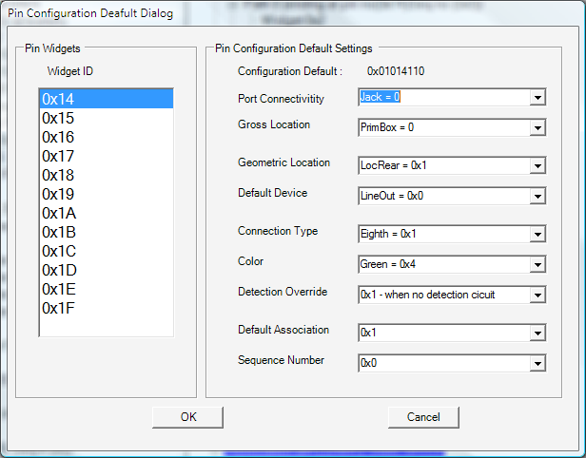
Figure 8. HDAU Pin Configuration Default Dialog dialog box
For this screen to make sense, you must understand the capabilities of the HD Audio codec that is installed on the system and how the codec is connected to the physical jacks. Obtain the codec data sheet from the HD Audio codec vendor for this step. This sheet includes data such as the capabilities of each pin widget, how many digital-to-analog and analog-to-digital converters (DACs and ADCs) are used, and so on. These values are necessary to set the pin configuration values to match the system design.
Example
Suppose you want to change pin widget 0x1a (which is currently a Line In device) and pin widget 0x18 (which is currently a Mic device) to a Muxed Capture device. To do this:
1. Put both of the pin widgets in the same association.
2. Change the Sequence Number of one of these devices to 0xe.

Note: The reasoning behind this procedure is explained in the Microsoft HD Audio Pin Configuration Guidelines white paper, which is listed in "Resources" at the end of this paper.
Similarly, to change the pin widgets to a Mixed Capture device, change the sequence number to 0xf. After you have completed your changes, in the Pin Configuration Default Dialog dialog box, click OK to return to the main window.

Step 9: Parse the Code to Register the Changes
After you have set the new pin configuration, you must parse the codec again to register the changes. To do so, on the HDAU.exe window Actions menu, click Parse Codec. Figure 9 shows the result of this operation for the change that was discussed in the previous section. It shows a Muxed Capture device instead of independent Line In and Mic devices.
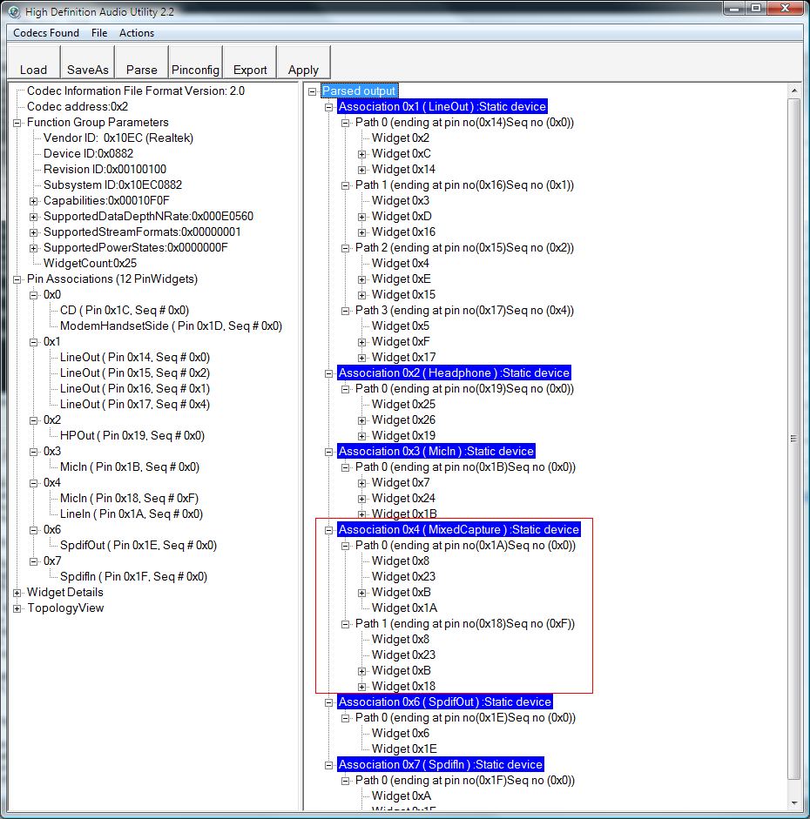
Figure 9. New pin configuration values after reparsing the codec
Use the process in Steps 8 and 9 for all the devices that you want the system to expose to Windows Vista. Remember that—based on the codec DAC and ADC resources—certain devices must be exposed to pass Windows Logo Program tests.

Step 10: Save the Pin Configuration Values
After you think you have a good set of pin configuration values, you are ready to test them on the system or board. The first step is to save the pin configuration values as a registry (.reg) file so that they can be imported into the registry. In the HDAU.exe window:
1. On the File menu, click Export PinConfig Settings As.
2. Specify a file name with a .reg extension and save it to your hard drive.
3. Open the saved registry file in Notepad. The contents should look similar to Figure 10. Notice the text "<your driver instance>" in the first line. This is a placeholder that must be replaced, as discussed in the Step 11.
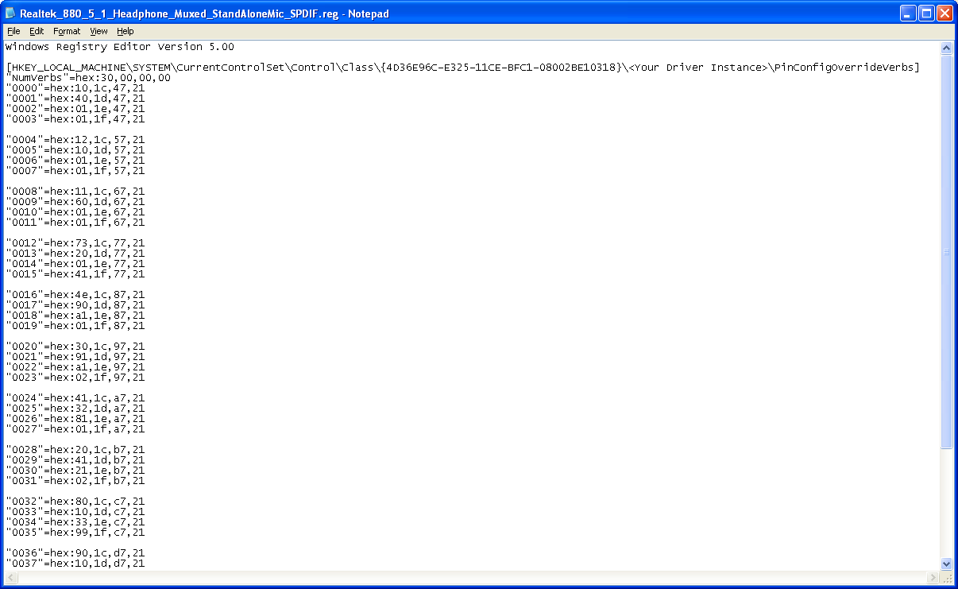
Figure 10. Pin configuration registry file from HDAU.exe

Step 11: Assign the Correct Driver Instance Value
You must replace the "<Your Driver Instance>" text in the pin configuration registry file with the correct driver instance value for the device. To find this value:
1. Launch Device Manager.
2. Display the High Definition Audio Device Properties dialog box.
3. On the Details tab, in the Property list box, select Driver Key to display the driver key.

The results of this procedure are shown in Figure 11.
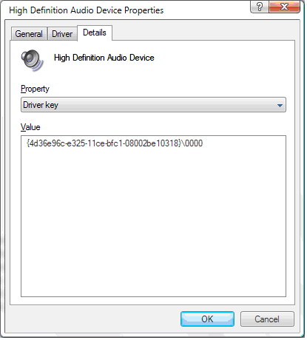
Figure 11. Driver instance value
The last four digits of the Value number are the driver instance value that you need. In this case, it is 0000. Open your pin configuration registry file in Notepad and replace “<Your Driver Instance>” with the four digits that are associated with your device and save the file. Figure 12 shows the example from Step 10, with a new driver instance value of 0000.
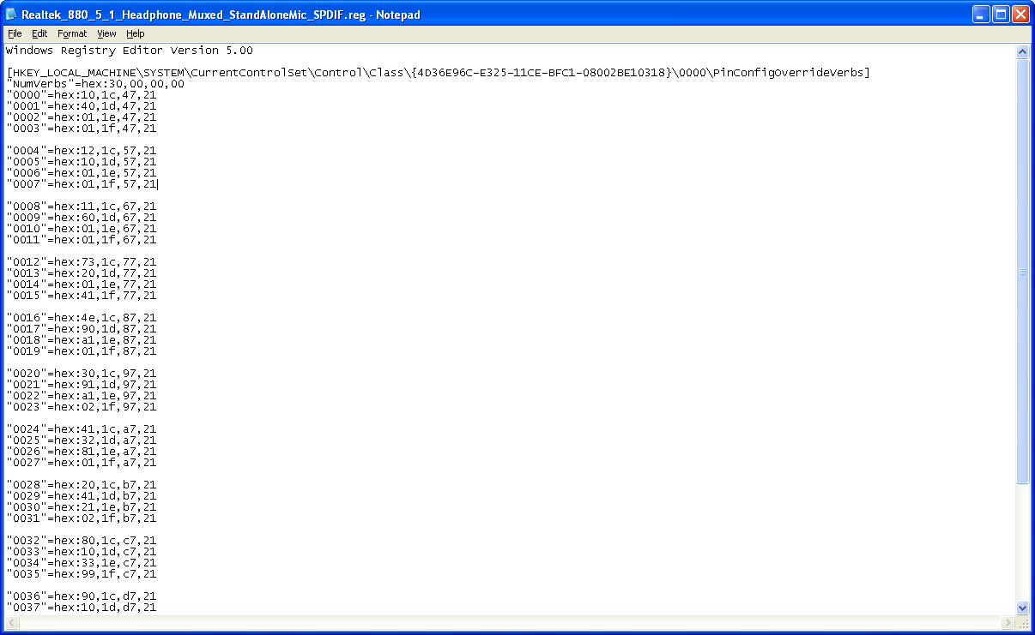
Figure 12. Pin configuration registry file with the correct driver instance value

Step 12: Load the New Pin Configuration
After you save your changes, you must load the new pin configuration by importing the contents of the pin configuration registry file into the registry:
1. Double-click the registry file to launch it in Regedit.
2. In the Regedit window, click Yes to indicate that you want to import the contents of the file into the registry.

After you have loaded the new pin configuration, you must reinstall the HD Audio class driver so that it can read and use the new settings:
1. Launch Device Manager.
2. Right-click HD Audio Device and select Update Driver from the shortcut menu to launch the Add Hardware Wizard.
3. Select the I don’t have the disc. Show me other options. check box and go to the next dialog box.
4. Select the Browse my computer for driver software (advanced) check box and then select the Let me pick from a list of device drivers on my computer check box.
5. High Definition Audio Device should appear in the Model list box, as shown in Figure 13. Select it and then click Next to reinstall the driver.
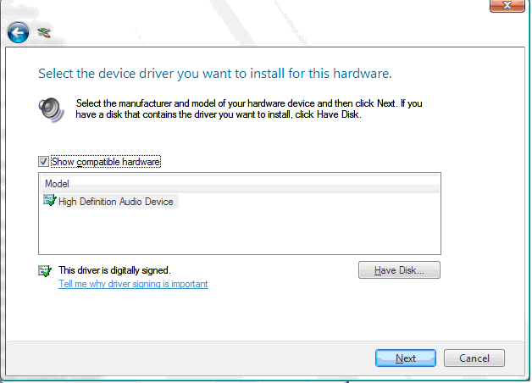
Figure 13. Driver installation dialog box
Note: With this example, the driver reads the pin configuration settings from the registry. However, that is only for test purposes. After you have determined the appropriate settings, they should be incorporated into the BIOS, as discussed in Step 14.

Step 13: Check Whether the Devices Are Correctly Exposed
After the HD Audio driver has been reinstalled, the logical devices that you created in the previous steps should be correctly exposed by the UAA HD Audio class driver. If so, they will appear in the Control Panel Multimedia application (mmsys.cpl). To check:
1. In Windows Control Panel, launch Sounds and Speech Recognition.
2. Open the Control Panel Multimedia application, and check that the correct devices appear in the Audio Devices and Sound Themes dialog box.

Figures 14 and 15 show examples of the Sound dialog box, but the details will vary from system to system based on the particular pin configuration defaults. Be aware that certain devices must be exposed based on the ADC and DAC resources in the codec. For more information on what devices are permissible for the Windows Vista logo, see the Windows Logo Program documents.
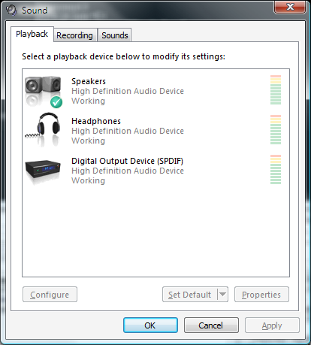
Figure 14. Windows Vista Sound dialog box, Playback tab, displaying correctly exposed devices
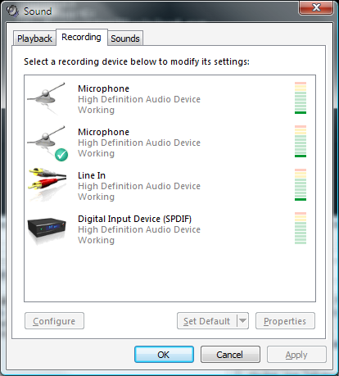
Figure 15. Windows Vista Sound dialog box, Recording tab, displaying correctly exposed devices

Step 14: Incorporate the Final Pin Configuration Settings into the BIOS
The registry-based approach that was discussed earlier provides a convenient way to determine the correct pin configuration settings. After you have determined the correct settings and verified that all of the devices appear properly in the Control Panel Multimedia application, the settings can be incorporated into the BIOS. First, you must put the pin configuration values into a format that a BIOS engineers can use. They can then incorporate the settings into the BIOS so that it can program the correct pin configuration into the HD Audio codec after a power state transition.
1. Launch HDAU.exe and, on the File menu, click Export PinConfig Settings As.
2. Select Verb Table for the export format. Your BIOS engineer should be familiar with this format. They can copy the contents of the exported file to incorporate the new pin configuration settings into the system BIOS.

Note: Please send any questions on this process to uaa@microsoft.com. Reply will be prompt within U.S. Pacific Standard Time Zone work hours.

A Recommended Validation Procedure for System and Board Hardware Testers
The following procedure can be used by system and board hardware testers to validate HD Audio pin configuration settings.
1. Install a recent Windows Vista build—5270 or later—on your HD Audio-based system or board.
2. Launch Windows Device Manager and check the HD Audio device entry. If it is disabled with a Code 10, your system’s pin configuration default values are probably so incorrect that the Microsoft UAA HD Audio class driver cannot recognize any logical device. In this condition, the system or board will not pass the Windows Logo Program tests. File a bug against the system BIOS and have the system engineers use the process that was described earlier in this paper to create the correct the pin configuration values. They can then provide you with a BIOS HD Audio Pin Configuration Verb Table that contains the correct values.
3. After the driver has loaded and is running, plug in the appropriate audio peripherals—a headphone into the headphone jack, a microphone into the microphone jack, and so on—into all of the 3.5-mm (1/8-inch) analog jacks on the system.
4. Launch the Control Panel Windows Vista Audio Device UI application. Check that the devices that the Windows Logo Program requires—based on the resources in the codec—are exposed to the user and available for streaming render or capture. To determine what devices are required, see the Windows Logo Program documents.
5. Unplug the peripherals and ensure that the devices are removed in the Control Panel Windows Vista Audio Device UI application. Then plug the devices in again to ensure that they return.

Example 1
Assume that you have a system with:
- A headphone output and microphone input on the front panel.
- A line in and a multichannel output device on the rear panel.
When you examine the Control Panel Windows Vista Audio Device UI application, all devices appear and work correctly as dynamic devices with the in-box UAA HD Audio class driver. The system has properly configured pin configuration register defaults.
Note: Often some of the devices that you would like to expose do not appear in the Control Panel Windows Vista Audio Device UI application. The system engineers must troubleshoot the pin configuration register values to ensure compliance with the Microsoft UAA HD Audio class driver.
Example 2
This example assumes the same hardware configuration as Example 1. However, The Control Panel Windows Vista Audio Device UI application displays only the microphone input on the front panel and the line in on the rear panel. It does not display the headphone on the front panel or the multichannel output on the rear panel.
In this case the pin configuration values for the multichannel and headphone pin widgets have errors that prevent the Microsoft UAA HD Audio class driver from exposing these devices. You should file a bug against the system for further investigation by system engineers because it will not pass the Windows Logo Program tests.

Conclusion
Motherboard and system vendors can rely on the Windows operating system to provide driver support for their HD Audio solutions. This paper presents a set of guidelines to test whether the pin configuration register programming meets Microsoft requirements. By using the test procedures in this paper to test pin configuration BIOS verb tables, motherboard and system vendors can ensure that the Microsoft UAA HD Audio class driver correctly identifies each audio device and makes that device available to Windows Vista applications. The test provides assurance that the system or board will pass the HD Audio Pin Configuration tests in the Windows Logo Program test kit.

Call to Action
Follow the test procedures in this paper to ensure appropriate default values for the pin configuration registers in the HD Audio codec in your system and board designs. This will allow the UAA HD Audio class driver to accurately identify the audio devices in your system.
System integrators (OEMs and ODMs) and BIOS developers:
Use the Microsoft HD Audio Pin Configuration Validation Tools that is available from https://home.ep.microsoft.com/ to ensure Windows Logo Program compliance for your Windows Vista system design.
Use the Microsoft UAA HD Audio class driver as part of your system startup test matrix. The driver ships in Windows Vista builds, but more recent versions can sometimes be obtained by contacting uaa@microsoft.com.
Codec hardware manufacturers:
Educate your customers about how to configure the audio devices in their Windows systems by testing following the guidelines in this paper. This will allow them to make more of the capabilities of those devices available to users.
Other hardware vendors:
Microsoft is working with hardware vendors and system integrators to ensure that the UAA HD Audio class driver provides full support for the audio devices in their HD Audio codecs. To ensure complete driver support for your codec, contact Microsoft.
If you have questions about UAA, these test procedures, or the tools that were discussed in this paper, send e-mail to uaa@microsoft.com.

Resources
White Papers
Pin Configuration Guidelines for High Definition Audio Devices. This white paper contains information about HD Audio pin configuration register programming for system vendors.
http://www.microsoft.com/whdc/device/audio/PinConfig.mspx
Intel High Definition Audio Specification. This specification contains information about the Intel HD Audio architecture.
http://www.intel.com/standards/hdaudio/
Universal Audio Architecture. This white paper contains an overview of the Microsoft UAA initiative.
http://www.microsoft.com/whdc/device/audio/uaa.mspx
Plug and Play Guidelines for High Definition Audio Devices. This white paper contains information about providing Plug and Play support for HD Audio devices.
http://www.microsoft.com/whdc/device/audio/HD-aud_PnP.mspx
Windows Logo Program Requirements. This Web site contains information about Windows compatibility guidelines for UAA devices, including HD Audio solutions.
http://www.microsoft.com/whdc/winlogo/hwrequirements.mspx
Other Resources
Windows Hardware Developer Central (WHDC). This Web site contains technical information, development and testing kits, and other essential resources for system and device manufacturers, driver developers, and other professionals who create products that run with Windows.
http://www.microsoft.com/whdc/default.mspx

