Microsoft Driver Quality Rating

Version 1.0 – April 4, 2008

Abstract

This paper describes how Microsoft calculates Driver Quality Rating (DQR), the tools associated with it, and how it is used in conjunction with the Windows® Logo Program.

DQR is a key indicator of how a driver is performing in terms of stability. It is a scoring system that is based on statistical information supplied by Windows Error Reporting (WER). Microsoft uses this data to make crash performance comparisons against that of other drivers and to assign a rating.

This information applies for the following operating systems:  
 Windows Server® 2008  
 Windows Vista®

References and resources discussed here are listed at the end of this paper.

For the latest information, see:   
 <http://www.microsoft.com/whdc/winlogo/DQR.mspx>

Disclaimer: This is a preliminary document and may be changed substantially prior to final commercial release of the software described herein.

The information contained in this document represents the current view of Microsoft Corporation on the issues discussed as of the date of publication. Because Microsoft must respond to changing market conditions, it should not be interpreted to be a commitment on the part of Microsoft, and Microsoft cannot guarantee the accuracy of any information presented after the date of publication.

This White Paper is for informational purposes only. MICROSOFT MAKES NO WARRANTIES, EXPRESS, IMPLIED OR STATUTORY, AS TO THE INFORMATION IN THIS DOCUMENT.

Complying with all applicable copyright laws is the responsibility of the user. Without limiting the rights under copyright, no part of this document may be reproduced, stored in or introduced into a retrieval system, or transmitted in any form or by any means (electronic, mechanical, photocopying, recording, or otherwise), or for any purpose, without the express written permission of Microsoft Corporation.

Microsoft may have patents, patent applications, trademarks, copyrights, or other intellectual property rights covering subject matter in this document. Except as expressly provided in any written license agreement from Microsoft, the furnishing of this document does not give you any license to these patents, trademarks, copyrights, or other intellectual property.

Unless otherwise noted, the example companies, organizations, products, domain names, e-mail addresses, logos, people, places and events depicted herein are fictitious, and no association with any real company, organization, product, domain name, email address, logo, person, place or event is intended or should be inferred.

© 2008 Microsoft Corporation. All rights reserved.

Microsoft, Excel, Windows, Windows Server, and Windows Vista are either registered trademarks or trademarks of Microsoft Corporation in the United States and/or other countries.

The names of actual companies and products mentioned herein may be the trademarks of their respective owners.

Document History

| **Date** | **Change** |  |  |  |
| --- | --- | --- | --- | --- |
| April 4, 2008 | First publication | | | |

Contents

Introduction 3

Online Crash Analysis Tools 3

How DQR Is Calculated 4

Viewing DQR Data 6

DQR and the Windows Logo Program 9

Enforcement 9

Posting Fixes to Windows Update 9

Update Effect on DQR 9

Call to Action 10

Glossary of Terms 10

Resources 10

# Introduction

The goal of the Windows® Logo Program (WLP) is to help to improve the overall quality of vendor drivers so that customers have a great user experience while working on the Windows platform. Device drivers must function efficiently so that end users can fully exploit the capabilities of their hardware and software. Customers look for the Windows logo as assurance of driver quality. We want to partner with you as a hardware ecosystem vendor who participates in the WLP to accomplish this goal.

Driver quality issues also result in customer service calls to both Microsoft and you as our hardware partner. The Microsoft Driver Quality Rating (DQR) uses a value of 1 (the lowest) to 5 (the highest) stars to indicate the relative crash stability of your driver. To determine a DQR, we use Online Crash Analysis (OCA) figures to calculate a driver’s crash ratio and compare that to the average ratio of other drivers in the same device technology area. You can use this DQR to identify and improve the rating of any low-performing driver.

On June 1, 2007, the WLP team added logo requirement ID DEVFUND-0027, which requires independent hardware vendors (IHVs) to monitor their DQR values. The requirement states that device drivers that have qualified for a Premium logo must maintain a DQR between 3 and 5 stars to retain that logo. If your driver falls below 3 stars and remains at that rating for more than 120 days, the driver is considered out of compliance. To retain the Windows logo, you must update that driver based on OCA reports and post an update to Windows Update within 90 days.

We calculate DQRs on the 1st of each month, and a report of driver rating is available for viewing on or about the 5th day of each month. You can view this data and sort it in the Windows Error Reports (WER) **My Driver Quality Rating** page in your Winqual account. You can export the data into Microsoft® Excel® and use tools to view trends, performance, and ratings, and to filter them by using your own criteria.

# Online Crash Analysis Tools

End users provide WER crash data. When users experience a crash, they can choose to send an error report to Microsoft. If the user sends the report, a minidump records a list of all drivers on that user’s system and flags the specific driver on that system that caused the crash.

When we receive the report, we sort the information according to its contents and, whenever possible, associate the information with a particular vendor, general device type, and system manufacturer. WER also categorizes data and sends a response to end users if a solution is available.

We also analyze the WER data as the basis for assigning the driver’s DQR. This information for your drivers then appears in your company’s Winqual account. To view the WER data, someone from your company with permission to sign legal agreements must first accept the WER Terms of Use agreement online.

# How DQR Is Calculated

DQR-rated drivers have a rating from 1 to 5 stars, with 1 star indicating the greatest frequency of crashes and 5 stars indicating the lowest frequency. We assign a DQR value to any driver that has a minimum 500-system installation base. The installation base is calculated from each unique system on which the driver is installed and is loaded in memory at the time of the crash. Ratings for installation counts lower than 500 systems tend to be unreliable. Therefore, these drivers are shown only for reference and are excluded from roll-up counts and from DQR values.

DQRs are updated on the 1st day of each month and reflect the previous month’s data. WER data is classified into different buckets (categories) that contain error reports for the same issue. At the end of each month, we calculate the individual crash ratios for each bucket and use that ratio to determine the DQR. Table 1 shows the range for each DQR.

Table 1. Range for Determining DQR

| **Stars** | **Range** |
| --- | --- |
| ***** | Crash ratio is less than or equal to 0.25 times the device technology area average. |
| **** | Crash ratio is greater than 0.25 and less than or equal to 0.75 times the device technology area average. |
| *** | Crash ratio is greater than 0.75 and less than or equal to 2 times the device technology area average. |
| ** | Crash ratio is greater than 2 times and less than or equal to 9 times the device technology area average. |
| * | Crash ratio is greater than 9 times the device technology average. |
| 0 | NA |

Table 2 shows the crash averages for different device technology areas. We review the crash ratio averages quarterly and update the averages if we find a significant difference.

Table 2. Crash Averages by Device Technology Area

| **Device Technology Area** | **Crash Average** |
| --- | --- |
| Application Drivers | 0.007 |
| Audio | 0.011 |
| Display | 0.100 |
| Imaging | 0.112 |
| Input | 0.002 |
| Networking | 0.007 |
| Printing | 0.015 |
| Storage | 0.010 |
| Streaming Media | 0.049 |
| System Devices | 0.026 |
| Unclassified | 0.001 |
| Wireless LAN | 0.060 |

Table 3 shows data for a fictitious company. It compares number of installations and number of crashes for five example drivers.

Table 3. Example Crash Data

| **Driver** | **Installations** | **Crashes** |
| --- | --- | --- |
| **Driver Name:** vga.sys  **Category:** Display  **Driver Date:** 2007-02-17  06:10:30  **Driver Version:** 5.2.3790.3959  **Period:** March 2007 | 12,049 | 1 |
| **Driver Name:** vga.sys  **Category:** Display  **Driver Date:** 2007-03-08  12:29:47  **Driver Version:** 6.0.6001.16478  **Period:** February 2007 | 1,458 | 0 |
| **Driver Name:** vga.sys  **Category:** Display  **Driver Date:** 2007-03-13  11:36:02  **Driver Version:** 6.0.6001.16478  **Period:** January 2007 | 1,446 | 0 |
| **Driver Name:** CrashKernelDrv.sys  **Category:** Application Drivers  **Driver Date:** 2007-03-18  11:44:55  **Driver Version:** 0.0.0000.00000  **Period:** March 2007 | 5 | 4 |
| **Driver Name:** CrashKernelDrv.sys  **Category:** Application Drivers  **Driver Date:** 2007-03-22  **Driver Version:** 0.0.0000.00  **Period:** January 2007 | 28 | 6 |

Table 4 shows the same five example drivers. These drivers have now been assigned a DQR value based on the crash averages in Table 2.

Table 4. DQR Calculation

| **Driver** | **Installations** | **Crashes** | **Crash Average** | **DQR** |
| --- | --- | --- | --- | --- |
| **Driver Name:** vga.sys  **Category:** Display  **Driver Date:** 2007-02-17  06:10:30  **Driver Version:** 5.2.3790.3959  **Period:** March 2007 | 12,049 | 1 | 0.009 | ***** |
| **Driver Name:** vga.sys  **Category:** Display  **Driver Date:** 2007-03-08  12:29:47  **Driver Version:** 6.0.6001.16478  **Period:** February 2007 | 1,458 | 0 | 0.000 | ***** |
| **Driver Name:** vga.sys  **Category:** Display  **Driver Date:** 2007-03-13  11:36:02  **Driver Version:** 6.0.6001.16478  **Period:** January 2007 | 1,446 | 0 | 0.000 | ***** |
| **Driver Name:** CrashKernelDrv.sys  **Category:** Application Drivers  **Driver Date:** 2007-03-18  11:44:55  **Driver Version:** 0.0.0000.00000  **Period:** March 2007 | 5 | 4 | 0.800 | NA |
| **Driver Name:** CrashKernelDrv.sys  **Category:** Application Drivers  **Driver Date:** 2007-03-22  **Driver Version:** 0.0.0000.00  **Period:** January 2007 | 28 | 6 | 0.214 | NA |

The three vga.sys drivers have a DQR of 5 stars because their ratios fall within the range of a 5‑star DQR. The two CrashKernelDrv.sys drivers do not have a DQR value because their installation base is less than 500.

# Viewing DQR Data

As stated previously, you can view your DQR data through your Winqual account. You should work with the WER team to have your company’s drivers mapped to your Winqual account.

To view your DQR data

1. Log on to your Winqual account.

2. In the left pane, under **Windows Error Reports**, point to **Hardware** and click **My Driver Quality Rating**.



3. The **My Driver Quality Rating** page appears and displays the top-ten driver view, which is a roll-up of all driver versions for the previous month.

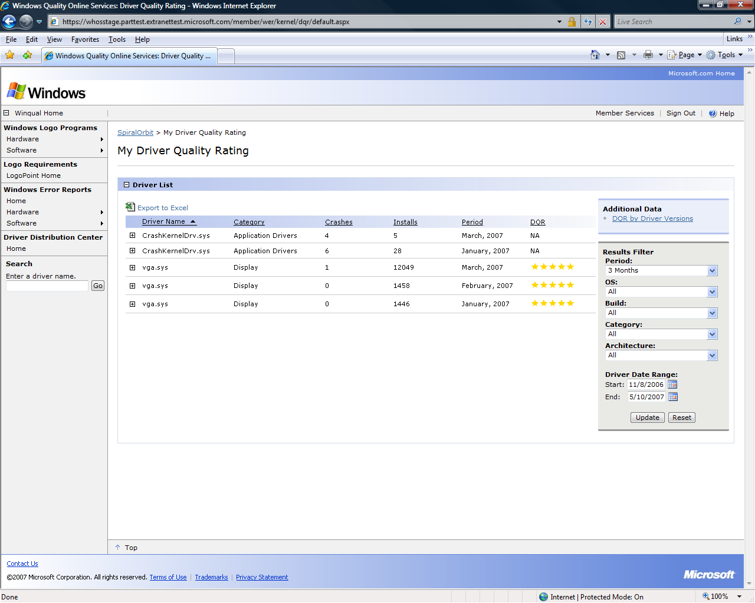

4. To see an expanded view of all versions of a particular driver, click the plus sign (+) in front of the driver name.

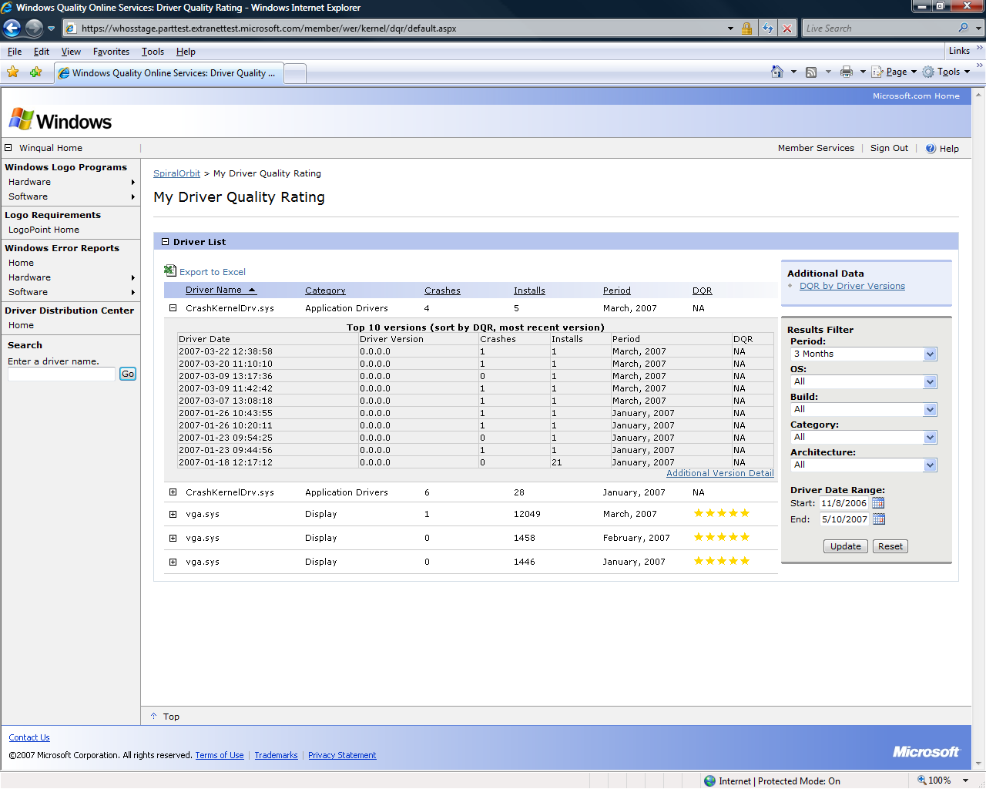

5. To search for a driver by name, in the left pane, under **Search**, enter a driver name and click **Go**.

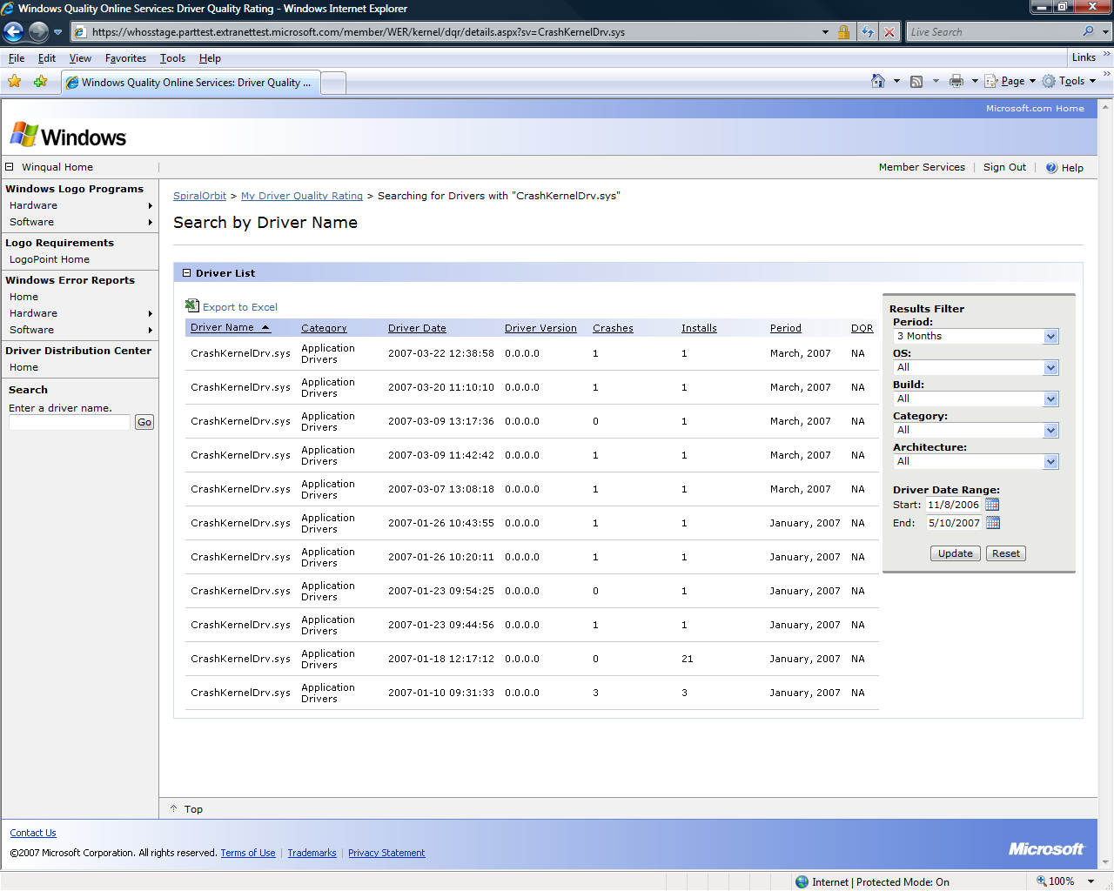

# DQR and the Windows Logo Program

As stated earlier in “Introduction,” logo requirement ID DEVFUND‑0027, effective June 1, 2007, requires IHVs to monitor their DQR score. Device drivers that have qualified for a Premium logo must maintain a DQR between 3 and 5 stars to retain that logo. If a driver falls below 3 stars and remains at that rating for more than 120 days, the driver is considered out of compliance. To retain the Windows logo, an updated driver must be made available within 90 days.

For example, a driver that was signed on July 1, 2007, could have a DQR of less than 3 stars for July, August, September, and October of that year with no consequence. However, from November 2007 on, this driver must maintain a DQR of 3 stars or higher. If the DQR drops below 3 stars, then the 90-day countdown begins. Failure to fix the driver within 90 days would result in noncompliance, and all submissions linked to that driver would fail.

Based on feedback, beginning June 1, 2008, this requirement will be expanded to apply to Basic logos and Unclassified test device driver logos as well as Premium logos.

Also starting June 1, 2008, is the enforcement of SYSFUND‑0040, a System Fundamental requirement that is similar to DEVFUND‑027. We use a marker file to help associate WER data with specific computer models and post lists of these drivers online. Original equipment manufacturers (OEMs) can view and analyze crash dumps from their systems to help them make decisions about which drivers to include in their products.

## Enforcement

If the DQR for one of your company’s drivers drops to 1 or 2 stars, you must immediately log on to your Winqual account and create a notification. WER will automatically send this notification to any end user who encounters a crash that was caused by this driver and is classified into the same OCA bucket.

Within 90 days you must also update the driver that is causing crashes in the top OCA buckets. If you do not provide this updated driver within 90 days, the logo for products that are associated with that driver is revoked and the driver is removed from Windows Update.

## Posting Fixes to Windows Update

As part of resubmitting an updated driver, you must post the driver to Windows Update and create a WER notification to inform end users that a driver update is available. Drivers that are not eligible to be posted to Windows Update must be posted to your Web site and that Web site URL must be added to the WER notification.

## Update Effect on DQR

Sometimes the DQR does not change even after a driver update has been distributed to end users. This occurs because the systems that had been crashing are no longer crashing, which causes the detected installation base to be low and results in a monthly DQR of 0.

This low DQR has no negative effect on end users. The most important fact to them is that you have updated your driver and it is available to them for download.

# Call to Action

Monitor your DQR ratings every month. The updated DQR ratings and WER buckets are available approximately the 5th day of each month. This information will keep you informed of major quality issues for your drivers.

For the latest information on this or any logo requirements, go to the LogoPoint Web site, which can be accessed through your Winqual account.

# Glossary of Terms

Windows Error Report (WER)

A set of feedback technologies that is built into Windows Vista®, Windows Server® 2003, and Windows® XP that captures crash data from end users who agree to report the data to Microsoft.

WER bucket

A way of categorizing crashes.

WER notification

A way for vendors to provide their users with a real-time solution. When the WER system receives crash data from an end user, it determines if an appropriate message exists and, if so, returns that message to the end user.

marker file

A file that is used to help associate WER data with a specific computer model.

Windows Quality Online Services (Winqual)

The gateway that vendors use to qualify their hardware devices for a Microsoft logo.

# Resources

Windows Quality Online Services (Winqual)  
Log on and use LogoPoint to communicate with the Windows Logo Program team

<https://winqual.microsoft.com>

Windows Logo Program Home Page

<http://www.microsoft.com/whdc/winlogo/default.mspx>

To communicate with the Windows Error Reporting team, e-mail:

[werpasup@microsoft.com](mailto:werpasup@microsoft.com)