Bluetooth Wireless Technology FAQ - 2008

August 27, 2008

Abstract

This FAQ provides information about Bluetooth wireless technology support for the Windows® family of operating systems, focusing primarily on Windows Vista®. It is intended primarily for independent hardware vendors (IHVs) who are new to the Bluetooth ecosystem on Windows and addresses topics of interest to both hardware and software developers.

This information applies for the following operating systems:  
 Windows Vista  
 Windows XP

For the latest information, see:  
 <http://www.microsoft.com/whdc/device/connect/Bth_faq.mspx>

References and resources discussed here are listed at the end of this paper.

Disclaimer: This is a preliminary document and may be changed substantially prior to final commercial release of the software described herein.

The information contained in this document represents the current view of Microsoft Corporation on the issues discussed as of the date of publication. Because Microsoft must respond to changing market conditions, it should not be interpreted to be a commitment on the part of Microsoft, and Microsoft cannot guarantee the accuracy of any information presented after the date of publication.

This White Paper is for informational purposes only. MICROSOFT MAKES NO WARRANTIES, EXPRESS, IMPLIED OR STATUTORY, AS TO THE INFORMATION IN THIS DOCUMENT.

Complying with all applicable copyright laws is the responsibility of the user. Without limiting the rights under copyright, no part of this document may be reproduced, stored in or introduced into a retrieval system, or transmitted in any form or by any means (electronic, mechanical, photocopying, recording, or otherwise), or for any purpose, without the express written permission of Microsoft Corporation.

Microsoft may have patents, patent applications, trademarks, copyrights, or other intellectual property rights covering subject matter in this document. Except as expressly provided in any written license agreement from Microsoft, the furnishing of this document does not give you any license to these patents, trademarks, copyrights, or other intellectual property.

Unless otherwise noted, the example companies, organizations, products, domain names, e-mail addresses, logos, people, places and events depicted herein are fictitious, and no association with any real company, organization, product, domain name, email address, logo, person, place or event is intended or should be inferred.

© 2007–2008 Microsoft Corporation. All rights reserved.

Microsoft, Windows, Windows Server, and Windows Vista are either registered trademarks or trademarks of Microsoft Corporation in the United States and/or other countries.

The names of actual companies and products mentioned herein may be the trademarks of their respective owners.

Document History

|  |  |  |  |  |
| --- | --- | --- | --- | --- |
| Date | Change |  |  |  |
| August 27, 2008 | Updated for 2008 | | | |
| September 17, 2007 | First publication | | | |

Contents

Introduction 3

General Operating System Support 4

Bluetooth Host Radio Support 9

User Interface 12

Windows Logo Program 14

Resources 14

Appendix A: How to Install an In-Box Bluetooth Driver on New Hardware 16

Appendix B: An Example of a Vendor-Provided INF 19

# Introduction

This FAQ provides answers to a range of common questions about how Windows®—particularly Windows Vista®—supports Bluetooth wireless technology. For convenience, the following list provides links to the questions.

General Operating System Support

Which Versions of Windows Support Bluetooth Wireless Technology  
Which Bluetooth Versions Does Windows Support?  
What Is New for Windows Vista?  
Which Bluetooth Profiles Have In-Box Windows Support?  
Does Windows Vista Support Bluetooth Version 2.1 Features?  
Does Windows Support Wake from S3 or S4 for Bluetooth Devices?  
How Many Bluetooth Radios Can Windows Vista Support?  
Must Bluetooth Devices Be Paired Again After Upgrading a System to Windows Vista?  
What Programming Interfaces Were New for Windows Vista?  
How Can Bluetooth and Wi-Fi Radios Coexist Effectively?  
How Do I Enable AFH in Windows Vista?  
How Do I Enable Remote Wake in Windows Vista?

Bluetooth Host Radio Support

Which Bluetooth Host Controllers Does Windows Support?  
How Do I Force the Bluetooth Stack to Load if Windows Can’t Match the Device ID?  
How Do I Ensure In-Box Support for Bluetooth Radios?  
Should Third-Party INFs Use the Microsoft-Defined Class GUID?  
Why Is the Bluetooth Control Panel Application Missing?  
Does Windows Vista Support Bluetooth Radio Firmware Updates?  
Does Windows Vista Support Vendor-Specific Passthrough Commands?  
Does Windows Vista Support Vendor-Supplied Profiles?  
Why Are Only Some Bluetooth Profiles Enabled by Default?  
Can Group Policy Block Bluetooth Radio Installation?

User Interface

Can an IHV Replace the Bluetooth Control Panel Application?  
Why Does the Bluetooth Notification Area Icon Sometimes Disappear?  
Can Vendors Add Tabs to the Control Panel Bluetooth Devices Application?  
Why Does Windows Vista Display a Pop-up Message When a Bluetooth Audio Device Is Initially Connected?

Windows Logo Program

Where Are the Windows Logo Program Requirements for Bluetooth Wireless Technology?  
Are There New Requirements for Bluetooth Version 2.1?

# General Operating System Support

## Which Versions of Windows Support Bluetooth Wireless Technology?

The following versions of Windows include in-box support for Bluetooth wireless technology:

* All client SKUs of Windows XP with SP2 and later versions.
* Windows XP, x64 version.
* All Windows Vista SKUs.

The following versions of Windows do not have in-box support for Bluetooth wireless technology:

* All SKUs of Windows 2000.
* All SKUs of Windows Server® 2003 and Windows Server 2008.

Although these versions of Windows do not have in-box Bluetooth wireless technology support, third-party Bluetooth drivers might be available from independent software vendors (IHVs).

**Note:** The Windows XP SP1 release supported Bluetooth wireless technology, but did so with a driver that was available only to PC system partners. Windows XP SP2 integrated Bluetooth wireless technology support into a regular service pack release and was available to all customers.

## Which Bluetooth Versions Does Windows Support?

Windows supports Bluetooth version 1.1 and later versions. Windows does not support Bluetooth version 1.0 because that specification lacks several critical updates that Windows requires to support Bluetooth wireless technology well. Bluetooth version 2.1 radios and devices are backward compatible and will run on Windows XP and Windows Vista. However, these Windows versions cannot take advantage of the full Bluetooth version 2.1 feature set because the Bluetooth version 2.1 specification was not ratified before Windows Vista was released.

Windows support for different versions of the Bluetooth specification depends on the Windows version.

Table 1. Windows Support for Bluetooth Versions

| **Windows version** | **Supported Bluetooth versions** |
| --- | --- |
| Windows 2000 | Not supported. |
| Windows XP | Version 1.1 Version 2.0 Version 2.0 with enhanced data rate (EDR) |
| Windows 2003 Server | Not supported. |
| Windows Vista | Version 1.1 Version 2.0 Version 2.0 with enhanced data rate (EDR)*  Version 2.1 with enhanced data rate (EDR)** |
| Windows Server 2008 | Not supported. |
| *The Windows Vista EDR support is enhanced relative to the Bluetooth stack for Windows XP.  **Version 2.1+EDR is supported through the Windows Vista Feature Pack for Wireless, KB 942567.   Version 2.1 support is expected to be included in an upcoming Windows Vista service pack. | |

## What Is New in Windows Vista?

Windows Vista includes the following enhancements to the Bluetooth stack and related software:

* Improved EDR performance.
* Adaptive frequency hopping (AFH). This feature improves coexistence between Bluetooth radios and 802.11 (Wi-Fi) network adapters, which both operate in the 2.4-GHz frequency range.
* Synchronous connection-oriented (SCO) link support. This support is necessary for the headset and hands-free profiles.
* Kernel-mode device driver interface (DDI) support for the logical link control and adaptation layer protocol (L2CAP), service discovery protocol (SDP), and SCO.
* Table 2 lists the Bluetooth hardware IDs that are new for Windows Vista.

Table 2. New Bluetooth Hardware IDs for Windows Vista

| **VID** | **PID** | **Description** |
| --- | --- | --- |
| 03F0 | 011D | Hewlett Packard integrated Bluetooth module |
| 03F0 | 011D&Rev_0017 | Hewlett Packard nc4200 |
| 03F0 | 171D | Hewlett Packard integrated Bluetooth module |
| 03F0 | D104 | BT450 Bluetooth wireless printer and PC adapter |
| 044E | 300A | Sony Bluetooth USB adapter |
| 044E | 300C | Sony Bluetooth USB adapter |
| 049F | 0086 | Hewlett Packard Integrated Bluetooth module |
| 049F | 0086&Rev_1393 | Hewlett Packard nx7000 |
| 0930 | 0508 | Toshiba Bluetooth adapter |
| 0930 | 0509 | Toshiba Bluetooth adapter |
| 0A5C | 201E | IBM Integrated Bluetooth IV |
| 0A5C | 2110 | ThinkPad Bluetooth with enhanced data rate |
| 0B05 | 1712 | Generic Bluetooth adapter |
| 0DB0 | 6855&Rev_2000 | MSI Bluetooth device |
| 413C | 8120 | Dell wireless Bluetooth module |
| 413C | 8126 | Dell Truemobile 355 Bluetooth + EDR |

## Which Bluetooth Profiles Have In-Box Windows Support?

Windows includes in-box support for the Bluetooth profiles that are shown in Table 3.

Table 3. In-Box Bluetooth Profiles

| **Profile** | **Description** |
| --- | --- |
| HID v1.0 | Human input devices |
| PANU | Personal-area network – User |
| SPP | Serial Port Profile |
| OPP | Object push profile |
| DUN | Dial-up networking |

Because Windows Vista provides both kernel-mode and user-mode programming interfaces for its Bluetooth stack, hardware and software vendors can implement additional profiles in both kernel mode and user mode. We encourage vendors that create such profiles to test their software by using the Windows Logo Program and the appropriate Windows Driver Kit (WDK) test suites and have their packages digitally signed. If a profile does not correspond to a WDK device category, IHVs should validate their software with the WDK’s unclassified test suite.

## Does Windows Vista Support Bluetooth Version 2.1 Features?

Windows Vista RTM and SP1 both support Bluetooth version 2.0 with EDR. The Bluetooth version 2.1 specification was not finalized until after Windows Vista shipped. Bluetooth version 2.1 support is available in the Windows Vista Feature Pack for Wireless. The feature pack was released to PC OEMs for inclusion on new systems with version 2.1 radios. Some Bluetooth module manufacturers will include this feature pack with their Bluetooth version 2.1 devices.

For more information about the Feature Pack and its availability, see the [Windows Vista Feature Pack for Wireless white paper](http://www.microsoft.com/whdc/connect/wireless/FP_Wireless.mspx).

## Does Windows Support Wake from S3 or S4 for Bluetooth Devices?

With the Windows Vista Feature Pack for Wireless installed, Windows Vista offers software support to wake the PC from S3 or S4. However, this capability ultimately depends on the hardware. The Bluetooth module itself must also support wake from S3 and/or S4. Additionally, the USB connection must provide the Bluetooth module with enough power to wake from these low-power states.

## How Many Bluetooth Radios Can Windows Vista Support?

The Bluetooth stack on Windows Vista supports one Bluetooth radio. This radio must comply with the Bluetooth USB Host Controller Interface (HCI) specification and the latest Windows Logo Program requirements.

## Must Bluetooth Devices Be Paired Again After Upgrading a System to Windows Vista?

If users upgrade a Windows XP system to Windows Vista, they will probably need to reestablish their Bluetooth device pairings. There are two primary reasons:

* Most Windows XP systems have third-party Bluetooth drivers that use proprietary formats to store pairing information.
* Many of the changes in Windows Vista require customers to install new drivers, which require new pairings.

Pairing information is preserved when you upgrade from Windows XP to Windows Vista for some devices, primarily Bluetooth wireless technology keyboards and mouse devices. This ensures that customers are not required to switch back to a wired keyboard and mouse to upgrade their Windows version. They can use their Bluetooth wireless technology keyboard and mouse for the entire procedure.

## What Programming Interfaces Were New for Windows Vista?

Windows Vista introduced a kernel-mode DDI for Bluetooth wireless technology, which provides access to SCO, SDP, and L2CAP. The DDI is included with WDK build 6000, which was released with Windows Vista. We do not currently plan to make the kernel-mode DDI available on earlier versions of Windows. The WDK also includes Driver Test Manager (DTM). This tool verifies that kernel-mode Bluetooth drivers comply with standard driver development practices and use the DDI correctly.

Windows Vista also supports the user-mode RFComm and Bluetooth APIs. For details, see ”Bluetooth.”

The WDK includes documentation for the new kernel-mode DDI, as well as for the DTM kit. For details on how to download the WDK, see ”Windows Driver Kit (WDK) - Overview.”

## How Can Bluetooth and Wi-Fi Radios Coexist Effectively?

Both Bluetooth and Wi-Fi radios operate in the 2.4-GHz frequency range, so they could momentarily try to use the same frequency. The frequency hopping technique that Bluetooth wireless technology uses prevents such a conflict from causing a complete connectivity loss, but it could reduce the transfer rates for both radios.

Version 2.0 of the Bluetooth specification supports AFH. With AFH, a Bluetooth radio senses traffic from other types of radios, marks the busy channels as ”noisy,” and avoids those channels as it hops frequencies. Windows Vista improves AFH even further by treating the ”air” as a shareable spectrum. This feature lets wireless technologies such as Wi-Fi adapters report which channels they intend to use. When the Bluetooth stack becomes active, it is notified of the reported in‑use channels and marks them as noisy.

## How Do I Enable AFH in Windows Vista?

Windows Vista includes a new shared-spectrum model to support AFH for radios based on version 2.0 and later versions of the Bluetooth specification. However, this feature is disabled by default. For a system to support the shared spectrum model, the OEM must explicitly enable the feature and specify the width of the frequency band that should be blocked around an active Wi‑Fi channel. To specify the width of the frequency band, set the following registry value:

HKLM\SYSTEM\CurrentControlSet\Services\BthServ\Parameters  
\ChannelAvoidanceRange

**ChannelAvoidance** is a REG_DWORD value of the **Parameters** key that enables or disables spectrum sharing and specifies the width of the blocked frequency band:

* To enable spectrum sharing, set **ChannelAvoidance** to the full width of the frequency band that should be blocked around an active Wi-Fi channel. The units are MHz and can range from 20 to 40 (0.02 to 0.04 GHz). OEMs must determine an appropriate bandwidth based on a selected set of radios, antenna characteristics, and radio manufacturer feedback.
* To disable spectrum sharing, set **ChannelAvoidance** to 0.

A new **ChannelAvoidance** value takes affect only after the system has been rebooted. Ideally, **ChannelAvoidance** should be set during the preinstallation operation.

For the Windows Vista shared spectrum model to work effectively, Wi-Fi miniport drivers must report their channel usage to the networking connections manager. The networking stack then passes the channel-use information to the Bluetooth stack.

## How Do I Enable Remote Wake in Windows Vista?

The Windows Vista Feature Pack for Wireless provides software support that lets Bluetooth enabled keyboards and mouse devices wake the PC from sleep (S3) or hibernate (S4). For such a wake to be successful, the Bluetooth module must be self-powered and must have enough power to wake the PC. Even if Windows enables wake from S4, if the Bluetooth module has no power in S4, the PC will not wake.

To enable Remote Wake in software, verify that the Bluetooth module can support wake and set the following registry keys:

* HKLM\System\CCS\Services\Bthport\Parameters  
  \SystemRemoteWakeSupported : (DWORD) 1
* HKLM\System\CCS\Enum\USB\<vid_pid>\<Bluetooth Radio ID>  
  \Device Parameters\RemoteWakeEnabled : (DWORD) 1
* HKLM\System\CCS\Enum\USB\<vid_pid>\<Bluetooth Radio ID>  
  \Device Parameters\DeviceRemoteWakeSupported : (DWORD) 1

**Note:** If the Bluetooth radio’s property page in Device Manager has a **Power Management** tab, the radio can support wake. If there is no **Power Management** tab, the radio might support wake, but it is unlikely.

# Bluetooth Host Radio Support

## Which Bluetooth Host Controllers Does Windows Support?

With Windows Vista and Windows XP, a Bluetooth radio can be packaged as an external dongle or embedded inside a PC but it must be connected to one of the computer’s USB ports. The Bluetooth stack that is currently included with Windows does not support Bluetooth radio connections over PCI, I2C, Serial, secure digital I/O (SDIO), Compact Flash, or PC Card interfaces.

## How Do I Force the Bluetooth Stack to Load if Windows Can’t Match the Device ID?

A new Bluetooth radio might not match any of the device IDs in the Bluetooth INF (Bth.inf) that is included with Windows. This prevents Windows from loading a Bluetooth stack for the device. IHVs should ensure that their radio works with the native Bluetooth stack in one of the following ways:

* Create an INF for the radio that references Bth.inf.
* Store an extended compat ID OS descriptor in the device firmware that specifies an appropriate compatible and subcompatible ID.
* Force the Bluetooth stack to load.

.

For more information on Bluetooth wireless technology and extended compat ID OS descriptors, see “” and ”Microsoft OS Descriptors.”

The following procedure summarizes how to use Device Manager to force the Bluetooth stack to load on a new radio:

1. Run the Control Panel Device Manager application and identify the Bluetooth radio on the list of devices.

2. Right-click the Bluetooth radio item, and select **Update Driver Software** to run the Update Driver Software Wizard.

3. Use the wizard to force the Bluetooth stack to install.

For a detailed description of this procedure, see Appendix A.

## How Do I Ensure In-Box Support for Bluetooth Radios?

IHVs should take the following steps to ensure that their Bluetooth radios have in‑box support on Windows:

* Ensure that the radio supports the extended compat ID OS feature descriptor. For details, see “Microsoft OS Feature Descriptors.”
* Obtain a Windows logo for the hardware and INF. For an example of a vendor-specific INF, see Appendix B.
* Use the Winqual Web site to make the INF available through Windows Update.

It is no longer possible to add radios to the in-box bth.inf file for Windows Vista. Windows Vista has shipped, and therefore this file can no longer be updated or modified.

## Should Third-Party INFs Use the Microsoft-Defined Class GUID?

IHVs should use the Microsoft-defined class globally unique identifier (GUID) ({e0cbf06c‑cd8b‑4647‑bb8a‑263b43f0f974}) for Bluetooth devices only in those INFs that reference the in-box Bluetooth INF (Bth.inf). This means that the device uses the native Windows co‑installer, services, and notification area icon. IHVs that implement their own Bluetooth stack must create a vendor-specific class GUID and use the WDK test tools to ensure that the stack complies with the unclassified program.

## Why Is the Bluetooth Control Panel Application Missing?

After a Windows Vista–compliant Bluetooth radio is attached to a computer and turned on, Control Panel displays a Bluetooth application under the Hardware and Sound category. The Control Panel Classic View displays an equivalent Bluetooth icon. If Control Panel does not include the Bluetooth application—even in Classic View—it is probably because the radio does not have native Windows Vista support. Users should contact the radio’s manufacturer to obtain a Windows Vista–compliant package.

## Does Windows Vista Support Bluetooth Radio Firmware Updates?

Currently, the Bluetooth stack that is included with Windows does not directly support firmware updates. However, Bluetooth radios must be connected through a USB port and Windows does support firmware updates in compliance with the USB Device Firmware Update (DFU) specification. IHVs can create a user-mode utility that communicates with their Bluetooth radio over the DFU interface to perform the firmware update and restart the radio.

## Does Windows Vista Support Vendor-Specific Passthrough Commands?

The Windows Vista Feature Pack for Wireless includes support for vendor-specific passthrough commands. These new kernel-mode interfaces are documented in the WDK.

## Does Windows Vista Support Vendor-Supplied Profiles?

Windows Vista supports vendor-supplied Bluetooth profiles. The GUIDs for those profiles that have been standardized by the Bluetooth SIG are included in the in‑box INF (Bth.inf).

When users pair a Bluetooth device with a computer, the device’s profiles are compared to the profiles that are listed in Bth.inf. If the device profile does not match one of those profiles, users receive a dialog box that asks them to provide appropriate vendor software.

Vendors that want a vendor-specific profile must use their own GUID and reference it in a vendor-specific INF. This INF can use **Include** and **Needs** directives to reference the appropriate Bth.inf sections and directives. For an example of a vendor-specific INF, see Appendix B.

## Why Are Only Some Bluetooth Profiles and Protocols Enabled by Default?

The Bluetooth stack that is included with Windows provides in-box support for only some profiles. Vendors must implement the required services to support any other profiles, much like they do for USB and PCI. Windows can use Bluetooth profiles that are enabled by default—referred to as supported profiles—to generate physical device objects (PDOs). This allows the default loading of the drivers that are required to enable the profile. You can identify supported profiles in the registry by looking in the registry (HKEY_LOCAL_MACHINE\SYSTEM  
\CurrentControlSet\Services\BTHPORT\ Parameters) and looking under the ”SupportedServices” and ”UnsupportedServices” values.

**Note:** The BTHPORT key is added to the registry only after you have installed a Bluetooth device.

Table 4 lists profiles in Bth.inf that are supported by Windows XP.

Table 4. Windows XP Bluetooth Profiles

| **Service ID** | **Description** |
| --- | --- |
| **{00001101-0000-1000-8000-00805f9b34fb}** | Serial Port Profile (SPP) |
| **{00001103-0000-1000-8000-00805f9b34fb}** | Dial-up networking (DUN) |
| **{00001124-0000-1000-8000-00805f9b34fb}** | Human-interface device (HID) |
| **{00001126-0000-1000-8000-00805f9b34fb}** | Hardcopy Cable Replacement Profile (HCRP) |

Table 5 lists the unsupported Bluetooth profiles and protocols. Note that, in this context, ”unsupported” means that Windows does not automatically generate a PDO or devnode or display the Add New Hardware Wizard. Some in-box profiles and protocols are unsupported in that sense of the word. For example, SDP is an in-box protocol that has a Bluetooth service ID but does not require a PDO. The SDP protocol is therefore marked as unsupported in Bluetooth.inf to prevent the creation of a PDO.

Table 5. Unsupported Bluetooth Profiles and Protocols

| **Service ID** | **In-box** | **Description** |
| --- | --- | --- |
| **{0000110a-0000-1000-8000-00805f9b34fb}** | No | Audio Source |
| **{0000110c-0000-1000-8000-00805f9b34fb}** | No | AV Remote Target |
| **{00001001-0000-1000-8000-00805f9b34fb}** | No | Browse Group Service |
| **{00001111-0000-1000-8000-00805f9b34fb}** | No | Fax Service |
| **{0000111f-0000-1000-8000-00805f9b34fb}** | No | Handsfree Audio Gateway |
| **{00001112-0000-1000-8000-00805f9b34fb}** | No | Headset Audio Gateway |
| **{00001104-0000-1000-8000-00805f9b34fb}** | No | Infrared Mobile Communication (IRMC) Sync Service |
| **{00001107-0000-1000-8000-00805f9b34fb}** | No | IRMC Sync Commands |
| **{00001106-0000-1000-8000-00805f9b34fb}** | Yes | Obex File Transfer |
| **{00001105-0000-1000-8000-00805f9b34fb}** | Yes | Object Push |
| **{00001117-0000-1000-8000-00805f9b34fb}** | No | PAN group ad hoc network (PAN GN) |
| **{00001116-0000-1000-8000-00805f9b34fb}** | No | PAN network access point (PAN NAP) |
| **{00001115-0000-1000-8000-00805f9b34fb}** | Yes | PAN U |
| **{0000112e-0000-1000-8000-00805f9b34fb}** | No | Phone book client equipment (PCE) service |
| **{0000112f-0000-1000-8000-00805f9b34fb}** | No | Phone book server equipment (PSE) service |
| **{00001200-0000-1000-8000-00805f9b34fb}** | Yes | PnP service |
| **{00001002-0000-1000-8000-00805f9b34fb}** | No | Public Browse Group Service |
| **{00001000-0000-1000-8000-00805f9b34fb}** | Yes | SDP |
| **{0000112d-0000-1000-8000-00805f9b34fb}** | No | Sim Access |

If IHVs do not want Windows to automatically generate a PDO for their device, they can add the service GUID to the list of unsupported services. For examples, see Bth.inf.

## Can Group Policy Block Bluetooth Radio Installation?

For details on how to use Group Policy to block the installation of Bluetooth radios, see ”Step-by-Step Guide to Controlling Device Installation and Usage with Group Policy.”

# User Interface

## Can an IHV Replace the Bluetooth Control Panel Application?

It depends on whether you use the in-box Bluetooth stack or provide your own:

* If your device uses the in-box Bluetooth stack, you must use the Control Panel application that Windows provides. With Windows Vista, the association service and the kernel-mode device stack are tightly coupled with the Control Panel application. IHVs cannot replicate that coupling.
* If you provide your own Bluetooth stack, you can replace the native Control Panel application with your own.

For more information on Control Panel applications, see “Control Panel Items.”

**Note:** If you provide your own Bluetooth stack, Microsoft wants to have a better understanding of your needs. To contact the Bluetooth team at Microsoft, send e‑mail to [bthfb@microsoft.com](mailto:bthfb@microsoft.com).

## Why Does the Bluetooth Notification Area Icon Sometimes Disappear?

In Windows Vista RTM and SP1, the Bluetooth notification area icon appears when the device is connected to the computer. The icon is configured to stay active for up to 10 minutes, but after that period the icon disappears from the notification area.

If users want a persistent Bluetooth notification area icon, they can select **Show the Bluetooth icon in the notification area** under the **Options** tab of the Bluetooth Devices Control Panel application.

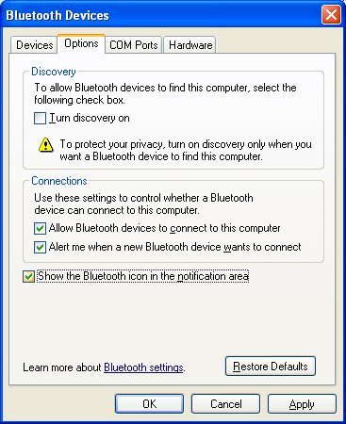

Figure 1. Control Panel Bluetooth Devices Application

**Note:** Even if no Bluetooth icon is in the notification area, you can still use the Control Panel Bluetooth Devices application to perform related tasks such as adding new Bluetooth devices, making the computer discoverable, and so on.

With the Windows Vista Feature Pack for Wireless installed, the **Show the Bluetooth icon in the notification area** check box is selected by default. Therefore, the Bluetooth icon should not disappear unless the user modifies the settings.

## Can Vendors Add Tabs to the Control Panel Bluetooth Devices Application?

Yes, by implementing a shell property sheet handler for the application. For example, IHVs that implement extensions to the in-box Bluetooth stack could implement a property sheet handler that adds tabs for profiles such as file transfer, enhancements added to version 2.1 of the Bluetooth specification, and so on. For more information on how to implement property sheet handlers, see ”Creating Property Sheet Handlers.”

## Why Does Windows Vista Display a Pop-up Message When a Bluetooth Audio Device Is Initially Connected?

Windows Vista might not provide default support for headset (HSP), hands-free (HFP), or advanced audio distribution (A2DP) audio profiles. If a Bluetooth audio device is paired with a system that does not have the necessary drivers, Windows typically displays the **Found New Hardware** dialog box. However, the dialog box might not be displayed if:

* The computer’s OEM provides a profile pack that supports Bluetooth audio.
* The end user has already installed a Bluetooth headset and downloaded the audio drivers from media that the IHV or Windows Update provided.

# Windows Logo Program

## Where Are the Windows Logo Program Requirements for Bluetooth Wireless Technology?

The Windows Logo Program specifies the requirements for hardware and software to work optimally with Windows Vista. For details about the Windows Logo Program requirements for Bluetooth radios and devices, see ”Windows Logo Program Requirements.”

## Are There New Requirements for Bluetooth Version 2.1?

Effective June 2009, the Windows Logo Program will require support for Bluetooth version 2.1. These new requirements are available for preview. Updated tests, for preview, will be released as part of the Windows Logo Kit (WLK). Passing these tests is not required until June 2009.

# Resources

For additional information on Bluetooth and Windows, see the following documents

## Windows Resources:

Additional information on Bluetooth Wireless Technology

<http://www.microsoft.com/whdc/device/network/wireless/default.mspx>

Bluetooth

<http://msdn2.microsoft.com/en-us/library/aa362932.aspx>

Control Panel Items

<http://msdn2.microsoft.com/en-us/library/bb419049.aspx>

Creating Property Sheet Handlers

<http://msdn2.microsoft.com/en-us/library/aa969349.aspx>

Microsoft OS Descriptors

<http://www.microsoft.com/whdc/device/connect/OS_Desc.mspx>

Platform SDK - Setup API

<http://msdn2.microsoft.com/en-us/library/Aa377657.aspx>

Step-by-Step Guide to Controlling Device Installation and Usage with Group Policy

<http://download.microsoft.com/download/3/b/a/3ba6d659-6e39-4cd7-b3a2-9c96482f5353/Step%20by%20Step%20Guide%20to%20Controlling%20Device%20Installation%20and%20Usage%20with%20Group%20Policy.doc>

Windows Logo Program Test Specifications, HCTs, and testing notes

<http://www.microsoft.com/whdc/whql/default.mspx>

Windows Driver Kit (WDK) - Overview

<http://www.microsoft.com/whdc/DevTools/WDK/default.mspx>

Windows Logo Program Requirements

<http://www.microsoft.com/whdc/winlogo/hwrequirements.mspx>

Windows Vista Feature Pack for Wireless

<http://www.microsoft.com/whdc/connect/wireless/FP_Wireless.mspx>

Windows Vista Logo Program: Proposed Requirements for Hardware (Systems and Devices)

<http://www.microsoft.com/whdc/winlogo/hwrequirements.mspx>

## Industry Specifications:

Bluetooth Wireless Technology Specifications

<http://www.bluetooth.org/>

# Appendix A: How to Install an In-Box Bluetooth Driver on New Hardware

This appendix describes the procedure for forcing the Bluetooth driver that is included with Windows Vista to install on a new Bluetooth radio. Windows XP SP2 uses a similar procedure, although some of the details are different.

### Step 1: Start Device Manager and Select the Bluetooth Radio

To start Device Manager:

1. Click **Start**, navigate to **All** **Programs** > **Accessories** > **Command** **Prompt**, right-click **Command** **Prompt**, and then click **Run as administrator** to open a command window with elevated privileges.

2. Type:  
 Devmgmt.msc

Find the entry for the Bluetooth radio on Device Manager’s list of devices under **Other Devices**. In Figure A-1, the radio’s name is ”UGT”. On some portable computers, you might need to first turn on the Bluetooth radio by using a key combination such as Fn+F5.

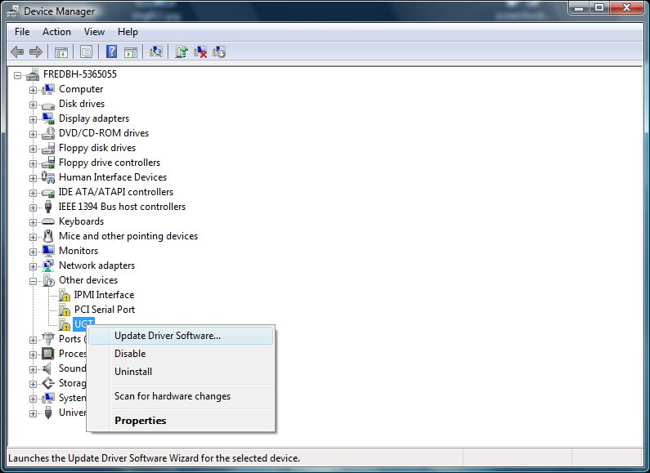

Figure A-1. Device Manager

To verify that the selected device is a Bluetooth radio, right-click the device name and then click **Properties** to display the **Properties** dialog box. On the **Details** tab, verify that the device has the compatible ID for a Bluetooth radio:   
 **USB\Class_e0&SubClass_01&Prot_01**

### Step 2: Start the Update Driver Software Wizard

Right-click the Bluetooth radio node again and then click **Update Driver Software** to start the Update Driver Software Wizard. Click **Browse my computer for driver software** to go to the page shown in Figure A-2. Click **Let me pick from a list of device drivers on my computer** to manually select a driver.

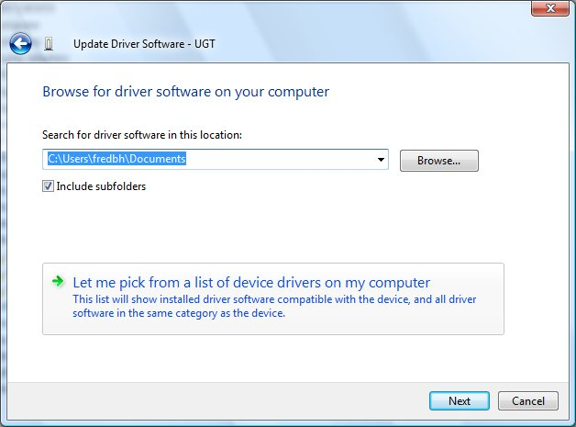

Figure A-2. Update Driver Software Wizard: Manually Install a Driver

### Step 3: Select the Generic Bluetooth Driver

The Update Driver Software Wizard next displays a list of available drivers. Select **Bluetooth Radios** and then select a Bluetooth radio that matches your system, as shown in Figure A-3. If you are not sure which driver to use, you can use the generic driver for testing. To do this, select **Generic Adapter** as manufacturer and **Generic Bluetooth Adapter** as the model.

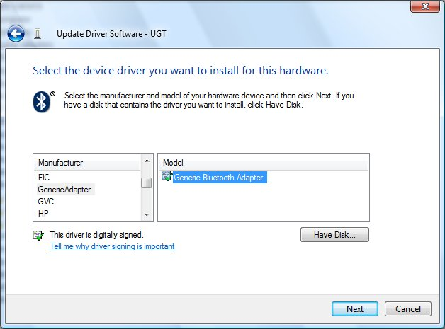

Figure A-3. Update Driver Software Wizard: Select Generic Bluetooth Driver

After you select a driver, the wizard asks you to confirm that you want to install the specified driver on the new Bluetooth radio. If you try to install a Bluetooth drivers on a device that is not a Bluetooth radio, the driver will probably not start.

If the driver loads correctly, Device Manager should have a **Generic Bluetooth Adapter** entry under the **Bluetooth Radios** node, as shown in Figure A-4.

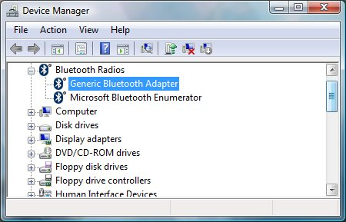

Figure A-4. Device Manager: The Newly Installed Driver

If the driver failed to start, for example, if Windows returned a start error code, examine the event log to help determine the cause.

# Appendix B: An Example of a Vendor-Provided INF

This appendix includes an example of how to implement a vendor-provided INF that references Bth.inf. This particular example is implemented to install a radio that is compatible with version 2.0 plus EDR of the Bluetooth specification. The INFs for other types of Bluetooth devices are similar. This INF can be used to install the device on the following versions of Windows:

* All SKUs of the 32-bit version of Windows XP SP2 and later service packs.
* All SKUs of the 64-bit version of Windows XP.
* All SKUs of Windows Vista.

**Note:** The INF cannot be used with Windows 2000, Windows Server 2003, or any versions of Windows XP that have not been upgraded to at least SP2.

See the numbered notes that follow the sample for an explanation of the highlighted sections and directives.

; XYZ Vendor INF File for Bluetooth Radio

;

; A sample INF for a stand-alone Bluetooth radio that does not

; have native Windows Vista support

**; [1]**

[Version]

Signature = "$Windows NT$"

Provider = %ProviderName%

Class = Bluetooth

**CLASSGUID = {e0cbf06c-cd8b-4647-bb8a-263b43f0f974};**

**DriverVer = 10/28/2006,6.0.0.0 ;**

CatalogFile.NT = BTHXYZ1.CAB

[ControlFlags]

ExcludeFromSelect=*

[SourceDisksNames]

1=%SourceDisk%,,1

[Manufacturer]

%ManufacturerName% = XYZBth,NT.5.1,NTx86,NTamd64

; Match on a hardware ID generated by the device, for x86 and x64.

**; [2]**

[ZYXBth.NT.5.1]

%BthRadio1% = Bt1.NT.5.1, USB\VID_xxxx&PID_yyyy

[ZYXBth.NTx86]

% BthRadio1% = Bt1.NT.5.1, USB\VID_xxxx&PID_yyyy

[ZYXBth.NTamd64]

% BthRadio1% = Bt1.NT.5.1, USB\VID_xxxx&PID_yyyy

; Windows XP specific sections -------------------------

**; [3]**

[Bt1.NT.5.1]

**include = bth.inf**

**needs = BthUsb.NT**

[Bt1.NT.5.1.HW]

**include = bth.inf**

**needs = BthUsb.NT.HW**

**DelReg = DeleteRegKeys**

[Bt1.NT.5.1.Services]

**include = bth.inf**

**needs = BthUsb.NT.Services**

**; [4]**

[DeleteRegKeys]

; Delete support for the Microsoft FaxService

HKLM,"SYSTEM\CurrentControlSet\Services\BTHPORT\Parameters\UnsupportedServices","{00001111-0000-1000-8000-00805f9b34fb}"

[Strings]

; While strings are localizable, in this sample INF, we have

; not created any localized strings.

ProviderName = "Vendor XYZ (c)"

ManufacturerName = "Vendor XYZ (c)"

BthRadio1 = "Bluetooth 2.0+EDR Model 3.2 from XYZ (c)"

SourceDisk = "Windows Vista CD"

**Notes:**

1. The **Version** section should have the **CLASSGUID** and **DriverVer** directives set as follows:

**CLASSGUID**. Use the Microsoft class GUID for Bluetooth devices ({e0cbf06c-cd8b-4647-bb8a-263b43f0f974}), not a third-party GUID.

DriverVer: If you want to supersede the default in-box driver, the driver version must be set to provide a higher ranking match than what is in Bth.inf.

2. Hardware IDs. The combination of vendor identifier (VID) and product identifier (PID) must be unique to the manufacturer and device. This ensures that the same hardware ID does not correspond to multiple names and settings.

3. **Include** and **Needs** directives. The **Include** directives in these three sections reference Bth.inf. The **Needs** directives indicate which sections from Bth.inf should be processed during device installation.

4. The **DelReg** directive, which references the **DeleteRegKeys** section, deletes registry keys or values that prevent Windows from creating a PDO or devnode for a device. For example, the fax service profile is currently on the Windows Vista list of unsupported services, so it is a value of the **UnsupportedServices** registry key. This example deletes the fax services profile from the **UnsupportedServices** key, which lets Windows create a devnode for the device.

We strongly recommend that you run the latest WHQL tests on the device and INF and push the INF package to Windows Update. This ensures that customers can automatically download the INF from the Internet when they connect their new radio to their computer.