Windows 7 Brightness Control for Integrated Displays

January 9, 2009

Abstract

This paper provides information about integrated display brightness control for the Windows® family of operating systems. It provides guidelines for system manufacturers and firmware developers to expose brightness control infrastructure to Windows. The new brightness control user experiences for Windows 7 are discussed. Additionally, this paper provides power policy configuration information, including new policies for the adaptive display brightness feature and information on how to observe brightness control changes by using the PwrTest utility.

This information applies to the Windows 7 operating system.

References and resources discussed here are listed at the end of this paper.

For the latest information, see:   
 <http://www.microsoft.com/whdc/system/pnppwr/powermgmt/BrightnessCtrl.mspx>

Disclaimer: This is a preliminary document and may be changed substantially prior to final commercial release of the software described herein.

The information contained in this document represents the current view of Microsoft Corporation on the issues discussed as of the date of publication. Because Microsoft must respond to changing market conditions, it should not be interpreted to be a commitment on the part of Microsoft, and Microsoft cannot guarantee the accuracy of any information presented after the date of publication.

This White Paper is for informational purposes only. MICROSOFT MAKES NO WARRANTIES, EXPRESS, IMPLIED OR STATUTORY, AS TO THE INFORMATION IN THIS DOCUMENT.

Complying with all applicable copyright laws is the responsibility of the user. Without limiting the rights under copyright, no part of this document may be reproduced, stored in or introduced into a retrieval system, or transmitted in any form or by any means (electronic, mechanical, photocopying, recording, or otherwise), or for any purpose, without the express written permission of Microsoft Corporation.

Microsoft may have patents, patent applications, trademarks, copyrights, or other intellectual property rights covering subject matter in this document. Except as expressly provided in any written license agreement from Microsoft, the furnishing of this document does not give you any license to these patents, trademarks, copyrights, or other intellectual property.

Unless otherwise noted, the example companies, organizations, products, domain names, e-mail addresses, logos, people, places and events depicted herein are fictitious, and no association with any real company, organization, product, domain name, email address, logo, person, place or event is intended or should be inferred.

© 2009 Microsoft Corporation. All rights reserved.

Microsoft, Windows, Windows Server, Windows Vista, and PowerPoint are either registered trademarks or trademarks of Microsoft Corporation in the United States and/or other countries.

The names of actual companies and products mentioned herein may be the trademarks of their respective owners.

Document History

|  |  |  |  |  |
| --- | --- | --- | --- | --- |
| Date | Change |  |  |  |
| January 9, 2009 | First publication | | | |

Contents

Introduction 4

Brightness Control User Experiences 4

Power Options 5

Windows Mobility Center 8

Hardware Hot Keys 8

Battery Meter Brightness Warnings 9

Brightness Control Platform Infrastructure 9

ACPI-Based Brightness Control Interface 9

WDDM Driver DDI Brightness Control Interface 10

Hot Key Integration 11

Fading Transitions 11

Brightness Control Policies and Actions 12

Default Display Brightness Policies 12

Adaptive Display Brightness Policies 12

Advanced Adaptive Display Brightness Policies 13

Best Practices for Brightness Control Policy Configuration 14

Best Practices for Software Developers 15

Integration with Ambient Light Sensor Devices 15

Validation of Platform Brightness Control 15

The PwrTest MONITOR Scenario 15

Observation of Brightness Level Changes with the MONITOR Scenario 16

Call to Action 18

Resources 19

# Introduction

During ordinary use, the integrated display in most portable computers is the greatest consumer of power. To reduce power consumption and extend battery life, Windows® provides an infrastructure for controlling the brightness of the display.

Windows 7 simplifies the user experience for brightness control and configuration. Brightness controls are available in the Windows Mobility Center, the Control Panel **Power Options** application, and hot keys on the system keyboard. User adjustments to the brightness level are now applied to the current power policy, which preserves the user’s brightness level adjustment across sleep, resume, shutdown, and restart transitions. After a period of user inactivity, the display brightness automatically dims to help extend battery life.

Windows supports two ways to integrate brightness control: Windows Display Driver Model (WDDM) miniport device driver interfaces (DDIs) and Advanced Configuration and Power Interface (ACPI) firmware control methods. ACPI control methods are the preferred implementation solution for new platforms. The underlying brightness control infrastructure is configured by using power policy settings. System manufacturers can customize these settings based on the target platforms or display technologies.

System manufacturers and firmware developers should review this paper for details on the Windows brightness control infrastructure, new user experiences, and power policy configuration details for display brightness.

# Brightness Control User Experiences

Windows 7 improves the brightness control configuration user experience by simplifying the interaction between the various methods to set the display brightness. Adjustments to the display brightness that a user makes through Windows Mobility Center or keyboard hot keys now persist across system power-state transitions (standby and resume). A user can also easily adjust the display brightness level by using a new slider control in the Control Panel **Power Options** application. If the display brightness is set to a level that is greater than the default display brightness of the **On battery** policy for the active power plan, a warning appears in the battery meter to advise the user of the effect of the display brightness setting on the battery life of a portable computer.

## Power Options

The Control Panel **Power Options** application is the user’s primary interaction point for setting the display brightness. In Windows 7, a **Display brightness** adjustment slider is now available at the bottom of **Power** **Options**, as shown in Figure 1.

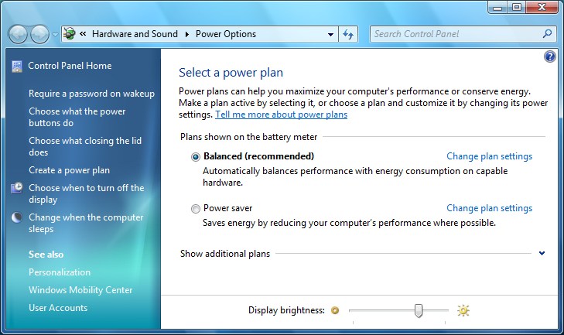

Figure 1. The Control Panel Power Options application

The **Display brightness** adjustment slider sets the brightness level for the current power plan.

Similar to Windows Vista®, in Windows 7 users can set the default brightness both for when the computer is running **On battery** and when it is **Plugged in** for each power plan. This functionality is available in **Power Options** by clicking **Change plan settings** for one of the power plans. This displays the **Edit plan settings** page, as shown in Figure 2.

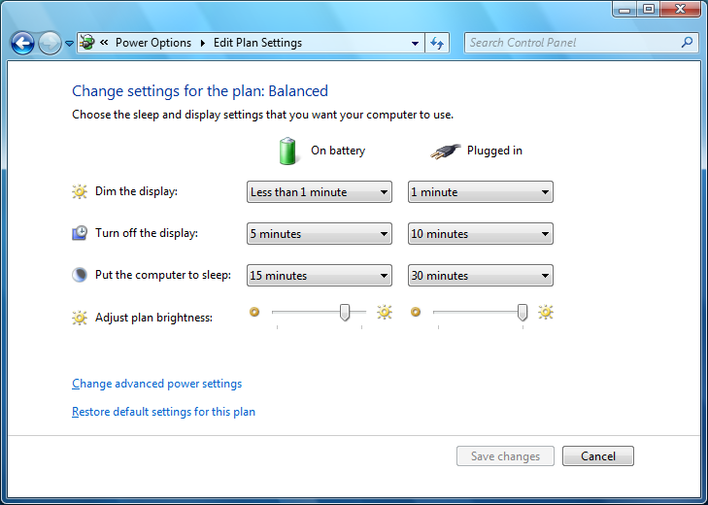

Figure 2. The Edit plan settings page in Power Options

New for Windows 7 are controls to configure adaptive display brightness. These controls set the amount of idle time after which Windows automatically reduces the display brightness to a lower brightness level to save power. These controls are available in the **Advanced settings** dialog box, which users can open by clicking the **Change advanced power settings** link on the **Edit** **plan settings** page. The adaptive display brightness controls are under the **Display**node, as shown in Figure 3.

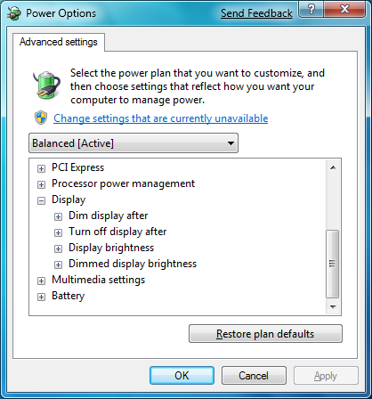

Figure 3. Power Options Advanced settings dialog box

## Windows Mobility Center

For Windows 7, the **Display brightness** slider remains in **Windows Mobility Center**, as shown in Figure 4. Users can access **Windows Mobility Center** from the battery meter icon shortcut menu or by pressing the  +X shortcut key.

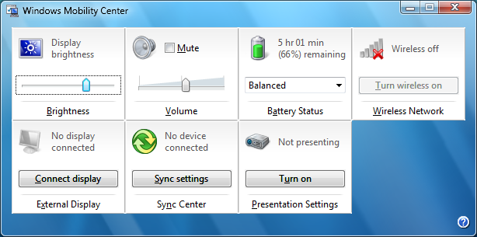

Figure 4. Windows Mobility Center

In earlier versions of Windows, if users adjusted the display brightness through the **Windows Mobility Center**, that setting was in effect only until the system changed its power source (switched between running on battery and being plugged in) or until the system changed its power state (sleep or restart). This behavior is different in Windows 7. If users adjust the display brightness through **Windows Mobility Center**, the new brightness level is applied to the current power policy. Therefore, when the system sleeps, resumes, or restarts, the display continues to use the same brightness level that the user set.

## Hardware Hot Keys

Many portable computers include hardware buttons or hot keys for changing the display brightness. Typically, users access these hot keys by pressing a function (Fn) button in combination with another key on the keyboard.

Similar to the update to **Windows Mobility Center**, if the user adjusts the display brightness by using hot keys in Windows 7, the new brightness level is applied to the current power policy. For example, if the user changes the display brightness to 80 percent by using the hot keys, the 80-percent setting is stored as either the **On battery** or **Plugged in** brightness level value in the current power plan, depending on whether the system is running on battery or is plugged in at the time that the user changes the display brightness.

## Battery Meter Brightness Warnings

In Windows 7, the battery meter displays a warning if the system is operating on battery and the display brightness is set to a level that is greater than the default display brightness of the battery policy for the active power plan, as shown in Figure 5. This warning helps users understand that reducing the display brightness is a simple step to extend the battery life of a portable computer.

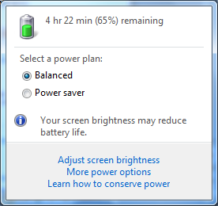

Figure 5. Battery meter brightness level warning

System manufacturers can adjust the default values for the display brightness policy for their systems to target the many display types and brightness levels in the Windows ecosystem. The display brightness warning is based on the default value of the **On battery**display brightness policy in the current power plan. If a system manufacturer does not customize the default values for the display brightness policy, the default value for the **On battery**display brightness is 30 percent.

# Brightness Control Platform Infrastructure

Any platform that exposes display brightness control functionality through a method that is compatible with Windows Vista is also compatible with Windows 7. A platform exposes its display brightness control functionality by using either ACPI control methods or WDDM miniport DDIs. We recommend that system manufacturers use ACPI control methods and that they support a minimum of 25 discrete display brightness levels.

The rest of this section of this paper summarizes the platform driver and firmware requirements for supporting brightness control functionality. For more information, see “Brightness Control in WDDM”on the WHDC Web site.

## ACPI-Based Brightness Control Interface

System manufacturers should expose brightness control functionality by using the ACPI control methods under the output device for the integrated display. The brightness control methods can be applied to portable computers and all‑in‑one desktop systems that have an integrated display. For more information about ACPI brightness control methods, see Appendix B in the ACPI specification.

The firmware must support all the ACPI brightness control methods in Table 1.

Table 1. ACPI Brightness Control Methods

|  |  |
| --- | --- |
| Method name | Description |
| _BQC | Enables the operating system to query the current display brightness level. |
| _BCL | Enumerates a list of supported brightness levels in units of percentage of maximum brightness. |
| _BCM | Enables the operating system to set the display brightness level. |

The _BCL control method returns a list of the supported brightness levels in units of the percentage of the maximum brightness and the firmware-provided default values for the display brightness when the system is running on battery and is plugged-in. Note that Windows ignores the firmware-provided default values and, without system manufacturer customization of the power policy, uses a **Plugged in** default value of 100 percent and an **On battery** default value of 30 percent.

We recommend that firmware developers support at least 25 discrete display brightness levels in the _BCL control method. Additional brightness levels help provide an optimal user experience if the user adjusts the display brightness by using the Windows Mobility Center slider and if the user has a system that is equipped with an ambient light sensor (ALS) device.

## WDDM Driver DDI Brightness Control Interface

Brightness controls are implemented in the monitor driver—Monitor.sys—that is included with Windows. The Windows monitor driver calls the display miniport driver's DxgkDdiQueryInterface function for the first video target in the system that is identified as having output technology that connects to an internal display device. This video target has the **InterfaceTechnology** member of the DXGK_VIDEO_OUTPUT_CAPABILITIES structure set to D3DKMDT_VOT_INTERNAL. This call queries for the brightness control interface that is identified by GUID_DEVINTERFACE_BRIGHTNESS and DXGK_BRIGHTNESS_INTERFACE_VERSION_1.

WDDM miniport drivers that expose brightness control functionality by using the GUID_DEVINTERFACE_BRIGHTNESS interface should support a minimum of 25 discrete display brightness levels. These levels let users smoothly adjust the display brightness by using slider controls and provides fine-grained adjustment for platforms that are equipped with an ALS device.

If the WDDM miniport driver does not support the brightness control interface, the monitor driver uses the ACPI control methods—_BCL, _BCM, and _BQC—if they are exposed by the platform firmware.

To avoid problems that might occur if both the system firmware and the monitor driver control the brightness of the display, the display miniport driver should set bit 2 of the argument to the _DOS method. Setting this bit notifies the system firmware that it should not perform any automatic display brightness changes. The WDDM driver must set this particular bit because it controls the _DOS method. The other bits in the _DOS method control the behavior of the firmware in response to the display switch hot keys.

## Hot Key Integration

Brightness control hot keys on the keyboard must be implemented by using ACPI notifications. These notifications are targeted to the integrated display device, not to the graphics adapter.

Windows supports the following ACPI notifications for keyboard hot key implementations:

#define ACPI_NOTIFY_CYCLE_BRIGHTNESS_HOTKEY 0x85  
#define ACPI_NOTIFY_INC_BRIGHTNESS_HOTKEY   0x86  
#define ACPI_NOTIFY_DEC_BRIGHTNESS_HOTKEY   0x87  
#define ACPI_NOTIFY_ZERO_BRIGHTNESS_HOTKEY 0x88

These notifications are described in the ACPI specification, version 3.0 and later versions. Typically, an implementation does not support all four of these notifications. Only the ACPI_NOTIFY_INC_BRIGHTNESS_HOTKEY and APCI_NOTIFY_DEC_BRIGHTNESS_HOTKEY notifications are usually supported. A platform can support a **Brightness Up** and a **Brightness Down** pair of hot keys with these two ACPI notifications.

The default behavior of the monitor driver in response to the ACPI_NOTIFY_INC_BRIGHTNESS_HOTKEY and ACPI_NOTIFY_DEC_BRIGHTNESS_HOTKEY notifications is to increase or decrease the display brightness level by at least 5 percent until the next available 5‑percent increment is reached (for example, 5, 10, 15, ..., 95, 100).

## Fading Transitions

Platforms that implement brightness control can implement a fade or a smooth transition between brightness levels. For example, because of user inactivity the display might be dimmed to 30 percent of the maximum brightness and then immediately increase to 100-percent brightness when it detects user input. To fade between the 30-percent and 100-percent brightness levels, the platform could change the display brightness to each intermediate brightness level (35, 40, 45, … 85, 90, and 95 percent), pausing at each intermediate brightness level for a very short amount of time, such as 20 milliseconds (ms). The result is a smooth transition in display brightness that is less jarring to the user, especially if the system is in an environment that has little ambient light.

Platforms that support fading between brightness levels must implement this feature in the platform's embedded controller. Platforms should not use the ACPI control methods that run on the main system processor to implement this feature. Using the embedded controller guarantees that the process of stepping through each intermediate brightness level is performed in real-time. Also, the embedded controller consumes much less power than the main system processor.

Platforms that implement fading between brightness levels should ensure that the duration of any Windows-directed brightness level change is less than 500 ms. The platform can choose to fade a brightness level transition only if the target brightness is sufficiently different from the current brightness. For example, a fade might be appropriate for a transition from 30 to 90 percent, but not for a transition from 75 to 65 percent.

# Brightness Control Policies and Actions

The configuration of the brightness control policies is performed through updates to the Windows power policy. The Windows power policy includes the default display brightness when the system is plugged in and when it is running on battery, and the adaptive display brightness time-out after which Windows automatically reduces the display brightness to save power.

System manufacturers should understand the brightness control policies for Windows 7 and customize them as appropriate for their platforms.

## Default Display Brightness Policies

The default display brightness is configured as a power policy setting with an **On battery** and **Plugged in**brightness level, which is described in Table 2. Each time that the user changes the display brightness by using the keyboard hot keys or a brightness slider, the display brightness policy setting is updated for the current power source (such as **On battery**) for the current power plan (such as **Balanced**).

Table 2. Display Brightness Level Setting

|  |  |
| --- | --- |
| Description | Default display brightness level. This setting applies only to portable computers that support Windows control of the brightness level of an integrated display device. |
| GUID | aded5e82-b909-4619-9949-f5d71dac0bcb |
| PowerCfg Alias | VIDEONORMALLEVEL (Windows 7 and later versions of Windows) |
| Minimum Value | 0 |
| Maximum Value | 100 |
| Label | Percentage (%) |
| Hidden | No |
| Operating System Versions | Available in Windows Vista and later versions of Windows. |

## Adaptive Display Brightness Policies

Beginning with Windows 7, the adaptive display brightness feature automatically reduces the brightness level of an integrated display after a period of user inactivity. Like the default display brightness policy, the functionality of this feature is also configured as a set of power policy settings.

The primary power policy setting for adaptive display brightness is the dim idle time‑out setting, which is described in Table 3. This setting configures the amount of time of user inactivity after which the system automatically reduces the display brightness level.

Table 3. Dim Idle Time-Out Setting

|  |  |
| --- | --- |
| Description | The period of inactivity before the display brightness is automatically reduced. This setting applies only to portable computers that support Windows control of the brightness level of an integrated display device. |
| GUID | 17aaa29b-8b43-4b94-aafe-35f64daaf1ee |
| PowerCfg Alias | VIDEODIM |
| Minimum Value | 0 (never automatically reduce display brightness) |
| Maximum Value | Maximum Integer |
| Label | Seconds |
| Hidden | No |
| Operating System Versions | Available in Windows 7 and later versions of Windows. |

Adaptive display brightness automatically extends dim idle time-out based on user input activity. For example, if the display brightness level is dimmed because of user inactivity but user input is detected within 5 seconds of the brightness level transition, dim idle time-out period automatically doubles. The adjusted time-out value can be extended up to the display power-off time-out. The adjusted time-out value is temporary. It is automatically reset back to the dim idle time-out setting that is specified in the power policy after a successful dim transition in which no user input is detected immediately following the transition.

When the dim idle time-out expires, Windows changes the display brightness to the dim display brightness level setting, which is described in Table 4. By default, this level is set to 30 percent when the system is running either on battery or plugged in. The system manufacturer should customize these default values based on the system's display technology and relative brightness levels.

Table 4. Dim Display Brightness Setting

|  |  |
| --- | --- |
| Description | Reduced display brightness level after the dim idle time-out has been reached. This setting applies only to portable computers that support Windows control of the brightness level of an integrated display device. |
| GUID | f1fbfde2-a960-4165-9f88-50667911ce96 |
| PowerCfg Alias | VIDEODIMLEVEL |
| Minimum Value | 0 |
| Maximum Value | 100 |
| Label | % (Percentage) |
| Hidden | No |
| Operating System Versions | Available in Windows 7 and later versions of Windows. |

## Advanced Adaptive Display Brightness Policies

The power policies described in Tables 5 and 6 configure advanced power policy settings for the adaptive display brightness feature. For most systems and user experiences, the system manufacturers are not required to customize these settings and should not change them from the default values without extensive testing and user feedback.

Table 5. Dim Adaptive Increase Percentage Setting

|  |  |
| --- | --- |
| Description | The percentage of the dim idle time-out value by which to automatically increase the dim idle time-out value if user annoyance is detected. This setting applies only to portable computers that support Windows control of the brightness level of an integrated display device. Usually, this setting should not be changed from the default value. |
| GUID | eed904df-b142-4183-b10b-5a1197a37864 |
| PowerCfg Alias | Not applicable |
| Minimum Value | 0 (do not automatically extend the dim idle time-out when user annoyance is detected) |
| Maximum Value | 100 |
| Label | % (Percentage) |
| Hidden | Yes |
| Operating System Versions | Available in Windows 7 and later versions of Windows. |

Table 6. Dim Annoyance Time-Out Setting

|  |  |
| --- | --- |
| Description | The user annoyance detection threshold. This setting specifies the duration between automatic display brightness level reduction and user input to consider the automatic display brightness level reduction as an annoyance to the user. This setting applies only to portable computers that support Windows control of the brightness level of an integrated display device. Usually, this setting should not be changed from the default value. |
| GUID | 82dbcf2d-cd67-40c5-bfdc-9f1a5ccd4663 |
| PowerCfg Alias | Not applicable |
| Minimum Value | 0 (do not detect user annoyance) |
| Maximum Value | Maximum Integer |
| Label | Seconds |
| Hidden | Yes |
| Operating System Versions | Available in Windows 7 and later versions of Windows. |

# Best Practices for Brightness Control Policy Configuration

We recommend that system manufacturers customize several of the brightness control power policies for individual systems. This customization is required because display technologies and their relative brightness levels vary widely across the Windows ecosystem.

System manufacturers should review the following guidelines for tailoring the brightness control power policies to individual systems.

* Reduce the dim idle time-out setting.

Ultramobile and small form factor mobile systems can benefit from increased power savings by reducing the dim idle time-out setting. We recommend that the dim idle time-out be a minimum of 30 seconds.

* Adjust the dim display brightness level setting.

The brightness range of an integrated display on a portable computer may vary widely based on size, display technology, and platform. The dim display brightness level setting should be adjusted from the 30-percent default value to a value that is suitable for the target platform. The value should be bright enough that the user can still view status updates on the display, such as notifications of new e-mail messages.

Adjusting the dim display brightness level setting is important because users cannot easily adjust this setting in the Control Panel **Power Options** application. The dim display brightness level should be the same value when the system is either running on battery or plugged in.

* Adjust the default display brightness level setting when the computer is running on battery**.**

Similar to dim display brightness level, the default display brightness level when running on battery might require adjustment based on the display technology and platform.

Generally, the default **Plugged in**display brightness level setting should be a value that is greater than the default **On battery** display brightness level setting. Similarly, the default **On battery** display brightness level setting should be greater than the dim display brightness level setting.

# Best Practices for Software Developers

In Windows Vista and earlier versions of Windows, APIs are provided to enable applications to control the display brightness level. System manufacturers typically use these APIs to enable value-added extensions for controlling the display brightness level on systems where the keyboard hot keys are not implemented using ACPI notifications.

We recommend that software developers do not use the existing Windows Management Instrumentation (WMI) APIs or legacy video driver I/O controls (IOCTLs) to change the display brightness level. Windows 7 supports adjusting the display brightness level based on the dim idle time-out setting to save power. Applications could unintentionally interfere with the adaptive display brightness feature, which results in a poor user experience.

If an application must adjust the display brightness level to provide an additional display brightness control interface such as a slider control, the application should adjust the current power policy settings. The application should first determine the current system power source and current power plan. Then, using this information, the application can change the display brightness level by calling either the **PowerWriteACValueIndex**or **PowerWriteDCValueIndex**function, as appropriate. For more information, see the documentation for these functions on the Microsoft Developer Network (MSDN) Web site.

# Integration with Ambient Light Sensor Devices

Beginning with Windows 7, Windows provides native support for ALS devices through the Windows Sensor and Location Platform feature.

If a platform includes ALS hardware, we recommend that system manufacturers expose the ALS as an ACPI device, compliant with the ACPI ALS methods that are described in the ACPI specification, version 3.0 and later versions.

For more information about Windows support for ACPI ALS devices, see ”Integrating Ambient Light Sensors with Windows 7 Computers.“

# Validation of Platform Brightness Control

System manufacturers and firmware developers can validate the brightness control support on a platform by using the PwrTest utility that is included in the Windows Driver Kit (WDK). Use PwrTest to observe display brightness level transitions and power management idle detection.

## The PwrTest MONITOR Scenario

The PwrTest utility supports various scenarios for power management testing and validation. New for the Windows 7 version of PwrTest is the MONITOR scenario, through which you can view display power management idle detection, brightness control policy changes, and display brightness level changes.

To start the MONITOR scenario, run the **pwrtest /monitor** command at an elevated command prompt:

C:\pwrtest>pwrtest /monitor

Waiting for Monitor Power Events

Will run for 30 minutes. Press 'q' anytime to quit...

Timestamp Session Info

-------------------------------------------------------------------------------

07:41:09 1 Screen Saver Timeout: 900 seconds

07:41:09 1 Blank Timeout: 300 seconds

07:41:09 1 Dim Timeout: 60 seconds

07:41:09 1 Dim Brightness: 30%

07:41:09 1 Normal Monitor Brightness: 70%

07:41:09 1 Idle Reset

07:41:14 1 Idle: 5 seconds

07:41:18 1 Idle: 10 seconds

07:41:23 1 Idle: 15 seconds

The MONITOR scenario runs for a default of 30 minutes. It can be stopped at any time by pressing the Q key. The MONITOR scenario generates an XML log file that is named “PwrTestLog.XML”in the same directory as the PwrTest utility. The XML log file contains the same information that appears in the console window.

You can specify the duration that the MONITOR scenario runs with the /t parameter. For example, the following MONITOR scenario executes for 10 minutes:

C:\pwrtest>pwrtest /monitor /t:10

Waiting for Monitor Power Events

Will run for 10 minutes. Press 'q' anytime to quit...

Timestamp Session Info

-------------------------------------------------------------------------------

07:41:09 1 Screen Saver Timeout: 900 seconds

## Observation of Brightness Level Changes with the MONITOR Scenario

The MONITOR scenario displays how much user idle time was detected, any updates to the brightness control power policies, and changes to the display brightness level.

For example, if a user presses a brightness control hot key on the keyboard , the MONITOR scenario displays a change in the display brightness level. The following appears when the user presses the brightness up hot key, which results in a change to the display brightness level from 70 to 80 percent:

07:46:55 console Physical Monitor Brightness Changed: 70% -> 80%

Similarly, a “Physical Monitor Brightness Changed” message appears if the user adjusts the **Display brightness** slider in **Windows Mobility Center** or the Control Panel **Power Options** application.

At the beginning of the MONITOR scenario, the console window displays the current brightness control power policies. These are the current policies that are based on the current power source (**On battery** or **Plugged in**). Each policy is updated in the console window if the power source is changed during the MONITOR scenario and the **On-battery** and **Plugged in** brightness level setting values are different for the current power plan.

In the following example, the screen saver time-out is set to 15 minutes (900 seconds), the display off time-out is set to 5 minutes (300 seconds), and the display dim time-out is set to 1 minute (60 seconds). In addition, the default brightness level for the current power source is 80 percent and the brightness level when the idle time exceeds the dim time-out is 30 percent:

C:\pwrtest>pwrtest /monitor /t:10

Waiting for Monitor Power Events

Will run for 10 minutes. Press 'q' anytime to quit...

Timestamp Session Info

-------------------------------------------------------------------------------

07:50:28 1 Screen Saver Timeout: 900 seconds

07:50:28 1 Blank Timeout: 300 seconds

07:50:28 1 Dim Timeout: 60 seconds

07:50:28 1 Dim Brightness: 30%

07:50:28 1 Normal Monitor Brightness: 80%

In addition to displaying policy changes and brightness level changes, the MONITOR scenario also displays how much user idle time has accrued on the system. This value validates that the system is correctly accruing idle time and that it will correctly dim or power off the display when the idle time exceeds the current policy time-out.

In the following example, the system has currently accrued 30 seconds of idle time. The display brightness level was reduced after being idle for 10 seconds, when it reached the dim policy time-out:

C:\pwrtest>pwrtest /monitor

Waiting for Monitor Power Events

Will run for 30 minutes. Press 'q' anytime to quit...

Timestamp Session Info

-------------------------------------------------------------------------------

08:01:12 1 Screen Saver Timeout: 900 seconds

08:01:12 1 Blank Timeout: 300 seconds

08:01:12 1 Dim Timeout: 10 seconds

08:01:12 1 Dim Brightness: 30%

08:01:12 1 Normal Monitor Brightness: 80%

08:01:12 1 Idle: 1 seconds

08:01:16 1 Idle: 5 seconds

08:01:21 console Physical Monitor Brightness Changed: 100% -> 30%

08:01:21 1 Idle: 10 seconds

08:01:21 1 Physical Monitor State: On -> Dim

08:01:26 1 Idle: 15 seconds

08:01:31 1 Idle: 20 seconds

08:01:36 1 Idle: 25 seconds

08:01:41 1 Idle: 30 seconds

When you view the idle time accounting that appears in the MONITOR scenario, it is useful to determine whether any applications have made a display availability request. Display availability requests prevent the display from dimming or powering off when the idle time exceeds the current policy time-out. Certain applications use display availability requests to keep the display on, such as when watching a full-screen DVD movie or when displaying a slide presentation.

Display availability requests can be displayed by using the PowerCfg utility that is included with Windows, specifying the /REQUESTS parameter. In the following example, the Microsoft® PowerPoint® presentation graphics program prevents display power management and the system from idling to sleep because of a slide presentation that is currently being shown:

C:\pwrtest>powercfg /requests

DISPLAY:

[PROCESS] POWERPNT.EXE

SYSTEM:

[PROCESS] POWERPNT.EXE

AWAYMODE:

C:\pwrtest>

# Call to Action

The display in a modern portable computer is often one of the greatest consumers of power. To help reduce that power consumption, Windows provides a rich infrastructure to automatically reduce the display brightness based on user inactivity or ambient lighting conditions.

We recommend that system manufacturers and firmware developers abide by the following guidelines when they develop Windows 7 platforms that include display brightness control features:

* Expose the display brightness control by using the ACPI control methods.

Platforms should expose display brightness control functionality to Windows by using the ACPI‑specified control methods and should expose a minimum of 25 discrete brightness levels. System manufacturers should also implement hardware brightness control hot keys as ACPI notifications to the integrated display output device.

* Fade the brightness transitions for improved user experiences.

Optionally, the platform firmware and embedded controller can fade the transitions between brightness levels to provide a smooth transition experience for the user.

* Customize the brightness control power policies.

System manufacturers should customize the brightness control power policies, including the default brightness levels and the dim brightness level, for target platforms and varying display technologies.

* Integrate ACPI-compatible ALS devices.

Platforms with ALS devices should expose them to Windows by using ACPI control methods to take advantage of native Windows support for ALS sensors. This enables Windows to automatically adjust the display brightness level based on the ambient lighting conditions.

* Validate brightness control by using the PwrTest Utility.

The PwrTest MONITOR scenario validates brightness control and display power management transitions on development platforms.

# Resources

Brightness Control in WDDM

<http://www.microsoft.com/whdc/device/display/aero/brightness.mspx>

Advanced Configuration and Power Interface Specification

<http://www.acpi.info>

Integrating Ambient Light Sensors with Windows 7 Computers

<http://www.microsoft.com/whdc/device/sensors/default.mspx>

PowerWriteACValueIndex

<http://msdn.microsoft.com/en-us/library/aa372765.aspx>

PowerWriteDCValueIndex

<http://msdn.microsoft.com/en-us/library/aa372769.aspx>