

Terminal Services Scaling and Performance on x64-Based Versions of Windows Server 2003
Microsoft Corporation
Published: December 20, 2005
Authors: Costin Hagiu, Dionysia Sofos, Tessa Wooley

Abstract
This white paper contains results, analyses, and sizing guidelines for Microsoft Windows Server™ 2003 Terminal Server when it is running on an x64-based version of Windows Server 2003. Hewlett Packard worked in cooperation with Microsoft to perform the initial sizing tests and data collection in the Microsoft Enterprise Engineering Center in Redmond, Washington.

The information contained in this document represents the current view of Microsoft Corporation on the issues discussed as of the date of publication. Because Microsoft must respond to changing market conditions, it should not be interpreted to be a commitment on the part of Microsoft, and Microsoft cannot guarantee the accuracy of any information presented after the date of publication.

This White Paper is for informational purposes only. MICROSOFT MAKES NO WARRANTIES, EXPRESS, IMPLIED OR STATUTORY, AS TO THE INFORMATION IN THIS DOCUMENT.

Complying with all applicable copyright laws is the responsibility of the user. Without limiting the rights under copyright, no part of this document may be reproduced, stored in or introduced into a retrieval system, or transmitted in any form or by any means (electronic, mechanical, photocopying, recording, or otherwise), or for any purpose, without the express written permission of Microsoft Corporation.

Microsoft may have patents, patent applications, trademarks, copyrights, or other intellectual property rights covering subject matter in this document. Except as expressly provided in any written license agreement from Microsoft, the furnishing of this document does not give you any license to these patents, trademarks, copyrights, or other intellectual property.

© 2005 Microsoft Corporation. All rights reserved.

Microsoft, MS-DOS, Windows, Windows Server, and Windows Vista are either registered trademarks or trademarks of Microsoft Corporation in the United States and/or other countries.

All other trademarks are property of their respective owners.

Contents
Terminal Services Scaling and Performance on x64-Based Versions of Windows Server 2003 5
Executive Summary 5
Introduction and Test Scenario 6
Results 6
Analysis 8
Overview 8
Kernel Virtual Address Space Impact 9
Effects of kernel virtual address space size limitations on x86-based systems 10
Effects of increased kernel virtual address space size on x64-based systems 10
CPU Impact 12
Memory Impact 13
Disk I/O Impact 16
Recommendations 17
Planning new x64-based deployments: 17
Planning for upgrades 18
See Also 18

Terminal Services Scaling and Performance on x64-Based Versions of Windows Server 2003

Executive Summary
This white paper explores the potential impact of the new x64-based versions of Microsoft Windows Server 2003 on Terminal Services deployments.
• The 64-bit architecture removes kernel virtual address space limitations that affect the number of sessions that are supported by the operating system in the 32-bit architecture. On a 32-bit system there is an effective limit of 300 user sessions for typical Knowledge Worker scenarios. (The actual user session limit is affected by the number of applications running in the session, resource consumption by each application, and user activity patterns.) On a 64-bit system, the theoretical user session limit is much higher.
• The low overhead in terms of CPU consumption in the x64 architecture makes it possible for Terminal Services deployments to take advantage of the new generation of high performance 64-bit CPUs (specifically the multi-core configurations) to support a larger number of users on a single server. Synthetic benchmark results were able to support as many as 600 users on a single server. This is well beyond the 32-bit architectural limitations.
• Migrating from 32-bit to 64-bit systems while deploying the same set of 32-bit applications requires special attention to memory configuration. (The Knowledge Worker workload test on 64-bit systems required between 1.5 to 2 times more RAM to perform at similar levels with the 32-bit systems.)
• Configurations with a large number of users typically require non-trivial storage support (more than the commonly-used one to two SCSI hard disks for system binaries and application data) that can handle a high level of disk I/O activity from both the operating system and from applications.

Introduction and Test Scenario
Microsoft Windows Server™ 2003 Terminal Server lets users run Microsoft Windows®-based applications on a remote computer that is running one of the Windows Server 2003 family of operating systems. This white paper contains results, analyses, and sizing guidelines for Terminal Services on x64-based versions of Windows Server 2003. Hewlett Packard worked in cooperation with Microsoft to perform the initial sizing tests and data collection in the Microsoft Enterprise Engineering Center in Redmond, Washington. The tests were performed using Microsoft Windows Server 2003, Enterprise x64 Edition and Windows Server 2003, Enterprise Edition with Service Pack 1 (SP1).
The results described in this white paper are based on the same scenarios that are described in the Windows Server 2003 Terminal Server Capacity and Scaling white paper, with the following modifications:
• The registry setting that is used to determine how often Microsoft Outlook does connection polling was changed to a large time interval. See "How to increase the number of Outlook 2003 clients that your Windows Server 2003 x64-based terminal server can support".
• Printing was handled by a set of remote printers that were installed on the same server that hosted Microsoft Exchange Server and Microsoft Internet Information Services (IIS), instead of by a local printer. This change was necessary to accommodate the high level of printing-related activity generated on the high-end systems and to increase the real-world likeliness of the scenario.
• Web site content used for the Microsoft Internet Explorer segment of the scenario was enhanced to be more realistic.
• Roaming user profiles were used for simulated users.
The goals of this analysis were to:
• Evaluate the impact of using the x64-based versions of the Windows Server 2003 operating system in Terminal Services deployment scenarios.
• Provide a limited comparison to the previously released Windows Server 2003 32-bit scaling information.

Results
The tests conducted for this analysis used the Knowledge Worker workload as described in the Windows Server 2003 Terminal Server Capacity and Scaling white paper, with the modifications mentioned in the preceding section of this white paper. For each server configuration, two different tests were conducted. Both tests used identical hardware configurations and applications, but different operating systems (32-bit Windows Server 2003 Enterprise Edition with SP1 and 64-bit Windows Server 2003, Enterprise x64 Edition).
Table 1: Server configuration and number of users supported

Server Model | CPU | RAM | Users (KW) on x86 | Users (KW) on x64
HP DL 385 | 2 x AMD Opteron | 16 GB | 2401 (2802) | 2401 (2602)
HP DL 585 | 4 x AMD Opteron | 32 GB | 2403 | 3802
HP DL 585 | 4 x AMD Opteron dual-core | 32 GB | 2303 (2703,4) | 6202

1Disk I/O limited
2CPU limited
3Kernel virtual address limited
4When system was configured with 8 GB RAM
The results presented for the HP DL 385 system show the number of users that were on the system when the disk I/O support limitations triggered degradation in response times. A second number is included (in parentheses) that shows the point where CPU resources were exhausted. Because the disk I/O degradation point can typically be mitigated with adequate storage support, it is interesting to note that the CPU usage-related degradation point is the most common degradation point.
It is very important to note that the performance of the 32-bit systems is negatively affected by the large amount of RAM. The 32-bit system performs significantly better when it uses less than 8 GB of RAM for this Knowledge Worker-specific workload. In an 8 GB RAM configuration, the number of supported users increases by approximately 15% compared to a configuration with 32 GB RAM. Although the performance impact is subject to the specific application set and usage scenario, the underlying cause--lower kernel virtual address space available because of data structures that are needed to manage the extra RAM--makes it likely to have an impact on most scenarios.
Number of users per CPU configuration
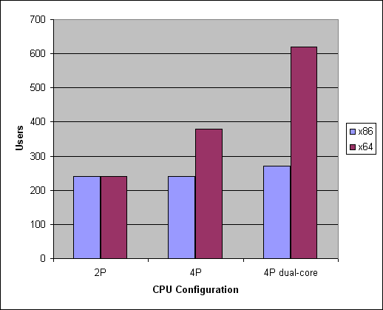

Analysis

Overview
One of the major issues when running Terminal Server on the 32-bit Windows architecture is the limited space available for the operating system kernel virtual address space. The 32-bit operating system reserves a 2-GB virtual address space for the kernel data structures. This virtual address space is shared by all processes that are running on the system. When this space is exhausted, no new process (or any system object) can be created. This means that new users will no longer be able to log on to the system and that the currently logged-on users will be severely impacted in terms of performance.
In this context, the appeal of the 64-bit architecture is the ability to provide a significantly larger virtual address space for the kernel data structures (8 terabytes (8 TB)). From this specific point of view, the 64-bit architecture will typically accommodate significantly more user sessions.

Kernel Virtual Address Space Impact
Table 2 compares the size of the various memory areas that are used by the x86-based and the x64-based Windows Server 2003 operating systems.
Table 2: Comparison of x86 and x64 memory areas

Architectural Component | x86-based Windows Server 2003 (Terminal Server optimized) | x64-based Windows Server 2003
Kernel virtual address space | 2 GB | 8 TB
Virtual memory | 4 GB | 16 TB
Paged pool | 260-480 MB1 | 128 GB
Non-paged pool | 256 MB | 128 GB
System cache | 1 GB | 1 TB
System PTEs | ~900 MB | 128 GB

1For more information about increasing paged pool memory, see "Server is unable to allocate memory from the system paged pool."
The greatest advantage of using 64-bit for a terminal server is the increase in kernel virtual address space. The increase is substantial--a total of 8 TB kernel virtual address space (with 128-GB paged pool and 128-GB system page table entries (PTEs)).
There are three areas in the kernel address space that have a significant impact on terminal server scalability: the paged pool area, the system PTEs area and the system cache area.
• The paged pool area holds memory allocation from kernel components and drivers that are pageable.
• System PTEs hold kernel stack allocations (stacks created in kernel mode for each thread to be used when that thread makes kernel calls) and page table data structures.
• The system file cache holds mapped views to files that are opened in the system.
Although these different allocations share the same area, the partition between them is fixed at system startup. If the system runs out of space in one of those areas, the other area cannot donate space to it, and applications may begin to encounter unexpected errors. Therefore, if you see a system that is experiencing unexpected errors or cannot accept new logins, without the system having some other resource limitation (such as CPU or disk limitations), it is possibly due to the paged pool area or the system PTEs area running out of space.

Effects of kernel virtual address space size limitations on x86-based systems
The kernel virtual address space size limitations on x86-based systems have the following effects:
• Limits the number of sessions supported. Increased session count eventually causes paged pool and system PTE exhaustion. The maximum number of sessions in the Knowledge Worker scenario is approximately 300 regardless of CPU, memory and I/O capacity.
• Limits high-user memory usage scenarios. Increased amounts of physical memory use significant kernel virtual address space. Therefore, there is typically little benefit in exceeding 8 GB of physical memory for x86-based systems.
• Degrades cache performance. High paged pool usage triggers a reclaim process for system cache data structures which in turn affects cache performance. This translates to slower response times on actions that are related to file access operations, such as opening a file, scrolling, listing the contents of a folder, and others.
• Reduces the amount of kernel virtual address space available in some special hardware configurations. For example, 2 bytes of virtual address space is lost for each byte of hot-swap memory, significantly reducing the available kernel virtual address space.

Effects of increased kernel virtual address space size on x64-based systems
The significant increase in the kernel virtual address space on x64-based systems has the following benefits:
• Supports a higher theoretical number of sessions. Based on current x64 system virtual address capacity, it is unlikely that kernel virtual address space will be a limitation for terminal server workloads on x64-based systems. Test results show that a four-processor AMD Opteron dual-core system can support as many as 620 Knowledge Worker-type users.
• Supports increased physical memory beyond 8 GB without degradation in performance. Increased amounts of physical memory have little effect on performance because the increase in kernel virtual address space can support the data structures that are used to manage the extra physical memory without significant performance penalties. Among other issues, this addresses the issues encountered with 32-bit systems regarding cache performance and the ability to support hot-swap memory.
As you can see in the following illustration, the critical kernel virtual address indicator for the Knowledge Worker scenario (System PTEs) on the 32-bit operating system drops to a very low value as the number of active sessions increases. However, the same indicator for the 64-bit system is almost unaffected. (Note the scale is logarithmic to accommodate the huge difference in value between the 32-bit and 64-bit system, so while x64 kernel virtual address does drop, it has no discernable impact).
Kernel virtual address space availability (32-bit vs. 64-bit)
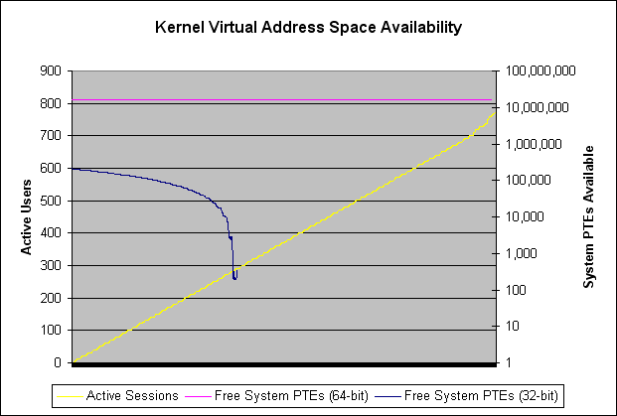

CPU Impact
Typically, when running 32-bit applications on a 64-bit architecture, there is a large performance impact in terms of CPU usage because of the data conversion between the 32-bit and the 64-bit formats. However, on an x64-based system that is running 32-bit applications, the impact on CPU usage is very limited when compared to the 32-bit system that is running the same applications. The low CPU overhead on the x64-based system greatly improves the ability of the 64-bit system to take almost full advantage of the processing power made available on dual-core multi-CPU systems without any of the concerns associated with the kernel virtual address limitations of the 32-bit systems.
Comparison of 32-bit vs. 64-bit CPU usage
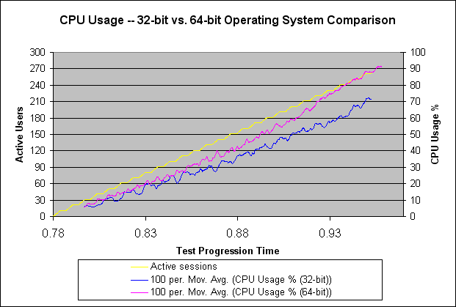

On a computer where the maximum number of users is limited by CPU saturation when running the 32-bit operating system, it is likely that the number of sessions that are supported when running the 64-bit operating system will decrease slightly. This is due to a slight increase in CPU usage when switching from the 32-bit to the 64-bit operating system. Because of the small relative value of the increase (typically < 10%), it is hard to determine with high accuracy the specific factors causing the increase. However, the increase in CPU usage can be partially attributed to the following:
• Overhead of the Windows on Windows 64 (WOW64) emulation layer. In the x64-based architecture, the WOW64 emulation layer operates more like a translation layer as opposed to a true emulation layer, which significantly limits its impact on CPU usage.
Note
A translation layer is a layer of software (or hardware) that converts one set of codes into another. In this case, the translation layer converts data between 32-bit and 64-bit formats.
• Reduced efficiency of the various layers of CPU cache. This can be explained mostly by increased size of system data structures under the 64-bit system (for example, data pointers are double in size). This increases the footprint of memory accesses and therefore decreases the CPU cache efficiency. Tests show that on an AMD Opteron 875 2.2 GHz CPU system with 2 MB L2 cache, when running the same Knowledge Worker scenario, the cache hit ratio was:
• 99% with the 32-bit operating system.
• 98% with the 64-bit operating system.

Memory Impact
When you compare the amount of memory used during the test, it is quite clear that when running the x64-based version, memory consumption increases substantially. In the following illustration, you can see that at the 280 active users mark, the 32-bit system is using approximately 5 GB RAM whereas the 64-bit system is using approximately 8.3 GB (~66% increase).
Comparison of memory usage between 32-bit and 64-bit systems
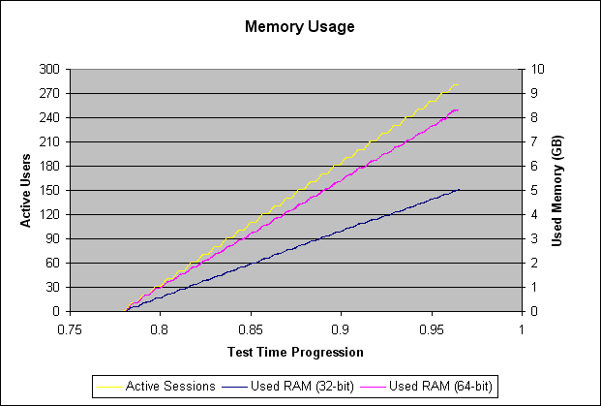

Committed memory also shows an increase: from approximately 15 GB on the 32-bit operating system to approximately 35 GB on the 64-bit operating system.
Committed memory (32-bit vs. 64-bit systems)
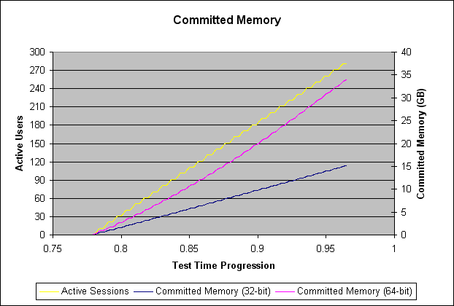

It is very important to note that these test runs did not stress the memory. Therefore, the memory manager did not attempt to trim the working set and optimize the applications' resident set. The per-application memory usage evaluated under such circumstances is expected to be quite different from the minimal working set required for that application to deliver acceptable performance. To better evaluate the actual memory needs, a memory-constrained configuration would be required. For more information, refer to the "Memory Requirements and Utilization" section in the Windows Server 2003 Terminal Server Capacity and Scaling white paper.
On the other hand, when the pressure on the disk I/O subsystem is high, the only way to improve disk access times is to maintain low pressure on the memory. As the number of sessions increases, the disk activity and the pressure on the disk I/O subsystem increases. If the file I/O activity on the system is high, the probability that requests will find the desired file data in memory decreases, thus negatively affecting the file access times. The percentage of requests that find the file data in memory can be monitored by using the Cache performance object with the Copy Read Hits % performance counter. Ideally, the values for this counter should not drop consistently under 95%. A very efficient file system cache can significantly reduce file access times. Under higher memory pressure, memory manager would reclaim some of the pages used to cache file data for other purposes thus reducing cache efficiency.

Disk I/O Impact
In the 2002-2005 timeframe, several large customer Terminal Server environments ranging from 10 Terminal Server farms to farms with hundreds of terminal servers capable of servicing over 15,000 concurrent users were examined. In these customer environments, it was found that the disk subsystem was the component that was typically not optimized and did not conform to Microsoft recommendations, resulting in insufficient disk subsystem performance. We recommend that you examine your terminal server environment, including servers currently in production and those that you plan to put into production to ensure that the recommended logical and physical disk metrics are met. This will help to ensure optimal usage of the platform.
Although this is not specific to 64-bit systems, disk I/O activity needs to be carefully monitored for systems that support a relatively high number of users. On 64-bit systems, where the ability to take full advantage of four-core and eight-core systems is greatly improved, disk I/O activity becomes one of the main concerns. A detailed analysis of the different factors that could play a role in this issue is beyond the scope of this white paper, but a few general guidelines and observations are worth mentioning:
• Built-in storage support (two to five SCSI/SATA hard drives) is often insufficient for hosting a large number of users. Plan for additional RAID arrays/SAN support for deployments that are meant to support a large number of users.
• When you use SCSI RAID arrays to host user profiles and page files, the number of spindles that are used has a significant impact on the response times of actions associated with file access. Tests using a few hard disks of high capacity performed significantly worse than tests using significantly more hard disks of less capacity.
• Consider a battery-backed caching controller as an integral part of the server hardware specifications when using Direct Attached Storage (DAS). A battery-backed caching controller allows for write-back policy and has the obvious benefits of tuning the cache and the battery to protect writes not yet committed to disk in the event of an outage.
• Large amounts of RAM can effectively mitigate the impact of high I/O activity by keeping pages in the cache from previous file accesses. This typically requires that you install significantly more RAM than is required by the effective application working sets. However, this may be more cost effective than expensive external storage.
To determine if your disk I/O configuration is sufficient, use the System Monitor tool to help tune your system until the disk subsystem meets the following specifications:
• Logical and Physical disk %Idle Time should always be at or above 50% as an average.
• Avg. Disk sec/Read and Avg. Disk sec/Write under 25 milliseconds (.025 seconds) average and 50 millisecond (.050 second) momentary peaks. Any values higher than this will begin to cause disk bottlenecks, so you should increase the capability of your disk subsystem, or decrease the number of users or applications to fit within these guidelines.

Recommendations

Planning new x64-based deployments:
• Consider deploying four-core and eight-core systems with x64-based operating systems.
• Plan for adequate memory support. If there is memory usage data available for similar deployments that used the 32-bit operating system, plan to increase the memory by 50-100%.
• Plan for adequate storage support. On systems that consolidate a substantial numbers of users, plan for higher-performance storage support for page file and for user data. Adequate storage support should include a battery-backed caching controller, and an additional hard disk spindle for every 10 users, assuming a typical Knowledge Worker-level activity of a full desktop, full Microsoft Office suite, and one to three custom applications. Note that this is a general guideline; use the System Monitor LogicalDisk and PhysicalDisk counters as authoritative.
• Monitor disk activity using the % Idle Time, the Avg. Disk/sec Read, the Avg. Disk/sec Write, and the Avg. Disk Queue Length performance counters for the LogicalDisk and PhysicalDisk performance objects. The % Idle Time counter should always be at or above 50% as an average. The Avg. Disk sec/Read and Avg. Disk sec/Write counters should be under 25 milliseconds (.025 seconds) average and 50 millisecond (.050 second) peaks.
• Monitor system cache efficiency using the Cache performance object with the Cache Read Hits % counter. Increase RAM size if the hit ratio drops below 95%.

Planning for upgrades
If the system is hitting kernel virtual address space limitations, make sure that you do the following when you plan an upgrade:
• Evaluate memory usage patterns to make sure that the system will accommodate the extra 50-100% additional RAM consumption of the 64-bit systems.
• Evaluate CPU usage to determine if there is enough of a margin for the increased usage associated with the 64-bit system.

See Also
Windows Server 2003 Terminal Server Capacity and Scaling white paper
Comparison of 32-bit and 64-bit memory architecture for 64-bit editions of Windows XP and Windows Server 2003

