

Reviewers Guide
Published: May 2006
For the latest information, please see http://www.microsoft.com/hpc


Abstract

For customers solving complex computational problems, Microsoft® Windows® Compute Cluster Server 2003 accelerates time-to-insight by providing a high-performance computing (HPC) platform that is easy to deploy, operate, and integrate using an organization’s existing infrastructure and tools. In the past, setting up and configuring a cluster was a technically complex task that often required dedicated support staff. Windows Compute Cluster Server 2003 has made the task easy by offering prescriptive setup procedures that simplify network configuration, the ability to load nodes remotely using Remote Installation Services (RIS), automated node configuration, and tools and technologies that help organizations configure cluster security settings. The integrated Job Scheduler, which can be accessed through a command-line interface (CLI) or through several application programming interfaces (APIs), can be used to submit and manage cluster workloads. Active Directory® integration provides end-to-end identity management and security features, while the Microsoft Management Console (MMC) supports extensible snap-ins and integration with Microsoft Operations Manager (MOM). Organizations can run leading applications from key independent software vendors (ISVs) on their clusters to help meet their needs in a timely and cost-effective manner while maintaining high performance. They can run parallel jobs using the Message Passing Interface (MPI) support provided in Windows Compute Cluster Server 2003, a full implementation of the MPI chameleon (MPICH) standard. Microsoft Visual Studio® 2005 provides developers an integrated development environment that includes parallel compiling and debugging capabilities. Windows Compute Cluster Server 2003 provides seamless integration with the Microsoft Windows Server™ 2003 operating systems, resulting in security, storage, and productivity gains for organizations.

Contents
Overview of Windows Compute Cluster Server 2003 1
Primer on Windows Compute Cluster Server 2003 2
What is Windows Compute Cluster Server 2003? 2
About MPI, MPICH, and MS-MPI 4
System Requirements 6
Hardware Requirements 6
Software Requirements 7
Network Requirements 8
Getting Started 9
Setting up a Cluster 9
Create a head node 9
Install the Compute Cluster Pack 9
Configure the Cluster 12
Technical Overview 14
Architecture 14
Network Topology 15
Scenario One: Two NICs on the Head Node; One NIC on the Compute Nodes 15
Scenario Two: Two NICs on Each Node 17
Scenario Three: Three NICs on the Head Node; Two NICs on the Compute Nodes 18
Scenario Four: Three NICs on Each Node 19
Scenario Five: One NIC Per Node 21
Features 21
Compute Cluster Administrator 21
Compute Cluster Job Scheduler 25
Task Execution 27
CLI 29
The Compute Cluster Pack Application Programming Interface (CCPAPI) 30
MS-MPI Features 31
Cluster Security 32
Cluster Administrators 32
Cluster Users 32
Security Considerations for Jobs and Tasks 32
Summary 34
Related Links 35

Overview of Windows Compute Cluster Server 2003
Microsoft® Windows® Compute Cluster Server 2003 provides an integrated application platform for developing, deploying, running, and managing high-performance computing (HPC) applications. Using this platform, individuals and organizations can perform multi-node workload computing using commodity hardware in an environment that will shorten their time to insight.
HPC is increasingly being achieved with clusters of industry standard servers that can range from a few nodes (individual computers) to hundreds of nodes. Wiring, provisioning, configuring, monitoring, and managing these nodes and providing appropriate, secured user access is a complex endeavor that often requires costly support and administrative resources. Because users typically spend more time on cluster administration and management tasks than on running jobs, organizations experience a loss in productivity, as well. The goals of Windows Compute Cluster Server 2003 are to simplify management and reduce the total cost of ownership (TCO) of compute clusters, making them accessible to a broader audience.
Based on these goals, Windows Compute Cluster Server 2003 has been designed to be intuitive to administer and manage. Its installation and system configuration processes are fully prescribed and largely automated. In addition, users will probably be familiar with the standard Windows features that it includes for deploying and managing clusters remotely. For example, because Windows Compute Cluster Server 2003 is fully integrated with the Microsoft Windows Server System™ solution stack, users can also benefit from the advanced management technologies available in the Active Directory® directory service and in Microsoft Operations Manager (MOM). Users familiar with the Windows Server™ platform can become productive faster.
Users whose work demands HPC solutions also require applications that execute complex computations and elaborate data output. Microsoft has worked with independent software vendors (ISVs) to port applications to Windows Compute Cluster Server 2003 that serve several markets, such as manufacturing, life sciences, geological sciences, and financial services. To help deliver on the promise of usability, a full-function Job Scheduler is provided which enables comprehensive job management through a Job Manager user interface (UI) or through a command line interface (CLI).
Windows Compute Cluster Server 2003 supports the execution of parallel applications based on the Message Passing Interface (MPI) standard. Users can take advantage of the enhancements in Microsoft Visual Studio® 2005 aimed at parallel computing, including support for the OpenMP standard and a parallel debugging capability that supports MPI.
When a user submits a job to the cluster, the job is recorded in the head node database along with its properties, entered into the execution queue, and then run when the resources it requires become available. Because the cluster is in the user’s Active Directory domain, jobs execute using that user’s permissions. As a result, the complexity of using and synchronizing different credentials is eliminated, and the user does not have to use different methods of sharing data or compensate for permission differences among different operating systems. This means that Windows Compute Cluster Server 2003 offers transparent execution, access to data, and integrated security technologies.

Primer on Windows Compute Cluster Server 2003
HPC has evolved considerably during the last 15 years. The “supercomputer” solutions of the early 1990s provided enormous parallel computing power, but they cost tens of millions of U.S. dollars and required a great deal of expertise to deploy, manage, and maintain. Consequently, customers for these solutions were generally limited to governments and large research institutions.
The most advanced supercomputing solutions available today are still too expensive for many organizations, costing about one hundred million dollars. Almost any organization can harness the power of HPC by clustering inexpensive and readily available commodity hardware, thanks to the increased computing power based on 64-bit processor architecture and the associated increase in memory address space. The cost to create a small cluster for HPC is on the order of five to 10 thousand U.S. dollars—about 10,000 times less than it cost 15 years ago to produce the same computing power.
This decrease in the cost of clustered HPC solutions gives organizations more options. For example, they can submit large scale or high precision jobs to supercomputer systems while executing smaller, routine tasks using a local cluster.
Unfortunately, most solutions are still difficult and costly to use, manage, and integrate into an overall computing infrastructure. In addition, they often do not support standard applications. With the release of Windows Compute Cluster Server 2003, Microsoft aims to remove the barriers that prevent individual engineers and scientists from independently leveraging the computing power available today. In addition, large enterprises with HPC needs can also benefit, because their resources are freed up to deploy local clusters that solve more problems more quickly.
Windows Compute Cluster Server 2003 provides:
- Faster time-to-insight—a superior out-of-the-box deployment experience; an integrated software stack that includes the operating system, Job Scheduler, and MPI layer; and the leading applications for each targeted vertical market.
- Better integration with IT infrastructure—seamless integration with existing Windows infrastructures through features such as Active Directory, making it possible to leverage existing skills and technology.
- A familiar development environment—intuitive design so developers can leverage their existing Windows-based skills and experience. In addition, Visual Studio is the most widely used integrated development environment (IDE) in the industry, and Visual Studio 2005 includes support for developing HPC applications, including parallel compiling and debugging capabilities. Microsoft Partners provide additional compiler and math library options. Also supports the MPI standard through the Microsoft MPI stack (called MS-MPI) or through non-Microsoft stacks.
Windows Compute Cluster Server 2003 puts an HPC solution within reach of individuals and organizations that might not otherwise be able to afford its TCO. They can now leverage their investment in a Windows-based infrastructure and skilled resources to harness the power of HPC.

What is Windows Compute Cluster Server 2003?
Windows Compute Cluster Server 2003 uses clustered commodity servers that are built with a combination of the Windows Server 2003, Compute Cluster Edition operating system and the Microsoft Compute Cluster Pack.
Windows Server 2003, Computer Cluster Edition is a specialized, 64-bit operating system based on the 64-bit edition of Microsoft Windows Server 2003. Although it is a full version of the Windows Server 2003 64-bit operating system, it is not intended for use as a general purpose server. Server roles in Windows Server 2003, Computer Cluster Edition are restricted to make Windows Compute Cluster Server 2003 available at a lower price. If users want to install Microsoft SQL Server™ 2005 on a cluster server, for example, they must license and install Windows Server 2003, x64 Standard Edition or Windows Server 2003, x64 Enterprise Edition. Also, it is not possible to deploy Windows Compute Cluster Server 2003 on 32-bit hardware. For more information, see “System Requirements.”
The Compute Cluster Pack contains the services, interfaces, and supporting software that users need to create and configure the cluster nodes, as well as the utilities and management infrastructure. The Compute Cluster Pack provides support for the Argonne National Labs Open Source MPI2 standard. For more information about MP12, see “About MPI, MPICH, and MS-MPI.” The Compute Cluster Pack also contains an integrated Job Scheduler and cluster resource management tools.
Windows Compute Cluster Server 2003 is made up of the components listed in Table 1 and is deployed by installing two CDs. CD1 contains Windows Server 2003, Computer Cluster Edition. CD2 contains the Compute Cluster Pack.
Table 1. Components of Windows Compute Cluster Server 2003
Component | Description
Active Directory directory service | Each node of a cluster must be a member of an Active Directory domain, because Active Directory provides authorization and authentication services for Windows Compute Cluster Server 2003. The domain can be independent of the cluster; for example, with a cluster running in a production Active Directory domain. Alternatively, it can run within the cluster, on the head node in scenarios where the cluster is a production environment.
Head Node | Provides user interfaces (UIs) and management services to the server cluster. The UIs include the Compute Cluster Administrator, the Compute Cluster Job Manager, and a command line interface (CLI). Management services include job scheduling, job and resource management, and Remote Installation Services (RIS). The head node can also serve as a network address translation (NAT) gateway between the public network and the private network that make up the cluster.
Compute Nodes | Computers configured as part of a compute cluster that provide computational the resources users to run jobs. Compute nodes can only be created on computers running a supported operating system, but nodes within the same cluster do not have to run the same operating system or use the same hardware configurations. However a similar configuration simplifies deployment, administration, and (especially) resource management. Tasks. Those with different hardware configurations will limit the cluster’s capabilities, because jobs running in Parallel mode and requiring nodes of different capabilities will be able to run only at the speed of the slowest processor in the selected nodes.
Job Scheduler | A service that runs on the head node and manages the job queue, resource allocation, and job execution by communicating with the Node Manager Service that runs on each compute node.
MS-MPI Software | A cluster’s key networking component that can use any Ethernet connection supported by Windows Server 2003, as well as low-latency and high-bandwidth connections such as InfiniBand or Myrinet. Gigabit Ethernet provides a high-speed and cost-effective connection fabric, while InfiniBand is ideal for latency sensitive and high-bandwidth applications. MS-MPI supports several networking scenarios.
Management Infrastructure | The Compute Cluster Pack offers a complete management infrastructure that enables the cluster administrator to deploy and manage compute nodes. This infrastructure consists of the cluster services running on the head node and all compute nodes, providing the administrative, user, and command-line interfaces used to administer the cluster, submit jobs, and manage the job queue.
Compute Cluster Administrator and Job Manager | Interfaces used by cluster administrators and users for cluster operations, job submissions, and management. The Compute Cluster Administrator is used to configure the cluster, manage nodes, and monitor cluster activity and health. The Job Manager is used for job creation, submission, and monitoring.
Command Line Interface (CLI) | The Compute Cluster Pack offers a CLI for node and job management. These operations can also be scripted. Administrators can use the CLI to automate job, job queue, and node operations.
Public and Private Networks | Compute nodes are often connected to each other through network interfaces. To manage and deploy nodes, administrators can configure compute clusters with a private network. They can also use a private network for MPI traffic. This traffic can be shared with the private network used for management, but the highest level of performance is achieved with a second, dedicated private network that supports only MPI traffic.

Windows Compute Cluster Server 2003 allows organizations to easily and quickly deploy a computing cluster using standard Windows deployment technologies, and they can add more compute nodes to a compute cluster automatically by plugging the nodes in and connecting them to the cluster. The MS-MPI implementation is fully compatible with the MPICH2 standard and implements end-to-end security on all jobs. Integration with Active Directory enables role-based security for administration and users, and the use of the Microsoft Management Console (MMC) provides a familiar administrative and scheduling interface.

About MPI, MPICH, and MS-MPI
MPI is a standard API and specification for message passing. It was designed specifically for HPC scenarios executed on large computer systems or on clustered commodity computers.
The MS-MPI is a version of the Argonne National Labs Open Source MPICH2 implementation that is widely used by existing HPC clusters. MS-MPI is compatible with the MPICH2 Reference Implementation and includes a full-featured API with more than 160 function calls.
The MS-MPI software in Windows Compute Cluster Server 2003 is built on the Windows Sockets networking API (WinSock) so MS-MPI networking traffic can use TCP/IP as normal, or for best performance and CPU efficiency can use WinSock Direct Provider (driver) to bypass the TCP stack and go directly to the networking hardware’s native interface. MS-MPI can utilize any Ethernet interconnect that is supported on Windows Server 2003 as well as low-latency and high-bandwidth interconnections, such as InfiniBand or Myrinet, through Winsock Direct drivers provided by hardware manufacturers. As a result, a single MPI stack supports many fabrics. This flexibility should ease the burden of management for network administrators. More importantly, such flexibility means that applications do not have to be rebuilt for specific network hardware. As a result, ISVs have a much smaller test matrix for their products (speeding their time to market and lowering cost) and customers do not have to buy and maintain multiple versions (one for each type of network hardware they have) of a single application. Gigabit Ethernet provides a high-speed, cost-effective interconnection fabric, while InfiniBand is ideal for latency-sensitive and high-bandwidth applications.
MS-MPI includes support (bindings) for the C, Fortran77, and Fortran90 programming languages. Microsoft Visual Studio 2005 includes a parallel debugger that works with MS-MPI. Developers can launch their MPI applications on multiple compute nodes from within the Visual Studio environment, and Visual Studio automatically connects the processes on each node, enabling developers to individually pause and examine program variables on each node.

System Requirements
In Windows Compute Cluster Server 2003, any computer designated as either a head node or a compute node must meet minimum hardware and software requirements. If an organization’s plans include installing the administrative and user components on a remote computer, the remote computer must have an operating system that is compatible with the Compute Cluster Pack. Head nodes may also have additional software requirements, such as Remote Installation Services (RIS) or Internet Connection Sharing (ICS) Network Address Translation (NAT), depending on the networking environment in which the cluster is installed.
Windows Compute Cluster Server 2003 requires the Microsoft .NET Framework version 2.0, which is included on the Compute Cluster Pack CD. The Compute Cluster Administrator requires Microsoft Management Console (MMC) version 3.0.

Hardware Requirements
The minimum system hardware requirements for Windows Compute Cluster Server 2003 are similar to the hardware requirements for Windows Server 2003, Standard x64 Edition.
Table 2. System requirements of Windows Compute Cluster Server 2003
Requirement | Windows Server 2003, Compute Cluster Edition
CPU Requirement | 64-bit architecture computer  Intel Pentium, or Xeon family with Intel Extended Memory 64 Technology (EM64T) processor architecture, or  AMD Opteron family, AMD Athlon family, or compatible processor(s)  Note:  32-bit hardware can run CCS client software:  - command line interface  - job console  - administrator console  CCS SDK supports 32-bit hardware: developers can create both 32-bit and 64-bit applications that will run on CCS nodes
Minimum RAM | 512 MB
Maximum RAM | 32 GB
Multiprocessor Support | Up to 4 processors
Disk Space for Setup | 4 GB
Disk Volumes | For a head node, the Windows Compute Cluster Server 2003 installation process requires a minimum of two volumes (C:\ and D:\)—one for the system partition, and one that RIS can use.  Compute nodes only require one volume.  RAID 0,1,5 may be used as appropriate, although it is not required.
Network Interface Cards (NICs) | All nodes require at least one NIC.  If a private network is planned, and depending on the network topology selected, the head node requires a minimum of two NICs to create a public and private network.  Each node may require more NICs as appropriate in case of public network access or in support of an MPI-based network.

Software Requirements
This section describes the software requirements for Windows Compute Cluster Server 2003.
The following are the required or compatible operating systems for Windows Compute Cluster Server 2003:

Head Node and Compute Nodes
The Computer Cluster Pack must be installed on a supported operating system. The supported operating systems are the same for both head node and compute nodes and include:
- Windows Server 2003, Compute Cluster Edition
- Windows Server 2003, Standard x64 Edition
- Windows Server 2003, Enterprise x64 Edition
- Windows Server 2003 R2, Standard x64 Edition
- Windows Server 2003 R2, Enterprise x64 Edition

Remote Workstation Computer
The Compute Cluster Administrator and the Cluster Job Manager are installed on the head node by default, but clusters can be managed and operated from a remote workstation. If the Compute Cluster Administrator or the Cluster Job Manager are installed on a remote computer, the computer must be running one of the following operating systems:
- Windows XP Professional with Service Pack 2 (SP2)
- Windows XP Professional x64 Edition
- Windows Server 2003 with Service Pack 1 (SP1), Standard Edition
- Windows Server 2003, Standard x64 Edition
- Windows Server 2003 with Service Pack 1 (SP1), Enterprise Edition
- Windows Server 2003, Enterprise x64 Edition
- Windows Server 2003 R2, Standard Edition
- Windows Server 2003 R2, Standard x64 Edition
- Windows Server 2003 R2, Enterprise Edition
- Windows Server 2003 R2, Enterprise x64 Edition

RIS
RIS can be used to automatically install compute nodes that are part of the cluster. Third party system imaging tools can also be used for deploying compute nodes.

Active Directory
The Active Directory directory service is a central component of the Windows platform that provides the means to manage the identities and relationships that make up network environments. Active Directory stores information about objects on a network and makes this information available to users and network administrators. It gives network users access to permitted resources anywhere on the network using a single logon process. Membership in an Active Directory domain is required for Windows Compute Cluster Server 2003 head and compute nodes.
All compute nodes must be in the same Active Directory domain as the head node. All computers in the compute cluster should be joined to an existing corporate Active Directory domain to leverage the existing directory service, authentication, and security infrastructure. If an Active Directory domain is not available, the head node can be used as a domain controller by running DCpromo.exe. If a unique domain is used for the cluster, trust relationships must be created between the new cluster domain and existing domains. To permit access from one domain to the other, more administrative tasks may have to be performed.

Software Development Kit (SDK)
The Windows Compute Cluster Server 2003 Software Development Kit (SDK) and associated utilities are supported by the operating systems in the Remote Workstation Computer list.

Network Requirements
Windows Compute Cluster Server 2003 supports five different network topologies, each with implications for performance and accessibility. The topologies involve at least one and possibly combinations of the following types of networks: public, private, and MPI.
A public network is an organizational network connected to one or more cluster nodes. This is often a preexisting Ethernet network that most users log onto to perform their work. If the cluster is not connected to a dedicated private network, then all intra-cluster management and deployment traffic is carried on the public network.
A private network is a dedicated cluster network that carries intra-cluster communication between nodes. This network carries management, deployment, and MPI traffic (if no MPI network exists) between nodes in the cluster.
An MPI network is a dedicated, high-speed network that carries parallel application communication between compute nodes in a cluster. If no MPI network exists, then MPI communication is carried by a private network. If a private network does not exist, MPI traffic is carried by an external public network.
Using a separate network to carry intra-cluster and MPI traffic between compute nodes and the head node will improve cluster performance and offload that traffic from the public network. Access from compute nodes to the public network can still be achieved by using NAT services on the head node.
Four of the five network scenarios supported by the Compute Cluster Pack offer varying degrees of performance improvements attained by using one or more private networks to support cluster communications. Each scenario also provides a different degree of accessibility to the compute nodes from the public network. In the fifth scenario, all nodes comprising the cluster are attached to the public network. This scenario offers the greatest access to each compute node but also creates the heaviest network traffic demands on the public network.
For detailed information on network topology scenarios see “Technical Overview.”
Getting Started
Installing Windows Compute Cluster Server 2003 involves installing the Windows Server 2003, Compute Cluster Edition operating system (on CD1) and the Compute Cluster Pack (on CD2).

Setting up a Cluster
Setting up a computing cluster with Windows Compute Cluster Server 2003 begins with confirming that the computer selected to be the head node of the cluster meets the minimum hardware requirements. For more information, see “Hardware Requirements.” The next step is to install the operating system and other prerequisite software, and then install the Compute Cluster Pack software. Configuring the network and RIS (where appropriate), and then adding nodes and users are the final steps.

Create a head node
- Install the operating system using the Windows Server 2003, Compute Cluster Edition disk.
- If RIS will be used to create compute nodes, create a second disk volume (for example, D:\) that RIS can use while installing the operating system, because RIS cannot be installed on a system partition.
- Join the computer to an existing Active Directory domain (recommended), or create a new domain for the cluster by running DCpromo.exe and establishing a trust relationship between domains as necessary.
- Eject the Windows Server 2003, Compute Cluster CD and insert the Compute Cluster Pack CD.
- Configure the head node as explained in the following procedures.

Note: You can also create a head node on a computer running a supported operating system by using the Compute Cluster Pack CD alone. The Compute Cluster Pack will not install if the computer used for the head node is not a member of an Active Directory domain.

Install the Compute Cluster Pack
- Insert CD2, the Compute Cluster Pack CD into the CD-ROM drive of the computer; Setup.exe should automatically run.
- In the Microsoft Compute Cluster Pack Installation Wizard, select one or more of the three installation options, as shown in Figure 1. Then click Next.

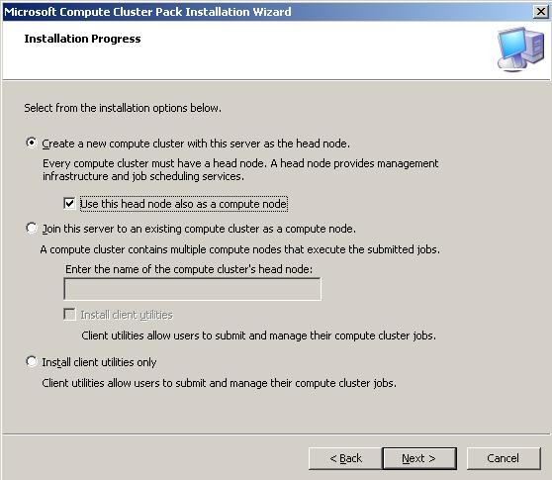
Figure 1. Node selection options, Compute Cluster Pack Installation Wizard

- On the Welcome page, click Next.
- On the End-User License Agreement page, read the terms of the license agreement as shown in Figure 2. Choose to accept or reject them, and click Next.
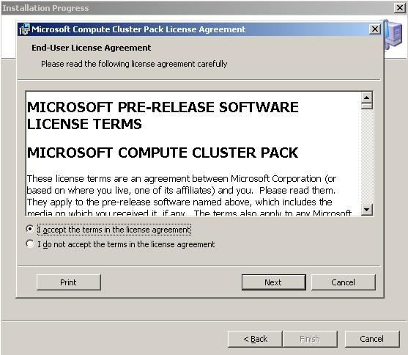
Figure 2. End-User License Agreement page

- On the Installation Folder page, either click Change to change the folder where the Compute Cluster Pack will be installed, or click Next.
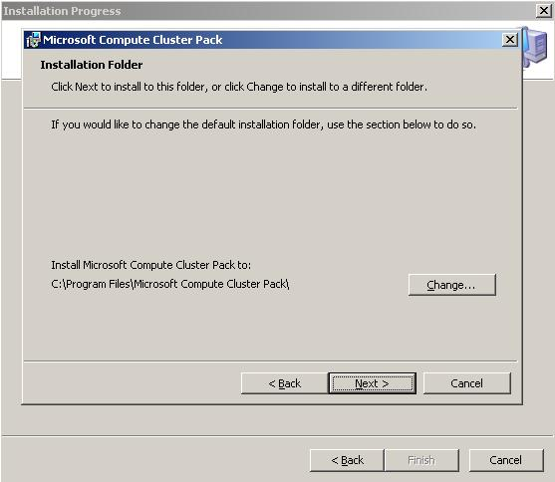
Figure 3. Installation Folder page

- Click Install.

Notes:
- In step 2, if the head node option is selected, the computer name of the node becomes the cluster name.
- MMC 3.0, .NET Framework 2.0, and updates for RIS and ICS are prerequisites for installing the head node. Setup helps to install them.
- In step 7, the installation of Compute Cluster Pack can be cancelled at any time by clicking Cancel.
- When the installation process is complete, the To Do List page appears. You can also access the information it displays through the Compute Cluster Administrator.

Configure the Cluster
- Using either the To Do List or the Compute Cluster Administrator, define the cluster network topology, configuring the public, private, and MPI network interfaces of the head node as applicable to the chosen configuration. On the Networking tile, click Define cluster network topology as shown in Figure 4.
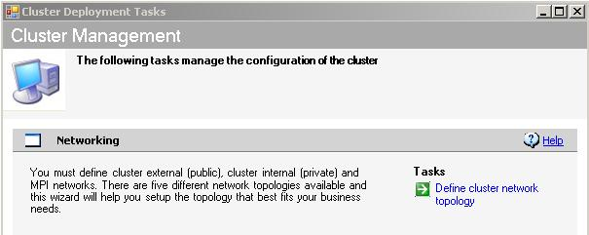
Figure 4. Cluster Management

- Configure RIS if applicable. If the automated method of adding and re-imaging nodes will be used, RIS and a hotfix for RIS must be installed. To install RIS, use the Remote Installation Services (RIS) tile to access the Configure RIS wizard.
- Create a RIS installation image if RIS will be used. To do this, use the Remote Installation Services (RIS) tile to access the Manage Images wizard. Windows Compute Cluster Server 2003 allows storage of multiple images on the head node.
- Modify the RIS image with a valid license key.
- Add compute nodes. To do this, use the Node Management tile to access the Add Nodes Wizard. The nodes will require approval from the cluster administrator before the can be added to the cluster. Compute nodes can be added by running CD2 and selecting the compute node option, or by using the To Do List to access the Add Nodes wizard, and then selecting Automated.
- Configure cluster users and administrators. To do this, use the Cluster Security tile to access the Configure Users wizard.
Notes:
- In step 2, the automated method of adding a node to a cluster can be used only if the following prerequisites are met:
- The cluster is supported by a private network.
- RIS and the update for RIS are installed on the head node.
- A RIS image has been created, and the correct license key has been applied to that image.
  - The computer or computers being added to the cluster are configured to perform a PXE boot before booting from local media.
- In step 5, using the automated Add Nodes method requires the cluster administrator to provide a domain account user name and password to install the nodes. This account is used to create computer accounts for each node in Active Directory. The cluster administrator must also enter a Node Series Name for the node(s) to be added. If more than one node will be added, this name is used as a prefix for the series of computers that will be added.

Technical Overview
While Microsoft has supported fault-tolerant and high-availability clustering for many years, the release of Windows Compute Cluster Server 2003 brings the supercomputing power of HPC to the personal and workgroup level with the familiarity and ease-of-use of a Windows operating system.

Architecture
Windows Compute Cluster Server 2003 is a cluster of servers that includes a single head node and one or more compute nodes, as shown in Figure 5. The head node controls and mediates all access to the cluster resources and is the single point of management, deployment, and job scheduling for the compute cluster. Windows Compute Cluster Server 2003 can use an existing corporate Active Directory infrastructure for security, account management, and overall operations management as well as integrate with management tools such as MOM 2005 and SMS 2003.
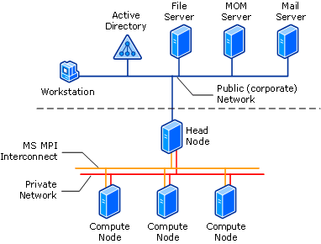
Figure 5. Typical Windows Compute Cluster Server 2003 network

Deploying Windows Compute Cluster Server 2003 involves installing the operating system on the head node, joining it to an existing Active Directory domain, and then installing the Compute Cluster Pack. If organizations plan to use RIS to automatically deploy compute nodes, RIS will be installed and configured after installation is complete.
When Compute Cluster Pack installation is complete on the head node, it displays a To Do List that shows the steps necessary to complete configuration of the compute cluster. These steps include defining the network topology, configuring RIS using the Configure RIS wizard, adding compute nodes to the cluster, and configuring cluster users and administrators.
Table 3 describes the services installed on the head node and what they do. Many of them are new services that perform functions specific to Windows Compute Cluster Server 2003.

Table 3. Services installed on the head node
Service | Description
Microsoft Compute Cluster Management Service | Cluster management, node discovery, and configuration management
Microsoft Compute Cluster Scheduler Service | Job queuing, scheduling, resource allocation, and job execution
Microsoft Compute Cluster SDM Store Service | Read/write operations from the System Definition Model (SDM) data store, integrity management
Microsoft Compute Cluster MPI Service | Microsoft implementation of the MPI stack from MPICH 2 code base
Microsoft Compute Cluster Node Manager Service | When the head node is also configured as a compute node, then this service is also installed.  This service interacts with the Compute Cluster Scheduler Service; responsible for job execution.
Microsoft Compute Cluster SQL Service (MSSQL$COMPUTECLUSTER) | Microsoft SQL Server 2000 Desktop Engine (MSDE)

Table 4 describes the services installed on the compute nodes and what they do. Many of them are new services that perform functions specific to Windows Compute Cluster Server 2003.
Table 4. Services installed on compute nodes
Service | Description
Microsoft Compute Cluster Management Service | Interacts with the same service running on the head node. Handles cluster management, node discovery, and configuration management from the compute node side.
Microsoft Compute Cluster MPI Service | Microsoft implementation of the MPI stack from MPICH 2 code base
Microsoft Compute Cluster Node Manager Service | Interacts with the Compute Cluster Scheduler Service on the head node; responsible for job execution.  If the head node is also configured as a compute node, then this service is also installed and runs on the head node.

Network Topology
Windows Compute Cluster Server 2003 supports five different network topologies with one to three NICs on each node.
MS-MPI is a high-speed networking interface that runs over and network connection including Gigabit Ethernet, InfiniBand, or any network that provides a driver enabled for WinSock Direct. MS-MPI is based on and compatible with the Argonne National Labs MPICH2 implementation of MPI2. For more information see “About MPI, MPICH, and MS-MPI.”

Scenario One: Two NICs on the Head Node; One NIC on the Compute Nodes

In the first topology scenario, shown in Figure 6, the head node has two NICs. One is connected to the existing public or organizational network. The other is connected to a private cluster network that connects the head node to the compute nodes. The private network carries all communication between the head node and compute nodes, including deployment, management, and MPI traffic.
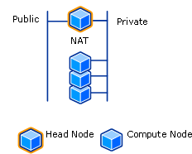
Figure 6. Scenario One network topology

In this scenario, only the head node has a public network interface: all traffic between the computing cluster and the public corporate network flows through the head node. Users on the corporate network can access only the head node. NAT must be enabled on the head node so that cluster compute nodes can access corporate resources such as data and services. NAT also enables limited Dynamic Host Configuration Protocol (DHCP) and DNS services on the private network. These services are used to configure the IP settings of the compute node private interfaces. Windows Computer Cluster Server 2003 uses ICS to configure NAT and provide DHCP and DNS services on a private network.
Table 5. Scenario One: Configuring NAT, DHCP, and DNS
Item | Note
NAT using ICS | The head node must be configured to provide NAT using ICS. If NAT is not configured on the head node, the solution will not work in this scenario. If NAT using ICS is configured, the private interface of the head node is assigned a static IP address. This address is 192.168.0.1 with a subnet mask of 255.255.255.0  Windows Compute Cluster Server 2003 does not support routing and remote access service (RRAS.) Therefore, RRAS cannot be used to configure NAT.  To use RRAS, ICS must first be disabled to prevent conflicts between the services.
DHCP | The public interface of the head node itself can be assigned a static IP address, or it can obtain a dynamic IP address from DHCP servers on the public network.  When NAT using ICS is installed on the head node, it provides limited DHCP and DNS services to compute nodes on the private network. In this way, the private interfaces of the compute nodes can obtain IP addresses dynamically from the head node. Static IP addresses can also be assigned to them.
DNS | Compute nodes get DNS services from the head node that is running NAT using ICS. The public interface of the head node registers with DNS servers on the public network.

Scenario Two: Two NICs on Each Node

In the second topology scenario, shown in Figure 7, both the head node and all compute nodes have two NICs. As in Scenario One, communications between nodes—including deployment, management, and MPI traffic— are all carried on the private network. However, in this case, the public network is attached to each compute node as well as the head node.
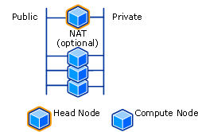
Figure 7. Scenario Two network topology

In most cases, each node of the computing cluster obtains an IP address from DHCP servers on the public network. This arrangement increases accessibility from the public network while the performance of the private network remains the same as in Scenario One.
Table 6. Scenario Two: Configuring NAT, DHCP, and DNS
Item | Note
NAT | In Scenario Two, installing NAT using ICS on the head node is optional. If NAT is installed, the private interfaces of the compute nodes can obtain IP addresses dynamically from the head node as in scenario one.  If another DHCP server is detected on the network, the ICS DHCP server service is stopped.  If the head node does not have NAT using ICS installed, then NAT can be enabled on the public network. In either case, NAT allows the compute nodes on the private network to access resources on the public network.
DHCP | If NAT is configured, the private interface of the head node is assigned a static IP address. This address is 192.168.0.1 with a subnet mask of 255.255.255.0  If the head node does not have NAT installed, and RIS will be used to install nodes, the cluster administrator should configure DHCP on the private network so that compute nodes can acquire IP addresses dynamically when they are restarted for RIS image installation.  Because each node is attached to a public network, DHCP servers on the public network can provide IP addresses to the public interfaces of each compute node. Static IP addresses can also be assigned to them.
DNS | The public interfaces of each cluster node can obtain IP addresses from public DHCP servers; in this scenario, nodes typically register with DNS servers on the public network.

Scenario Three: Three NICs on the Head Node; Two NICs on the Compute Nodes

The third topology scenario, shown in Figure 8, is similar to the first in that the public network is attached only to the head node, which acts as a gateway between the compute nodes and the public network. The key difference between Scenarios One and Three is that in Scenario Three, the cluster is installed with an MPI network that connects all nodes. The head node now has an additional NIC, a high-speed adaptor connected to the MPI network. In addition, each compute node has a second NIC, one for the private network and another for the MPI network. The MPI network is used to isolate MPI traffic that is latency sensitive.

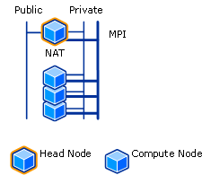
Figure 8. Scenario Three network topology

Scenario 3 offers the greatest interconnectivity performance, while accessibility from the public network is limited, as in Scenario One, to the head node itself.
Table 7. Scenario Three: Configuring NAT, DHCP, and DNS
Item | Note
NAT | The head node should be configured to provide NAT using ICS. Running NAT allows the compute nodes on the private network to access resources on the public network.
DHCP | NAT installed on the head node provides limited DHCP and DNS services to compute nodes on the private network.  If NAT is configured, the private interface of the head node is assigned a static IP address. This address is 192.168.0.1 with a subnet mask of 255.255.255.0  The head node can obtain an IP address on the public network interface from DHCP servers on the public network. A static IP addresses can also be assigned to it.
DNS | Compute nodes obtain DNS services from the head node that is running NAT. The public interface of the head node registers with DNS servers on the public network.

Scenario Four: Three NICs on Each Node

The fourth network topology scenario, shown in Figure 9, is the same as the second, except that it includes a high speed MPI network. The private cluster network carries only deployment and management traffic. The public network typically provides DHCP services to the public NICs of all cluster nodes. The MPI network exists, as in Scenario Three, to isolate MPI traffic that is latency sensitive. In this scenario, as in Scenario Two, NAT is an optional component.
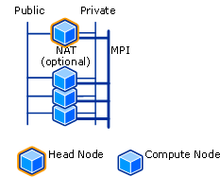
Figure 9. Scenario Four network topology

In this scenario, as in Scenario Two, NAT is an optional component.
Table 8. Scenario Four: Configuring NAT, DHCP, and DNS
Item | Note
NAT | In this scenario, it is optional to install NAT using ICS on the head node.  If the head node has NAT installed, the compute nodes of the cluster can obtain dynamic IP addresses for their private network interfaces.  If the head node does not have NAT installed, then NAT can be enabled on the public network. In either case, NAT allows the compute nodes on the private network to access resources on the public network.
DHCP | If NAT is configured, the private interface of the head node is assigned a static IP address. This address is 192.168.0.1 with a subnet mask of 255.255.255.0  If the head node does not have NAT installed and RIS will be used to install nodes, the cluster administrator should configure DHCP on the private network so that compute nodes can acquire IP addresses dynamically when they are restarted for RIS image installation.  Since each node is attached to a public network, DHCP servers on the public network can provide IP addresses to the public interfaces of each compute node. Static IP addresses can also be assigned to them.
DNS | All public interfaces that receive IP addresses from public DHCP servers typically register with DNS servers on the public network.

Scenario Five: One NIC per Node
Scenario 5 has no private intra-cluster network. All traffic, including intra-cluster, MPI, and public traffic, is carried over the public organizational network. This maximizes accessibility, but at the expense of network performance. All nodes obtain IP addresses from corporate DHCP servers. There is no requirement for NAT on the head node in this scenario.
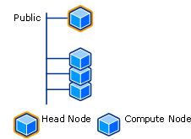
Figure 10. Scenario Five network topology

Table 9. Scenario Five: Configuring NAT, DHCP, and DNS
Item | Configuration
NAT | Not required.
DHCP | Because each node is attached to a public network, DHCP servers on the public network can provide dynamic IP addresses to the cluster nodes.
DNS | Public DNS servers are used for name resolution.

Features

Compute Cluster Administrator
The Compute Cluster Administrator, shown in Figure 11, is an MMC 3.0 snap-in named Computeclusteradmin.msc. It is installed on the head node of a cluster during setup and also when the SDK and client utilities are installed. It can also be installed on a remote workstation and used for remote access and management of the head node and the cluster.
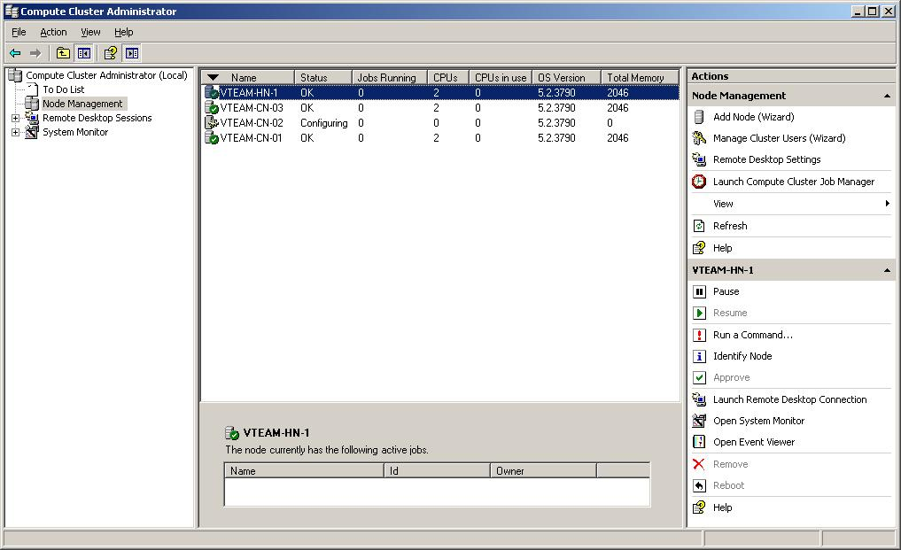
Figure 11. The Compute Cluster Administrator
The Compute Console Administrator has the following five major pages, each accessed from the navigation pane on the left side of the console:
- Start Page: This page, shown in Figure 12, appears when the Compute Cluster Administrator is started. It offers an overview of cluster and job status, and provides the administrator with access to the Cluster Job Manager.
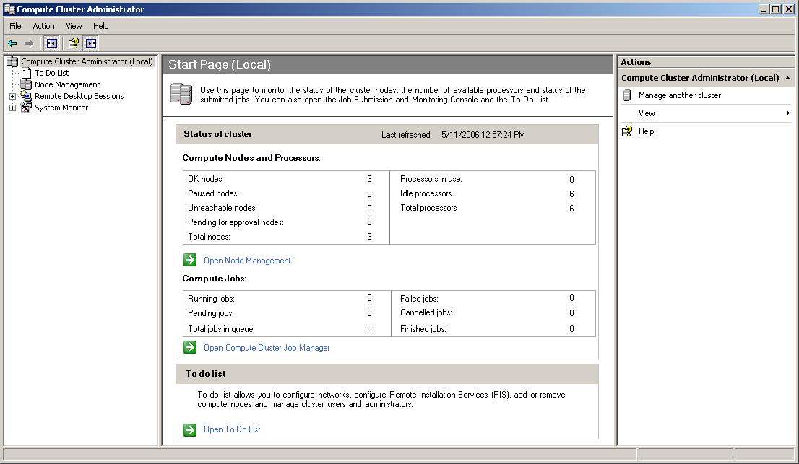
Figure 12. The Start page in the Compute Cluster Administrator
- To Do List: This page, shown in Figure 13, helps to quickly deploy the compute cluster. It contains four tiles in the MMC display pane. Each tile displays state or status notifications and provides access to the appropriate wizards.
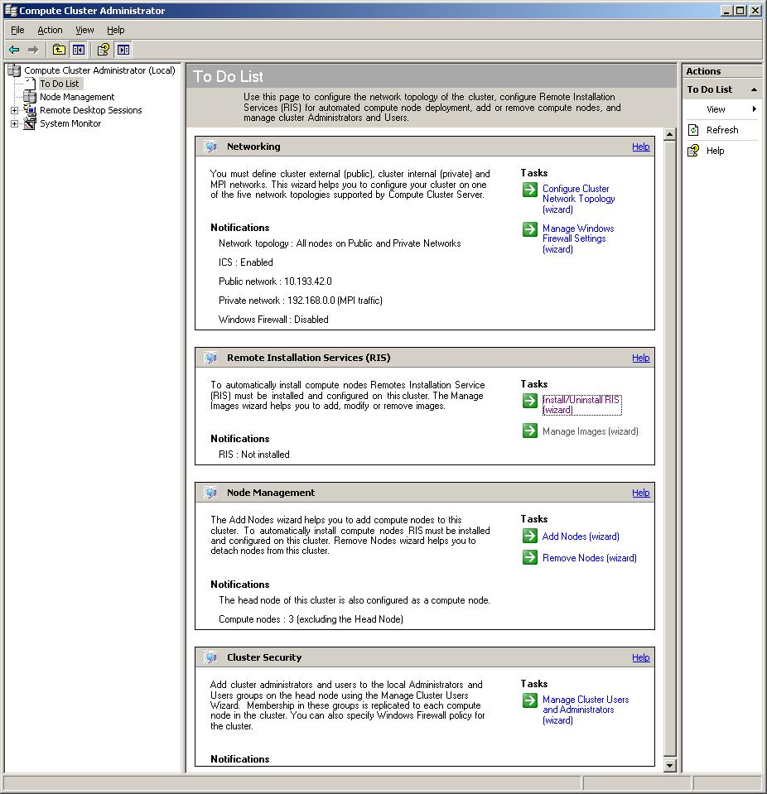
Figure 13. The To Do List in the Compute Cluster Administrator

- Node Management: This page, shown in Figure 14, displays information about head and compute nodes in columnar format. The Add Node Wizard and the Cluster Job Manager can be launched from it. Computer name, node status, number of jobs, and CPU information are displayed by default.
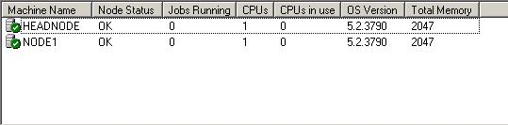
Figure 14. The Node Management page in the Compute Cluster Administrator

- Remote Desktop Sessions: This page, shown in Figure 15, can be used to create and close remote desktop sessions to one or more nodes. Each active remote desktop session is added to a list in the navigation pane under the Remote Desktop Sessions item. This design allows for ease of navigation from session to session.
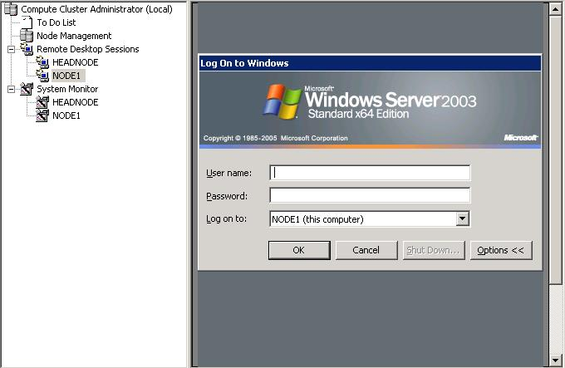
Figure 15. The Remote Desktop Sessions page in the Compute Cluster Administrator

- System Monitor: A System Monitor session for each node can be opened by selecting one or more nodes on the Node Management page, right-clicking, and then selecting Start Perfmon Task. Each System Monitor session appears in the left-hand navigation pane under System Monitor, as shown in Figure 16.
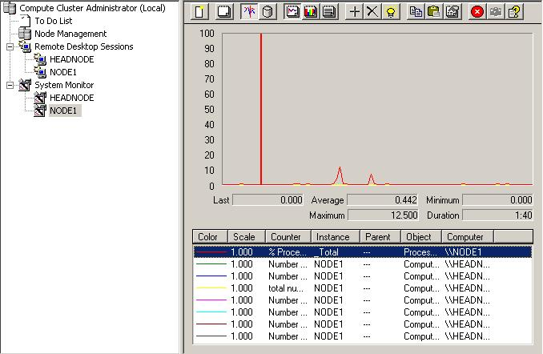
Figure 16. System Monitor in the Compute Cluster Administrator

Compute Cluster Job Scheduler
Jobs are the activities scheduled to perform on the compute cluster. Tasks are the discrete commands that jobs execute. The Job Scheduler queues jobs and their sub-tasks. It allocates resources to these jobs; initiates the tasks on the compute nodes of the cluster; and monitors the status of jobs, tasks, and compute nodes. Job scheduling is performed through a set of rules called scheduling policies. Figure 17 illustrates the job scheduler stack and its interaction with the job life cycle. The stack consists of three layers, each corresponding to one aspect of the job life cycle:
- The interface layer provides job and task submission, manipulation, and monitoring services accessible through a various entry points.
- The scheduling layer provides a decision-making mechanism that balances supply and demand by applying scheduling policies. The workload is distributed among available nodes among the cluster, implementing the concepts of job priorities, equitable sharing, and allocation of resources.
- The execution layer provides the workspace used by tasks. This layer creates and monitors the job execution environment and releases the resources assigned to the task upon task completion. The execution environment supplies the workspace customization for the task, including environment variables, scratch disk settings, security context, and execution integrity as well as application-specific launching mechanisms and recovery from system interruptions.
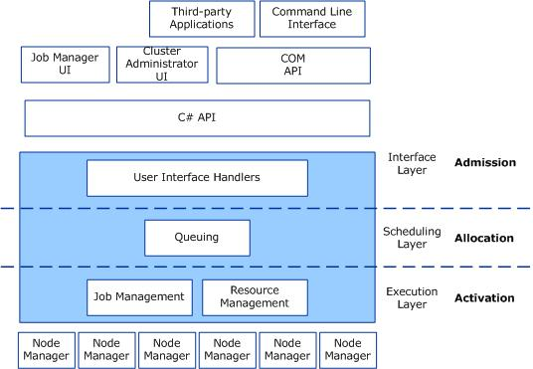
Figure 17. The job scheduler stack and its interaction with the job life cycle

Scheduling Policies
Job scheduling includes the order of jobs within the job queue and computing resource allocation. Operationally this is referred to as allocation. Job order and resource allocation are controlled through scheduling policies. Windows Compute Cluster Server 2003 supports four policies, with each policy focusing on a specific scheduling issue:
- Priority-based FCFS. This scheduling policy combines FCFS and priorities to run jobs. Jobs are placed in higher- or lower-priority groups when scheduled, based on the priority setting of the job itself, but when a job is placed within a group, it is always placed at the end of the queue.
- Backfilling. The Job Scheduler calculates the time and resources required to execute a job. Resources are reserved based on these calculations. If the Job Scheduler identifies open windows for resources within the reserved timelines, it can backfill by selecting smaller jobs for execution within this window.
- Nonexclusive schedules. By default, a job will use the allocated nodes exclusively. Nonexclusive schedules do not exclusively reserve resources for execution, so resources that these jobs use can be shared. Shared resources can be consumed at either the job or the task level. By default, jobs run in Exclusive mode while tasks run in Shared mode.
- License-aware scheduling. Windows Compute Cluster Server 2003 can manage job schedules through special license filters that verify licensing requirements for each job. If license requirements are not met, the job fails. This method helps ensure job compliance.
These policies should be used appropriately when allocating resources for jobs. Users can perform allocation through any one of the job scheduler interfaces, and the allocation becomes part of the job properties.
The default behavior of the job scheduler for all resource allocation strategies is to first sort candidate nodes according to memory size, and then sort nodes by their speed. Next, the scheduler allocates the CPUs from the sorted nodes to satisfy the minimum and maximum processor requirements for the job. The scheduler attempts to satisfy the maximum number of CPUs for the job before considering another job.

Filters
Administrators can control jobs through filters that run the job through a set of conditions before the job actually begins. Two types of filters are available:
- Submission filters
- Activation filters
Administrators can use these filter sets together to verify that jobs meet specific requirements before they pass through the system. Examples of the conditions for these filters include:
- Project validation. This condition verifies that the project name is that of a valid project and that the user is a member of the project.
- Mandatory policy. This condition ensures that run times are not set to infinite, which would clog up the cluster, and that the job does not exceed the user’s resource allocation limit.
- Usage time. Usage time ensures that the user’s time allocations are not exceeded. Unlike the mandatory policy, this filter limits jobs to the overall time allocations users have for all possible jobs.
In addition, activation filters can ensure that jobs meet licensing conditions before they run. Filters are a powerful job-control feature that should be part of every Windows Compute Cluster Server 2003 implementation. The Job Scheduler invokes the filters by parsing the job file, which contains all the job properties. The exit code of the filter program tells the Job Scheduler what to do. Three types of values are possible:
- 0: It is okay to submit the job without changing its terms
- 1: It is okay to submit the job with changed terms
If any other value appears, the job is rejected

Task Execution
The Compute Cluster Job Scheduler includes powerful features for job and task management. These job and task management features include:
- Error Recovery. Failed jobs or tasks are automatically retried and unresponsive nodes are identified;
- Automated Job Cleanup. After jobs are complete they are automatically retired to avoid runaway processes on the compute nodes.
- Security. Each job runs in the user’s security context, limiting job and task access rights to those of the user initiating them.
Tasks operate in either serial or parallel modes. In serial mode, tasks run sequentially on available resources in the nodes. Figure 5 illustrates how task 1 is assigned to the first processor on the first node, task 2 is assigned to the second processor, and task 3 moves to the first processor of the second node, and so on.
Figure 6 illustrates a single task running in parallel mode. Parallel tasks typically call upon the Microsoft MPI software through the mpiexec task launcher on compute nodes. Task processes are started through the MPI-specific nodal daemon for Single Program Multiple Data (SPMD) programming. Each node can run only one SMPD process, but parallel tasks can call on several nodes to launch the SMPD process. Then, when all nodes are ready, the task is executed. Windows File Sharing supports client-side caching, so applications have to be loaded only once. The application will reside on the compute node’s local disk after it has been loaded, which will speed processing. This configuration must be made on the file server to work and can be done when creating the file share.
The scheduler keeps track of each task and job through task and job ID numbers. It relies on these ID numbers to display task and job status information to Windows Compute Cluster Server 2003 users.
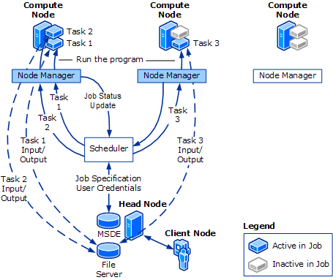
Figure 18. Serial task execution

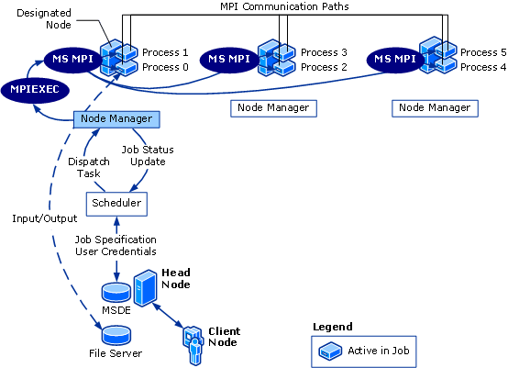
Figure 19. Parallel task execution

Job Manager UI
The Compute Cluster Job Manager is a GUI-based application that provides access to the Job Scheduler for job creation, submission, and monitoring. The Compute Cluster Job Manager can be installed and run on a computer outside the cluster, such as a workstation. This allows users to manage clusters remotely and potentially choose from multiple clusters with which to work.
The Computer Cluster Job Manager UI consists of a title bar, a menu bar, and an upper and lower display pane.
The title bar displays the host name of the head node. The default is the local system, always identified as Localhost.
The menu bar contains the menu items, File, View, and Show. File and View access screens for cluster connection, job creation and submission, and also system level options. Show makes it possible to filter the jobs displayed in the job queue according to different criteria.
The upper pane displays the job queue in tabular form. Each line represents a job, while each column represents a status, property, or other statistic belonging to the job.
The lower pane displays the task list of the selected job. Each line represents a task while each column represents a status, property, or other statistic belonging to the task.

Job and Task Templates
Jobs can be created and submitted interactively or from a job template. Jobs and tasks can be saved as templates through the Job Manager by clicking Save as Template in the Job and Task Properties sheets. Template files are saved in Extensible Markup Language (XML) format and can therefore be edited in a text editor after they are created.
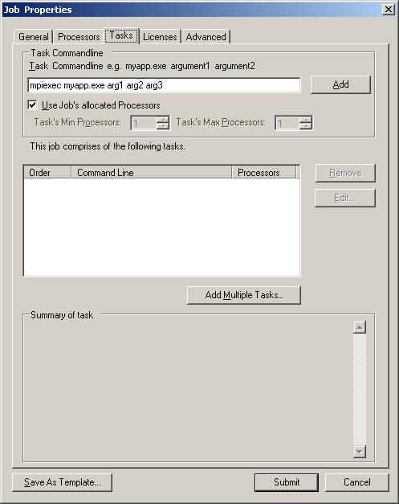
Figure 20. Save As Template option visible from a component of the Job Manager GUI

Command Line Interface
The command line interface (CLI) is another interface that can be used to access the job scheduler. Each Job Manager feature has a corresponding equivalent in the CLI. a set of Windows Compute Cluster Server commands entered at command prompt to create, submit, and manage jobs (user operations), as well as manage the cluster itself (administrator operations). Many HPC users prefer command line tools over a GUI. Also, the CLI tools make it possible for script writers to write complex scripts for working with the compute cluster.

CLI Command Set
As a command set, the CLI consists of five primary commands: job, task, cluscfg, and node. Each command is in effect multiple commands, as determined by the operator that follows; for example, job new, job submit, and job list. For purposes of user operations, only the commands, job and task are used.
A complete list of the options available for the job, task, and cluscfg commands appears in Table 10.
Table 10. CLI Commands
Command | Operators | Description
job | job new [job_terms] | Create a job container
 | job add jobID [task_terms] | Add tasks to a job
 | job submit /id:jobid | Submit a job created through the “job new” command
 | job submit [job_terms][task_terms] | Submit a job
 | job cancel jobID | Cancel a job
 | job modify [options] | Modify a job
 | job requeue JobID | Re-queue a job
 | job list | List jobs in the cluster
 | job listtasks | List the tasks of a job
 | job view JobID | View details of a job
task | task view taskID | View details of a task
 | task cancel taskID | Cancel a task
 | task requeue taskID | Re-queue a task
cluscfg | cluscfg view | View details of a cluster
 | cluscfg listparams/setparams | View or set configuration parameters
 | cluscfg listenvs/setenv | List or set cluster-wide environment
 | cluscfg delcreds/setcreds | Set or delete user credentials

For example, to create a task through the CLI the user types the following at the command line:
job add <jobID> [standard_task_options] [/jobfile:<template_file>] <command> [arguments]
where jobID is the number of the job, template_file is the file containing job commands , and command is additional actions for the job to perform.

The Compute Cluster Pack Application Programming Interface (CCPAPI)
The Compute Cluster Pack Application Programming Interface (CCPAPI) is a C# API that provides another method by which to access the Job Scheduler. By writing applications or scripts using these interfaces, you can connect to a cluster and manage jobs, job resources, tasks, nodes, environment variables, extended job terms and much more.
Using CCPAPI, in its simplest terms, is a five step process.
- Connect to the cluster
- Create a job
- Create a task
- Add the task to the job
- Submit the job/task for execution
To connect to the cluster use the ICluster::Connect method. Create a job using the ICluster::CreateJob method. To create a task, use the ICluster::CreateTask method. To add a child task to a job, use the ICluster::AddTask method. Finally, submit the job using ICluster::SubmitJob() method.

MS-MPI Features
MS-MPI is a full-featured implementation of the MPI2 specification.

Programming Features of MS-MPI
MPI uses objects called communicators to control which collections of processes can communicate with each other. Each process has an ID or rank in the communicator. The default communicator includes all processes for the job and is known as MPI_COMM_WORLD. Programmers can create their own communicators to limit communications to a subset of MPI_COMM_WORLD as appropriate.
The MS MPI communications routines also include collective operations. These collective operations allow the programmer to collect and evaluate all the results of a particular operation across all nodes in a communicator in one call.
MPI supports a high degree of control over communications and buffers across the nodes of the cluster. The standard routines are appropriate for many actions, but when you want specific buffering, MPI supports it. Communications routines can also be blocking or non-blocking, as appropriate.
MPI supports both predefined data types and derived data types. The built-in data type primitives are contiguous, but derived data types can be contiguous or noncontiguous.

Mpiexec
MPI applications executed on the compute cluster are started with an executable called mpiexec. The job submit command is the usual mechanism for starting jobs in a Windows Compute Cluster Server 2003 cluster. This command specifies the mpiexec command parameters for the job. You can specify the number of processors required and the specific nodes that should be used for a given job. Mpiexec, in turn, gives you full control over how a job is executed on the cluster. A typical command line might be:
job submit /numprocessors:8 /runtime:5:0 mpiexec myapp.exe
This command line submits the application, myapp.exe, to the Job Scheduler, which assigns it to eight processors for a running time not to exceed five hours. Table 11 shows other common Mpiexec arguments:
Table 11. Common Mpiexec arguments
Argument | Result
Mpiexec -env MPICH_NETMASK 157.59.0.0/255.255.0.0 MyApp.exe | Routes MyApp.exe MPI traffic to the 157.59.x.x/255.255.0.0 network in the cluster
mpiexec -hosts 2 Node1 1 Node2 1 MyApp.exe | Forces one process on each node
mpiexec -n 4 MyApp.exe | Simulates a cluster on one computer
mpiexec -wdir \headnode\shared\Parallel\ MyApp.exe | Simulates a cluster on one computer by running 4 processes on a single node with MPI communication between them

Mpiexec supports command-line arguments, environment variables, and command files for execution, providing maximum flexibility in job control to both the administrator and user on a Windows Compute Cluster Server cluster. You can set environment variables for a specific job, or you can set them globally, across the entire cluster.
An important improvement that MS-MPI brings to MPICH2 is in how security is managed during execution of MPI jobs. Each job is run with the credentials of the user. Credentials are only present while the job is being executed and they are erased when the job completes. Individual processes only have access to a logon token for their process, and processes do not have access to the job credentials or to the credentials used by other processes.
Developers can also use the Job Scheduler to reserve nodes for a job (including credentials), and then submit the jobs directly from Visual Studio 2005 using Mpiexec. This functionality greatly simplifies the debugging process of building an application. Alternatively, you can create a smaller debugging cluster to use directly from Visual Studio with Mpiexec.

Cluster Security
The task of adding and removing cluster administrators and users is performed using the Compute Cluster Administrator.
Windows Compute Cluster Server 2003 uses the existing local Administrator and User groups on the head node to assign administrators and user privileges on the cluster. When the Manage Users Wizard is used to add new users and administrators to the cluster, the changes in membership are propagated to all compute nodes through changes to local group membership.
Both Administrator and User group memberships are propagated to all nodes on a cluster automatically as part of the configuration process.
Compute nodes that are pending approval do not receive the new Administrator and User group information.
User rights management using centralized Active Directory authentication and local group membership differentiates Windows Compute Cluster Server 2003 from prevailing methods that rely on replicating user accounts and passwords across nodes.

Cluster Administrators
Cluster Administrators have full access to all nodes on the cluster and automatically become members of the local Administrators group on each node in the cluster. Cluster Administrators can use the Compute Cluster Administrator to add and remove compute nodes and add or remove cluster users. Administrators can submit jobs and manage the job queue by using the Cluster Job Manager or the CLI.

Cluster Users
Cluster users can also submit jobs by using the Cluster Job Manager or the CLI. Users can view the entire job queue but can modify only their own jobs. Jobs run under the user credentials of the person who submitted the job; as a result, jobs can only access resources and services when they are being executed.

Security Considerations for Jobs and Tasks
Windows Compute Cluster Server 2003 uses standard Windows mechanisms to manage security within the cluster context. Jobs are executed with the submitting user’s credentials. These credentials are stored in encrypted format on the local machine by the Job Manager, and only the head node has access to the decryption key.
The first time a user submits a job, the system prompts for credentials in the form of a user name and password. At this point, the credentials can be stored in the credential cache of the submission machine. When in transit, credentials are protected through a secure Microsoft .NET Remoting channel, then secured through the Windows Data Protection application programming interface (DPAPI) and stored in the job database. When a job runs, the head node decrypts the credentials and uses another secure .NET Remoting channel to pass them along to compute nodes, where they are used to create a token, and then erased. All tasks are performed using this token, which does not include the explicit credentials. When jobs are complete, the head node deletes the credentials from the job database.
When the same user submits the same job for execution again, no credentials are requested because they are already cached on the local machine running the Job Manager. This feature simplifies resubmission and provides integrated security for credentials throughout the job life cycle, as shown in Figure 21.

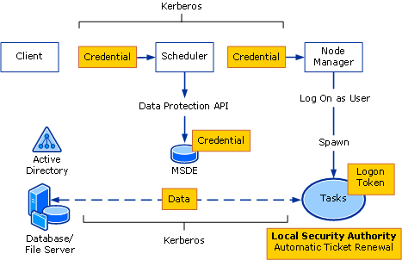
Figure 21. The end-to-end Windows Compute Cluster Server 2003 security mode

Summary
Windows Compute Cluster Server 2003 is a new member of the Windows Server family that will allow researchers and engineers to achieve faster time to insight by using high performance, affordable clusters of x64 systems. With prescriptive installation scripts and automated setup processes that lead novice administrators through setup tasks, Windows Compute Cluster Server 2003 removes the administrative barriers found in common high-performance computing configurations. The operating system user interface and management console uses the familiar Windows look and feel that further simplifies and eases cluster management and administration. Windows Compute Cluster Server 2003 provides a complete Job Scheduler to help submit and track workloads on the cluster. Parallel applications can be run with full MPI support provided, using the MS-MPI which is an implementation of the MPI-2 standard. Leading applications from key ISVs can be run on the cluster to help individuals and organizations meet their needs in a timely and cost-effective yet high performance manner. Windows Compute Cluster Server 2003 provides seamless integration with Windows for security, storage, and user productivity. For developers of parallel applications, Visual Studio 2005 is enhanced with parallel debugging capabilities that support MS-MPI.

Related Links
For further information about Windows Compute Cluster Server 2003 and high-performance computing see the Windows high-performance computing Web site at http://www.microsoft.com/hpc. For more information on the Windows Server 2003 family, see the Windows Server 2003 Web site at http://www.microsoft.com/windowsserver2003. Among the resources on the site are numerous technical articles describing technologies and features in Windows Server 2003.
Supporting information also can be found for:
- Microsoft .NET at http://www.microsoft.com/net
- Windows XP Professional operating system at http://www.microsoft.com/windowsxp/pro
- Microsoft enterprise servers at http://www.microsoft.com/servers
- MSDN® at http://www.microsoft.com/msdn
- TechNet at www.microsoft.com/technet



The information contained in this document represents the current view of Microsoft Corporation on the issues discussed as of the date of publication. Because Microsoft must respond to changing market conditions, it should not be interpreted to be a commitment on the part of Microsoft, and Microsoft cannot guarantee the accuracy of any information presented after the date of publication.
This white paper is for informational purposes only. MICROSOFT MAKES NO WARRANTIES, EXPRESS OR IMPLIED, IN THIS
DOCUMENT.
Complying with all applicable copyright laws is the responsibility of the user. Without limiting the rights under copyright, no part of this document may be reproduced, stored in, or introduced into a retrieval system, or transmitted in any form or by any means (electronic, mechanical, photocopying, recording, or otherwise), or for any purpose, without the express written permission of Microsoft Corporation.
Microsoft may have patents, patent applications, trademarks, copyrights, or other intellectual property rights covering subject matter in this document. Except as expressly provided in any written license agreement from Microsoft, the furnishing of this document does not give you any license to these patents, trademarks, copyrights, or other intellectual property.
© 2006 Microsoft Corporation. All rights reserved.
Microsoft, Active Directory, Visual Studio, Windows, the Windows logo, Windows Server, and, Windows Server System are either registered trademarks or trademarks of Microsoft Corporation in the United States and/or other countries.
The names of actual companies and products mentioned herein may be the trademarks of their respective owners.

