

Overview of the Microsoft File Server Migration Toolkit
Microsoft Corporation
Published: March 2005

Abstract
The File Server Migration Toolkit helps you copy files and folders from servers running Microsoft® Windows® 2000 Server or Microsoft® Windows NT® Server 4.0 operating systems to a server running Microsoft® Windows Server™ 2003 operating systems or Microsoft® Windows® Storage Server 2003. Whether you plan to consolidate multiple file servers or migrate data from one file server to another, the File Server Migration Toolkit is designed to simplify the process of copying data and minimize the impact of the consolidation or migration on end users.
This white paper briefly describes the tools included in the File Server Migration Toolkit, their benefits, and their requirements.

The information contained in this document represents the current view of Microsoft Corporation on the issues discussed as of the date of publication. Because Microsoft must respond to changing market conditions, it should not be interpreted to be a commitment on the part of Microsoft, and Microsoft cannot guarantee the accuracy of any information presented after the date of publication.
This White Paper is for informational purposes only. MICROSOFT MAKES NO WARRANTIES, EXPRESS, IMPLIED OR STATUTORY, AS TO THE INFORMATION IN THIS DOCUMENT.
Complying with all applicable copyright laws is the responsibility of the user. Without limiting the rights under copyright, no part of this document may be reproduced, stored in or introduced into a retrieval system, or transmitted in any form or by any means (electronic, mechanical, photocopying, recording, or otherwise), or for any purpose, without the express written permission of Microsoft Corporation.
Microsoft may have patents, patent applications, trademarks, copyrights, or other intellectual property rights covering subject matter in this document. Except as expressly provided in any written license agreement from Microsoft, the furnishing of this document does not give you any license to these patents, trademarks, copyrights, or other intellectual property.
Unless otherwise noted, the example companies, organizations, products, domain names, e-mail addresses, logos, people, places, and events depicted herein are fictitious, and no association with any real company, organization, product, domain name, e-mail address, logo, person, place, or event is intended or should be inferred.
© 2005 Microsoft Corporation. All rights reserved.
Microsoft, Windows, Windows NT, Windows Server, Windows Server System are either registered trademarks or trademarks of Microsoft Corporation in the United States and/or other countries.

The names of actual companies and products mentioned herein may be the trademarks of their respective owners.

Contents
Overview of the Microsoft File Server Migration Toolkit 5
Introduction to the Microsoft File Server Migration Toolkit 5
File Server Migration Toolkit Benefits 6
File Server Migration Wizard Overview 8
DFS Consolidation Root Wizard and Dfsconsolidate.exe Overview 11
Consolidation and Migration Scenario 13
System and Account Requirements 16
DFS Consolidation Root Wizard and Dfsconsolidate.exe requirements 16
System requirements 16
Account requirements 18
File Server Migration Wizard requirements 18
System requirements 18
Account requirements 18
Scalability Considerations for DFS Consolidation Roots 19
Additional Resources 19
Appendix: Basic DFS Creation and Startup Performance 21

Overview of the Microsoft File Server Migration Toolkit

Introduction to the Microsoft File Server Migration Toolkit
Microsoft® Windows® server technologies deliver low total cost of ownership (TCO) and reliable file services that are essential to enterprise computing infrastructures. The Microsoft® Windows Server™ 2003 operating systems deliver an exciting set of customer-focused improvements in file services, especially for customers currently using Microsoft® Windows NT® Server 4.0 to provide file services.
The File Server Migration Toolkit helps you copy files and folders from servers running Microsoft® Windows® 2000 Server or Windows NT Server 4.0 operating systems to a server running Windows Server 2003 or Microsoft® Windows® Storage Server 2003. Whether you plan to consolidate multiple file servers or migrate data from one file server to another, the File Server Migration Toolkit is designed to simplify the process of copying data and minimize the impact of the consolidation or migration on end users.
After the consolidation or migration is complete, your organization can take advantage of new features in Windows Server 2003, such as Shadow Copies for Shared Folders, and enhancements to other technologies, such as Distributed File System (DFS). For more information about file services available in Windows Server 2003, see “Technical Overview of Windows Server 2003 File Services” at http://go.microsoft.com/fwlink/?LinkId=28869.
The tools provided in the File Server Migration Toolkit are described below. For information about the tool requirements, including server and client compatibility, see “System and Account Requirements” later in this document.

File Server Migration Wizard
The File Server Migration Wizard is a graphical user interface (GUI) tool for copying files, folders, and their security settings from one or more source file servers to a target file server. The wizard walks you step by step through the copy process, which includes creating a migration project where project-specific settings are stored, monitoring the progress of the file copying, and viewing a final report of the copying results. You can start and stop a migration project at any time, and settings are maintained for that project the next time you start the wizard.

DFS Consolidation Root Wizard
The DFS Consolidation Root Wizard reduces the impact of file server consolidation or migration on end users by maintaining the original Universal Naming Convention (UNC) paths of files and folders after they are copied to a new server. Because the original UNC paths are maintained, you do not need to inform users about new server names, and line-of-business applications as well as shortcuts and OLE links in user files and e-mail messages continue to work after the consolidation or migration is complete.

Dfsconsolidate.exe command-line tool
Dfsconsolidate.exe is the command-line tool that is invoked by the DFS Consolidation Root Wizard to perform the tasks that are necessary to maintain the original UNC paths of files and folders. You can use Dfsconsolidate.exe to create new DFS consolidation roots, modify or correct settings that you specified in the DFS Consolidation Root Wizard, and remove DFS consolidation roots and settings that you originally created by using the DFS Consolidation Root Wizard.

File Server Migration Toolkit Benefits
The File Server Migration Toolkit provides the following benefits.

Simplifies the complex and error-prone migration process
The File Server Migration Wizard validates all settings before copying files to ensure that copying will complete successfully. Any errors and warnings encountered during validation are provided in the report for you to review before continuing the migration. The initial copying of data does not require downtime of the source file servers, and you can re-run the copying process as many times as necessary to re-copy files that have changed since the last copying pass. Choosing whether to copy security settings is easy — just select the security-related options in the wizard. The File Server Migration Wizard also provides an option to stop sharing source folders after the migration is complete.

Maintains UNC paths and eliminates broken shortcuts and links
Using DFS consolidation roots to maintain the original UNC paths of files ensures a transparent migration experience for end users. There is no need to use a separate utility that can identify and fix broken links on client computers, such as OLE links or application-related links in the registry. Users can continue to access shared folders just as they did prior to the migration, and line-of-business applications continue to work correctly.

Maintains security settings after the migration
To ensure the security of files and folders after they are migrated to a target file server, the File Server Migration Wizard applies permissions that are the same as or more restrictive than they were on the source files and folders, depending on the option you select. For example, if you do not choose to copy security settings from the source to the target files and folders, the wizard applies permissions to the target files, folders, and shared folders by granting Full Control permission to the local Administrators group of the target file server. If you select the Copy security settings option, the File Server Migration Wizard copies all security settings for files, folders, and shared folders, including NTFS file system permissions, auditing, ownership, and shared folder permissions. If you also select the Resolve invalid security descriptors option, the wizard cleans up security descriptors whose security identifiers (SIDs) cannot be resolved on the target file server.

Consolidates shared folders with the same names from different servers
Migrating shared folders from multiple source file servers to a single target file server can result in name conflicts if two or more shared folders have the same name. For example, a shared folder called Teams on source file servers named FS1 and FS2 will cause a conflict if they are both copied to the same target file server named Corp-FS-1 because the UNC path \\Corp-FS-1\Teams can represent only one of the shared folders. The File Server Migration Wizard eliminates this problem by using default target shared folder names that have the format Sharename_SourceServerName, where Sharename is the name of the shared folder on the source file server, and SourceServerName is the name of the source file server. You can modify the default target shared folder name for each source folder prior to beginning the migration.

Supports server clusters as source and target file servers
The DFS Consolidation Root Wizard and Dfsconsolidate.exe can create DFS consolidation roots on server clusters, and the File Server Migration Wizard can create the necessary File Share resources to represent shared folders on the target server clusters. For large migration projects that are nearing the maximum number of cluster resources (1,674 resources, including File Share resources), the File Server Migration Wizard provides an option to optimize cluster resources so that only the parent folder of the migrated folders is shared as a File Share resource.

Provides roll-back functionality
If network connectivity or other problems prevent the File Server Migration Wizard from completing the migration successfully, the wizard can attempt to restore access to the source file servers. This roll-back process allows users to continue accessing data on the source file servers while you investigate and repair the problem and then complete the migration.

File Server Migration Wizard Overview
The File Server Migration Wizard provides a number of options for copying data. For example, you can:
• Copy permission, auditing, and ownership information that is associated with files and folders.
• Resolve invalid security descriptors on the target files and folders.
• Stop sharing the shared folders on the source file servers after the copying is finalized.
• Prestage the target file server—for example, by restoring a backup of the source file server—and then use the File Server Migration Wizard to recopy changed files and share the target folders.
• Specify the DFS root server that hosts DFS consolidation roots that are created by the DFS Consolidation Root Wizard. When you select this setting, the DFS links that correspond to each copied folder are updated with the new Universal Naming Convention (UNC) paths of the target folders.
• Specify an existing DFS namespace where you want to add DFS links for each copied shared folder. You can select this setting even if you do not use the DFS Consolidation Root Wizard.
The File Server Migration Wizard does not provide the following features:
• Local group migration
• Bandwidth throttling
• Migrating files and folders from servers running operating systems other than Windows Server 2003, Windows 2000 Server, Windows NT Server 4.0, or Windows Storage Server 2003.
The following sections describe the four phases of the File Server Migration Wizard.

Setup phase
During this phase, you set up a migration project by customizing settings related to the migration. For example, you select the source file servers, specify the location to migrate the files to on the target server, and so forth. These settings are stored in an .XML project file, which allows you to stop a migration project at any time and return to the settings the next time you start the File Server Migration Wizard.
After you configure settings, the File Server Migration Wizard validates your settings and creates a report that describes successful validation tasks and warns you about potential conflicts or other problems that might be encountered during the migration. The figure below illustrates the File Server Migration Wizard after it has completed the Setup phase.
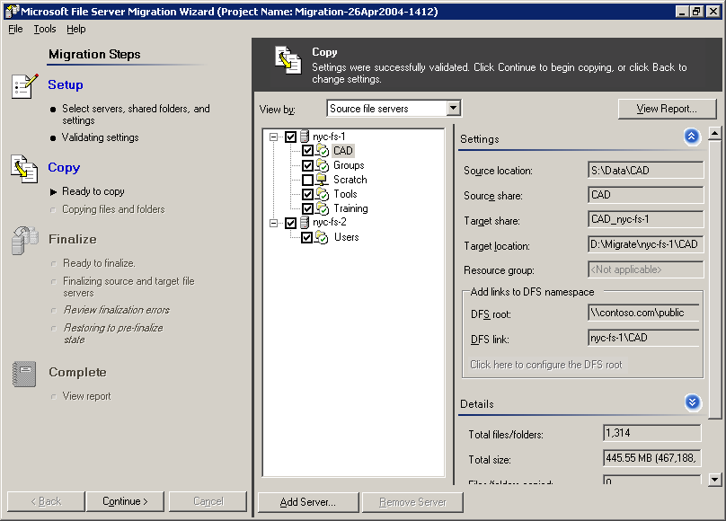

Copy phase
During this phase, the File Server Migration Wizard creates the target folders and begins copying files from the source file servers to the target file server. No server downtime occurs during this phase. Open files will be skipped during this phase but will be closed and copied during the Finalize phase.
The wizard shows the copying progress for the entire project and for a selected shared folder as illustrated in the following figure.
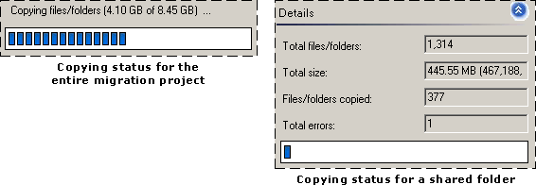

At the end of this phase, the File Server Migration Wizard creates a report that describes successful and failed copy attempts. You can repeat this phase multiple times; only changed files will be copied in successive attempts.

Finalize phase
During this phase, the File Server Migration Wizard completes the migration. Because users are disconnected from the source file servers during this phase, we recommend that you begin this phase during a maintenance window. When the Finalize phase is complete, the File Server Migration Wizard creates a report that describes the final results of the copying. If the Finalize phase is not successful, you have the option of rolling back servers to a prefinalize state.

Complete phase
During this phase, you can view a report that contains details about the source file servers and shared folders that were copied. The report also contains links to .txt files that describe any errors that occurred when individual files were copied.
The following figure illustrates the report that is created after the migration is complete.
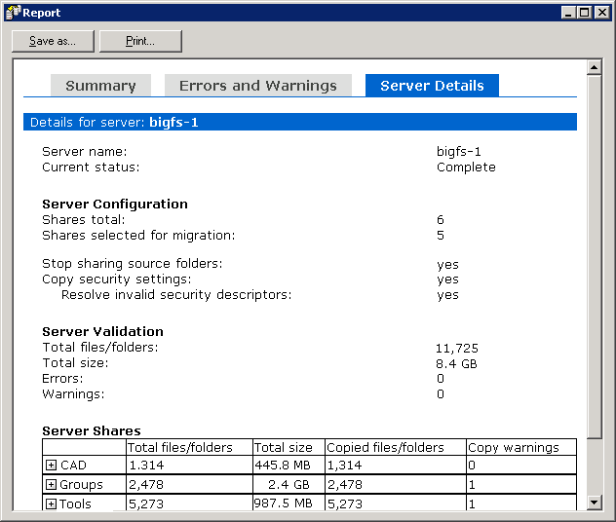

DFS Consolidation Root Wizard and Dfsconsolidate.exe Overview
To maintain the original UNC paths of files, the DFS Consolidation Root Wizard and Dfsconsolidate.exe use new functionality in Distributed File System (DFS). These tools also modify Domain Name System (DNS) records and Windows Internet Name Service (WINS) records (through registry entries) for nonclustered servers. For server clusters, the tools create a Network Name resource. These modifications enable users who attempt to access the original UNC path of the files to be redirected to the DFS root server that hosts the namespace. The DFS root server sends the client a referral that contains the current UNC path of the files. Whether the files still reside on the source file server (before the files are migrated) or whether they reside on the target file server (after the files are migrated), users can continue to access the files by using their original UNC path.
Important
The DFS root server must run the DFS Consolidation Root hotfix that is described in article 829885 in the Microsoft Knowledge Base at http://go.microsoft.com/fwlink/?LinkID=23225. Although this article contains manual installation steps for creating DFS consolidation roots, you do not need to follow these manual installation steps if you use Dfsconsolidate.exe or the DFS Consolidation Root Wizard. These tools will configure DFS consolidation roots for you.
The following figure illustrates a page in the DFS Consolidation Root Wizard. On this page, you specify the original names of the servers whose UNC paths you want to maintain, and you specify the current names of the servers after they were renamed. (The servers must be renamed prior to running this wizard to allow the DFS root server to respond to requests from clients to access the original server names.)
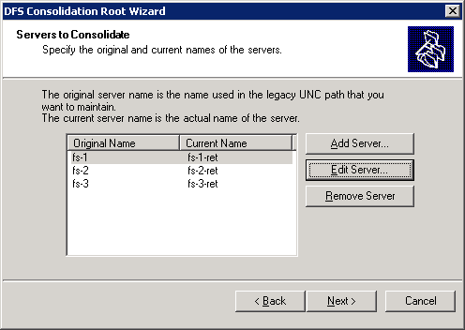

Note
After you complete the migration, you can use the Distributed File System snap-in, the Dfscmd.exe command-line tool, and the Dfsutil.exe command-line tool to manage DFS namespaces created by the DFS Consolidation Root Wizard.

Consolidation and Migration Scenario
This scenario describes a fictional consolidation and migration project to illustrate how the wizards in the File Server Migration Toolkit interact, the changes that they make, and how the original Universal Naming Convention (UNC) paths are maintained.
In this scenario, an administrator wants to consolidate three source file servers running Windows NT Server 4.0 into a single server running Windows Server 2003. The administrator also wants to maintain the original UNC paths of the files after they are migrated. The source file server names, source shared folder names, and original UNC paths that are used in this scenario are shown in the following table.

Source file server | Source shared folder names | Original UNC path
FS1 | Teams | \\FS1\Teams
 | Templates | \\FS1\Templates
FS2 | Teams | \\FS2\Teams
 | Tools | \\FS2\Tools
FS3 | Archive | \\FS3\Archive
 | Public | \\FS3\Public

These servers are illustrated in the following figure.
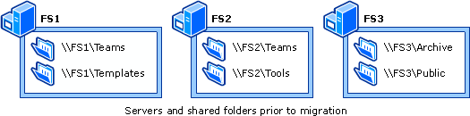

The two phases of the migration are setting up DFS consolidation roots and migrating the data to the target file server, described as follows.
Setting up DFS consolidation roots
During a maintenance window, the administrator begins the process of setting up DFS consolidation roots to maintain the original UNC paths of files. The steps in this process are as follows:
1. The administrator renames the source file servers to FS1-Ret, FS2-Ret, and FS3-Ret, where “Ret” means “Retired.” (Renaming the source file servers is necessary so that the DFS root server can respond to users who attempt to access the original server names. Renaming a server requires you to restart the server, which is why this task is performed during a maintenance window.)
2. The administrator runs the DFS Consolidation Root Wizard, which sets up DFS consolidation roots for each of the source file servers and creates DFS links for each of the source shared folders. The DFS consolidation roots and DFS links are created on a server named DFS-1, as shown in the following table.

DFS consolidation root name | DFS link name | UNC path of DFS link target | Original UNC path
#FS1 | Teams | \\FS1-Ret\Teams | \\FS1\Teams
 | Templates | \\FS1-Ret\Templates | \\FS1\Templates
#FS2 | Teams | \\FS2-Ret\Teams | \\FS2\Teams
 | Tools | \\FS2-Ret\Tools | \\FS2\Tools
#FS3 | Archive | \\FS3-Ret\Archive | \\FS3\Archive
 | Public | \\FS3-Ret\Public | \\FS3\Public

At this point, the environment is fully functional, and Distributed File System (DFS) enables users to access their data by using the original UNC paths.
Migrating the data to the target file server
When the data migration is scheduled to begin, the administrator uses the File Server Migration Wizard to set up a migration project. As part of the project, the administrator can select various options, such as whether to copy security settings, whether to disable shared folders on source file servers after migration is finished, and so forth. The administrator also specifies the name of the DFS root server, DFS-1, that hosts the consolidation roots. This option enables the File Server Migration Wizard to automatically populate the list of source file servers (as entered in the DFS Consolidation Root Wizard) and update the existing DFS link targets to point to the UNC path of the migrated shared folders on the target server called CORP-FS-1.
After the migration project is set up, the administrator uses the File Server Migration Wizard to begin copying files from the source file servers to the target file server. Because file copying does not disrupt users' access to the source file servers, the copying can take place anytime. The administrator can repeat the copying phase to perform an incremental copy of new or changed files.
To complete the migration, the administrator starts the Finalize phase in the File Server Migration Wizard. Because the Finalize phase disconnects users from the source file servers, the administrator begins this phase during a maintenance window. In the Finalize phase, the wizard synchronizes all files and folders on the target file server so that the files, folders, and their security settings are identical to those on the source file server.
When the migration is complete, the target file server, CORP-FS-1, is configured as shown in the following table.

Target shared folder name | UNC path of DFS link target | Original UNC path
Teams_FS1 | \\CORP-FS-1\Teams_FS1 | \\FS1\Teams
Templates_FS1 | \\CORP-FS-1\Templates_FS1 | \\FS1\Templates
Teams_FS2 | \\CORP-FS-1\Teams_FS2 | \\FS2\Teams
Tools_FS2 | \\CORP-FS-1\Tools_FS2 | \\FS2\Tools
Archive_FS3 | \\CORP-FS-1\Archive_FS3 | \\FS3\Archive
Public_FS3 | \\CORP-FS-1\Public_FS3 | \\FS3\Public

In this table, notice how the File Server Migration Wizard renames the target shared folder names by appending the source file server name. This prevents shared folder name conflicts when the folders are moved to a single server. However, the original UNC paths are still maintained as part of the DFS consolidation roots that are set up by the DFS Consolidation Root Wizard; therefore, renaming the shared folders does not affect users. When the migration process is complete, the File Server Migration Wizard updates the UNC paths of the DFS link targets to point to the target file server.
The following figure illustrates the environment after the migration is complete.
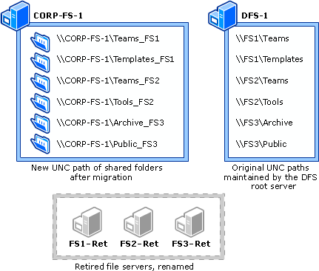

System and Account Requirements
You can install the File Server Migration Toolkit on x86-based servers running Windows Server 2003 operating systems or the Windows Storage Server 2003. The following sections describe additional requirements for the tools in the toolkit.

DFS Consolidation Root Wizard and Dfsconsolidate.exe requirements

System requirements
The Distributed File System (DFS) root server that hosts DFS consolidation roots must meet the following requirements:
• The DFS root server cannot be a domain controller.
• The DFS root server must run Windows Server 2003, Enterprise Edition, or Windows Server 2003, Datacenter Edition.
• The DFS root server must run the DFS Consolidation Root hotfix that is described in article 829885 in the Microsoft Knowledge Base at http://go.microsoft.com/fwlink/?LinkId=23225. Although this article contains manual installation steps for creating DFS consolidation roots, you do not need to follow these manual installation steps if you use Dfsconsolidate.exe or the DFS Consolidation Root Wizard. These tools will configure DFS consolidation roots for you.
• If the DFS root server is part of a server cluster, before you run the DFS Consolidation Root Wizard, you must create the resource group where the DFS consolidation root will be created or you must identify an existing resource group. The resource group must contain an IP Address resource and a Physical Disk resource.
Clients that access the DFS namespaces that are set up by the DFS Consolidation Root Wizard and Dfsconsolidate.exe must run one of the following operating systems or Windows Server System products:
• Windows Server 2003
• Windows 2000 Server
• Windows NT Server 4.0 with Service Pack 6a (SP6a)
• Windows Storage Server 2003
• Microsoft® Windows® XP Professional
• Microsoft® Windows® 2000 Professional
• Microsoft® Windows NT® Workstation 4.0 with SP6a
Important
After you run the DFS Consolidation Root Wizard or Dfsconsolidate.exe, you must delete and recreate all clients’ persistent drive mappings to the maintained UNC paths. If you do not, clients cannot access the consolidated data. Restarting the client does not reset persistent drive mappings, so you must delete and recreate the mapped drives manually (using the net use driveletter: /delete and net use driveletter: \\UNCpath commands) or by using a script. This issue only affects persistent drive mappings. Drives that are mapped through logon scripts at each log on work correctly.
Clients running Microsoft® Windows® 98 or Microsoft® Windows® 95 cannot access namespaces that are set up by the DFS Consolidation Root Wizard. However, these clients can access the migrated shared folders by using the UNC paths that point to the new file server.
Note
If you are using a non-clustered DFS root server to host consolidation roots, client computers will use the NTLM authentication protocol when they connect to the DFS root server. This only applies when a client requests DFS referrals; when a client accesses a file server, the client will use whatever authentication protocol is supported.

Account requirements
You must be a member of the local Administrators group on the DFS root server that hosts DFS consolidation roots.

File Server Migration Wizard requirements

System requirements
The target file servers and source file servers that you specify in the File Server Migration Wizard must meet the following requirements:
• Source file servers must be running Windows Server 2003, Windows 2000 Server, Windows NT Server 4.0, or Windows Storage Server 2003.
• Target file servers must be running Windows Server 2003 or Windows Storage Server 2003.
• Source and target file servers can be server clusters.
• Target volumes must be formatted with the NTFS file system.
• Source folders must be shared. If you want to migrate folders that are not shared, you must share them first.

Account requirements
To run the File Server Migration Wizard, you must be a member of the local Administrators group on the source and target file servers.

Scalability Considerations for DFS Consolidation Roots
Based on our performance testing, we recommend that you plan to consolidate no more than 50-100 servers per single DFS consolidation root server, with a maximum of 200 servers (assuming an average of 500 shared folders per server that is consolidated using the DFS Consolidation Root Wizard or Dfsconsolidate.exe.) This recommendation is based on the following goals:
• Keeping the startup latency of the Distributed File System service to less than one minute on the DFS consolidation root server. This is especially important in the case of clustered DFS consolidation root servers, which have additional cluster failover latency.
• Keeping the client impact low. Prior to consolidation, client load is spread across many servers. After consolidation, clients must first contact a single DFS consolidation root server to obtain a referral that directs the client to a server that contains the consolidated data. In addition, the DFS Consolidation Root Wizard and Dfsconsolidate.exe add the DNS and NetBIOS names of all consolidated servers to the DFS consolidation root server as part of the consolidation process. (This is how the DFS consolidation root server is able to redirect clients accessing UNC paths pointing to the old servers to the new servers.) With a large number of additional names, performance issues might occur when a large number of clients use the DFS consolidation root server for the mapping operation that maps the old server names (before they were renamed) to the new server names.
For details of the performance testing that led to our recommendations, see "Appendix: Basic DFS Creation and Startup Performance" later in this document.

Additional Resources

DFS Web site
For links to demonstrations, case studies, documentation, and frequently asked questions (FAQs) about Distributed File System (DFS), see "Distributed File System and File Replication Services" on the Microsoft Web site at http://go.microsoft.com/fwlink/?LinkId=18421.

File Server Migration Toolkit Web site
To download the File Server Migration Toolkit, see “Microsoft File Server Migration Toolkit” on the Microsoft Web site at http://go.microsoft.com/fwlink/?LinkId=26396.

Knowledge Base articles about renaming domain controllers
If you need to rename a domain controller before running the DFS Consolidation Root Wizard, refer to the following Knowledge Base articles:
• For instructions about renaming domain controllers running Windows NT Server 4.0, see article 150298 in the Microsoft Knowledge Base at http://go.microsoft.com/fwlink/?LinkId=28870.
• For instructions about renaming domain controllers running Windows 2000 Server, see article 296592 in the Microsoft Knowledge Base at http://go.microsoft.com/fwlink/?LinkId=28871.

Solution Accelerator for Consolidating and Migrating File and Print Servers
The Solution Accelerator for Consolidating and Migrating File and Print Servers is a documentation set that provides guidance for consolidating and migrating file and print servers running Windows NT Server 4.0 to Windows Server 2003 and Windows Storage Server 2003. It details the benefits of consolidation and migration and provides technical information, recommendations, processes, build notes, job aids, test scripts, and a well-documented and tested process for consolidation and migration. To download the Solution Accelerator, see “Solution Accelerator for Consolidating and Migrating File and Print Servers from Windows NT Server 4.0” on the Microsoft Web site at http://go.microsoft.com/fwlink/?LinkId=24719.

SubInACL.exe command-line tool
SubInACL is a command-line tool that enables administrators to obtain security information about files, registry keys, and services, and transfer this information from user to user, from local or global group to group, and from domain to domain. To download Subinacl.exe, see“SubInACL (SubInACL.exe)” on the Microsoft Web site at http://go.microsoft.com/fwlink/?LinkId=23418.

Technical overview of Windows Server 2003 file services
For information about file services available in Windows Server 2003, see “Technical Overview of Windows Server 2003 File Services” on the Microsoft Web site at http://go.microsoft.com/fwlink/?LinkId=28869.

Windows Server 2003 Web site
For information about Windows Server 2003, see “Windows Server 2003” on the Microsoft Web site at http://go.microsoft.com/fwlink/?LinkId=17075.

Windows Storage Server 2003 Web site
For information about Windows Storage Server 2003, see “Windows Storage Server 2003” on the Microsoft Web site at http://go.microsoft.com/fwlink/?LinkId=28872.

Appendix: Basic DFS Creation and Startup Performance
We used the following hardware for the DFS consolidation root server:
• Intel x64 processor
• 1 gigabyte (GB) RAM
• 3.40 gigahertz (GHz) Pentium 4 with hyperthreading
• 150 GB Western Digital hard disk, model WD1600JD-75HBB0, ATA interface
• Windows Server 2003 with the x64 version of Service Pack 1
To create the namespaces and links, scripts were run directly on the DFS consolidation root server, not across the network. Link targets for all links were exactly the same. These tests were performed on non-clustered root servers. Namespaces created on clustered root servers have additional cluster failover latency.
Note
The performance measurements were taken based on single runs and not as averages of multiple runs. The intent is to provide a general idea of performance impact of adding more DFS namespaces and DFS links.
Namespace Creation and Startup Latency Statistics for a Namespace with No Links
Number of Roots | Time to Create Namespace | DFSSVC.EXE Startup Latency
25 | 3.86 seconds | Less than 1 second
50 | 7.03 seconds | Less than 1 second
100 | 14.09 seconds | Less than 1 second
250 | 35.16 seconds | Less than 1 second
500 | 1 minute, 10.33 seconds | Less than 1 second
1000 | 2 minutes, 20.68 seconds | Approximately 1 second
5000 | 12 minutes, 3.90 seconds | 20 seconds
10,000 | 25 minutes, 16.92 seconds | 1 minute, 12 seconds

Namespace Creation and Startup Latency Statistics for a Namespace with 25 Links Per Namespace
Number of Roots | Time to Create Namespace | DFSSVC.EXE Startup Latency
25 | 19.66 seconds | Less than 1 second
50 | 38.56 seconds | Less than 1 second
100 | 1 minute, 18.08 seconds | Approximately 1 second
250 | 3 minutes, 12.92 seconds | Approximately 1 second
500 | 6 minutes, 37.54 seconds | 2 seconds
1000 | 13 minutes, 10.55 seconds | 5 seconds
5000 | 1 hour, 12 minutes, 47.54 seconds | 1 minute, 16 seconds
10,000 | 2 hours, 52 minutes, 42.14 seconds | 3 minutes, 12 seconds

Namespace Creation and Startup Latency Statistics for a Namespace with 500 Links Per Namespace
Number of Roots | Time to Create Namespace | DFSSVC.EXE Startup Latency
25 | 11 minutes, 36.21 seconds | 2 seconds
50 | 23 minutes 40.82 seconds | 4 seconds
100 | 54 minutes, 36.5 seconds | 11 seconds
250 | 2 hours, 25 minutes, 23.37 seconds | 58 seconds
500 | 4 hours, 54 minutes, 52.62 seconds | 2 minutes, 21 seconds
1,000 | 9 hours, 58 minutes, 34.06 seconds | 4 minutes, 18 seconds

Namespace Creation and Startup Latency Statistics for a Namespace with 1000 Links Per Namespace
Number of Roots | Time to Create Namespace | DFSSVC.EXE startup latency
25 | 43 minutes, 50.17 seconds | 5 seconds
50 | 1 hour, 24 minutes, 21.64 seconds | 11 seconds
100 | 1 hour, 56 minutes, 37.88 seconds | 25 seconds
250 | 3 hours, 59 minutes, 54.05 seconds | 1 minute, 11 seconds
500 | 10 hours, 55 minutes, 21.64 seconds | 5 minutes, 1 second
1,000 | 28 hours, 27 minutes, 34.56 seconds | 12 minutes, 17 seconds

Namespace Creation and Startup Latency Statistics for a Single Stand-Alone Namespace
Number of Links | Time to Create Namespace | DFSSVC.EXE Startup Latency
25 | 1 minute, 00.76 seconds | 0 seconds
50 | 1 minute, 01.45 seconds | 0 seconds
100 | 1 minute, 02.89 seconds | 0 seconds
250 | 1 minute, 08.18 seconds | 0 seconds
500 | 1 minute, 20.34 seconds | 0 seconds
1,000 | 1 minute, 57.42 seconds | 0 seconds
5,000 | 16 minutes, 58.43 seconds | 2 seconds
10,000 | 1 hour, 9 minutes, 56.45 seconds | 8 seconds
25,000 | 9 hours, 7 minutes, 15.40 seconds | 48 seconds
50,000 | 26 hours, 56 minutes, 17.58 seconds | 3 minutes, 12 seconds

