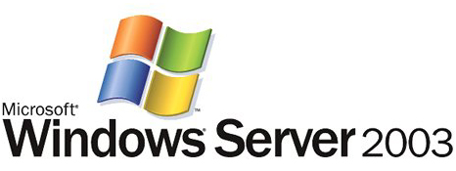

Remote Administration of Windows Servers Using Remote Desktop for Administration

Microsoft Corporation
Published: March 2003

Abstract
Remote Desktop is a feature in Microsoft® Windows® Server 2003. It provides the Windows graphical user interface to remote devices over local area network (LAN), wide area network (WAN), or Internet connections. This white paper explores the design goals and implementation of Remote Desktop in Windows Server 2003, and explains how an enterprise can use this feature.

This is a preliminary document and may be changed substantially prior to final commercial release of the software described herein.
The information contained in this document represents the current view of Microsoft Corporation on the issues discussed as of the date of publication. Because Microsoft must respond to changing market conditions, it should not be interpreted to be a commitment on the part of Microsoft, and Microsoft cannot guarantee the accuracy of any information presented after the date of publication.
This document is for informational purposes only. MICROSOFT MAKES NO WARRANTIES, EXPRESS OR IMPLIED, AS TO THE INFORMATION IN THIS DOCUMENT.
Complying with all applicable copyright laws is the responsibility of the user. Without limiting the rights under copyright, no part of this document may be reproduced, stored in or introduced into a retrieval system, or transmitted in any form or by any means (electronic, mechanical, photocopying, recording, or otherwise), or for any purpose, without the express written permission of Microsoft Corporation.
Microsoft may have patents, patent applications, trademarks, copyrights, or other intellectual property rights covering subject matter in this document. Except as expressly provided in any written license agreement from Microsoft, the furnishing of this document does not give you any license to these patents, trademarks, copyrights, or other intellectual property.
© 2003 Microsoft Corporation. All rights reserved.
Microsoft, Windows, Windows NT, and the Windows logo, are either registered trademarks or trademarks of Microsoft Corporation in the United States and/or other countries.
The names of actual companies and products mentioned herein may be the trademarks of their respective owners.

Contents

Overview of Remote Desktop for Administration and Terminal Server 1
Terminal Services Modes and Clients 1
Remote Desktop for Administration—Features and Benefits 1
Terminal Services Integration 2
Deploying Terminal Services 3
Enabling Remote Desktop for Administration 3
Remote Desktop for Administration 3
Changing the Session Encryption Levels 4
Remote Desktop Connection 5
Devices Supported 5
Installing Remote Desktop Connection 5
Connection Improvements 5
Enhanced Interface 6
Client Resource Redirection 6
File System Redirection 6
Port and Printer Redirection 6
Remote Desktop for Administration Best Practices 7
Connect to the Console 7
Coordinate Remote Administration Tasks with Other Administrators 7
Remote Administration Is Not Application Serving 7
Configure the Remote Desktop Session to Disconnect when Connection is Broken 7
Configure Disconnect and Reset Timeouts 7
Avoid Tasks that Require Reboots 8
Administrator Collaboration 8
Administration Tools 9
Connecting to the Console 9
Terminal Services Group Policy 9
Remote Desktops MMC 9
Terminal Services Manager 10
Terminal Services Configuration 10
Event Viewer 10
Command-line Utilities 10
Query User 11
Disconnect 11
Summary 12
Related Links 13

Overview of Remote Desktop for Administration and Terminal Server
Remote Desktop for Administration and Terminal Server are features of Microsoft® Windows® Server 2003. They provide the Windows graphical user interface to remote devices over local area network (LAN), wide area network (WAN), or Internet connections. All of the application processing is performed at the server, and only data from devices such as the display monitor, keyboard, and mouse are transmitted between the server and the client computer.

Terminal Services Modes and Clients
Terminal Services may be enabled in one of two modes:
- ‘Terminal Server’ mode (formerly Application Server mode in Windows 2000 Server).
- ‘Remote Desktop for Administration’ (formerly Remote Administration mode).
Terminal Server mode allows multiple remote clients to simultaneously access Windows-based applications that run on the server. This is the traditional Terminal Server deployment.
Remote Desktop for Administration is used to remotely manage Windows Server 2003 servers. This mode is designed to provide operators and administrators with remote access to typical back-end servers and domain controllers. The administrator has access to the graphical user interface-based tools that are available in the Windows environment, even if he or she is not using a Windows-based computer to administer the server.
Remote Desktop for Administration allows for the management of servers from any location without affecting server performance or application compatibility. In addition to the console session, up to two remote administration sessions are supported, Since this is meant as a single-user remote access solution, no Terminal Server Client Access License (CAL) is required to use Remote Desktop for Administration.
The most recent Terminal Services client is included with Windows Server 2003 and is also shipped with Microsoft Windows XP Professional. A Macintosh Remote Desktop Connection client is also available. Other non-Windows clients require a third-party add-on.

Remote Desktop for Administration—Features and Benefits
Remote Desktop for Administration includes the following features and benefits:
- Graphical administration of Windows Server 2003 and Windows 2000 servers from any Terminal Services client. (Clients are available for computers running Windows for Workgroups, Windows 95, Windows 98, Windows CE 2.11, Windows CE.NET, Windows NT®, Windows 2000, Windows XP Professional, and Macintosh OS-X.)
- Remote upgrades, reboots, and promotion and demotion of domain controllers.
- Access to servers over low-bandwidth connections, with up to 128-bit encryption.
- Roaming disconnect support. (This support enables data-sensitive or time-consuming tasks to be completed successfully if the remote session is disconnected deliberately, or due to network problems.)
- Remote application installation and execution—with fast access to local disks and media (For example, when copying large files and virus scans).
- Negligible performance impact on the server, and no impact on application compatibility.
- Two remote administrators can share a session for collaboration purposes.
- Remote Desktop Protocol (RDP) feature set. This includes local and network printing; file system redirection, clipboard mapping (cut, copy and paste); smart card redirection; serial device redirection; and support for any RDP virtual channel applications.

Terminal Services Integration
The Terminal Services component of the Windows Server 2003 family is tightly integrated into the kernel and is available on every Windows Server 2003 installation. Enabling Remote Desktop for Administration requires no additional disk space and has a minimal impact on performance. It requires only about 2 megabytes (MB) of server memory and has a negligible impact on CPU usage. Performance is only affected when a remote session is logged on, similar in cost to the console.
It is for these reasons that Microsoft recommends enabling Remote Desktop for Administration on every Windows Server 2003 computer and domain controller. This will provide substantial flexibility and responsiveness in administering an organization’s servers, regardless of their location.

Deploying Terminal Services
This section illustrates how to enable Remote Desktop for Administration, along with how to change session encryption levels.

Enabling Remote Desktop for Administration
Terminal Server mode and Remote Desktop for Administration are now separately configurable components in Windows Server 2003, and provide more flexible options for administration.

Remote Desktop for Administration
Remote Desktop for Administration is installed by default in Windows Server 2003, but for security reasons comes preconfigured as disabled. It can be enabled through the System control panel’s Remote Tab as shown in Figure 1 below.
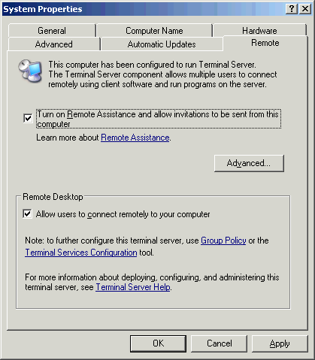
Figure 1. Enabling Remote Desktop for Administration
In addition to the two virtual sessions that are available in Windows 2000 Terminal Services Remote Administration mode, an administrator can also remotely connect to the real console of a server with the Remote Desktop for Administration feature in Windows Server 2003. Tools that would not work in a virtual session before, because they interacted with ‘session 0’, will now work remotely. Some applications will not install unless using the console session.

Changing the Session Encryption Levels
By default, all Terminal Services sessions connect using high encryption, which provides bi-directional security using a 128-bit cipher. However, some older versions of the Terminal Services client do not support this high level of encryption. Clients that do not support this level of encryption will not be able to connect. Therefore, the encryption level can be set to “client compatible” to provide the highest encryption level supported by the client. Both levels use the standard RSA RC4 encryption.
Changing the encryption level is performed within the Terminal Services Configuration utility, located under All Programs, Administrative Tools. Open the Properties dialog box of the Microsoft RDP 5.2 protocol type in the Connections folder, as shown in Figure 2 below, and click the General tab. This reveals the Encryption level box, which can be changed between high and client compatible.
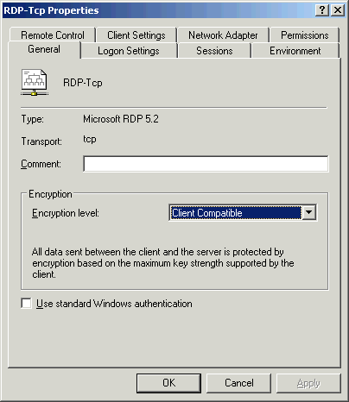
Figure 2. Changing the encryption level

Remote Desktop Connection
The new Terminal Services client, called the Remote Desktop Connection (RDC), uses the latest advances of Microsoft Remote Desktop Protocol (RDP) 5.2 to provide substantial improvements over previous releases. RDC can be used to connect to previous versions of Terminal Services as well.
The Remote Desktop Connection software communicates over a TCP/IP network connection using RDP 5.2. This protocol is based on the International Telecommunications Union’s (ITU) T.120 protocol, an international, standard, multi-channel protocol used first in Microsoft NetMeeting® conferencing software. It is tuned for high and low bandwidth environments and also supports three levels of encryption.

Devices Supported
RDC supports the following devices:
- 16-bit Windows-based computers running Windows for Workgroups with MS TCP/IP-32.
- 32-bit Windows-based computers running Windows 95, Windows 98, Windows NT 3.51, Windows NT 4.0, Windows 2000 Professional, Windows XP Professional, or Windows Server 2003.
In addition, there is RDC support for the following devices:
- Windows CE-based Handheld Professional devices (H/PC Pro 3.0).
- Windows CE-based terminals.

Installing Remote Desktop Connection
Remote Desktop Connection is built into Windows XP and Windows Server 2003, and it can be installed on other computers by several methods.
- Use tools such as Microsoft Systems Management Server or Windows 2000 Group Policy to publish/assign the Windows Installer-based RDC.
- Share the %systemroot%\system32\clients\tsclient\win32 directory on Windows Server 2003. (This can also be done with Windows 2000 Server.)
- Install directly from the Windows XP or Windows Server 2003 CD, using the ‘Perform Additional Tasks’ selection from the CD’s autoplay menu. (This does not require installing the operating system.)
- Download the RDC from http://www.microsoft.com/windowsxp/remotedesktop/.

Connection Improvements
The previously separate Connection Manager has been fully integrated into RDC. This allows users and administrators to save connection settings files and use them locally or deploy them to other users. Saved passwords are securely encrypted and can only be decrypted on the original computer.
Remote Desktop Connection supports automatic restoration of interrupted network connections. Should the connection drop while an administrator is in the middle of a process, RDC will reconnect to the session without losing the administrator’s place, so that mission-critical processes can be finished.

Enhanced Interface
Remote sessions using Remote Desktop Connection are high-color and full-screen, with a connection bar to allow quick switching between the remote session and the local desktop. The remote connection can be customized to suit your needs, with options for display, local resources, programs, and experience. The Experience settings allow you to choose your connection speed and graphic options, such as themes or menu and window animation, in order to optimize performance for lower-bandwidth connections.

Client Resource Redirection
Client resource redirection is available to clients on Windows Server 2003 or Windows XP Professional, and offers a variety of data redirection types. To maximize security, each type of redirection can be enabled or disabled separately by either the client or the server. Also, a security alert is displayed when file system, port, or smart card redirection is requested, allowing the user to refuse the redirection or even cancel the connection if desired.
Remote Desktop Connection allows audio feedback, such as “error” or “new mail” notifications, to be redirected to the client. Key combinations such as Alt-Tab and Control-Escape are sent to the remote session by default, while Control-Alt-Delete is always handled by the client computer, maintaining the security of the server. Time zone information can also be redirected to the server from clients, enabling one server to handle multiple users across different time zones. Applications with calendar features can also take advantage of time zone redirection.

File System Redirection
Copying files between the client and server is easier than ever. Client drives, both local and network, are now available within the server session. Users can access their own local drives and transfer files between client and server without having to leave the remote session.

Port and Printer Redirection
Both local and network printers installed on the client are also available in the remote session, with easier-to-read names. Client serial ports can also be mounted so that software on the server can access the connected hardware. Clients that recognize smart cards—Windows 2000, Windows XP, and Windows CE .NET—can provide the smart card credentials for log on to a Windows Server 2003 remote session.

Remote Desktop for Administration Best Practices
For best results with Remote Desktop for Administration, it is necessary to fully understand how Remote Desktop for Administration works and how best to utilize its functionality. The following considerations should be taken into account when using Remote Desktop for Administration.

Connect to the Console
With Windows Server 2003, administrators can now remotely connect to the console session (session 0). Although an administrator can connect to another virtual session, it is a best practice to connect directly to the console session. This will enable the administrator to interact with the server just as if he or she were at the physical server. All pop-ups and messages that may only appear on the console of the server will be visible remotely using Remote Desktop for Administration as long as the administrator is in the console session. For security, when an administrator remotely connects to the console session remotely, the physical console of the server will automatically lock to prevent eavesdropping.

Coordinate Remote Administration Tasks with Other Administrators
Remote administration mode is not meant to provide a managed multi-user experience. The two remote connections plus the console allow collaborative operation, but should not be used to support general access by multiple simultaneous administrators. In particular, ensure that administrators don’t run potentially destructive applications at the same time. For instance, two administrators trying to reconfigure the disk subsystem can undermine each other’s work, or worse, destroy data. The presence of other administrators can be checked for using the Terminal Services Manager utility (Programs/Administrative Tools) or the quser command line utility. A special tool, which provides a system tray icon showing the number of active sessions, is available in the Windows 2000 Server Resource Kit to help with this need.

Remote Administration Is Not Application Serving
Many general office applications require special installation, install scripts, or environment management to perform well in a remote session. Terminal Services provides these when you install Terminal Server, but they are not available for Remote Desktop for Administration. For general desktop and application remote access requirements, use a dedicated server with Terminal Server installed.

Configure the Remote Desktop Session to Disconnect when Connection is Broken
This is the default setting when you enable Remote Desktop for Administration, and is especially important if you perform system updates over unreliable network connections (for example, dial-up connections). If a session is interrupted due to a network problem, the session will go into a disconnect state and continue executing whatever processes the session was running at the time. If the session is configured to reset when the connection breaks, all processes running in that session will be abruptly terminated, a process which is similar to stopping an application using End Task.

Configure Disconnect and Reset Timeouts
Because it is not possible to log on to more than two remote sessions, remote administrators may find themselves locked out of a server if there are two remote sessions (using different user accounts) that are either in an active or disconnected state. When configuring disconnect timeouts, it is critical that sessions that were accidentally or deliberately disconnected do not get reset prematurely. For this reason, it may be useful to perform remote administration tasks that should not be accidentally reset using a shared administrator account, such as a local machine account. This account can be configured not to reset after it is disconnected, using the account Properties tab.
Note Group Policy settings may override settings in the user account Properties tab.
Information on disconnect and reset timeouts can be found in the product documentation.

Avoid Tasks that Require Reboots
Although tasks that require reboots at their completion (for example, system upgrades, domain controller promotion) work perfectly well from within a Remote Desktop session, be aware that something as simple as a floppy disk in the drive or a bad boot sector on the disk could prevent the server from restarting. Therefore, it is advisable not to remotely reboot mission critical servers unless you have the ability to physically intervene at the server should a problem occur.

Administrator Collaboration
Using the Terminal Services Manager, it is possible to control another Terminal Services session remotely.
Note It is not possible to perform any administrative actions with the console session in this manner, although messages can be sent to the console session.
For more details, refer to the Help in the Terminal Services Manager program.

Administration Tools
The following is a limited sample of the administration tools that can help you manage remote sessions:

Connecting to the Console
To connect to the console, administrators can choose one of the following methods:
- Use the Remote Desktop Microsoft Management Console (MMC) snap-in.
- Run the Remote Desktop Connection (mstsc.exe) program with the /console switch.
- Create Remote Desktop Web Connection pages that set the ConnectToServerConsole property.

Terminal Services Group Policy
Group Policy can be used to administer Terminal Services for computers running Windows server operating systems. Terminal Services group policies can configure Terminal Services connection settings, set user policies, configure terminal server clusters, and manage Terminal Services sessions.

Remote Desktops MMC
The Remote Desktops Microsoft Management Console (MMC) Snap-in enables administrators to host multiple Terminal Services connections. It is also useful for managing many servers that are running the Windows Server 2003 family or Windows 2000 Server .
A navigable tree display allows administrators to view, control, and quickly switch between multiple sessions from a single window, as shown in Figure 3 below. As with the Remote Desktop Connection tool, the remote computers can be configured to run specific programs upon connecting, and to redirect local drives to appear in the remote session. Logon information and client screen area also can be configured from the snap-in. Administrators can create remote connections to the console session of a computer running Windows server operating systems, as well.
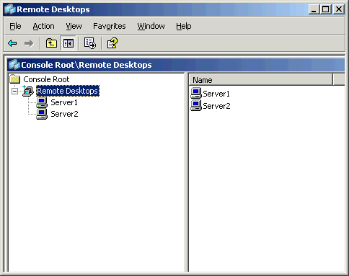
Figure 3. Remote Desktops MMC

Terminal Services Manager
This utility, tsadmin.exe, is used to manage Terminal Services users, sessions, and processes on any server running Terminal Services on the network. Using this tool, you can connect and disconnect, log off, reset, and remotely control sessions. You can also use it to connect to other servers in trusted domains, to manage sessions on a remote server, send messages to users or log them off, and terminate processes.

Terminal Services Configuration
This utility, tscc.msc, is used to change the default encryption settings, and to configure reset and disconnect timeouts. To configure reset and disconnect timeouts for individual accounts, use the Sessions tab of the user’s Account Properties page. Many of the settings can also be set with Terminal Services Group Policy or Windows Management Instrumentation, in which case Terminal Services configuration settings are overridden.

Event Viewer
Use Event Viewer, eventvwr.msc, to look for events that may have occurred as pop-up dialogs on the server console.

Command-line Utilities
Command-line utilities include the following:

Query User
This command line utility, quser, lists active and disconnected users.

Disconnect
This command line utility, tsdiscon, disconnects the session, a procedure analogous to turning off the monitor while leaving the computer running. Disconnect is also accessible through the Start/Shutdown list box. To reconnect to the session, simply log on to the server again as the same user using the Remote Desktop Connection.

Summary
Using Remote Desktop for Administration for remotely managing computers running Windows Server 2003 can greatly reduce administrative overhead in any Windows Server 2003 environment.
Administrators can access servers from anywhere: be it inside the computer room, or from halfway around the world over a WAN, VPN, or dial-up connection. They can start time-consuming batch processing jobs like tape backups, disconnect, and then dial-in to the corporate network at a later time to check the progress.
Server application and operating system upgrades can be completed remotely, as well as tasks that are not usually possible unless the administrator is sitting at the console—for example, domain controller promotion/demotion and disk defragmentation.
Server file system tasks, such as copying large files and virus scanning, are much more efficient when performed within a Terminal Services session, rather than using utilities that are executed on a client computer. And administration tasks are quicker and more intuitive than using command-line utilities, although it is still possible to open up a command shell.

Related Links
See the following resources for further information:
- Managing Terminal Servers Using Microsoft Operations Manager and Microsoft Systems Management Server at www.microsoft.com /windowsserver2003/techinfo/overview/tsmomsms.mspx
- Terminal Services in Windows Server 2003 at http://www.microsoft.com/windowsserver2003/technologies/terminalservices/default.mspx

For the latest information about Windows Server 2003, see the Windows Server 2003 Web site at http://www.microsoft.com/windowsserver2003.

