Microsoft Office Visio 2007

Microsoft® Office Visio® 2007 makes it easy for IT and business professionals to visualize, explore, and communicate complex information. Go from complicated text and tables that are hard to understand to Visio diagrams that communicate information at a glance. Instead of static pictures, create data-connected Visio diagrams that display data, are easy to refresh, and dramatically increase your productivity. Use the wide variety of diagrams in Office Visio 2007 to understand, act on, and share information about organizational systems, resources, and processes throughout your enterprise
Visualize Complex Information
Using Office Visio 2007, easily understand the current state of your key processes, resources, and systems by visualizing them using a wide range of Visio diagrams.
- Quickly access templates you use often.
In the new Getting Started window that appears when you start Office Visio 2007, quickly find the template you need by browsing simplified template categories and using large template previews. Access the templates you used recently with the new Recent Templates view in the Getting Started window.
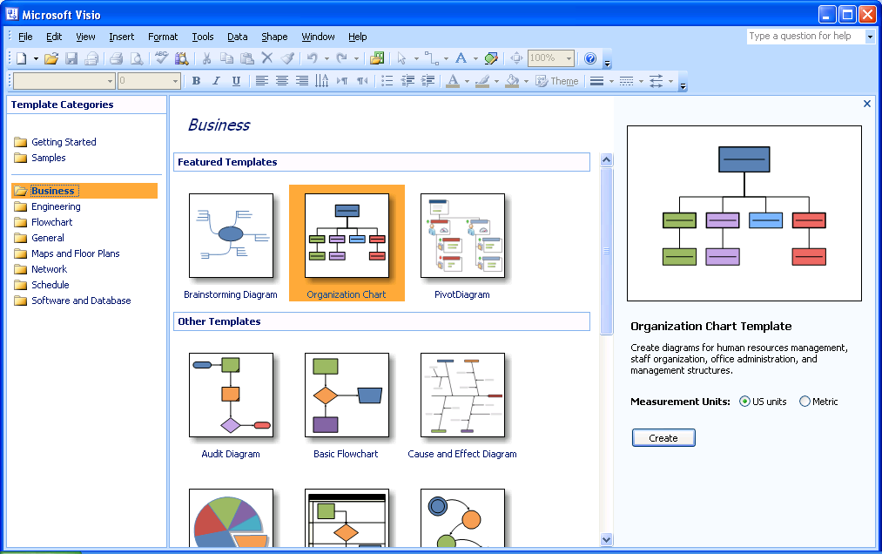
The new Getting Started window makes it easy to find the templates you use often.
- Get inspired by sample diagrams.
Use the new Samples category in the Getting Started window to more easily find new sample diagrams that are integrated with data and included in Office Visio Professional 2007. View them to get ideas for creating your own diagrams. You can also look at them to see how data provides more context for many diagram types and to determine which template you want to use.
- Connect shapes without drawing connectors.
New AutoConnect functionality in Office Visio 2007 connects shapes, distributes them evenly, and aligns them for you—with only one click. When you move the connected shapes, they stay connected and the connectors automatically reroute between the shapes.
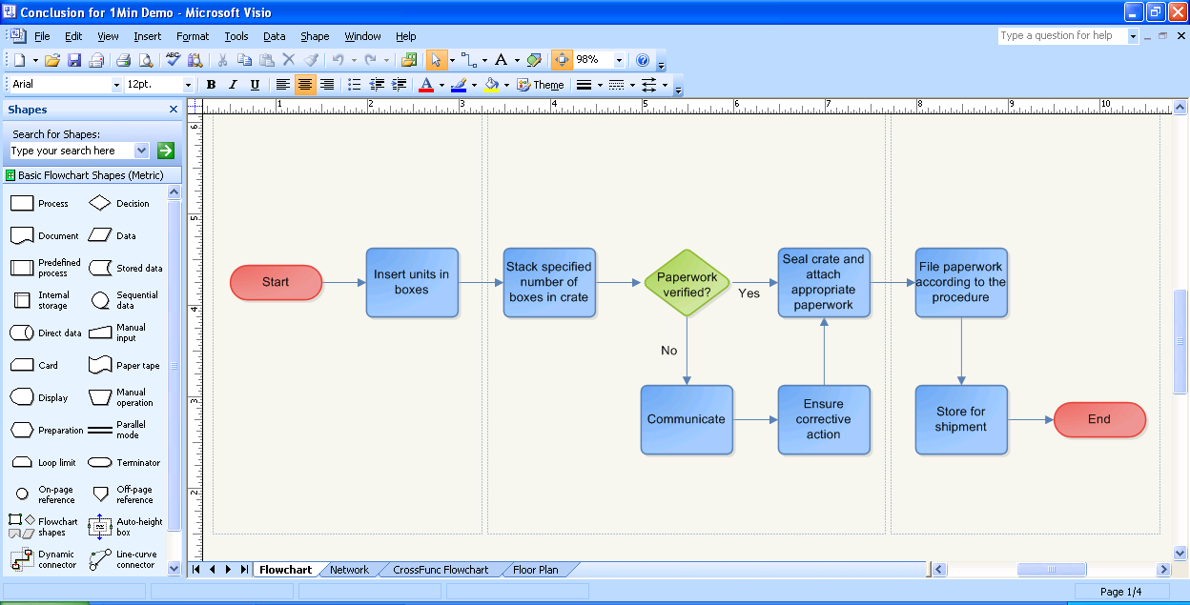
Connecting shapes in Office Visio 2007 has become even easier.
Explore Information and Identify Key Trends
Using Office Visio Professional 2007, explore business information to identify key data trends, issues, and exceptions, and act on them.
- Easily connect data to diagrams and link data to shapes.
Connect diagrams to one or more data sources, such as Microsoft Office Excel® spreadsheets or Microsoft Office Access databases, by using the new Data Link functionality in Office Visio Professional 2007. Save time associating data with shapes by using intuitive new linking methods. For example, link all the shapes in a diagram to rows of data from connected data sources by using the new Automatic Link Wizard.
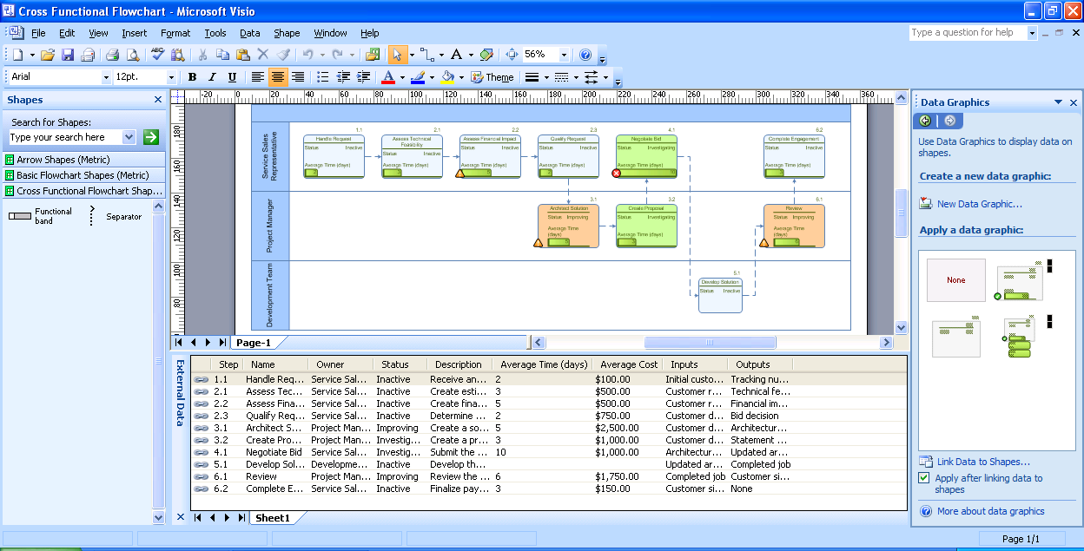
Easily connect Visio diagrams to one or more data sources and associate data with shapes in a diagram.
- Display data attractively in diagrams.
Easily display data associated with shapes in attractive ways by using the new Data Graphics feature in Office Visio Professional 2007 to choose from a number of data formatting options.
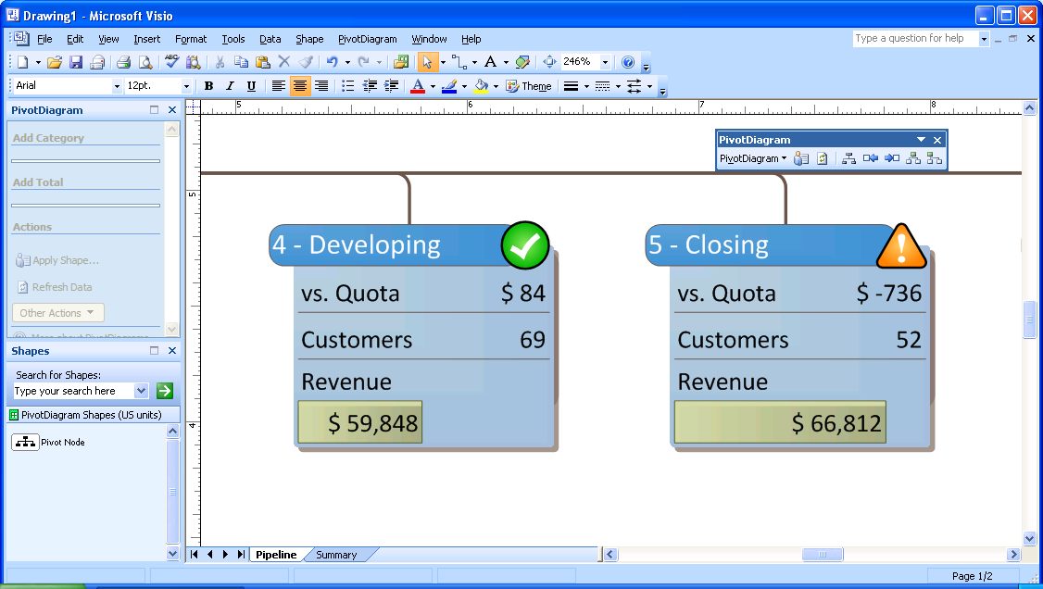
Visualize data as text, data bars, or icons and use color-coding to identify trends and issues.
- Easily refresh data in diagrams.
The new Refresh Data feature puts Office Visio Professional 2007 to work for you. Use it to automatically refresh all the data in your diagrams so you don’t have to do it manually. If data conflicts arise, resolve them easily by using the Refresh Conflicts task pane, also included with Office Visio Professional 2007.
- Visualize and explore business data.
Visually explore business data that’s normally shown in static text and tables by using PivotDiagrams, a new diagram type in Office Visio Professional 2007. Rapidly identify key issues, modify PivotDiagrams on the fly, and create different views of the same data to more fully understand the real issues.
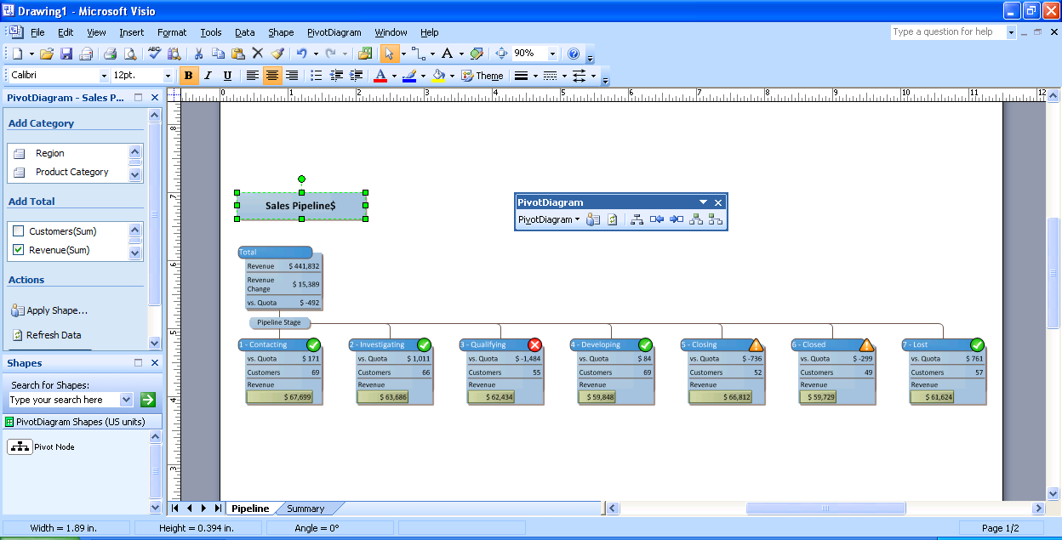
PivotDiagrams show data in a hierarchical form of data groups
and totals.
- Visually report on project information.
Office Visio 2007 is an indispensable tool for visualizing complex project information. Easily generate reports directly from within Microsoft Office Project and Microsoft Office SharePoint® Portal Server 2003 that track project tasks, owners, roles, and responsibilities, and depict complex project ownership structures. Automatically modify the reports as project information changes.
Communicate with a Broad Audience
Using Office Visio 2007, communicate effectively using professional-looking diagrams. Share diagrams with anyone, even those who don’t have Visio installed on their computer.
- Communicate effectively with new shapes and diagram types.
Easily find a template to fit your needs by using the simplified diagram categories in Office Visio 2007. Create a broader range of diagrams with new templates, such as the ITIL (Information Technology Infrastructure Library) template and the Value Stream Mapping template in Office Visio Professional 2007. Create more dynamic workflows with new 3-D Work Flow shapes.
- Design professional-looking diagrams.
The new Theme feature in Office Visio 2007 makes it easy to format the colors and effects in an entire diagram with a single click. Office Visio 2007 even uses the same colors as other 2007 Microsoft Office system programs, so you can easily design professional-looking diagrams that match your documents and presentations.
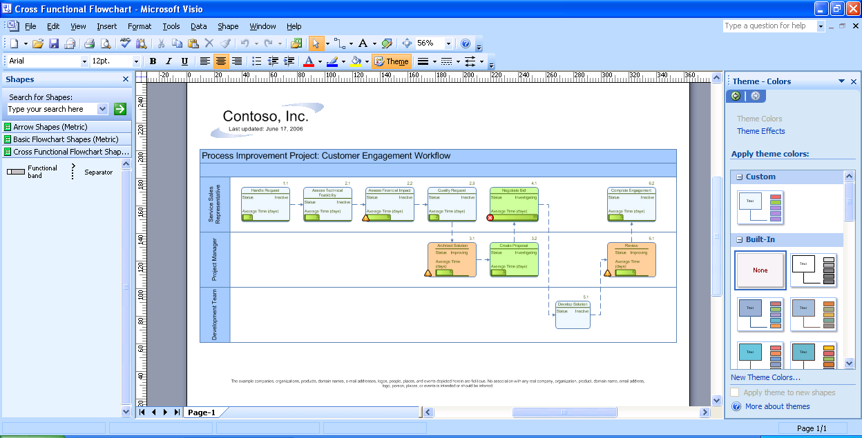
Quickly choose from a wide variety of professional-looking color and effects themes in the task pane.
- Share diagrams in more ways.
Save Office Visio 2007 diagrams as PDFs or in the new XPS file format to make them more portable and reach broader audiences. View Visio diagram attachments from within Microsoft Office Outlook® 2007. View Visio diagrams—even if you don’t have Visio installed on your computer—within Microsoft Internet Explorer by downloading and installing the free Visio Viewer. Save your diagrams as Web pages complete with navigation controls, a shape data viewer, reports, choice of image format, and style sheet options.
NOTE You can save as a PDF or XPS file from a 2007 Microsoft Office system program only after you install an add-in. For more information, see Install and use a PDF or XPS add-in.

For More Information
Microsoft Office Visio 2007 is available in two stand-alone editions: Office Visio Professional 2007 and Office Visio Standard 2007, which has the same basic functionality as Visio Professional, but includes a subset of its features and templates.
Learn more about Office Visio 2007 and the Microsoft Office system at www.microsoft.com/office/visio.

For complete system requirements, visit www.microsoft.com/office/visio.

This document is for informational purposes only. MICROSOFT MAKES NO WARRANTIES, EXPRESS OR IMPLIED, IN THIS SUMMARY.

The example companies, organizations, products, domain names, e-mail addresses, logos, people, places, and events depicted herein are fictitious. No association with any real company, organization, product, domain name, e-mail address, logo, person, place, or event is intended or should be inferred.


© 2006 Microsoft Corporation. All rights reserved. Microsoft, Excel, the Office logo, Outlook, SharePoint, and Visio are either registered trademarks or trademarks of Microsoft Corporation in the United States and/or other countries. All other trademarks are property of their respective owners.

