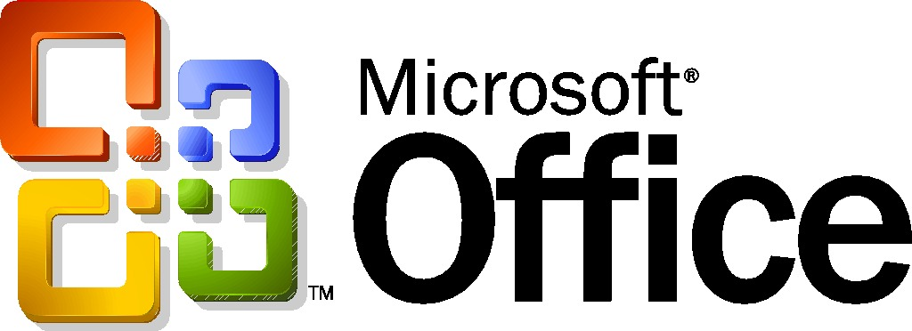
Integration of Microsoft Office Small Business Accounting 2006 with Microsoft Office 2003 Editions
Microsoft Corporation
April 2005
Applies to:
Microsoft® Office Small Business Accounting 2006
Summary: This white paper illustrates the capabilities enabled by this integration, with examples of Small Business Accounting 2006 in combination with Microsoft Office Word 2003, Microsoft Office Excel® 2003, and an updated version of Microsoft Outlook® 2003 with Business Contact Manager Update. It details how the integration helps increase productivity, decreasing errors from data re-entry and increasing knowledge sharing across the company.
© 2005 Microsoft Corp. All rights reserved.
The information contained in this document represents the current view of Microsoft Corp. on the issues discussed as of the date of publication. Because Microsoft must respond to changing market conditions, it should not be interpreted to be a commitment on the part of Microsoft, and Microsoft cannot guarantee the accuracy of any information presented after the date of publication.
This white paper is for informational purposes only. MICROSOFT MAKES NO WARRANTIES, EXPRESS OR IMPLIED, IN THIS DOCUMENT.
Complying with all applicable copyright laws is the responsibility of the user. Without limiting the rights under copyright, no part of this document may be reproduced, stored in or introduced into a retrieval system, or transmitted in any form or by any means (electronic, mechanical, photocopying, recording or otherwise), or for any purpose, without the express written permission of Microsoft Corp.
Microsoft may have patents, patent applications, trademarks, copyrights or other intellectual property rights covering subject matter in this document. Except as expressly provided in any written license agreement from Microsoft, the furnishing of this document does not give you any license to these patents, trademarks, copyrights or other intellectual property.
Microsoft, Excel, Outlook, and PivotTable are either registered trademarks or trademarks of Microsoft Corp. in the United States and/or other countries.
All other trademarks are property of their respective owners.
Microsoft Corp.• One Microsoft Way • Redmond, WA 98052-6399 • USA

Contents
Small Business Accounting 2006 as Part of the Microsoft Office System 4
Small Business Accounting with Microsoft Office Word 2003 4
Small Business Accounting with Microsoft Office Excel 2003 5
Small Business Accounting with Outlook 2003 with Business Contact Manager Update 7
Small Business Accounting with Microsoft Office Access 2003 9
For More Information 11

Small Business Accounting 2006 as Part of the Microsoft Office System
Microsoft Office Small Business Accounting 2006 is a full-featured accounting program, designed to handle bookkeeping and financial management for businesses with 25 or fewer employees. Small Business Accounting 2006 addresses the needs of the small business, giving businesses a product that integrates fully with the software that they use everyday. The integration of Small Business Accounting 2006 with Microsoft Office 2003 Editions allows users to build on existing software knowledge. The familiar Office interface helps users get started quickly and build on their existing knowledge of the Office look and feel, while continuing to benefit from the features and functionality in other Office programs that they use and understand.
For example, many small businesses collect day-to-day data in either Excel spreadsheets or Word documents, and the data is usually manually entered. Customer communication and account information is often stored in disparate programs, including Word, Excel, Outlook, or Microsoft Office Access.
With Small Business Accounting 2006, businesses can share data among Office programs, eliminating the need for data re-entry. Small Business Accounting 2006 fully integrates with Word 2003, Excel 2003, Access 2003, and Outlook 2003 with Business Contact Manager Update, allowing users to rely on the powerful functionality specific to each program. As a result, Small Business Accounting 2006 offers powerful new account management capabilities to Microsoft Office System programs, while they expand and enhance the capabilities offered by Small Business Accounting 2006.
This integration allows users of Small Business Accounting 2006 to:
- Forecast and predict scenarios in Excel 2003 using exported data.
- Share customer contact and account information when used with the new updated version of Outlook 2003 with Business Contact Manager.
- Create templates in Word 2003 for frequently used customer forms such as sales orders, credit memos, quotes, customer statements, and packing slips.
To illustrate the capabilities afforded by Small Business Accounting 2006 integration with Microsoft Office programs, we will look at examples of its capabilities when used with Word 2003, Excel 2003, Outlook 2003 with Business Contact Manager Update, and Access 2003.
Small Business Accounting 2006 with Microsoft Office Word 2003
Microsoft Office Word 2003 allows business users to customize and enhance customer communications with formatting, corporate branding, and more. Small Business Accounting 2006 provides a number of out-of-the-box Word 2003-based templates for common business forms such as invoices, sales orders, quotes, customer credit memos, customer statements, and purchase orders. Users can create a custom form from scratch or edit one of the templates provided.
Typically, only one click of a toolbar button is required to export a document from Small Business Accounting 2006 to Word 2003, or convert a selection of data into a selected template format. From this point, users can add customization, while maintaining an elegant, professional feel in the familiar Word interface they use daily. The template can be used again and again, which helps bring consistency to the look and feel of customer correspondence, further enhancing the company’s professional presentation and image.
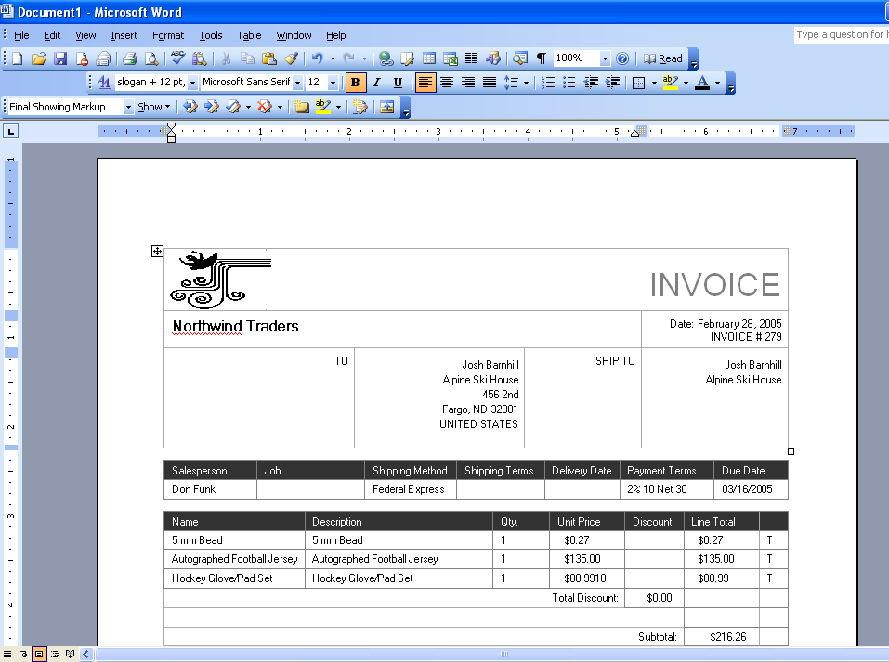
Integration with Microsoft Office Word 2003 makes it easy to create consistent, accurate documents to communicate with customers, vendors, employees, and partners.
Small Business Accounting 2006 also features a Write Letters Wizard, with which users can create and modify letters from Word 2003 templates for customers, vendors, and employees. The Write Letters Wizard allows users to create collection notices for customers with overdue payments pending, credit requests for vendors, or appreciation letters for exemplary employees. In the Write Letters Wizard, users can also filter recipients as active or inactive, and add a closing signature to client communications.
Small Business Accounting 2006 with Microsoft Office Excel 2003
Small Business Accounting 2006 offers strong integration with Excel 2003. Excel is often used by the smallest companies as a major part of their bookkeeping function. As a part of initial loading and configuration, Small Business Accounting 2006 offers to import data from Excel 2003, incorporating it immediately into the various functions and features of Small Business Accounting 2006. After setup, users can continue to import data using the Small Business Accounting 2006 Import Data Wizard, allowing users to get started quickly with the information that is most urgent to the company.
Small Business Accounting 2006 ships with more than 60 reports and lists that can easily be customized to give you the view you want. Reports can then be exported to Excel 2003, with appropriate formatting and formulas intact, with a single click of a toolbar button. This not only saves time and reduces errors, it also allows companies to use all of the power of Excel 2003 to create a variety of charts, or to put the data through different calculations as needed.
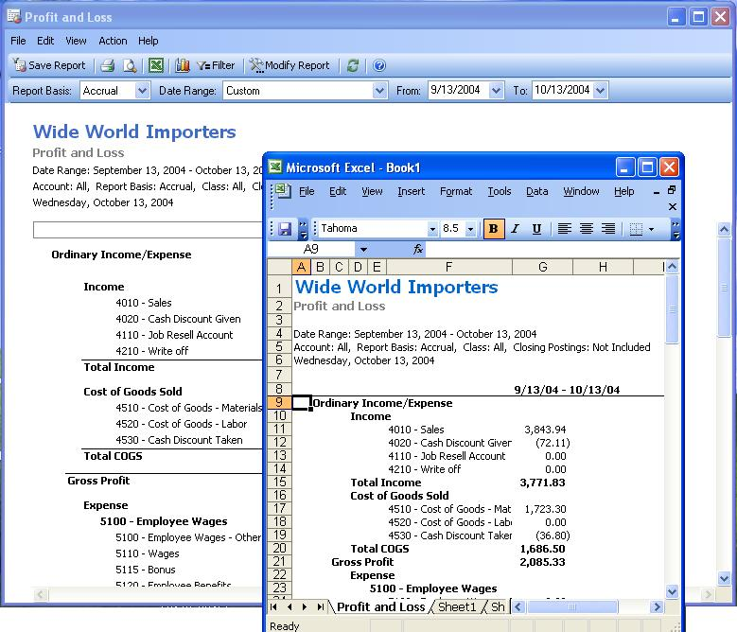
Data can easily be shared between Small Business Accounting 2006 and Microsoft Office Excel 2003, allowing companies to create comprehensive reports using the powerful capabilities of Excel with the financial information stored in the accounting program.
Another useful tool in Small Business Accounting 2006 is the Cash Flow Forecast form. Frequent monitoring of cash flow is a highly important task for companies of any size, allowing strategic decisions, forming a critical part of any business plan, and standing as a major consideration by banking institutions in credit or loan decisions. A Cash Flow Forecast form in Small Business Accounting 2006 can be exported to Excel 2003 to take advantage of Excel analytical tools: Users can alter the company’s cash flow forecast by using a variety of variables, such as adding new cash accounts, new receivables, new quotes, new expenses, and payables to vendors. This enables “what-if” scenarios that help plan the best path for the business.
Analysis Tools that ship in Small Business Accounting 2006 include pre-populated Excel PivotTable® dynamic reports covering sales and purchases. PivotTable reports compartmentalize the various pieces of information (such as customer names, items sold, time periods), so they can be moved around to see how they all relate to each other. Because a PivotTable report is interactive, users can change the view of the data to see more details or calculate different summaries, such as inventory counts or sales averages. This way, sales teams can stay on top of inventory lists, and small business owners and managers can analyze and project sales cycles and best practices for their sales team.
Small Business Accounting 2006 with Outlook 2003 with Business Contact Manager Update
The combination of Small Business Accounting 2006 with Outlook 2003 with Business Contact Manager Update brings powerful customer relationship management (CRM) tools to the small company. Integration with Outlook 2003 with Business Contact Manager Update, which is available in Microsoft Office Small Business Edition 2003, Microsoft Office Professional Edition 2003, and Microsoft Office Small Business Management Edition 2006 (available in fall 2005), enables the Small Business Accounting 2006 user to accomplish the following with just a few clicks:
- Add customer records, contacts, and product and service items from Small Business Accounting 2006 to Outlook 2003 with Business Contact Manager Update. Customer records are added as Account records.
- Import product and service items from Small Business Accounting 2006 to Outlook 2003 with Business Contact Manager Update.
- Add Account records from Outlook 2003 with Business Contact Manager Update to Small Business Accounting 2006 as customer records.
- Link a Business Contact Manager Account record to a Small Business Accounting 2006 customer record so that a user can view and update financial information in Outlook 2003 with Business Contact Manager Update.
- Create a quote, a sales order, or an invoice from an Account record in Outlook 2003 with Business Contact Manager Update.
- Create a quote, a sales order, or an invoice from an Opportunity record in Outlook 2003 with Business Contact Manager Update.
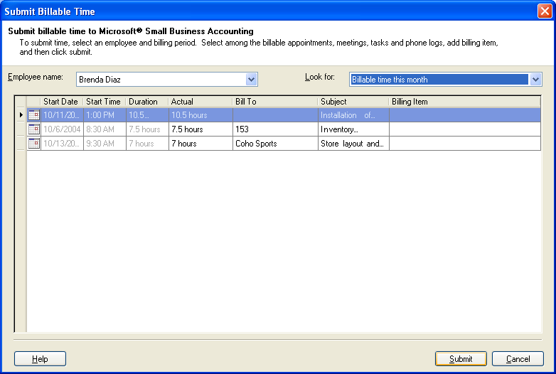
Appointments can be marked as billable in the user’s Outlook Calendar and easily submitted as billable time directly from Outlook 2003 to Small Business Accounting 2006.
Companies can use Outlook 2003 with Business Contact Manager Update to share customer account data with other users in the company. Employees with access permissions can get a comprehensive view of the account, including financial status, sales opportunities, communications history, and more. This enables prompt, thorough, and informed sales and service support to customers, because any employee with access can get necessary information, without leaving Outlook 2003. It also enables users to move from the opportunity phase to the quote phase to the sales order phase of the sales cycle seamlessly.
Employees can also create a Time Entry to record billable time from an appointment, phone log, or task in Outlook 2003 with Business Contact Manager Update. With just a few clicks, the time can be invoiced to the customer. Multiple customers can be billed from the same timesheet, and files such as communications, quotes, or reports can be linked to the timesheet and the invoice. Companies that bill by the job can convert Time Entries into service items for invoicing.
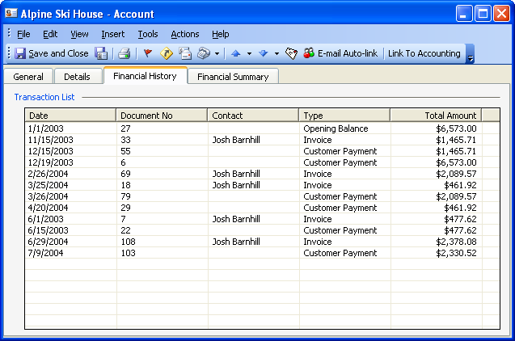
Outlook 2003 with Business Contact Manager Update provides a complete view of each customer’s financial history.

Companies can combine information from Small Business Accounting 2006 and Outlook 2003 with Business Contact Manager Update to put a personalized and up-to-the-minute touch on sales and marketing publications.
Small Business Accounting 2006 with Microsoft Office Access 2003
Because Small Business Accounting 2006 is built on the desktop version of the Microsoft SQL Servertm business database program, it can import data to Microsoft Office Access 2003, the Microsoft Office System data organization program. Access 2003 accepts imported data from SQL Server-based databases as well as Excel 2003, providing numerous additional ways to organize, combine, and compare financial and account data. Account information can be exported from Small Business Accounting 2006 to Access 2003 to construct a comprehensive customer database and report.
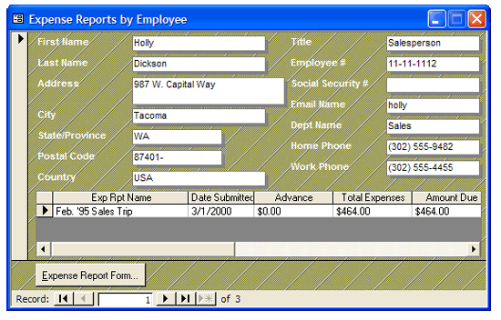
Small Business Accounting 2006 can share information with Microsoft Office Access 2003 to customize many reports and financial data.
Small Business Accounting 2006 reports can be exported to Access 2003 for formatting and customization. Access 2003 can organize and format financial information, including purchases, inventory, expense reports, and more. Businesses with commissioned sales personnel can also import their commissions schedule from Access 2003 to Small Business Accounting 2006, where it can be integrated with other payroll information to ensure that timely and accurate payments are made to employees.
Analysis Tools in Small Business Accounting 2006 let users create Access 2003 database reports, as well as PivotTable dynamic reports in Excel. These help businesses extract meaningful information from data to help make more sense of company transactions. Users can choose from eight out-of-the box Access 2003 reports to see comparisons, reveal patterns and relationships, analyze trends, and more.

For More Information
Microsoft Office Small Business Accounting 2006 can be licensed as a stand-alone program or as an integrated component of the Microsoft Office Small Business Management Edition 2003. Companies using other Microsoft Office 2003 Editions can realize the full benefits of integration with the stand-alone program.
Integration of Small Business Accounting 2006 with Microsoft Office 2003 programs gives the small company a wide range of new ways to use and benefit from company financial data. The combination offers the ability to seamlessly incorporate up-to-the-minute financial data into Word 2003 documents, put financials through detailed analysis in Excel 2003, or share financial and customer account information in a CRM package specially designed for the small business.
Find more information about Small Business Accounting 2006, and Microsoft Office 2003 Edition programs, at the Microsoft Web site.
For more information on Small Business Accounting 2006, visit
http://www.microsoft.com/office/accounting/prodinfo/default.mspx
To find out more about Microsoft Office Small Business Management Edition 2003, visit
http://www.microsoft.com/office/editions/prodinfo/smallbusiness/management/default.mspx
To learn more about Outlook 2003 with Business Contact Manager Update, visit
http://www.microsoft.com/office/outlook/contactmanager/prodinfo/default.mspx
For information on all Microsoft Office 2003 Editions for small business, visit
http://www.microsoft.com/office/editions/prodinfo/smallbusiness/default.mspx

