Contribution to Imagine Cup 2005

b:link, a new friend facilitator

Hildebrand S. & Noirfalise J.

Computer Science Department (INPRES)
Haute Ecole Rennequin Sualem
(Higher Education Institution)
Liege, Belgium

"Dissolving the boundaries between us"

Who are we?

We are 2 Belgian students in final year (3 of 3) of the Bachelor Degree in Computer Science at the Department of Computer Science (INPRES) of Haute Ecole Rennequin Sualem (Higher Education Institution) of the Province of Liège, Belgium:

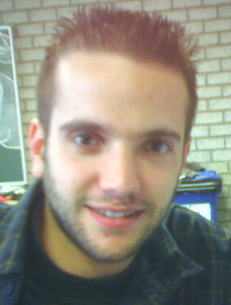 | Hildebrand Stéphane  Email: stef@teledisnet.be
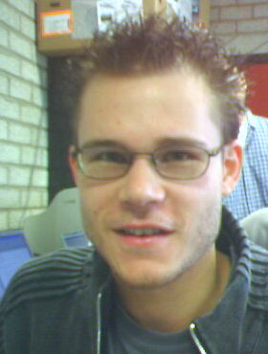 | Noirfalise Jérôme  Email: jnoirfal@teledisnet.be

This document describes our contribution to Imagine Cup 2005, category Software Design.

Our contribution to Imagine Cup 2005

In spite of the development of IT, shy people will be shy. As new communication devices have not tackled the problem of face-to-face communication so far, we have decided to create a tool that could help people to get in touch quickly and easily.

Our idea, that became a challenge, is an attempt to solve the problem of direct communication: how to help people to get in touch, not over long distance wire or wireless communication channels but face-to-face, in the street or at any social event? In other words: how to help people to make new friends?

Welcome to b:link

b:link is our contribution to help people who don't know each other to get in touch and communicate face-to-face. Everyone knows that a common interest helps to make new friends. We would like to develop that opportunity.

First, do they need special hardware? Not at all : they use a PocketPC or smartphone but these devices are mainly there to signal that someone with some common interest is around, ie less than 75 meters. The system doesn’t imply any communication cost. These devices, that keep their usual capabilities, must be Windows Mobile 2003 compatible. As today, this is not true yet for most of the cell phones but we are confident it will be so in a very near future.

Let's take a few scenarios to explain who could find interest in our application. Suppose you attend a national event. Wouldn't it be nice to get in touch with people from your city or any community, even if you don't know them (yet) and even if you are not aware of their attendance? Another scenario: wouldn't be nice, while at any location, to get in touch and start a conversation with someone, unknown up to now, with whom you share a passion?

We hope that you are convinced that b:link opens new opportunities to make new friends. We mean friends, not virtual friends.

Now, let's explain how this becomes possible with b:link.

Looking for (or specifying) topics of interests

First, you have to visit our b:link web site : you have to look for or create topics of interest, with a contact word associated with each of them. This visit is even not mandatory : we can imagine magazines providing keywords for specific topics of interest.

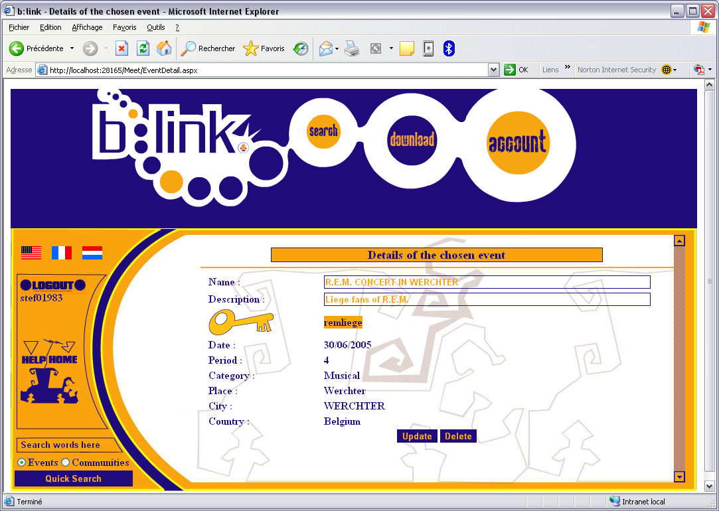

Let’s suppose you select the topic "BUTTERFLIES" because you have some passion for butterflies. Our web site provides an easy Flash navigation system to find the different topics. In case the subject is not in the database, you can create it. In our implementation, only logged-on users can create topics, so we should soon get for free a database of the people with a strong implication in some domains.

In case the search is successful, our web site provides a contact keyword for that topic (this contact keyword was specified by the creator of the topic). You enter it in your PocketPC or smartphone b:link program :

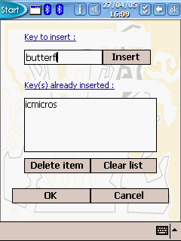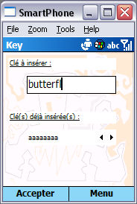

Up to three contact keywords can be activated at one time.

Our b:link web site also offers pages specially adapted to PocketPC or smartphone browsers. On top of that, we also offer a Web Service as an alternative to provide contact names based on topics of interest.

Our b:link web site can also search for a specific event in a specific location and at a specific date (or time interval).

It automatically adapts itself to the user's language, though an explicit choice (as today) between English, Dutch and French is available.

In search of new friends

The PocketPC or smartphone b:link programs (that run on these devices) can be downloaded from our b:link web site. These programs also adapt themselves to the user's language. After installation (a very easy process), one is ready to use b:link at any location.

At any time, the PocketPC or smartphone user can activate a b:link search activity. There is no need to activate b:link in some circumstances, for instance while driving.

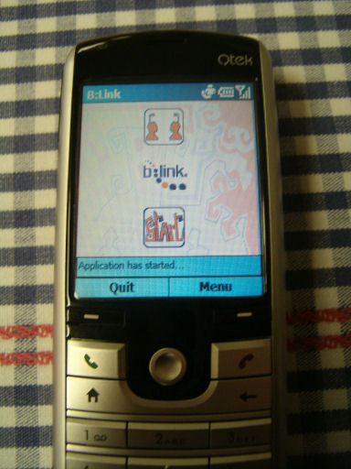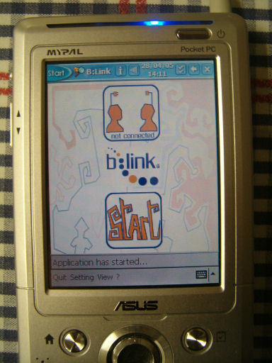

While a b:link search is active, the PocketPC or smartphone periodically searches for other Bluetooth connections. In case one is found, provided it is controlled by a b-link program and there is an agreement on at least one contact word, the user is informed with a sound. It means that someone, somewhere in the surrounding (about 75 meters around), has programmed his/her PocketPC or smartphone for an identical contact name !

A new friend is around!

You then enter a new and exciting visual search game ! Correspondents can then also enter a chat (even a pen chat provided both of them use a PocketPC) or refuse communication. Smileys help you make the communication easier.

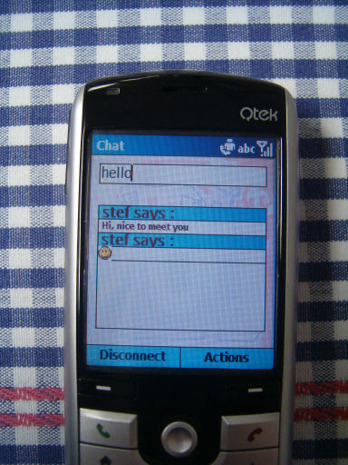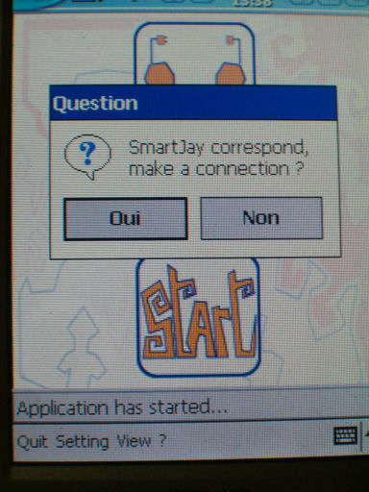

Technical notes

Programming PocketPCs and smartphones for Bluetooth communication raises a problem: there are several Bluetooth stacks. The Widcomm stack is widely used in PocketPCs while the Microsoft stack is present in all smarphones. The way to program them is totally different.

PocketPC application

Unfortunately, we couldn't afford the Widcomm Bluetooth sdk ($1800) and we didn't succeed in getting it for free. Instead, we are using an evaluation version (no time limit, just a little pop up at the first call) of “BTAccess”, developed by “High point”. Thanks to “High point”, the PocketPC is able to detect other devices around and establishes a serial SPP connection with them.

For our purpose, this library is unfortunately not sufficient (for instance, no such basic operation as sending bytes). It's why we had to program at a lower level by emulating a serial port for the Bluetooth communication. Interoperability features of the .NET compact framework were helpful.

Smartphone application

All smartphones use the Microsoft Bluetooth stack. Moreover, there is an active open source community, OpenNETCF, which provides a good library to control the Bluetooth stack (with functionalities similar to BTAccess). Except that point, protocols and implementation are similar to the PocketPC ones. So, it uses the emulation of serial port to send and receive data.

Functionalities and interactions

How does the communication mechanism work? The mobile first detects the different devices around it and checks if b:link is running on these devices. Then it tries to establish an SPP connection, opens a serial port and sends the contact names. In case there is a correspondence, the two devices are connected and a two-way communication is established.

As soon as the connection is established, the user has access to some information (transmitted at the beginning of the connection) about the remote user (name, language, etc.).

Two correspondents, if they want to, can communicate thru a classic chat and moreover they can include smileys to make communication easier. In case two PocketPCs are talking to each other, a PenChat is implemented for handwritten communication.

In case a connection is lost, a reconnection mechanism is present. Doing so, the user has a chance to get back to his/her correspondent.

Other characteristics of the PocketPC or smartphone b:link

As for the web site, our b:link application is fully multilingual (English, French and Dutch are currently implemented). This is true for PocketPCs and smartphones. Different resx files have been created for that purpose.

The deployment onto the PocketPC and smartphone is user-friendly: just a few clicks. An MSI file installs the application (from our web site) first onto a desktop computer. From there, it's deployed into a PocketPC or smartphone, with automatic CAB detection (different CAB files are generated for the different processors).

Our b:link web site

Our b:link web site was developed in C# using ASP.NET version 2. It uses Flash for some navigation.

We use Sql Server 2005 Beta 2 to store our data. Stored procedures have been implemented to add security and speed. Please find here our Relational Database Model without the automatically created tables.

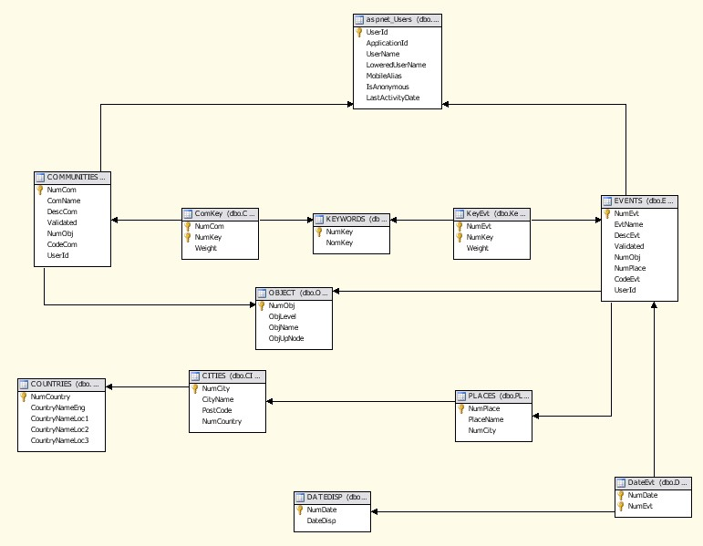

We have three types of users : Admin, Members and anonymous. Anonymous users can only search for an event or a community. Members can add an event or a community. They can also remove the topics they added. Administrators can modify events and communities or remove them.

To make the site more attractive, we use Flash components mainly for the navigation. All these Flash components interact with our ASP.NET pages.

Another technical point is the search engine (a quick search). First, the search engine manages the typing errors. We implemented the Levenstein Distance algorithm that compares two strings and returns an integer that indicates a level of similarities between the two strings.

It also includes a database job, executed daily, which clears all past events.

Tools used:

- Microsoft Visual Studio .NET 2003 to program in C# the PocketPC and the smartphone.

- Microsoft Visual Studio .NET 2005 beta 2 to program the web site (in C#).

- Microsoft SQL Server 2005 beta 2 for our database.

- Photoshop from Adobe for computer graphics.

- Flash from Macromedia to provide animations in the web site.

