

**Technical Brief**

**User Accounts and Shared Folders**

Microsoft Corporation

Published: August 2008

Version: 1.1

**Abstract**

This Technical Brief provides an in-depth look at the features and functionality of Windows Home Server User Accounts and Shared Folders. This brief has been updated to include additional information from Power Pack 1.

To learn more about other aspects of WindowsHome Server, see the Microsoft web site at: <http://www.microsoft.com/WindowsHomeServer>



*The information contained in this document represents the current view of Microsoft Corporation on the issues discussed as of the date of publication.  Because Microsoft must respond to changing market conditions, it should not be interpreted to be a commitment on the part of Microsoft, and Microsoft cannot guarantee the accuracy of any information presented after the date of publication.*

*The information contained in this document represents the current view of Microsoft Corporation on the issues discussed as of the date of publication. Because Microsoft must respond to changing market conditions, it should not be interpreted to be a commitment on the part of Microsoft, and Microsoft cannot guarantee the accuracy of any information presented after the date of publication.*

*This Technical Brief is for informational purposes only. MICROSOFT MAKES NO WARRANTIES, EXPRESS, IMPLIED OR STATUTORY, AS TO THE INFORMATION IN THIS DOCUMENT.*

*Complying with all applicable copyright laws is the responsibility of the user. Without limiting the rights under copyright, no part of this document may be reproduced, stored in or introduced into a retrieval system, or transmitted in any form or by any means (electronic, mechanical, photocopying, recording, or otherwise), or for any purpose, without the express written permission of Microsoft Corporation.*

*Microsoft may have patents, patent applications, trademarks, copyrights, or other intellectual property rights covering subject matter in this document. Except as expressly provided in any written license agreement from Microsoft, the furnishing of this document does not give you any license to these patents, trademarks, copyrights, or other intellectual property.*

*Unless otherwise noted, the companies, organizations, products, domain names, e-mail addresses, logos, people, places, and events depicted in examples herein are fictitious. No association with any real company, organization, product, domain name, e-mail address, logo, person, place, or event is intended or should be inferred.*

*© 2008 Microsoft Corporation. All rights reserved.*

*Microsoft, ActiveX, Windows, Windows Server, and Windows Vista are trademarks of the Microsoft group of companies.*

*UPnP is a certification mark of the UPnP Implementers Corporation.*

*All other trademarks are property of their respective owners.*

**Contents**

[Overview of User Accounts and Shared Folders 4](#_Toc207092779)

[Features & Functionality 4](#_Toc207092780)

[Benefits 5](#_Toc207092781)

[User Accounts and Shared Folders 6](#_Toc207092782)

[User Accounts 6](#_Toc207092783)

[Creating and Removing User Accounts 7](#_Toc207092784)

[Configuring User Accounts 11](#_Toc207092785)

[User Accounts and Shared Folders on Your Home Network 13](#_Toc207092787)

[Default Shared Folders 14](#_Toc207092788)

[Music, Photos and Videos Shared Folders 15](#_Toc207092789)

[Software Shared Folder 15](#_Toc207092790)

[Creating and Removing Shared Folders 1](#_Toc207092791)6

[Accessing Shared Folders 1](#_Toc207092792)7

[Shared Folder Duplication 20](#_Toc207092793)

[Shared Folder Disk Space Usage 2](#_Toc207092794)0

[Using Remote Access and Shared Folders 21](#_Toc207092795)

[Summary 2](#_Toc207092796)2

# Overview of User Accounts and Shared Folders

You can use the Shared Folders and User Accounts features in WindowsHome Server to centrally store, protect and access your data on your home server. Files can be accessed from both within your home network and remotely from the web.

## Features & Functionality

After you configure User Accounts and Shared Folders you can easily access your protected data and files from home and remote computers.

* **User Accounts**

User Accounts dictate who has access to content stored in Shared Folders on your home server and add a higher level of protection to your files. Windows Home Server will ensure that a user has the appropriate permission to view and access folders and files. Windows Home Server makes configuration of user accounts simple by verifying that user accounts and passwords on your home network are synchronized.

* **Shared Folders**

Shared Folders simplify the task of organizing and sharing your files. This feature of Windows Home Server gives every user in your home the ability to store files in one central location and access the content from any computer on the home network. You can also access music and other entertainment content through your Xbox 360 or compatible digital media receiver.

* **Shared Folder Duplication**

Enabling the folder duplication feature on a shared folder will create a second copy of the files on another hard drive on your home server. This redundancy will help prevent data loss in the event of hard drive failure. To conserve space on your hard drive you can turn off folder duplication to prevent large or unimportant files from being duplicated. The ability to control duplication at a shared folder level makes Windows Home Server duplication more practical than a set of mirrored hard drives.

## Benefits

Windows Home Server User Accounts and Shared Folders provide the following benefits:

* **Organization**

Centrally storing your photos, videos, music and other important documents helps you always know where to find them. By saving the file to the Windows Home Server, you know exactly where the file is and who has access to the file.

* **Sharing**

This allows Windows Home Server to act as a media hub for your photos, music, and movies, making them accessiblefrom your multiple home computers and network-attached media players.

* **Protection**

With Shared Folder duplication enabled on selected folders, Windows Home Server will make sure there is a second copy of your data in that shared folder on another hard drive. This will help prevent data loss in the event that a single hard drive fails. User Accounts enable you to set different user permissions for each shared folder.

# User Accounts and Shared Folders

## User Accounts

This section of the technical brief will go into further depth of how Windows Home Server User Accounts work.

Before you begin setting up user accounts and shared folders, you should understand each level of access permission:

**Full –** The user can view, add, modify, and delete files in the shared folder.

**Read –** The user can view files in the shared folder, but cannot add, modify, or delete files.

**None –** The user cannot view, add, modify, or delete files in the shared folder.

If a user has **Read** access to the Music shared folder wanted to listen to music or copy music from the shared folder they could do that. However, if the user felt the name was wrong on the song, they could not change the song name. If the user had other music to put into the Musicshared folder, they would not be allowed unless they were given **Full** permissions or used another user account with **Full** permissions.

important_dd**Important**

After you add a shared folder, some users may receive Access Denied errors when they try to access the shared folder. If this happens, they may need to log off and then log on to their home computer before they can access the shared folder.

When a user account has access set at **None** for a shared folder, they would receive an Access Denied error when trying to open up that shared folder. This means the user cannot see the files in the folder, they cannot add files to the folder, they cannot remove files from the folder, they cannot execute the files from the folder and they cannot copy the folder.

**Caution**



The guest account can be used to give access to shared folders for users that do not have their own user account for Windows Home Server. Enabling the guest account will provide default **Read** permission to the shared folders: Music, Photos, Videos, Public, and Software. For security reasons, the guest account cannot be accessed remotely.

### Creating and Removing User Accounts

You are allowed to create 10 user accounts on Windows Home Server. By default, only the guest account exists, however it does not get counted against the total of 10 user accounts. Each user will automatically be provided with a shared folder that only they have access to, for example, [\\server\users\jeff](file://server/users/jeff) would get created when you add a user named Jeff via the Windows Home Server Console. It is a best practice to create the user accounts on your home server with the same names that you are using on your home computers. This will streamline your home network setup so you can fully benefit from centralized storage without having to remember different usernames and passwords. If you do not maintain user accounts with logon names that match across your home network, you can still access shared folders on Windows Home Server. However, you will be prompted for a valid user name and password when you connect to your home server.

important_dd**Important**

User accounts should be created using the Windows Home Server Console. This document assumes you have already installed the Windows Home Server Connector software on at least one home computer.

Adding User Accounts



You can use the User Accounts tab on the Windows Home Server Console to add, remove, and change user accounts on your home server. You should add a user account for each person who uses your home network so they can access various shared folders on your home server.

1. From a home computer, **right-click** the **Windows Home Server tray icon**, and then click **Windows Home Server Console**.
2. Type the Windows Home Server password, and then click **Next**.
3. On the Windows Home Server Console, click the **User Accounts** tab.
4. Click **Add**, and then complete the Add User Account Wizard. The following information is displayed for each user account on Windows Home Server:
   1. **Name**   
      Displays the name of the person associated with the user account.
   2. **Logon Name**   
      Displays the user account name that is used to log on to the home server.
   3. **Remote Access**   
      Indicates if Remote Access is enabled for this user account.
   4. **Account Status**   
      Indicates if the user account is enabled or disabled.
5. Repeat for each user account that you want to add.

When you add a new user account, Windows Home Server does the following:

* **Creates a new user account**   
  The new user account can have a first name, last name, logon name, and password.
* **Configures the access level for shared folders**   
  You can set the type of access to shared folders as Full, Read, or None.
* **Creates a personal shared folder**   
  By default, no other user accounts can access each user’s personal shared folder.
* **Configures remote access**   
  By default, Remote Access is not enabled for new user accounts.

During the User Account wizard, setup will ask you if you would like to enable Remote Access. Enabling remote access requires a strong password. This is a requirement even if you have changed password settings to weak.

Windows XP and Windows Vista use two different ways to display user information. They both display descriptions and username. Your username is what is used for network authentication. As mentioned above, the username you define on your home server and your home computer should match in order to streamline authentication.

If a user account does not exist on your home server with the same username as on your home computer, the Windows Home Server Connector software on the home computer will display a popup.

**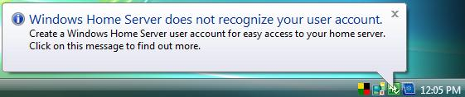**

The home server software will notify you if the username that you are using on your home computer has not been correctly configured in the Windows Home Server Console. This notification will display the logon name of your user account that you are currently using on your home computer.

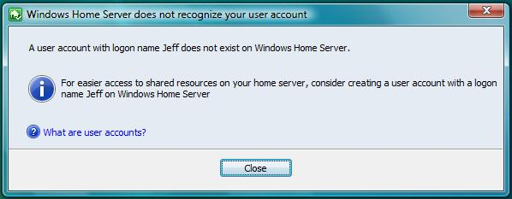

**** Determining your current user accounts

If you missed the above message, you can check the username that you are using on your home computer by doing the following.

Windows XP Home

1. Click start
2. Run
3. Type, “control userpasswords2”
4. Click OK
5. The usernames will be listed in the Windows under User Name.

Windows Vista

1. Click start
2. Type in the search bar, “CMD”
3. When the command window opens type, “whoami”
4. You your username will be displayed as “computer name\username”.

* Removing a user account

1. From a home computer, **right-click** the **Windows Home Server tray icon**, and then click **Windows Home Server Console**.
2. Type the Windows Home Server password, and then click **Next**.
3. On the Windows Home Server Console, click the **User Accounts** tab.
4. **Right-click** a user account and click **Remove** to start the Remove a User Account wizard.

The wizard helps you remove a user account and its associated shared folder. You can choose either to keep the shared folder or to remove it. If you choose to keep the shared folder, you can allow one existing user account to have access to the folder. You can also change this at a later time from the Shared Folders tab.

### Configuring User Accounts

After a user account has been created, you can alter the settings and permissions through the User Accounts tab in the console.

You can enable Remote Access for a user in the console. Enabling remote access requires a strong password. This is a requirement that cannot be changed, even if you have set the Password Policy settings dialog to weak.

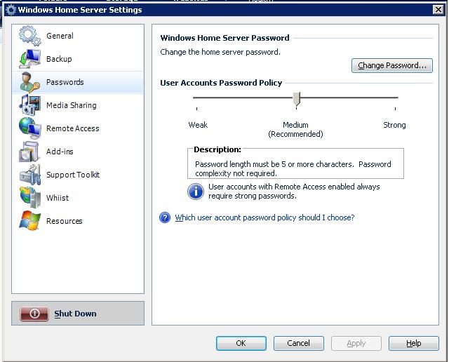

After clicking settings in the Windows Home Server Console, you can select the passwords page to make changes to the User Accounts Password Policy.

You can choose the following password policies:

* **Medium (default)**  
  By default, passwords for user accounts must be at least five characters long, with no complexity requirement.
* **Weak**  
  If you want shorter passwords, you can select the Weak password policy, which allows passwords of any length (including zero length, or no password) and which has no complexity requirement. This setting is not recommended because user accounts with short passwords reduce your network security.
* **Strong**  
  If you want to make access to your home network more secure, you can select the Strong password policy. The Strong password policy requires complex passwords that are at least seven characters long. A complex password must contain at least three of the following four character categories:
  + Uppercase letters
  + Lowercase letters
  + Numbers
  + Symbols (such as !, @, #, etc.)

|  |  |
| --- | --- |
| important_dd | **Important** |
|  | Regardless of which password policy you choose, all user accounts with Remote Access enabled require strong passwords. This cannot be changed. |

###### To enable remote access for a user



1. From a home computer, **right-click** the **Windows Home Server tray icon**, and then click **Windows Home Server Console**.
2. Type the Windows Home Server password, and then click **Next**.
3. On the Windows Home Server Console, click the **User Accounts** tab.
4. **Right-click** the **user account**, and then click **Properties**.
5. Check **Enable remote access for this user**
6. Select from the drop down the level of access you would like the user to have
   1. Allow access to shared folders and home computers.
   2. Allow access to shared folders only.
   3. Allow access to home computers only.
7. Click **OK**

|  |
| --- |
| Remote Access is not enabled by default when you add a new user account. To maintain security, you cannot enable Remote Access for the Guest account. You must add a user account and then enable remote access for that user account. |
|  |

###### To change users access



1. From a home computer, **right-click** the **Windows Home Server tray icon**, and then click **Windows Home Server Console**.
2. Type the Windows Home Server password, and then click **Next**.
3. On the Windows Home Server Console, click the **User Accounts** tab.
4. **Right-click** the **user account**, and then click **Properties**.
5. Click the **Shared Folder Access** tab
6. Select the **Full, Read** or **None** for the level access you would like to give that specific user to that specific shared folder.
7. Click **OK**

### User Accounts and Shared Folders on Your Home Network

A user account must be created and given access to a shared folder in order to view, change or add to the contents of that specific folder. If you are logged into your home computer as a username that is unrecognized by the Windows Home Server, you will be presented with an authentication box in order to access your home server. After you receive the authentication box, type a username and password that already exists in the Windows Home Server Console.

To access the share folders on your home server from a home computer, right-click the **Windows Home Server tray icon**, and then click **Shared Folders**. A Windows Explorer window will open displaying all of the shared folders on your home server. Though you can see all the shared folders, you will only be able to open the folders for which you have **Read** or **Full** permissions. If the user does not have permissions to the folder, an Access Denied message will be displayed. If a user needs permissions to a folder, their settings will have to be changed through the Windows Home Server Console.

**Important**



When users view shared folders from the Remote Access website, they will only be able to view the shared folders for which they have **Read** and **Full** permissions.

### Default Shared Folders

Windows Home Server creates default folders: Music, Photo, Videos, Software and Public. You can choose which users have access to these folders and the permissions for each user. These default shared folders cannot be deleted.

#### Music, Photos and Videos Shared Folders

With the Media Sharing feature enabled, you are able to copy content into the Music, Photos and Videos shared folders and have the content available to media receivers on your home network, such as Xbox 360.

important_dd**Important**

Even if you set every user’s access levels to **None**, with Media Sharing feature enabled, Media Connect Devices will still have **Read** access to these folders. To learn more about media sharing and media streaming, please review the Windows Home Server Media Sharing Technical Brief.

#### Software Shared Folder

By default, Windows Home Server creates the Software shared folder with three subfolders.

caution_dd**Caution**

Do not delete, move or rename any of the subfolders under the Software shared folder. Windows Home Server relies on these subfolders to exist for the Connector software and Add-Ins to be installed correctly.

* **Home Server Connector Software**

When you purchased your Windows Home Server, it may have come with a Windows Home Server Connector CD. You can install the Connector software from the CD or you can install the Connector software from the [\\Server\Software\Home Server Connector Software](file://Server/Software/Home%20Server%20Connector%20Software) shared folder. This folder is also updated via Windows Update and should not be altered or deleted. If this folder is altered or deleted, you will no longer receive Windows Updates for the Windows Home Server Connector Software. You can also access the Connector software through <http://server:55000>. This can be useful in a scenario where a user does not have access to the Software shared folder.

* **Home Computer Restore CD**

To obtain the latest version of the Home Computer Restore CD, please go to <http://go.microsoft.com/fwlink/?LinkID=104683>. You can use the Home Computer Restore CD subfolder to store any updated versions of this CD image.

* **Add-Ins**

Windows Home Server has been designed with extensibility in mind, so that software developers can develop innovative Add-Ins, such as home web cameras, home automation, and home security solutions that work with your home server. After placing a Windows Home Server Add-In software solution into the Add-In folder, you will be able to install the Add-In through **Windows Home Server Console** - **Settings** – **Add-ins** page.

|  |
| --- |
| **To install an Add-In** |
|  |
|  |
|  |

1. On a home computer, right-click the Windows Home Server tray icon, and then click **Shared Folders**.
2. In **Shared Folders**, double-click the **Software** folder.
3. Double-click the **Add-Ins** folder.
4. Copy the .msi file for the Windows Home Server add-in to the **Add-Ins** folder.
5. Close the **Add-Ins** folder.
6. Right-click the Windows Home Server tray icon, and then click **Windows Home Server Console**.
7. Type the Windows Home Server password, and then click **Next**.
8. Click **Settings** on the console.
9. On Windows Home Server **Settings**, click **Add-ins**.
10. Click the **Available** tab.
11. Click **Install** to install the selected Add-in.
12. Click **OK** on the **Installation succeeded** dialog box to restart the console.
13. Reconnect to the console. If your new Add-in includes a console tab, the new tab now appears in the console.

### Creating and Removing Shared Folders

**Creating Shared Folders**



1. From a home computer, **right-click** the **Windows Home Server tray icon**, and then click **Windows Home Server Console**.
2. Type the Windows Home Server password, and then click **Next**.
3. On the Windows Home Server Console, click the **Shared Folders** tab.
4. Click **Add**
5. Create a **Name** for your folder and a **Description** and check **Enable Folder Duplication** if you would like this folder duplicated.
6. Choose the desired level of access for each user for this shared folder
7. Click **Finish**

important_dd**Important**

Shared Folders must be created using the Windows Home Server Console. This allows you to control user access and enable folder duplication using Windows Home Server. Sub-folders created within Windows Explorer will inherit the permissions of the Shared Folder.

**Removing Shared Folders**



important_dd**Important**

It is important to save all contents of a shared folder you wish to keep before following the steps outlined below, as all of the files in the shared folder will be deleted and non-recoverable.

1. From a home computer, **right-click** the **Windows Home Server tray icon**, and then click **Windows Home Server Console**.
2. Type the Windows Home Server password, and then click **Next**.
3. On the Windows Home Server Console, click the **Shared Folders** tab.
4. Click **Remove**

You will be prompted that the shared folder will be permanently deleted along with all of the contents. Click **Finish** to delete the shared folder.

### Accessing Shared Folders

There are several different ways that you can access your shared folders on Windows Home Server from your home computer:

 **Windows Home Server tray icon**

When you install the Windows Home Server Connector software, an icon is added to your the tray on your home computer.

C:\Users\v-joelbu\Documents\WHS\Technical Guides\Joels\Taskbar.jpg

1. Right-click the Windows Home Server tray icon
2. Click **Shared Folders**.
3. Double-click a shared folder in the window to open it.

**Desktop shortcut**When you install the Windows Home Server Connector software, a shortcut is created on the desktop of your home computer.   
  
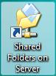



1. Double-click this shortcut to see the shared folders on your home server
2. Double-click a shared folder to open it.

**Windows Start Menu**



**Windows Vista**

1. Click **Start**
2. Type **\\SERVER** in the **Start Search** text box.
3. Double-click a shared folder in the window to open it.

**Windows XP**

1. Click **Start**
2. **C**lick **Run**
3. Type **\\SERVER** in the **Open** text box.

**Home Network**



**Windows Vista**

1. Click **Start**
2. **C**lick **Network**
3. Double-click the computer icon next to **SERVER**. There may be more one than SERVER item in the list. Double-click the icon that looks like this one:

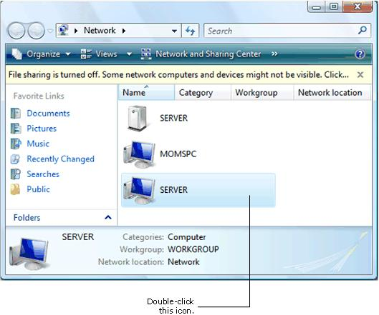

**Windows XP**

1. Click **Start**
2. Click **My Network Places**. The shared folders that your user account has access to automatically appear.

**Note**



This does not work if the home computer has been configured to work on a business network that employs a Windows Domain.

|  |
| --- |
|  |
|  |

**Changing Access to Shared Folders**



1. From a home computer, **right-click** the **Windows Home Server tray icon**, and then click **Windows Home Server Console**.
2. Type the Windows Home Server password, and then click **Next**.
3. Click the **Shared Folders** tab.
4. Click a shared folder
5. Click **Properties** to open the properties page for the selected shared folder.
6. On the **User Access**, you can change the user account permissions for the shared folder. If the shared folder is associated with a specific user account, the name of user account appears in bold.
7. Click **OK**

**Note**



You cannot change the name of any of the shared folders that are automatically created; Music, Photos, Videos, Software and Public cannot be deleted or renamed.

If you change the user access to a shared folder, some users may receive Access Denied errors when they try to access the shared folder. If this happens, they may need to log off and then log onto their home computer before they can access the shared folder with the desired permissions.

### Shared Folder Duplication

Enabling the folder duplication feature on your shared folders will create a second copy of the selected folders onto another hard drive on your home server. This will help prevent data loss in the event of hard drive failure.

 **Enabling Shared Folder Duplication**

1. From a home computer, **right-click** the **Windows Home Server tray icon**, and then click **Windows Home Server Console**.
2. Type the Windows Home Server password, and then click **Next**.
3. Click the **Shared Folders** tab.
4. Click the **Shared Folder**
5. Click **Properties**
6. Click **Enable Folder Duplication**
7. Click **OK**

Windows Home Server will begin to enable Folder Duplication. There needs to be enough room for Folder Duplication to complete or the Network Health will turn red in the Windows Home Server Console.

### Shared Folder Disk Space Usage

Windows Home Server tracks the disk space usage history for all of the shared folders on your home server.

###### Viewing Shared Folders History



1. From a home computer, **right-click** the **Windows Home Server tray icon**, and then click **Windows Home Server Console**.
2. Type the Windows Home Server password, and then click **Next**.
3. Click the **Shared Folders** tab.
4. Right-click a shared folder and click **View History** to see a graph representing the growth of the folder over time.

**Note**



A shared folder must exist for one week before **View History** will display a graph.

### Using Remote Access and Shared Folders

You can also use Remote Access to create new folders within a shared folder, to rename files and folders, and to delete files and folders on your home server.

**Note**



To add new shared folders on Windows Home Server, you must use Windows Home Server Console. To connect to the console from within Remote Access, click the **Computers** tab, and then click **Connect to your Home Server**.

After logging in remotely to your home server, click on the **Shared Folders** tab. Then click on a specific shared folder to open it. A list of the files and folders in that shared folder is displayed.

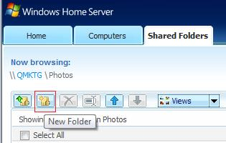

**To create a new folder**



1. Click the new folder icon.
2. Type a name for the folder then click **OK**.

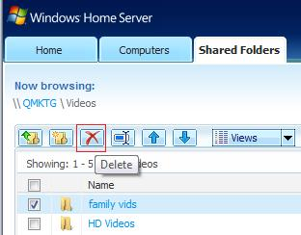

**To delete a file or folder**



1. Select the check box next to the files or folders that you want to delete, and then click the delete icon.
2. To confirm that you want to delete the selected files and folders, click **OK.**

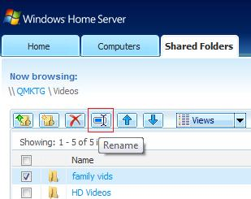

**To rename a file or folder**



1. Select the check box next to the file or folder that you want to rename, and then click **Rename**.
2. Type a new name in the text box, and then click **OK**.

# Summary

This Technical Brief provided an in-depth look at the features and functionality of WindowsHome Server User Accounts and Shared Folders.

Windows® Home Server User Accounts and Shared Folders enables you to easily connect, protect and organize your important content.

To learn more about other aspects of WindowsHome Server, please visit the Microsoft web site at: <http://www.microsoft.com/WindowsHomeServer>. You can also visit the Community Forums at <http://forums.microsoft.com/WindowsHomeServer> to discover additional tips about Windows Home Server User Accounts and Shared Folders.