
Microsoft® FrontPage® 2000

Product Enhancements Guide

Published: October 1998

Table of Contents
Introduction 1
Overview of New Features 2
Easily create engaging Web sites that look and work exactly the way they want 2
Quickly and flexibly manage Internet or team intranet Web sites 3
Works together with Office to save time—creating a Web site has never been easier 5
New Features in Detail 7
Everything Needed to Create Great-Looking Web Sites 7
Pixel Precise Positioning and Layering 7
60 Pre-Designed Themes 7
Custom Themes 8
Cross-Browser DHTML Animation Effects 8
Color Tools Everywhere 8
Cascading Style Sheets 9
Better-Than-Notepad HTML Editing 9
Easy Database Integration 12
Supports the Latest Web Technology 12
Extensibility and Programmability Features 14
Quickly and flexibly manage Internet or team intranet Web sites 15
Site Management Reports and Views Summarize a Site at a Glance 15
Flexible Publishing Features 16
Flexible Collaboration Features 17
Automate Routine Tasks 19
Web Sites That Work Anywhere 20
Works Great with Other Widely Used Microsoft Products 21
Works together with Office to save time—creating a Web site has never been easier 21
Simplified features make creating Web content easier than ever 21
Works Great with Microsoft Office 22
Designed for Worldwide Use 24
Get Up and Running Quickly and Easily 25

Microsoft FrontPage 2000
Product Enhancements Guide

Published: October 1998
For the latest information, please see http://www.microsoft.com/office/

Introduction
Microsoft® FrontPage® 2000 Web site creation and management tool was developed to take the best features of award-winning FrontPage 98, make them even easier than before, and add to them new features that customers have requested. FrontPage 2000 gives users everything they need to easily create and manage great Web sites.

This release of FrontPage includes many new features that allow users to easily create Web sites exactly the way they want, to easily update their sites, and to use FrontPage with Microsoft Office even more effectively than before. It allows users developing pages to control the way their pages look and work, and allows Web professionals to quickly code in either Normal View (WYSIWYG—what you see is what you get) or HTML View. And workgroups and teams developing Web content can work together better than ever before. FrontPage 2000 can also enable users and third parties to create rich add-on and custom Web applications.

This Product Enhancements Guide is designed to assist in your evaluation of Microsoft FrontPage 2000, and focuses on the new and improved features throughout the product.

FrontPage 2000 allows users to:
- Easily create Web sites exactly the way they want.
- Easily update sites--quickly and flexibly manage Internet or team intranet Web sites.
- Work together with Office to save time—creating a Web site has never been easier.

Overview of New Features
FrontPage 2000 allows users to:

Easily create engaging Web sites that look and work exactly the way they want
FrontPage 2000 gives users control of their Web sites like never before. They can position elements exactly where they want them on the page, give their Web site a professional and consistent look across all of its pages, import and edit HTML just as they like, and use the latest in Web technology.

 | Feature | Description
 | Tools for creating great-looking Web sites
New | Pixel Precise Positioning and Layering |  | Place page elements like graphics and text anywhere on the page--even layer content, through absolute and relative positioning.
Improved | 60 Pre-Designed Themes |  | Users can choose from 60 new pre-designed business-ready Themes to provide a consistent look across a single page, multiple pages, or an entire Web site.
New | Custom Themes |  | Users can pick from 60 pre-designed Themes and customize their colors, logos, graphics, backgrounds, and bullets to create the right look for their site.
Improved | Cross-Browser DHTML Animation Effects |  | Add Dynamic HTML effects including animation and collapsible outlines to pages with the click of a button. Animation effects work seamlessly with Netscape Navigator 4.0 and Microsoft® Internet Explorer 4.0, and appear statically across version 3 browsers.
Improved | Enhanced Color Tools |  | Choose custom colors from a color picker or color wheel, pick a specific color from a graphic to add to your custom colors, or choose from coordinating Web-safe color schemes. Custom colors are available everywhere colors are available, and across editing sessions.
Improved | Cascading Style Sheets |  | Use Cascading Style Sheets (CSS) to provide customized and consistent formatting on a page, or with FrontPage 2000, apply CSS to several pages, or even across an entire site.
 | Better-than-Notepad HTML Editing
New | 100% HTML Source Preservation |  |  | Edit existing HTML and scripts (including ASP) worry-free in FrontPage. Bring HTML created in other tools into FrontPage, and it will not modify the code. Tag and comment order, capitalization, and even white space are preserved.
New | Quickly Insert Code in HTML View |  |  | Use simple buttons or drop-down menus to insert code directly in HTML View.
New | Personalized HTML Formatting |  |  | Allows users to decide how they want their code indented, what colors they want their tags to appear in, when to capitalize, and when to use optional tags. When pages are imported or new content is created, FrontPage automatically applies those preferences to the new code.
New | Reveal HTML Tags in WYSIWYG View |  |  | Users can quickly see what tags create the effects on their pages by using Reveal HTML tags in a page while still in the Normal View (WYSIWYG mode).
 | Easy database integration
Improved | Database Results Wizard | Allows users without prior database experience to easily and automatically incorporate database queries directly into their pages. The data is dynamic and current data is returned from the database each time the page is loaded.
New | Data Access Pages | Easily incorporate Microsoft Access databases into Web pages, and have users add to or edit the database directly from their browsers.
New | One-Button Database Publishing | Makes creating and updating a database as easy as creating a form, by allowing users to create a new Access database, or modify an existing one, based on form data on a page.
 | Supports the latest Web technology
New | Pre-Built Web Components | Easily insert advanced functionality directly into Web pages through FrontPage components like the Category Component, and Office Web Components like the Spreadsheet, PivotTable® dynamic views, and Chart.
Improved | Edit HTML, DHTML, script, ASP, and XML | Use the HTML tab to view pages and scripts, and edit them directly. Includes HTML, DHTML, script, ASP, and XML.
New | Microsoft Script Editor | Edit and debug scripts including JavaScript and Visual Basic® Scripting Edition (VB Script) more quickly with the built-in Script Editor.
 | Extensibility and programmability
New | Visual Basic for Applications (VBA) | Build powerful FrontPage-based solutions using VBA. Leverage existing expertise to extend these solutions across Office applications.
New | Application, Document, and Web Object Models | Enable developers to programmatically manipulate FrontPage, FrontPage-created Web pages, and FrontPage-based Webs.
Improved | Integration with Design Time Controls and Visual InterDev™ | Extend FrontPage functionality by creating Design Time Controls with Microsoft Visual InterDev Web development system.

Quickly and flexibly manage Internet or team intranet Web sites
FrontPage 2000 allows users to do much more than just create Web pages. They can set up and maintain their site as a whole, easily monitor the condition of their Web site and make updates. Workgroups or teams can work together on sites, and companies can install and administer FrontPage 2000 across their company and even worldwide.

 |  | Feature | Description
 |  | Site management reports and views summarize a site at a glance
New |  | Page View | Integrated FrontPage Explorer and FrontPage Editor let you view and edit pages, and manage your site from within one easy-to-use application.
Improved |  | Folders View | Allows users to see all of the Web pages, graphics, and files in their Web.
Improved |  | Reports View | Users can quickly see the pages, graphics, and files in their Web, and easily run reports listing slow pages, unlinked, recently added or changed files, broken hyperlinks, component errors, review status, name assigned to, categories, publish status, or checkout status for any of the files.
Improved |  | Navigation View | Easily manage how your site’s navigation bars work by quickly creating navigation bars, easily viewing the navigational layout of your site, persisting settings across editing sessions, and zooming in to specific nodes for a close-up view.
Improved |  | Hyperlinks View | Graphically see all of the items that link to or from a specific page or Microsoft Office document, and visually see if any links are broken.
Improved |  | Tasks View | Track what tasks need to be done and to whom the tasks are assigned, and quickly see the status, description, and the priority of the tasks.
 |  | Flexible publishing features
Improved |  | Page-Level Control Over Publishing | Users decide exactly which pages are to be uploaded to the server by setting specific pages as “do not publish” or by publishing only pages that have changed.
Improved |  | Progress Indicator when Publishing | Progress indicator makes it more clear what is happening during the publishing process.
Improved |  | Publish Anywhere | Easily publish to an ISP with or without the FrontPage Server Extensions installed using the FrontPage built-in FTP. ISPs can choose Microsoft Windows NT® or a broad variety of UNIX platforms and operating systems.
 |  | Flexible collaboration features
Improved |  | Microsoft Office 2000 Save To Web | Users can lighten their workload because every team member can open and save Office 2000 documents directly to their FrontPage-based Web.
New |  | Nested Subwebs | Set rights to the Web as a whole and also specific rights to subgroups that want to be in total control of their sub-sites.
New | Check In/Check Out |  |  | Reserve a file in the FrontPage-based Web so that no one else can edit it. This prevents another user from saving edits on top of the file they are currently working on. It also allows you to quickly revert to the previous version of a file.
New |  | Workflow Reports | Users can assign responsibility for a page to a team member when pages are saved, and even set up and assign approval levels or stages in their own publishing process.
Improved |  | Multi-User and Remote Authoring and Management | Multiple users can author and add content to FrontPage-based Web sites at the same time, allowing teams to work together easily. Users can author content directly to a server running the FrontPage Server Extensions, save user environment preferences across editing sessions, and administer FrontPage-based Webs remotely.
 |  | Automate routine tasks
New |  | Category Component | Publish Web pages and Office documents to the FrontPage-based Web, and pages are automatically updated with links to these new documents.
Improved |  | Automatic Hyperlink Fix-Up | Rename or move a page or graphic in the FrontPage-based Web site, and hyperlinks are automatically fixed. Even works from within Microsoft Office.
 |  | Web sites that work anywhere
New |  | Target Specific Browsers, Features and Servers | Pre-select which environments to target (browser, server, FrontPage Server Extensions, ASP, DHTML, CSS, Java, script), and FrontPage automatically restricts features that will not work on the targeted systems.
Improved |  | Database Results Wizard | Allows users without prior database experience to easily and automatically incorporate database queries directly into their pages. The data is dynamic and current data is returned from the database each time the page is loaded.
Improved |  | Works Great with Other Widely Used Microsoft Products | Uses the same management console as Windows NT Server, Microsoft Internet Information Services, and other BackOffice® family applications, and ships with Windows NT Server, Microsoft Site Server and Visual InterDev.

Works together with Office to save time—creating a Web site has never been easier
Most FrontPage users also use one or more Microsoft Office applications. FrontPage 2000 was designed to function more like Office does, so that users can get up and running with FrontPage more quickly than ever.

 | Feature | Description
 | Simplified features make creating Web content easier than ever
Improved | Integrated FrontPage Editor and FrontPage Explorer | It’s easier than ever to get started using FrontPage because all of the Web page creation and site management tools users need are in one easy to use application.
Improved | Looks Like Microsoft Office | Office 2000 and FrontPage 2000 share common Themes, toolbars, menus, shortcuts, and tools like the Format Painter, HTML Help, and background spell checking.
Improved | Shared Web Themes | With Office 2000 and FrontPage 2000, Themes are shared so that pages created by Word or Access or FrontPage can share the same look.
Improved | Looks Like Microsoft Office | Office 2000 and FrontPage 2000 share common Themes, toolbars, menus, shortcuts, and tools like the Format Painter, HTML Help, and background spell checking.
New | Personalized Menus | Only the items used most often are prominently featured on the menu. Menus are easily expanded to reveal all commands; they also expand automatically based on IntelliSense® rules.
New | Personalized Toolbars | To reduce screen clutter, toolbars intelligently share space on the screen based on usage. This allows multiple toolbars to be stored in a single row on screen. As a part of a toolbar is used, it is “promoted” and displayed in a hierarchical fashion.
New | Customizable Toolbars | Toolbars are quicker and easier than ever to customize with Yes/No customization and drag-and-drop command controls on the toolbar.
New | Format Painter | Users can quickly apply the formatting from one piece of text to another by placing the cursor on the text with the format they want, pressing the Format Painter button, and then highlighting the text to be formatted.
New | Background Spell Checking | FrontPage 2000 brings users the familiar red squiggly lines to show misspelled or unrecognized words, and allows them to right-click on these words for suggestions on the correct spelling.
New | HTML Help | HTML Help allows users to see help while continuing to work within FrontPage, which means that they can follow the steps more closely and get questions answered more quickly.
New | Answer Wizard | Lets users get answers more quickly because they can ask questions in natural language, and FrontPage infers what the user needs help with from the way the question is phrased.
 | Works great with Microsoft Office
New | Office 2000 Uses HTML as a Native File Format | HTML has been elevated to the same level as the Office proprietary file formats. This means that HTML documents can be used in much the same way that Office binary files (*.doc, *.xls, *.ppt, *.mdb) are used today, and can be readily saved to and edited from a FrontPage-based Web.
Improved | Open & Save Office 2000 Documents to FrontPage-Based Webs | Office users can save Office documents and Web pages directly to FrontPage-based Web sites as easily as saving a file to a hard drive.
New | Integrated HTML Editing with Office Applications | When users edit an Office 2000 file from their FrontPage-based Web, the Office application in which they created the file launches so they can continue to edit in the application in which they created the files.
Improved | Automatic Hyperlink Fix-Up | Rename or move a page or graphic in the FrontPage-based Web site, and hyperlinks are automatically fixed. Even works from within Microsoft Office.
Improved | Access Database Connectivity | Easily incorporate Microsoft Access databases and Data Access Pages into FrontPage-based Web pages, and then users can add to or edit the database directly from their browsers.
New | Add, Edit, and Manage Office 2000 Web Components | Microsoft Office Web Components (such as the Spreadsheet, PivotTable views, and Chart) allow users to add the functionality of Microsoft Excel directly to Web pages, from within FrontPage 2000.
New | Common Server Extensions | Office Server Extensions incorporate the functionality of the FrontPage Server Extensions. This allows users to host FrontPage-based Webs on servers running the Office Server Extensions.
 | Designed for worldwide use
Improved | Available in 15 Languages | The FrontPage 2000 user interface is available in English, French, German, Italian, Japanese, Spanish, as well as the newly added languages of Norwegian, Dutch, Swedish, Korean, Traditional Chinese, Brazilian, Simplified Chinese, Danish, and Finnish. Additionally, with any language FrontPage product, users can create and manage Web content in the language of their Windows operating system.
Improved | Single Worldwide Executable | One worldwide executable means that companies can standardize the base Office 2000 or FrontPage installation around the globe, then add support for appropriate languages when required.
Improved | Global User Interface and Multilingual Editing | When additional languages are required, the user simply installs them from the appropriate language pack. Users can also have the FrontPage user interface in one language, but create content in other languages.
New | Set Language by Page | FrontPage 2000 allows users to select which language the proofing tools should use for each page, making it easier than ever for one user to create Web content in multiple languages. This also allows search products like Microsoft Index Server to offer search capability by the language the page was created in.
 | Get up and running quickly and easily
New | Windows Installer Technology | Uses the Microsoft standard Windows Installer Technology, the same installation program as Office, so companies can easily roll out FrontPage 2000 along with Office 2000.
New | Install on Demand | Programs and components are installed as needed, saving space on a hard drive until users need the functionality.
New | Self-Repairing Application | FrontPage 2000 determines at launch if essential files are missing and where they can be found. It then reinstalls the missing files with little or no user intervention.
New | Microsoft Office Custom Installation Wizard (CIW) | This tool allows administrators to help deploy customized versions of Microsoft Office 2000 and FrontPage 2000 that contain pre-selected configuration options at the individual feature, menu and toolbar level.
New | Create Webs Anywhere | Users do not need to have access to a Web server in order to create Web content. They can create a complete Web site right on their hard drive or Personal Web Server, then publish to a server when ready.
Improved | Easier Web Server Administration | Uses the same management console as Windows NT and Internet Information Services, and allows users to manage FrontPage-based Webs remotely.
New | Roaming User Profiles | Set up the FrontPage work environment, and FrontPage saves preferences on a server so that whatever computer a user logs in from, the FrontPage environment looks the same.

New Features in Detail

Everything Needed to Create Great-Looking Web Sites
FrontPage 2000 allows users to create engaging Web sites that look and work exactly the way they want them to. FrontPage includes the ability to lay out pages with exacting care, and design the pages with elements that color coordinate. Cutting edge features like Dynamic HTML and Cascading Style Sheets add style, movement, and interest to pages.

Pixel Precise Positioning and Layering
FrontPage 2000 allows users to place page elements like graphics and text anywhere on the page, and even layer content, through absolute and relative positioning. Objects can be aligned with one another, and text can be wrapped around an image to give users exactly the look they want.

60 Pre-Designed Themes
FrontPage includes a gallery of 60 professionally designed business-ready graphics and color schemes—called Themes—that can be applied to any FrontPage-based Web. Themes enhance the appearance of list bullets, fonts, navigation bars, table borders, horizontal lines, and page backgrounds, and they lend an attractive and consistent appearance to any FrontPage Web.

Custom Themes
FrontPage 2000 includes 60 pre-designed Themes, and users can even customize these Themes with the colors, logos, graphics, backgrounds, and bullets they want. This allows even a novice user to start out with one of the Themes that comes with FrontPage, and quickly and easily customize it to give it their own distinctive look.

Cross-Browser DHTML Animation Effects
FrontPage 2000 includes new Dynamic HTML effects that can be applied to images and text to add interest and movement to pages. For example, a user can create a page that has text that flies, hops, or spirals onto the page, has a blinds effect, or they can quickly add animations and collapsible outlines. In FrontPage 2000, the Effects work seamlessly with Netscape Navigator 4.0 and Microsoft Internet Explorer 4.0, and appear statically across version 3 browsers.

Color Tools Everywhere
FrontPage 2000 allows users to quickly and easily choose custom colors from a color picker or color wheel, or even pick a color from a graphic. Once custom colors are added, they are then available everywhere colors can be chosen.
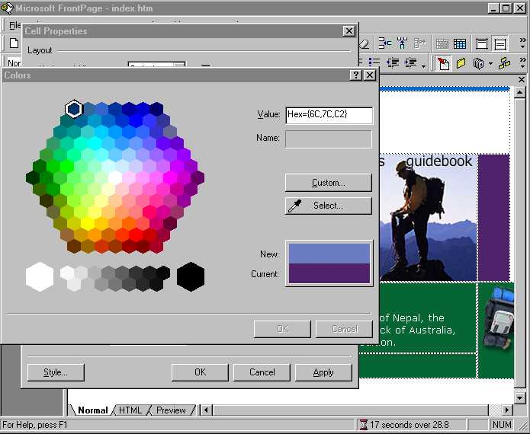
For example, a user could use the color picker (looks like an eyedropper) to select the color of the mountains on the graphic on a page. Once the color is selected, it is automatically added to the custom colors. Then anywhere a user can choose a color (such as when selecting a font or filling in a shape), that custom color is available, including across editing sessions.
FrontPage 2000 also includes Web color schemes that can be applied to a page or Theme, and give pages a special look, with coordinating colors from a Web-safe color palette. It also allows users to specify colors in HEX, such as “0000FF” or a familiar name, such as “BLUE”.

Cascading Style Sheets
Cascading Style Sheets or CSS is a standard Internet technology that gives Web authors word processor-like control over the text in HTML documents, so they can define complex styles for Web elements such as paragraphs, documents and collections of documents. Cascading Style Sheets allow users to change the look of an entire site by simply editing one file. Because individual pages don’t have to contain formatting information, pages load more quickly.

Popular Web browsers supporting CSS include Microsoft Internet Explorer 3.0 and higher and Netscape Navigator 4.0. Users can take advantage of leading Cascading Style Sheets support in FrontPage 2000 to provide customized and consistent formatting on a page, multiple pages, or an entire Web site with just the click of a button. It’s as easy as changing a font on text.

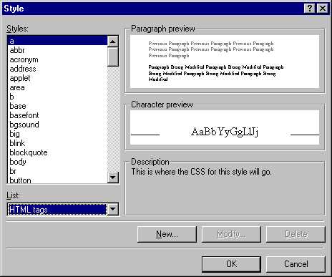

Better-Than-Notepad HTML Editing
FrontPage 2000 allows users who code in a text editor and know HTML well to create code more quickly, and create code that is formatted in exactly the way they want. This is a breakthrough for HTML authors who want to preserve their formatting and coding preferences, or for those who want to switch back and forth between multiple HTML editors without unnecessary format changes.

100% HTML Source Preservation
Edit existing HTML and scripts (including ASP) worry-free in FrontPage. FrontPage 2000 allows users who create or import content from another HTML editor (like Notepad) to bring the content into FrontPage without FrontPage changing the code. Tag and comment order, capitalization, and even white space are preserved.
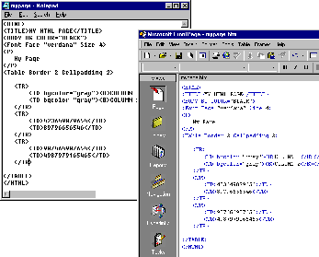For example, a user could take this page from Notepad and import it into FrontPage 2000 and the coding would be the same:

Quickly Insert Code in HTML View
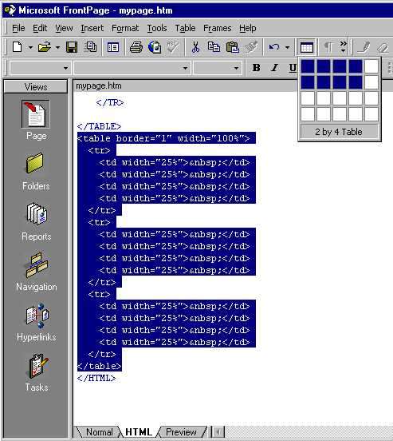
FrontPage users are accustomed to being able to easily create tables, add and format text, and insert images using FrontPage WYSIWYG (what you see is what you get) page editing features. With FrontPage 2000, users who want to code in an HTML View similar to that of Notepad can have the best of both worlds. They can edit in an environment that is similar to Notepad, but contains color-coded tags for easy reading, and they can use simple buttons and drop-down menus to insert code directly into HTML view.

For example, while still in HTML view, users can select the Table button, select the number of rows and columns they want, and then the HTML code will be entered automatically.

Personalized HTML Formatting
FrontPage 2000 takes the commitment to preserve hand-coded HTML even further by allowing users to personalize how their HTML is formatted. Users tell FrontPage how they want code indented, what colors they want their tags to appear in, when to capitalize, and when to use optional tags. When pages are imported or new content is created, FrontPage automatically applies those preferences to the new code.

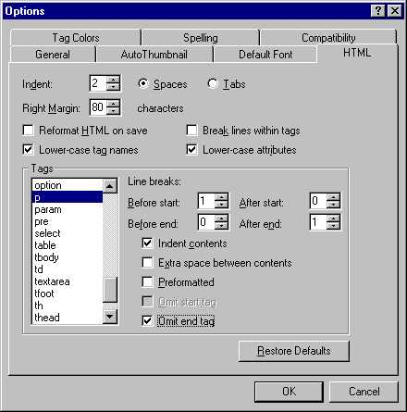

Reveal HTML Tags in Normal View
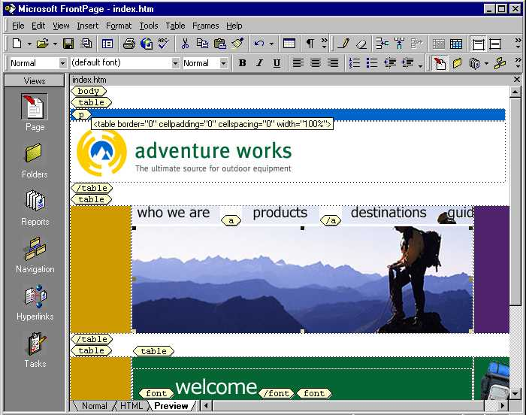
Users often want to be able to see the HTML tags in their Web page, but it is sometimes tricky to find the tag they are looking for in HTML View. This is why FrontPage 2000 allows them to reveal the tags in a page while still in Normal View. This also makes it easier for the user to select and edit in complex pages.

Easy Database Integration
One of the most common requests for feature enhancements in FrontPage is the ability to take database queries and easily incorporate them into FrontPage-based Web pages. With FrontPage 2000, this becomes much easier, and users can even create Web sites with pages in which the data is updated when the user enters the page or refreshes it. This provides the user with the latest information at all times, and saves the Webmaster from having to keep re-posting fresh snapshots of the database.

Database Results Wizard
The FrontPage 2000 Database Results Wizard allows users without prior database experience to easily and automatically incorporate database queries directly into their pages. The data is dynamic, and current data is returned from the database each time the page is loaded. The database can be any ODBC-compliant database, including Microsoft Access. The database can be stored on the Web server itself, on a network share (UNC address), or via other network access.

Dynamic database results require that a server that supports Active Server Pages, such as Microsoft Internet Information Services. In addition, a new form feature called Save Form to Database allows users to add data directly to the database from any browser.

Data Access Pages
Access 2000 allows for more frequent database updates and increased Web interactivity with Data Access Pages. They allow a user to take an Access database, incorporate it into a Web page, and then have another user add to or edit the database directly from their browser (as long as the browser supports data binding—as some versions of Microsoft Internet Explorer do). Users can even open the Data Access Pages in FrontPage 2000 to edit them or change the page layout.

One-Button Database Publishing
The One-Button Database Publishing feature makes creating and updating a database as easy as creating a form, by allowing users to create a new Access database, or modify an existing one, based on form data on a page. The Create Database button creates the Access database, creates a table in the database, and populates a table with fields from the form on the page. It then posts the database to the FrontPage-based Web so that no one can browse it, and then creates the connection to the database.

Database Starter Sites
FrontPage 2000 ships with database starter sites that users can customize and build upon for their own use. For example, it includes sample databases and pages for an employee phone list and a product catalog. (Available on the FrontPage 2000 CD in English only.)

Supports the Latest Web Technology
FrontPage 2000 allows users to create Web sites that sizzle with more than just plain HTML. They can take advantage of the latest Web functionality by using the pre-built Web components that ship with FrontPage, buying third-party add-ons, or using FrontPage programmability features to create add-ons of their own.

Pre-Built Web Components
FrontPage 2000 ships with Web components that accomplish a variety of specialized tasks, and FrontPage enables the development of third-party enhancements to extend its capabilities. These precompiled CGI scripts and Java applets let even novice users add powerful, interactive functionality to their Web sites. A component can simply be dropped onto a Web page to generate full text searches, discussion groups, and more.

FrontPage 2000 Components
Category Component. In the past, users could easily add Microsoft Word, Excel, or PowerPoint® files directly to a FrontPage-based Web. However, the user still had to ask their Webmaster to create links to the pages they added to the Web. With FrontPage 2000, we’ve made it easier on the user and the Webmaster, because users can publish Office documents to the FrontPage-based Web, and pages can automatically be updated with links to these new documents.

FrontPage 2000 does this by allowing users to create pages that are saved with customizable category fields. First, the user goes into the page properties and selects the category or categories the page should be saved in (they can either use existing categories, or create their own).

Next, the Webmaster uses the Category Component to create HTML pages that automatically include links to all of the pages in a specified category. When a user adds another page, the page containing the links to the pages in that category automatically updates, without anyone’s intervention.

Microsoft Office Web Components
Office 2000 ships with Microsoft Office Web Components that allow users to insert spreadsheet functionality into Web pages. Users can easily insert, edit, and manage these components from within FrontPage-based Webs:
- Spreadsheet component. Allows users to add Excel spreadsheet capabilities. Perfect for quick calculations or scenario analysis while online.
- PivotTable dynamic views component. Allows users to group Excel data by certain fields so that they can perform analysis of data directly from a Web page.
- Chart component. Allows users to create charts from spreadsheet data on the fly from within a Web page.

Rich Support for Add-Ins
FrontPage 2000 allows third parties to create snap-in tools and utilities to extend its functionality. These add-ins can be Java applets, Visual InterDev Design Time Controls, ActiveX® controls, COM components, browser plug-ins, etc. Examples include electronic commerce shopping cart applications, streaming media players, and 3-D graphics tools.

Edit HTML, DHTML, script, and XML
Use the HTML tab to view pages and scripts, and edit them directly. Includes HTML, DHTML, script, Active Server Pages (ASP), and XML. For fast script debugging, use the built-in Microsoft Script Editor.

Microsoft Script Editor
FrontPage 2000 includes built-in support for advanced script editing and debugging with the Microsoft Script Editor. It allows users to add any scripting language code directly into FrontPage, and even provides statement completion to help users adding code to finish their work even more quickly.

Extensibility and Programmability Features
FrontPage 2000 adds the extensibility and programmability that companies and independent software vendors have been asking for. It allows them to create macros, Design Time Controls, and programs to automate the creation of content across Microsoft Office applications, including Microsoft FrontPage 2000.

Visual Basic for Applications
FrontPage 2000 adds Visual Basic for Applications 6.0, which enables companies to build powerful FrontPage-based solutions that span Office applications. For example, a company could create a macro that runs a query against an Access database, opens FrontPage, creates a page formatted with a specific FrontPage template, and then publishes the page to a Web server.

Application, Document, and Web Object Models
FrontPage 2000 supports object models to enable developers to programmatically manipulate FrontPage-based Web sites and pages.
- Application Object Model. Application Object Model allows a software developer to add functionality directly to FrontPage. For example, a developer can create an electronic commerce application that incorporates shopping cart functionality directly into FrontPage.
- Document Object Model (DOM). DOM allows a developer to create functions that traverse individual Web pages to edit or pull information or data from them. For example, a developer could create a routine to automatically check FrontPage Web pages for oversized images before they are saved.
- Web Object Model (WOM). A WOM allows programmatic manipulation of a Web site (or multiple Web sites) and pages. For example, a developer could create a program to crawl through selected Web sites to check for conformance to company formatting guidelines, or automatically insert copyright information on each page, then edit the Web properties to document the fact that the conformance checking has been done.

Integration with Design Time Controls and Visual InterDev
FrontPage functionality can be extended by creating custom components (formerly called “WebBot® Components”). For example, there are several third parties today that offer customer components for FrontPage electronic commerce. With FrontPage 2000, developers can also extend FrontPage functionality by creating Design Time Controls with Microsoft Visual InterDev. DTCs are written at design time, and can be expanded and run either on the client or the server (depending on the implementation). When run against a server with the FrontPage Server Extensions loaded, the controls are inserted as components. When they are run against a server running Internet Information Services, the controls are DTCs using Active Server Pages.

Quickly and flexibly manage Internet or team intranet Web sites
FrontPage 2000 allows users to take a Web-wide view of all of the elements that make up their sites, and make sure that they are operating at top performance, and just the way they want them to. FrontPage 2000 allows users to work together more effectively than ever in workgroups or teams.

Site Management Reports and Views Summarize a Site at a Glance
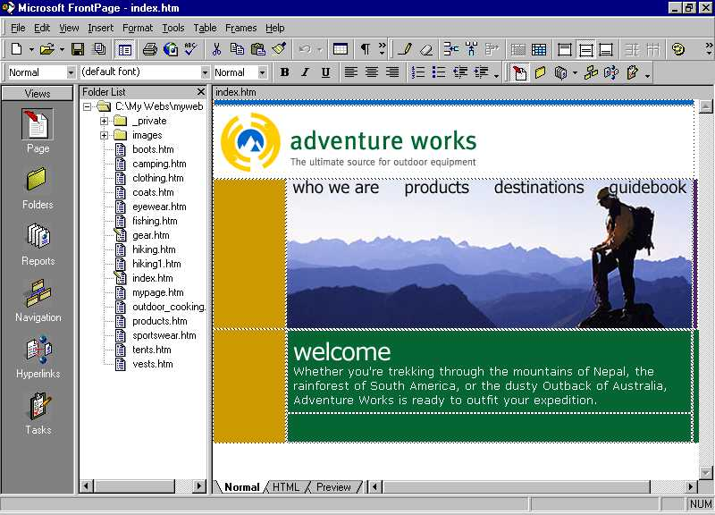
Updating Web sites is easy with new management reports and views. FrontPage 2000 uses a toolbar, like the one in Microsoft Outlook™ messaging and collaboration client, on the left side of the screen to help users to see their Web site quickly and easily, just as they want to. This allows users to get to the key areas in FrontPage that used to be located in two different programs—the FrontPage Explorer and the FrontPage Editor.

Views Bar
FrontPage 2000 features a Views Bar along the left side that gives users one-click access to all the FrontPage views, including the new Page view. Similar in style to the Outlook Bar found in the Microsoft Outlook messaging and collaboration client, the FrontPage Views Bar also includes other site management views such as Page, Folders, Reports, Navigation, Hyperlinks, and Tasks.
- Page View. Open a page in Page View and start creating and editing Web content immediately. With FrontPage 98, this would be accomplished in the FrontPage Editor. FrontPage 2000 integrates the FrontPage Explorer and the FrontPage Editor into one program, making it easy to manage Web pages and Web sites, and providing easy access to files for dragging and dropping into the pages.
- Folders View. Allows users to see all of the Web pages, graphics, and files in their Web. Looks much like the Microsoft Windows Explorer, but here if files that are linked to are renamed or moved, FrontPage will automatically fix the links.
- Reports View. Quickly see the pages, graphics, and files in the Web, and easily run reports listing slow pages, unlinked (unused files), recently added or changed files, broken hyperlinks, component errors, review status, assigned to, categories, publish status, our checkout status for any of the files.
- Navigation View. From one screen, design how navigation bars on all of the pages on the site should be laid out. Change navigation elements on all pages in seconds by simply updating the layout in the Navigation View. With FrontPage 2000, the Navigation View is also much more scalable, with the ability to manage thousands of pages. Users can zoom in to a node on the tree, zoom in and out, and even keep the settings between sessions so they can return to the same settings later.
- Hyperlinks View. Select a file in the FrontPage-based Web and graphically see all of the items that link to it, and all of the items that it links to. Quickly see which links are broken, even in Microsoft Office documents (like Word, Excel, and PowerPoint files).
- Tasks View. Keep track of the things that need to be done on the Web site in the Tasks View. It allows users to track what tasks need to be done, and who the tasks are assigned to, as well as the status, description, and priority of tasks. Users can even sort based on any of these fields and print the results.

Flexible Publishing Features
FrontPage 2000 makes updating sites even easier with the inclusion of several improvements to the process of publishing Web pages and files to Web servers.

Page-Level Control over Publishing
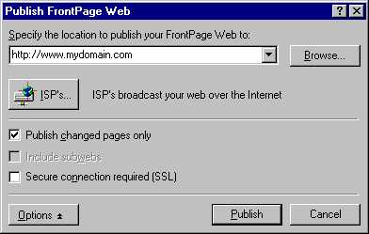
FrontPage 2000 enables more flexibility in publishing Web sites to a Web server (whether or not it is running the FrontPage Server Extensions). For example, it allows users to set up a staging server where content is created, and then they can easily publish their finished Web to the actual Web server that will host the content. It also offers more choices when it comes time to publish the Web, including the option to flag specific pages as “do not publish” or to publish only pages that have changed.

Feedback During Web Site Publishing
With FrontPage 98, publishing was easy, but users were sometimes uncertain whether the publishing process was processing normally, or whether it had stopped. With FrontPage 2000, a progress indicator gives the user more feedback during the publishing process, thus eliminating the guesswork.

Publish Anywhere
FrontPage 2000 has built-in FTP support, which allows users to easily publish content to the server of their choice, whether that server is at their Internet Service Provider (ISP) with the FrontPage Server Extensions loaded, or not. ISPs who want to offer enhanced FrontPage functionality to their customers can get the FrontPage Server Extensions for a broad variety of operating systems, server platforms, and Web servers—including Windows NT Server running Internet Information Services, and Apache, BSD, CERN, Linux, Netscape, Solaris, HP/UX, AIX, SCO, and many more. (See the Server Extensions Resource Kit on http://www.microsoft.com/frontpage for the complete list.)

Flexible Collaboration Features
One of the design goals for FrontPage 2000 was to make it easier for groups of people to work together on their Web-based projects. Flexible collaboration features make working with others on Web sites easier than ever.

Microsoft Office 2000 Save To Web
Users can lighten their workload because all team members can open and save Office 2000 documents directly to their FrontPage-based Web.

Nested Subwebs
As more and more people contribute to Web sites created with FrontPage, we have heard repeatedly that they want more flexibility in how they configure their Webs so that multiple teams can contribute, but not step on other people’s work. That’s why with FrontPage 2000, we add the ability to create Nested Subwebs, or Webs within Webs. This allows the Webmaster to set rights to the Web as a whole, and also specific rights to subgroups that want to be in total control of their sub-sites. For example, a school might have an intranet that contains school-wide information that they want only the school’s administration to contribute to. However, they might also want their intranet to have a subweb for each classroom so that class teachers and their students could contribute to it. With Nested Subwebs in the FrontPage 2000 administration, this is easy to set up.

Check In/Check out
Working in teams is made easier in FrontPage 2000 with Check In/Check Out. This allows a user to reserve a file that only they can edit in the FrontPage-based Web. This prevents another user from saving edits on top of the file they are currently working on, and helps preserve the right versions of files. For example, in a busy team with different people working on various Web site elements, one user could check out a file to work on, and if another user tried to work on that page, they would be notified that another user had the file checked out. Also, a user could check out a file, make changes, and undo the checkout to automatically revert to the previous version of the file.

Workflow Reports: Assign-To & Review
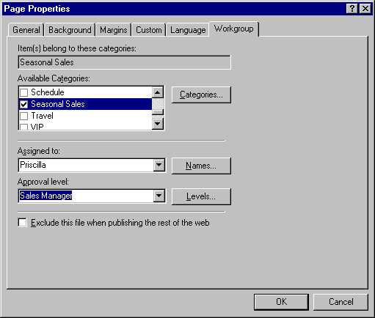
FrontPage 2000 allows users to quickly assign responsibility for a page to a team member when pages are saved, and even set up and assign approval levels or stages in their own publishing process. For example, a team might follow a standard process whereby one person writes the pages, then assigns them to the editorial team to check for accuracy, then sends them to the legal department for approval, then to the Webmaster, and finally for the OK to publish. With FrontPage 2000, it’s easy to add Editorial, Legal, Webmaster, and OK to Publish stages to the page properties so users can track where specific pages are in their own company’s publishing process.

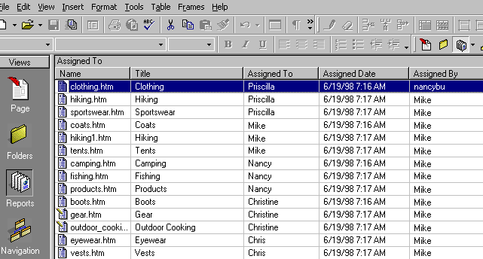Once the pages are assigned to specific people, and flagged with the appropriate stage of the publishing process, or the appropriate approval level, it’s easy to get a quick status overview by viewing the Reports View:

This shows which pages have been assigned to whom, and gives the current approval level for each.

Multi-User and Remote Authoring and Management
FrontPage 2000 generates standard HTML, not proprietary file formats that are later converted to HTML. That means that multiple users can author and add content to FrontPage-based Web sites at the same time, allowing teams to work together easily. Additionally, FrontPage 2000 provides check in/check out functionality so that one person can work on a file without fear of someone else making changes at the same time.

FrontPage 2000 also allows users to author content directly to a server running the FrontPage Server Extensions. This means that they don’t have to have a staging server; they can author directly to the server that their content will ultimately run from. Users can also author FrontPage-based Webs on a variety of PCs, since FrontPage 2000 can save user environment preferences so that no matter what computer they author from, their environment will look the same. Users can also administer FrontPage-based Web sites remotely using standard HTML, so they don’t have to be physically close to the FrontPage server to keep an eye on it.

Automate Routine Tasks
FrontPage 2000 was designed to make creating and maintaining Web sites as easy and worry-free as possible. It helps automate routine tasks such as automatically fixing hyperlinks to pages or files when they are renamed, making long documents easier to read and navigate, and even automatically inserting links into pages based on the category they are saved with.

Category Component Automatically Creates and Updates Hyperlinks
In the past, users could easily add Word, Excel, or PowerPoint files directly to a FrontPage-based Web. However, the user still had to ask their Webmaster to create links to the pages they added to the Web. With FrontPage 2000, we have made it easier on the user and the Webmaster, because users can publish Office documents to the FrontPage-based Web, and pages can be automatically updated with links to these new documents.

FrontPage 2000 does this by allowing users to create pages that are saved with customizable category fields. First, the user goes into the page properties and selects the category or categories the page should be saved in (they can either use existing categories, or create their own).

Next, the Webmaster uses the Category Component to create HTML pages that automatically include links to all of the pages in a specified category. When a user adds another page, the page containing the links to the pages in that category automatically updates, without anyone’s intervention.

Automatic Hyperlink Fix-Up
FrontPage 2000 helps keep Web sites current and healthy. When Office documents, Web pages or graphics are moved or renamed, it automatically fixes the links to them. The FrontPage Hyperlinks View lets users graphically see how pages are laid out, and lets them identify any broken links quickly, so that they can go in and fix them. For example, at a glance users can use it to see which pages link to an Office document, and see which pages that Office document links to. The Reports View allows users to quickly find slow pages, unlinked or unused files, broken links, and other information to help them keep sites working the way they want them to.

Web Sites That Work Anywhere
FrontPage 2000 allows users to incorporate advanced functionality that works on the browser and server platform that they want to target.

Target Specific Browsers, Features and Servers
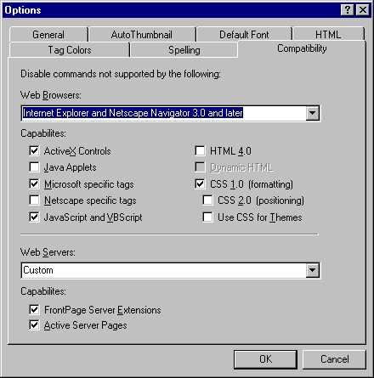
FrontPage 2000 is designed to create Web sites that work just the way users want them to, on the client and server platforms they select.

For example, users can pre-select the browser platform they would like to target, (such as Microsoft Internet Explorer and Netscape Navigator 3.0 and later, or even WebTV® service internet terminal), and features that will not work on those particular platforms will be restricted. In this way, users avoid wasting time incorporating functionality that won’t work on targeted browser platforms. Users can also specifically decide not to use tags that work only on Microsoft Internet Explorer or Netscape Navigator, or not to use CSS, JavaScript, VBScript, Java Applets, or DHTML. Additionally, users can select their Web server target, and whether it supports the FrontPage Server Extensions or Active Server Pages, so that functionality that requires those server setups will be restricted when the user tries to add it to a page.

Database Results Wizard for Dynamic Databases
The FrontPage 2000 Database Results Wizard allows users without prior database experience to easily and automatically incorporate database queries directly into their pages. The data is dynamic, with current data returned from the database each time the page is loaded. The database can be any ODBC-compliant database, including Microsoft Access. The database can be stored on the Web server itself, on a network share (UNC address), or via other network access.

Dynamic database results require that a server that supports Active Server Pages, (such as Microsoft Internet Information Services), must host the Web. In addition, a new form called Save Form to Database allows users to add data directly to the database from any browser.

Works Great with Other Widely Used Microsoft Products
FrontPage 2000 is complementary to many of the products that customers already own. For example, it uses the same management console as Windows NT Server, Internet Information Services, and other BackOffice applications, and ships with Windows NT Server, Microsoft Site Server and Visual InterDev. This allows administrators to manage FrontPage-based Webs in a familiar environment, and to create Web content in an environment that is as familiar to them as Microsoft Office.

Works together with Office to save time—creating a Web site has never been easier

Simplified features make creating Web content easier than ever
FrontPage 98 has gone through many rounds of usability testing, and we have collected feedback from hundreds of users about how to make common tasks even easier to accomplish. As a result of this feedback, here are some simplified features in FrontPage 2000.

Integrated FrontPage Editor and FrontPage Explorer
It’s easier than ever to get started using FrontPage because all of the Web page creation and site management tools users need are in one easy to use application. Users can edit pages and still have one-button access to the sophisticated site management features in the Folders, Reports, Hyperlink, Navigation, and Tasks Views.

Looks Like Microsoft Office
Creating a Web site has never been easier because FrontPage 2000 has so much in common with Office applications like Word and PowerPoint that if a user knows Word or PowerPoint, they can get started with FrontPage quickly. And FrontPage 2000 even simplifies some of the most commonly used features to save time for all users.

Shared Web Themes
A FrontPage Theme consists of unified design elements and color schemes for bullets, fonts, images, navigation bars, and other page elements. When applied, a Theme gives the pages and navigation bars in the FrontPage Web an attractive and consistent appearance. With Office 2000 and FrontPage 2000, Themes are shared so that pages created by Word, Access or FrontPage can share the same look.

Office 2000 includes a subset of the Themes included in FrontPage, and can use any Themes created from within FrontPage. Word 2000 and Microsoft Access 2000 include the Web Themes feature, and PowerPoint 2000 includes new presentation designs that match the formatting provided by shared Web Themes.

Personalized Menus
Personalized Menus are a unique solution to a long-term problem — how to focus on just the things a user needs and uses. When users first start FrontPage, the application menus will contain those commands that are used 95 percent of the time, while infrequently used commands do not immediately clutter the menu. At the bottom of each menu is a button that expands the menu to the full selection of choices so users can still easily find all menu commands. In addition, the menu will automatically expand based on IntelliSense rules (e.g., timing, hovering, etc.). As users access menu commands, these commands are “promoted” and are displayed higher on the list. Unused menu commands eventually are “demoted” and are not displayed on Personalized Menus. After a period of usage, menus will display the commands used most often and hide the ones never or rarely used. When users want to explore new features, they can quickly expand the menus to find them. In the meantime, they are only shown what they use, greatly simplifying the interface. IT administrators have the flexibility to customize or disable this feature.

Personalized Toolbars
FrontPage 2000 Personalized Toolbars are displayed on a single row overlapped. Users can click a “slider” button to see and access a full toolbar. As users click on buttons and use them, they are promoted and displayed. Unused buttons are put under the overlap. Over time, the toolbars thus configure themselves to users’ needs. This provides for less screen clutter and increased accessibility to the functions that users access most commonly.

Customizable Toolbars
Customizing toolbars is now easier than ever. Users simply click the Toolbar Options button on any toolbar to display a list of the potential buttons on that toolbar. They can select the ones they want to display and uncheck the ones they want to hide.

Format Painter
Users can quickly apply the formatting from one piece of text to another by placing the cursor on the text with the format they want, pressing the Format Painter button, and then highlighting the text they want to apply the format to.

Background Spell Checking
FrontPage 2000 brings users the familiar red squiggly lines to show misspelled or unrecognized words, and allows them to right-click on these words for suggestions on the correct spelling.

HTML Help
HTML Help allows the user to see Help while continuing to work within FrontPage, which means that they can follow the steps more closely and have questions answered more quickly.

Answer Wizard
The Answer Wizard lets users ask questions in their natural language, and FrontPage infers what the user needs help with from the way the question is phrased. This allows users to be more productive by providing the answer they are looking for more quickly.

Works Great with Microsoft Office
When we visit customers who create Web content, one of the things they always ask for is better integration between FrontPage and Office applications like Word, Excel, PowerPoint, and Access. This is because so many users already produce documents and presentations, and they would like it to be easy to post them on an intranet or Internet Web site. FrontPage 2000 makes great strides in its interoperability with Microsoft Office documents, allowing users to quickly and painlessly publish Web content.

Office 2000 Uses HTML as a Native File Format
HTML has been elevated to the same level as the Office proprietary file formats. This means that HTML documents can be used in much the same way that Office binary files (*.doc, *.xls, *.ppt, *.mdb) are used today. Office 2000 can easily create high-quality HTML documents that maintain the rich formatting of Office documents while enabling universal viewing to anyone with a Web browser, on any platform. In addition to viewing, HTML documents preserve the functionality users expect in Office documents (such as styles, PivotTable dynamic views, revision marks, OLE objects, command bar customizations, document properties and more). This enables the Office user to reopen the HTML document in the Office application that created it and receive the same functionality, formatting and edit state as when originally created (referred to as file “round-tripping”). Office 2000 accomplishes this by fully embracing existing Web technologies.

Open & Save Office 2000 Documents to FrontPage-Based Webs
One of the things we heard from visiting many customers with intranets is that they still have users send the Webmaster documents to put on the intranet, and often they do it by converting pages to HTML and then posting them. This is time-consuming for the Webmaster, and also means that when the document changes they have to make edits to the HTML version. With Office 2000 and FrontPage 2000, users can post their Office documents directly to FrontPage-based Webs (if granted the rights to do so) as easily as they save files to a hard disk.

It is also now possible to preview published documents in the default Web browser right from Office. On the main command bar, the Print Preview button has been expanded to support Web Preview. The File menu also includes this command. Web Preview makes it easy to see the final result just as others will view it.

Integrated HTML Editing with Office Applications
When users edit an Office 2000 file from their FrontPage-based Web, the Office application in which they created the file launches so they can continue to edit in the application in which they created the file. For example, if a user adds a Word 2000 document to the FrontPage Web, when he/she double-clicks on that .DOC or Word-generated .HTM file, Word launches so the user can edit it. When the user is done editing and saves the file, the FrontPage-based Web is updated.

Automatic Hyperlink Fix-Up
FrontPage 2000 helps keep Web sites current and healthy. When Office documents, Web pages or graphics are moved or renamed, it automatically fixes the links to them. The FrontPage Hyperlinks View lets users graphically see how pages are laid out, and lets them identify any broken links quickly, so that they can go in and fix them. For example, at a glance users can use it to see which pages link to an Office document, and see which pages that Office document links to. The Reports View allows users to quickly find slow pages, unlinked or unused files, broken links, and other information to help them keep sites working the way they want them to.

Access Database Connectivity
Access 2000 allows for more frequent database updates and increased Web interactivity with Data Access Pages. They allow a user to take an Access database, incorporate it into a Web page, and then have another user add to or edit the database directly from their browser (as long as the browser supports data binding—for example, Microsoft Internet Explorer 4 and higher). Users can even open the Data Access Pages in FrontPage 2000 to edit them or change the page layout.

Add, Edit, and Manage Office 2000 Web Components
Office 2000 ships with Microsoft Office Web Components that allow users to insert spreadsheet functionality into Web pages. Users can easily insert, edit, and manage these components from within FrontPage-based Webs:
- Spreadsheet component. Allows users to add Excel spreadsheet capabilities. Perfect for quick calculations or scenario analysis while online.
- PivotTable component. Allows users to group Excel data by certain fields so that they can perform analysis of data directly from a Web page.
- Chart component. Allows users to create charts from spreadsheet data on the fly from within a Web page.

Common Server Extensions
The Office Server Extensions (OSE) are a collection of Microsoft Internet Information Services extensions, and other technologies like the FrontPage Server Extensions, that reside on an HTTP server to provide additional publishing, collaboration, and document management capabilities. When OSE are present on the server, they enhance the functionality of Office 2000, the FrontPage-based Webs they host, the Windows Explorer, and the Web browser. OSE do not replace existing Web server technologies. Rather, they are designed to enhance the user’s experience with Office on a Web server. Because the Office Server Extensions incorporate the functionality of the FrontPage Server Extension, users can host FrontPage-based Webs on servers running the Office Server Extensions.

Designed for Worldwide Use
FrontPage 2000 was designed with the knowledge that the person creating FrontPage-based Webs does not always live in the country for which the content is destined, and recognizes that FrontPage is used all around the world. That’s why we have added international features such as additional languages, a single worldwide executable, a global user interface, and multilingual editing.

Support For New Languages (15 Total)
FrontPage 2000 is available in a variety of user interfaces for different languages. Users can either buy the FrontPage product for specific languages, or they can buy Office 2000 Premium with its Multi-Language Pack to get the FrontPage user interface in the languages listed below. Here is the expected schedule (subject to change):
- U.S. English
- French (+30 days)
- German (+30 days)
- Italian (+30 days)
- Norwegian (+30 days)
- Japanese (+50 days)
- Spanish (+60 days)
- Dutch (+60 days) – new in FrontPage 2000
- Swedish (+60 days) – new in FrontPage 2000
- Traditional Chinese (+60 days) – new in FrontPage 2000
- Korean (+75 days) – new in FrontPage 2000
- Brazilian (+90 days) – new in FrontPage 2000
- Simplified Chinese (+90 days) – new in FrontPage 2000
- Danish (+100 days) – new in FrontPage 2000
- Finnish (+120 days) – new in FrontPage 2000
Additionally, users can create Web content in whatever language their Windows operating system supports. For example, users running Windows 98 in Portuguese could use the English, German or Spanish version of FrontPage to create and manage Web sites written in Portuguese.

Single Worldwide Executable
The installation process for FrontPage 2000 uses one worldwide executable, and then the Microsoft Office 2000 Multi-Language Pack adds support for non-English languages that are also supported by FrontPage. This means that companies can standardize the base installation around the globe, then add support for appropriate languages when required.

Global Interface and Multilingual Editing
FrontPage 2000 has a worldwide executable that allows companies to roll out a standardized installation process across the globe, and decrease support costs by providing a consistent user interface no matter what language the user works in. When additional languages are required, the user simply installs from the appropriate language pack. FrontPage 2000 also allows a user creating Web content to have the FrontPage user interface in one language, but to create content in other languages. This is perfect for the Web developer who uses FrontPage to create content to be viewed in other countries.

Set Language by Page
FrontPage 2000 allows users to select which language the proofing tools should use for each page, making it easier than ever for one user to create Web content in multiple languages. With Install on Demand capabilities, the proofing tools for a given language can even be installed automatically when they are accessed.

When the user sets the language in the FrontPage page properties, a meta tag designating the language in which the page was created is added to the HTML code. This means that search products like Microsoft Index Server can offer the ability to search for pages created in specific languages.

Get Up and Running Quickly and Easily
FrontPage makes it easier to set up Web sites and keep them running, both for the individual FrontPage user installing and using FrontPage, and for companies deploying FrontPage 2000 across their organizations.

Windows Installer Technology
FrontPage 2000 uses the Microsoft standard Windows Installer Technology, the same installation program as Office, so companies can easily roll out FrontPage 2000 along with Office 2000.

Microsoft Windows Installer technology allows IT administrators to decide where each Office component or file will reside — on the client, on the server or on a hybrid configuration. An administrator can design profiles that range from placing components on both the desktop and the server to even allowing components on the desktop to be Installed on Demand from the server:
- Run from Terminal Server. Office 2000 has been optimized to run from a server-based terminal, using a Microsoft Windows-based terminal, giving administrators full control. This allows an administrator to maintain Office 2000 in one place — a central server location — rather than on individual users’ desktops, helping to reduce desktop management costs as well as hardware demands.
- Run from network server. Another option, in which the IT administrator has full control, is to run the applications directly from a server location. The applications are stored centrally, but the processing occurs on the desktop, reducing the need for an extremely powerful server without compromising the centralized control.
- Run from desktop. To support laptops or desktop computers that are not always connected to a server, Office 2000 can be installed to run completely from a desktop or laptop computer. This allows the user to be completely self-sufficient.

Install on Demand
Administrators can display shortcuts, icons or menu entries for not-yet-installed FrontPage 2000 functionality, indicating their availability without requiring their installation on the user’s computer. When the user selects a not-yet-installed component, the code is available from a hierarchy of sources, determined by the administrator, ranging from different server locations to the CD-ROM. This allows for better resource management because the end user will not install additional features until they are needed. If users are running the Windows 98 operating system or Windows NT 5.0, they could get additional levels of Advertisement and Install on Demand. Shell-level advertisement, or shortcuts on the Start menu are available on Windows 98 and Windows NT 5.0 or higher. FrontPage 2000 supports on demand installation of clip art, file converters and graphics filters, Visual Basic for Applications, Microsoft Script Editor, spellers and thesaurus (for the language of the page being edited), Themes, the Office Name Space Extension, and language-specific support (such as user interface, templates, and help).

Self-Repairing Application
FrontPage 2000 uses Microsoft Windows Installer technology to determine at launch if essential files are missing and where they can be found. It then reinstalls the missing files with little or no user intervention. It also automatically checks related registry entries for missing or corrupted information and repairs them as needed. The goal is to get users working again as quickly as possible, often without their even knowing there was a problem.

Microsoft Office Custom Installation Wizard (CIW)
This tool allows administrators to help deploy customized versions of Microsoft Office 2000 and FrontPage 2000 that contain pre-selected configuration options at the individual feature, menu and toolbar level. The wizard helps an administrator through the process of creating profiles that can be established for all types of users based on their needs. Network administrators can use the CIW to customize registry entries, shortcuts and files. They can also use the System Policy Editor to disable portions of the user interface, such as toolbar items that they don’t want their users to see. For example, a network administrator can disable FrontPage features that require Server Extensions, or features that require Microsoft Internet Explorer 4.0 or Netscape Navigator 4.0 or later browsers. They can also prevent users from turning the functionality back on by using Windows NT policies.

Create Webs Anywhere
With FrontPage 2000, users don’t need to have access to a Web server or have TCP/IP installed on their computer in order to create Web content. They can create a complete Web site right on their hard drive or Personal Web Server, then publish to a staging server, production server, or to their Internet Service Provider’s server when ready.

Additionally, Universal Naming Convention (UNC) locations can be used when linking to content that exists on intranet servers. For example, with FrontPage 98, inserting a hyperlink to a network drive was automatically inserted as x:/path/pagename.htm, and to recognize UNC locations, the user had to manually edit the hyperlink to change it to \\server\share\path\pagename.htm. FrontPage 2000 eliminates this problem and allows users to create hyperlinks using UNC names.

Support For Roaming User Profiles
With FrontPage 2000, we recognize that users often create and manage Web-based content from a variety of locations, such as their office desktop computer, their home computer, and their notebook or laptop computer. FrontPage 2000 allows users to set up their FrontPage work environments, and save their preferences on a server so that no matter which computer they log in to, their FrontPage environments look the same.

Easier Web Server Administration
Microsoft Management Console (MMC) is an extensible, common console framework for management applications. MMC is part of Windows NT and will run on both Windows NT (4.0 and later versions) and Windows 95 operating systems (current and future versions).
MMC itself does not provide any management behavior, but it offers a common environment for Microsoft or third party Snap-Ins, which supply the actual management behavior. The MMC environment provides for seamless integration between Snap-Ins, even those provided by different vendors. FrontPage 2000 provides an administration Snap-In for MMC, which means that Windows NT and Internet Information Services administrators will already know how to manage FrontPage-based servers. A new FrontPage-extended Subweb Wizard makes setting up a FrontPage Web on Internet Information Services (IIS) a snap. FrontPage server extensions are also installed by default with IIS 5.0, which allows IIS network administrators to host FrontPage-based Webs out of the box.

Also, FrontPage administrators can manage their Web sites remotely from any location.

For more information: http://www.microsoft.com/office/



This is a preliminary document and may be changed substantially prior to final commercial release. This document is provided for informational purposes only and Microsoft makes no warranties, either express or implied, in this document. Information in this document is subject to change without notice. The entire risk of the use or the results of the use of this document remains with the user. The example companies, organizations, products, people and events depicted herein are fictitious. No association with any real company, organization, product, person or event is intended or should be inferred. Complying with all applicable copyright laws is the responsibility of the user. Without limiting the rights under copyright, no part of this document may be reproduced, stored in or introduced into a retrieval system, or transmitted in any form or by any means (electronic, mechanical, photocopying, recording, or otherwise), or for any purpose, without the express written permission of Microsoft Corporation.
Microsoft may have patents, patent applications, trademarks, copyrights, or other intellectual property rights covering subject matter in this document. Except as expressly provided in any written license agreement from Microsoft, the furnishing of this document does not give you any license to these patents, trademarks, copyrights, or other intellectual property.
Unpublished work. © 1998 Microsoft Corporation. All rights reserved.
Microsoft, ActiveX, BackOffice, FrontPage, IntelliSense, the Office logo, Outlook, PivotTable, PowerPoint, Visual Basic, Visual InterDev, WebBot, WebTV, Windows and Windows NT are either registered trademarks or trademarks of Microsoft Corporation in the U.S.A. and/or other countries.
The names of actual companies and products mentioned herein may be the trademarks of their respective owners.

