

Deploying a Stand-Alone Windows Compute Cluster Server

Updated: May 2007
For the latest version of this document, see http://go.microsoft.com/fwlink/?LinkId=55927

Abstract
This white paper explains how to set up Microsoft® Windows® Compute Cluster Server 2003 as an isolated cluster outside the corporate Active Directory® infrastructure. It also lists the hardware and software requirements for a Windows Compute Cluster deployment, the Active Directory considerations, and the distinct differences between deploying the cluster in a corporate Active Directory environment versus in an isolated environment. The paper presents the specific scenarios where an isolated deployment can be carried out and identifies some of the limitations of this type of deployment. Finally, there is a step-by-step guide for the installation of the Compute Cluster pack on the head nodes and compute nodes.


Table of Contents

An Introduction to Microsoft Windows Compute Cluster Server 2003 1
A Brief Technical Overview 2
Cluster Architecture: 2
Network Topology 3
Active Directory 6
System Requirements 7
Hardware Requirements 7
Software Requirements 7
Setting Up the Windows Compute Cluster Server 2003 8
Getting Started 8
Preparing the Domain Controller 8
Preparing the Head Node 12
Install the Compute Cluster Pack (on the Head Node) 12
Configuring the Cluster 14
Adding a Compute Node 16
Alternate Scenario: The Head Node as the Domain Controller 17
Summary 19
Deployment Checklist: Compute Cluster in a Non-Corporate Active 20
Directory Environment 20

An Introduction to Microsoft Windows Compute Cluster Server 2003
Microsoft Windows Compute Cluster Server (CCS) 2003 is an integrated, standards-based compute clustering platform built on top of Windows Server® 2003 x64 Edition.

There are a number of different usage scenarios for compute clusters, including multiuser compute clusters, personal compute clusters, and cycle scavenging clusters. These Windows clusters are deployed as part of an existing corporate network and can leverage services that are provided by the corporate network, including authorization, authentication, Domain Naming System (DNS), and Dynamic Host Configuration Protocol (DHCP).

CCS requires Active Directory for authorization and authentication of users and their jobs.

Deploying the Windows Cluster in an Isolated Network
In some cases, an existing network is not present—for example, in a secure, isolated environment. CCS can be deployed in an isolated environment by creating a separate Active Directory infrastructure for the compute cluster. If you are considering deploying an isolated cluster, it is recommended that you use additional servers for Active Directory and not those that are a part of the cluster. It is also recommended that you do not use the head node as the domain controller for anything other than simple evaluation scenarios. However, if an additional server is not an option, the head node can be used as an additional domain controller for the domain.

Limitations of an Isolated Network Cluster Deployment
In an isolated network Compute Cluster deployment, the server will act not only as a head node, but also as a domain controller. It will host and service requests for Windows services, such as DHCP for Internet Protocol (IP) address management, and DNS for host name resolution, and for services related to Active Directory, such as Net Logon for user authentication. These Windows services form a part of the Active Directory infrastructure. The main disadvantage of this type of deployment is that if a head node fails, Active Directory also goes offline. In this case, if you try to deploy another server as a head node, you will not have access to Active Directory.

Another limitation of CSS deployment becomes evident if you need multiple departmental clusters. In this case, you end up with multiple, parallel versions of Active Directory for each cluster, instead of a single one. Such an arrangement escalates IT infrastructure management challenges, requiring increased IT support to add new users and devices across multiple clusters. In contrast, a single domain controller enables users to submit jobs to different clusters by using a single set of credentials.

Note: For more information on Active Directory best practices, visit the following Web sites:
Windows Server 2003 Active Directory
Best Practices for Active Directory Design and Deployment
ADD-03: Best Practices for designing the Active Directory Structure

Isolated clusters are typically deployed in the following situations:
- Secure Lab Setups
In secure laboratory setups where maintaining the confidentiality of projects is crucial, the cluster is not connected to any outside networks or centralized Active Directory infrastructure. In this case, you should create a separate Active Directory infrastructure.
- Evaluation and Testing Environments
In testing environments where products are under development, Windows clusters can be set up for a short period or for specific tasks. In these cases, it is important to not use production infrastructure for developmental tasks, which might cause applications and servers to fail. Here, it is safest to set up a separate cluster with its own Active Directory infrastructure.
- Reviews and Analysis
An isolated cluster can be used in evaluation deployments where Windows clusters are deployed for reviews by journalists, analysts, and reviewers, or others who want to learn how a Windows cluster is set up.
- Cluster-in-a-Box
An ideal example is of an isolated cluster is a portable rack of nodes that can be transported easily in a mobile rack or case. For example, a race team might take a cluster to the track. With a portable cluster, team members can run their flow dynamics calculations on the fly and make adjustments at pit stops, instead of waiting until the next day for the calculations to be completed. Be aware, however, that a portable cluster has no network connectivity; therefore, the nodes cannot connect to a corporate Active Directory infrastructure.
The subsequent sections of this paper list the steps to be followed when deploying a Windows Compute Cluster for the scenarios mentioned above.

A Brief Technical Overview

Cluster Architecture:
A Windows Compute Cluster is a cluster of servers with a single head node and multiple compute nodes. The head node provides management, deployment, and job scheduling for the compute cluster. Separate servers are used as domain controllers and for the Active Directory security infrastructure.

CCS uses Active Directory infrastructure for security, account management, and overall operations management of the cluster. In contrast to a corporate environment, where CCS can use the existing Active Directory infrastructure—as well as optional tools, such as Microsoft Operations Manager (MOM) 2005 and Microsoft Systems Management Server (SMS) 2003—an isolated CCS requires the deployment of a dedicated Active Directory for operational security and management.
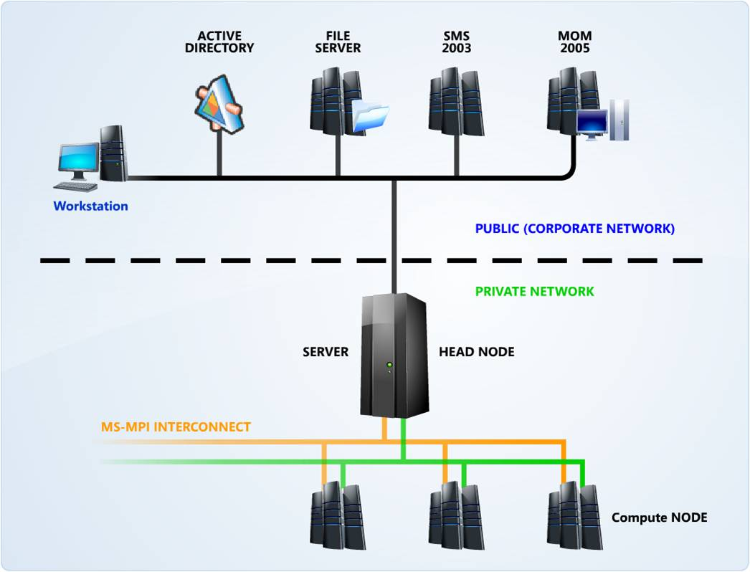
Figure 1 A typical Compute Cluster setup in a corporate Active Directory
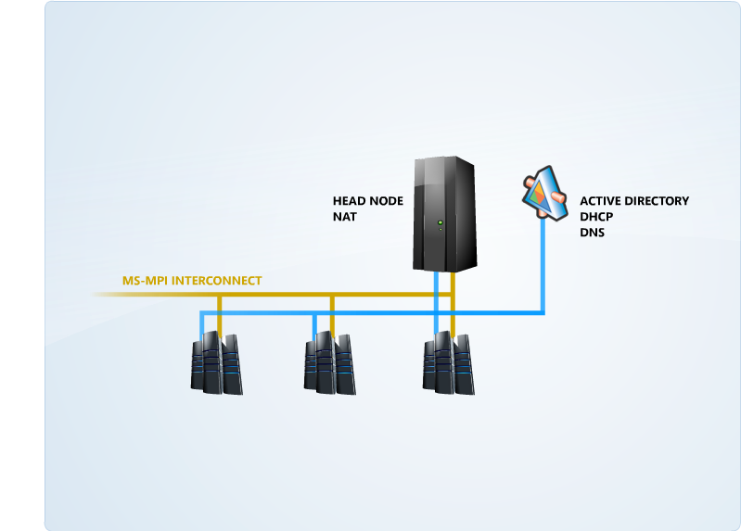
Figure 2 A typical Compute Cluster setup in a non-corporate Active Directory
Deploying the Windows Compute Cluster involves installing the Windows operating system on the head node, creating an Active Directory domain on a separate server, joining the head node to the Active Directory domain, and finally, installing the Compute Cluster Pack. If you are planning to use the Remote Installations Service (RIS) to deploy the compute nodes, you will need to install and configure RIS after the head node installation is complete.

When the installation of the head node is complete, the Compute Cluster must be configured through the Microsoft Management Console (MMC) snap-in to establish the network topology, as well as other parameters that the computer will use—RIS, node addition and approval, and security settings.

Network Topology
CCS supports five different types of network topologies; each topology has implications for the performance and the accessibility of the compute cluster. The topologies involve as least one or more of the following types of networks—public, private, and Message Passing Interface (MPI). A public network is the organizational network that is connected to one or more nodes. A private network is a dedicated Compute Cluster network that carries the intracluster traffic between nodes. This network also carries the MPI traffic if a separate MPI network is not configured. Using a separate network to carry intracluster traffic and MPI traffic between compute nodes will significantly improve cluster performance.

Each of the five network scenarios supported by CCS offers varying degrees of performance, as illustrated in the following scenarios.

Scenario One: One Network Interface Card (NIC) on each node. In this topology, there is no private network for intracluster traffic. All traffic, including intracluster, MPI, and public traffic, is on a single network. This topology maximizes accessibility at the cost of network performance. In this scenario, Network Address Translation (NAT) is not required, and you cannot use RIS to install the compute nodes.
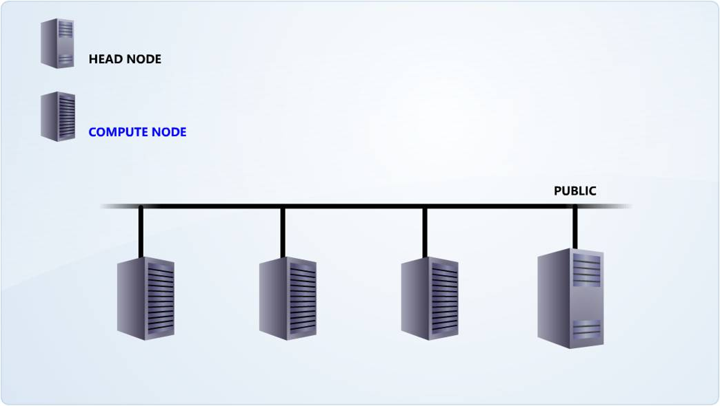
Figure 3 Scenario One: Cluster topology
Scenario Two: Two NICs on each node. In this scenario, one NIC is connected to the public network, and the other is connected to the private network. All intracluster traffic is carried on the private network.
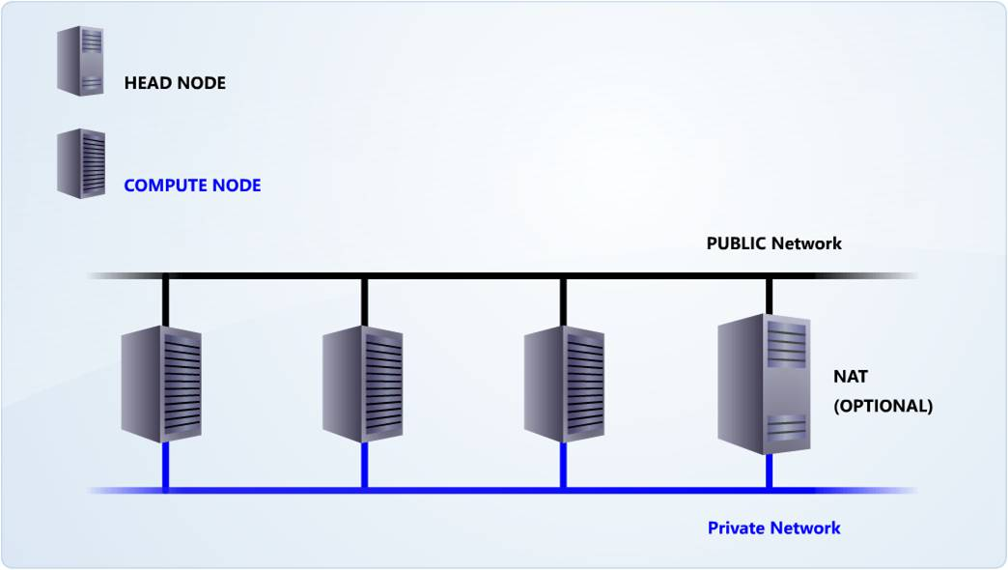
Figure 4 Scenario Two: Cluster topology
Scenario Three: Two NICs on the head node, one NIC on the compute nodes. In this topology, all of the nodes are connected to a private network, and the head node provides NAT between the compute nodes and the public network. All intracluster traffic is carried on the private network.
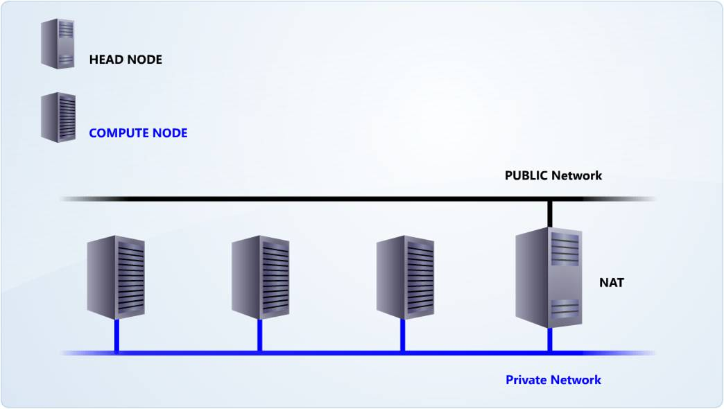
Figure 5 Scenario Three: Cluster topology
Scenario Four: Three NICs on each node. In this topology, one NIC is connected to the public network; the second NIC is connected to a private dedicated cluster management network; and the third NIC is connected to a high-speed MPI network.
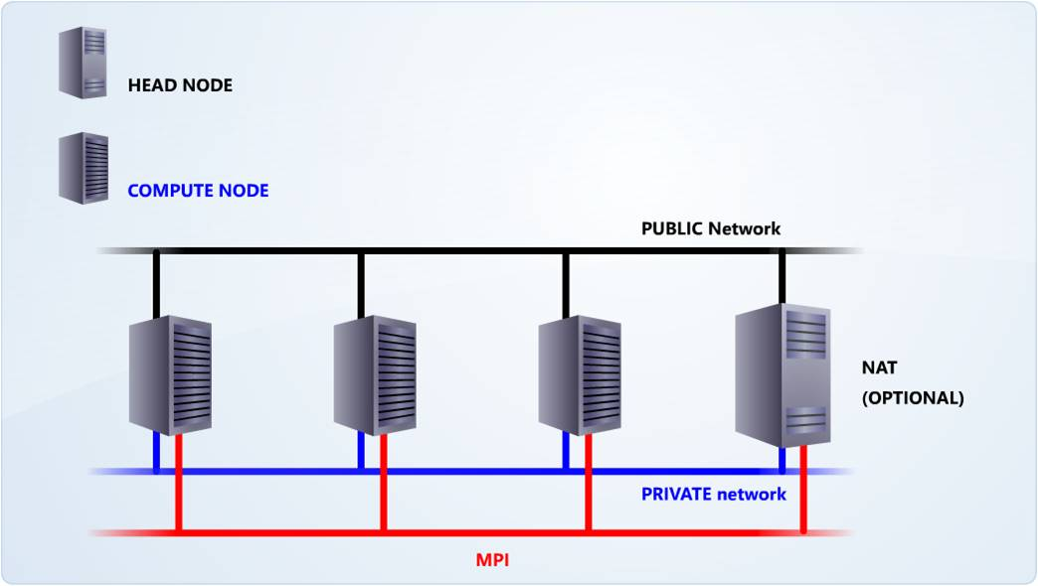
Figure 6 Scenario Four: Cluster topology
Scenario Five: Three NICs on the head node, two NICs on the compute nodes. In this topology, one NIC of each node is connected to a private cluster management network. The second NIC of each node is connected to a high-speed MPI network. The third NIC on the head node is connected to the public network. The head node provides the NAT between the compute nodes and the public network.
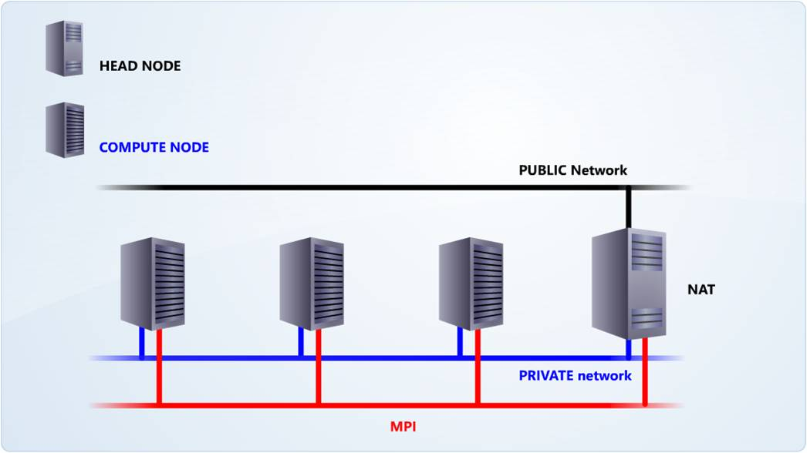
Figure 7 Scenario Five: Cluster topology

Active Directory
The Active Directory service is central to the Windows platform. It provides the means to manage the identities and relationships that comprise the network environment. Active Directory is a repository of information about objects on a network that is available to users and network administrators. This directory gives network users access to permitted resources anywhere on the network, through a single logon.

Note: The head node and the compute nodes must be members of the same Active Directory domain.

In an isolated environment, it is recommended that you use independent servers as domain controllers. If an additional server is not a viable option, you can make the head node an additional domain controller. In very rare cases, the head node can be used as a domain controller, but this setup should be avoided if the cluster is to be used in production roles.

If a unique domain is used for the cluster, and access is required from other corporate domains, then trust relationships must be created between the new cluster domain and the existing domains. The administrator may have to perform additional tasks to permit access from one domain to the other.

The following table shows the key differences of deploying CCS in a corporate scenario versus deploying CCS in an isolated scenario.

Scenario Number | Cluster that is a part of the corporate Active Directory | Isolated cluster that is not a part of a corporate Active Directory
1 | Can take advantage of the existing Active Directory. | No existing Active Directory available. An independent Active Directory needs to be set up.
2 | Nodes are not domain controllers. | The head node may need to be used as a second domain controller.
3 | No need to set up trust relationships because a central Active Directory is used. | Need to set up trusts relationships to interact across domain lines.
4 | No need to create new  cluster-specific users because users will be authenticated and authorized from the existing domain. | New user accounts will have to be created for the new domain.
5 | The existing Active Directory infrastructure can be used for network communications. | The entire Active Directory infrastructure, including DNS and DHCP, needs to be set up for network communications because centralized resources are not available.

System Requirements

Hardware Requirements
The minimum system hardware requirements for Windows Compute Cluster Server 2003 are similar to the hardware requirements for Windows Server 2003, Standard x64 Edition.

Hardware requirements of Windows Compute Cluster Server 2003
Requirement | Windows Server 2003, Compute Cluster Edition
CPU Requirement | 64-bit architecture computer  Intel Pentium, or Xeon family with Intel Extended Memory 64 Technology (EM64T) processor architecture, or  AMD Opteron family, AMD Athlon family, or compatible processor(s)  Note:  32-bit hardware can run CCS client software:  command line interface, job console, administrator console
Minimum RAM | 512 MB
Maximum RAM | 32 GB
Multiprocessor Support | Up to 4 processors
Disk Space for Setup | 4 GB
Disk Volumes | For a head node, the Windows Compute Cluster Server 2003 installation process requires a minimum of two volumes e.g. (C:\ and D:\)—one for the system partition, and one that RIS can use.  Compute nodes only require one volume.  RAID 0,1,5 may be used as appropriate, although RAID is not a mandatory requirement.
Network Interface Cards (NICs) | All nodes require at least one NIC.  If a private network is planned, and depending on the network topology selected, the head node requires a minimum of two NICs to create a public and private network.  Each node may require more NICs, as appropriate, in case of public network access or in support of an MPI-based network.

Software Requirements
The following list shows the compatible operating systems for Windows Compute Cluster Server 2003.

Head Node and Compute Nodes
- Windows Server 2003, Compute Cluster Edition
- Windows Server 2003, Standard x64 Edition
- Windows Server 2003, Enterprise x64 Edition
- Windows Server 2003 R2, Standard x64 Edition
- Windows Server 2003 R2, Enterprise x64 Edition

Head nodes may also have additional software requirements, such as RIS or Internet Connection Sharing (ICS), and NAT, depending on the networking environment used. Windows Compute Cluster Server 2003 requires the Microsoft .NET Framework version 2.0 (included on the Compute Cluster Pack CD). The Compute Cluster Administrator requires MMC version 3.0.

Remote Workstation Computer
The Compute Cluster Administrator and the Compute Cluster Job Manager are installed on the head node by default. If you install the client utilities on a remote workstation, an administrator can manage clusters from that workstation. If you install the Compute Cluster Administrator or Job Manager on a remote computer, the computer must have one of the following operating systems installed:
- Windows XP Professional with Service Pack 2 (SP2)
- Windows XP Professional x64 Edition
- Windows Server 2003 with Service Pack 1 (SP1), Standard Edition
- Windows Server 2003, Standard x64 Edition
- Windows Server 2003 with Service Pack 1 (SP1), Enterprise Edition
- Windows Server 2003, Enterprise x64 Edition
- Windows Server 2003 R2, Standard Edition
- Windows Server 2003 R2, Standard x64 Edition
- Windows Server 2003 R2, Enterprise Edition
- Windows Server 2003 R2, Enterprise x64 Edition

Setting Up the Windows Compute Cluster Server 2003

Getting Started
Microsoft Windows Compute Cluster Server 2003 includes Windows Server 2003, Compute Cluster Edition Operating System (on CD1), and the Compute Cluster Pack (on CD2). Before starting installation, be sure that the head node and compute nodes meet the minimum hardware requirements of the operating system and the other software that you will install on the cluster.

Preparing the Domain Controller
- Install the operating system that is mentioned in the Software requirements section.
- Assign a static IP address to the NIC. The IP address will depend on the network topology selected.
- Install DHCP to dynamically assign IP addresses to the nodes if they are not connected to the public network, or if a private network is deployed for intra-cluster traffic.
- Install and configure Active Directory and DNS.

The final two steps—installing DHCP and installing and configuring Active Directory and DNS—are documented below.

Note: If DHCP is used, do not configure ICS in the network topology setup.

Setting up the Active Directory
Active Directory is a prerequisite to installing the compute cluster pack. To promote the head node to a domain controller, follow these steps:
- On the Start menu, click Run. The Run dialog box appears.
- Type dcpromo.exe, and then press ENTER.
- The Active Directory Installation Wizard opens. Click Next.
- The page to check the operating system compatibility opens. Select the operating system compatibility and click Next.
- The Domain Controller Type page appears, as shown in Figure 8. Click the Domain Controller in a new domain option.
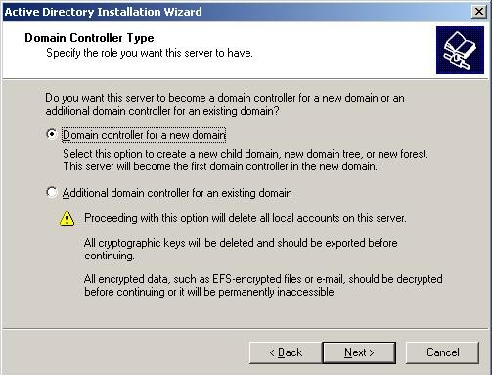
Figure 8 Domain controller type
Note: We are installing the cluster in a non-corporate Active Directory environment.
- Click Next. The Create New Domain page appears, as shown in Figure 9.
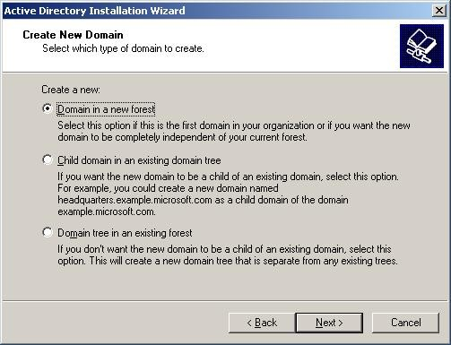
Figure 9 Create new domain
- Select Domain in a new forest, and then click Next.
Note: Because this is a stand-alone installation, select Domain in a new forest.
- On the New Domain Name page (shown in Figure 10), specify a Fully Qualified Domain Name (FQDN) for the domain—for this example, hpc.contoso.com.
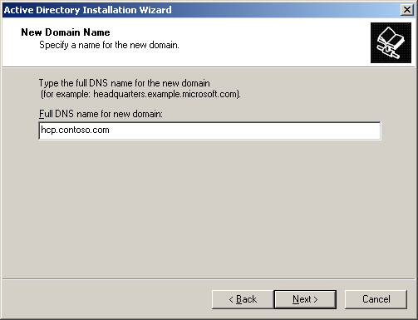
Figure 10 New domain name
- On the NetBIOS domain name page, enter domain name from the FQDN (in this example, contoso.com), and then click Next.
- Select the locations for the database and log folders, and then click Next.
- Select the Shared System Volume folder location, and then click Next.
- Select the default locations provided by the Active Directory Initialization Wizard.
- On the Install or Configure DNS page (shown in Figure 11), select the appropriate option, and then click Next.
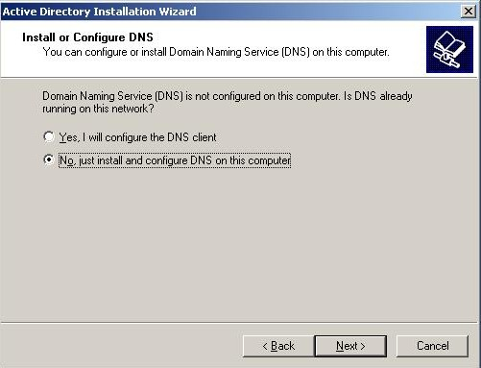
Figure 11 DNS Install page
Note: DNS can be installed and configured separately, or through the Active Directory Install Wizard.
- Select Permissions Compatible with Windows 2000 or Windows 2003 operating systems, and then click Next.
- Type and confirm a password on the Directory Services Restore Mode Administrator Password page, and then click Next.
- To view the summary of your selection, click Next.
- On the summary page, click Next to start the Active Directory Installation progress screen.
- Insert the Operating System CD-ROM/DVD-ROM, and then click OK. The Completing the Active Directory Wizard message appears, as shown in Figure 12.
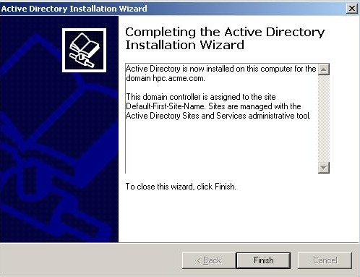
Figure 12 Active Directory Installation Wizard final page
- Click Finish.
- Restart the computer when prompted.

Setting up the DHCP
To run an error-free TCP/IP network and to avoid a duplicate IP address, it is recommended that you set up DHCP.
To install DHCP, follow these steps:
- On the Start menu, click Setting, and then click Control Panel.
- Click Add or Remove Programs, and then click Add/Remove Windows Components. The Windows Components Wizard screen appears.
- Select Networking Services, and then click the Details button.
- Select the Dynamic Host Configuration Protocol (DHCP) check box.
- Click OK, and then click Next. The progress bar for the installation of DHCP appears.
- After the wizard completes, click Finish.
To configure DHCP, follow these steps:
- On the Start menu, click Programs, and then click Administrative Tools.
- Click DHCP from the list of installed tools. A Microsoft Management Console (MMC) opens, showing the local computer as the DHCP Server.
- Right-click the Server icon, and then click the New Scope option.
- On the welcome page of the wizard, click Next.
- Type a scope name and description, and then click Next.
- Assign a range of IP addresses and a Subnet Mask and the Subnet Mask bits.
- Click Next.
- Assign any IP addresses for exclusion (optional).
- Click Next.
- Assign the lease duration.
- Click Next. You will now be asked if you want to configure any DHCP options.
Note: You can configure DHCP scope options later.
- Click Next.
- To save and activate the scope, click Finish.
- Once you have completed this wizard, you must authorize the server. To do this, right-click the server in question in the console, and then select Authorize. Then right-click the scope in the console and select Authorize.

Note: For more information on Active Directory, visit the following Web sites:
Windows Server 2003 Active Directory
Designing and Deploying Directory and Security Services

Preparing the Head Node
Install the operating system that is mentioned in the Software Requirements section, or the operating system that is a part of CD1. Join the server to the domain.

Install the Compute Cluster Pack (on the Head Node)
- To run the Compute Cluster Installation Wizard, insert the Compute Cluster Pack CD (CD2) into the CD-ROM drive and click Next.
Tip: If Setup.exe does not auto run on the Start menu, click Run, and then type F:\setup.exe (where F:\ is your CD-ROM drive).
- The Microsoft Software License Terms page opens. Click the I accept the License Agreement option, as shown in Figure 13, and then click Next.
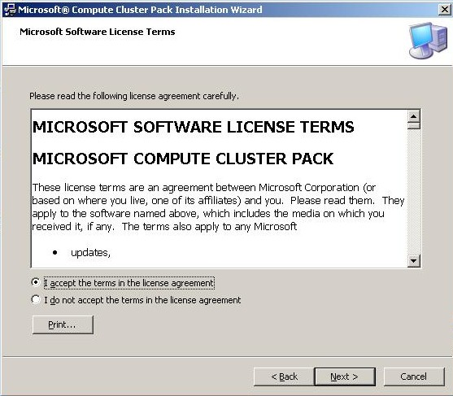
Figure 13 License agreement
- On the Select Installation Type page (shown in Figure 14), select Create a new compute cluster with this server as the head node and click Next.
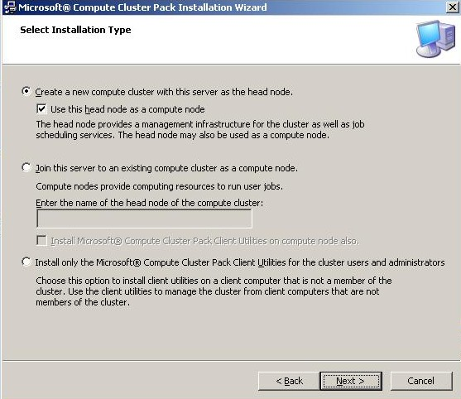
Figure 14 Cluster node installation type
Note: You also have the option on this page of the wizard to make the head node a compute node as well (as shown in Figure 14).
- On the Select Installation Location page, specify the installation location for the files of the compute cluster and click Next.
Note: Because you are installing a new cluster, you need to install a head
node first.
- A list appears, showing components that are installed as part of the compute cluster setup, as shown in Figure 15. To install components individually, select the component, and then click Install.
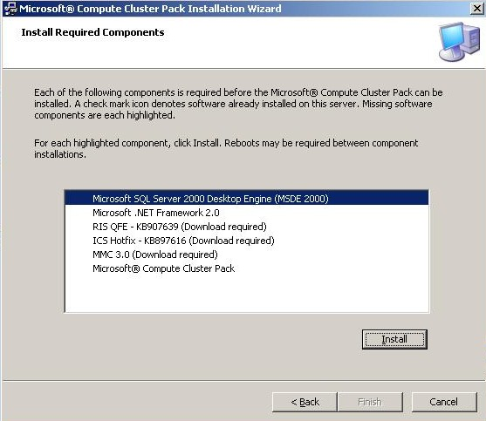
Figure 15 Components Install page
Note: Serially install each component in the list. These component installations may require one or multiple reboots.
- To complete the installation, click Finish.
- The message, Microsoft Compute Cluster Pack has been successfully installed, appears, as shown in Figure 16.
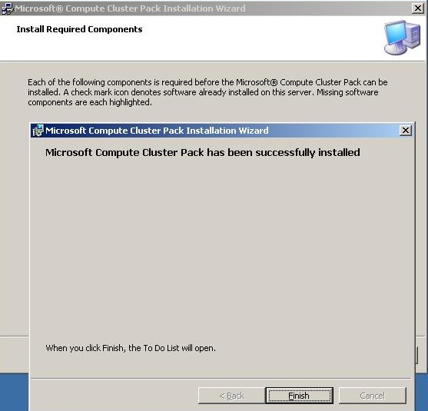
Figure 16 Successful Installation page
- Click Finish.

Once you have finished installing the Compute Cluster Pack on the head node, the To Do List will open.

Configuring the Cluster
Use the To Do List or the Compute cluster administrator to configure the cluster network topology, add nodes, and configure Internet Connection Sharing.
Note: If DHCP is used, do not configure ICS in the network topology setup.
- On the Start menu, click Microsoft Compute Cluster Pack, and then click Compute Cluster Administrator. The To Do List appears, as shown in Figure 17.
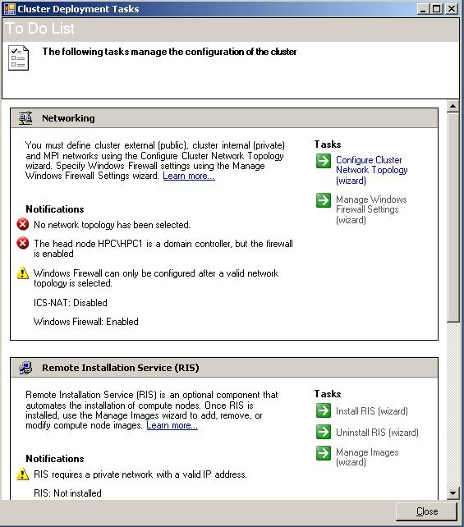
Figure 17 The To Do List
- To start the wizard to configure the network topology of the cluster, under Tasks, click Configure Network Topology.
- Select the topology that matches your cluster, as shown in Figure 18.
Note: The topology depends on the number of NICs that you have per node.
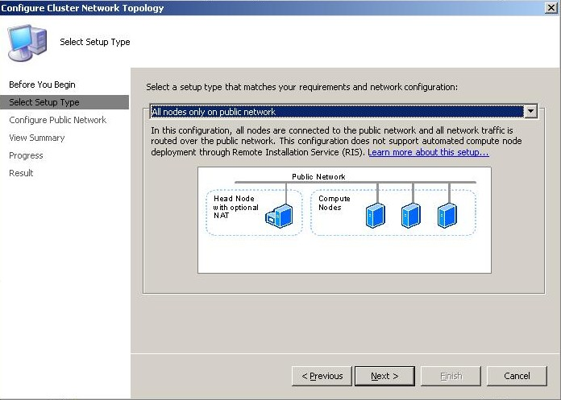
Figure 18 Select Setup Type dialog page
- Select the private, public, and MPI network (as shown in Figure 19), and then click Next.
Note: Your selection will depend on the network topology used.
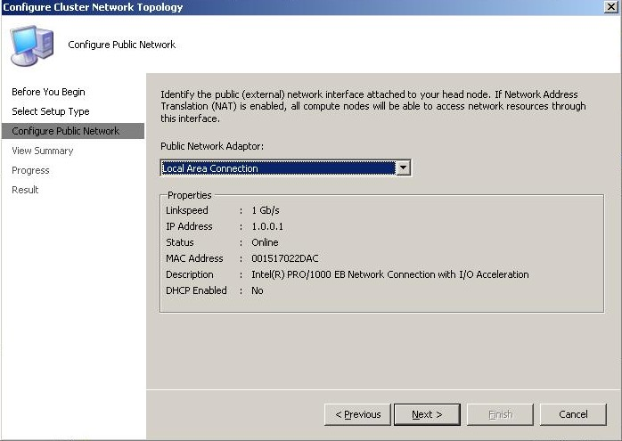
Figure 19 Configure Public Network dialog page
- To complete the installation, click Finish.
- Click Close to close the Configure Cluster Network Topology window.

Adding a Compute Node
The compute node must be a part of the domain that is created on the head node. Join the compute node to the domain on the head node. If DHCP has been set up on the head node, configure the TCP/IP settings to obtain the IP address automatically.

To set up a compute node, follow these steps:
- On the Start menu, click Microsoft Compute Cluster Pack, and then click Compute Cluster Administrator. The To Do List appears.
- To start the wizard to configure the network topology of the cluster, under Tasks, click Configure Network Topology.
- Select the topology that matches your cluster, as shown in Figure 18.
- Note: The topology depends on the number of NICs that you have per node.
- Select the private, public, and MPI network (as shown in Figure 19), and then click Next.
- Note: Your selection will depend on the network topology used.
- Click Join this server to an existing compute cluster as a compute node and then type the name of the head node server in the text box. Click Next.
- On the Select Installation Location page, specify the installation location for the files of the compute cluster and click Next.
- A list of components that are installed as a part of the Compute Cluster setup will appear. To install components individually, select the component, and then click Install.
Note: Serially install each component in the list. These component installations may require one or multiple reboots.
- To complete the installation, click Finish.
Note: To verify the successful addition of a compute node to the cluster:
- Log on to the head node.
- Start the Compute Cluster Administrator program.
- Navigate to the node management section. The newly added node will appear in a pending approval state. Go ahead and approve these pending approvals.

Alternate Scenario: The Head Node as the Domain Controller
As an alternative to the deployment scenario listed above, where the security of the Active Directory on a separate server is not required, the head node can be used as the domain controller for the Windows cluster. This is not a recommended deployment strategy in a production environment. However, certain scenarios discussed previously might make this setup necessary—for example, in restricted test or evaluation environments. If this server fails, both the head node and the Active Directory infrastructure of the cluster will be unavailable.

To deploy this cluster scenario, you need to follow the steps listed earlier, but with some important differences:
- Follow the installation steps that are described in the Preparing the Domain Controller section.
- Follow the steps that are listed in the Preparing the Head Node section.
Note: This step will be carried out on the same server.
- Skip the step of joining the head node to the domain.

Cluster Administration
The Compute Cluster Administrator is an MMC 3.0 snap-in (Computeclusteradmin.msc) that is installed on the head node of a cluster during the setup, or when the SDK and the client utilities are installed (see Figure 20). It can also be installed on a remote workstation to be used for remote access and management of the head node and the cluster.
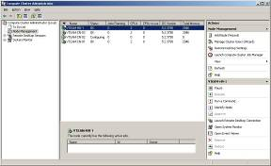
Figure 20 MMC: Compute Cluster Administrator
The Compute Console Administrator has five major pages that are accessed from the navigation pane on the left side of the console. The Start Page offers an overview of cluster and job status. It also provides the administrator with access to the Cluster Job Manager, as shown in Figure 21.
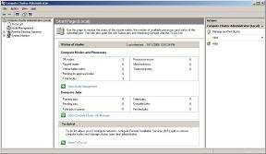
Figure 21 The Start Page in the Compute Cluster Administrator
The To Do List page helps in quick deployment of the compute cluster. The tiles in the MMC display pane show the status, or provide status notifications. In addition, the list also provides access to wizards for various tasks, as shown in Figure 22.
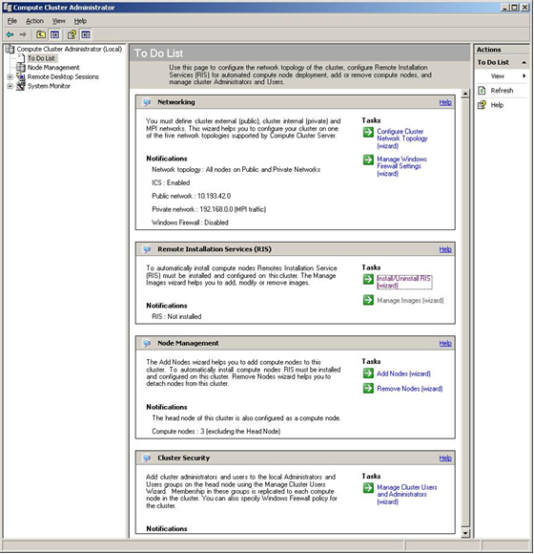
Figure 22 The To Do List in the Compute Cluster Administrator
The Node Management page displays information about head and compute nodes in a columnar format. The Add Node Wizard and the Cluster Job Manager can be launched from here, as shown in Figure 23.
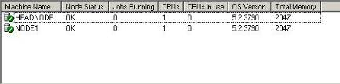
Figure 23 The Node Management page in the Compute Cluster Administrator
The Remote Desktop Sessions page can be used to create and close remote desktop sessions to one or more nodes. Each active remote desktop session is added to a list in the navigation pane under Remote Desktop Sessions, as shown in Figure 24. This design allows for ease of navigation between sessions.
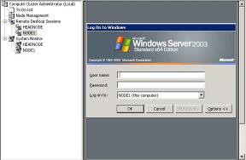
Figure 24 The Remote Desktop Sessions page in the Compute Cluster Administrator
A System Monitor session for each node can be opened by following these steps:
- Select one or more nodes on the Node Management page.
- Right-click, and then select Start Perform Task.
Each System Monitor session appears in the left-hand navigation pane under System Monitor, as shown in Figure 25.

Figure 25 System Monitor in the Compute Cluster Administrator
All of the tasks of managing and monitoring the cluster can be carried out through the Compute Cluster Administrator. Tasks such as adding nodes are simplified through easy-to-use wizards. This helps to significantly reduce the administrative overhead that is usually associated with other High Performance Computing (HPC) environments.

Summary
Microsoft Windows Compute Cluster Server 2003 combines the power of commodity x64-bit computers, the ease-of-use and the security of Active Directory, and the familiarity of the Windows Operating System, to provide a secure and affordable HPC solution. Although Windows Compute Cluster Server 2003 can be easily and quickly deployed in an isolated mode using its own Active Directory infrastructure, it should be deployed in selective scenarios only. Ideally, a Windows Compute cluster should use the central Active Directory infrastructure, when it is available.

Deployment Checklist: Compute Cluster in a Non-Corporate Active

Directory Environment
Step | Action | Reference
1. | Review concepts for Windows Compute Cluster Server 2003, including system hardware and software requirements. | Compute Cluster System requirements
2 | Verify topology for your compute cluster. | Compute Cluster Network topology
3. | Verify that a supported operating system is installed. | Compute Cluster Software requirements
4. | Create a second disk volume (D:\) to store installation images if you plan to use RIS to add compute nodes.
5. | Create and configure your head node. | Creating a head node
6. | Join head node to an Active Directory domain (existing) or create a new domain.
7. | Install Microsoft Management Console (MMC) 3.0.
8. | Install RIS hotfix. | RIS Hotfix (KB907639)
9. | Install ICS hotfix. | ICS Hotfix (KB897616)
10. | Reboot your system.
11. | Install Compute Cluster Pack on the head node. | Installing Compute Cluster Pack On the head node
12. | Configure network interfaces on the head node. | Configuring Network Adapters on the head node
13. | Enable RIS (optional) from the Compute Cluster Pack if you intend to use the Automated method to add compute nodes to your cluster. Then add one or more installation images, and configure the images with valid product keys and identifying descriptions.
14. | Add compute nodes to your cluster by using either the Automated Addition or the Manual Addition method.

The information contained in this document represents the current view of Microsoft Corporation on the issues discussed as of the date of publication. Because Microsoft must respond to changing market conditions, it should not be interpreted to be a commitment on the part of Microsoft, and Microsoft cannot guarantee the accuracy of any information presented after the date of publication.
This white paper is for informational purposes only. MICROSOFT MAKES NO WARRANTIES, EXPRESS OR IMPLIED, IN THIS
DOCUMENT.
Complying with all applicable copyright laws is the responsibility of the user. Without limiting the rights under copyright, no part of this document may be reproduced, stored in, or introduced into a retrieval system, or transmitted in any form or by any means (electronic, mechanical, photocopying, recording, or otherwise), or for any purpose, without the express written permission of Microsoft Corporation.
Microsoft may have patents, patent applications, trademarks, copyrights, or other intellectual property rights covering subject matter in this document. Except as expressly provided in any written license agreement from Microsoft, the furnishing of this document does not give you any license to these patents, trademarks, copyrights, or other intellectual property.
© 2007 Microsoft Corporation. All rights reserved.
Microsoft, Active Directory, Windows, the Windows logo, and Windows Server are either registered trademarks or trademarks of Microsoft Corporation in the United States and/or other countries.
The names of actual companies and products mentioned herein may be the trademarks of their respective owners.

