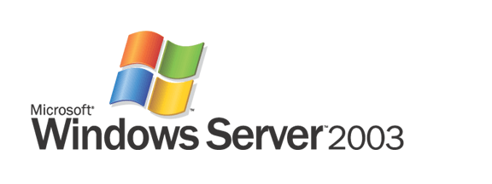

Updates to Understanding IPv6

Microsoft Corporation
Published: September 2003
Updated: January 2008

Abstract
This white paper contains updates for changes in Internet Protocol version 6 (IPv6) standards and their implementation in Microsoft® Windows® XP Windows Server® 2003, Windows Vista, and Windows Server 2008, as described in the Microsoft Press® book titled Understanding IPv6, by Joseph Davies (ISBN 0-7356-1245-5).
Understanding IPv6, Second Edition, by Joseph Davies (ISBN 9780735624467 or ISBN-10 0-7356-2446-1), updates and replaces Understanding IPv6 and is now available from Microsoft Press. For more information, see http://www.microsoft.com/MSPress/books/11607.aspx.

This is a preliminary document and may be changed substantially prior to final commercial release of the software described herein.
The information contained in this document represents the current view of Microsoft Corporation on the issues discussed as of the date of publication. Because Microsoft must respond to changing market conditions, it should not be interpreted to be a commitment on the part of Microsoft, and Microsoft cannot guarantee the accuracy of any information presented after the date of publication.
This document is for informational purposes only. MICROSOFT MAKES NO WARRANTIES, EXPRESS OR IMPLIED, AS TO THE INFORMATION IN THIS DOCUMENT.
Complying with all applicable copyright laws is the responsibility of the user. Without limiting the rights under copyright, no part of this document may be reproduced, stored in or introduced into a retrieval system, or transmitted in any form or by any means (electronic, mechanical, photocopying, recording, or otherwise), or for any purpose, without the express written permission of Microsoft Corporation.
Microsoft may have patents, patent applications, trademarks, copyrights, or other intellectual property rights covering subject matter in this document. Except as expressly provided in any written license agreement from Microsoft, the furnishing of this document does not give you any license to these patents, trademarks, copyrights, or other intellectual property.
© 2008 Microsoft Corporation. All rights reserved.
Microsoft, Active Directory, Microsoft Press, Windows Vista, Windows, the Windows logo, Windows Mobile, and Windows Server are either registered trademarks or trademarks of Microsoft Corporation in the United States and/or other countries.
The names of actual companies and products mentioned herein may be the trademarks of their respective owners.

Contents

Global Changes 1
Chapter 1: Introduction to IPv6 2
Chapter 2: IPv6 in the Windows Server 2003 Family 3
Chapter 3: IPv6 Addressing 5
Global Addresses 5
Site-Local Addresses 6
Zone IDs for Local-Use Addresses 7
Unique Local IPv6 Unicast Addresses 8
IPv6 Multicast Flags 8
IPv6 Multicast Scope Definitions 9
Randomly Derived Interface Identifiers 9
Chapter 4: The IPv6 Header 10
Chapter 9: IPv6 and Name Resolution 11
Configuration of DNS Traffic Over IPv6 11
DNS Traffic over IPv6 Using Locally Configured Unicast Addresses 11
DNS Traffic over IPv6 Using Well-Known Unicast Addresses 11
Source and Destination Address Selection 12
Chapter 11: IPv6 Coexistence and Migration 13
Chapter 12: IPv6 Mobility 14
Advanced Networking Pack for Windows XP 15
IPv6 Internet Connection Firewall (ICF) 15
Teredo 16
Teredo Components 17
Teredo Addresses 18
How Teredo Works 19
Changes to IPv6 in Windows XP SP2 22
Changes to IPv6 in Windows Server 2003 Service Pack 1 24
Changes to IPv6 in Windows Vista and Windows Server 2008 25
Changes to IPv6 25
Dual IP Layer Architecture 25
Installed and Enabled by Default 26
GUI-based Configuration 26
Full Support for IPsec 29
MLDv2 29
LLMNR 30
Literal IPv6 Addresses in URLs 30
Support for ipv6-literal.net Names 30
IPv6 over PPP 31
DHCPv6 31
Random Interface IDs 31
Changes to Teredo 31
Security with IPv6 and Teredo 32
Disabling IPv6 33
Summary 35
Related Links 36

Global Changes
Throughout the book, the term Windows .NET Server 2003 family should be replaced with the term Windows Server 2003 family. Microsoft changed the product name after the book was finalized for printing.

Chapter 1: Introduction to IPv6
The following are updates to the information in Chapter 1:
- New domain for IPv6 reverse name space
On page 11, Table 1-1 states that IPv6 uses pointer records in the IP6.INT DNS domains for reverse name resolution for IPv6 addresses. According to RFC 3152, Internet Engineering Task Force (IETF) consensus has been reached that the IP6.ARPA domain be used, instead of IP6.INT. Additionally, RFC 4159 formally deprecates the use of IP6.INT. The IP6.ARPA domain is the domain used by IPv6 for Windows Server 2003. The instance of IP6.INT in Table 1-2 should be replaced with IP6.ARPA.

Chapter 2: IPv6 in the Windows Server 2003 Family
The following are updates to the information in Chapter 2:
- Internet Protocol security (IPsec) for IPv6 supports the SHA1 HMAC
IPsec for IPv6 in Windows Server 2003 also supports the Secure Hash Algorithm 1 (SHA1) hashed message authentication code (HMAC). To specify the use of SHA1, use the "HMAC-SHA1" string in the .sad file when using the Ipsec6.exe command to specify the entries in the security association database.
- File and printer sharing component can use global addresses
The file and printer sharing components of Windows Server 2003, the Client for Microsoft Networks and File and Printer Sharing for Microsoft Networks services installed in Network Connections, now supports the use of global addresses. Page 25 states that file and printer sharing are only available within a site. This should be changed to state that file and print sharing could use both site-local and global addresses, as long as the global addresses for the client and server computer are from the same site prefix.
- IPv6 support for simple TCP services
Windows Server 2003 includes IPv6 support for both the client and server-side of the simple TCP/IP services. The client-side simple TCP services are available using the Telnet.exe tool. The server-side is installed as Simple TCP Services, an optionally installed Windows component (under Networking Services) using the Add or Remove Programs item in Control Panel.
- IPv6 support for DCOM
Windows Server 2003 includes support for the Distributed Component Object Model (DCOM) application programming interface. DCOM extends the Component Object Model (COM) to support communication among objects on different computers—on a LAN, a WAN, or even the Internet. With DCOM, your application can be distributed at locations that make the most sense to your customer and to the application.
- Temporary addresses disabled by default for Windows Server 2003
The creation and use of temporary addresses, global addresses with a randomly derived interface ID to provide a level of anonymity when communicating over the IPv6 Internet, are disabled by default for Windows Server 2003. Temporary addresses are designed to primarily provide anonymity for client computers and client applications. To enable temporary addresses on a computer running Windows Server 2003, use the netsh interface ipv6 set privacy state=enabled.
- Additional Windows XP Service Pack 1 (SP1) and Windows XP Service Pack 2 (SP2) feature set differences
Windows XP SP1 and Windows XP SP2 do not include IPv6 support for file and print sharing (both as a file sharing client and as a file sharing server) and the IPHelper and DCOM APIs.
- DNS traffic over IPv6 disabled by default for DNS Server service
By default, the Windows Server 2003 DNS Server service does not listen for DNS traffic sent over IPv6. To enable the DNS Server service to use DNS over IPv6, use the dnscmd /config /EnableIPv6 1 command, and then restart the DNS Server service. Dnscmd.exe is part of the Windows Support Tools installed from the \Support\Tools folder on the Windows Server 2003 product CD.
- Basic firewall support for IPv6 traffic
IPv6 for Windows Server 2003 includes support for a basic firewall on an interface. When enabled, IPv6 drops incoming TCP Synchronize (SYN) segments and drops all incoming unsolicited UDP messages. This functionality is disabled by default on all interfaces and can be enabled with the netsh interface ipv6 set interface interface=NameOrIndex firewall=enabled command. The basic firewall is replaced with Windows Firewall in Windows Server 2003 Service Pack 1.
- IPv6 support for Ttcp.exe
Windows Server 2003 includes IPv6 support for Ttcp.exe, a TCP and UDP diagnostics and troubleshooting tool. Ttcp.exe is available from the Valueadd\Msft\Net\Tools folder on the Windows Server 2003 product CD.
- .NET Framework version 1.1 support for IPv6 is not enabled by default
Although the .NET Framework version 1.1 supports IPv6, it is not enabled by default. To configure the .NET Framework to support IPv6, change <ipv6 enabled="false"/> to <ipv6 enabled="true"/> in the <system.net> section of the Machine.config file in the Systemroot\Microsoft.net\Framework\v.1.1.4322\Config folder.
The .NET Framework version 2.0 and later has IPv6 support enabled by default.

Chapter 3: IPv6 Addressing
The discussions in Chapter 3 are based on RFC 2373. RFC 4291 is the new version of the "Internet Protocol Version 6 (IPv6) Addressing Architecture" RFC, which makes RFC 2373 obsolete. RFC 4291 includes new definitions of global addresses, site-local addresses, and scopes for IPv6 multicast addresses.

Global Addresses
The definition of global addresses has changed (pages 52 through 54). The term aggregateable global unicast addresses has been changed to global unicast addresses. Global unicast addresses are not confined to the prefix 2000::/3.
Figure 1 shows the structure of global unicast addresses currently being allocated by IANA, as defined in RFC 3587.
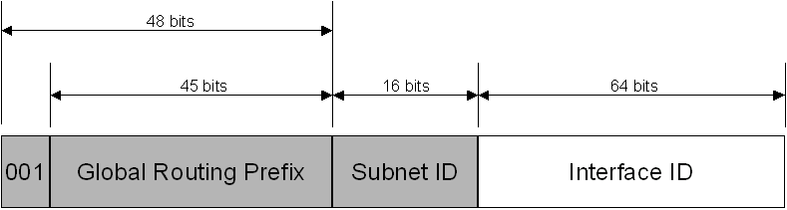
Figure 1 The global unicast address as defined in RFC 3587
The fields in the global unicast address are:
Fixed portion set to 001 – The three high-order bits are set to 001.
Global Routing Prefix – Indicates the global routing prefix for a specific organization's site. The combination of the three fixed bits and the 45-bit Global Routing Prefix is used to create a 48-bit site prefix, which is assigned to an individual site of an organization. Once assigned, routers on the IPv6 Internet forward IPv6 traffic matching the 48-bit prefix to the routers of the organization's site.
Subnet ID – The Subnet ID is used within an organization's site to identify subnets. The size of this field is 16 bits. The organization's site can use these 16 bits within its site to create 65,536 subnets or multiple levels of addressing hierarchy and an efficient routing infrastructure.
Interface ID – Indicates the interface on a specific subnet within the site. The size of this field is 64 bits.
The fields within the global unicast address create a three-level structure shown in Figure 2.
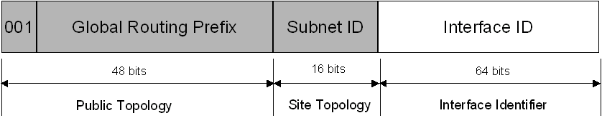
Figure 2 The three-level structure of the global unicast address
Although IANA is currently assigning global addresses from the 2000::/3 prefix, global addresses are not confined to this prefix.
In the new definition of the global address as defined in RFC 3587, there is no longer TLA ID, NLA ID, or SLA ID fields. Therefore, the discussion of subnetting an NLA ID on pages 64 through 69 no longer applies, and the discussion of the subnetting of SLA IDs/Subnet IDs on pages 69 through 73 only applies to subnetting the Subnet ID field of global addresses.

Site-Local Addresses
The definition of the site-local address has changed (page 55). The 38 bits that were set to 0 after the first 10 fixed bits of 1111 1110 11 are now available for use for subnetting within the site. The result is a 54-bit Subnet ID field, as shown in Figure 3.
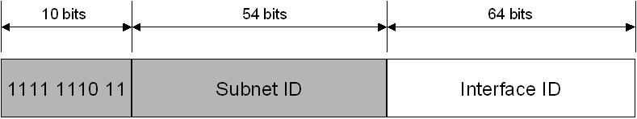
Figure 3 The new definition of a site-local address in RFC 4291
Because the global address and the site-local address no longer share the same number of bits in the same location, the discussion of using the same subnet identifier for both types of addresses on page 56 is no longer valid unless you are only using the last 16 bits in the Subnet ID field of the site-local address space as the subnet identifier in your organization. Additionally, the discussion of subnetting SLA IDs/Subnet IDs on pages 69 through 73 only applies to the subnetting the Subnet ID field for global addresses and for site-local address schemes that use only the last 16 bits in the Subnet ID field for the subnet identifier.
For Table 3-8 titled "IPv4 Addressing Concepts and their IPv6 Equivalents", the right-hand column for the second entry in the table on page 81 should be changed to "Site-local addresses (FEC0::/10)".
In Appendix D on page 400, the answer to question 9 should be changed to:
- When you use the last 16 bits of the site-local address space as the subnet identifier, the global address and site-local address share the same structure beyond the first 48 bits of the address. In global addresses, the Subnet ID field identifies the subnet within an organization. For site-local addresses, the Subnet ID field can perform the same function. Because of this, when you only use the last 16 bits of the site-local address space for the Subnet ID (setting the upper 38 bits to 0), you can create a subnetting infrastructure that is used for both site-local and global unicast addresses.
In Appendix D on page 401, the answer to question 18 for the "Site-local unicast address" entry should be changed to "FEC, FED, FEE, or FEF".
Note Site-local addresses have been formally deprecated in RFC 3879 for future IPv6 implementations. Existing implementations of IPv6 can continue to use site-local addresses until a replacement has been standardized.

Zone IDs for Local-Use Addresses
Unlike global addresses, local-use addresses (link-local and site-local addresses) can be reused. Link-local addresses are reused on each link. Site-local addresses can be reused within each site of an organization. Because of this address reuse capability, link-local and site-local addresses are ambiguous. To specify which link on which the destination is located or within which site the destination is located, an additional identifier is needed. This additional identifier is a zone identifier (ID), also known as a scope ID, which identifies a connected portion of a network that has a specified scope. The syntax specified in RFC 4007 for identifying the zone associated with a local-use address is the following:
Address%zone_ID
Address is a local-use unicast IPv6 address and zone_ID is an integer value representing the zone. The values of the zone ID are defined relative to the sending host. Therefore, different hosts might determine different zone ID values for the same physical zone. For example, Host A might choose 3 to represent the zone of an attached link and host B might choose 4 to represent the same link.
For Windows-based IPv6 hosts, the zone IDs for link-local and site-local addresses are defined as follows:
- For link-local addresses, the zone ID is typically the interface index of the interface either assigned the address or to be used as the sending interface for a link-local destination. The interface index is an integer starting at 1 that is assigned to IPv6 interfaces, which include a loopback and one or multiple tunnel or LAN interfaces. You can view the list of interface indexes from the display of the netsh interface ipv6 show interface command.
- For site-local addresses, the zone ID is the site ID, an integer assigned to the site of an organization. For organizations that do not reuse the site-local address prefix, the site ID is set to 1 by default and does not need to be specified. You can view the site ID from the display of the netsh interface ipv6 show address level=verbose command.
The following are examples of using Windows tools and the zone ID:
- ping fe80::2b0:d0ff:fee9:4143%3 In this case, 3 is the interface index of the interface attached to the link containing the destination address.
- tracert fec0::f282:2b0:d0ff:fee9:4143%2 In this case, 2 is the site ID of the organization site containing the destination address.
In Windows XP and Windows Server 2003, the Ipconfig.exe tool displays the zone ID of local-use IPv6 addresses. The following is an excerpt from the display of the ipconfig command:
Ethernet adapter Local Area Connection:

Connection-specific DNS Suffix . : wcoast.example.com
IP Address. . . . . . . . . . . . : 157.60.14.219
Subnet Mask . . . . . . . . . . . : 255.255.255.0
IP Address. . . . . . . . . . . . : 3ffe:ffff:2a1c:2:1cc8:ef1d:1dd9:8066
IP Address. . . . . . . . . . . . : 3ffe:ffff:2a1c:204:5aff:fe56:f5b
IP Address. . . . . . . . . . . . : fe80::204:5aff:fe56:f5b%4
Default Gateway . . . . . . . . . : 157.60.14.1
fe80::20a:42ff:feb0:5400%4

For the link-local addresses in the display of the ipconfig command, the zone ID indicates the interface index of the interface either assigned the address (for IP Address) or the interface through which an address is reachable (for Default Gateway).

Unique Local IPv6 Unicast Addresses
Site-local addresses provide a private addressing alternative to using global addresses for intranet traffic. However, because the site-local address prefix can be used to address multiple sites within an organization, a site-local address prefix address can be duplicated. The ambiguity of site-local addresses in an organization adds complexity and difficulty for applications, routers, and network managers. For more information, see section 2 of RFC 3879.
To replace site-local addresses with a new type of address that is private to an organization, yet unique across all of the sites of the organization, RFC 4193 defines unique local IPv6 unicast addresses. Figure 4 show the structure of unique local addresses.
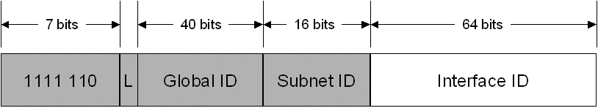
Figure 4 The unique local address defined in RFC 4193
The first 7 bits have the fixed binary value of 1111110. All unique local addresses have the address prefix FC00::/7. The Local (L) flag is set 1 to indicate a local address. The L flag value set to 0 has not yet been defined. Therefore, unique local addresses with the L flag set to 1 have the address prefix of FD00::/8. The Global ID identifies a specific site within an organization and is set to a randomly derived 40-bit value. By deriving a random value for the Global ID, an organization can have statistically unique 48-bit prefixes assigned to the sites of their organizations. Additionally, two organizations that use unique local addresses that merge have a low probability of duplicating a 48-bit unique local address prefix, minimizing site renumbering. Unlike the Global Routing Prefix in global addresses, you should not assign Global IDs in unique local address prefixes so that they can be summarized.
The global address and unique local address share the same structure beyond the first 48 bits of the address. In global addresses, the Subnet ID field identifies the subnet within an organization. For unique local addresses, the Subnet ID field can perform the same function. Therefore, you can create a subnet numbering scheme that can be used for both local and global unicast addresses.
Unique local addresses have a global scope but their reachability is defined by routing topology. Organizations will not advertise their unique local address prefixes outside of their organizations or create DNS AAAA entries with unique local addresses in the Internet DNS.

IPv6 Multicast Flags
RFC 4291 defines two additional flags in the Flags field of the IPv6 multicast address. The second low-order bit is for the Prefix (P) flag, which indicates whether the multicast address is based on a unicast address prefix. RFC 3306 describes the P flag. The third low-order bit is for the Rendezvous Point Address (R) flag, which indicates whether the multicast address contains an embedded rendezvous point address. RFC 3956 describes the R flag.

IPv6 Multicast Scope Definitions
RFC 4291 includes new definitions for the values of the Scope field for IPv6 multicast addresses. Table 3-3 on page 59 should be updated to list the values in Table 1.
Table 1 Defined Values for the Scope Field in RFC 4291
Value | Scope
0 | Reserved
1 | Interface-local scope
2 | Link-local scope
3 | Reserved
4 | Admin-local scope
5 | Site-local scope
8 | Organization-local scope
E | Global scope
F | Reserved
All instances of the term node-local scope in Chapter 3 should be replaced with interface-local scope.

Randomly Derived Interface Identifiers
To prevent address scans of IPv6 addresses based on the known company IDs of network adapter manufacturers, Windows Vista™ and Windows Server 2008 by default generate random interface IDs for non-temporary autoconfigured IPv6 addresses, including public and link-local addresses. A public IPv6 address is a global address that is registered in DNS and is typically used by server applications for incoming connections, such as a Web server.
Note that this new behavior is different than that for temporary IPv6 addresses, as described in RFC 3041. Temporary addresses also use randomly derived interface IDs. However, they are not registered in DNS and are typically used by client applications when initiating communication, such as a Web browser.
You can disable this behavior with the netsh interface ipv6 set global randomizeidentifiers=disabled command. You can enable this behavior with the netsh interface ipv6 set global randomizeidentifiers=enabled command.

Chapter 4: The IPv6 Header
Page 101 states that Microsoft implementations of IPv6 do not support jumbograms. The IPv6 protocol in Windows XP SP2 now includes support for incoming jumbograms at the IPv6 layer. However, there is no support for sending jumbograms or for receiving jumbograms by UDP or TCP.
Page 90 states that the use of the Flow Label field has not yet been defined. RFC 3697 now defines the use of the Flow Label field, requirements for IPv6 source nodes, IPv6 routers, and flow state establishment methods.

Chapter 9: IPv6 and Name Resolution
The following are updates to the information in Chapter 9:
- New domain for IPv6 reverse name space
On pages 230, 231, and 233, the IP6.INT DNS domain is stated as the domain for reverse name resolution for IPv6 addresses. The IP6.ARPA domain is now used, instead of IP6.INT. RFC 4159 formally deprecates the use of IP6.INT. All instances of IP6.INT should be replaced with IP6.ARPA.
- DNS traffic over IPv6 disabled by default for DNS Server service
By default, the Windows Server 2003 DNS Server service does not listen for DNS traffic sent over IPv6. To enable the DNS Server service to use DNS over IPv6, use the dnscmd /config /EnableIPv6 1 command, and then restart the DNS Server service. Dnscmd.exe is part of the Windows Support Tools installed from the \Support\Tools folder on the Windows Server 2003 product CD.

Configuration of DNS Traffic Over IPv6
You can configure DNS traffic over IPv6 to use either locally configured or well-known unicast addresses of DNS servers.

DNS Traffic over IPv6 Using Locally Configured Unicast Addresses
In this method, DNS traffic sent from DNS clients and DNS servers over IPv6 is sent to a unicast address locally assigned to the DNS server, such as a site-local or global address configured on the DNS server based on the receipt of a Router Advertisement message. This method requires the following steps:
- On each Windows Server 2003 DNS server, enable the DNS Server service for DNS traffic over IPv6 as previously described.
- Obtain the site-local or global addresses of each DNS server by using the Ipconfig.exe tool.
- Configure each DNS client computer with the unicast IPv6 addresses of your DNS servers using the netsh interface ipv6 add dns interface=NameOrIndex address=IPv6Address index=PreferenceLevel command (one command for each DNS IPv6 address). This step can be automated by placing these commands in a login or other startup script.

DNS Traffic over IPv6 Using Well-Known Unicast Addresses
In this method, DNS traffic sent from DNS clients and DNS servers over IPv6 is sent to a set of well-known unicast address manually configured on the DNS server. This method requires the following steps:
- On each Windows Server 2003 DNS server, enable the DNS Server service for DNS traffic over IPv6 as previously described.
- Designate which well-known unicast addresses are to be assigned to which DNS servers. The three well-known unicast addresses are FEC0:0:0:FFFF::1, FEC0:0:0:FFFF::2, and FEC0:0:0:FFFF::3.
- On each DNS server, add one or more of the well-known unicast addresses using the netsh interface ipv6 add address interface=NameOrIndex address=IPv6Address.
- Add host routes for the well-known unicast addresses to your routing infrastructure so that the DNS servers are reachable. First, you must add host routes for the DNS server addresses to the neighboring routers of the DNS servers. If you are using an IPv6 routing protocol, configure it to propagate host routes to the non-neighboring routers. If you are using static routers, add host routes with the appropriate next-hop and metric information to all the non-neighboring routers.

Source and Destination Address Selection
For a typical IPv4-only host that has a single interface assigned one IPv4 address and resolves names using DNS, the choice of which IPv4 addresses to use as the source and destination when initiating communication is straightforward. The source IPv4 address is the address assigned to the interface of the host. The destination addresses to which connections are attempted are the IPv4 addresses returned in the DNS Name Query Response message.
For a typical IPv6 host that has multiple IPv6 addresses assigned to multiple interfaces and multiple IPv6 addresses are returned in the DNS Name Query Response message, the choice of the source and destination IPv6 address is more complex. The source and destination IPv6 addresses should be matched in scope and purpose. For example, an IPv6 host should not choose a link-local source address when communicating with a global destination address. Additionally, the possible destination address should be sorted by preference.
To provide a standardized method to choose source and destination IPv6 addresses with which to attempt connections, RFC 3484 defines the following required algorithms:
- A source address selection algorithm to choose the best source address to use with a destination address.
- A destination address selection algorithm to sort the list of possible destination addresses in order of preference.
For more information about the source and destination address selection algorithms defined in RFC 3484, see Source and Destination Address Selection for IPv6 at http://www.microsoft.com/technet/community/columns/cableguy/cg0206.mspx.

Chapter 11: IPv6 Coexistence and Migration
The following are updates to the information in Chapter 11:
- New domain for IPv6 reverse name space
On pages 268 and 299, the IP6.INT DNS domain is stated as the domain for reverse name resolution for IPv6 addresses. The IP6.ARPA domain is now used, instead of IP6.INT. RFC 4159 formally deprecates the use of IP6.INT. All instances of IP6.INT should be replaced with IP6.ARPA.
- Windows Server 2003 Service Pack 1, Windows XP SP2, and Windows XP SP1 with the Advanced Networking Pack for Windows XP support the Teredo IPv6 transition technology. For more information, see "Advanced Networking Pack for Windows XP" and "Changes to IPv6 in Windows XP SP2" in this white paper.
The Next Generation TCP/IP stack in Windows Vista and Windows Server 2008 is a new implementation of the TCP/IP protocol suite that includes both IPv4 and IPv6 in a dual IP layer architecture as displayed by Figure 11-1 on page 265. For more information, see Next Generation TCP/IP Stack in Windows Vista and Windows Server 2008 at http://www.microsoft.com/technet/community/columns/cableguy/cg0905.mspx.
For additional information about ISATAP, see the Manageable Transition to IPv6 using ISATAP at http://www.microsoft.com/downloads/details.aspx?FamilyId=B8F50E07-17BF-4B5C-A1F9-5A09E2AF698B&displaylang=en and Intra-site Automatic Tunnel Addressing Protocol Deployment Guide at http://www.microsoft.com/downloads/details.aspx?FamilyID=0f3a8868-e337-43d1-b271-b8c8702344cd&displaylang=en.

Chapter 12: IPv6 Mobility
Chapter 12 is a detailed discussion of version 13 of the "Mobility Support in IPv6" Internet draft, which, at the time or the writing of Understanding IPv6, was the version that some networking vendors including Microsoft were supporting. Mobile IPv6 is now defined in RFC 3775, "Mobility Support in IPv6", and RFC 3776, "Using IPsec to Protect Mobile IPv6 Signaling Between Mobile Nodes and Home Agents".
Although the information in Chapter 12 does not reflect the support for IPv6 mobility as defined in RFCs 3775 and 3776, it does properly describe how the correspondent node provided with the IPv6 protocol for Windows Server 2003 works based on version 13 of the "Mobility Support in IPv6" Internet draft.
For an overview of Mobile IPv6 as defined in RFC 3775, see Introduction to Mobile IPv6 at http://www.microsoft.com/technet/community/columns/cableguy/cg0904.mspx. For a detailed discussion of how the Mobile IPv6 protocol works as defined in RFC 3775, see Appendix F of the Understanding IPv6, Second Edition Microsoft Press book by Joseph Davies (ISBN 9780735624467 or ISBN-10 0-7356-2446-1). See http://www.microsoft.com/MSPress/books/11607.aspx.

Advanced Networking Pack for Windows XP
The Advanced Networking Pack for Windows XP at http://www.microsoft.com/downloads/details.aspx?familyid=E88CC382-8CE6-4739-97C0-1A52A6F005E4&displaylang=en is a free Web download that provides a set of platform technologies designed to run on Windows XP with SP1 to enable the use and deployment of distributed, peer-to-peer applications based on Internet standards. The update includes a new version of the IPv6 stack, including support for NAT traversal for IPv6 applications. An IPv6 firewall is included to protect the end-user's machine from unsolicited incoming IPv6 traffic, while the peer-to-peer platform makes it simple to write distributed solutions.
Windows Peer-to-Peer Networking is a developer platform that you can use to create peer-to-peer applications for computers running Windows XP with SP1. The Advanced Networking Pack for Windows XP provides the components to run Windows Peer-to-Peer Networking applications. For more information, see Windows Peer-to-Peer Networking Web page at http://www.microsoft.com/p2p. The Windows Peer-to-Peer Networking platform runs exclusively over IPv6.
The enhancements to IPv6 included in the Advanced Networking Pack for Windows XP are the following:
- IPv6 Internet Connection Firewall (ICF)
Computers using Windows Peer-to-Peer Networking must be protected from malicious users that are using IPv6 traffic in the same way that ICF in Windows XP protects computers from malicious users that are using IPv4 traffic.
- Teredo
When connecting to the Internet, many computers running Windows XP are behind network address translators (NATs), which translate traffic between private and public IPv4 addresses. Teredo is a NAT traversal technology that provides unicast IPv6 connectivity across the IPv4 Internet.
All of the functionality in the Advanced Networking Pack for Windows XP is either included or enhanced in Windows XP SP2. For more information, see "Changes to IPv6 in Windows XP SP2" in this white paper.

IPv6 Internet Connection Firewall (ICF)
A firewall provides security by creating a protective boundary between a computer or network and the Internet. You can use IPv6 ICF to dynamically set restrictions for traffic allowed from the Internet. IPv6 ICF is different than the existing ICF in Windows XP, which is used for IPv4 traffic. For more information about ICF for IPv4, see Windows XP Help and Support.
IPv6 Internet Connection Firewall (ICF):
- Runs automatically and provides filters for all network connections on which IPv6 is enabled.
- Monitors all outbound traffic and dynamically creates inbound packet filters for response traffic. This is known as stateful filtering. IPv6 ICF silently discards all unsolicited inbound traffic.
- Logs IPv6 traffic events to a separate log file (from IPv4 ICF). By default, this log file is systemroot\Pfirewall-v6.log.
IPv6 ICF protects your computer by silently dropping all packets that are initiated from a source outside the IPv6 ICF computer, such as the Internet. IPv6 ICF stops common attempts to illegally gain access to your computer or network by malicious Internet users using techniques such as port scanning. Instead of notifying you of inbound discarded traffic, IPv6 ICF creates entries in a security log from which you can view the activity that is tracked by the firewall.
IPv6 ICF is configured using commands in the netsh firewall context. You can use netsh commands to configure IPv6 ICF to allow specific types of ICMPv6 traffic or traffic to specific TCP or UDP ports.
Note Windows XP only shows the IPv4 ICF configuration in Network Connections. IPv6 ICF may appear disabled, but it is actually enabled and filtering IPv6 traffic.
IPv6 ICF has been replaced with Windows Firewall in Windows XP Service Pack 2. For more information, see "Changes to IPv6 in Windows XP SP2" in this article.

Teredo
Teredo, also known as IPv4 NAT traversal for IPv6, is an IPv6/IPv4 transition technology defined in RFC 4380. Teredo provides address assignment and host-to-host automatic tunneling for unicast IPv6 connectivity across the IPv4 Internet when IPv6/IPv4 hosts are located behind one or multiple IPv4 NATs. To traverse IPv4 NATs, IPv6 packets are sent as IPv4-based User Datagram Protocol (UDP) messages. For more information about how network address translation works, see Windows 2000 Network Address Translator (NAT) at http://www.microsoft.com/technet/community/columns/cableguy/cg0301.mspx.
6to4 provides the same function as Teredo; however, 6to4 router support is required in the edge device that is connected to the Internet. 6to4 router functionality is not widely supported by IPv4 NATs. Even if the NAT were 6to4-enabled, 6to4 would still not work for configurations in which there are multiple NATs between a site and the Internet.
Note Windows XP with Internet Connection Sharing and the IPv6 protocol supports 6to4 router functionality.
Teredo resolves the issues of the lack of 6to4 functionality in modern-day NATs or multi-layered NAT configurations by tunneling IPv6 packets between the hosts within the sites. In contrast, 6to4 uses tunneling from the edge device. Tunneling from the hosts presents another issue for NATs: IPv4-encapsulated IPv6 packets are sent with the Protocol field in the IPv4 header set to 41. Most NATs only translate TCP or UDP traffic and must either be manually configured to translate other protocols or have an installed NAT editor that handles the translation. Because Protocol 41 translation is not a common feature of NATs, IPv4-encapsulated IPv6 traffic will not flow through typical NATs. Therefore, the IPv6 packet is encapsulated as an IPv4 UDP message, containing both IPv4 and UDP headers. UDP messages can be translated by most NATs and can traverse multiple layers of NATs.
It is important to note that Teredo is designed as a last resort transition technology for IPv6 connectivity. If native IPv6, 6to4, or Intra-Site Automatic Tunnel Addressing Protocol (ISATAP) connectivity is present between communicating nodes, Teredo is not used. As more IPv4 NATs are upgraded to support 6to4 and IPv6 connectivity become ubiquitous, Teredo will be used less and less, until eventually it is not used at all.
Note Teredo in Windows XP and Windows Server 2003 works only over cone and restricted NATs. A cone NAT stores a mapping between an internal (private) address and port number and an external (public) address and port number. After the NAT translation table entry is in place, inbound traffic to the external address and port number is allowed from any source address and port number. A restricted NAT stores a mapping between an internal address and port number and an external address and port number, for either specific external addresses or specific external addresses and port numbers. An inbound packet that does not match a NAT translation table entry for both the external destination address and port number and a specific external address or port number is silently discarded. There is an additional type of NAT, known as a symmetric NAT, which maps the same internal address and port number to different external addresses and ports, depending on the external destination address (for outbound traffic). Teredo in Windows XP and Windows Server 2003 does not work over symmetric NATs.

Teredo Components
The set of components that enables Teredo connectivity is shown in Figure 5.
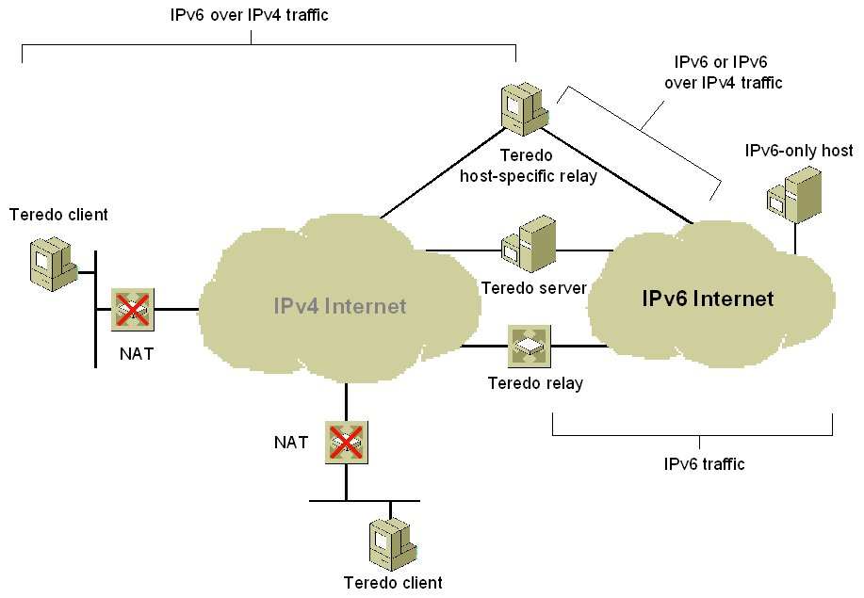
Figure 5 Components of Teredo connectivity
- Teredo client
An IPv6/IPv4 node that supports a Teredo tunneling interface through which packets are tunneled to either other Teredo clients or nodes on the IPv6 Internet (through a Teredo relay).
- Teredo server
An IPv6/IPv4 node that is connected to both the IPv4 Internet and the IPv6 Internet. The role of the Teredo server is to assist in the initial configuration of Teredo clients and to facilitate the initial communication between either different Teredo clients or between Teredo clients and IPv6-only hosts.
- Teredo relay
An IPv6/IPv4 router that can forward packets between Teredo clients on the IPv4 Internet and IPv6-only hosts.
- Teredo host-specific relay
An IPv6/IPv4 node that has an interface and connectivity to both the IPv4 Internet and the IPv6 Internet and can communicate directly with Teredo clients over the IPv4 Internet, without the need for an intermediate Teredo relay. The connectivity to the IPv4 Internet can be through a public IPv4 address or through a private IPv4 address and a neighboring NAT. The connectivity to the IPv6 Internet can be through a direct connection to the IPv6 Internet or through an IPv6/IPv4 transition technology such as 6to4.
The Windows XP Advanced Networking Pack for Windows XP includes Teredo client and Teredo host-specific relay functionality. When the Advanced Networking Pack for Windows XP is installed, the Teredo host-specific relay functionality is automatically enabled if a global IPv6 address has been assigned. A global address can be assigned from a Router Advertisement message that is received from a native IPv6 router, an ISATAP router, or a 6to4 router. If there is no global address configured, Teredo client functionality is enabled.

Teredo Addresses
Teredo addresses have the format shown in Figure 6.
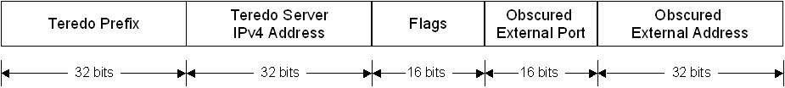
Figure 6 The Teredo address format
A Teredo address consists of the following:
- Teredo prefix
The first 32 bits are for the Teredo prefix, which is the same for all Teredo addresses. Windows XP and Windows Server 2003 initially used the 3FFE:831F::/32 Teredo prefix. The prefix defined for Teredo in RFC 4380 is 2001::/32 and is the prefix used by Teredo in Windows Vista and Windows Server 2008. Computers running Windows XP and Windows Server 2003 will use the 2001::/32 Teredo prefix when updated with Microsoft Security Bulletin MS06-064 at http://www.microsoft.com/technet/security/Bulletin/MS06-064.mspx.
- Teredo server IPv4 address
The next 32 bits contain the IPv4 public address of the Teredo server that assisted in the configuration of this Teredo address.
- Flags
The next 16 bits are reserved for Teredo flags. The only defined flag is the high-order bit known as the Cone flag. The Cone flag is set when the NAT connected to the Internet is a cone NAT. For Windows Vista and Windows Server 2008-based Teredo clients, unused bits within the Flags field provide a level of protection from address scans by malicious users. The 16 bits within the Flags field for Windows Vista and Windows Server 2008-based Teredo clients consists of the following: CRAAAAUG AAAAAAAA. The C bit is for the Cone flag. The R bit is reserved for future use. The U bit is for the Universal/Local flag (set to 0). The G bit is Individual/Group flag (set to 0). The A bits are set to a 12-bit randomly generated number. By using a random number for the A bits, a malicious user that has determined the rest of the Teredo address by capturing the initial configuration exchange of packets between the Teredo client and Teredo server will have to try up to 4,096 (212) different addresses to determine a Teredo client's address during an address scan.
- Obscured external port
The next 16 bits store an obscured version of the external UDP port that corresponds to all Teredo traffic for this Teredo client. When the Teredo client sends its initial packet to a Teredo server, the source UDP port of the packet is mapped by the NAT to a different, external UDP port. All Teredo traffic for the host uses the same external, mapped UDP port.
The external port is obscured by exclusive ORing (XORing) the external port with 0xFFFF. For example, the obscured version of the external port 5000 in hexadecimal format is EC77 (5000 equals 0x1388, and 0x1388 XOR 0xFFFF equals 0xEC77). Obscuring the external port prevents NATs from translating it within the payload of the packets that are being forwarded.
- Obscured external address
The last 32 bits store an obscured version of the external IPv4 address that corresponds to all Teredo traffic for this Teredo client. Just like the external port, when the Teredo client sends its initial packet to a Teredo server, the source IP address of the packet is mapped by the NAT to a different, external address.
The external address is obscured by XORing the external address with 0xFFFFFFFF. For example, the obscured version of the public IPv4 address 131.107.0.1 in colon-hexadecimal format is 7C94:FFFE (131.107.0.1 equals 0x836B0001, and 0x836B0001 XOR 0xFFFFFFFF equals 0x7C94FFFE). Obscuring the external address prevents NATs from translating it within the payload of the packets that are being forwarded.

How Teredo Works
For two Windows-based computers, the most crucial Teredo processes are those used for initial configuration and communication with a peer in a different site.

Initial Configuration
Initial configuration for Teredo clients is accomplished by sending a series of Router Solicitation messages to Teredo servers. The responses are used to derive a Teredo address and determine whether the client is behind a cone, restricted, or symmetric NAT. If the Teredo client is behind a symmetric NAT, then Teredo in Windows XP and Windows Server 2003 cannot function. You can see what type of NAT the Teredo client has discovered from the display of the netsh interface ipv6 show teredo command.
Based on the received Router Advertisement messages, the Teredo client constructs its Teredo address from the following:
- The first 64 bits are set to the value included in the Prefix Information option of the received router advertisement. The 64-bit prefix advertised by the Teredo server consists of the Teredo prefix (32 bits) and the public IPv4 address of the Teredo server (32 bits).
- The next 16 bits have the Cone flag set to 1 (cone NAT) or 0 (restricted NAT) and, for Teredo clients running Windows Vista or Windows Server 2008, the 12 additional bits are set to obscure the Teredo address.
- The next 16 bits are set to the obscured external UDP port number that is included in a special Teredo header in the router advertisement.
- The last 32 bits are set to the obscured external IP address that is included in a special Teredo header in the router advertisement.

Initial Communication Between Two Teredo Clients in Different Sites
The success of initial communication between Teredo clients located in different sites depends on whether those sites are using cone NATs or restricted NATs.
When both Teredo clients are located behind cone NATs, the NAT translation table entries for Teredo traffic for each Teredo client allows traffic from any source IP address or source UDP port. Therefore, a Teredo client in one site can send packets directly to a Teredo client in another site without the use of additional packets to establish NAT translation table entries.
When the Teredo clients are located behind restricted NATs, additional NAT translation table entries must be established before unicast packets can be exchanged. Figure 7 shows the initial communication process between Teredo clients that are located in different sites when both sites are using restricted NATs.
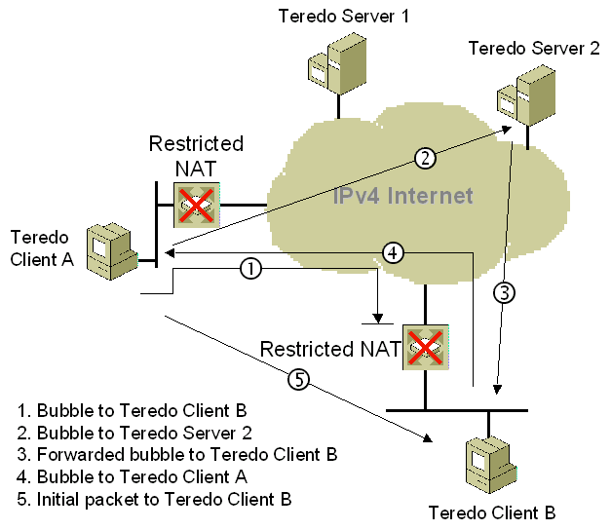
Figure 7 Sending traffic between two Teredo clients behind restricted NATs
To send an initial communication packet from Teredo Client A to Teredo Client B, the following process is used:
- Teredo Client A sends a bubble packet directly to Teredo Client B. A bubble packet contains no data and is used to create or maintain NAT mappings. Because Teredo Client B is behind a restricted NAT, Teredo traffic from an arbitrary source IPv4 address and UDP port number is not allowed unless there is a source-specific NAT translation table entry. Assuming that there is none, the restricted NAT silently discards the bubble packet. However, when the restricted NAT for Teredo Client A forwarded the bubble packet, it created a source-specific NAT translation table entry that will allow future packets sent from Teredo Client B to be forwarded to Teredo Client A.
- Teredo Client A sends a bubble packet to Teredo Client B through Teredo Server 2 (Teredo Client B's Teredo server). The IPv4 destination address in the bubble packet is set to the IPv4 address of Teredo Server 2, which Teredo Client A determines from the third and fourth blocks of Teredo Client B's Teredo address.
- Teredo Server 2 forwards the bubble packet to Teredo Client B. The restricted NAT for Teredo Client B forwards the packet because there is an existing source-specific mapping for Teredo traffic from Teredo Server 2 (established by the initial configuration of Teredo Client B).
- Teredo Client B responds to the bubble packet received from Teredo Client A with its own bubble packet, which is sent directly to Teredo Client A. Because Teredo Client A's restricted NAT has a source-specific mapping for Teredo traffic from Teredo Client B (as established by the initial bubble packet sent from Teredo Client A in step 1), it forwards the bubble packet to Teredo Client A.
- Upon receipt of the bubble packet from Teredo Client B, Teredo Client A determines that source-specific NAT mappings exist for both NATs. Teredo Client A sends an initial communication packet directly to Teredo Client B.
This process occurs transparently to the user at Teredo Client A.
There are additional initial communication processes that depend on whether the destination for the initial communication is on the same link, on the IPv6 Internet, or for a Teredo host-specific relay. For more information, see the Teredo Overview white paper at http://www.microsoft.com/technet/prodtechnol/winxppro/maintain/teredo.mspx.

Changes to IPv6 in Windows XP SP2
Windows XP SP2 includes the IPv6 protocol that was provided with the Advanced Networking Pack for Windows XP, which includes Teredo client and host-specific relay support. Additionally, IPv6 ICF has been replaced with Windows Firewall, a replacement for the Internet Connection Firewall (ICF) component included in Windows XP and Windows XP with SP1.
The Windows Firewall has built-in support for IPv6 traffic and is automatically enabled on all IPv6 connections. Both IPv4 and IPv6 share the same settings for excepted traffic. For example, if you except file and print sharing traffic, then both IPv4 and IPv6-based unsolicited incoming file and print sharing traffic is allowed.
You can configure the Windows Firewall to allow excepted IPv4 and IPv6 traffic in the following ways:
- Windows Firewall Control Panel applet
For more information, see Manually Configuring Windows Firewall in Windows XP Service Pack 2 at http://www.microsoft.com/technet/community/columns/cableguy/cg0204.mspx.
- Netsh commands
You can configure Windows Firewall settings through a series of commands in the netsh firewall context. Using Netsh, you can create Netsh scripts to automatically configure a set of Windows Firewall settings for both IPv4 and IPv6. For more information, see Appendix B of Deploying Windows Firewall Settings for Microsoft Windows XP with Service Pack 2 at http://www.microsoft.com/downloads/details.aspx?FamilyID=4454e0e1-61fa-447a-bdcd-499f73a637d1&DisplayLang=en.
- New configuration APIs
With Windows XP and Windows XP with SP1, there are APIs by which applications can automatically configure excepted traffic and configure ICF settings. With Windows XP SP2, there are new APIs through which you can configure Windows Firewall for global settings for all the items that are available through the Windows Firewall Control Panel applet. You can use these APIs to create customized configuration programs that can be run by users on an organization network. For information about the new Windows Firewall APIs, see Windows Firewall in the Windows Software Development Kit (SDK) at http://msdn2.microsoft.com/en-us/library/aa366453.aspx.
- Extensive support to configure settings using Group Policy
To centralize the configuration of large numbers of computers in an organization network that use the Active Directory® directory service, Windows Firewall settings for computers running Windows XP with SP2 can be deployed through Computer Configuration Group Policy. A new set of Computer Configuration Group Policy Windows Firewall settings allow a network administrator to configure Windows Firewall operation modes, excepted traffic, and other settings using a Group Policy object. For more information, see Deploying Windows Firewall Settings for Microsoft Windows XP with Service Pack 2 at http://www.microsoft.com/downloads/details.aspx?FamilyID=4454e0e1-61fa-447a-bdcd-499f73a637d1&DisplayLang=en.
For more information about Windows Firewall, see the Windows Firewall Web page at http://technet.microsoft.com/en-us/network/bb545423.aspx.
To protect the computer between when the computer starts and when the Windows Firewall (WF)/Internet Connection Sharing (ICS) service is started, the IPv6 protocol uses a startup firewall policy. Unfortunately, this startup policy blocks incoming Router Advertisement messages, causing a delay in router discovery and address autoconfiguration until the Windows Firewall (WF)/Internet Connection Sharing (ICS) service is started and the next multicast Router Advertisement is received. The fix for this issue for Windows XP is being considered for Windows XP Service Pack 3. One workaround is to lower the pseudo-periodic interval at which your routers send their router advertisements so that Windows XP SP2-based computers do not have to wait long after the startup policy is removed to perform address autoconfiguration. This issue has been fixed for Windows Firewall in Windows Server 2003 Service Pack 1.
Windows XP SP2 also includes support for incoming jumbograms at the IPv6 layer. However, there is no support for sending jumbograms or for receiving jumbograms by UDP or TCP.

Changes to IPv6 in Windows Server 2003 Service Pack 1
Windows Server 2003 Service Pack 1 includes the Teredo client and host-specific relay and Windows Firewall support for IPv6 traffic that is included in Windows XP SP2.

Changes to IPv6 in Windows Vista and Windows Server 2008
Windows Vista and Windows Server 2008 include the Next Generation TCP/IP stack, a new implementation of the TCP/IP protocol suite that includes both IPv4 and IPv6 in a dual IP layer architecture.
For information about the features and architecture of the Next Generation TCP/IP stack, see Next Generation TCP/IP Stack in Windows Vista and Windows Server 2008 at http://www.microsoft.com/technet/community/columns/cableguy/cg0905.mspx.

Changes to IPv6
The changes to IPv6 in Windows Vista and Windows Server 2008 are the following:
- Dual IP layer architecture
- Installed and enabled by default
- Graphical user interface (GUI)-based configuration
- Full Support for IPsec
- MLDv2
- LLMNR
- Literal IPv6 addresses in URLs
- Support for ipv6-literal.net names
- IPv6 over PPP
- DHCPv6
- Random interface IDs

Dual IP Layer Architecture
The implementation of IPv6 in Windows XP and Windows Server 2003 is a dual stack architecture, which has separate protocol components for IPv4 and IPv6 that are installed through the Network Connections folder. The separate IPv4 and IPv6 protocol components had their own Transport layer that included Transmission Control Protocol (TCP) and User Datagram Protocol (UDP) and framing layer.
The Next Generation TCP/IP stack is a single protocol component installed through the Network Connections folder that supports the dual IP layer architecture, in which both IPv4 and IPv6 share common Transport and Framing layers.
Because there is a single implementation of TCP, TCP traffic over IPv6 can take advantage of all the performance features of the Next Generation TCP/IP stack. These features include all of the performance enhancements of the IPv4 protocol stack of Windows XP and Windows Server 2003 and additional enhancements new to the Next Generation TCP/IP stack, such as Receive Window Auto Tuning and Compound TCP—which can dramatically improve performance on high-latency/high-delay connections—and better support for TCP traffic in high-loss environments (such as wireless LAN networks). For more information, see Performance Enhancements in the Next Generation TCP/IP Stack at http://www.microsoft.com/technet/community/columns/cableguy/cg1105.mspx.

Installed and Enabled by Default
In Windows Vista and Windows Server 2008, IPv6 is installed and enabled by default as the Internet Protocol version 6 (TCP/IPv6) component from the properties of a connection in the Connections and Adapters folder. In Windows Vista and Windows Server 2008, many operating system components now support IPv6.
When both IPv4 and IPv6 are enabled, the Next Generation TCP/IP stack prefers the use of IPv6. For example, if a Domain Name System (DNS) Name Query Response message contains a list of both IPv6 and IPv4 addresses, the Next Generation TCP/IP stack will attempt to communicate over IPv6 first, subject to the address selection rules that are defined in RFC 3484. For more information, see Source and Destination Address Selection for IPv6 at http://www.microsoft.com/technet/community/columns/cableguy/cg0206.mspx.
The preference of IPv6 over IPv4 offers IPv6-enabled applications better network connectivity because IPv6 connections can use IPv6 transition technologies such as Teredo, which allow peer or server applications to operate behind network address translators (NATs) without requiring NAT configuration or application modification.
Enabling IPv6 by default and preferring of IPv6 traffic does not impair IPv4 connectivity. For example, on networks without IPv6 records in the DNS infrastructure, communications using IPv6 addresses are not attempted unless the user or application specifies the destination IPv6 address.
To take advantage of IPv6 connectivity, networking applications must be updated to use Windows Sockets functions that are not specific to IPv4 or IPv6. For more information, see the IPv6 Guide for Windows Sockets Applications at http://msdn2.microsoft.com/en-us/library/ms738649.aspx.
Note Due to misconfigured DNS servers on the Internet, computers that use both IPv4 and IPv6 might not be able to resolve names and connect to Internet resources. This rare problem occurs when a misconfigured DNS server receives a request to resolve a name to one or more IPv6 addresses (a request for AAAA records). If the DNS server does not support IPv6, the name query fails. The querying node then sends a request to resolve the name to a set of IPv4 addresses (a request for A records). The misconfigured DNS server drops the subsequent DNS query for IPv4 addresses and the entire name resolution attempt fails, resulting in impaired network connectivity for the requesting node. If you are experiencing this problem, ask your Internet service provider to reconfigure their DNS server to accept the subsequent DNS query for A records after failing the DNS query for AAAA records. Alternately, you can temporarily disable IPv6 on the requesting computer. This issue exists on the DNS servers and is common to all computers that use both IPv4 and IPv6.

GUI-based Configuration
In Windows XP and Windows Server 2003, you must manually configure IPv6 configuration settings with netsh interface ipv6 commands at a Windows command prompt. Windows Vista and Windows Server 2008 now allow you to also manually configure IPv6 settings through the properties of the Internet Protocol version 6 (TCP/IPv6) component in the Connections folder.
To manually configure IPv6 settings through the Windows graphical user interface, do the following:
- From the Network Connections folder, right-click the connection or adapter on which you want to manually configure IPv6, and then click Properties.
- On the Configure tab for the properties of the connection or adapter, double-click Internet Protocol Version 6 (TCP/IPv6) in the list under This connection uses the following items.
Windows Vista displays the Internet Protocol Version 6 (TCP/IPv6) Properties dialog box. Figure 8 shows an example.
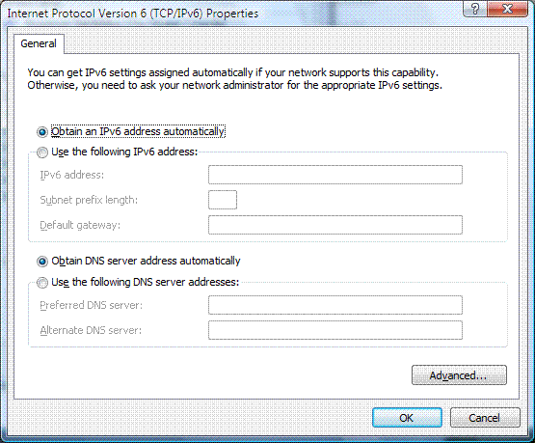
Figure 8 The Internet Protocol Version 6 (TCP/IPv6) Properties dialog box
On the General tab of the Internet Protocol Version 6 (TCP/IPv6) Properties dialog box, you can configure the following:
- Obtain an IPv6 address automatically Specifies that IPv6 addresses for this connection or adapter are automatically determined by stateful or stateless address autoconfiguration.
- Use the following IPv6 address Specifies that an IPv6 address and default gateway for this connection or adapter are manually configured.
- IPv6 address Provides a space for you to type an IPv6 unicast address. You can specify additional IPv6 addresses from the Advanced TCP/IP Settings dialog box described later in this article.
- Subnet prefix length Provides a space for you to type the subnet prefix length for the IPv6 address. For IPv6 unicast addresses, this value should be set to 64, its default value.
- Default gateway Provides a space for you to type the IPv6 unicast address of the default gateway.
- Obtain DNS server address automatically Specifies that the IPv6 addresses for DNS servers are automatically determined by stateful address autoconfiguration (DHCPv6).
- Use the following DNS server addresses Specifies that the IPv6 addresses of the preferred and alternate DNS servers for this connection or adapter are manually configured.
- Preferred DNS server Provides a space for you to type the IPv6 unicast address of the preferred DNS server.
- Alternate DNS server Provides a space for you to type the IPv6 unicast address of the alternate DNS server. You can specify additional DNS servers from the Advanced TCP/IP Settings dialog box.
From the General tab, you can click Advanced to access the Advanced TCP/IP Settings dialog box. This dialog box is very similar to the Advanced TCP/IP Settings dialog box for the Internet Protocol Version 4 (TCP/IPv4) component except there is no WINS tab (IPv6 does not use NetBIOS and the Windows Internet Name Service [WINS]) or Options tab (TCP/IP filtering is only defined for IPv4 traffic). For IPv6, the Advanced TCP/IP Settings dialog box has IP Settings and DNS tabs. Figure 9 shows an example of the IP Settings tab.
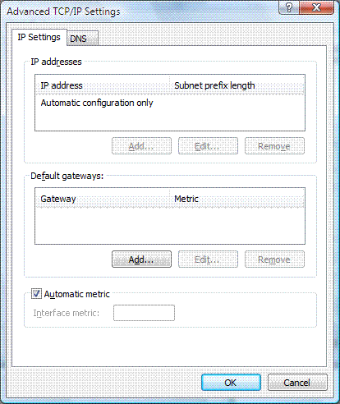
Figure 9 An example of the IP Settings tab
From the IP Settings tab, you can configure the following:
- Multiple IPv6 addresses (click Add under IP addresses)
For each unicast IPv6 address, you must specify an IPv6 address and a subnet prefix length. The Add button is only available if the Use the following IPv6 address option has been selected on the General tab of the Internet Protocol Version 6 (TCP/IPv6) Properties dialog box.
- Multiple default gateways (click Add under Default gateways)
For each default gateway, you must specify the IPv6 address of the gateway and whether you want the metric for the default route associated with this default gateway to be manually specified or based on the speed of the connection or adapter. The Add button is only available if the Use the following IPv6 address option has been selected on the General tab of the Internet Protocol Version 6 (TCP/IPv6) Properties dialog box.
- Whether to use a specific metric for the routes associated with the configuration of IPv6 addresses or default gateways or a metric determined by the speed of the connection or adapter.
Figure 10 shows an example of the DNS tab.
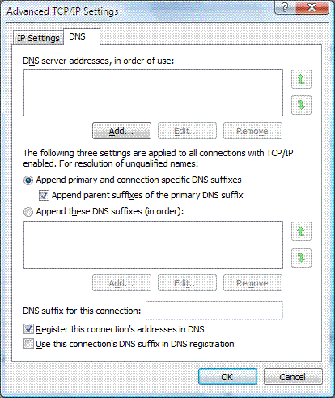
Figure 10 An example of the DNS tab
From the DNS tab, you can configure the following:
- The IPv6 addresses of DNS servers, in order of use (click Add under DNS server addresses, in order of use).
- Primary and connection-specific DNS suffix and name registration and devolution behavior. These settings are the same as for IPv4.

Full Support for IPsec
Internet Protocol security (IPsec) support for IPv6 traffic in Windows XP and Windows Server 2003 is limited. There is no support for Internet Key Exchange (IKE) or data encryption. IPsec security policies, security associations and keys are configured through text files and activated through a command line tool, IPsec6.exe.
In Windows Vista and Windows Server 2008, IPsec support for IPv6 traffic is the same as that for IPv4, including support for IKE and data encryption with the Advanced Encryption Standard (AES) 128/192/256. The IP Security Policies snap-in now supports the configuration of IPsec policies for IPv6 traffic in the same way as IPv4 traffic using either the IP Security Policies snap-in or the new Windows Firewall with Advanced Security snap-in.

MLDv2
Windows Vista and Windows Server 2008 supports Multicast Listener Discovery version 2 (MLDv2), specified in RFC 3810, which allows IPv6 hosts to register interest in source-specific multicast traffic with their local multicast routers. A host running on Windows Vista or Windows Server 2008 can register interest in receiving IPv6 multicast traffic from only specific source addresses (an include list) or from any source except specific source addresses (an exclude list).

LLMNR
Windows Vista and Windows Server 2008 support Link-Local Multicast Name Resolution (LLMNR), which allows IPv6 hosts on a single subnet without a DNS server to resolve each other’s names. This capability is useful for single-subnet home networks and ad hoc wireless networks. Rather than unicasting a DNS query to a DNS server, LLMNR nodes send their DNS queries to a multicast address on which all the LLMNR-capable nodes of the subnet are listening. The owner of the queried name sends a unicast response. IPv4 nodes can also use LLMNR to perform local subnet name resolution without having to rely on NetBIOS over TCP/IP broadcasts. For more information, see Link-Local Multicast Name Resolution at http://www.microsoft.com/technet/community/columns/cableguy/cg1106.mspx.

Literal IPv6 Addresses in URLs
The WinINet API in Windows Vista and Windows Server 2008 now supports RFC 2732 and the use of IPv6 literal addresses in URLs. For example, to connect to the Web server at the IPv6 address 2001:db8:100:2a5f::1, a user with a WinINet-based Web browser (such as Internet Explorer) can type http://[2001:db8:100:2a5f::1] as the URL. Although typical users might not use IPv6 literal addresses, the ability to specify the IPv6 address in the URL is valuable to application developers, software testers, and network troubleshooters.

Support for ipv6-literal.net Names
Windows Vista and Windows Server 2008 now support the use of IPv6Address.ipv6-literal.net names. To specify an IPv6 address within the ipv6-literal.net name, convert the colons (:) in the address to dashes (-). For example, for the IPv6 address 2001:db8:28:3:f98a:5b31:67b7:67ef, the corresponding ipv6-literal.net name is 2001-db8-28-3-f98a-5b31-67b7-67ef.ipv6-literal.net. When submitted by an application for name resolution, the 2001-db8-28-3-f98a-5b31-67b7-67ef.ipv6-literal.net name resolves to 2001:db8:28:3:f98a:5b31:67b7:67ef.
The IPv6 address in the name can be global, unique local, or link local (with or without a zone ID). To specify a zone ID (also known as a scope ID), replace the “%” used to separate the IPv6 address from the zone ID with an “s”. For example to specify the destination fe80::218:8bff:fe17:a226%4, the name is fe80--218-8bff-fe17-a226s4.ipv6-literal.net.
An ipv6-literal.net name can be used in services or applications that do not recognize the syntax of IPv6 addresses. It is always preferable to use a DNS name that corresponds to a destination, such as filesrv1.example.com. However, the ipv6-literal.net name can be used for connectivity when the DNS name for the destination is not registered and the IPv6 address is known.
You can use an ipv6-literal.net name in the computer name part of a Universal Naming Convention (UNC) path. For example, to specify the Docs share of the computer with the IPv6 address of 2001:db8:28:3:f98a:5b31:67b7:67ef, use the UNC path \\2001-db8-28-3-f98a-5b31-67b7-67ef.ipv6-literal.net\docs.
The ipv6-literal.net name is an alias for the name of the file server. See Knowledge Base article 281308 at http://support.microsoft.com/default.aspx?scid=kb;en-us;281308 for details about how to configure an IPv6-capable Windows Server 2003-based file server to accept alias names in a UNC.

IPv6 over PPP
The built-in remote access client now supports IPv6 over the Point-to-Point Protocol (PPP), as defined in RFC 2472. Native IPv6 traffic can now be sent over PPP-based connections. For example, IPv6 over PPP support allows you to connect with an IPv6-based Internet service provider (ISP) through dial-up or PPP over Ethernet (PPPoE)-based connections that might be used for broadband Internet access. Additionally, IPv6 over PPP supports Layer Two Tunneling Protocol (L2TP)-based virtual private network connections.
For more information about IPv6 over PPP, see IPv6 over Point-to-Point Protocol Links at http://www.microsoft.com/technet/community/columns/cableguy/cg1206.mspx.

DHCPv6
The DHCP Client service in Windows Vista and Windows Server 2008 supports Dynamic Host Configuration Protocol for IPv6 (DHCPv6) defined in RFCs 3315 and 3736. A computer running Windows Vista or Windows Server 2008 can perform both stateful and stateless DHCPv6 configuration on a native IPv6 network.

Random Interface IDs
To prevent address scans of IPv6 addresses based on the known company IDs of network adapter manufacturers, Windows Vista and Windows Server 2008 by default generate random interface IDs for non-temporary autoconfigured IPv6 addresses, including public and link-local addresses. A public IPv6 address is a global address that is registered in DNS and is typically used by server applications for incoming connections, such as a Web server.
Note that this new behavior is different than that for temporary IPv6 addresses, as described in RFC 3041. Temporary addresses also use randomly derived interface IDs. However, they are not registered in DNS and are typically used by client applications when initiating communication, such as a Web browser.
You can disable this behavior with the netsh interface ipv6 set global randomizeidentifiers=disabled command. You can enable this behavior with the netsh interface ipv6 set global randomizeidentifiers=enabled command.

Changes to Teredo
Teredo is an IPv6 transition technology that allows IPv6/IPv4 nodes that are separated by one or more NATs to communicate end-to-end with global IPv6 addresses. NATs are commonly used on the Internet to preserve the public IPv4 address space by translating the addresses and port numbers of traffic to and from private network hosts that use private IPv4 addresses.
Although NATs extend the life of the public IPv4 address space, this functionality comes at the cost of violating the original design principle of the Internet that all nodes should communicate with a unique global address. Because of the reuse of private addresses and the translation between private and public addresses that occur at the NAT, servers and peers that are located on private networks behind NATs cannot communicate without either manually configuring the NAT or modifying application protocols.
Although IPv4 traffic for servers and peers that are behind a NAT might have problems traversing a NAT, Teredo-based IPv6 traffic can traverse a NAT without having to configure the NAT or modify application protocols. Teredo IPv6 addresses are global addresses, unique to the entire Internet. Teredo restores global addressing and end-to-end connectivity for IPv6 traffic for an environment that does not support global addressing and end-to-end connectivity for IPv4 traffic.
Teredo was first released with the Advanced Networking Pack for Windows XP with Service Pack 1 and is included with Windows XP Service Pack 2 and Windows Server 2003 Service Pack 1. Windows Vista and Windows Server 2008 also support Teredo.
In Windows Vista, Teredo is enabled but inactive by default. In order to become active, you must either use an application that requires Teredo, or configure advanced settings on a Windows Firewall inbound rule to allow edge traversal. In Windows Server 2008, Teredo is disabled by default.
Teredo in Windows Vista and Windows Server 2008 supports the following:
- Teredo is now enabled for domain member computers. Teredo for Windows XP and Windows Server 2003 automatically disabled itself if the computer was a member of a domain. A domain member computer is more likely to be attached to a network that has deployed either native IPv6 connectivity or Intra-Site Automatic Tunnel Addressing Protocol (ISATAP), an IPv6 transition technology. However, domain member computers can also benefit from Teredo-based IPv6 connectivity.
- Teredo can now work if there is one Teredo client behind one or more symmetric NATs. A symmetric NAT maps the same internal (private) address and port number to different external (public) addresses and ports, depending on the external destination address (for outbound traffic). Teredo for Windows XP and Windows Server 2003 disables itself if it detects that it is behind a symmetric NAT. This new behavior allows Teredo to work between a larger set of Internet-connected hosts.
Note Teredo traffic is IPv6 packets that have been encapsulated as IPv4-based UDP messages. A Teredo client cannot initialize or communicate with other Teredo clients if an edge firewall drops all outbound UDP traffic.

Security with IPv6 and Teredo
Having IPv6 and Teredo enabled by default does not make your computer more vulnerable to attack by malicious users or programs because of the following:
- Windows Firewall, included with and enabled by default for both Windows Vista and Windows Server 2008, is a stateful host-based firewall for both IPv4 and IPv6 traffic. All of the protections against unwanted, unsolicited, incoming traffic apply to both IPv4 and IPv6 traffic.
- Windows Firewall allows exceptions for wanted, unsolicited, incoming traffic based on TCP or UDP ports or by specifying a program name and apply to an individual computer. Windows Firewall-based exceptions are much more specific than exceptions configured on typical NATs.
- The Windows Filtering Platform is a new architecture in Windows Vista and Windows Server 2008 that allows third-party software developers access to the TCP/IP packet processing path, wherein outgoing and incoming packets can be examined or changed before allowing them to be processed further. By tapping into the TCP/IP processing path, ISVs can create firewalls, antivirus software, diagnostic software, and other types of applications and services. The Windows Filtering Platform is designed for both IPv4 and IPv6 traffic. Third-party host-based firewall products that use the Windows Filtering Platform will typically support both IPv4 and IPv6 traffic.
Computers running Windows Vista have IPv6, Teredo, and Windows Firewall enabled by default, and are protected from unwanted, unsolicited, incoming IPv6 traffic.
For more information about the security implications of using IPv6 and Teredo, see Using IPv6 and Teredo at http://www.microsoft.com/technet/prodtechnol/winxppro/evaluate/ipv6_teredo.mspx.

Disabling IPv6
Unlike Windows XP, IPv6 in Windows Vista and Windows Server 2008 cannot be uninstalled. To disable IPv6 on a specific connection, you can do the following:
- In the Network Connections folder, obtain properties of the connection and clear the check box next to the Internet Protocol version 6 (TCP/IPv6) component in the list under This connection uses the following items. This method disables IPv6 on your LAN interfaces and connections, but does not disable IPv6 on tunnel interfaces or the IPv6 loopback interface.
To selectively disable Pv6 components and configure behaviors for IPv6 in Windows Vista, create and configure the following registry value (DWORD type):
HKEY_LOCAL_MACHINE\SYSTEM\CurrentControlSet\Services\tcpip6\Parameters\DisabledComponents
DisabledComponents is set to 0 by default.
The DisabledComponents registry value is a bit mask that controls the following series of flags, starting with the low order bit (Bit 0):
- Bit 0 Set to 1 to disable all IPv6 tunnel interfaces, including ISATAP, 6to4, and Teredo tunnels. Default value is 0.
- Bit 1 Set to 1 to disable all 6to4-based interfaces. Default value is 0.
- Bit 2 Set to 1 to disable all ISATAP-based interfaces. Default value is 0.
- Bit 3 Set to 1 to disable all Teredo-based interfaces. Default value is 0.
- Bit 4 Set to 1 to disable IPv6 over all non-tunnel interfaces, including LAN interfaces and Point-to-Point Protocol (PPP)-based interfaces. Default value is 0.
- Bit 5 Set to 1 to modify the default prefix policy table to prefer IPv4 to IPv6 when attempting connections. Default value is 0. For more information about the prefix policy table, see Source and Destination Address Selection for IPv6 at http://www.microsoft.com/technet/community/columns/cableguy/cg0206.mspx.
To determine the value of DisabledComponents for a specific set of bits, construct a binary number consisting of the bits and their values in their correct position and convert the resulting number to hexadecimal. For example, if you want to disable 6to4 interfaces, disable Teredo interfaces, and prefer IPv4 to IPv6, you would construct the following binary number: 101010. When converted to hexadecimal, the value of DisabledComponents is 0x2A.
Table 2 lists some common configuration combinations and the corresponding value of DisabledComponents.

Table 2 Common configuration combinations and the DisabledComponents value
Configuration combination | DisabledComponents value
Disable all tunnel interfaces | 0x1
Disable 6to4 | 0x2
Disable ISATAP | 0x4
Disable Teredo | 0x8
Disable Teredo and 6to4 | 0xA
Disable all LAN and PPP interfaces | 0x10
Disable all LAN, PPP, and tunnel interfaces | 0x11
Prefer IPv4 over IPv6 | 0x20
Disable IPv6 over all interfaces and prefer IPv4 to IPv6 | 0xFF
You must restart the computer for the changes to the DisabledComponents registry value to take effect.

Summary
The Microsoft Press book Understanding IPv6 by Joseph Davies, published in 2002, does not include the changes and updates to IPv6 and its implementation in the final release of Windows Server 2003, the Advanced Networking Pack for Windows XP, Windows XP with Service Pack 1, Windows XP with Service Pack 2, Windows Server 2003 with Service Pack 1, Windows Vista, and Windows Server 2008.
The Microsoft Press book Understanding IPv6, Second Edition, by Joseph Davies (ISBN 9780735624467 or ISBN-10 0-7356-2446-1), updates and replaces Understanding IPv6 and is now available from Microsoft Press. For more information, see http://www.microsoft.com/MSPress/books/11607.aspx.

Related Links
See the following resources for further information:
- Microsoft Windows IPv6 Web site at http://www.microsoft.com/ipv6
- "Understanding IPv6, Second Edition" Microsoft Press book at http://www.microsoft.com/MSPress/books/11607.aspx
- "Understanding IPv6" Microsoft Press book at http://www.microsoft.com/MSPress/books/4883.asp

