BUSINESS VALUE CASE STUDY

Achieving Optimisation of IT Infrastructure and Business Processes in Healthcare with Microsoft Technology


Hospital of the Future Adopts OneIT to Deliver Improved Patient Care, Efficiency Savings, and Productivity Gains



- Executive Summary 3
Contents
Client Profile 3
Healthcare Industry Requirements 3
Competitive Advantage Gained Through IT 3
Solution 3
Business value 5
2. Healthcare Industry Requirements 6
Company Profile: Asklepios 6
Seamless Deployment 7
Effective Standardisation 8
Cost-Efficient Solutions 8
The Asklepios Future Hospital 9
3. Economic Analysis: OneIT 10
Background 10
Cost Transparency and TCO 10
Infrastructure Quality Assessment 11
4. Effects on TCO 13
Impact on Daily Medical Routines 13
Technology Deployed 15
5. Technology Partners—Overview 17

Further Information 19

  - Client Profile
- Executive Summary
The Asklepios Group was founded in 1984. With an annual turnover of €2 billion (U.S.$2.7 billion), it is one of the three largest private hospital contractors in Germany. The group operates 68 hospitals and 18 social facilities in Germany and six hospitals in the United States.

Key Figures
92 institutions, of which 86 are in Germany
68 of these institutions are hospitals and 48 are acute care clinics
Six institutions in the United States
14 rehabilitation clinics and near-acute care rehabilitation clinics
18 social facilities
32,000 employees
20,000 beds

Healthcare Industry Requirements
Because of longer life expectancy and reduced numbers of workers, healthcare systems are coming under increasing pressure worldwide. While this requires highly efficient working, IT systems are often unable to deliver the time and cost savings required.

“In terms of efficient IT infrastructures, the healthcare sector is a long way behind the industrial sector,” says Uwe Pöttgen, Head of Central IT Services, Asklepios. “In most cases, hospital IT was initially designed specifically for individual sites and subsequently developed over the years. The result is heterogeneous systems, decentralised structures, and numerous data islands.”

Competitive Advantage Gained Through IT
As well as providing streamlined processes and rapid access to patient data, standardised IT infrastructures offer the key to efficient management of modern hospitals. They ensure optimised interactions between medical-technical equipment and facilities and create the conditions necessary for flexible, demand-orientated assignment of doctors and nurses.

Solution
Challenges and Aims
Asklepios launched a large-scale project, known as OneIT, to standardise its computing environment and enhance its delivery of medical services. The scale of the project was unprecedented in the history of the Germany healthcare industry.

Key challenges were to:
- Achieve harmonisation of organically grown, heterogeneous systems.
- Centralise disparate directory services.
- Standardise heterogeneous desktop software and deploy automated administration processes.
- Automate software distribution and monitoring.
- Replace the decentralised Lotus Notes infrastructure.
- Centralise the disparate file and print infrastructure.

Additional aims were to:
- Centralise provision of IT services and enhance services for end users.
- Introduce standardised desktop equipment based on the Intel® Stable Image Platform Program (Intel® SIPP).
- Implement a central Active Directory® directory service.
- Deploy Microsoft® Operations Manager (MOM) 2005.
- Automate and centralise software distribution using Microsoft Systems Management Server (SMS) 2003.
- Enhance network security with Microsoft Internet Security and Acceleration (ISA) Server 2006.
- Introduce a central e-mail messaging system using Microsoft Exchange Server 2003 based on Intel® Xeon® processors.
- Establish a centralised intranet platform based on Microsoft Office SharePoint® Portal Server 2003.
- Deploy a Wireless Local Area Network (WLAN) infrastructure to deploy innovative mobile services, such as doctors receiving patient information in their laptop computers on the ward.
- Establish central file and print services.
- Prepare standardised procedures based on the Microsoft Infrastructure Optimisation Initiative (IOI) for fast hospital migration.

Solution:
OneIT was first implemented at LBK Hamburg which, with 1,600 doctors and 6,000 nurses, is one of the largest hospital associations in Europe. The initiative will be deployed in all associated hospitals.

The standardisation programme was successfully completed in early 2007. During the project, around 200 computers were migrated to the OneIT standard every day, and 25 per cent of all computers were replaced entirely. The number of servers in the architecture was reduced from 120 to 20, resulting in a substantial increase in availability.

With uniform data services, a single Active Directory domain, and a stable high-speed network, all barriers to information sharing between hospitals have been removed. Due to meticulous preparation, the migration of hospitals with 300 to 600 computers was managed in just one week.

The results of the conversion phase are well evidenced. A study based on a total cost of ownership (TCO) model—carried out by Asklepios, Microsoft, and Intel®—showed that the OneIT standardisation project not only simplifies administration and increases security, but also delivers cost savings per client of almost one third.

Availability of IT services has been substantially increased, while waiting times and downtime have dropped. In addition, users can log on to any computer, increasing their ability to work effectively from any location. Following the successful completion of the project at LBK Hamburg, OneIT will be deployed at more than 90 Asklepios hospitals in Germany and abroad. The process model will also be offered to institutions outside the group.

Business value
Activity | Initial situation | Results | Performance  improvement | Client benefit
Consolidation and standardisation of the IT environment | - Heterogeneous systems  - Decentralised structures and data islands  - Heterogeneous desktops | - Uniform, modern client and server platform  - Professional, cost-efficient IT operations | - 36.7 per cent reduction of annual costs per client | Cost reductions offer opportunities to develop additional IT services and enhance day-to-day medical operations with new equipment, such as mobile devices
Investment in IT infrastructure processes and technologies | - Lack of centralised IT management  - Cost-intensive, manual, decentralised administration  - Lack of central communications services and file and print infrastructure services | - Greater maturity of IT operations  - Significant improvement, especially in the fields of security, standardisation, inventory, and change management | - Above-average IT maturity  - Over 50 per cent improvement compared to the initial situation | - Reduction in direct costs (in the operations field and other areas)  - Reduction in indirect costs resulting from lower unplanned downtime and other improvements
Digital linking of sites and systems | - Lack of interfaces with medical systems, such as radiology and pathology | - Faster operation of day-to-day medical processes combined with improved service levels at the service units  - Reduced overheads resulting from keeping multiple records and other inefficiencies | - Quicker data availability—laboratory data is available 75 per cent faster, while radiology results are available 89 per cent faster  - 18 per cent reduction in day-to-day overheads | Greater opportunities for working with patients and extending the range of medical services available
Provision of technology to support innovative hospital solutions | - Outdated IT facilities  - Few mobile devices  - No mobile access to patient data | - Increased use of mobile devices  - Creation of a comprehensive WLAN in the Barmbeck Asklepios hospital | - Relevant information such as patient data can be accessed swiftly everywhere  - Immediate availability of archive data | Improved quality of medical care, including better consultations at patients’ bedsides

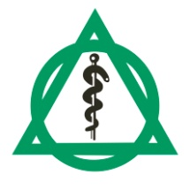
Company Profile: Asklepios
- Healthcare Industry Requirements
Asklepios
Facts & Figures (2006)
92 institutions, of which 86 are in Germany
68 of these institutions are hospitals and 48 are acute care clinics
Six institutions in the United States
14 rehabilitation clinics and near-acute care rehabilitation clinics
18 social facilities
32,000 staff
20,000 beds

Healthcare systems are coming under increasing pressure worldwide because people are living longer and medical staffing resources are often over stretched. While this requires highly efficient working, IT systems are often unable to deliver the time and cost savings required. Asklepios, based in Königstein-Falkenstein near Frankfurt am Main, decided to face this challenge head on. Together with Microsoft and Intel®, the company has set up the “Asklepios Future Hospital Programme” to drive reform in national and international healthcare systems.

The programme aims to set new standards in healthcare quality and efficiency. In addition, it embraces those people, companies, and technologies that wish to promote innovation in healthcare.

Besides an improvement in the quality and efficiency of treatment, the programme aims to increase integration of IT systems. The ultimate goal is seamless communication between all healthcare service participants.

The Asklepios Group
Following the partial privatisation of LBK Hamburg in December 2004, Asklepios became the largest private hospital group in Germany. The company, which was founded in 1984, has around 100 institutions and an annual turnover of €2 billion (U.S.$2.7 billion).

Beyond the management of its own institutions, and responsibility for managing a range of other hospitals, Asklepios also holds participating interests in other healthcare institutions. The group also owns the Pacific Health Corporation, an enterprise consisting of six acute-care hospitals in the United States.

In the field of new IT developments and applications, the Asklepios hospital in Hamburg Barmbek has become the central reference for all group hospitals since opening in 2006. All new solutions must meet strict integration and scalability criteria. They must also deliver measurable value in terms of treatment processes before they are adopted by the other Asklepios hospitals.

Competitive Advantage
As well as providing streamlined processes and rapid access to patient data, standardised IT infrastructures offer the key to efficient management of modern hospitals. They ensure optimised interactions between medical-technical equipment and facilities and create the conditions necessary for flexible, demand-orientated assignment of doctors and nurses.

Initial Situation
“In terms of efficient IT infrastructures, the healthcare sector is a long way behind the industrial sector,” says Uwe Pöttgen, Head of Central IT Services at Asklepios. “In most cases, hospital IT was initially designed specifically for individual sites and subsequently developed over the years. The result is heterogeneous systems, decentralised structures, and numerous data islands.

“What may function for individual hospitals in terms of service and costs is unsustainable in the context of an association of hospitals. Centralised IT management is practically unachievable, and the costs associated with maintenance and on-site support are astronomical.”

Frequently, there is no central directory service, no central server monitoring, no structured software distribution, and no uniformity of system and application software. Pöttgen says: “Almost all hospitals providing central priority care and maximum care face these problems.”

As the largest association of hospitals in Europe, LBK is familiar with these issues. The organisation has 1,600 doctors, 6,000 nurses, and 5,000 computer workplaces in the management, administration, medical and nursing divisions.

The organisation operates 20 domains and 5,000 computers, with operating systems ranging from Microsoft Windows® 98 to Microsoft Windows XP®. Its variety of hardware and software made on-site management cost-intensive. It rendered central management practically unachievable.

“Engineers had to walk between sites to address technical issues,” says Pöttgen. “Although this worked, it was inefficient and unsustainable in the long run.” Along with evidence of an increasing number of weak points in the medical care field, this scenario led to widespread concerns in the administration and controlling areas.

Location-independent working, for example, to process medical results, was practically impossible. Neither was it possible to access patient data on the move using mobile devices.
In addition, the availability and stability of hospital systems fluctuated and security was difficult to guarantee. Interfaces with modern medical-technical systems could not be exploited. As a result, it was impossible to directly transfer data from or to the pathology or radiology departments, for example.

Seamless Deployment
The “OneIT” project was launched in September 2006. With support from Microsoft and Intel®, Asklepios hospitals standardised the IT infrastructure of the LBK hospitals in Hamburg and implemented a central IT management infrastructure.

OneIT turned into the largest migration project in the history of the German healthcare industry. Its aim was to achieve a significant improvement in the fields of availability, security, efficiency, and data protection.

The OneIT project started with the migration of the AK Barmbek hospital. Deployment at other hospitals followed from September 2006 onwards. After a year of intensive work, the conversion of the LBK hospitals to OneIT was concluded in January 2007 in Altona. The newly standardised computer and data environment has now become an established part of day-to-day operations at Barmbek, Harburg, St. Georg, and Wandsbek.

The OneIT team had to work without disrupting the day-to-day running of hospitals. Meticulous preparation and tight project management were critical to achieving this goal. “We effectively converted facilities—such as Wandsbek, with around 600 beds—in one day,” says Robert Lacroix, Head of Enabling Technology, Asklepios. “At 0700, a team of 15 technology professionals would begin with the preparatory conversion of 180 computers, followed by the setting-up of a project office onsite. The team would proceed to convert the infrastructure, and, by the same evening, OneIT would be fully implemented.” During the first implementation of OneIT, engineers converted around 70 computers a day. With the experience they have gained, they can now migrate almost 200 each day.

OneIT Benefits
OneIT provides for consistent standardisation of all major system and network components. To support standardised, location-independent access to data, 20 domains were migrated to a single Active Directory domain. As a result, administration was simplified and centralised, and central safety backups were set up. This ensures compliance with statutory archiving requirements and supports centralised print and file services.

The Microsoft Exchange Server 2003 messaging environment supports centralised user administration. Around 25 per cent of computers were replaced altogether, and all desktops were equipped with Windows XP Service Pack 2 and Microsoft Office 2003, both of which deliver automated software update management.

During the project, servers were consolidated and their numbers significantly reduced. Around 120 servers were removed and migrated to 20 new devices equipped with Intel® Xeon processors. A central server monitoring system was also implemented.

The stable, high-speed network guarantees swift exchange of data between hospitals. An almost ubiquitous WLAN at the Barmbek Asklepios hospital provides mobile devices, equipped with Intel® Centrino® technology, with access to current patient data.

Effective Standardisation
Unsurprisingly, the extensive standardisation project did not always meet with popular approval. “Standardisation inevitably means fewer rights for individual users and administrators,” says Pöttgen.

However, after some time, the employees came to appreciate the new mobility tools, as well as the system’s security and stability. Dr. Anna Niemeyer at LBK-Klinikum Hamburg Harburg says: “An efficient IT infrastructure that provides location and time-independent access to information is capable of achieving substantial improvements in patient care, as well as speeding up day-to-day hospital processes.”

Cost-Efficient Solutions
The cost savings delivered by the deployment exceeded the team’s expectations. “Compared to other standardisation projects, OneIT is extremely streamlined and affordable,” says Pöttgen.

Investment resources, which are tight in most cases, were used prudently. “Within the framework of the general budget, financing was fairly flexible,” Pöttgen adds. “As a result, an adjustment to usual depreciation periods was feasible.

“Significant cost savings are delivered by the elimination of manual issue resolution. Engineers no longer spend time walking between workstations to fix problems.”

The Asklepios Future Hospital
OneIT will not only be deployed at LBK. The process is a fundamental component of the comprehensive Asklepios Future Hospital Programme. Together with Intel® and Microsoft, the private chain of hospitals is developing groundbreaking solutions for efficient and patient-oriented hospitals of the future.

“OneIT is the basis for many of the 30 current projects that form part of the Hospital of the Future Programme,” says Pöttgen. “We have made sure that solutions are scalable from the beginning, while remaining cost effective and adaptable to a range of hospital sizes.”

The process model will also be offered to institutions outside the group.

Because of its positive experience, Asklepios has been convinced by the advantages and savings delivered by OneIT. As a result, all group locations will benefit from new infrastructure delivered by the programme. Economic analysis is being carried out to support this decision.
“What has been standard practice in the industrial sector for years is still in its infancy in healthcare. We are talking about an efficient and standardised IT environment that spans several locations. In implementing OneIT, we have taken a decisive step towards a standard platform. The results are impressive and convincing.”
Uwe Pöttgen
Head of Central IT Services
Asklepios Group

Background
- Economic Analysis: OneIT
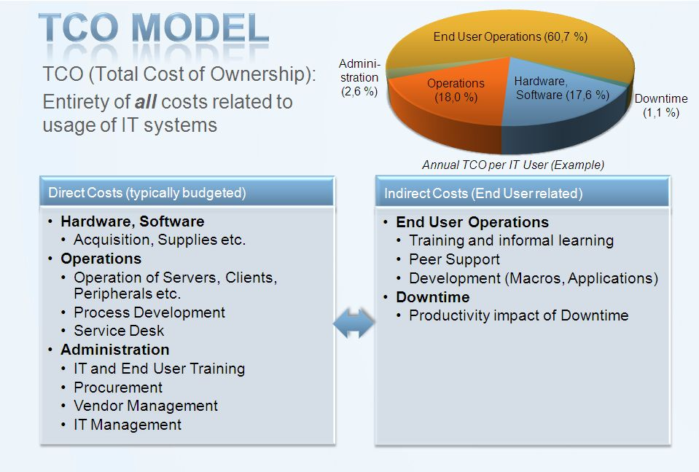
To assess the economic impact of the OneIT project, Asklepios, Microsoft, and Intel® carried out an efficiency analysis in the third quarter of 2006.

The representation of IT costs was based on a universally recognised TCO model. Allowing for a comprehensive insight into IT costs, the selection of this model seems particularly appropriate for this analysis. Among other factors, user aspects such as the impact of downtime are included as “indirect costs.” Using this industry standard methodology ensures that analysis is transparent.
TCO Simulation
The aim of TCO analysis is to determine the total costs of the IT infrasturcture, including all direct costs (e.g. operating expenses), as well as all indirect costs (e.g. system failures and their impact on productivity).
Three main factors affect TCO:
- Asset base (e.g. number of client and server systems and peripherals)
- IT best practices (e.g. level of standardisation and extent of process automation)
- Complexity (e.g. the number of sites covered by IT services)
Two simulations were carried out using the TCO model and toolset. “Barmbek 2004” and “Barmbek 2006” refer to the status of these factors before and after the implementation of OneIT.
The result was a TCO reduction of 36.7 per cent per client.

Asklepios Hospital Barmbek was used to analyse the benefits of the OneIT project. Reference values from prior to the migration (2004) were compared with reference values from after the migration (2006). This analysis was expected to reveal:

- The effect of the IT infrastructure optimisation at Asklepios Hospital Barmbek on IT costs.
- The impact on the maturity of IT operations.
- The effects on daily medical routines.

Cost Transparency and TCO
TCO relates to the total costs of a company’s IT operations throughout its entire lifecycle. This includes the costs of acquisition, deployment, maintenance, and redundancy.
In contrast to other types of cost analysis, this is a holistic approach. All costs incurred are included, whether budgeted or hidden. Even costs that are not directly part of the
IT budget—such as user training or outsourced IT segments—are considered.

Principally, a distinction is made between two different cost categories. Budgeted costs are typically part of direct costs, which include hardware, software licences, operational, and maintenance costs. In addition, the impact of indirect costs on the user is analysed. These include loss of working hours due to downtime or time spent on development activities, such as programming access.

As an important quality index, the level of indirect costs indicates to what degree various departments are supported, or even hindered, by the delivery of IT services.
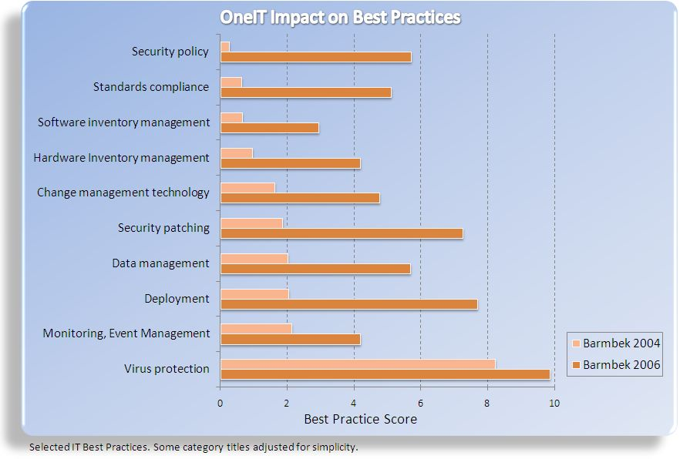
Indirect costs often make up the major share of the cost per user and are closely related to direct costs. Unbalanced cut-backs intended to reduce direct costs—such as cut-backs in the help desk area—may lead to multiple increases in indirect costs.

The TCO analysis at Asklepios Barmbek hospital paid particular attention to the development of indirect costs.

Infrastructure Quality Assessment
One of the main factors affecting the TCO is the quality or maturity of IT operations. This raises the following questions:

- Has the environment been standardised or has it been “thrown together”?

- Have IT processes been automated, for example, during deployment, or does manual administration prevail?

- How smooth is the coordination between IT and other hospital departments?

The TCO model assessed these issues and further aspects with the aid of 25 IT tasks, or “Best Practices,” which were each rated on a scale of zero to 10.

The effects of the OneIT deployment at the Asklepios Hospital between 2004 and 2006 can be understood by comparing both profiles (see graph).

The most significant improvements achieved by OneIT relate to “best practices” aspects, with a strong link to IT infrastructure management improvements. The study shows that:

■ Significant improvements were achieved in security policy by using the Personal Firewall in Windows XP alongside a centrally defined, homogeneous security configuration.

■ Standards compliance for clients was significantly improved because configurations for different user groups are managed centrally using Active Directory.

■ SMS 2003 established homogenous software and hardware inventory management.

■ The deployment improved support in change management technology through automated software deployment and up-to-date inventory.

■ Quality of security updating was increased by changing from manual to comprehensive automated processes.

The benchmarking results show that annual costs per client (TCO of desktop infrastructure) were reduced by a total of 36.7 per cent.
- Effects on TCO

“It is certainly normal for our customers to see noticeable cost reductions after consistent infrastructure optimisation,” says Andreas Kopp, Microsoft Business Value Analyst. “Having said that, Asklepios has set new benchmarks with the amount it was able to save in just two years.”

A summary of cost savings in a number of areas is as follows:

■ Annual costs for hardware and software were lowered by 15.3 per cent per client. This is a remarkable figure considering that acquisition costs should have been higher due to the deployment of mobile Tablet PCs. The impact was compensated by consolidating servers and printers, using Intel® hardware as standard, and enhancing asset management.

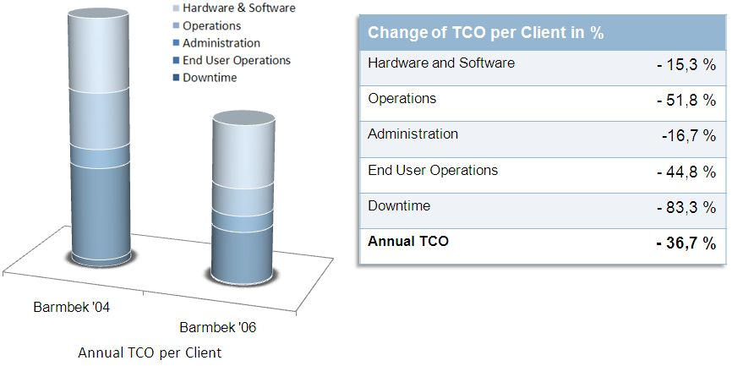
■ Changes to IT operations have lowered the cost per client by 51.8 per cent, which is mainly due to improvements in IT operations and server consolidation. The number of servers was reduced from 120 to 20, and 20 domains were migrated to a single domain.

■ Expenditure for IT-related administrative work was reduced by 16.7 per cent, which is mainly due to the improvements in inventory and asset management.

■ Significant TCO reductions were achieved for indirect costs. Expenditure due to reduced end-user productivity (end-user operations) was cut by 44.8 per cent, which is mainly due to consistent lock-downs of the client configuration and an improved help desk service. The number of trouble tickets has decreased significantly, while their processing speed has increased. The goal is to process trouble-tickets raised before 15:00 on the same day.

■ Investments made to stabilise the infrastructure have reduced downtime costs by 83 per cent per client.

Impact on Daily Medical Routines

As positive as significant cost reductions may be, they still do not reveal much about service improvements. Analysis of reductions in indirect costs only gives indications that the productivity of users has increased and that service downtime has been reduced.

For Asklepios, Intel®, and Microsoft, this assessment alone was not sufficient for a final evaluation. Possible impact on key performance indicators in daily medical routines was researched, providing far more detailed information than required by the TCO model. Senior consultants from various departments of the Asklepios Barmbek hospital were interviewed about their experience with Hospital of the Future IT Innovations.

Even though impact levels differed greatly from department to department, senior consultants were unanimous in their opinion. In addition, they were generally positive about the effects of the deployment on day-to-day medical routines:

■ Relevant information—such as patient data and diagnoses—can be located faster and is of better quality.

■ Medical decisions can be made more quickly based on faster availability of test results.

■ Digital communication has improved inter-disciplinary collaboration between hospital departments.

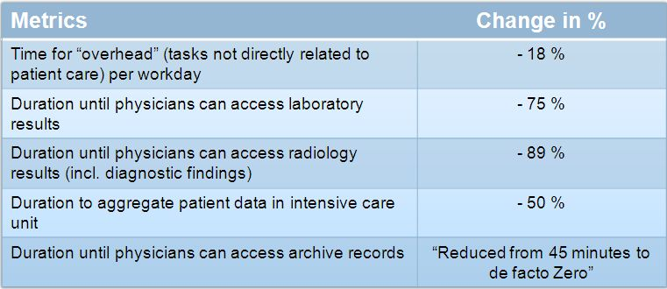
■ Daily routines have generally improved in all departments, and unnecessary overheads have decreased.

■ Entry of data into multiple, unconnected systems is no longer required, reducing administrative workloads and errors.

■ Mobile technologies have streamlined processes, such as transportation of beds or other equipment.

■ Innovations create free time, which can be used to enhance patient care. Tablet PCs, for example, are used on “mobile ward rounds” to explain treatments to patients directly at their bedsides.

Increased Productivity
In addition to the described qualitative feedback by physicians, key data was collected to show the extent of process improvements in daily hospital routines:

■ Daily time overheads, meaning activities not directly connected to patient care, were reduced by 18 per cent on average. This includes completing forms and searching for information. This is a remarkable figure, considering the amount of documentation required increased during the same period of time.

■ Significant process improvements emerged from the laboratory and radiology departments of the hospital. The time required to make test results available to doctors was reduced by 75 per cent and by 89 per cent in the radiology department. Where processing for radiology test results usually took several hours, these can now be made available in 60 minutes. Access for physicians has also improved dramatically through the use of mobile support. Tablet PCs, for example, are now in use throughout the entire hospital.

■ The intensive care department depends on patient information that is collected from several medical subsystems each day. Because of enhanced integration, this can be achieved in half the time previously required.

■ Finally, the time required to retrieve archived data has been greatly increased. Where paper-based archives had to be searched manually, data can now be interrogated rapidly using electronic methods.

Technology Deployed
The implementation of centrally configured IT services, based on technology from Microsoft and Intel® has helped Asklepios to achieve a 36.7 per cent reduction in TCO per client. This has been achieved at the Asklepios Barmbek hospital in just two years.

Software Deployed
■ Windows Server® 2003 was used to replace various Novell NetWare, Linux, and UNIX systems.
■ Active Directory was deployed as a company-wide directory service, replacing heterogeneous Novell, Domino Directory, and Microsoft Windows NT domain implementations.
■ SharePoint Portal Server 2003 supports collaboration between employees and resident doctors through the doctors’ portal.
■ SQL Server 2005 provides the required database functions, replacing an Oracle system, among others.
■ Exchange Server 2003 replaces Lotus Domino and Lotus Notes.
■ SMS 2003 centrally deploys software to servers and workstations.
■ MOM 2005 provides a central platform for monitoring network performance.
■ ISA Server 2006 increases network security.
■ Microsoft Office 2003 Enterprise Edition enhances employee productivity across the group.

Hardware Deployed
■ Fujitsu Siemens FSC TC 4010 Windows XP-based Tablet-PCs provide mobile support for healthcare workers.
■ Fujitsu Siemens FSC Esprimo Desktop PCs.
■ Fujitsu Siemens Primergy Servers.
■ Windows CE-based mobile devices help to coordinate bed and equipment transport.
■ Intel® Stable Image Technology is an integral part of some of Intel®’s mobile and desktop products. With Stable Image Technology in its SIPP Chipsets, Intel® guarantees that smaller technological changes are compatible with previously tested computer platform configurations. By giving due notice of any innovations or new platforms, Intel® also supports IT managers in strategic IT planning.
■ Intel® Xeon® Dual-Core Processors offer scalable performance, robust virtualisation, and reliable uptime for demanding corporate applications in 64- and 32-Bit versions. Intel® Xeon® Dual-Core Processors are designed for servers with four or more processors. These have enhanced capacity reserves, ensure reliability, and deliver comprehensive support features necessary for simultaneous processing of multiple transactions. Applications supported include databases, supply chain management tools, and business intelligence applications. They also support virtualisation and server consolidation, ensuring more efficient use of computer centre servers.
■ Intel® Centrino mobile technology offers excellent performance and reliable wireless connectivity.
Microsoft in the Healthcare Industry
- Technology Partners—Overview
Microsoft has many years’ experience in the healthcare industry. As such, it works to drive technological transformation that adds strategic value and delivers measurable results.

Microsoft Connected Health
To support information networks in healthcare, Microsoft created the “Connected Health Framework.” This incorporates a range of scenarios that show how integrated and interoperable technology solutions can optimise administrative and medical processes. Apart from technologies, such as the Microsoft .NET Framework and the Microsoft BizTalk® Accelerator, Microsoft can offer framework architectures for the healthcare industry.

Working together, Intel® and the Asklepios Ingolstadt Hospital have developed the eHealth Interoperability Platform (eHIP). This integration and communications platform supports stakeholders in healthcare with the implementation of integrated care. It also serves as operations and development platform for innovative solutions for customers and partners alike.

Microsoft at Asklepios Future Hospital
In early 2005, Microsoft, Intel®, and the Asklepios Hospitals instigated the Asklepios Hospital of the Future Programme. The emphasis of the collaboration was on infrastructure optimisation for the modern hospital, including solutions for “Integrated Healthcare” and “Telehealth.”

“By implementing the Asklepios Hospital of the Future concept, we have set new benchmarks,” says Jens Dommel, Director of the Healthcare Sector, Microsoft Germany. “It has created a new synergy between organisations, processes, and IT, and enhanced collaboration between doctors, rehabilitation hospitals, and health insurance companies.

“Together with Asklepios and Intel®, we have created a highly effective infrastructure at Barmbek. This is a foundation for a dynamic and service-oriented IT environment.”

Intel® in the Healthcare Industry
For many years, Intel® has been meeting the technology needs of the healthcare industry by delivering comprehensive solutions with the concerns of patients and care workers in mind.

Intel®’s aim is to improve existing processes, lower costs, and enhance medical care continually. As such, the quality of care remains the focus of any technology solution. Intel® established its Digital Health Group as a business unit that significantly supports the digitisation of healthcare processes globally.

Intel® and Microsoft at Asklepios Future Hospital
Intel®, Asklepios, and Microsoft have a common vision. This is the Hospital of the Future, a hospital that uses innovative processes and future-oriented solutions to take patient care to the next level. Intel® Solution Services are helping Asklepios realise this vision.

“The implementation of these solutions at the Asklepios Hospital of the Future is a step towards achieving our mutual aspirations,” says Christian Ganz, Manager of Digital Health, Intel® Germany. “We are optimising patient care through the use of innovative technologies.”



Further Information

Reference Customer
Asklepios Kliniken
Hubertusstraße 12-22
D - 16547 Birkenwerder
Tel.: +(44) (0)3303 522404
Fax: +(44) (0)3303 522420
E-mail: zd.marketing@asklepios.com
www.asklepios.com

Business Customer Support
Microsoft Deutschland GmbH
Konrad-Zuse-Straße 1
D - 85716 Unterschleißheim
Tel.: 0180 5 672330*
Fax: 0180 5 229554*
E-mail: btob@microsoft.com
*0.12 Euro/Min., within Germany

View existing case studies at:
www.microsoft.com/germany/kundenreferenzen

© 2007 Microsoft Corporation. All rights reserved.
This case study is for informational purposes only. MICROSOFT MAKES NO WARRANTIES, EXPRESS OR IMPLIED,

